Supplementary tables

Reverse primer | Forward primer | Gene Symbol
5'-AGCACTTCCTCCAGAGGTTTG-3' | 5'-TACATGCCCAAGAAGGCCAC-3' | IL-2
5'-TTCCTGTCGAGCCGTTTCAG-3' | 5'-CTTTGCTGCCTCCAAGAACAC-3' | IL-4
5'- AAGTGGGTGCAGCTGTTCTC -3 | 5'- AAGAAGGCATGCACAGCTCA -3' | IL-10
5'-AACCTCGCCTCCTTTGTGAC-3' | 5'-GTGAGGTCTTAGGCTCTGGC-3' | IL-12
5'-GCACAACTCCGGTGACATCAA-3' | 5'-CAATTCCTGGCGATACCTCAG-3' | TGFβ
5'-ATGTCGGATGGATGAAACCC-3' | 5'-CCAGCGTACTCCAAAGATTC-3' | B2M
Table S1. Sequence of primers used in real-time PCR

Supplementary Figures

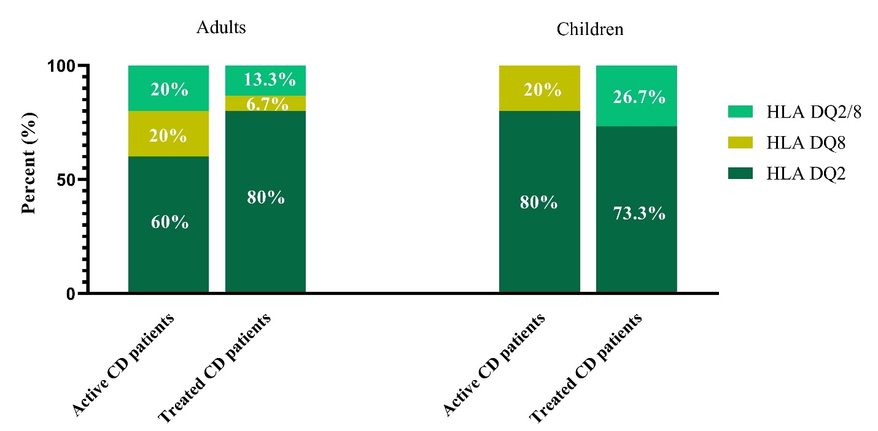 Figure S1. HLA status of studied patients

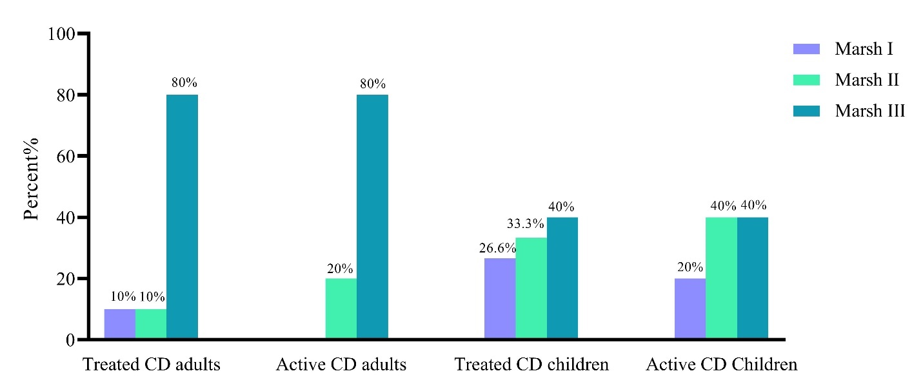
Figure S2. Histological classification of studied patients

