Supplementary Materials
Superb Li-ion storage of Sn-based anode assisted by the conductive hybrid buffering matrix

Jinsil Shin¹, Sung-Hoon Park^{2*}, Jaehyun Hur^{1*}

¹Department of Chemical and Biological Engineering, Gachon University, 1342 Seongnam-daero, Seongnam 13120, Republic of Korea
²Department of Mechanical Engineering, Soongsil University, 369 Sangdo-ro, Dongjakgu, Seoul 06978, Republic of Korea

Correspondence should be addressed to Prof. Jaehyun Hur* (jhhur@gachon.ac.kr) and Prof. Sung-Hoon Park* (leopark@ssu.ac.kr).

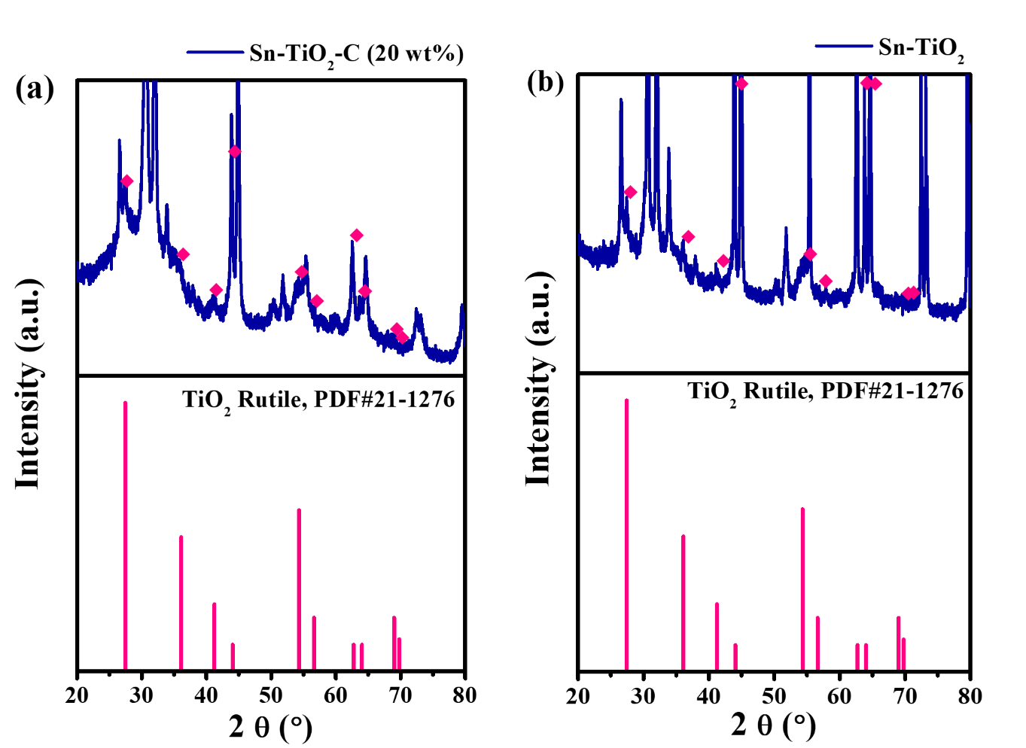
Figure S1. Enlarged view of XRD spectra of (a) Sn-TiO₂-C (20 wt%) and (b) Sn-TiO₂ along with theoretical peak of rutile TiO₂ (PDF#21-1276).
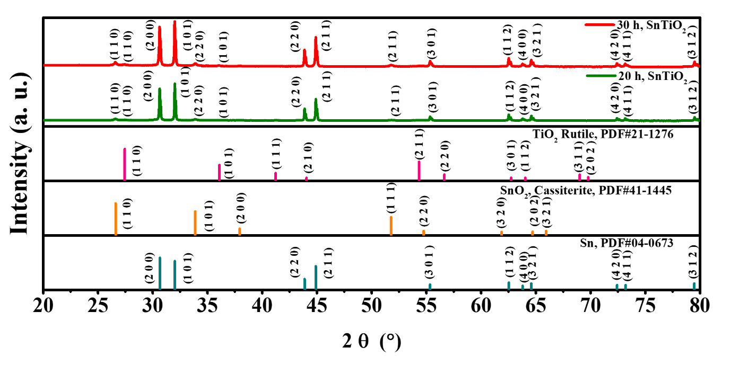
Figure S2. XRD spectra of Sn-TiO₂ after 20 h and 30 h milling.

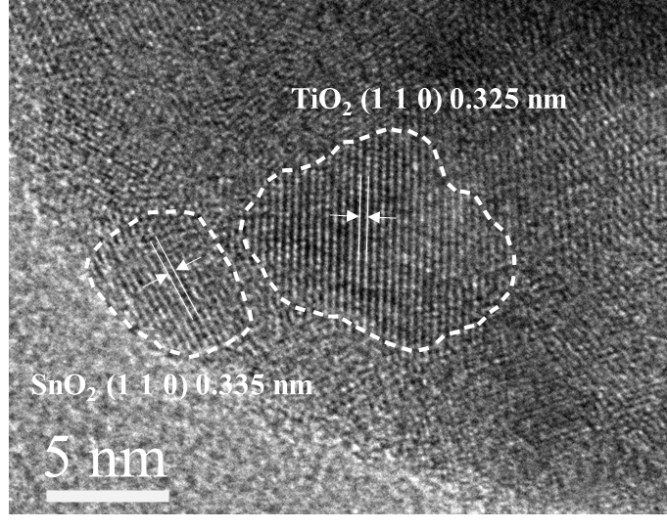
Figure S3. HRTEM image of Sn-TiO₂-C (20 wt%) showing the existence of SnO₂.

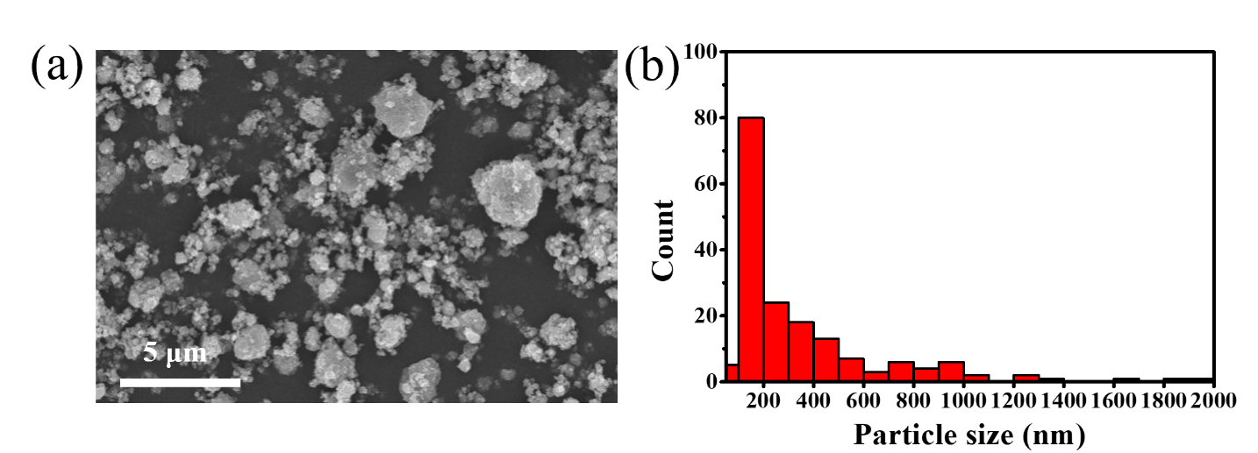
Figure S4. (a) SEM image and (b) particle size distribution of Sn-TiO₂-C (20wt%).
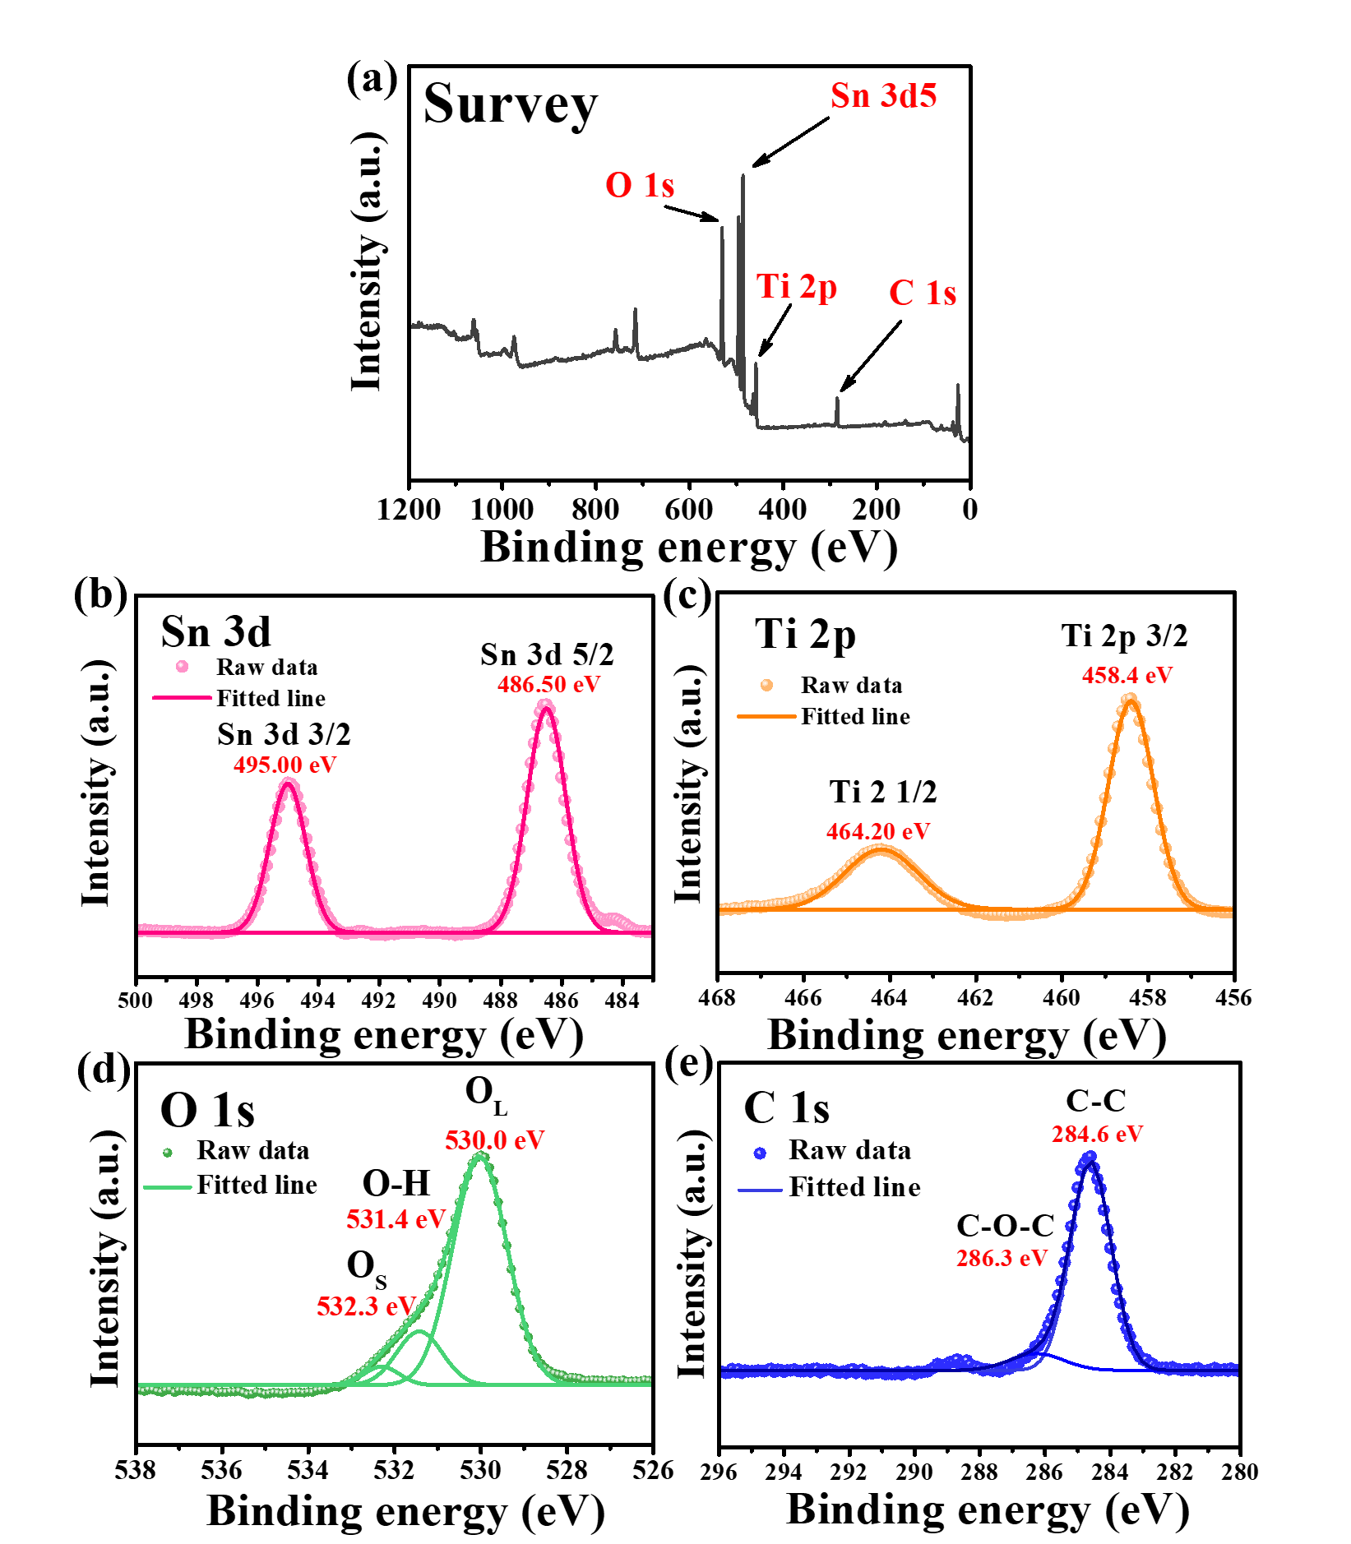
Figure S5. High-resolution XPS spectra of Sn-TiO₂ powder. (a) survey (b) Sn, (c) Ti, (d) O (O_{L} (lattice oxygen), O-H bond, and O_{s} (adsorbed oxygen)), and (e) C

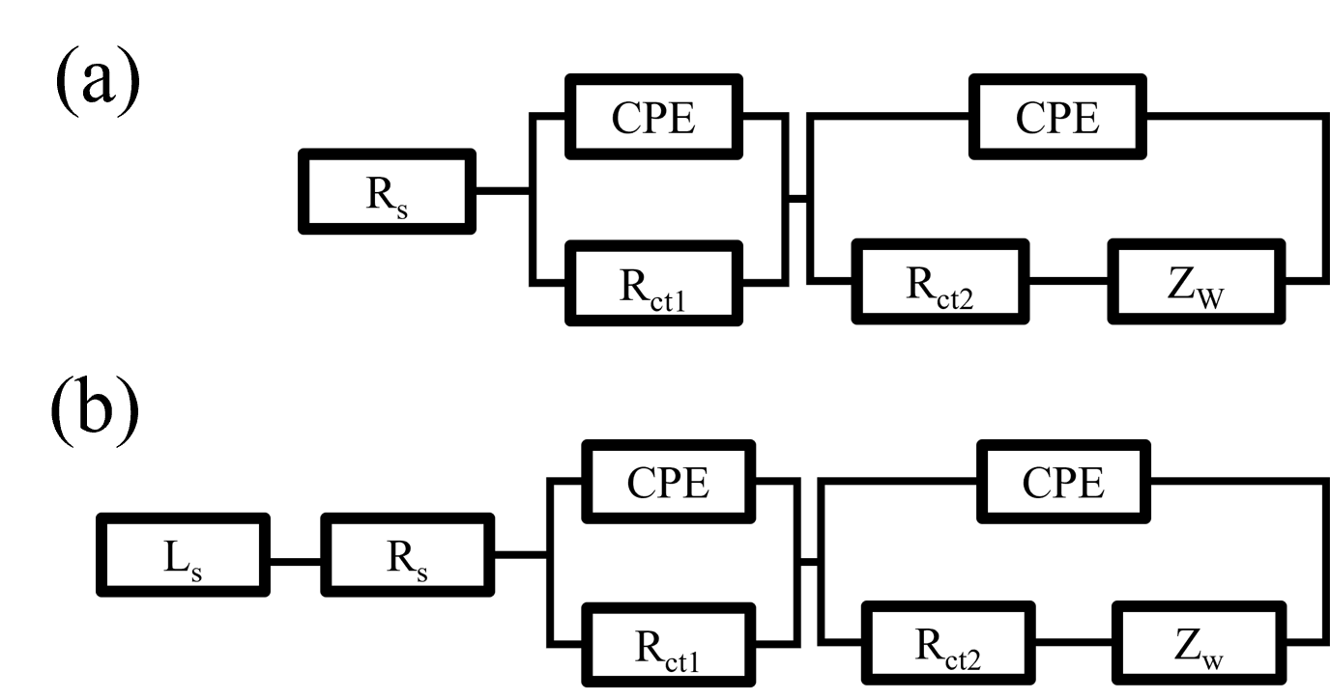
Figure S6. The equivalent circuit for (a) Sn-TiO₂-C (20 wt%) and (b) Sn-TiO₂ and Sn-C (20 wt%)

Table. S1. Theoretical capacity of Sn-TiO₂-C (20 wt%), Sn-TiO₂, and Sn-C (20 wt%)

Composite | Theoretical capacity
Sn-TiO₂-C (20 wt%) | 657 mAh g⁻¹
Sn-TiO₂ | 728 mAh g⁻¹
Sn-C (20 wt%) | 869 mAh g⁻¹

Table S2. Performance of Sn-based anode for Li-ion batteries
Composite | Specific capacity | Cycles number | Current density | Ref
Sn-C | 410 mAh g⁻¹ | 100 cycles | 100 mA g⁻¹ | [19]
Sn-Co | 515.5 mAh g⁻¹ | 50 cycles | 50 mA g⁻¹ | [20]
Sn/CNT | 413 mAh g⁻¹ | 100 cycles | 30 mA g⁻¹ | [21]
Sn-Ca | 280 mAh g⁻¹ | 60 cycles | 50 mA g⁻¹ | [22]
3D Cu-Sn | 590 mAh g⁻¹ | 50 cycles | 0.3 C | [23]
Sn-Ni | 448.9 mAh g⁻¹ | 20 cycles | 0.1 C | [24]
SnSb-C | 300 mAh g⁻¹ | 100 cycles | 100 mA g⁻¹ | [25]
SnS_{x}/NRGO | 562 mAh g⁻¹ | 200 cycles | 0.2 A g⁻¹ | [26]
Sn-TiO₂-C | 669 mAh g⁻¹ | 100 cycles | 200 mA g⁻¹ | This work

Table S3. Coulombic efficiency of Sn-TiO₂-C, Sn-TiO₂, and Sn-C at 1, 2, 3, 10, and 50th cycle at current density of 200 mA g⁻¹

Cycle number | Coulombic efficiency
 | Sn-TiO₂-C (20 wt%) | Sn-TiO₂ | Sn-C (20 wt%)
1st | 81.89 | 63.54 | 73.50
2nd | 84.38 | 67.56 | 90.78
3rd | 95.51 | 89.12 | 91.24
10th | 98.31 | 96.19 | 94.43
50th | 98.73 | 98.30 | 97.54

Table S4. Fitted parameter values of R_{s}, R_{ct1}, and R_{ct2} of Sn-TiO₂-C (20 wt%), Sn-TiO₂, and Sn-C (20 wt%) at 200 mA g⁻¹ after 20 cycles

Parameter | Sn-TiO₂-C (20 wt%) | Sn-TiO₂ | Sn-C (20 wt%)
R_{s} | 2.62 | 5.59 | 3.56
R_{ct1} | 4.83 ⅹ 10¹ | 6.45 ⅹ 10¹ | 9.83 ⅹ 10¹
R_{ct2} | 1.80 ⅹ 10² | 2.17 ⅹ 10² | 1.95 ⅹ 10²

