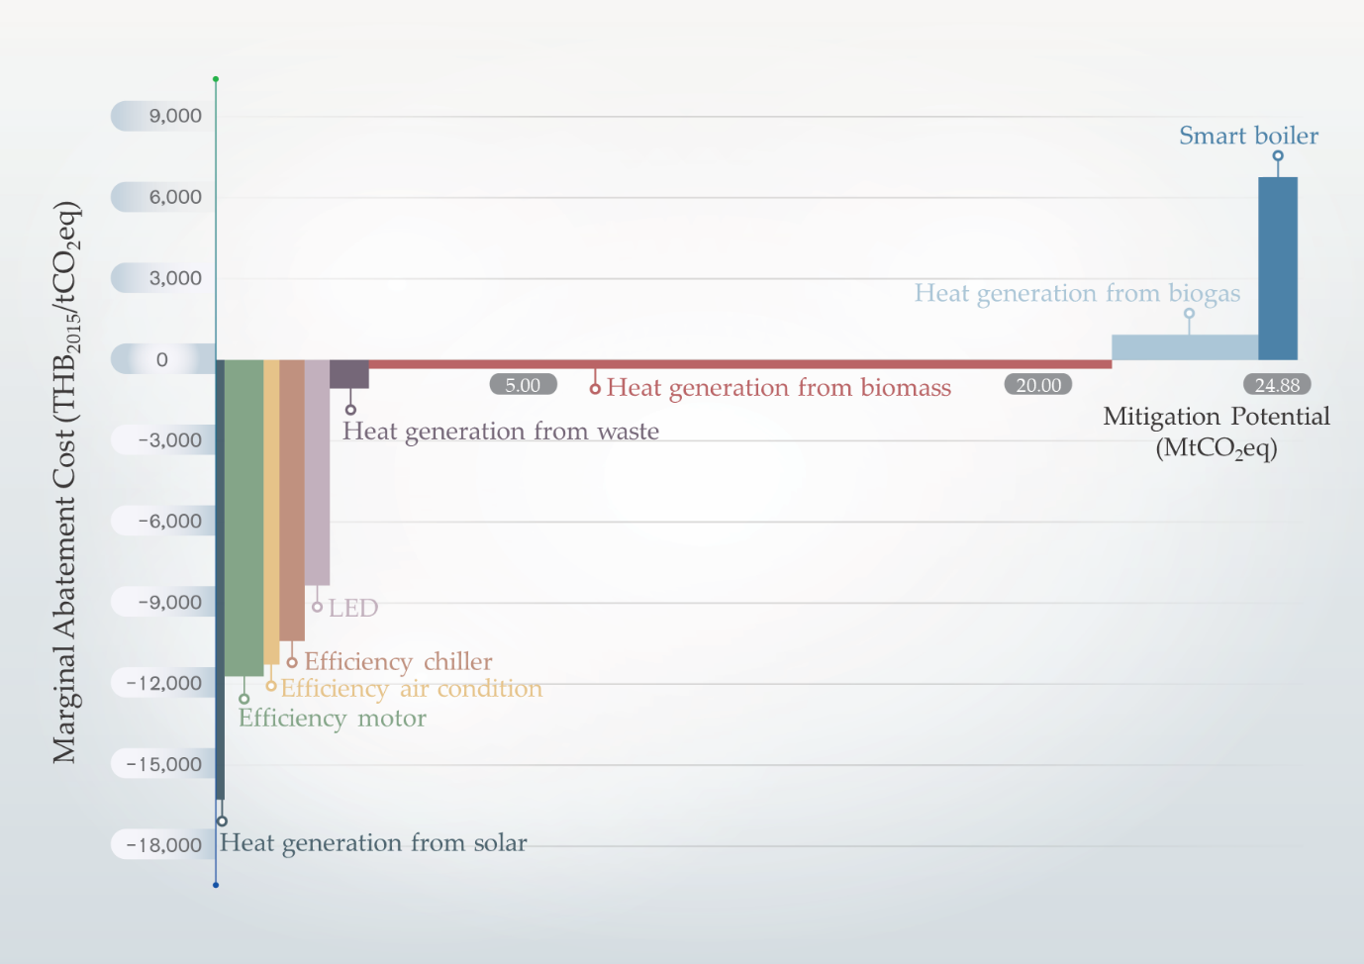
Figure S1. Marginal abatement cost curve of GHG technology in industry sector in 2020.
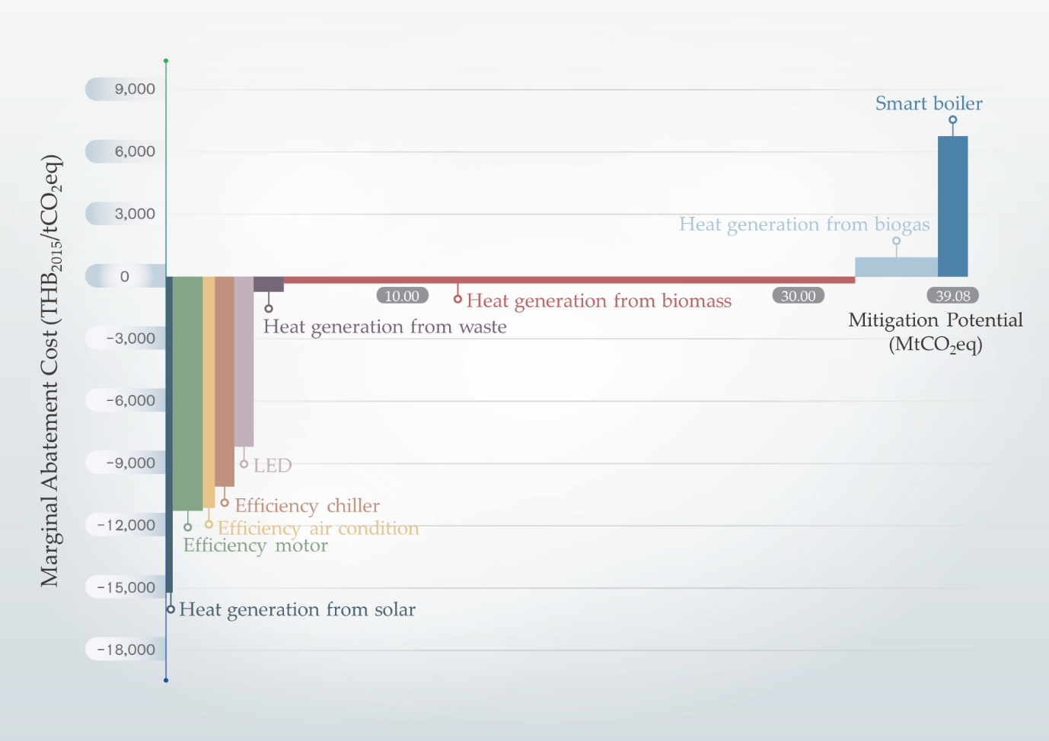
Figure S2. Marginal abatement cost curve of GHG technology in industry sector in 2025.
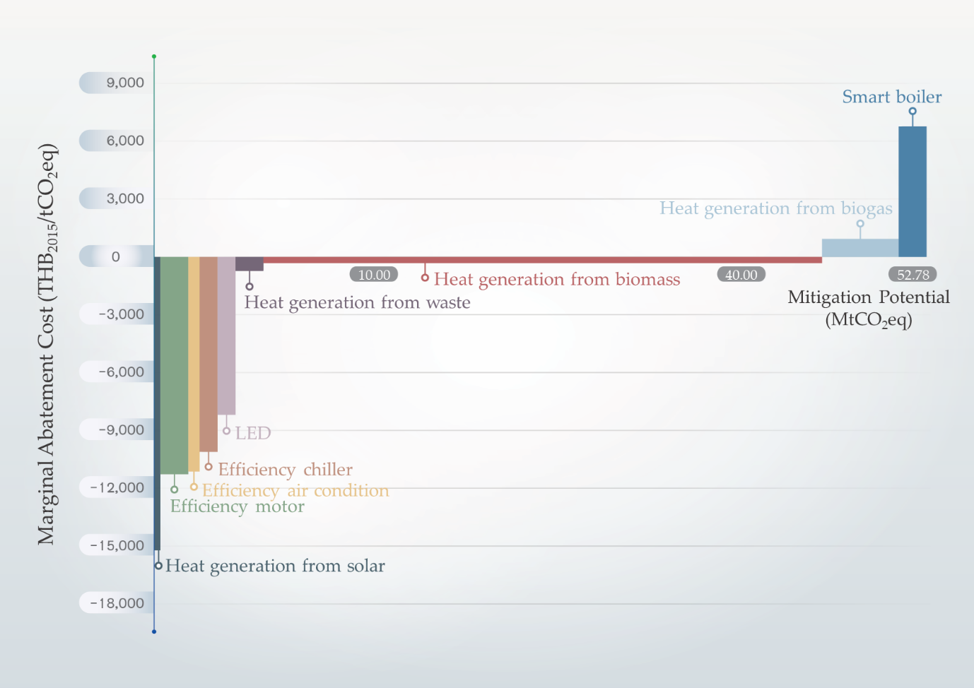
Figure S3. Marginal abatement cost curve of GHG technology in industry sector in 2030.
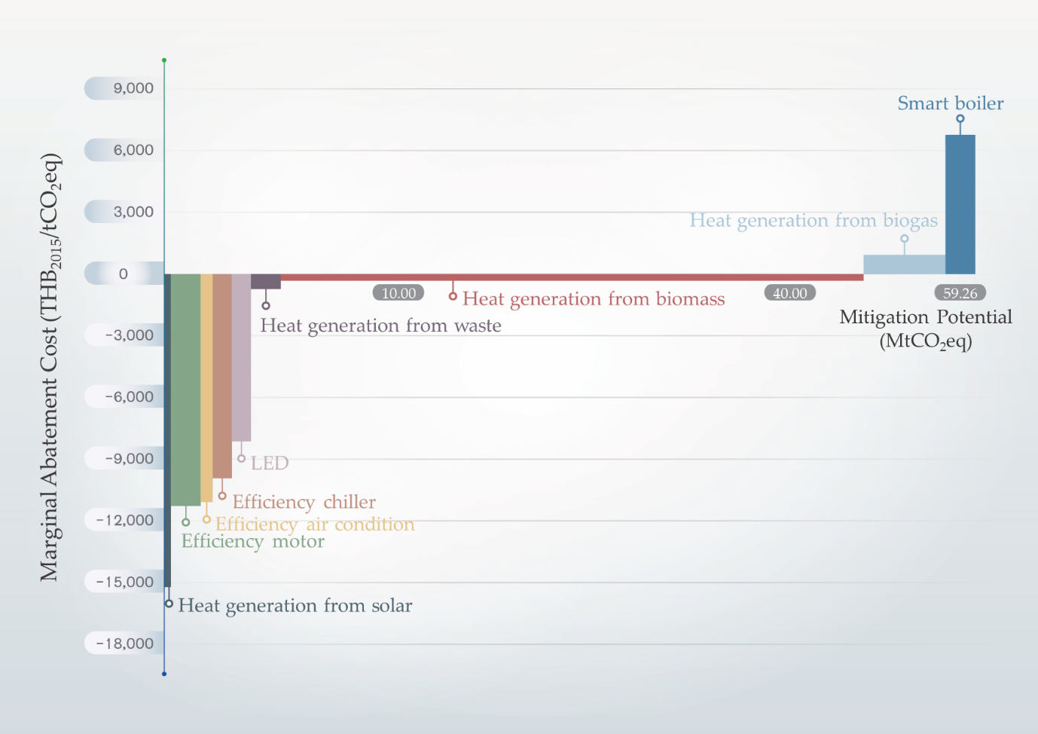
Figure S4. Marginal abatement cost curve of GHG technology in industry sector in 2035.
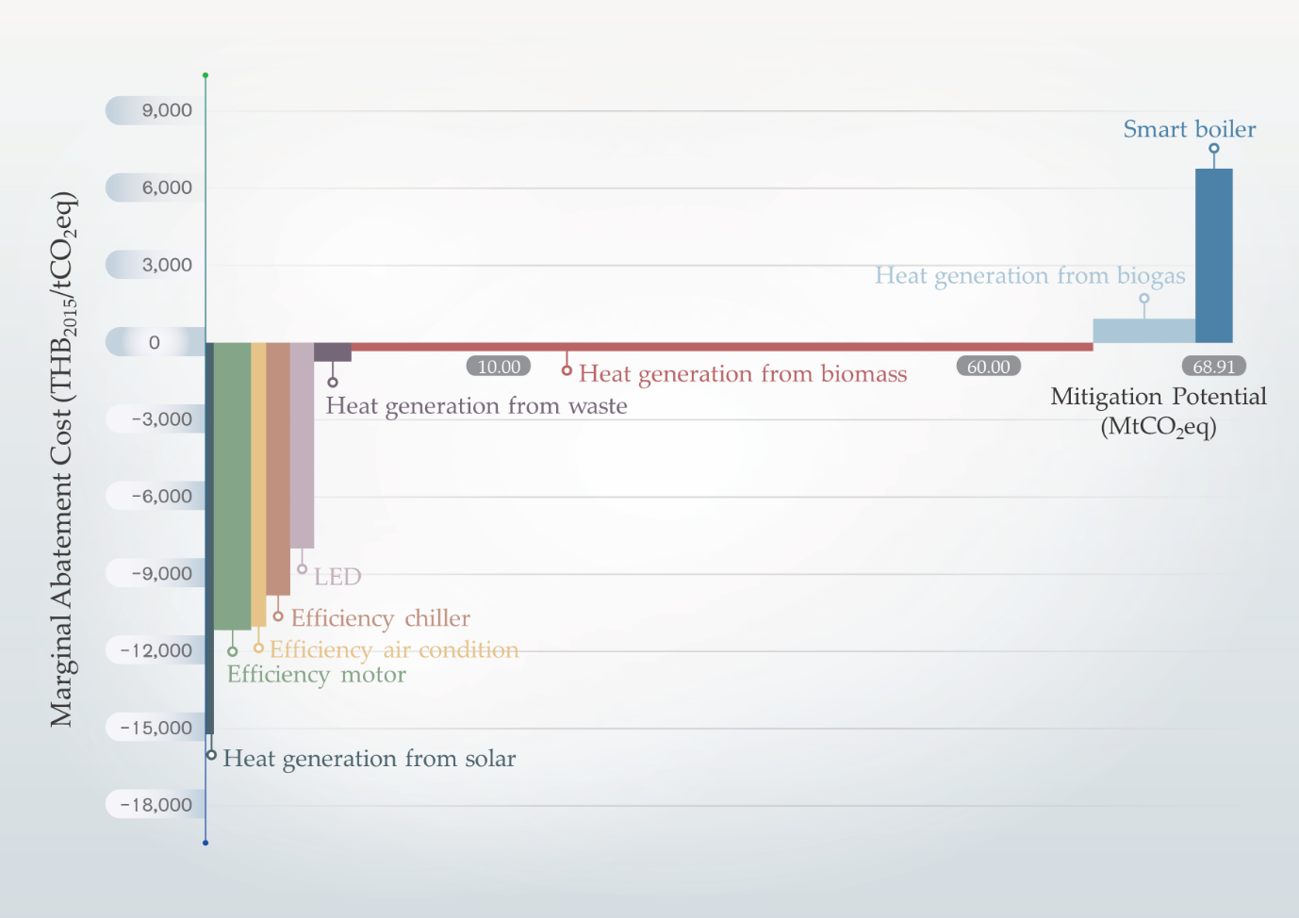
Figure S5. Marginal abatement cost curve of GHG technology in industry sector in 2040.
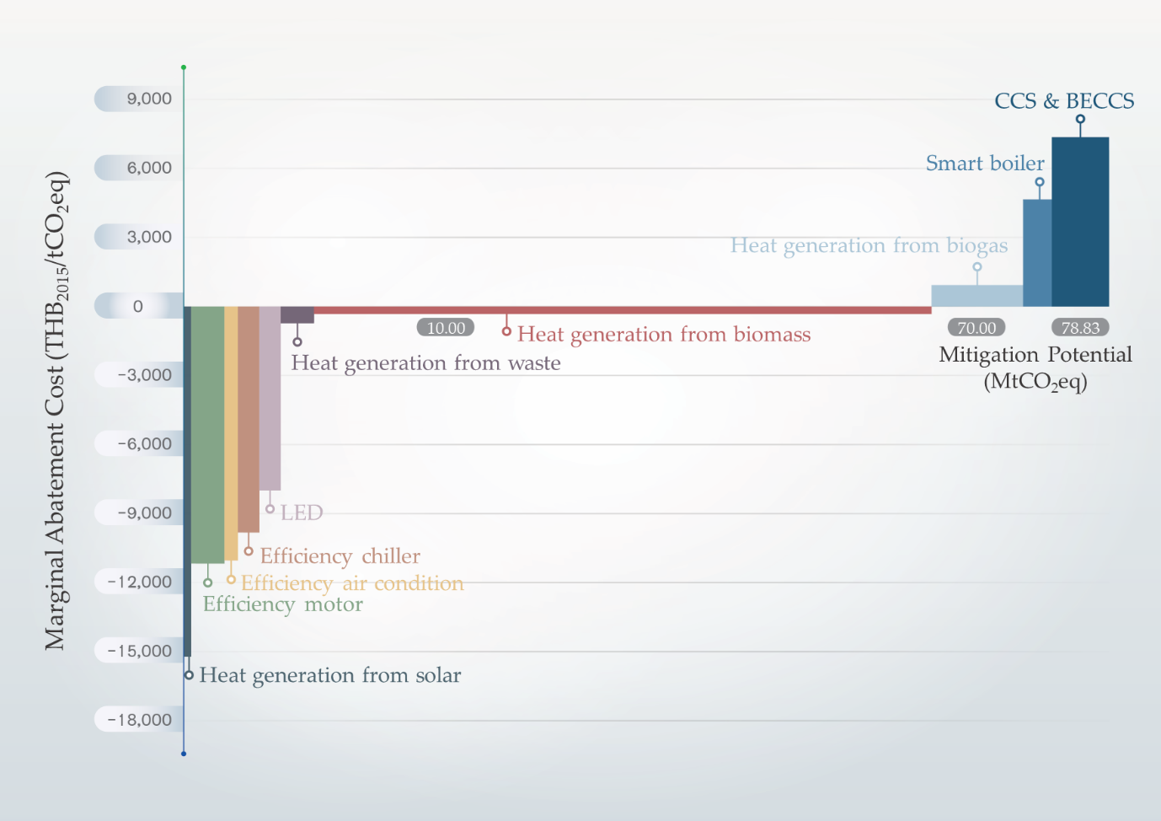
Figure S6. Marginal abatement cost curve of GHG technology in industry sector in 2045.
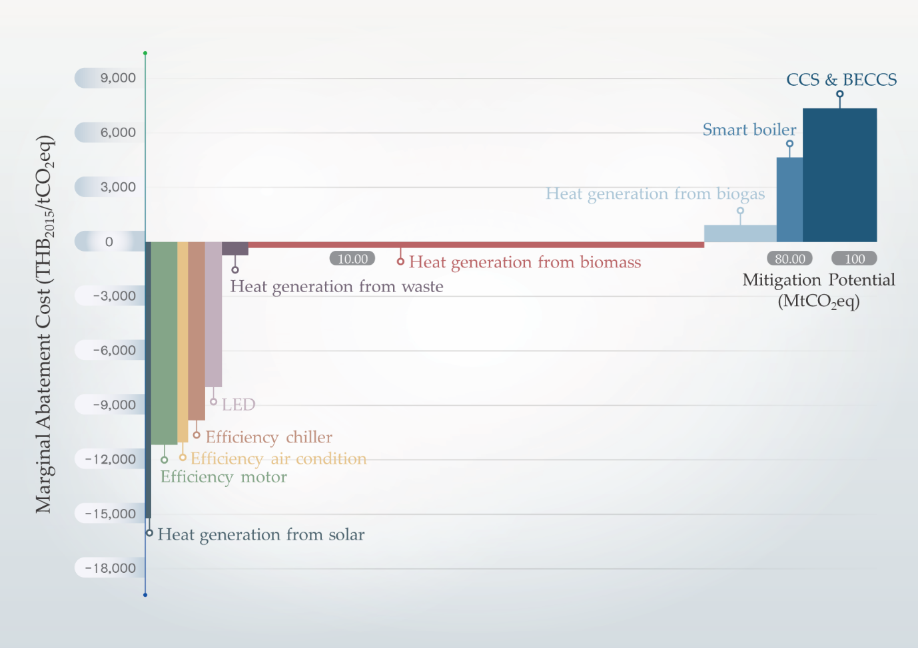
Figure S7. Marginal abatement cost curve of GHG technology in industry sector in 2050.
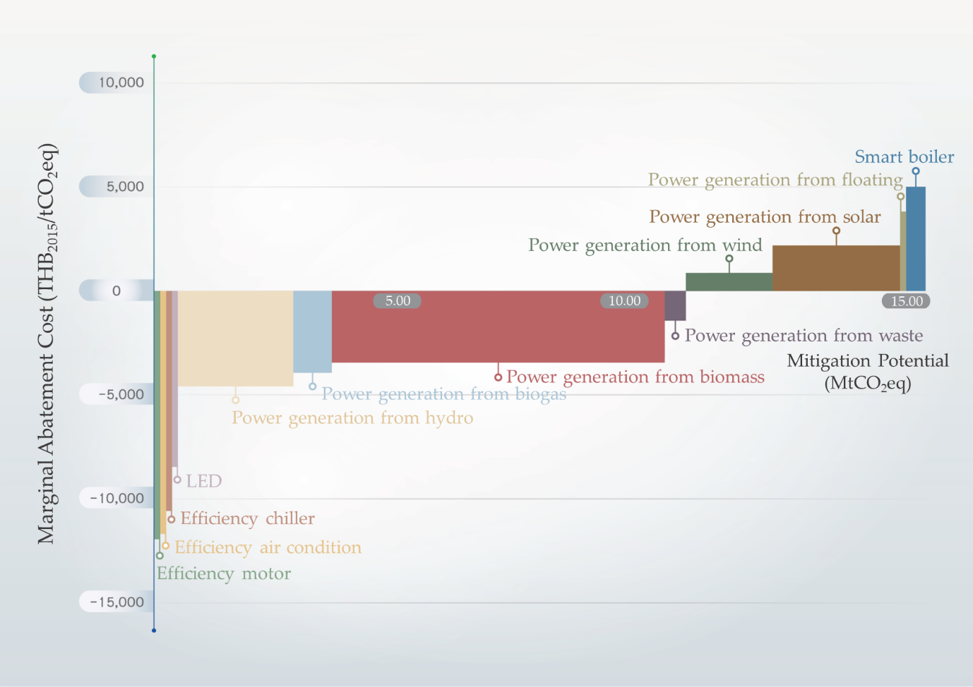
Figure S8. Marginal abatement cost curve of GHG technology in power sector in 2020.
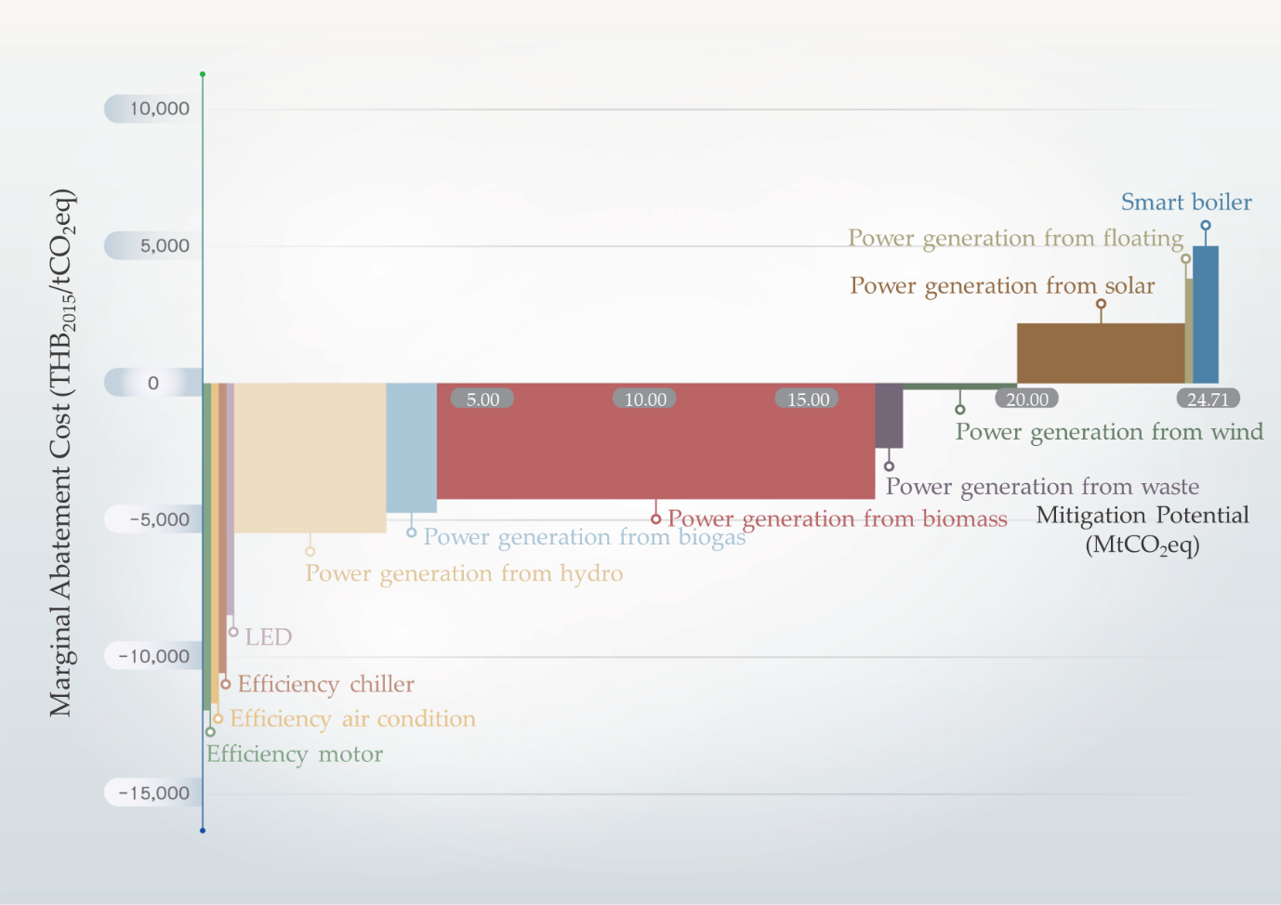
Figure S9. Marginal abatement cost curve of GHG technology in power sector in 2025.
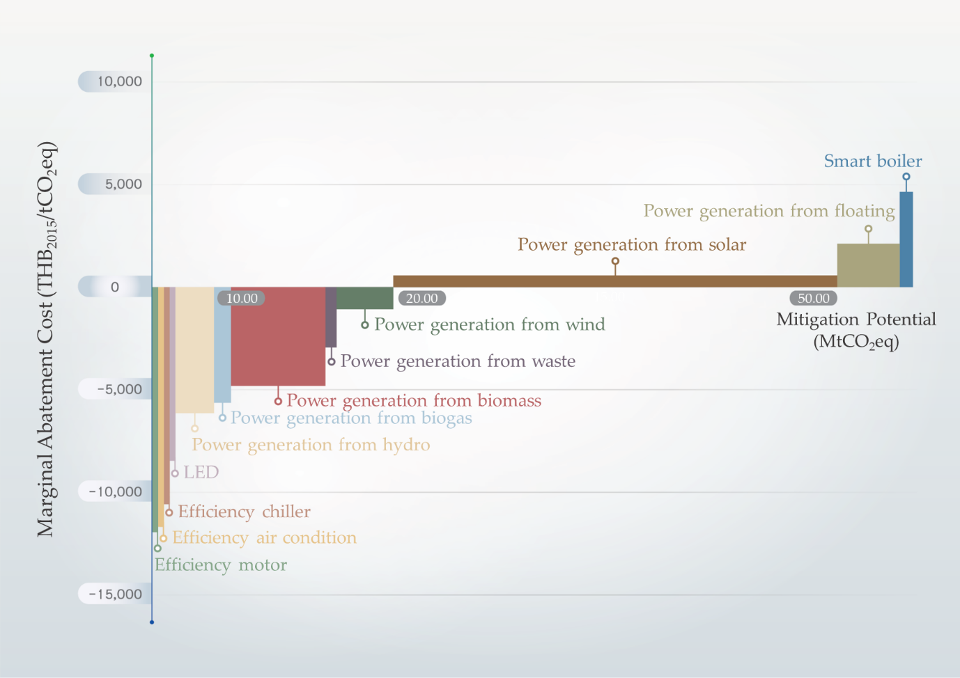
Figure S10. Marginal abatement cost curve of GHG technology in power sector in 2030.
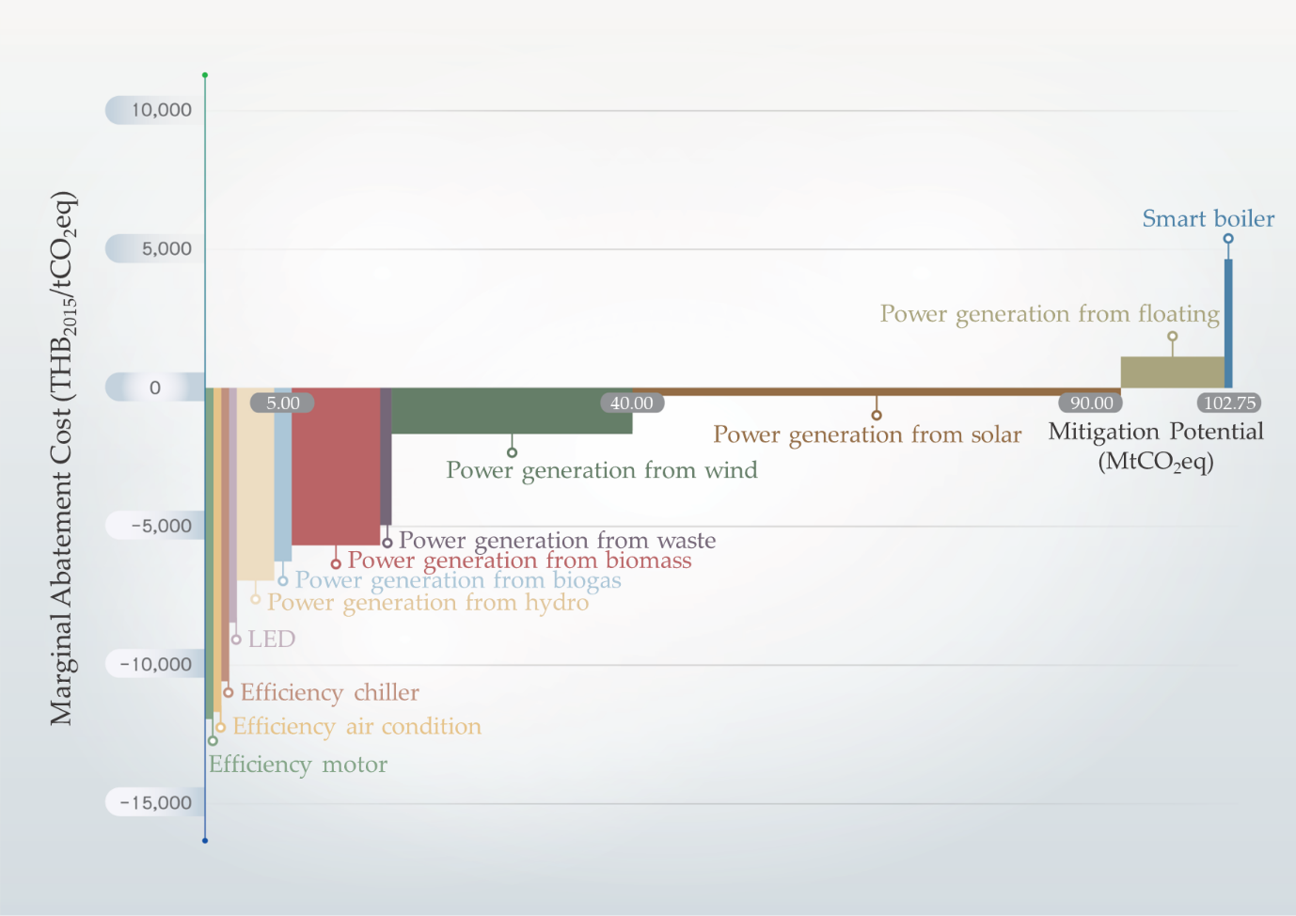
Figure S11. Marginal abatement cost curve of GHG technology in power sector in 2035.
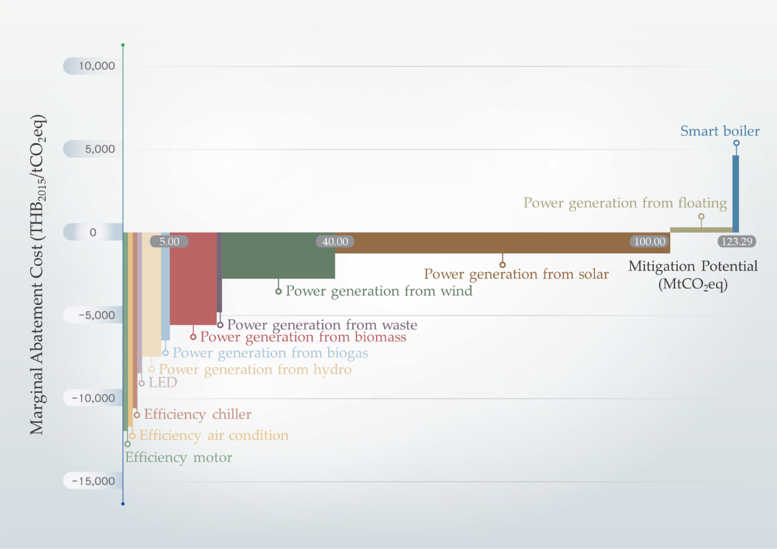
Figure S12. Marginal abatement cost curve of GHG technology in power sector in 2040.
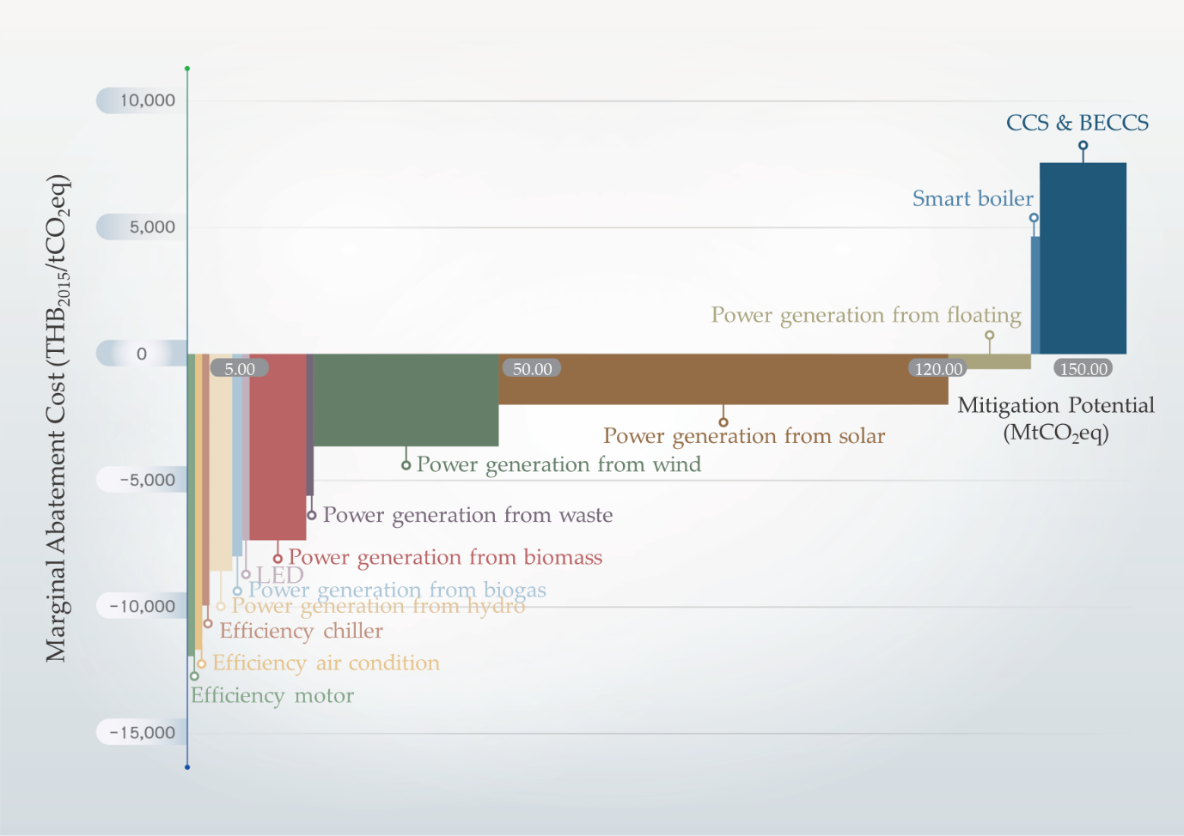
Figure S13. Marginal abatement cost curve of GHG technology in power sector in 2045.
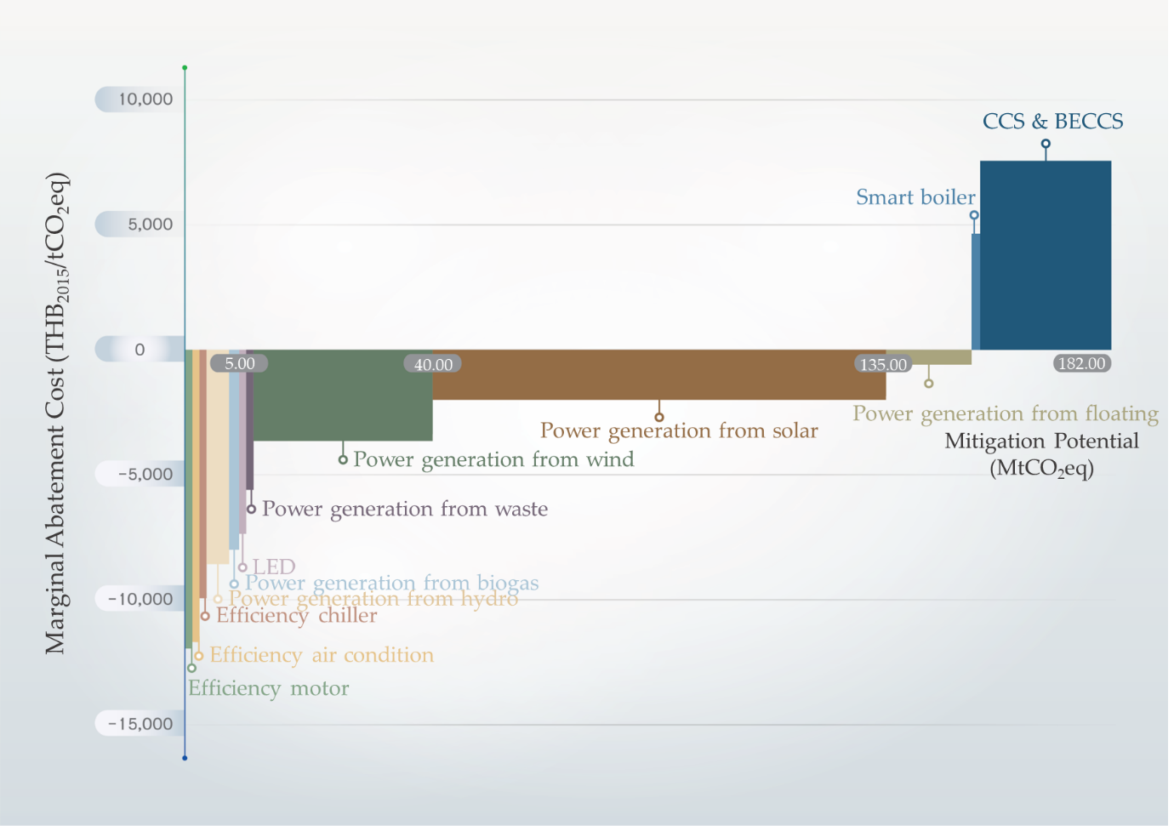
Figure S14. Marginal abatement cost curve of GHG technology in power sector in 2050.

