Supporting Information for
Caboxamycin with Antiviral Activity in CVB3-Induced Myocarditis Mouse Model

Hong-Gi Kim^{1,#}, Prima F. Hillman^{2,#}, You-Jeung Lee³, Ha-Eun Jeon¹, Byung-Kwan Lim^{1,*}, and Sang-Jip Nam^{2,*}

¹Department of Biomedical Science, Jungwon University, Goesan-gun, Chungbuk 28024, Republic of Korea; ghdrl368@naver.com (H.G.K); wjs20007@gmail.com (H.E.J); bklim@jwu.ac.kr (B.K.L)
²Department of Chemistry and Nanoscience, Ewha Womans University, Seoul 03760, Republic primafitriah@gmail.com (P.F.H); sjnam@ewha.ac.kr (S.-J.N)
³Division of Cardiology, Samsung Medical Center, 50 Irwon dong, Gangnam-gu, Seoul 06351, Republic of Korea; eelulee@daum.net (Y.J.L)
#These authors equally contributed to this work
*Correspondence: bklim@jwu.ac.kr (B.K.L); sjnam@ewha.ac.kr (S.-J.N)
Table of Contents
Table S1. Real-time PCR primer sequences ……………………………………………………………………..………………………. | S3
Figure S1. ¹H NMR Spectrum of Caboxamycin (1) in CDCl₃ …………………………………………………………………….……….. | S4
Figure S2. ¹³C NMR Spectrum of Caboxamycin (1) in CDCl₃ ………………………………………………………………………….…. | S5

Table S1. Real-time PCR primer sequences
 | Sense (5’→3’) | Antisense (5’→3’)
IL-1 | TTG ACG GAC CCC AAA GAG TG | ACT CCT GTA CTC GTG GAA GA
IL-6 | GTA CTC CAG AAG ACC AGA GG | TGC TGG TGA CAA CCA CGG CC
TNF- | TTG ACC TCA GCG CTG AGT TG | CCT GTA GCC CAC GTC GTA GC
MCP-1 | ACC TGG ATC GGA ACC AAA TG | CCT TAG GGC AGA TGC AGT TTT AA
CD4 | GTT CAG GAC AGC GAC TTC TGG A | GAA GGA GAA CTC CGC TGA CTC T
CD8 | ACT ACC AAG CCA GTG CTG CGA A | ATC ACA GGC GAA GTC CAA TCC G
CD68 | CTT CCC ACA GGC AGC ACA G | AAT GAT GAG AGG CAG CAA GAG G
NPPA | TACAGTGCGGTGTCCAACACAG | TGCTTCCTCAGTCTGCTCACTC
Myh7 | GCTGAAAGCAGAAAGAGATTATC | TGGAGTTCTTCTCTTCTGGAG
GAPDH | ATC AAC GAC CCC TTC ATT GAC C | CCA GTA GAC TCC ACG ACA TAC TCA GC

Figure S1. ¹H NMR Spectrum of Merochlorin G (1) in CDCl₃
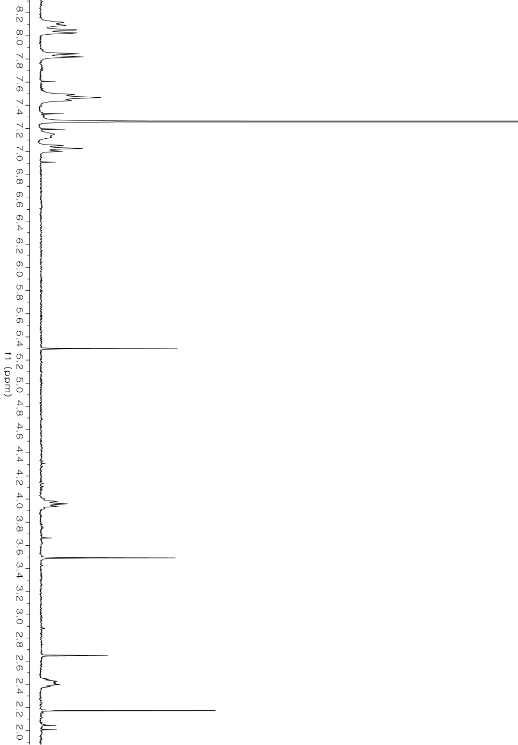
Figure S2. ¹³C NMR Spectrum of Merochlorin G (1) in CDCl₃
