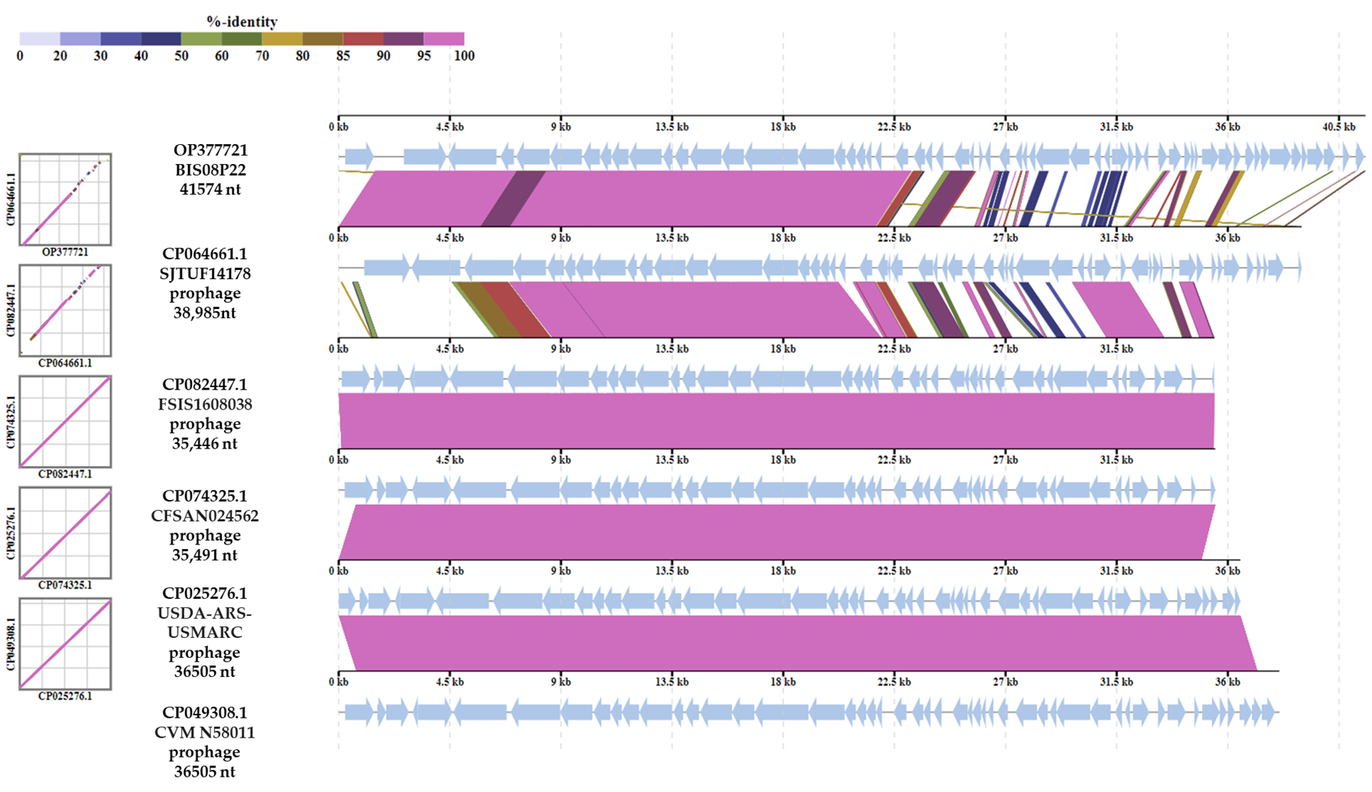

Figure S1. Alignment of Salmonella phage BIS08P22 various ORFs with close prophage homologs. These prophage sequences were extracted form chromosome sequences of their respective hosts in BLASTn. The scale on top left gives percentage homology depicted as rainbow of colors.
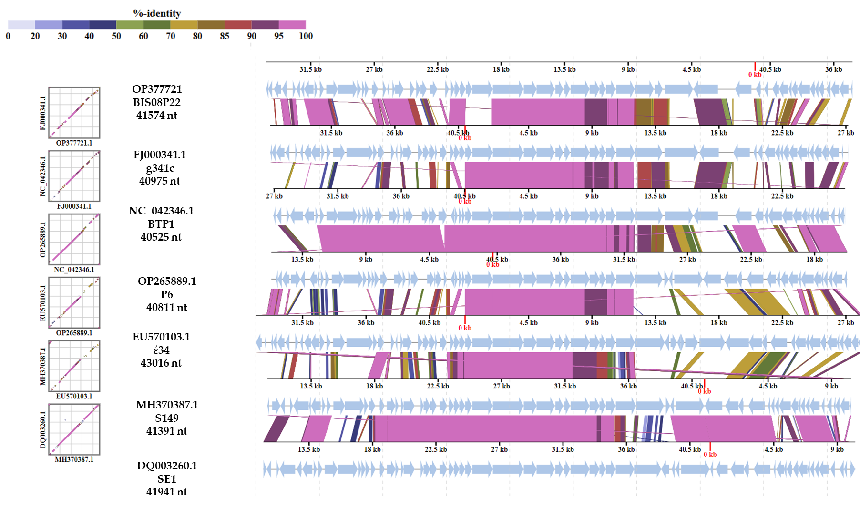

Figure S2. Alignment of Salmonella phage BIS08P22 various ORFs with close Phage homologs. These phage sequences were extracted form NCBI nucleotide BLASTn. The scale on top left gives percentage homology depicted as rainbow of colors.

Table S1. VIRIDIC cluster table of BIS08 with its close

prophage homologs
Serial No | Prophage Genome  Acc. No. | Species Cluster | Genus  Cluster
1 | CP074325.1 | 1 | 1
2 | CP082447.1 | 1 | 1
3 | CP025276.1 | 1 | 1
4 | CP049308.1 | 1 | 1
5 | CP064661.1 | 2 | 2
6 | OP377721  (Salmonella phage BIS08P22) | 3 | 3

Table S2. VIRIDIC cluster table for BIS08 with its close BLASTn

Phage homologs
Serial No | Phage Genome  & Acc. No. | Species Cluster | Genus  Cluster
1 | Salmonella phage BTP1, NC_042346.1 | 5 | 3
2 | Salmonella phage P6, OP265889.1 | 6 | 3
3 | Salmonella phage SE1, DQ003260.1 | 1 | 1
4 | Salmonella phage 149, MH370387.1 | 4 | 1
5 | Salmonella phage BIS08P22  OP377721 | 7 | 4
6 | Salmonella phage epsilon 34 EU570103.1 | 2 | 2
7 | Salmonella phage g341c, FJ000341.1 | 3 | 2

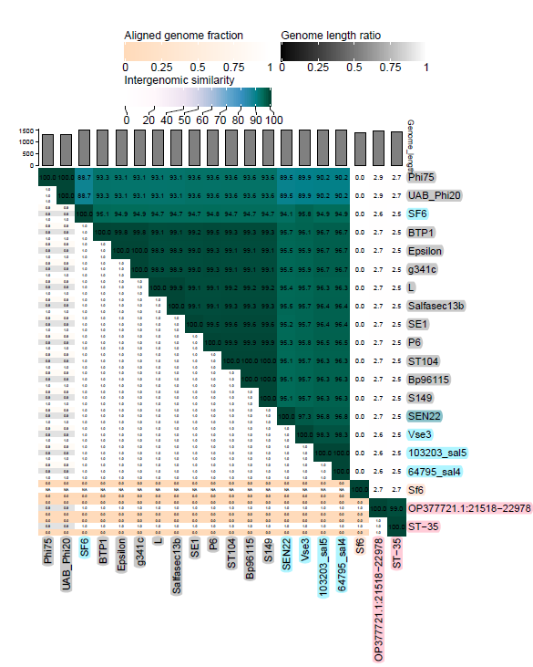

Figure S3; A VIRIDIC heat map generated for nucleotide sequence comparison of terminase gene in selected Accessions of the Lederbergvirus genus and unclassified Lederbergvirus division. The phage names are color coded as per Phylogenetic divisions given in main manuscript in Figure 3 that align with VIRIDIC data.

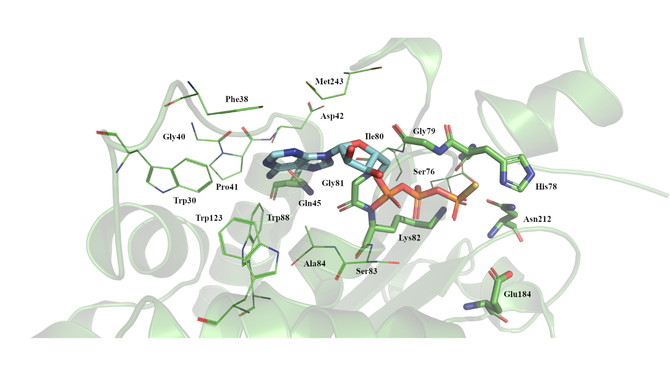

Figure S4; The Potential ATP binding site of the BIS08 Terminase Large subunit present in the n-terminus. Residues (shown in line and stick formation) within 5 Å of the superimposed AGS of the large terminase of Sf6 (in blue; PDB code 4IEE) are shown and labelled. Residues in stick formation highlight common residues in near identical positions for the enzymes discovered during DALI analysis.

Table S3; The number of core genes identified by CoreGenes5.0 software in close homologs of BIS08
Sr. No | Salmonella phage BIS08P22  OP377721.1 | Salmonella phage P22  NC_002371 | Salmonella phage P6  OP265889.1 | Salmonella phage g341c  NC_013059.1 | Salmonella phage g341c  FJ000341.1 | Lederbergvirus BTP1  NC_042346.1 | Salmonella phage epsilon34  NC_011976.1 | Salmonella phage SE1 (in:P22virus)  NC_011802.1 | Salmonella phage S149  MH370387.1 | Salmonella phage Bp96115  MG407615.1
1 | UWV16642.1  Product:hypothetical protein | NP_059593.1  Product:hypothetical protein | UXQ90485.1  Product:hypothetical protein | YP_003090245.1  Product:DUF2737 family protein | ACN18307.1  Product:P22 gp33- like protein | YP_009639231.1  Product:DUF2737 family protein | YP_002533492.1  Product:DUF2737 family protein | YP_002455848.1  Product:DUF2737 family protein | AXC42623.1  Product:hypothetical protein | AUG84787.1  Product: hypothetical protein
2* | UWV16643.1  Product: anti-RecBCD 2 protein | NP_059594.1  Product:abc2 anti- RecBCD | UXQ90484.1  Product:Abc2 protein | YP_003090246.1  Product:abc2 anti- RecBCD | ACN18308.1  Product: Putative ABC transporter ATP-binding protein | YP_009639232.1  Product:abc2 anti- RecBCD | YP_002533493.1  Product:abc2 anti- RecBCD | YP_002455849.1  Product:abc2 anti- RecBCD | AXC42624.1  Product: anti-RecBCD | PI:AUG84788.1  Product:Abc2 protein
3 | PI:UWV16663.1  Product: recombination protein | PI:NP_059612.1  Product: NinB/ Orf homologous recombination mediator | PI :UXQ90463.1  Product : protein NinB | PI:YP_003090267.1  Product: NinB/ Orf homologous recombination mediator | PI:ACN18329.1  Product: NinB protein | PI:YP_009639254.1  Product: NinB/ Orf homologous recombination mediator | PI:YP_002533515.1  Product: NinB/ Orf homologous recombination mediator | PI:YP_002455870.1  Product: NinB/ Orf homologous recombination mediator | PI:AXC42646.1  Product: NinB-like protein | PI:AUG84749.1  Product: NinB
4* | PI:UWV16670.1  Product: spanin (Rz) protein | YP_010247143.1  Product: Rz-like spanin | PI: UXQ90455.1  Product : lyses protein Rz | YP_003090278.1  Product: Rz-like spanin | ACN18340.1  Product : Rz protein | PI:YP_009639263.1  Product: Rz-like spanin | PI:YP_002533526.1  Product: Rz-like spanin | PI:YP_002455882.1  Product:Rz-like spanin | PI:AXC42658.1  Product: outer membrane lytic protein Rz | PI:AUG84758.1  Product: endopeptidase
5 | PI:UWV16674.1  Product:hypothetical protein | PI:NP_059625.1  Product:Orf80 | PI:UXQ90451.1  Product: protein of unknown function (DUF2560) | PI:YP_003090283.1  Product:DUF2560 family protein | PI:ACN18345.1  Product: Conserved hypothetical phage protein | PI:YP_009639266.1  Product:DUF2560 family protein | PI:YP_002533530.1  Product:DUF2560 family protein | PI:YP_002455884.1  Product:hypothetical protein | PI:AXC42660.1  Product:hypothetical protein | PI:AUG84760.1  Product:hypothetical protein
6 | PI:UWV16677.1  Product: portal protein | PI:YP_063735.1  Product: portal protein | PI:UXQ90510.1  Product:hypothetical protein | PI:YP_003090220.1  Product: portal protein | PI:ACN18282.1  Product: Portal protein | PI:YP_009639208.1  Product: portal protein | PI:YP_002533462.1  Product :portal protein | PI:YP_002455889.1  Product: portal protein | PI:AXC42665.1  Product: portal protein | PI:AUG84765.1  Product: portal protein
7 | PI:UWV16678.1  Product: scaffolding protein | PI:YP_063736.1  Product: head  scaffolding protein | PI:UXQ90509.1  Product: scaffolding protein | PI:YP_003090221.1  Product: head  scaffolding protein | PI:ACN18283.1  Product: Scaffolding protein | PI:YP_009639209.1  Product: head  scaffolding protein | PI:YP_002533463.1  Product: head  scaffolding protein | PI:YP_002455890.1  Product: head  scaffolding protein | PI:AXC42666.1  Product: capsid and scaffold protein | PI:AUG84766.1  Product: scaffolding protein
8 | PI:UWV16679.1  Product: major capsid protein | PI:NP_059630.1  Product: head protein | PI:UXQ90508.1  Product:putative coat protein | PI:YP_003090222.1  Product: head protein | PI:ACN18284.1  Product: Coat protein | PI:YP_009639210.1  Product: head protein | PI:YP_002533464.1  Produt: head protein | PI:YP_002455891.1  Product: head protein | PI:AXC42667.1  Product:  capsid protein | PI:AUG84767.1  Product: capsid protein
9 | PI:UWV16681.1  Product:head  stabilization protein | PI:NP_059632.1  Product:head-tail adaptor Ad3 | PI:UXQ90506.1  Product:hypothetical protein | PI:YP_003090224.1  Product:head-tail adaptor Ad3 | PI:ACN18286.1  Product:Conserved hypothetical phage protein | PI:YP_009639212.1  Product:head-tail adaptor Ad3 | PI:YP_002533466.1  Product:head-tail adaptor Ad3 | PI:YP_002455893.1  Product:head-tail adaptor Ad3 | PI:AXC42669.1  Product:DNA stabilizator | PI:AUG84769.1  Product:head  completion protein
10 | PI:UWV16682.1  Product:tail tube protein | PI:NP_059633.1  Product:head closure Hc3 | PI:UXQ90505.1  Product:hypothetical protein | PI:YP_003090225.1  Product:head closure Hc3 | PI:ACN18287.1  Product:Conserved hypothetical phage protein | PI:YP_009639213.1  Product:head closure Hc3 | PI:YP_002533467.1  Product:head closure Hc3 | PI:YP_002455894.1  Product:head closure Hc3 | PI:AXC42670.1  Product:DNA stabilizator | PI:AUG84770.1  Product:tail accessory protein
11 | PI:UWV16683.1  Product:needle protein/ tail accessory protein | PI:YP_063715.1  Product:tail needle protein | PI:UXQ90504.1  Product:hypothetical protein | PI:YP_003090226.1  Product:tail needle protein | PI:ACN18288.1  Product:Conserved hypothetical phage protein | PI:YP_009639214.1  Product:tail needle protein | PI:YP_002533468.1  Product:tail needle protein | PI:YP_002455895.1  Product:tail needle protein | PI:AXC42671.1  Product:packaged DNA stabilization protein | PI:AUG84771.1  Product:hypothetical protein
12 | PI:UWV16684.1  Product:head  assembly protein | PI:YP_063716.1  Product:head morphogenesis | PI:UXQ90503.1  Product:virion stability protein | PI:YP_003090227.1  Product:head morphogenesis | PI:ACN18289.1  Product:Conserved hypothetical phage protein | PI:YP_009639215.1  Product:head morphogenesis | PI:YP_002533469.1  Product:head morphogenesis | PI:YP_002455896.1  Product:head morphogenesis | PI:AXC42672.1  Product:head  assembly protein | PI:AUG84772.1  Product:hypothetical protein
13 | PI:UWV16685.1  Product:virion  stability and injection protein | PI:YP_063717.1  Product:DNA ejection | PI:UXQ90502.1  Product:DNA transfer protein | PI:YP_003090228.1  Product:DNA ejection | PI:ACN18290.1  Product:DNA transfer protein | PI:YP_009639216.1  Product:DNA ejection | PI:YP_002533470.1  Product:DNA ejection | PI:YP_002455897.1  Product:DNA ejection | PI:AXC42673.1  Product:DNA transfer protein | PI:AUG84773.1  Product:hypothetical protein
14 | PI:UWV16686.1  Product:DNA ejection protein | PI:NP_059637.1  Product:released from the phage upon host infection | PI:UXQ90501.1  Product:ejection protein | PI:YP_003090229.1  Product:released from the phage upon host infection | PI:ACN18291.1  Product:Conserved hypothetical phage protein | PI:YP_009639217.1  Product:released from the phage upon host infection | PI:YP_002533471.1  Product:released from the phage upon host infection | PI:YP_002455898.1  Product:released from the phage upon host infection | PI:AXC42674.1  Product:DNA transfer protein | PI:AUG84774.1  Product:DNA transfer protein
15 | PI:UWV16687.1  Product:DNA transfer protein | PI:YP_063718.1  Product:head morphogenesis | PI:UXQ90500.1  Product:hypothetical protein | PI:YP_003090230.1  Product:DNA transfer protein | PI:ACN18292.1  Product:Conserved hypothetical phage protein | PI:YP_009639218.1  Product:DNA transfer protein | PI:YP_002533472.1  Product:DNA transfer protein | PI:YP_002455899.1  Product:DNA transfer protein | PI:AXC42675.1  Product:DNA transfer protein | PI:AUG84775.1  Product:DNA transfer protein
*These orthologs from core genes were used to generate phylogenetic trees

Table S4; The number of core genes identified by CoreGenes5.0 software shared by BIS08 with Lederbergvirus registered phage members (The number of homologs in each column is :12)
Serial No. | Salmonella phage BIS08P22  OP377721.1 | Lederbergvirus BTP1  NC_042346.1 | Enterobacteria phage HK620  NC_00237102 | Salmonella phage SF6  NC_002730.1 | Salmonella phage ST64T  MK972689.1 | Salmonella phage SE1 (in:P22virus)  NC_004348.1
1 | PI:UWV16642.1  Product: hypothetical protein | PI:YP_009639231.1  Product: DUF2737 family protein | PI:NP_112042.1  Product: DUF2737 family protein | PI:QEI23265.1  Product: DUF2737 family protein | PI:NP_720288.1  Product: DUF2737 family protein | PI:AAY46464.1  Product: unknown
2 | PI:UWV16643.1  Product: anti-RecBCD 2 protein | PI:YP_009639232.1  Product:abc2 anti-RecBCD | PI:NP_112043.1  Product:abc2 anti-RecBCD | PI:QEI23266.1  Product: DUF2856 family protein | PI:NP_720289.1  Product:abc2 anti-RecBCD | PI:AAY46465.1  Product: Abc2
3 | PI:UWV16664.1  Product: NinE protein | PI:YP_009639255.1  Product: NinE family protein | PI:NP_112061.1  Product: NinE family protein | PI:QEI23289.1  Product: NinE | PI:NP_720310.1  Product: NinE family protein | PI:AAY46488.1  Product:NinE
4 | PI:UWV16670.1  Product:spanin (Rz) protein | PI:YP_009639263.1  Product:Rz-like spanin | PI:NP_112070.1  Product:Rz-like spanin | PI:QEI23298.1  Product:lysis protein | PI:NP_720321.1  Product:Rz-like spanin | PI:AAY46498.1  Product:Gp15
5 | PI:UWV16674.1  Product:hypothetical protein | PI:YP_009639266.1  Product:DUF2560 family protein | PI:NP_112073.1  Product:DUF2560 family protein | PI:QEI23300.1  Product:DUF2560 family protein | PI:NP_720322.1  Product:hypothetical protein | PI:AAY46500.1  Product:unknown
6 | PI:UWV16677.1  Product:portal protein | PI:YP_009639208.1  Product:portal protein | PI:NP_112077.1  Product:portal protein | PI:QEI23304.1  Product:portal protein | PI:NP_720327.1  Product:portal protein | PI:AAY46505.1  Product:Gp1
7 | PI:UWV16681.1  Product:head stabilization protein | PI:YP_009639212.1  Product:head-tail adaptor Ad3 | PI:NP_112081.1  Product:head-tail adaptor Ad3 | PI:QEI23308.1  Product:DNA stabilization protein | PI:NP_720331.1  Product:head-tail adaptor Ad3 | PI:AAY46509.1  Product:Gp4
8 | PI:UWV16682.1  Product:tail tube protein | PI:YP_009639213.1  Product:head closure Hc3 | PI:NP_112082.1  Product:head closure Hc3 | PI:QEI23246.1  Product:DNA stabilization protein | PI:NP_720332.1  Product:head closure Hc3 | PI:AAY46510.1  Product:Gp10
9 | PI:UWV16683.1  Product:needle protein/ tail accessory protein | PI:YP_009639214.1  Product:tail needle protein | PI:NP_112083.1  Product:tail needle protein | PI:QEI23247.1  Product:DNA stabilization protein | PI:NP_720333.1  Product:tail needle protein | PI:AAY46511.1  Product:Gp26
10 | PI:UWV16684.1  Product:head assembly protein | PI:YP_009639215.1  Product:head morphogenesis | PI:NP_112084.1  Product:head morphogenesis | PI:QEI23248.1  Product:capsid protein | PI:NP_720334.1  Product:head morphogenesis | PI:AAY46512.1  Product:Gp14
11 | PI:UWV16685.1  Product:virion stability and injection protein | PI:YP_009639216.1  Product:DNA ejection | PI:NP_112085.1  Product: DNA ejection | PI:QEI23249.1  Product:DNA transfer protein | PI:NP_720335.1  Product:DNA ejection | PI:AAY46513.1  Product:Gp7
12 | PI:UWV16686.1  Product:DNA ejection protein | PI:YP_009639217.1  Product: released from the phage upon host infection | PI:NP_112086.1  Product:released from the phage upon host infection | PI:QEI23250.1  Product:DNA transfer protein | PI:NP_720336.1  Product:released from the phage upon host infection | PI:AAY46514.1  Product:Gp20

Table S5; VIRIDIC cluster table for phages placed in Lederbergvirus genus and unclassified Lederbergvirus division
Serial No | ֎Phage Name | NCBI Accession Nos | Species Cluster | Genus Cluster
1 | Proteus phage vB_PmiP_ Brookers | OL539469.1 | 38 | 32
2 | MAG: Phage NV18 | MK047640.1 | 18 | 13
3 | Salmonella phage MS2 LVA | MZ614453.1 | 29 | 23
4 | Escherichia phage HZ41 | OM022251.1 | 39 | 33
5 | Enterobacteria phage IME10 | NC_019501.1 | 33 | 27
6 | Escherichia phage APC_JM3.2 | MG197996.1 | 14 | 9
7 | Escherichia phage N7, | MH717096.1 | 17 | 12
8 | Enterobacteria phage Sf6 | NC_005344.1 | 31 | 25
9 | Escherichia phage HF4s | MT833387.1 | 25 | 19
10 | Escherichia phage Gally | OV696608.1 | 47 | 38
11 | Enterobacteria phage HK620 | NC_002730.1 | 30 | 24
12 | Escherichia phage vB_EcoP-611R6 | ON470589.1 | 40 | 34
13 | Escherichia phage vB_EcoP-683R2 | ON470594.1 | 41 | 35
14 | Escherichia phage JEP4 | MT740315.1 | 22 | 16
15 | Escherichia phage E212 | MZ043897.1 | 28 | 22
16 | Escherichia phage vB_EcoP_Kapi1 | MT813197.1 | 24 | 18
17 | Enterobacteria phage CUS-3 | CP000711.1 | 3 | 3
18 | Escherichia phage phiv205-1 | MN340231.1 | 21 | 15
19 | Enterobacteria phage Sf101 | NC_027398.1 | 34 | 28
20 | Escherichia phage vB_EcoP-720R6 | ON470605.1 | 42 | 36
21 | Klebsiella phage phiKp_30 DNA | LC768498.2 | 13 | 8
22 | Salmonella phage SEN22 | NC_028696.2 | 35 | 29
23 | Salmonella phage BIS08P22 | OP377721.1 | 45 | 37
24 | Salmonella phage epsilon34 | EU570103.1 | 7 | 6
25 | Salmonella phage epsilon34 | NC_011976.1 | 7 | 6
26 | Salmonella phage g341c | FJ000341.1 | 8 | 6
27 | Salmonella phage epsilon34 | NC_013059.1 | 8 | 6
28 | Salmonella phage SI8 | MK972688.1 | 20 | 14
29 | Salmonella phage SF10 | MK972697.1 | 20 | 14
30 | Salmonella phage SI5 | MK972695.1 | 20 | 14
31 | Salmonella phage vB_SemP_ Emek | NC_018275.1 | 32 | 26
32 | Salmonella phage UPF_BP1 | NC_047875.1 | 37 | 31
33 | Salmonella virus BTP1 | NC_042346.1 | 36 | 30
34 | Salmonella phage MG40 | MT774487.1 | 23 | 17
35 | Salmonella phage GE_ vB_ TR | MG969415.1 | 16 | 11
36 | Salmonella phage P6 | OP265889.1 | 44 | 30
37 | Salmonella phage vB_Se_GLBO_sp11 | OP924285.1 | 46 | 10
38 | Salmonella phage Salfasec13b | ON809756.1 | 43 | 10
39 | Salmonella phage Bp96115 | MG407615.1 | 15 | 10
40 | Salmonella phage S149 | MH370387.1 | 15 | 10
41 | Enterobacteria phage ST104 | NC_005841.1, | 15 | 10
42 | Salmonella phage S9-5 | MW722521.1 | 27 | 21
43 | Salmonella phage vB_SalP_ABTNLsp11242 | MW790496.1 | 27 | 21
44 | Salmonella phage vB_SalP_PM43 | MF188997.1 | 2 | 2
45 | Enterobacteria phage ST64T | NC_004348.1 | 2 | 2
46 | Salmonella phage L cI-40 13-am43 | MW013502.1 | 2 | 2
47 | Salmonella phage L cII-101 | MW013503.1 | 2 | 2
48 | Salmonella phage SE1 | DQ003260.1 | 6 | 4
49 | Salmonella enterica bacteriophage SE1 | NC_011802.1 | 6 | 4
50 | Salmonella phage SW-70 | CP051272.1 | 4 | 4
51 | Salmonella phage ST-29 | CP051288.1 | 4 | 4
52 | Salmonella phage ST-87 | CP051278.1 | 4 | 4
53 | Salmonella phage ST-32 | CP051285.1 | 4 | 4
54 | Salmonella phage ST160 | NC_014900.1 | 4 | 4
55 | Salmonella phage ST-35 | CP051279.1 | 5 | 5
56 | Salmonella phage SPN9CC | JF900176.1 | 10 | 7
57 | Salmonella phage SPN9CC | NC_017985.1 | 10 | 7
58 | Salmonella phage 146851_sal5 | KU927491.1 | 11 | 7
59 | Salmonella phage 103203_sal5 | KU927494.1 | 12 | 7
60 | Salmonella Phage 103203_sal5, | NC_031946.1 | 12 | 7
61 | Salmonella phage 103203_sal4 | KU927495.1 | 11 | 7
62 | Salmonella phage 118970_sal4 | NC_030919.1 | 11 | 7
63 | Salmonella phage 64795_sal4 | KU927498.1 | 11 | 7
64 | Salmonella phage 101962B_sal5 | KU927496.1 | 11 | 7
65 | Salmonella phage 146851_sal4 | KU927492.1 | 11 | 7
66 | Salmonella phage SE16 | MK770414.1 | 19 | 1
67 | Salmonella phage SE21 | MK972692.1 | 19 | 1
68 | Salmonella phage SF3 | MK972686.1 | 19 | 1
69 | Salmonella phage SE10 | MK972685.1 | 19 | 1
70 | Salmonella phage SF11 | MK770415.1 | 19 | 1
71 | Salmonella phage SI23 | MK972693.1 | 19 | 1
72 | Salmonella phage SE1 | MK972687.1 | 19 | 1
73 | Salmonella phage SE22 | MK972694.1 | 19 | 1
74 | Salmonella phage VSe13 | MT932212.1 | 26 | 20
75 | Enterobacteria phage UAB_Phi20 | NC_031019.1 | 9 | 1
76 | Enterobacteria phage Phi75 | GQ422451.1 | 9 | 1
77 | Enterobacteria phage UAB_Phi20 | GQ422450.1 | 9 | 1
78 | Salmonella phage 22 | KR296686.1 | 1 | 1
79 | Salmonella phage P22 | NC_002371.2 | 1 | 1
80 | Salmonella phage P22 | LC730322.1 | 1 | 1
81 | Bacteriophage P22-pbi | AF527608.1 | 1 | 1
82 | Salmonella phage 34 | KR296688.1 | 1 | 1
83 | Salmonella phage vB_SenP_ER25 | MW355480.1 | 1 | 1
84 | Salmonella phage HT105/1 | MN161573.1 | 1 | 1
85 | Salmonella phage 25 | KR296687.1 | 1 | 1
86 | Salmonella phage P22virB-3 | OQ031658.1 | 1 | 1
֎ Phages are arranged in order of appearance in phylogenetic tree Figure 8.

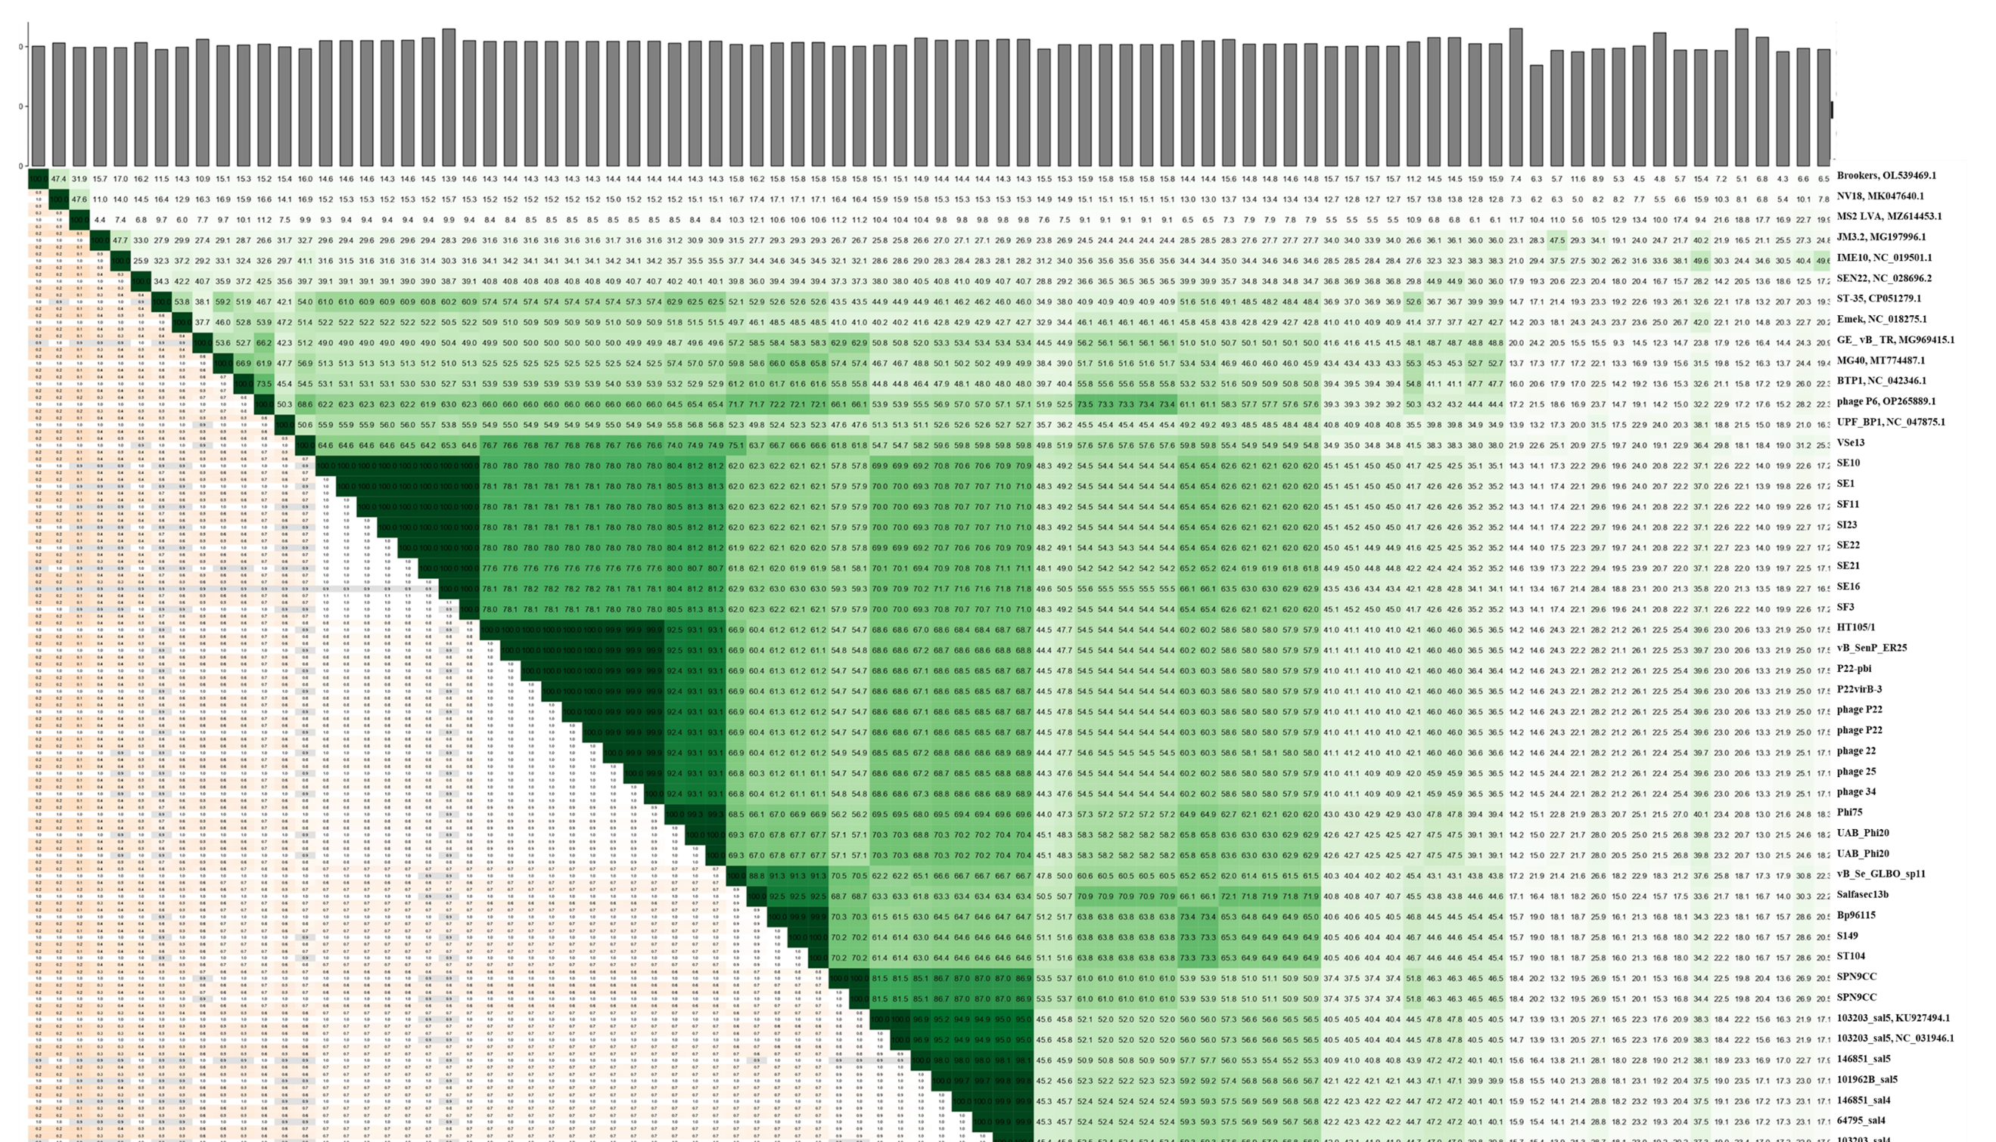

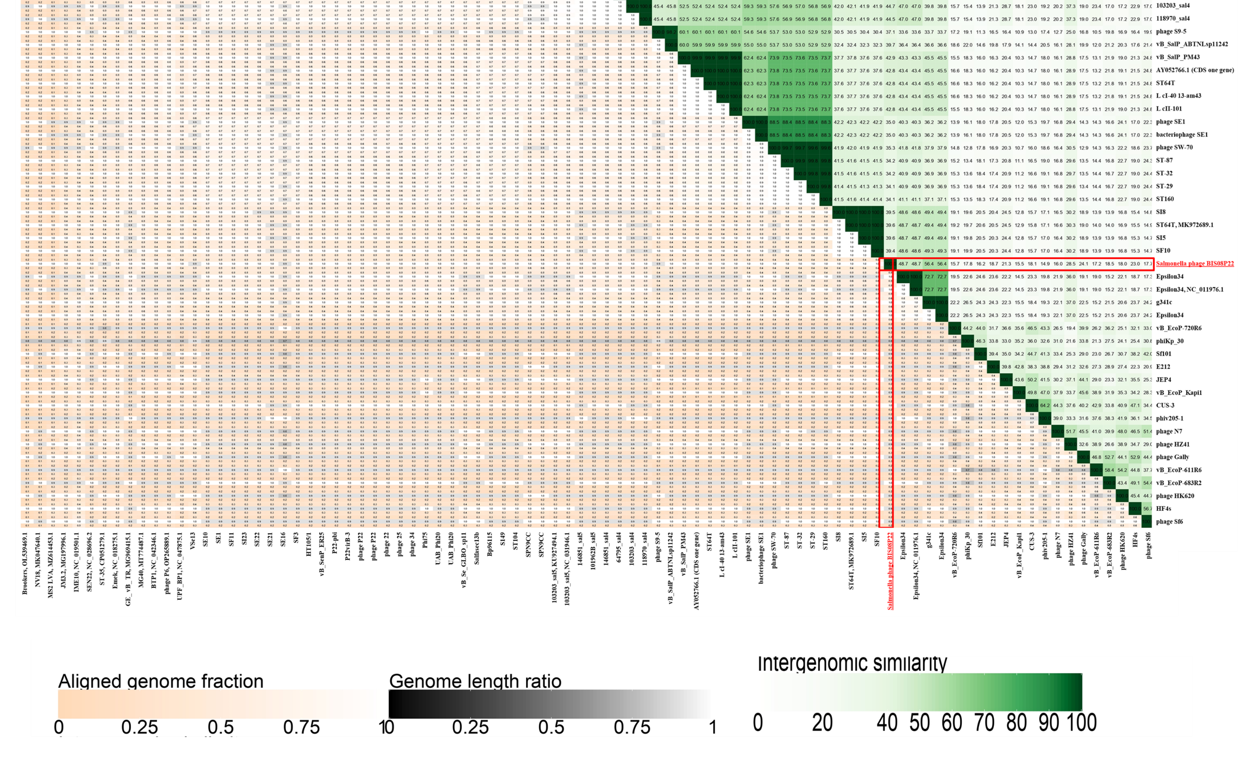

Figure S5; A heat map generated by VIRIDIC software using all accession numbers present in Lederbergvirus genus and unclassified Lederbergvirus division in NCBI. This map and cluster table provided in Table S5 provides an accurate relationship of these accession genomes. VIRIDIC divided these accessions in 38 genera and 39 species in total.
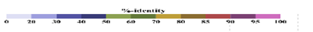
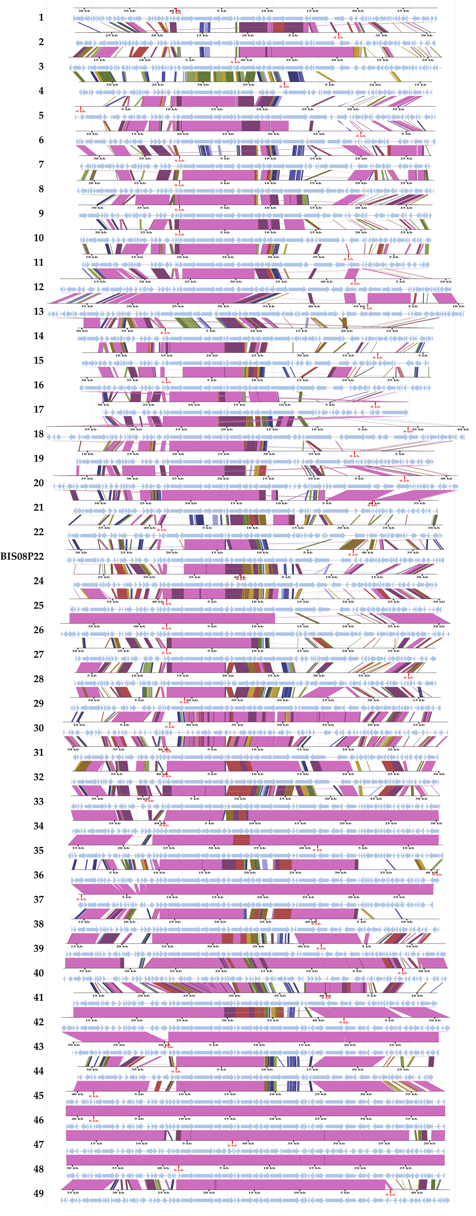

Figure S6; The genome wide ORF alignment produced by VIP tree software by using tBLASTx results for members of Lederbergvirus genus and unclassified Lederberg virus division phages. One member of each species was selected for this purpose. Moreover, the numbers on the left-hand side represent order of viruses in Table S5. Majority viruses classified by VIRIDIC software in separate genera share ORF homology to structural modules only.

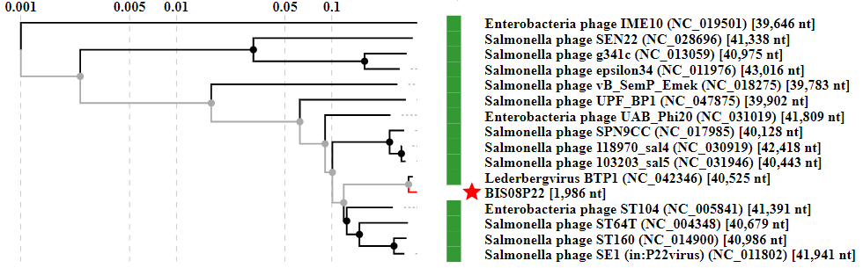

Figure S7; VIP tree based phylogenetic tree of BIS08 tail spike protein (ORF5) produced by tBLASTx analysis. BIS08 and BTP1 make a separate lineage.

