Elucidating the Role of MLL1 nsSNPs: Structural and Functional Alterations and Their Contribution to Hematological Malignancies Susceptibility
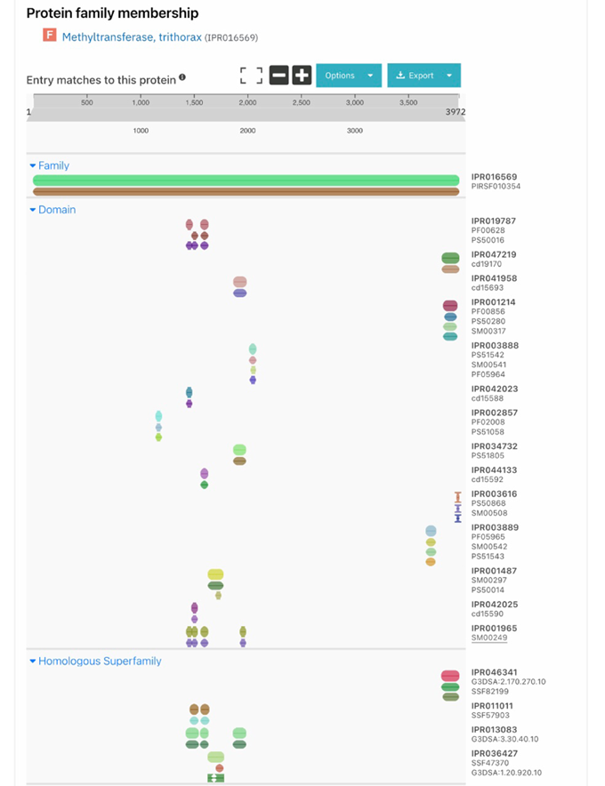
Hakeemah H Al-nakhle ^{1, *}, Hind S Yagoub ¹,², Rahaf Y Alrehaili ¹, Ola A Shaqroon ¹, Minna K Khan ¹, Ghaidaa S Alsharif ¹

Figure S1. Domain identification of MLL1 protein using InterPRO server. IPR016569 indicates the MLL1 protein (1-3969 aa), the Post SET domain (3953-3969); SET domain (3829-3951); FY rich C (3666-3753); Znf PHD4 finger (1932-1978); Bromodomain (1633-17767); Znf PHD3 finger (1568-1625); Znf PHD2 finger (1481-1531); Znf PHD1 finger (1433-1480) and Zinc finger, CXXC (1147-1195).

1 11 21 31 41
MAHSCRWRFP ARPGTTGGGG GGGRRGLGGA PRQRVPALLL PPGPPVGGGG
eeeebebebe eeeeeeeeee eeeeebeeee eeeebeebbb beeeeeeeee
ff f f ff f f
51 61 71 81 91
PGAPPSPPAV AAAAAAAGSS GAGVPGGAAA ASAASSSSAS SSSSSSSSAS
eeeeeeeebb bbbbbeeeee eeeeeebbbb bbbbeeeeee eeeeeeeeee
101 111 121 131 141
SGPALLRVGP GFDAALQVSA AIGTNLRRFR AVFGESGGGG GSGEDEQFLG
ebebbbebbe ebebbbebbb bbbebbeebe ebbbebeeee eeeeeeebbe
fsss s s s f
151 161 171 181 191
FGSDEEVRVR SPTRSPSVKT SPRKPRGRPR SGSDRNSAIL SDPSVFSPLN
bbeeeebebe eeeeeeeeee eeeeeeeeee eeeeebeebb eeeeebeeee
ff ffffffff
201 211 221 231 241
KSETKSGDKI KKKDSKSIEK KRGRPPTFPG VKIKITHGKD ISELPKGNKE
eeeeeeeeeb eeeeeeeeee eeeeeeebee bebebeeeee eeeeeeeeee
f ff fffff f f f
251 261 271 281 291
DSLKKIKRTP SATFQQATKI KKLRAGKLSP LKSKFKTGKL QIGRKGVQIV
eebeebeeee eeebeebeeb eebeeeeeee beeeeeeeeb ebeeebbebb
f f f f f fs ff f ffff ff f f f f
301 311 321 331 341
RRRGRPPSTE RIKTPSGLLI NSELEKPQKV RKDKEGTPPL TKEDKTVVRQ
eeeeeeeeee ebeebeebbb eeeeeeeeee eeeeeeeeee eeeeeeebee
ffffffff f f f f f f f ff
351 361 371 381 391
SPRRIKPVRI IPSSKRTDAT IAKQLLQRAK KGAQKKIEKE AAQLQGRKVK
eeeebeebeb beeeeeeebe bbeebbeebe eeeeeebeee bbeeeeeeee
ffff ffsf f ffff ssffssf s ffffff fff ssffff f
401 411 421 431 441
TQVKNIRQFI MPVVSAISSR IIKTPRRFIE DEDYDPPIKI ARLESTPNSR
eebeebeebb bbbbbbbbbe bbebeeebbe eeeeeeebeb bebeeeeebe
ffsffsffss ssssss ssf ssfsfffssf ffff ff f f f f f
451 461 471 481 491
FSAPSCGSSE KSSAASQHSS QMSSDSSRSS SPSVDTSTDS QASEEIQVLP
bebbebeeee eeeebeeebe ebeeeeeeee eeeeeebeee ebbeebeebe
fs fff ffff fffsf f ffffffff fff ffs ff fssf
501 511 521 531 541
EERSDTPEVH PPLPISQSPE NESNDRRSRR YSVSERSFGS RTTKKLSTLQ
eeeeeeeeee eebeeeeeee eeeeeeeeee bebbeeeeee ebbeebeeee
ff f ff
551 561 571 581 591
SAPQQQTSSS PPPPLLTPPP PLQPASSISD HTPWLMPPTI PLASPFLPAS
eeeeeeeeee eeeeeeeeee eeeeeeebee ebebbbbeeb ebbbebbebb
f f fff f f f s
601 611 621 631 641
TAPMQGKRKS ILREPTFRWT SLKHSRSEPQ YFSSAKYAKE GLIRKPIFDN
eeebeeeeee bbeeeebebb bbeebeeeee bbebbebbee ebbeeebbee
ff f ssffffsfss s f f f sfssfssff fssfff sff
651 661 671 681 691
FRPPPLTPED VGFASGFSAS GTAASARLFS PLHSGTRFDM HKRSPLLRAP
beeeeeeeee bbbbbbbeee eeebebebbb bbeebbebeb eeebebbebe
sffffff ff sss s f fs fffsf sfsf
701 711 721 731 741
RFTPSEAHSR IFESVTLPSN RTSAGTSSSG VSNRKRKRKV FSPIRSEPRS
ebeeeebbbe bbebbbbeee eeeeeeebee eeeeeeeeeb eeebeeeeee
fsffffsssf s fsss f f f f f ff
751 761 771 781 791
PSHSMRTRSG RLSSSELSPL TPPSSVSSSL SISVSPLATS ALNPTFTFPS
eeeebeeeee ebeeeebeeb eeeeeebebb ebbbbebbbe bbebebebee
ffffsfffff f s f ssf s
801 811 821 831 841
HSLTQSGESA EKNQRPRKQT SAPAEPFSSS SPTPLFPWFT PGSQTERGRN
eebeeeeeee eeeeeeeeee eeeeeeeeee eeeebbbbbe eeeeeeeeee
ss
851 861 871 881 891
KDKAPEELSK DRDADKSVEK DKSRERDRER EKENKRESRK EKRKKGSEIQ
eeebeeeeee eeeeeeeeee eeeeeeeeee eeeeeeeeee eeeeeeeeee
ff f f fffff f f f f
901 911 921 931 941
SSSALYPVGR VSKEKVVGED VATSSSAKKA TGRKKSSSHD SGTDITSVTL
ebebbbebee eeeeeeeeee beeeeebeee eeeeeeeeee ebeebbbbbb
f ff f
951 961 971 981 991
GDTTAVKTKI LIKKGRGNLE KTNLDLGPTA PSLEKEKTLC LSTPSSSTVK
eeebebeeee beeeeeeeee eeeeeeeeeb eeeeeeeeee beeeeeeebe
f f ff f

1001 1011 1021 1031 1041
HSTSSIGSML AQADKLPMTD KRVASLLKKA KAQLCKIEKS KSLKQTDQPK
ebbeebbbbb bebeebeeee eebbebbeeb eeebbebeee eeeeeeeeee
f f ff f ffss ss fs fffs fsff ffff f
1051 1061 1071 1081 1091
AQGQESDSSE TSVRGPRIKH VCRRAAVALG RKRAVFPDDM PTLSALPWEE
eeeeeeeeee beeebeebee bbebbbbebe eeeebbeeeb eebeebeeee
f fffffff fffsffsff ssfssssfsf ffffssfffs ffsffsffff
26
1101 1111 1121 1131 1141
REKILSSMGN DDKSSIAGSE DAEPLAPPIK PIKPVTRNKA PQEPPVKKGR
eeebbeeeee eeebebeebe ebeeeeeeee ebeeeeeeee eeeeeeeeee
fff sfffff fffsf ffsf sff fff f f ff ff f fffffffff
1151 1161 1171 1181 1191
RSRRCGQCPG CQVPEDCGVC TNCLDKPKFG GRNIKKQCCK MRKCQNLQWM
eeeeeeebee eeeeeeeeee eeeeeeeeee eeebeeebbe eeebeebeeb
fffffffs f ffffffff f ffffffffff fffsfffssf ff ffsffs
1201 1211 1221 1231 1241
PSKAYLQKQA KAVKKKEKKS KTSEKKDSKE SSVVKNVVDS SQKPTPSARE
ebeeebeeeb eeeeeeeeee eeeeeeeeee eeeeeeeeee eeeeeeeeee
fsf sfff f f fff f f f
1251 1261 1271 1281 1291
DPAPKKSSSE PPPRKPVEEK SEEGNVSAPG PESKQATTPA SRKSSKQVSQ
eeeeeeeeee eeeeeeeeee eeeeeeeeee eeeeeeeeee eeeeeeeeee
f ff
1301 1311 1321 1331 1341
PALVIPPQPP TTGPPRKEVP KTTPSEPKKK QPPPPESGPE QSKQKKVAPR
eeeeeeeeee eeeeeeeebe eeeeeeeeee eeeeeeeeee eeeeeeeeee
f f fff
1351 1361 1371 1381 1391
PSIPVKQKPK EKEKPPPVNK QENAGTLNIL STLSNGNSSK QKIPADGVHR
eeeeeeeeee eeeeeeeeee eeeeeebebb bebeeeeeee eeeeeeebbb
f f f s f f ffsss
1401 1411 1421 1431 1441
IRVDFKEDCE AENVWEMGGL GILTSVPITP RVVCFLCASS GHVEFVYCQV
bebebeeebe beebbebbbb bbbbbbbbbb ebbbbbbbee eebebbbbeb
sfsfsf f s s ss s s fsss sssff f fss sfs
1451 1461 1471 1481 1491
CCEPFHKFCL EENERPLEDQ LENWCCRRCK FCHVCGRQHQ ATKQLLECNK
ebeebeebbb eeeeeebeee beebbbeebe bbebbeeeee ebeebeebee
fsffsf sss ff fff f f ffsssffsf ssf sffff ff ffs f
1501 1511 1521 1531 1541
CRNSYHPECL GPNYPTKPTK KKKVWICTKC VRCKSCGSTT PGKGWDAQWS
beeeeeeebe eeeeeeeeee eeebebbbee bebeeeeeee eeeeeebebe
fffffffsf fff ffffff ff fs sff s sffff ff fff fsf f
1551 1561 1571 1581 1591
HDFSLCHDCA KLFAKGNFCP LCDKCYDDDD YESKMMQCGK CDRWVHSKCE
eebebbeebb ebbeeeebbe ebeebeeeee eebebeebee beeebebebe
ffsf sffss fs ffff sf fsffsfffff ffsfsffs f f f f fsf
1601 1611 1621 1631 1641
NLSGTEDEMY EILSNLPESV AYTCVNCTER HPAEWRLALE KELQISLKQV
eeeeeeeebb ebbeebeeeb bbbbbebeee eeeebebebe eebeeebeeb
ff fss f sf sfff ssss fsf ffffsf fs f f f
1651 1661 1671 1681 1691
LTALLNSRTT SHLLRYRQAA KPPDLNPETE ESIPSRSSPE GPDPPVLTEV
beebbeeebb eebbebeeee eeeeeeeeee eebeeeeeee eeeeebbeeb
ffssfffs ffssf ff ffffffffff ff fffffff fffff sffs
1701 1711 1721 1731 1741
SKQDDQQPLD LEGVKRKMDQ GNYTSVLEFS DDIVKIIQAA INSDGGQPEI
eeeeeeeeee eeebeeeeee eebbbbbebb eebbebbbbb beeeeeeeeb
f f ff f ff s ss s ff s s f fff ff
1751 1761 1771 1781 1791
KKANSMVKSF FIRQMERVFP WFSVKKSRFW EPNKVSSNSG MLPNAVLPPS
eebeeebebb bbeebeebbe bbebeebebe eeeeeeeeee bbbebbbbeb
ffsfff f s ffsff sf sffsf f f ff fff ssfssssfs
1801 1811 1821 1831 1841
LDHNYAQWQE REENSHTEQP PLMKKIIPAP KPKGPGEPDS PTPLHPPTPP
beeebbebee eeeeeeeeee ebbeebbeee eeeeeeeeee eeeeeeeeee
sfffssfsff ff ff ffssfff f f f f
1851 1861 1871 1881 1891
ILSTDRSRED SPELNPPPGI EDNRQCALCL TYGDDSANDA GRLLYIGQNE
eeeeeeeeee eeeeeeeeee eeeeebbbbb eeeeeeeeeb bebbbbbeee
ff ff fff ffffs sss ffff f sfsss sfff
1901 1911 1921 1931 1941
WTHVNCALWS AEVFEDDDGS LKNVHMAVIR GKQLRCEFCQ KPGATVGCCL
beebbbbbbb bebbeeeeee beebbbbbbe beebebebbe eeeeebbbbb
sff ssssss sfssffffff sffss ss f sff fsf s fffs ss
1951 1961 1971 1981 1991
TSCTSNYHFM CSRAKNCVFL DDKKVYCQRH RDLIKGEVVP ENGFEVFRRV
eeeeeebebb bbebeebbbb eeeeeebeeb eebbeeebee eebbebbeeb
ffffffsfss ssf s ss ffffffsffs f fff f ssfs ff
2001 2011 2021 2031 2041
FVDFEGISLR RKFLNGLEPE NIHMMIGSMT IDCLGILNDL SDCEDKLFPI
bbbbebbbbe eebbeebeee ebbbbbbbbb bbbbbbbeeb eebeeebbeb
ss fs f ff s fsfff s ssssss ssss s fs ffsf fssf
2051 2061 2071 2081 2091
GYQCSRVYWS TTDARKRCVY TCKIVECRPP VVEPDINSTV EHDENRTIAH
bbebbebebb beebeeebbb ebebbebeee eeeeebeeeb eeeeebbbee
ssfssfsfss sffsfffsss fsfs f f f fff f f s f
2101 2111 2121 2131 2141
SPTSFTESSS KESQNTAEII SPPSPDRPPH SQTSGSCYYH VISKVPRIRT
beeebeeeee eeeeeeeeee beeeeeeeee eeeeeebebe ebeeeeebeb
s f
2151 2161 2171 2181 2191
PSYSPTQRSP GCRPLPSAGS PTPTTHEIVT VGDPLLSSGL RSIGSRRHST
eeeeeeeeee eeeeeeeeee eeeeeeebbb bbbebbeebb ebbbbeeeee
ff ffffffff ff ss s sf sffs ffff
2201 2211 2221 2231 2241
SSLSPQRSKL RIMSPMRTGN TYSRNNVSSV STTGTATDLE SSAKVVDHVL
eeeeeeeeeb ebbbeeeeee eebeeeeeeb eeeeeeeeee eeeeeeeebe
ff
2251 2261 2271 2281 2291
GPLNSSTSLG QNTSTSSNLQ RTVVTVGNKN SHLDGSSSSE MKQSSASDLV
eeeeeeeeee eeeeeeeeee ebeeeeeeee eeeeeeeeee eeeeeeeebb
2301 2311 2321 2331 2341
SKSSSLKGEK TKVLSSKSSE GSAHNVAYPG IPKLAPQVHN TTSRELNVSK
eeeeeeeeee eeeeeeeeee eebebbeeee eeeeeeeeee eeeeeeeeee
f
28
2351 2361 2371 2381 2391
IGSFAEPSSV SFSSKEALSF PHLHLRGQRN DRDQHTDSTQ SANSSPDEDT
eeebeeeeee eeeeeeeeeb eebeeeeeee eeeeeeeeee eeeeeeeeee
2401 2411 2421 2431 2441
EVKTLKLSGM SNRSSIINEH MGSSSRDRRQ KGKKSCKETF KEKHSSKSFL
eeeebeeeee eeebeebeee beeeeeeeee eeeeeeeeeb eeeeeeeebe
2451 2461 2471 2481 2491
EPGQVTTGEE GNLKPEFMDE VLTPEYMGQR PCNNVSSDKI GDKGLSMPGV
eeeeeeeeee eeeeeebeee bbeeeebeee bbeeeeeeee eeeeeeeeee
2501 2511 2521 2531 2541
PKAPPMQVEG SAKELQAPRK RTVKVTLTPL KMENESQSKN ALKESSPASP
eeeeeeeeee eeeeeeeeee eebebebeeb eeeeeeeeee eeeeeeeeee
f ff
2551 2561 2571 2581 2591
LQIESTSPTE PISASENPGD GPVAQPSPNN TSCQDSQSNN YQNLPVQDRN
eeeeeeeeee eeeeeeeeee eeeeeeeeee eeeeeeeeee eeebeeeeee
2601 2611 2621 2631 2641
LMLPDGPKPQ EDGSFKRRYP RRSARARSNM FFGLTPLYGV RSYGEEDIPF
bbbeeeeeee eeeeeeeebe eeebebebeb bbbbbbbbbb eeeeeeebeb
f f f fffsf fffsfsfsfs ssssss sss fffffff fs
2651 2661 2671 2681 2691
YSSSTGKKRG KRSAEGQVDG ADDLSTSDED DLYYYNFTRT VISSGGEERL
eeeeeeeeee eeeeeeebee beeeeeeeee ebbbbbbbbb ebbeeeeeeb
f f ffff fffffffsff sff ffff f sssss ss f f
2701 2711 2721 2731 2741
ASHNLFREEE QCDLPKISQL DGVDDGTESD TSVTATTRKS SQIPKRNGKE
eeeebbeeee eeebeebeeb eeeeeeeeee eebebbeeeb eeeeeeeeee
sf f sffs fffff ffff f ff ff
2751 2761 2771 2781 2791
NGTENLKIDR PEDAGEKEHV TKSSVGHKNE PKMDNCHSVS RVKTQGQDSL
eeeeebeeee eeeeeeeeeb beeeeeeeee eeeeebeeeb ebeeeeeebb
ff f f f f f f ff
2801 2811 2821 2831 2841
EAQLSSLESS RRVHTSTPSD KNLLDTYNTE LLKSDSDNNN SDDCGNILPS
eeebeeeeeb eebeeeeeee eebbeebbee bbeeeeeeee eeebeebbbb
f fff ff f f f f s ffffffff fff ffssss
2851 2861 2871 2881 2891
DIMDFVLKNT PSMQALGESP ESSSSELLNL GEGLGLDSNR EKDMGLFEVF
ebbbbbbeee eebebeeeee eeeeeebbeb beebeeeeee eeebbbbebb
fssssssfff ffsf fffff ffffffs s f fff ff ff ssfss
2901 2911 2921 2931 2941
SQQLPTTEPV DSSVSSSISA EEQFELPLEL PSDLSVLTTR SPTVPSQNPS
eeebeeeeee eeebbbbbee eeebebeeeb eeebebbbee eeeeeeeeee
fffs f f ff s f ff fsfffs fffsfsssff ff f ff
29
2951 2961 2971 2981 2991
RLAVISDSGE KRVTITEKSV ASSESDPALL SPGVDPTPEG HMTPDHFIQG
ebbbbeeeee eebebeeeee eeeeeeebbb eeeeeeeeee ebeeeebbeb
s ff f f fff s
3001 3011 3021 3031 3041
HMDADHISSP PCGSVEQGHG NNQDLTRNSS TPGLQVPVSP TVPIQNQKYV
bbebeebeee eeeeeeeeee eeeebeeeee eeebebeeee ebeeeeeeee
f ff f f ff ffff ff
3051 3061 3071 3081 3091
PNSTDSPGPS QISNAAVQTT PPHLKPATEK LIVVNQNMQP LYVLQTLPNG
eeeeeeeeee ebbeebbeeb eeebeebeee bbbbeeebee bebbeebeee
f f f f f f ssfff ff sfs ff fff
3101 3111 3121 3131 3141
VTQKIQLTSS VSSTPSVMET NTSVLGPMGG GLTLTTGLNP SLPTSQSLFP
beeebebeee eeebeebbee ebebbbbbbe bbbbbeeeee eeeeeeeebe
fffsf f f f s s f
3151 3161 3171 3181 3191
SASKGLLPMS HHQHLHSFPA ATQSSFPPNI SNPPSGLLIG VQPPPDPQLL
eebeebbebe eeebbbebee beeeeeeeee eeeeebbbbb beeeeeeebb
f f s f s ss sf f s
3201 3211 3221 3231 3241
VSESSQRTDL STTVATPSSG LKKRPISRLQ TRKNKKLAPS STPSNIAPSD
beeeeeeeee eeeeeeeeee beeeebeebe eeeeeeeeee eeeeebbbee
ff f fff sffs f ff fff
3251 3261 3271 3281 3291
VVSNMTLINF TPSQLPNHPS LLDLGSLNTS SHRTVPNIIK RSKSSIMYFE
bbbbbbbbbb beeebeeeee bbebbbbeee eeeebeebbe ebeeebbbbe
sss s f f fs ff ffssf f f ssf
3301 3311 3321 3331 3341
PAPLLPQSVG GTAATAAGTS TISQDTSHLT SGSVSGLASS SSVLNVVSMQ
ebeebeeeee eebbebeeee ebbeeeeebe ebebebbbee eebbbbbbbe
f f f sss
3351 3361 3371 3381 3391
TTTTPTSSAS VPGHVTLTNP RLLGTPDIGS ISNLLIKASQ QSLGIQDQPV
beeeeeeeee eeeebbbebe ebbbebeebb bbebbbebbe eeeebeeeee
s ss f f f
3401 3411 3421 3431 3441
ALPPSSGMFP QLGTSQTPST AAITAASSIC VLPSTQTTGI TAASPSGEAD
ebbeeeeebb eeeeeeeeee bbbbbbebbb bbeeeeebeb ebeeeeeeee
f
3451 3461 3471 3481 3491
EHYQLQHVNQ LLASKTGIHS SQRDLDSASG PQVSNFTQTV DAPNSMGLEQ
eeeebeebee bbeeeeeeee eeeeeeeeee eeeeebeebb eeeeeeeeee
3501 3511 3521 3531 3541
NKALSSAVQA SPTSPGGSPS SPSSGQRSAS PSVPGPTKPK PKTKRFQLPL
eeeeeeebeb eeeeeeebeb eeeeeeeeee eeeeeeeeee eebeebeeee
f f f ff
3551 3561 3571 3581 3591
DKGNGKKHKV SHLRTSSSEA HIPDQETTSL TSGTGTPGAE AEQQDTASVE
eeeeeeeeee eebeeeeeee ebeeeeeeee eeeeeeeeee eeeeeeeeee
ffff
30
3601 3611 3621 3631 3641
QSSQKECGQP AGQVAVLPEV QVTQNPANEQ ESAEPKTVEE EESNFSSPLM
eeeeeeeeee eeeeeeeeee eeeeeeeeee eeeeeeeeee eeeebebebb
f f
3651 3661 3671 3681 3691
LWLQQEQKRK ESITEKKPKK GLVFEISSDD GFQICAESIE DAWKSLTDKV
bbbeeeeeee eeeeeeeeee ebbbebbeee bbebbbebbe ebbeebeeeb
f f s sfs fff ssfs f f ssffsfffs
3701 3711 3721 3731 3741
QEARSNARLK QLSFAGVNGL RMLGILHDAV VFLIEQLSGA KHCRNYKFRF
eebebeeebe ebbbebbbbb bbbbbbbebb bbbbeebeeb eebeebebeb
ffsfsfffsf f ssfss s sss sfss ss ffs fs fs fs sfs
3751 3761 3771 3781 3791
HKPEEANEPP LNPHGSARAE VHLRKSAFDM FNFLASKHRQ PPEYNPNDEE
eeeeeeeeee eeeeeebebe bebeebbbeb bebbbeeeee eeeeeeeeee
f f f f fffffsfsf f f s sfs sfsssfffff ff f f ff
3801 3811 3821 3831 3841
EEEVQLKSAR RATSMDLPMP MRFRHLKKTS KEAVGVYRSP IHGRGLFCKR
eeeeebeebe ebebeebebe bbbeebeeeb eebbebbebb bebebbbbee
fffffsffsf f fsffsf ssffs fs ff sfs fs sfsfssssff
3851 3861 3871 3881 3891
NIDAGEMVIE YAGNVIRSIQ TDKREKYYDS KGIGCYMFRI DDSEVVDATM
ebebbebbbe bbbebbbbbb eeeeeeeeee eebbbbbbbb eeeebbbbbb
fsfssfsssf sssfssss s fffffffff ffsss ssss ff fsssss
3901 3911 3921 3931 3941
HGNAARFINH SCEPNCYSRV INIDGQKHIV IFAMRKIYRG EELTYDYKFP
bbbbbebbeb ebeeebbbeb bebeeeebbb bbbbbebeee eebebebebe
sssssfssfs f fffs sfs ffffsss sss sfs ff ffsfsfsfsf
3951 3961 3971
IEDASNKLPC NCGAKKCRKF LN
beebeeebeb eeeeeebeee ee
sffs ffs s ffffffsfff ff

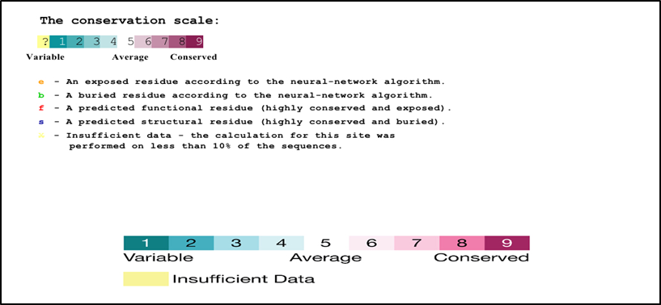

Figure S2. Evolutionary conservation analysis performed for MLL1 protein sequence 1 to 3969 aa using ConSurf.Amino acids are shaded according to their conservation ratings and levels. A grade of 1 represents fast-evolving (variable) sites and is marked in turquoise; a grade of 5 denotes sites evolving at a standard rate, shown in white; while a grade of 9 points to (evolutionarily conserved) sites that evolve slowly, represented in maroon. When a particular position covers a range of 4 or less color grades, its score is viewed as unreliable. These positions are highlighted in light yellow in the visual display.

Table S1. Predicted Functional Partners obtained from the STRING server.
54
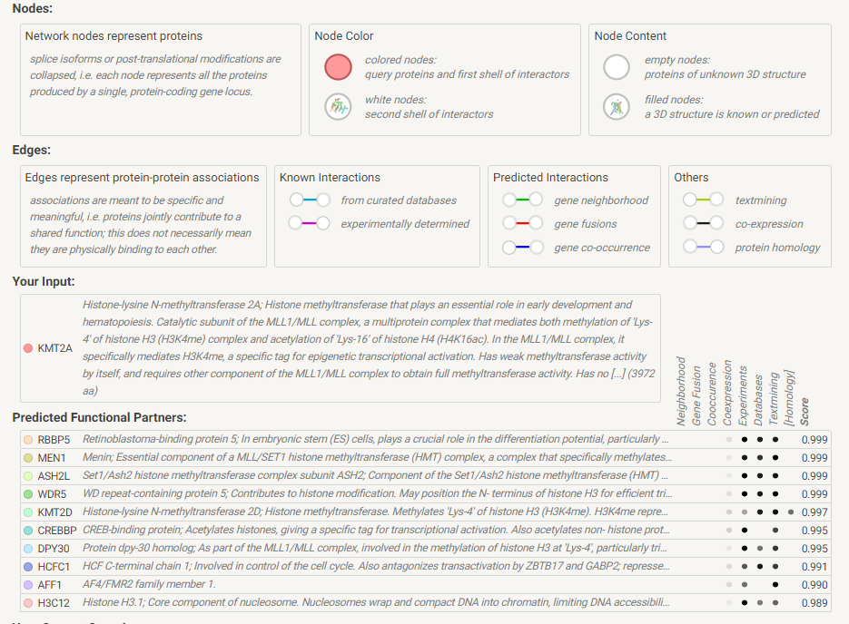
Score | Predicted Functional Partners:
0.999 | Retinoblastoma-binding protein 5; In embryonic stem (ES) cells, plays a crucial role in the differentiation potential, particularly along the neural lineage, regulating gene induction and H3 'Lys-4' methylation at key developmental loci, including that mediated by retinoic acid (By similarity). As part of the MLL1/MLL complex, involved in mono-, di- and trimethylation at 'Lys-4' of histone H3. Histone H3 'Lys-4' methylation represents a specific tag for epigenetic transcriptional activation; WD repeat domain-containing | RBBP5
0.999 | Menin; Essential component of a MLL/SET1 histone methyltransferase (HMT) complex, a complex that specifically methylates 'Lys-4' of histone H3 (H3K4). Functions as a transcriptional regulator. Binds to the TERT promoter and represses telomerase expression. Plays a role in TGFB1-mediated inhibition of cell-proliferation, possibly regulating SMAD3 transcriptional activity. Represses JUND-mediated transcriptional activation on AP1 sites and that mediated by NFKB subunit RELA. Positively regulates HOXC8 and HOXC6 gene expression. May be involved in normal hematopoiesis through the [...] | MEN1
0.999 | Set1/Ash2 histone methyltransferase complex subunit ASH2; Component of the Set1/Ash2 histone methyltransferase (HMT) complex, a complex that specifically methylates 'Lys-4' of histone H3, but not if the neighboring 'Lys-9' residue is already methylated. As part of the MLL1/MLL complex it is involved in methylation and dimethylation at 'Lys-4' of histone H3. May function as a transcriptional regulator. May play a role in hematopoiesis; PHD finger proteins | ASH2L
0.999 | WD repeat-containing protein 5; Contributes to histone modification. May position the N- terminus of histone H3 for efficient trimethylation at 'Lys-4'. As part of the MLL1/MLL complex it is involved in methylation and dimethylation at 'Lys-4' of histone H3. H3 'Lys-4' methylation represents a specific tag for epigenetic transcriptional activation. As part of the NSL complex it may be involved in acetylation of nucleosomal histone H4 on several lysine residues. May regulate osteoblasts differentiation; Belongs to the WD repeat WDR5/wds family | WDR5
0.992 | CREB-binding protein; Acetylates histones, giving a specific tag for transcriptional activation. Also acetylates non-histone proteins, like NCOA3 and FOXO1. Binds specifically to phosphorylated CREB and enhances its transcriptional activity toward cAMP-responsive genes. Acts as a coactivator of ALX1. Acts as a circadian transcriptional coactivator which enhances the activity of the circadian transcriptional activators: NPAS2-ARNTL/BMAL1 and CLOCK- ARNTL/BMAL1 heterodimers. Acetylates PCNA; acetylation promotes removal of chromatin-bound PCNA and its degradation during nucleotide excisi [...] | CREBBP
0.988 | Host cell factor 1; Involved in control of the cell cycle. Also antagonizes transactivation by ZBTB17 and GABP2; represses ZBTB17 activation of the p15(INK4b) promoter and inhibits its ability to recruit p300. Coactivator for EGR2 and GABP2. Tethers the chromatin modifying Set1/Ash2 histone H3 'Lys-4' methyltransferase (H3K4me) and Sin3 histone deacetylase (HDAC) complexes (involved in the activation and repression of transcription, respectively) together. Component of a THAP1/THAP3-HCFC1-OGT complex that is required for the regulation of the transcriptional activity of RRM1. As part o [...] | HCFC1
0.980 | Protein dpy-30 homolog; As part of the MLL1/MLL complex, involved in the methylation of histone H3 at 'Lys-4', particularly trimethylation. Histone H3 'Lys-4' methylation represents a specific tag for epigenetic transcriptional activation. May play some role in histone H3 acetylation. In a teratocarcinoma cell, plays a crucial role in retinoic acid-induced differentiation along the neural lineage, regulating gene induction and H3 'Lys-4' methylation at key developmental loci. May also play an indirect or direct role in endosomal transport; Belongs to the dpy-30 family | DPY30
0.969 | PC4 and SFRS1-interacting protein; Transcriptional coactivator involved in neuroepithelial stem cell differentiation and neurogenesis. Involved in particular in lens epithelial cell gene regulation and stress responses. May play an important role in lens epithelial to fiber cell terminal differentiation. May play a protective role during stress-induced apoptosis. Isoform 2 is a more general and stronger transcriptional coactivator. Isoform 2 may also act as an adapter to coordinate pre-mRNA splicing. Cellular cofactor for lentiviral integration; Heparin binding growth factor family | PSIP1
0.969 | Chromodomain-helicase-DNA-binding protein 8; DNA helicase that acts as a chromatin remodeling factor and regulates transcription. Acts as a transcription repressor by remodeling chromatin structure and recruiting histone H1 to target genes. Suppresses p53/TP53-mediated apoptosis by recruiting histone H1 and preventing p53/TP53 transactivation activity. Acts as a negative regulator of Wnt signaling pathway by regulating beta-catenin (CTNNB1) activity. Negatively regulates CTNNB1- targeted gene expression by being recruited specifically to the promoter regions of several CTNNB1 responsiv [...] | CHD8
0.963 | Transcriptional activator Myb; Transcriptional activator; DNA-binding protein that specifically recognize the sequence 5'-YAAC[GT]G-3'. Plays an important role in the control of proliferation and differentiation of hematopoietic progenitor cells; Myb/SANT domain containing | MYB

Table S2. GO enrichment analysis of the STRING networks created using the core module memberships revealed unique functions in the aging-associated module.
57
Table S2.Functional enrichments analysis of MLL1 network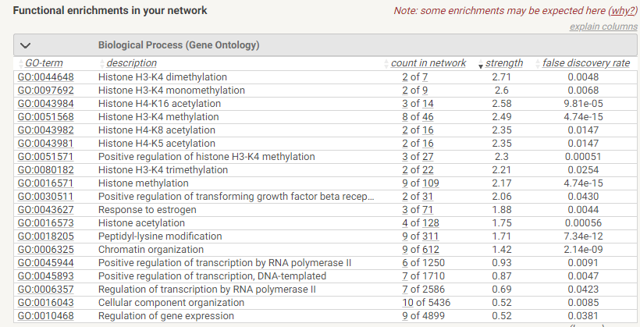
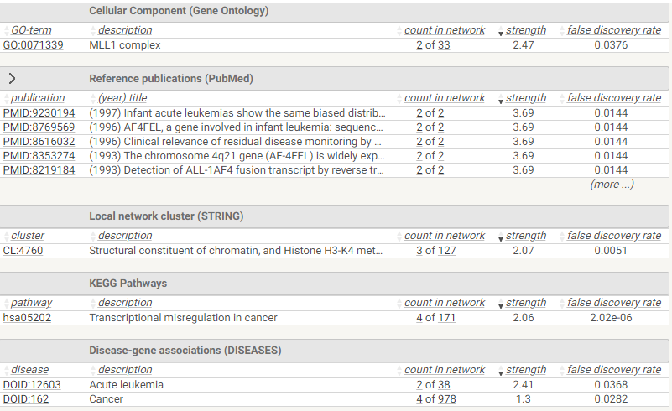
2.1.Biological Process (Gene Ontology)
False discovery rate |  | Strength |  | Count in network |  | Description |  |  | GO-term
5.47e-05 |  | 2.58 |  | 3 of 14 |  | Histone h4-k16 acetylation |  |  | GO:0043984
0.00010 |  | 2.47 |  | 3 of 18 |  | Positive regulation of histone h3-k4 methylation |  |  | GO:0051571
0.0063 |  | 2.47 |  | 2 of 12 |  | Viral latency |  |  | GO:0019042
1.76e-06 |  | 2.39 |  | 4 of 29 |  | beta-catenin-TCF complex assembly |  |  | GO:1904837
1.90e-08 |  | 2.38 |  | 5 of 37 |  | Histone h3-k4 methylation |  |  | GO:0051568
0.0092 |  | 2.35 |  | 2 of 16 |  | Histone h4-k8 acetylation |  |  | GO:0043982
0.0092 |  | 2.35 |  | 2 of 16 |  | Histone h4-k5 acetylation |  |  | GO:0043981
2.96e-09 |  | 2.18 |  | 6 of 71 |  | Histone lysine methylation |  |  | GO:0034968
3.06e-10 |  | 2.13 |  | 7 of 93 |  | Histone methylation |  |  | GO:0016571
0.0233 |  | 2.09 |  | 2 of 29 |  | Positive regulation of transforming growth factor beta receptor signaling pathway |  |  | GO:0030511
6.41e-07 |  | 2.04 |  | 5 of 82 |  | Regulation of megakaryocyte differentiation |  |  | GO:0045652
0.00015 |  | 1.83 |  | 4 of 105 |  | Histone acetylation |  |  | GO:0016573
1.36e-09 |  | 1.68 |  | 8 of 299 |  | Peptidyl-lysine modification |  |  | GO:0018205
3.42e-09 |  | 1.61 |  | 8 of 351 |  | Histone modification |  |  | GO:0016570
1.85e-06 |  | 1.61 |  | 6 of 260 |  | Regulation of myeloid cell differentiation |  |  | GO:0045637
0.0298 |  | 1.41 |  | 3 of 206 |  | Chromatin remodeling |  |  | GO:0006338
3.06e-10 |  | 1.4 |  | 10 of 713 |  | Chromatin organization |  |  | GO:0006325
1.76e-06 |  | 1.4 |  | 7 of 493 |  | Regulation of hemopoiesis |  |  | GO:1903706
0.00039 |  | 1.0 |  | 7 of 1253 |  | Positive regulation of transcription by rna polymerase ii |  |  | GO:0045944
0.0147 |  | 1.0 |  | 5 of 895 |  | Negative regulation of transcription by rna polymerase ii |  |  | GO:0000122
0.00014 |  | 0.95 |  | 8 of 1587 |  | Positive regulation of transcription, dna-templated |  |  | GO:0045893
0.0069 |  | 0.92 |  | 6 of 1293 |  | Protein-containing complex assembly |  |  | GO:0065003
3.89e-05 |  | 0.9 |  | 9 of 2005 |  | Positive regulation of cellular biosynthetic process |  |  | GO:0031328
0.00033 |  | 0.88 |  | 8 of 1874 |  | Regulation of cell differentiation |  |  | GO:0045595
0.0147 |  | 0.84 |  | 6 of 1528 |  | Negative regulation of nucleobase-containing compound metabolic process |  |  | GO:0045934
0.00086 |  | 0.82 |  | 8 of 2172 |  | Regulation of transcription by rna polymerase ii |  |  | GO:0006357
0.0171 |  | 0.71 |  | 7 of 2429 |  | Negative regulation of nitrogen compound metabolic process |  |  | GO:0051172
0.0011 |  | 0.69 |  | 9 of 3239 |  | Positive regulation of nitrogen compound metabolic process |  |  | GO:0051173
0.0267 |  | 0.68 |  | 7 of 2630 |  | Negative regulation of cellular metabolic process |  |  | GO:0031324
0.0025 |  | 0.65 |  | 9 of 3600 |  | Positive regulation of macromolecule metabolic process |  |  | GO:0010604
0.0116 |  | 0.64 |  | 8 of 3227 |  | Regulation of multicellular organismal process |  |  | GO:0051239
0.0434 |  | 0.64 |  | 7 of 2875 |  | Negative regulation of macromolecule metabolic process |  |  | GO:0010605
0.00030 |  | 0.56 |  | 11 of 5447 |  | Cellular component organization |  |  | GO:0016043
 | 2.2 Molecular Function (Gene Ontology)
 | False discovery rate |  | Strength |  | Count in network |  | Description |  |  | GO-term
 | 0.0286 |  | 2.1 |  | 2 of 28 |  | DNA secondary structure binding | GO:0000217
 | 0.0019 |  | 1.93 |  | 3 of 63 |  | Methylated histone binding | GO:0035064
 | 0.0045 |  | 1.77 |  | 3 of 90 |  | Activating transcription factor binding | GO:0033613
 | 0.00051 |  | 1.68 |  | 4 of 148 |  | Modification-dependent protein binding | GO:0140030
 | 0.0019 |  | 1.51 |  | 4 of 221 |  | Histone binding | GO:0042393
 | 0.00042 |  | 1.27 |  | 6 of 570 |  | Chromatin binding | GO:0003682
 | 0.0445 |  | 1.1 |  | 4 of 571 |  | Transcription coregulator activity | GO:0003712
 | 6.94e-05 |  | 1.09 |  | 8 of 1156 |  | Double-stranded dna binding | GO:0003690
 | 0.00042 |  | 1.08 |  | 7 of 1028 |  | Transcription regulatory region sequence-specific dna binding | GO:0000976
 | 0.00042 |  | 0.81 |  | 9 of 2470 |  | DNA binding | GO:0003677

2.3 Cellular Function (Gene Ontology)

False discovery rate | Strength | Count in network | Description | GO-term
4.04e-11 | 2.87 | 5 of 12 | Set1C/COMPASS complex | GO:0048188
3.10e-08 | 2.74 | 4 of 13 | MLL3/4 complex | GO:0044666
7.73e-12 | 2.54 | 6 of 31 | MLL1 complex | GO:0071339
1.85e-14 | 2.28 | 8 of 74 | Histone methyltransferase complex | GO:0035097
0.0016 | 1.81 | 3 of 83 | Histone acetyltransferase complex | GO:0000123
0.0049 | 1.6 | 3 of 133 | Nuclear periphery | GO:0034399
2.81e-09 | 1.33 | 9 of 752 | Transferase complex | GO:1990234
4.63e-06 | 0.69 | 11 of 3973 | Nucleoplasm | GO:0005654
2.4 KEGG Pathway
Pathway | Description | Count in network | strength | False discovery rate
hsa04934 | Cushing syndrome | 5 of 153 | 1.76 | 4.80e-0.6

Table S3. RegulomeDB variant classification scheme
Description | Category
Likely to affect binding and linked to the expression of a gene target
eQTL+ TF binding + matched TF motif + matched DNase footprint +DNase peak | 1a
eQTL+ TF binding + any motif + DNase footprint +DNase peak | 1b
eQTL+ TF binding + matched TF motif +DNase peak | 1c
eQTL+ TF binding + any motif + DNase footprint +DNase peak | 1d
eQTL+ TF binding + matched TF motif | 1e
eQTL+ TF binding / DNase peak | 1f
Likely to affect the binding
TF binding + matched TF motif + matched DNase footprint +DNase peak | 2a
TF binding + any motif +DNase footprint +DNase peak | 2b
TF binding + matched TF motif +DNase peak | 2c
Less likely to affect the binding
TF binding + any motif +DNase peak | 3a
TF binding + matched TF motif | 3b
Minimal binding evidence
TF binding +DNase peak | 4
TF binding or DNase peak | 5
Motif hit | 6

