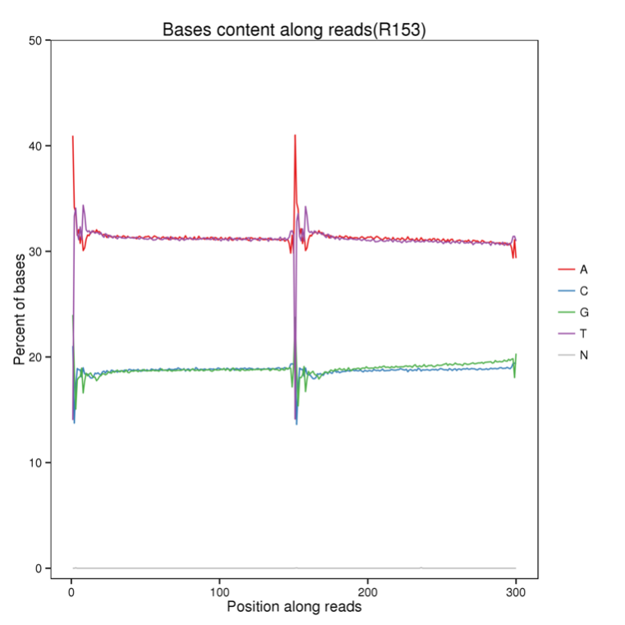
Supplementary Fig. S1 Base ratio distribution for the female parental line 05-DH-65.

Supplementary Table S1 Coverage depth and coverage ratio of the sequencing data
Sample | Average depth | Average coverage ratio 1X (%) | Average coverage ratio 5X (%) | Average coverage ratio 10X(%)
05-DH-65 | 64.00 | 93.73 | 91.50 | 89.97
06-DH-71 | 34.00 | 93.37 | 90.32 | 87.97
F1DH offspring | 2.60 | 72.55 | 16.24 | 3.01

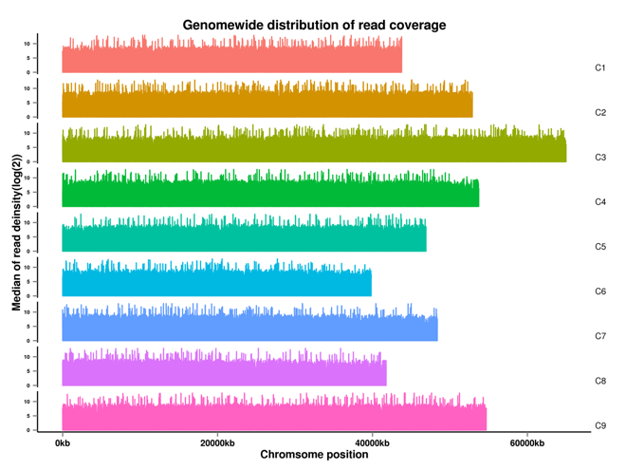
Supplementary Fig. S2 Coverage depth distribution on chromosomes of the female parental line. The x-axis represents the position on each chromosome. The y-axis presents the log₂ value of the coverage depth.

