Table S1: Antibodies for flow cytometry
Antibodies | Species reactivity | Clone | Fluorochrome | Supplier | RRID number
CD3 | Anti-mouse | 145-2C11 | BV421 | BD Horizon | AB_11153670
CD8 | Anti-mouse | 53-6.7 | BUV395 | BD Horizon | AB_2732919
c-Met | Anti-mouse | eBioclone7 | FITC | Invitrogen | AB_494112
Vβ13 | Anti-mouse | MR12-3 | APC | Invitrogen | AB_2573224
IFNγ | Anti-mouse | XMG1.2 | BUV737 | BD Horizon | AB_2870098
Granzyme B | Anti-mouse | NGZB | APC ef780 | Invitrogen | AB_2716966
TNFα | Anti-mouse | MP6-XT22 | PEcy7 | Invitrogen | AB_11042728
CD107a | Anti-mouse | 1D4B | BV786 | BD Horizon | AB_2738762
KLRG-1 | Anti-mouse | 2F1 | BV421 | BD Horizon | AB_2737875
PD-1 | Anti-mouse | J43 | APC ef780 | Invitrogen | AB_2574002
CTLA-4 | Anti-mouse | UC10-4F10-11 | APC-R700 | BD Horizon | AB_2739350
CD178/FasL | Anti-mouse | MFL3 | PE | BD OptiBuild | AB_395711
LAG-3 | Anti-mouse | eBioC9B7W (C9B7W) | PE | Invitrogen | AB_494214
Tim-3 | Anti-mouse | 5D12/TIM-3 | BV480 | BD OptiBuild | AB_2744184
CD3 | Anti-human | UCHT1 | PE-Cy7 | Biolegend | AB_439781
CD8 | Anti-human | SK1 | APC-Cy7 | BD Horizon | AB_2044005
c-Met | Anti-human | 95106 | FITC | R&D System | AB_1026292
IFNγ | Anti-human | 4S.B3 | APC | Invitrogen | AB_469506
Granzyme B | Anti-human | GB11 | PE | Invitrogen | AB_1659718

Figure S1
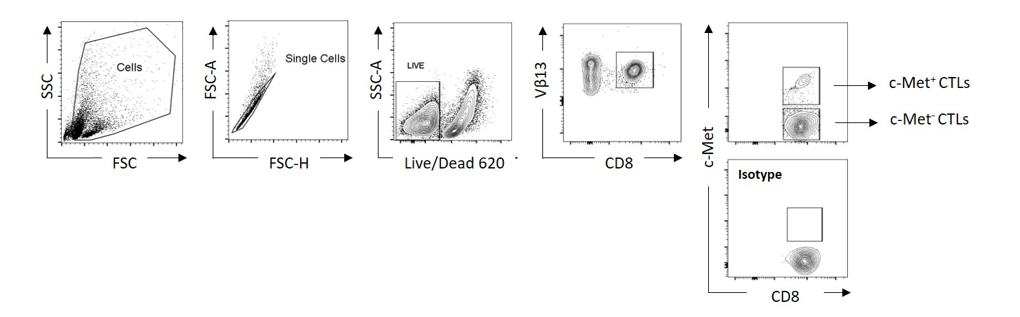
Figure S1. Flow cytometry gating strategy for the identification of Pmel-1 CD8⁺Vβ13⁺ T cells
Live lymphocytes were first selected for their morphology using FSC/SSC parameters, followed by the exclusion of doublets and dead cells (LD620), and CD8⁺Vβ13⁺ T lymphocytes were subsequently selected. c-Met expression was defined with FMO control condition.

Figure S2
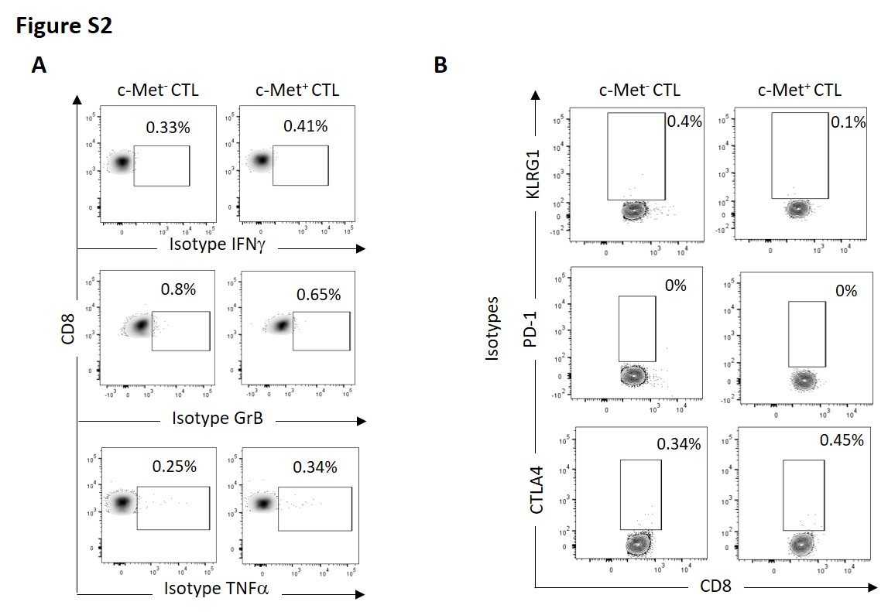
Figure S2. Isotypes controls presentation
Representative density (A) and contour plot (B) of isotype controls of IFNγ, GrB and TNFα (A) and KLRG1, PD-1 and CTLA-4 (B).

Figure S3
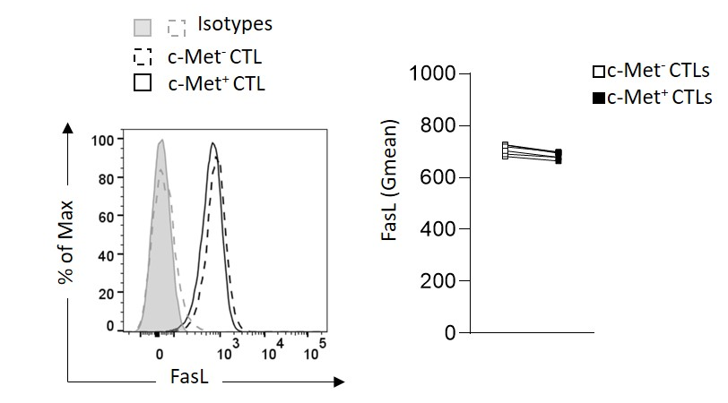
Figure S3. FasL expression by CTLs in contact with B16 Spheroids
Representative histogram (left panel) and paired flow cytometry quantifications (right panel) of FasL 4h after co-culture of B16 spheroids and CTLs c-Met⁺ vs c-Met⁻ from six experiments of (n=6 mice). P-values were calculated using a paired t-test.

Figure S4
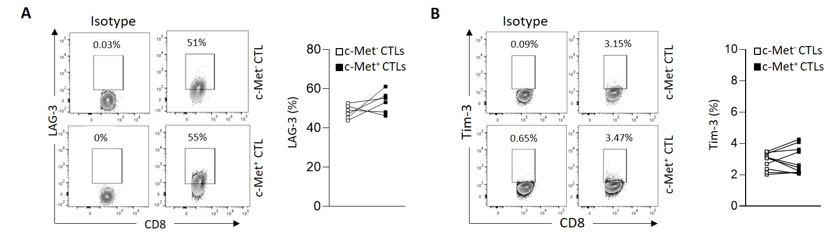
Figure S4. LAG-3 and Tim-3 expression by CTLs in contact with B16 Spheroids
(A, B) Representative contour plots (left panel) and paired flow cytometry quantifications (right panel) of LAG-3 and Tim-3 respectively 4h after co-culture of spheroids B16 and CTLs c-Met⁺ vs c-Met⁻ from six experiments of (n=6 mice). P-values were calculated using paired t-test.

