Supplementary material
- Algorithm of the continuous-time agent-based model of gonorrhea transmission
Notations:
- $f_{i}$: fraction of the MSM population initially infected at site $i$ with susceptible strain;
- $f_{ij}$: fraction of the MSM population initially infected at sites $i$ and $j$ with susceptible strain;
- $f_{sym}$: fraction of the urethral cases that are symptomatic initially;
- An infectious profile: $(i,r, s)$
  - $i$ is the anatomical site of infection, $i∈\left\{R,P, U\right\}$;
  - $r$ is the resistance status that takes 0 for susceptible to ceftriaxone and 1 for resistant to ceftriaxone;
  - $s$ is the symptom status that takes 0 for asymptomatic infection and 1 for symptomatic infection;
- $β:$ the yearly rate of sexual acts;
- $p_{j}$: probability that infection at anatomical site $j$ becomes symptomatic (it was assumed that $p_{R}=p_{P}=0$);
- $k_{i,j}$: probability of a sexual act between anatomical site $i$ and site $j$;
- $d_{i,j}$: probability of transmission between anatomical site $i$ and site $j$;
- $t_{i}$: average time until natural recovery for asymptomatic infection at site $i$;
- $t_{s}$: average time between screening episodes;
- $t_{t}$: average time until seeking treatment for individuals with symptomatic urethral infection;
- $t_{r}$: average time until recovery after receiving treatment;
- $p_{res}$: probability of developing resistance under treatment.

1. Initialization of individuals
At the start of the simulations, a population of $n$ susceptible agents is created.
2. Introduction of drug-susceptible strain of gonorrhea
A drug-susceptible infection is randomly introduced to the population, where $f_{R}$, $f_{P}$ and $f_{u}$ of individuals are allocated with infection at rectum, pharynx and urethra, respectively. Multi-site infection is also introduced, so $f_{RP}$, $f_{RU}$ and $f_{PU}$ of individuals are allocated with infection at rectum and pharynx, rectum and urethra, and pharynx and urethra, respectively.
3. Introduction of symptomatic urethral infection
A symptomatic urethral infection is randomly introduced to the population, so $f_{sym}$ of individuals infected at urethra initially (as a single-site and multi-site infection) develop symptoms.
4. Transmission of gonorrhea
In AnyLogic, transmission of infection (as well as any other interaction between agents) is modelled by sending messages with certain information. An infected agent sends a message which contains the type of infection (e.g. urethral asymptomatic resistant) at a certain rate to randomly selected agents. Upon receiving of the message, an agent develops the infection of that type.
For simplicity, the type of infection was referred as infectious profile.
- Individuals with infectious profile $(R, 0, 0)$ and $(R, 1, 0)$ send the following messages:
  - $(j, r, 1)$, with $j∈\{P, U\}$, $r∈\left\{0,1\right\}$ at the rate $βk_{i,j}d_{i,j}p_{j}$.
Individuals receiving the message develop symptomatic infection at site $j$ with resistance status $r$;
  - $(j, r, 0)$, with $j∈\{P, U\}$, $r∈\left\{0,1\right\}$ at the rate $βk_{i,j}d_{i,j}(1-p_{j})$.
Individuals receiving the message develop asymptomatic infection at site $j$ with resistance status $r$.

- Individuals with infectious profile $(P, 0, 0)$ and $(P, 1, 0)$ send the following messages:
  - $(j, r, 1)$, with $j∈\{R, P,U\}$, $r∈\left\{0,1\right\}$ at the rate $βk_{i,j}d_{i,j}p_{j}$.
Individuals receiving the message develop symptomatic infection at site $j$ with resistance status $r$;
  - $(j, r, 0)$, with $j∈\{R,P, U\}$, $r∈\left\{0,1\right\}$ at the rate $βk_{i,j}d_{i,j}(1-p_{j})$.
Individuals receiving the message develop asymptomatic infection at site $j$ with resistance status $r$.

- Individuals with infectious profile $(U, 0, 0)$, $(U, 1, 0)$, $(U, 0, 1)$ and $(U, 1, 1)$ send the following messages:
  - $\left(j, r, 1\right)$, with $j∈\left\{R,P, U\right\},$ $r∈\left\{0,1\right\}$ at the rate $βk_{i,j}d_{i,j}p_{j}$.
Individuals receiving the message develop symptomatic infection at site $j$ with resistance status $r$;
  - $(j, r, 0)$, with $j∈\{R,P, U\}$, $r∈\left\{0,1\right\}$ at the rate $βk_{i,j}d_{i,j}(1-p_{j})$.
Individuals receiving the message develop asymptomatic infection at site $j$ with resistance status $r$.
5. Natural recovery
The agents in the model move between different stages by undergoing the transitions. Each of these transitions has an associated rate.
Individuals with infectious profile $(i, r, s)$ with $i∈\{R,U, P\}$, $r∈\left\{0,1\right\}$and $s=0$ recover naturally$.$Time until natural recovery follows an exponential distribution with rate parameter $t_{i}$.
6. Screening of individuals
Individuals with infectious profile $(i, r, s)$ with $i∈\{R,U, P\}$, $r∈\{0,1\}$ and $s=0$ undergo screening. Time between screening episodes follows an exponential distribution with rate parameter $t_{s}$. Immediately after screening individuals receive the first-line treatment.
7. Seeking the first-line treatment for symptomatic urethral infection
Individuals with infectious profile $(U, 0, 1)$ and $(U, 1, 1)$ seek the first-line treatment. Time until seeking treatment for individuals with symptomatic urethral infection follows an exponential distribution with rate parameter $t_{t}$;
8. Receiving the first-line treatment, development of resistance and recovery
a) Treatment of drug-susceptible infection
Individuals with infectious profile $(R, 0, 0)$, $(P, 0, 0)$, $(U, 0, 0)$ and $(U, 0, 1)$ receive the first-line treatment as the result of infection detection during the screening or care seeking for a symptomatic urethral infection. Time until recovery after receiving the first-line treatment follows an exponential distribution with rate parameter $t_{r}$.
During the treatment, the infection might develop resistance with probability $p_{res}$, which results in changing the resistance status of infection to $r=1$. If resistance is not developed, the individual recovers at that site. In case of individuals being infected at two sites, the infection might develop resistance with the probability $p_{res}$ at one site or at another one, which results in changing the resistance status of infection to $r=1$ at that site. If resistance is not developed, the individual recovers at both sites.
b) Treatment of drug-resistant infection
Individuals with infectious profile $(R, 1, 0)$, $(P, 1, 0)$, $(U, 1, 0)$ and $(U, 1, 1)$ receive the first-line treatment which does not change their infectious profile.
9. Seeking the second-line treatment for symptomatic urethral infection
Individuals with infectious profile $(U, 1, 1)$ seek re-treatment with the second-line antibiotic. Time until seeking re-treatment for individuals with symptomatic urethral infection follows an exponential distribution with rate parameter $t_{t}$. Individuals with infectious profile ($R, 1, 0)$, $(P, 1, 0)$ and $(U, 1, 0)$ are unaware that the treatment has failed and remain infectious.
10. Receiving the second-line treatment for symptomatic urethral infection
Individuals with infectious profile $(U, 1, 1)$ receive the second-line treatment. Time until recovery after receiving the second-line treatment follows an exponential distribution with rate parameter $t_{r}$.

- Details of calibration
The model was calibrated to prevalence of gonorrhea at three anatomical sites, prevalence of AMR gonorrhea at three anatomical sites and incidence of gonorrhea (number of reported cases per 100,000 US MSM population). For the first six calibration targets, prevalence, the number of participants in study ($M$) and the number of positive cases in study ($m$) was reported in [1] [2] [3] [4]. For the last calibration target, we took the rate of reported gonorrhea cases from the Centers for Disease Control and Prevention report [5], and the confidence intervals as well as the values for $M_{7}$ and $m_{7}$ from [6] where they were calculated manually since the data provided in [5] were obtained by extending the estimates from the earlier years. The values used for the calibration targets are listed in Table A.

$$i$$ | Parameter | Number of participants in a study ($M$) and number of positive cases in a study ($m$) | Data | Source
1 | Prevalence of rectal gonorrhea among the US MSM | 2337, 117 | 5.01% [4.2%, 6%] | [2, 3]
2 | Prevalence of pharyngeal gonorrhea among the US MSM | 4547, 231 | 5.08% [4.5%; 5.8%] | [3, 4]
3 | Prevalence of urethral gonorrhea among the US MSM | 802, 12 | 1.5% [0.86%; 2.6%] | [2]
4 | Prevalence of rectal AMR gonorrhea among the US MSM | 1553, 2 | 0.13% [0.03%; 0.51%] | [1]
5 | Prevalence of pharyngeal AMR gonorrhea among the US MSM | 1049, 7 | 0.67% [0.32%; 1.4%] | [1]
6 | Prevalence of urethral AMR gonorrhea among the US MSM | 3974, 7 | 0.18% [0.08%; 0.37%] | [1]
7 | Incidence of gonorrhea (rate of reported gonorrhea cases per 100,000 US MSM population) | 1380, 90 | 6508 [5206, 7809] | [5, 6]

Table A. Values used for the calibration targets
For prevalence of rectal gonorrhea and prevalence of pharyngeal gonorrhea, we pooled the data from several studies in order to reflect the real-life situation better. Also, for prevalence of rectal, pharyngeal and urethral gonorrhea we used the data from community-based surveys and online sampling instead of data from sexually transmitted diseases (STD) clinics as the latter ones tend to overestimate prevalence [7] [8]. For prevalence of AMR gonorrhea only the data from STD clinics were available.
During the calibration, the simulations were run for 12 years and a total of 52000 runs were performed. Only the trajectories that satisfied the conditions listed below during the entire simulation were kept. These conditions were assigned based on the values listed in Table 1.
- Incidence of gonorrhea (rate of reported gonorrhea cases per 100,000 US MSM) is greater than 500 and less than 10000.
- Prevalence of rectal gonorrhea among the US MSM is greater than 2% and less than 8%.
- Prevalence of pharyngeal gonorrhea among the US MSM is greater than 2.5% and less than 8%.
- Prevalence of urethral gonorrhea among the US MSM is greater than 0.3% and less than 4%.
- Prevalence of rectal AMR gonorrhea among the US MSM is less than 2%.
- Prevalence of pharyngeal AMR gonorrhea among the US MSM is less than 2%.
- Prevalence of urethral AMR gonorrhea among the US MSM is less than 2%.
For each kept trajectory, seven functions (likelihoods) were computed at the end of simulation according to the formula:
$$L_{i}=m_{i}\ln{p_{i}}+(M_{i}-m_{i})\ln\left(1-p_{i}\right),$$
$i=1,..7$.
Here $p_{i}$ is the value of the parameter $i$ at the end of simulation, $M_{i}$ is the number of participants in study $i$ (Table 1), and $m_{i}$ is the number of positive cases in study $i$ (Table 1).
Then the function $L_{Total}$ was calculated for each kept trajectory as:
$$L_{Total}=\sum_{i=1}^{7}{L_{i}.}$$
Finally, we selected one hundred trajectories for which the value of $L_{Total}$ was the highest and used them for the investigations.

- Details of surveillance
A surveillance system was modeled as the sum of the percentage of diagnosed cases resistant to ceftriaxone and the estimation error due to the fact that only a certain percentage of cases is included in the monitoring. The estimation error was modelled as:
$ε_{t}\sim N(0, \sqrt{\frac{y_{t}(1-y_{t})}{K}}$),
where $K$ is the number of isolates collected in a year and $y_{t}$ is the percentage of diagnosed cases resistant to ceftriaxone in year t. In to estimate the value of K, we used the data from [9] where it was reported that 8628 isolates were submitted in 2018. In [10], the data on the percentage of the urethral isolates that came from the MSM attending the clinics participating in GISP are provided (about 37% in 2018). We assumed that the percentage of isolates that came from the MSM attending the clinics participating in eGISP is the same and that these two numbers remain fixed during the simulation horizon.
Accuracy, sensitivity and specificity of each surveillance system was calculated.
For each trajectory, we computed accuracy as:
$$\frac{x_{r}-\left|x_{r}-x_{s}\right|}{x_{r}},$$
where $x_{r}$ is the year when the percentage of diagnosed cases resistant to ceftriaxone reached 5% and $x_{s}$ is the year when this percentage was detected under a surveillance system. Then the average accuracy was computed for each surveillance system.
We also calculated sensitivity (the probability that when the percentage of diagnosed cases resistant to ceftriaxone cases passes 5% a surveillance system correctly detects that) and specificity (the probability that if the percentage of diagnosed cases resistant to ceftriaxone is below 5% a surveillance system correctly informs that) for both surveillance systems. For the analysis, we only used the trajectories for which the percentage of diagnosed cases resistant to ceftriaxone reached 5% and that value was detected under both surveillance systems.

- Model parameters
The values of the parameters that remain constant during the simulation are listed in Table B.

Parameter | Prior distribution | Source to inform prior distribution
Total MSM population ($n$) | 10,000
Probability that rectal infection becomes symptomatic ($p_{R}$) | 0 | Assumption
Probability that pharyngeal infection becomes symptomatic ($p_{p}$) | 0 | Assumption
Probability of a sexual act between two anatomical sites |  | [11]
$$k_{P,P}$$ | 0.83
$$k_{P,U}$$ | 0.825
$$k_{P,R}$$ | 0.6
$$k_{U,R}$$ | 0.478
$$k_{U,U}$$ | 0.03
$$k_{R,U}$$ | 0.478
$$k_{R,P}$$ | 0.6
$$k_{U,P}$$ | 0.825
Table B. The values of the parameters that remain constant during the simulation.
The prior distributions and posterior intervals of the parameters of the model that were determined during the calibration are listed in Tables 3-5. For assigning prior distributions for the fractions of people infected at different anatomical sites and the yearly rate of sexual acts we took the mean value ($x$) from the published literature [12] [13] and then assigned a distribution as uniform($x-σ$, $x+σ$), where the standard deviation ($σ$) was assigned as 0.2*$x$. In case a histogram that we obtained after a round of calibration was left-skewed or right-skewed, we extended the range to the right or to the left, respectively.

Parameter | Prior distribution  (all uniform) | Mean and 95% posterior interval | Source to inform prior distribution
Fraction of the MSM population initially infected at rectum with susceptible strain ($f_{R}$) | [0.04008, 0.06012] | 0.05 (0.04, 0.059) | [12]
Fraction of the MSM population initially infected at pharynx with susceptible strain ($f_{P}$) | [0.04064, 0.06096] | 0.051 (0.042, 0.06) | [12]
Fraction of the MSM population initially infected at urethra with susceptible strain ($f_{U}$) | [0.012, 0.018] | 0.015 (0.012, 0.018) | [12]
Fraction of the MSM population initially infected at rectum and pharynx with susceptible strain ($f_{RP}$) | [0.0016, 0.0024] | 0.002 (0.002, 0.002) | [12]
Fraction of the MSM population initially infected at rectum and urethra with susceptible strain ($f_{RU}$) | [0.00048, 0.00072] | 0.0006 (0.0005, 0.0007) | [12]
Fraction of the MSM population initially infected at pharynx and urethra with susceptible strain ($f_{PU}$) | [0.00032, 0.00048] | 0.0004 (0.00032, 0.00047) | [12]
Fraction of the urethral cases that are symptomatic initially ($f_{sym}$) | [0.01, 0.3] | 0.17 (0.016, 0.3) | Assumption
Table C. Prior distributions and posterior intervals of the initialization parameters.

Parameter | Prior distribution  (all uniform) | Mean and 95% posterior interval | Source to inform prior distribution
Probability that urethral infection becomes symptomatic ($p_{U}$) | [0.33, 0.94] | 0.75 (0.46, 0.92) | [14-17]
Yearly rate of sexual acts ($β$) | [64, 96] | 19.2 (10.3, 38.7) | [13]
Probability of transmission between two anatomical sites |  |  | Assumption
$$d_{P,P}$$ | [0.001, 0.1] | 0.038 (0.004, 0.091)
$$d_{P,U}$$ | [0.001, 0.1] | 0.06 (0.011, 0.098)
$$d_{P,R}$$ | [0.001, 0.1] | 0.05 (0.004, 0.096)
$$d_{U,R}$$ | [0.001, 0.1] | 0.053 (0.008, 0.097)
$$d_{U,U}$$ | [0.001, 0.1] | 0.052 (0.004, 0.097)
$$d_{R,U}$$ | [0.001, 0.1] | 0.06 (0.008, 0.098)
$$d_{U,P}$$ | [0.001, 0.1] | 0.043 (0.004, 0.09)
$$d_{R,P}$$ | [0.001, 0.1] | 0.05 (0.004, 0.096)

Table D. Prior distributions and posterior intervals of the transmission parameters.

Parameter | Prior distribution  (all uniform) | Mean and 95% posterior interval | Source to inform prior distribution
Average time until natural recovery for asymptomatic infection at different anatomical sites (years) |  |  | Assumption
$t_{R}$ | [1/12, 5] | 2.4 (0.6, 4.5)
$t_{U}$ | [1/12, 5] | 2.4 (0.25, 4.96)
$t_{P}$ | [1/12, 5] | 2.9 (0.67, 4.85)
Average time until seeking treatment for individuals with symptomatic urethral infection ($t_{t}$) (days) | [1, 14] | 7.2 (1.08, 13.32) | [6]
Average time between screening episodes ($t_{s}$) (years) | [1, 10] | 14.4 (9.42, 17.7) | Assumption
Average time until recovery after receiving treatment ($t_{r}$) (days) | [1, 14] | 6.84 (1.08, 12.96) | Assumption
Probability of developing resistance under treatment ($p_{res}$) | [0.00000001, 0.01] | 0.005 (0.001, 0.009) | Assumption

Table E. Prior distributions and posterior intervals of the recovery parameters.
The histograms of the posterior distributions are shown in Figure A.
The probabilities of transmission between two anatomical sites that we obtained are of the same order of magnitude for all the transmission routes. It was the highest for pharynx to urethra route (oral sex) and rectum to urethra route (anal sex), and the lowest for pharynx to pharynx route (kissing). Our calibration results indicate that the actual time between screening episodes is much longer that the one recommended by the CDC (at least annually for sexually active MSM [18]). We could not find any data on the fraction of the urethral cases that are symptomatic initially and the probability of developing resistance to ceftriaxone under treatment, so our results can shed some light. For the yearly rate of sexual acts we obtained a much lower range than our prior distribution that was formed based on the mean value reported in [13]. However, [13] focused on a specific population group: young, internet-using MSM. Finally, our results indicate that it takes longer to recover naturally from asymptomatic gonorrhea at pharynx than it does at rectum or urethra.

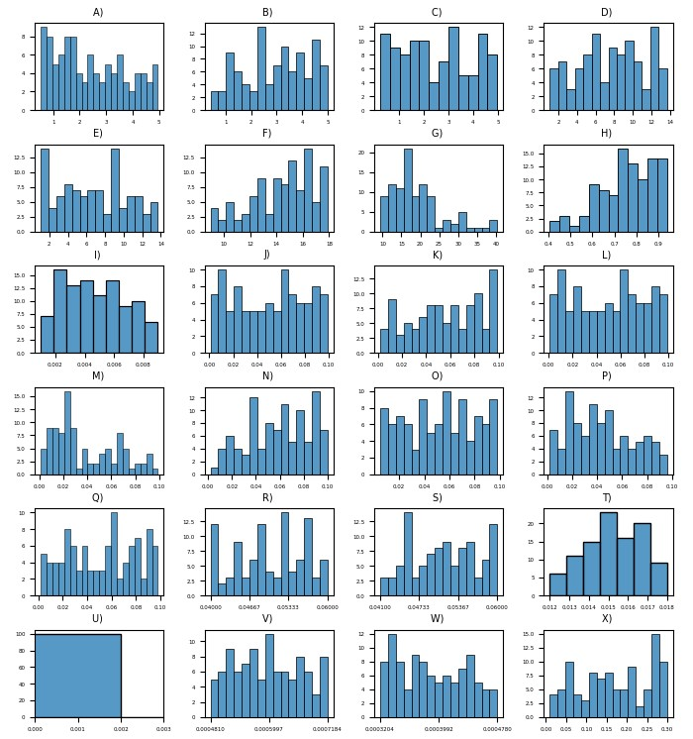
Figure A. Histograms of the posterior distributions. A) Average time until natural recovery at rectum (years) B) Average time until natural recovery at pharynx (years) C) Average time until natural recovery at urethra (years) D) Average time until seeking treatment for individuals with symptomatic urethral infection (days) E) Average time until recovery after receiving treatment (days) F) Average time between screening episodes (years) G) Yearly rate of sexual acts H) Probability that urethral infection becomes symptomatic I) Probability of developing resistance under treatment J) Probability of transmission from rectum to pharynx K) Probability of transmission from rectum to urethra L) Probability of transmission from pharynx to rectum M) Probability of transmission from pharynx to pharynx N) Probability of transmission from pharynx to urethra O) Probability of transmission from urethra to rectum P) Probability of transmission from urethra to pharynx Q) Probability of transmission from urethra to urethra R) Fraction of the MSM population initially infected at rectum with susceptible strain S) Fraction of the MSM population initially infected at pharynx with susceptible strain T) Fraction of the MSM population initially infected at urethra with susceptible strain U) Fraction of the MSM population initially infected at rectum and pharynx with susceptible strain V) Fraction of the MSM population initially infected at rectum and urethra with susceptible strain W) Fraction of the MSM population initially infected at pharynx and urethra with susceptible strain X) Fraction of the urethral cases that are symptomatic initially.

- Additional simulation results
The results for prevalence of AMR gonorrhea among the US MSM at a single site and at a combination of two sites and on the percentage of detected cases among the US MSM at different anatomical sites are presented in Figures B and C.
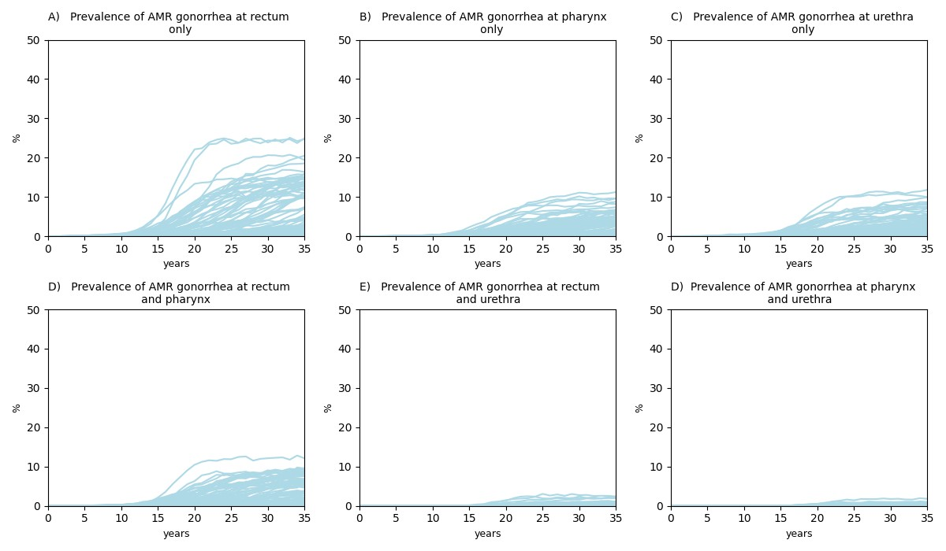
Figure B. Prevalence of AMR gonorrhea among the US MSM at a single site and at a combination of two sites for 35 years of simulation (2007-2042).
For some trajectories, there is a clear upward trend for prevalence of AMR gonorrhea. For the other ones, the level of prevalence increases for some time and then stabilizes. For few of the trajectories the resistance does not develop during the simulation horizon. This correlates well with the outcomes for the percentage of diagnosed cases resistant to ceftriaxone (Figure 1 in the main text). Also, the trends that we observe here are similar to the ones that we observe for prevalence of gonorrhea at a single site and at a combination of two sites (Figure 2 in the main text): the highest prevalence of AMR gonorrhea was detected at rectum only, while the lowest one was observed at rectum and urethra and at pharynx and urethra due to the fact of urethral infection being mostly symptomatic.
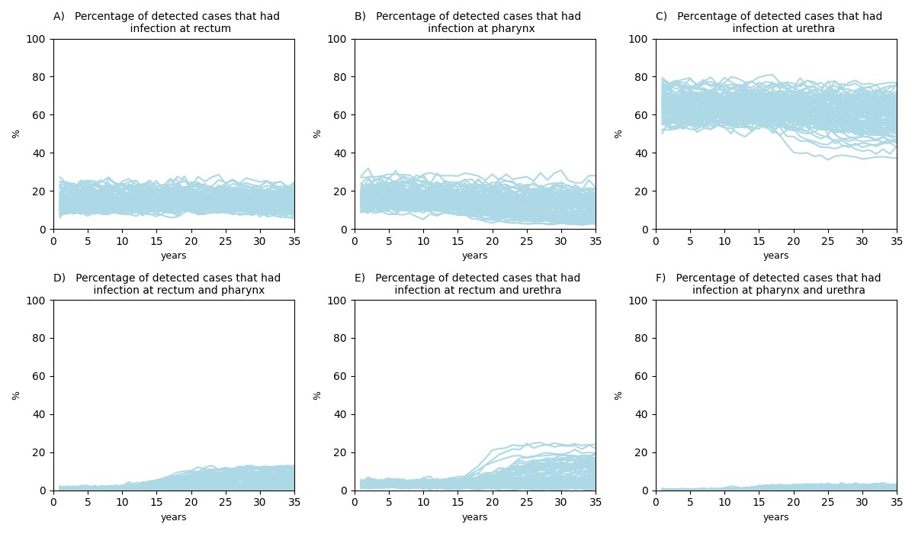
Figure C. Percentage of detected cases among the US MSM at different anatomical sites for 35 years of simulation (2007-2042).
Our results indicate that the highest percentage of cases was detected among the individuals who had infection at urethra only (predominantly between 55% and 80%) which is what is expected again due to mainly symptomatic nature of the urethral infection. In case of multi-site infections, much less cases were detected among those who had infection at pharynx and urethra (between 0.1% and 4%) than among those who had infection at the other two combination of sites. This correlates well with the outcomes that we obtained for the number of patients seeking treatment per 100,000 US MSM population (Figure 3 in the main text).

- Results of sensitivity analysis
The results of sensitivity analysis are presented below.
- Effect of the number of submitted isolates
The analysis that we conducted is based on the number of isolates submitted in 2018 (8628). We examined whether a greater or smaller number of isolated would affect our conclusions. In order to do this, we repeated the analysis for the situation when 7000 or 10000 isolates were submitted. The results are shown in Figure D.
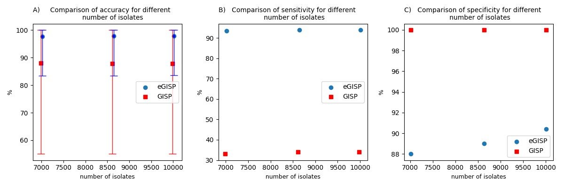
Figure D. Performance of GISP and eGISP for different number of isolates. The bars represent 95% uncertainty intervals.
It is evident that our conclusions are robust to the number of submitted isolates.

Effect of simulated trajectories used to calibrate the model

We recalibrated the model following the same calibration procedure, obtained the new set of trajectories and repeated the same analysis. This was done in order to ensure that we obtained enough trajectories. From Figure E one can see that the conclusions are not sensitive to the set of simulated trajectories. In fact, the value that we obtained for specificity of GISP and eGISP is exactly the same for both sets.
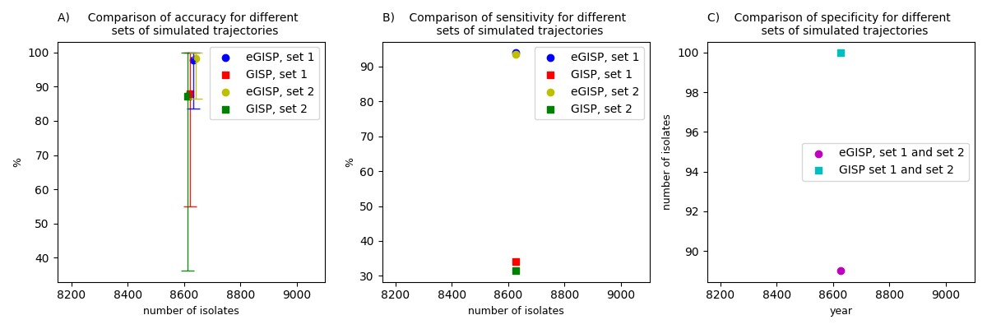
Figure E. Performance of GISP and eGISP for different set of simulated trajectories. The bars represent 95% uncertainty intervals.

Effect of the percentage of isolates that came from the MSM attending the eGISP clinics

Since we have not found any data on the percentage of isolates that came from the MSM attending the eGISP clinics, we assumed that it was 37% as it was for the MSM attending the GISP clinics. In order to ensure that this assumption has not affected our conclusions, we repeated the analysis under the assumption that 27% and 47% of isolates came from the MSM attending the eGISP clinics. The results are shown in Figure F.
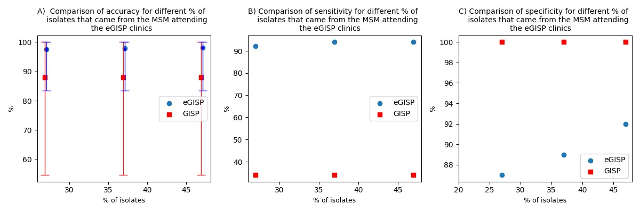
Figure F. Performance of GISP and eGISP for different percentage of isolates that came from the MSM attending the eGISP clinics. The bars represent 95% uncertainty intervals.
Clearly, our conclusions are robust to the percentage of isolates that came from the MSM attending the eGISP clinics.

- Effect of simulation duration
We ran the model for 25 and 45 years to ensure that the simulation duration would not affect our findings. From Figure G it is evident that they are robust to the simulation duration.
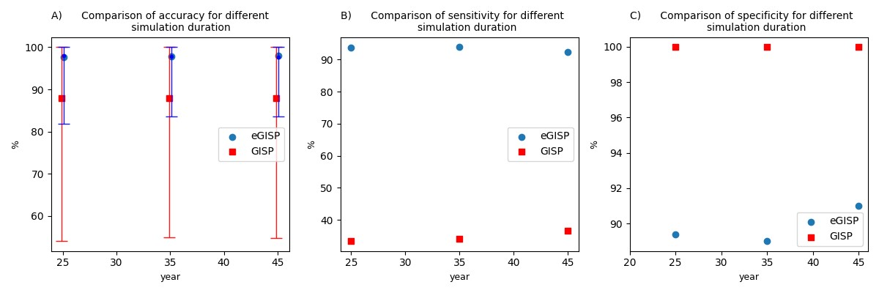
Figure G. Performance of GISP and eGISP for different simulation duration. The bars represent 95% uncertainty intervals.

References
1. Quilter, L.A.S., et al., Antimicrobial Susceptibility of Urogenital and Extragenital Neisseria gonorrhoeae Isolates Among Men Who Have Sex With Men: Strengthening the US Response to Resistant Gonorrhea and Enhanced Gonococcal Isolate Surveillance Project, 2018 to 2019. Sexually Transmitted Diseases, 2021. 48(12S): p. S111-S117.
2. Sullivan, P.S., et al., Understanding racial HIV/STI disparities in black and white men who have sex with men: a multilevel approach. PloS one, 2014. 9(3): p. e90514.
3. Jones, M.L.J., et al., Extragenital chlamydia and gonorrhea among community venue–attending men who have sex with men—five cities, United States, 2017. Morbidity and Mortality Weekly Report, 2019. 68(14): p. 321.
4. Morris, S.R., et al., Prevalence and incidence of pharyngeal gonorrhea in a longitudinal sample of men who have sex with men: the EXPLORE study. Clinical Infectious Diseases, 2006. 43(10): p. 1284-1289.
5. Bowen, V.B., et al., Sexually transmitted disease surveillance 2018. 2019.
6. Yaesoubi, R., et al., The Impact of Rapid Drug Susceptibility Tests on Gonorrhea Burden and the Life Span of Antibiotic Treatments: A Modeling Study Among Men Who Have Sex With Men in the United States. American Journal of Epidemiology, 2023: p. kwad175.
7. Torrone, E.A., et al., Prevalence of sexually transmitted infections and bacterial vaginosis among women in sub-Saharan Africa: an individual participant data meta-analysis of 18 HIV prevention studies. PLoS medicine, 2018. 15(2): p. e1002511.
8. Dandona, L., et al., Is the HIV burden in India being overestimated? BMC public health, 2006. 6: p. 1-10.
9. Kersh, E.N., et al., Expanding US laboratory capacity for Neisseria gonorrhoeae antimicrobial susceptibility testing and whole-genome sequencing through the CDC's Antibiotic Resistance Laboratory Network. Journal of Clinical Microbiology, 2020. 58(4): p. e01461-19.
10. Prevention, C.f.D.C.a., Sexually Transmitted Disease Surveillance 2020. 2020.
11. Duan, Q., et al., Modelling response strategies for controlling gonorrhoea outbreaks in men who have sex with men in Australia. PLoS Computational Biology, 2021. 17(11): p. e1009385.
12. Kent, C.K., et al., Prevalence of rectal, urethral, and pharyngeal chlamydia and gonorrhea detected in 2 clinical settings among men who have sex with men: San Francisco, California, 2003. Clinical Infectious Diseases, 2005. 41(1): p. 67-74.
13. Wall, K.M., R. Stephenson, and P.S. Sullivan, Frequency of sexual activity with most recent male partner among young, Internet-using men who have sex with men in the United States. Journal of Homosexuality, 2013. 60(10): p. 1520-1538.
14. Donovan, L.C., et al. The presence or absence of symptoms among cases of urethral gonorrhoea occurring in a cohort of men taking human immunodeficiency virus pre-exposure prophylaxis in the PrEPX study. in Open Forum Infectious Diseases. 2021. Oxford University Press US.
15. Ong, J., et al., Asymptomatic and symptomatic urethral gonorrhoea in men who have sex with men attending a sexual health service. Clinical Microbiology and Infection, 2017. 23(8): p. 555-559.
16. Martín-Sánchez, M., et al., Clinical presentation of asymptomatic and symptomatic heterosexual men who tested positive for urethral gonorrhoea at a sexual health clinic in Melbourne, Australia. BMC Infectious Diseases, 2020. 20: p. 1-9.
17. Handsfield, H.H., et al., Asymptomatic gonorrhea in men: diagnosis, natural course, prevalence and significance. New England Journal of Medicine, 1974. 290(3): p. 117-123.
18. Workowski, K.A., Sexually transmitted infections treatment guidelines, 2021. MMWR. Recommendations and Reports, 2021. 70.

