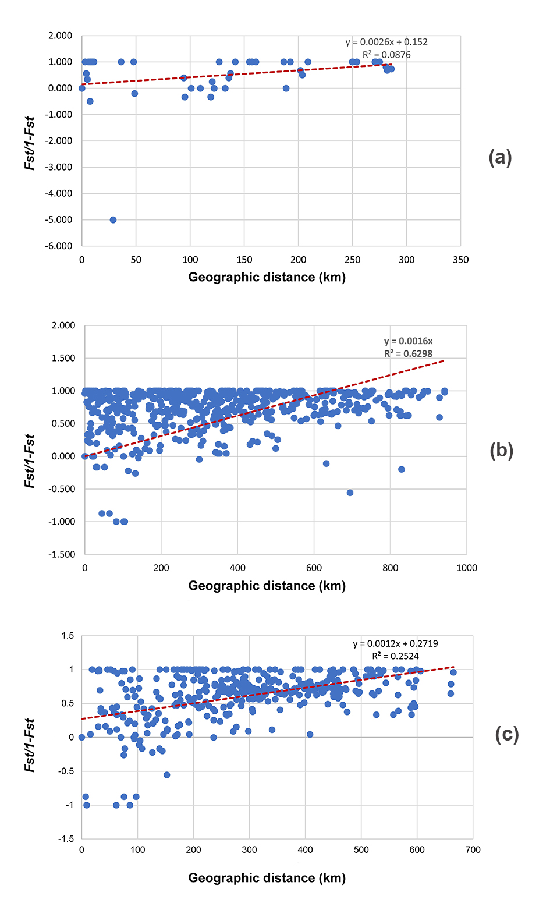

Figure S1. Correlation analysis between the pairwise F_{ST}/(1–F_{ST}) values and the geographic distance based on mtDNA COI sequences: for (a) Clade I, Zaisan populations; (b) Clade II, Dzungar populations; (c) all data.

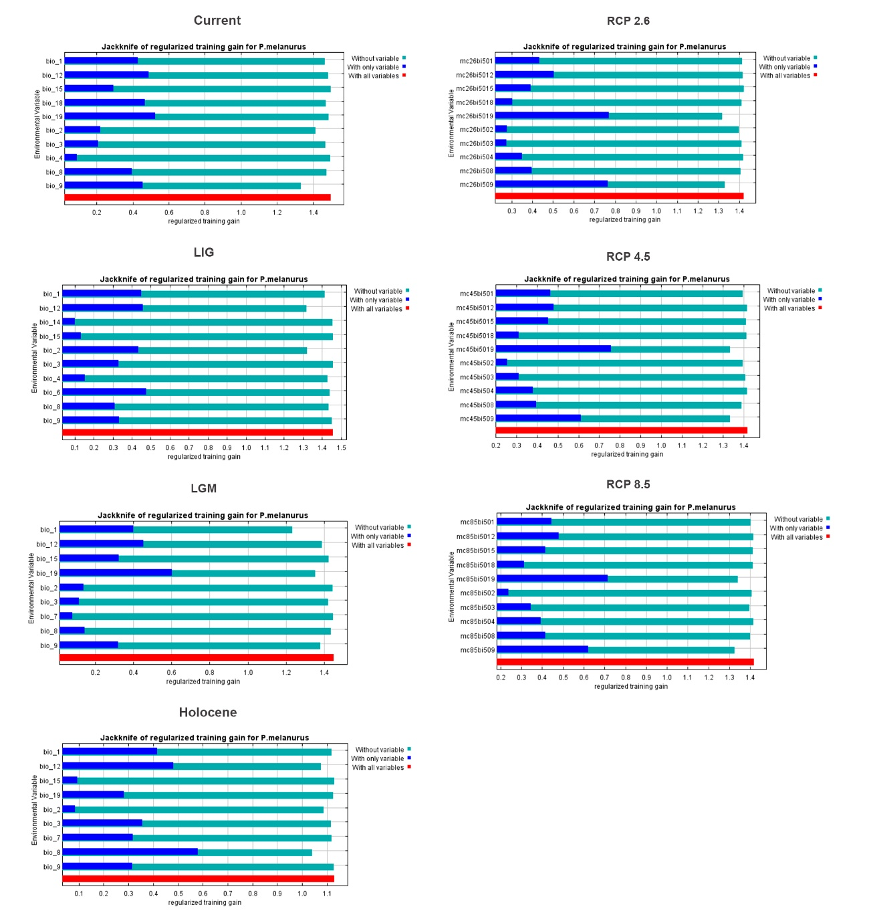

Figure S2. The Jackknife analysis of regularized training gain from retained environmental variables that highly contributed to the distribution model.

Table S1. List of analyzed specimens, geographical origin, clade assignment and GenBank accession number.
Site number | Voucher  number | Haplotype number | Locality  (Lat./Long.) | Clade/  Subclade | GenBank  accession number
Site 1 | Guo3161 | H6 | Ulungur (47.01/87.26) | IIc3 | MW856942
Site 1 | Guo3168 | H6 | Ulungur (47.01/87.26) | IIc3 | MW856943
Site 1 | Guo3169 | H12 | Ulungur (47.01/87.26) | IIc3 | MW856944
Site 1 | Guo3170 | H6 | Ulungur (47.01/87.26) | IIc3 | MW856945
Site 1 | Guo3171 | H13 | Ulungur (47.01/87.26) | IIc3 | MW856946
Site 2 | GXG294 | H6 | Karamay (46.41/85.95) | IIc3 | MW857007
Site 2 | GXG295 | H6 | Karamay (46.41/85.95) | IIc3 | MW857008
Site 2 | GXG296 | H31 | Karamay (46.41/85.95) | IIc3 | MW857009
Site 2 | GXG297 | H13 | Karamay (46.41/85.95) | IIc3 | MW857010
Site 2 | GXG298 | H32 | Karamay (46.41/85.95) | IIc3 | MW857011
Site 2 | GXG299 | H33 | Karamay (46.41/85.95) | IIc3 | MW857012
Site 2 | GXG303 | H34 | Karamay (46.41/85.95) | IIc3 | MW857013
Site 2 | GXG654 | H31 | Karamay (46.41/85.95) | IIc3 | MW857058
Site 2 | GXG655 | H6 | Karamay (46.41/85.95) | IIc3 | MW857059
Site 3 | Guo2320 | H6 | Karamay (45.13/85.05) | IIc3 | MW856928
Site 3 | Guo2321 | H7 | Karamay (45.13/85.05) | IIc3 | MW856929
Site 3 | Guo2322 | H6 | Karamay (45.13/85.05) | IIc3 | MW856930
Site 3 | Guo2324 | H6 | Karamay (45.13/85.05) | IIc3 | MW856931
Site 4 | GXG352 | H41 | Hoboksar (46.76/85.74) | IIc3 | MW857029
Site 4 | GXG353 | H41 | Hoboksar (46.76/85.74) | IIc3 | MW857030
Site 4 | GXG354 | H13 | Hoboksar (46.76/85.74) | IIc3 | MW857031
Site 4 | GXG355 | H41 | Hoboksar (46.76/85.74) | IIc3 | MW857032
Site 4 | GXG356 | H13 | Hoboksar (46.76/85.74) | IIc3 | MW857033
Site 4 | GXG357 | H13 | Hoboksar (46.76/85.74) | IIc3 | MW857034
Site 4 | GXG358 | H41 | Hoboksar (46.76/85.74) | IIc3 | MW857035
Site 4 | GXG359 | H41 | Hoboksar (46.76/85.74) | IIc3 | MW857036
Site 4 | GXG360 | H13 | Hoboksar (46.76/85.74) | IIc3 | MW857037
Site 4 | GXG665 | H41 | Hoboksar (46.76/85.74) | IIc3 | MW857062
Site 4 | GXG666 | H41 | Hoboksar (46.76/85.74) | IIc3 | MW857063
Site 5 | GXG315 | H6 | Hoboksar (46.57/85.64) | IIc3 | MW857014
Site 5 | GXG316 | H35 | Hoboksar (46.57/85.64) | IIc3 | MW85701
Site 5 | GXG318 | H36 | Hoboksar (46.57/85.64) | IIc3 | MW857016
Site 5 | GXG319 | H36 | Hoboksar (46.57/85.64) | IIc3 | MW857017
Site 5 | GXG320 | H35 | Hoboksar (46.57/85.64) | IIc3 | MW857018
Site 5 | GXG321 | H35 | Hoboksar (46.57/85.64) | IIc3 | MW857019
Site 6 | GXG325 | H37 | Hoboksar (46.50/85.14) | IIc3 | MW857020
Site 6 | GXG326 | H6 | Hoboksar (46.50/85.14) | IIc3 | MW857021
Site 6 | GXG327 | H38 | Hoboksar (46.50/85.14) | IIc3 | MW857022
Site 6 | GXG328 | H38 | Hoboksar (46.50/85.14) | IIc3 | MW857023
Site 6 | GXG329 | H37 | Hoboksar (46.50/85.14) | IIc3 | MW857024
Site 6 | GXG330 | H39 | Hoboksar (46.50/85.14) | IIc3 | MW857025
Site 6 | GXG331 | H37 | Hoboksar (46.50/85.14) | IIc3 | MW857026
Site 6 | GXG332 | H6 | Hoboksar (46.50/85.14) | IIc3 | MW857027
Site 6 | GXG657 | H38 | Hoboksar (46.50/85.14) | IIc3 | MW857060
Site 6 | GXG658 | H47 | Hoboksar (46.50/85.14) | IIc3 | MW857061
Site 7 | GXG351 | H40 | Emin (46.20/84.53) | IIc1 | MW857028
Site 8 | Guo2300 | H4 | Toli (45.88/84.49) | IIc3 | MW856984
Site 8 | Guo2301 | H4 | Toli (45.88/84.49) | IIc3 | MW856926
Site 8 | Guo2302 | H5 | Toli (45.88/84.49) | IIc3 | MW856927
Site 9 | GXG293 | H4 | Toli (45.93/84.62) | IIc3 | MW857006
Site 9 | GXG652 | H4 | Toli (45.93/84.62) | IIc3 | MW857057
Site 10 | GXG572 | H6 | Fuyun (46.42/89.02) | IIc3 | MW857051
Site 10 | GXG573 | H6 | Fuyun (46.42/89.02) | IIc3 | MW857052
Site 10 | GXG574 | H6 | Fuyun (46.42/89.02) | IIc3 | MW857053
Site 10 | GXG575 | H6 | Fuyun (46.42/89.02) | IIc3 | MW857054
Site 10 | GXG710 | H6 | Fuyun (46.42/89.02) | IIc3 | MW857073
Site 10 | GXG711 | H6 | Fuyun (46.42/89.02) | IIc3 | MW857074
Site 11 | GXG379 | H6 | Jeminay (47.31/86.76) | IIc3 | MW857038
Site 11 | GXG380 | H6 | Jeminay (47.31/86.76) | IIc3 | MW857039
Site 11 | GXG381 | H42 | Jeminay (47.31/86.76) | IIc3 | MW857040
Site 11 | GXG382 | H43 | Jeminay (47.31/86.76) | IIc3 | MW857041
Site 11 | GXG383 | H44 | Jeminay (47.31/86.76) | IIc3 | MW857042
Site 11 | GXG384 | H45 | Jeminay (47.31/86.76) | IIc3 | MW857043
Site 11 | GXG385 | H38 | Jeminay (47.31/86.76) | IIc3 | MW857044
Site 11 | GXG387 | H6 | Jeminay (47.31/86.76) | IIc3 | MW857045
Site 11 | GXG390 | H46 | Jeminay (47.31/86.76) | IIc3 | MW857046
Site 11 | GXG404 | H6 | Jeminay (47.31/86.76) | IIc3 | MW857047
Site 11 | GXG681 | H6 | Jeminay (47.31/86.76) | IIc3 | MW857064
Site 11 | GXG682 | H48 | Jeminay (47.31/86.76) | IIc3 | MW857065
Site 11 | GXG683 | H6 | Jeminay (47.31/86.76) | IIc3 | MW857066
Site 12 | Guo2208 | H1 | Shihezi (44.64/86.18) | IIc3 | MW856918
Site 13 | Guo4240 | H16 | Fukang (44.95/88.43) | IIc2 | MW856953
Site 13 | Guo4241 | H17 | Fukang (44.95/88.43) | IIc2 | MW856954
Site 13 | Guo4242 | H18 | Fukang (44.95/88.43) | IIc2 | MW856955
Site 13 | Guo4292 | H17 | Fukang (44.95/88.43) | IIc2 | MW856961
Site 14 | Guo4300 | H21 | Fukang (44.53/88.28) | IIc2 | MW856962
Site 14 | Guo4472 | H21 | Fukang (44.53/88.28) | IIc2 | MW856963
Site 14 | Guo4473 | H17 | Fukang (44.53/88.28) | IIc2 | MW856964
Site 15 | Guo4576 | H21 | Fukang (44.68/88.26) | IIc2 | MW856966
Site 15 | Guo4577 | H21 | Fukang (44.68/88.26) | IIc2 | MW856967
Site 16 | Guo4579 | H22 | Jimsar (44.51/88.82) | IIc2 | MW856968
Site 16 | Guo4580 | H22 | Jimsar (44.51/88.82) | IIc2 | MW856969
Site 16 | Guo4581 | H23 | Jimasar (44.51/88.82) | IIc2 | MW856970
Site 16 | Guo4286 | H16 | Jimsar (44.51/88.82) | IIc2 | MW856960
Site 17 | GXG255 | H27 | Ebinur (45.11/82.61) | IIc1 | MW856994
Site 17 | GXG256 | H30 | Ebinur (45.11/82.61) | IIc1 | MW856995
Site 18 | Guo7432 | H25 | Ebinur (44.77/82.87) | IIc1 | MW856978
Site 19 | Guo6433 | H24 | Bortala (44.61/81.69) | IIc1 | MW856975
Site 19 | Guo6434 | H24 | Bortala (44.61/81.69) | IIc1 | MW856976
Site 19 | Guo7437 | H24 | Bortala (44.61/81.69) | IIc1 | MW856979
Site 19 | Guo7438 | H24 | Bortala (44.61/81.69) | IIc1 | MW856980
Site 19 | Guo7439 | H26 | Bortala (44.61/81.69) | IIc1 | MW856981
Site 19 | Guo7440 | H24 | Bortala (44.61/81.69) | IIc1 | MW856982
Site 19 | Guo7441 | H24 | Bortala (44.61/81.69) | IIc1 | MW856983
Site 20 | GXG283 | H3 | Bortala (45.19/82.60) | IIc1 | MW857005
Site 21 | Guo4087 | H14 | Kuytun (44.36/85.11) | IIc1 | MW856947
Site 22 | GXG234 | H27 | Bole (44.92/81.69) | IIc1 | MW856985
Site 22 | GXG235 | H28 | Bole (44.92/81.69) | IIc1 | MW856986
Site 22 | GXG236 | H24 | Bole (44.92/81.69) | IIc1 | MW856987
Site 22 | GXG237 | H28 | Bole (44.92/81.69) | IIc1 | MW856988
Site 22 | GXG238 | H24 | Bole (44.92/81.69) | IIc1 | MW856989
Site 22 | GXG239 | H24 | Bole (44.92/81.69) | IIc1 | MW856990
Site 22 | GXG242 | H27 | Bole (44.92/81.69) | IIc1 | MW856991
Site 22 | GXG244 | H24 | Bole (44.92/81.69) | IIc1 | MW856992
Site 22 | GXG246 | H29 | Bole (44.92/81.69) | IIc1 | MW856993
Site 22 | GXG635 | H27 | Bole (44.92/81.69) | IIc1 | MW857055
Site 22 | GXG637 | H27 | Bole (44.92/81.69) | IIc1 | MW857056
Site 23 | Guo4562 | H19 | Qitai (44.19/90.03) | IIa | MW856965
Site 24 | Guo4258 | H2 | Qitai (44.54/90.02) | IIb | MW856956
Site 24 | Guo4259 | H19 | Qitai (44.54/90.02) | IIa | MW856957
Site 24 | Guo4260 | H20 | Qitai (44.54/90.02) | IIa | MW856958
Site 24 | Guo4262 | H19 | Qitai (44.54/90.02) | IIa | MW856959
Site 25 | GXG257 | H3 | Alashankou (45.25/82.62) | IIc1 | MW856996
Site 25 | GXG258 | H3 | Alashankou (45.25/82.62) | IIc1 | MW856997
Site 25 | GXG259 | H30 | Alashankou (45.25/82.62) | IIc1 | MW856998
Site 25 | GXG260 | H27 | Alashankou (45.25/82.62) | IIc1 | MW856999
Site 25 | GXG262 | H3 | Alashankou (45.25/82.62) | IIc1 | MW857000
Site 25 | GXG263 | H3 | Alashankou (45.25/82.62) | IIc1 | MW857001
Site 25 | GXG268 | H30 | Alashankou (45.25/82.62) | IIc1 | MW857002
Site 25 | GXG270 | H3 | Alashankou (45.25/82.62) | IIc1 | MW857003
Site 25 | GXG271 | H3 | Alashankou (45.25/82.62) | IIc1 | MW857004
Site 26 | Guo2209 | H2 | Jinghe (44.54/82.65) | IIb | MW856919
Site 26 | Guo2210 | H2 | Jinghe (44.54/82.65) | IIb | MW856920
Site 26 | Guo2211 | H2 | Jinghe (44.54/82.65) | IIb | MW856921
Site 26 | Guo2212 | H2 | Jinghe (44.54/82.65) | IIb | MW856922
Site 26 | Guo2213 | H2 | Jinghe (44.54/82.65) | IIb | MW856923
Site 26 | Guo2214 | H2 | Jinghe (44.54/82.65) | IIb | MW856924
Site 26 | Guo4095 | H15 | Jinghe (44.54/82.65) | IIb | MW856948
Site 26 | Guo4096 | H2 | Jinghe (44.54/82.65) | IIb | MW856949
Site 26 | Guo4100 | H2 | Jinghe (44.54/82.65) | IIb | MW856950
Site 26 | Guo4101 | H2 | Jinghe (44.54/82.65) | IIb | MW856951
Site 26 | Guo4102 | H2 | Jinghe (44.54/82.65) | IIb | MW856952
Site 27 | Guo541 | H2 | Jinghe (44.54/82.58) | IIb | MW856971
Site 27 | Guo542 | H3 | Jinghe (44.54/82.58) | IIc1 | MW856972
Site 27 | Guo544 | H2 | Jinghe (44.54/82.58) | IIb | MW856973
Site 27 | Guo545 | H2 | Jinghe (44.54/82.58) | IIb | MW856974
Site 28 | Guo7427 | H3 | Jinghe (44.56/83.37) | IIc1 | MW856977
Site 29 | Guo2285 | H3 | Jinghe (44.54/82.58) | IIc1 | MW856925
Site 30 | Guo3084 | H11 | Bolade (48.16/86.66) | I | MW856941
Site 31 | Guo3064 | H10 | Buerjin (48.03/86.90) | I | MW856936
Site 31 | Guo3065 | H10 | Buerjin (48.03/86.90) | I | MW856937
Site 31 | Guo3066 | H10 | Buerjin (48.03/86.90) | I | MW856938
Site 31 | Guo3067 | H10 | Buerjin (48.03/86.90) | I | MW856939
Site 31 | Guo3068 | H10 | Buerjin (48.03/86.90) | I | MW856940
Site 32 | GXG411 | H9 | Buerjin (47.68/86.81) | I | MW857048
Site 32 | GXG412 | H9 | Buerjin (47.68/86.81) | I | MW857049
Site 32 | GXG413 | H9 | Buerjin (47.68/86.81) | I | MW857050
Site 32 | GXG692 | H9 | Buerjin (47.68/86.81) | I | MW857067
Site 32 | GXG693 | H9 | Buerjin (47.68/86.81) | I | MW857068
Site 32 | GXG694 | H9 | Buerjin (47.68/86.81) | I | MW857069
Site 32 | GXG695 | H9 | Buerjin (47.68/86.81) | I | MW857070
Site 32 | GXG696 | H9 | Buerjin (47.68/86.81) | I | MW857071
Site 32 | GXG697 | H9 | Buerjin (47.68/86.81) | I | MW857072
Site 33 | Guo3028 | H8 | Zaisan (47.71/85.59) | I | MW856932
Site 33 | Guo3030 | H8 | Zaisan (47.71/85.59) | I | MW856933
Site 33 | Guo3038 | H9 | Zaisan (47.71/85.59) | I | MW856934
Site 33 | Guo3040 | H9 | Zaisan (47.71/85.59) | I | MW856935
Site 34 | KZL118 | H9 | Kurchum (47.94/85.08) | I | MW857082
Site 34 | KZL119 | H9 | Kurchum (47.94/85.08) | I | MW857078
Site 34 | KZL120 | H50 | Kurchum (47.94/85.08) | I | MW857079
Site 34 | KZL121 | H9 | Kurchum (47.94/85.08) | I | MW857080
Site 34 | KZL122 | H9 | Kurchum (47.94/85.08) | I | MW857081
Site 35 | KZ202 | H49 | Kurchum type locality (48.85/83.38) | I | MW857075
Site 36 | KZL107 | H49 | Kokpekty district E KZ (48.80/83.42) | I | MW857076
Site 36 | KZL108 | H49 | Kokpekty district E KZ (48.80/83.42) | I | MW857077
Sequences from previous studies
Site 37 | KF691725 | H52 | Bukhtarma (48.83/83.43) | I | [38]
Site 37 | MK461427 | H56 | Bukhtarma (48.83/83.43) | I | [32]
Site 38 | MK461428 | H54 | Alakol (45.64/82.17) | IIc1 | [38]
Site 38 | KF691726 | H51 | Alakol (45.64/82.17) | IIc1 | [38]
Site 39 | MF567976 | H51 | Dzungar Gate (45.31/82.42) | IIc1 | [32]
Site 40 | MK461426 | H53 | Zaisan county (47.65/85.54) | I | [32]
Site 41 | MK461384 | H55 | Zhalanashkol Lake (45.40/82.09) | IIc1 | [32]
Site 42 | MK461456 | H55 | Dzungar Gate (45.23/82.48) | IIc1 | [32]
Site 43 | MK461378 | H57 | Black Irtysh (47.90/85.01) | I | [32]
Site 44 | MK461377 | H58 | Aygyrkum (47.64/85.23) | I | [32]

Table S2. Environmental variables highly contributed to the SDM of P. melanurus with Pearson correlation coefficients r ≥ 0.8.

Environmental variable | Contribution %
Annual mean temperature (Bio 1) | 38.7%
Precipitation of driest month (Bio 14) | 14.5%
Mean diurnal range of temperature (Bio 2) | 12.7%
Temperature of the wettest quarter (Bio 8) | 9%
Isothermality (Bio 3) | 6.3%

Table S3. Sampling sites retained after rarefication for species distribution modeling.

Number | Site | Sampling Site | Longitude | Latitude
1 | Site 1 | Ulungur | 87.26 | 47.01
2 | Site 2 | Karamay | 85.95 | 46.41
3 | Site 3 | Karamay | 85.05 | 45.13
4 | Site 4 | Hoboksar | 85.74 | 46.76
5 | Site 6 | Hoboksar | 85.14 | 46.50
6 | Site 7 | Emin | 84.53 | 46.20
7 | Site 8 | Toli | 84.49 | 45.88
8 | Site 10 | Fuyun | 89.02 | 46.42
9 | Site 11 | Jeminay | 86.76 | 47.31
10 | Site 12 | Shihezi | 86.18 | 44.64
11 | Site 13 | Fukang | 88.43 | 44.95
12 | Site 14 | Fukang | 88.26 | 44.68
13 | Site 16 | Jimsar | 88.82 | 44.51
14 | Site 17 | Ebinur | 82.61 | 45.11
15 | Site 18 | Ebinur | 82.87 | 44.77
16 | Site 19 | Bortala | 81.69 | 44.61
17 | Site 21 | Kuytun | 85.11 | 44.36
18 | Site 22 | Bole | 81.69 | 44.92
19 | Site 23 | Qitai | 90.03 | 44.19
20 | Site 24 | Qitai | 90.02 | 44.54
21 | Site 26 | Jinghe | 82.65 | 44.54
22 | Site 29 | Jinghe | 82.58 | 44.54
23 | Site 30 | Bolade | 86.66 | 48.16
24 | Site 32 | Buerjin | 86.81 | 47.68
25 | Site 33 | Zaisan | 85.59 | 47.71
26 | Site 34 | Kurchum | 83.38 | 48.85
27 | Site 35 | Kokpekty | 83.42 | 48.80
28 | Site 38 | Alakol | 82.17 | 45.64
29 | Site 39 | Dzungar Gate | 82.48 | 45.23
30 | Site 41 | Zhalanashkol | 82.09 | 45.40
31 | Site 44 | Aygyrkum | 85.23 | 47.64

Table S4. Hierarchical analysis of AMOVA for testing the genetic subdivision of populations of P. melanurus using COI sequences. Statistical significance at p ≤ 0.001.

Source of variation | d.f. | Sum of squares | Variance  components | % of variation | Fixation indices  (p-value)
2 groups (Zaisan Basin, Dzungar Basin)
Among groups | 1 | 322.178 | 7.00170 | 73.94 | 0.73936 (p = 0.000)
Among populations within groups | 33 | 253.319 | 1.59203 | 16.81 | 0.64502 (p = 0.000)
Within populations | 119 | 104.263 | 0.87616 | 9.25 | 0.90748 (p = 0.000)
Total | 153 | 679.760 | 9.46989
4 groups (Zaisan Basin, Central, Southwest, and Southeast of Dzungar Basin)
Among groups | 3 | 460.058 | 4.23897 | 73.11 | 0.73105 (p = 0.000)
Among populations within groups | 31 | 115.439 | 0.68332 | 11.78 | 0.43817 (p = 0.000)
Within populations | 119 | 104.263 | 0.87616 | 15.12 | 0.84890 (p = 0.000)
Total | 153 | 679.760 | 5.79845

