Supporting information
Effect of Complexation with Closo-Decaborate Anion on Photophysical Properties of Copolyfluorenes Containing Dicyanophenanthrene Units in the Main Chain
Anton A. Yakimanskiy ¹, Ksenia I. Kaskevich ¹, Tatiana G. Chulkova ¹, Elena L. Krasnopeeva ^{1,}*, Serguei V. Savilov ^{2,3}, Vera V. Voinova ³, Nikolay K. Neumolotov ³, Andrey P. Zhdanov ³, Anastasia V. Rogova ⁴, Felix N. Tomilin ^{4,5}, Konstantin Yu. Zhizhin ³, and Alexander V. Yakimansky ¹
¹ Institute of Macromolecular Compounds RAS, Bolshoi Prospect of Vasilyevsky Island 31, St. Petersburg, 199004, Russia; yakimanskii@gmail.com (A.A.Y.); kaskevich-ksenia@yandex.ru (K.I.K.); tgc@mail.ru (T.G.C.); yakimansky@yahoo.com (A.V.Y.)
² Department of Chemistry, Lomonosov Moscow State University, Moscow 119991, Russia; savilov@mail.ru
³ Kurnakov Institute of General and Inorganic Chemistry RAS, Moscow, 119991, Russia; savilov@mail.ru (S.V.S); veravoinova@rx24.ru (V.V.V.); neumolotovn@gmail.com (N.K.N.); zh_dots@mail.ru (A.P.Z.); zhizhin@igic.ras.ru (K.Y.Z.)
⁴ Kirensky Institute of Physics, Federal Research Center KSC SB RAS, Krasnoyarsk 660036, Russia; arogova1927@gmail.com (A.V.R.); felixnt@gmail.com (F.N.T.)
⁵ Laboratory for Digital Controlled Drugs and Theranostics, Federal Research Center “Krasnoyarsk Science Center SB RAS”, Krasnoyarsk, 660041, Russia; felixnt@gmail.com
* Correspondence: opeeva@gmail.com; Tel.: +7-812-3237407
Table S1. Molecular mass¹ characteristics of copolyfluorenes.
CPF  name | Comonomer loading (x), mol% | M_{w}*10⁻³  g/mol | M_{n}*10⁻³  g/mol | M_{w}/M_{n}
PFCN0.5 [1] | 0.5 | 32.5 | 20.9 | 1.55
PFCN2.5 [1] | 2.5 | 11.5 | 9.0 | 1.3
PFCN5 | 5.0 | 9.5 | 6.8 | 1.4
¹ Weight-average molecular weight (M_{w}), number-average molecular weight (M_{n}) and molecular weight polydispersity ratio (M_{w}/M_{n}) of the samples were estimated by size exclusion chromatography (SEC). LS detector data presented.

Table S2. FT-IR and ¹H NMR selected data for synthesized compounds.
name | FT-IR data, cm⁻¹ | ¹H NMR data, ppm
PFCN0.5+B | 2921, s (ν_{as} CH₂) | 7.88-7.86 (m, 2H), 7.74-7.70 (m, 4H), H_{ar} fluorene
 | 2850, s (ν_{s} CH₂)  2492.5, m (ν BH)  1456, s (ν_{s} C-C_{ar}) | 4.14 (q, J = 7.0 Hz), CH₃CH₂O- (terminal)  3.32-3.19 (m), CH₃CH₂CH₂CH₂N-
 | 810, s (δ CH_{ar}) | 2.4-1.8 (m, 4H) CH₂ octyl  1.65 (m), CH₃CH₂CH₂CH₂N-
 |  | 1.54-1.44 (m), CH₃CH₂CH₂CH₂N-and CH₃CH₂O- (terminal)
1.25-1.17 (m, 20H), CH₂ octyl
1.02 (m), CH₃CH₂CH₂CH₂N-
 |  | 0.86-0.83 (m, 10H), CH₂ and CH₃ octyl
PFCN2.5+B | 2922, s (ν_{as} CH₂) | 7.88-7.86 (m, 2H), 7.74-7.70 (m, 4H), H_{ar} fluorene
 | 2850, s (ν_{s} CH₂)  2476, m (ν BH) | 4.14 (q, J = 7.0 Hz), CH₃CH₂O- (terminal)  3.32-3.19 (m), CH₃CH₂CH₂CH₂N-
 | 1458, s (ν_{s} C-C_{ar})  810, s (δ CH_{ar}) | 2.4-1.8 (m, 4H) CH₂ octyl  1.65 (m), CH₃CH₂CH₂CH₂N-
 |  | 1.55-1.45 (m), CH₃CH₂CH₂CH₂N-and CH₃CH₂O- (terminal)
1.25-1.17 (m, 20H), CH₂ octyl
1.02 (t, J = 7.3 Hz), CH₃CH₂CH₂CH₂N-
 |  | 0.86-0.83 (m, 10H), CH₂ and CH₃ octyl
PFCN5+B | 2923, s (ν_{as} CH₂)  2851, s (ν_{s} CH₂)  2492.5, m (ν BH)  1457, s (ν_{s} C-C_{ar})  811, s (δ CH_{ar}) | 7.88-7.86 (m, 2H), 7.74-7.70 (m, 4H), H_{ar} fluorene  4.17-4.11. (m), CH₃CH₂O- (terminal)  3.32-3.19 (m), CH₃CH₂CH₂CH₂N-  2.4-1.8 (m, 4H) CH₂ octyl  1.66 (m), CH₃CH₂CH₂CH₂N-  1.54-1.44 (m), CH₃CH₂CH₂CH₂N-and CH₃CH₂O- (terminal)  1.25-1.16 (m, 20H), CH₂ octyl  1.02 (t, J = 7.3 Hz), CH₃CH₂CH₂CH₂N-  0.86-0.83 (m, 10H), CH₂ and CH₃ octyl

Figure S1. ¹H NMR spectra of compounds (PFCN0.5+B, PFCN2.5+B, and PFCN5+B) in CDCl₃.
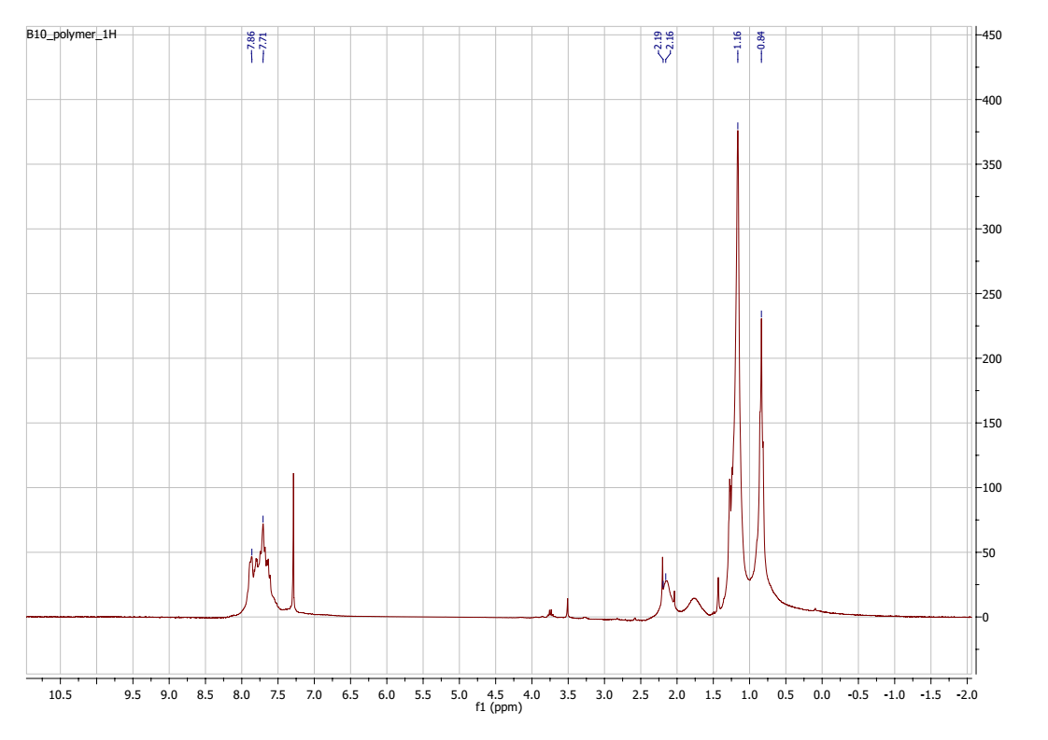Figure S2. ¹H NMR spectrum of PFCN2.5+B’ in CDCl₃.
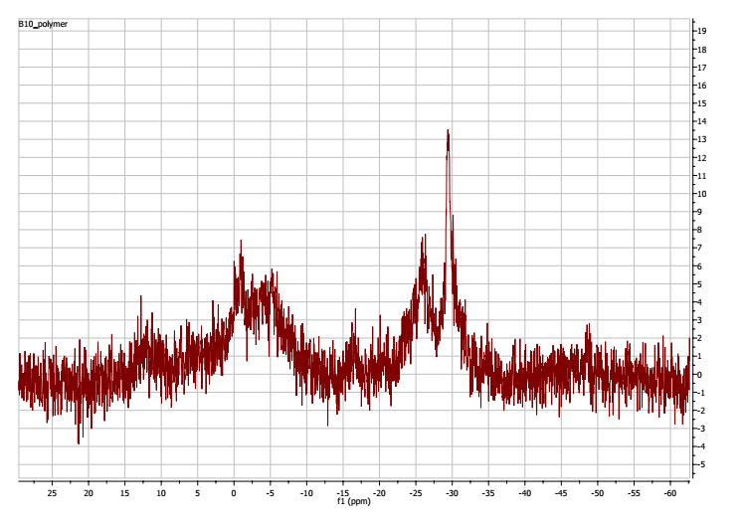
Figure S3. ¹¹B{¹H} NMR spectrum of PFCN2.5+B’ in CDCl₃.
Figure S4. FT-IR spectra of PFCN2.5 (top) and PFCN2.5+B’(bottom).
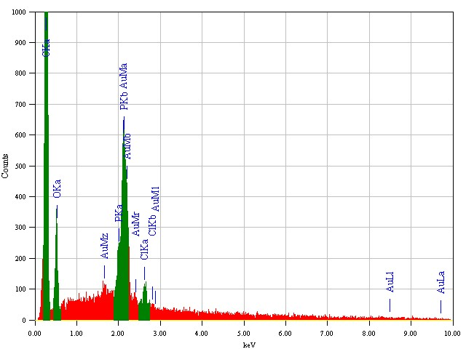
Figure S5. EDS for PFCN2.5+B’.

Table S3. UV-Vis and fluorescence spectral data for CPFs films.
CPFs | λ_{abs}, nm | λ_{em}, nm | Stokes shift, nm
PFCN0.5+B | 386, 394*, 433* | 498 | 65
PFCN0.5 [1] | 385, 426* | 499 | 73
PFCN2.5+B | 383, 398*, 432* | 465 | 33
PFCN2.5 [1] | 385, 424* | 463 | 39
PFCN5+B | 383, 395* | 527 | 132
PFCN5 | 383, 394* | 530 | 136
* Shoulder

Figure S6. PL spectra of PFCN2.5, PFCN2.5+B, PFCN2.5 after heating at 80°C for 4 h, and PFCN2.5+B after heating at 80°C for 4 h in films.
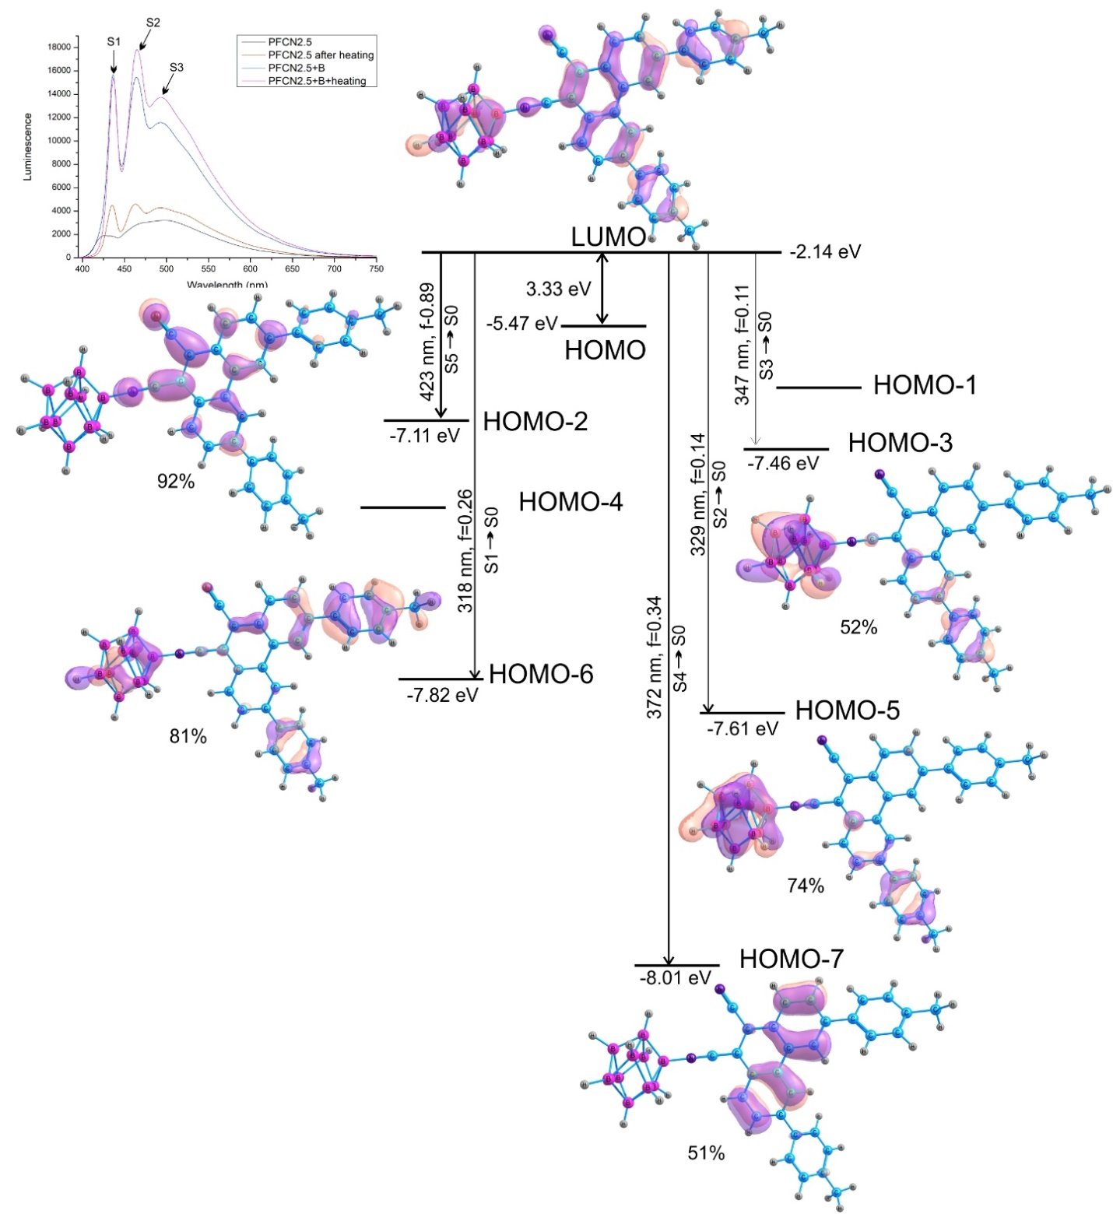
Figure S7. Transition scheme and molecular orbitals in the excited state of the PFCN-B1 molecule. Transition maxima in the luminescence spectrum according to Table 1. Energy of molecular orbitals in eV. The f is the oscillator strength. Maximum contributions of orbitals involved in this transition are given in percent (%). The inset shows the experimental luminescence spectrum.
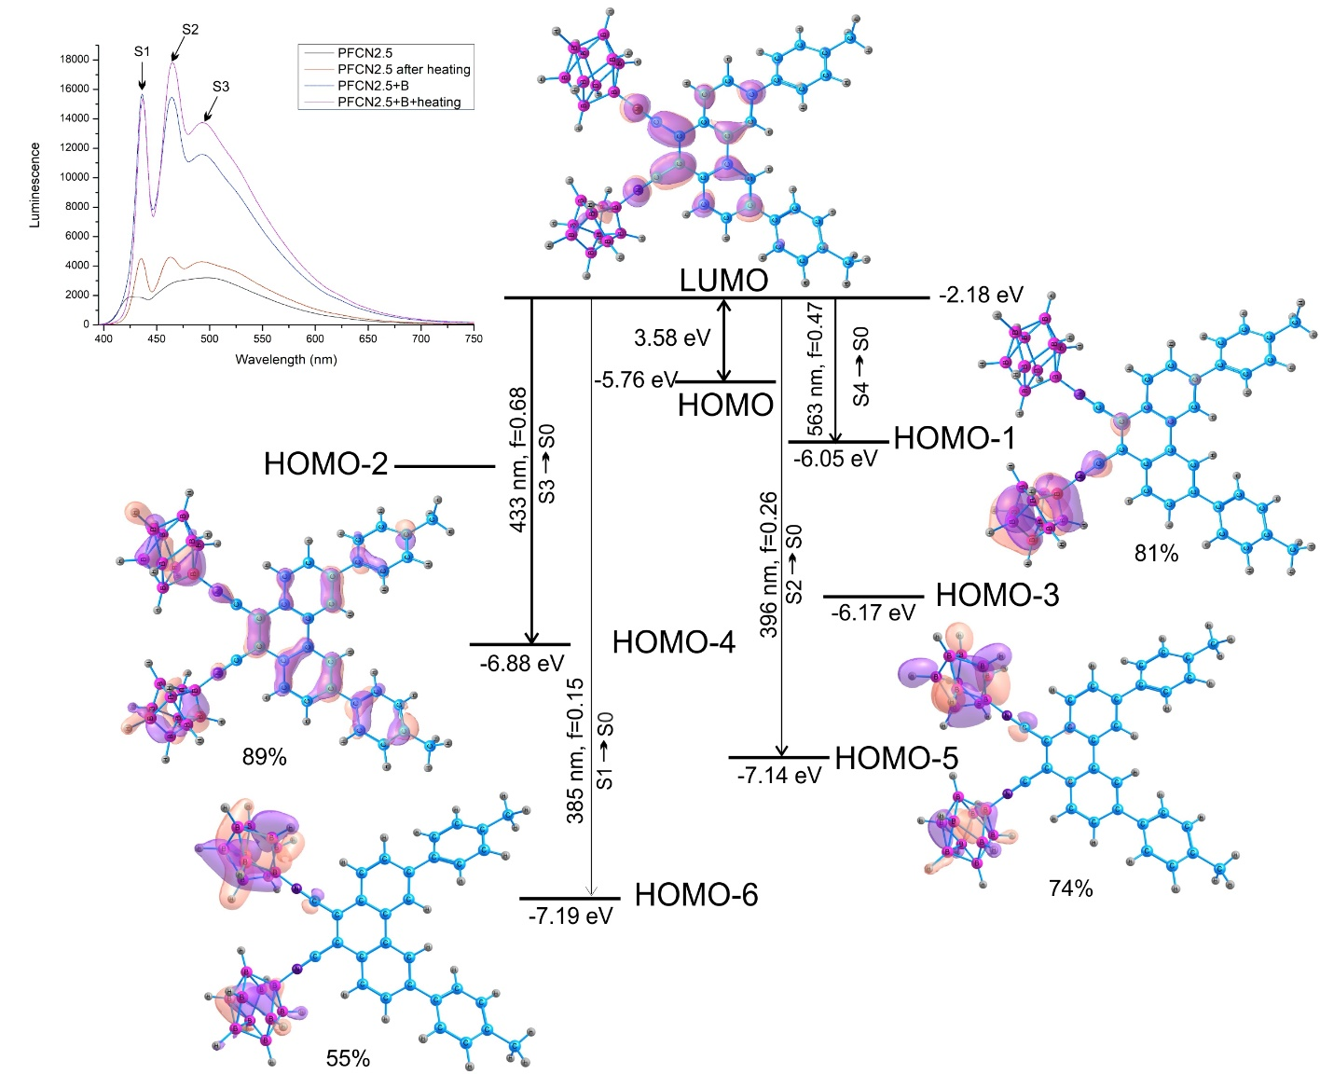
Figure S8. Transition scheme and molecular orbitals in the excited state of the PFCN-B2 molecule. Transition maxima in the luminescence spectrum according to Table 1. Energy of molecular orbitals in eV. The f is the oscillator strength. Maximum contributions of orbitals involved in this transition are given in percent (%). The inset shows the experimental luminescence spectrum.

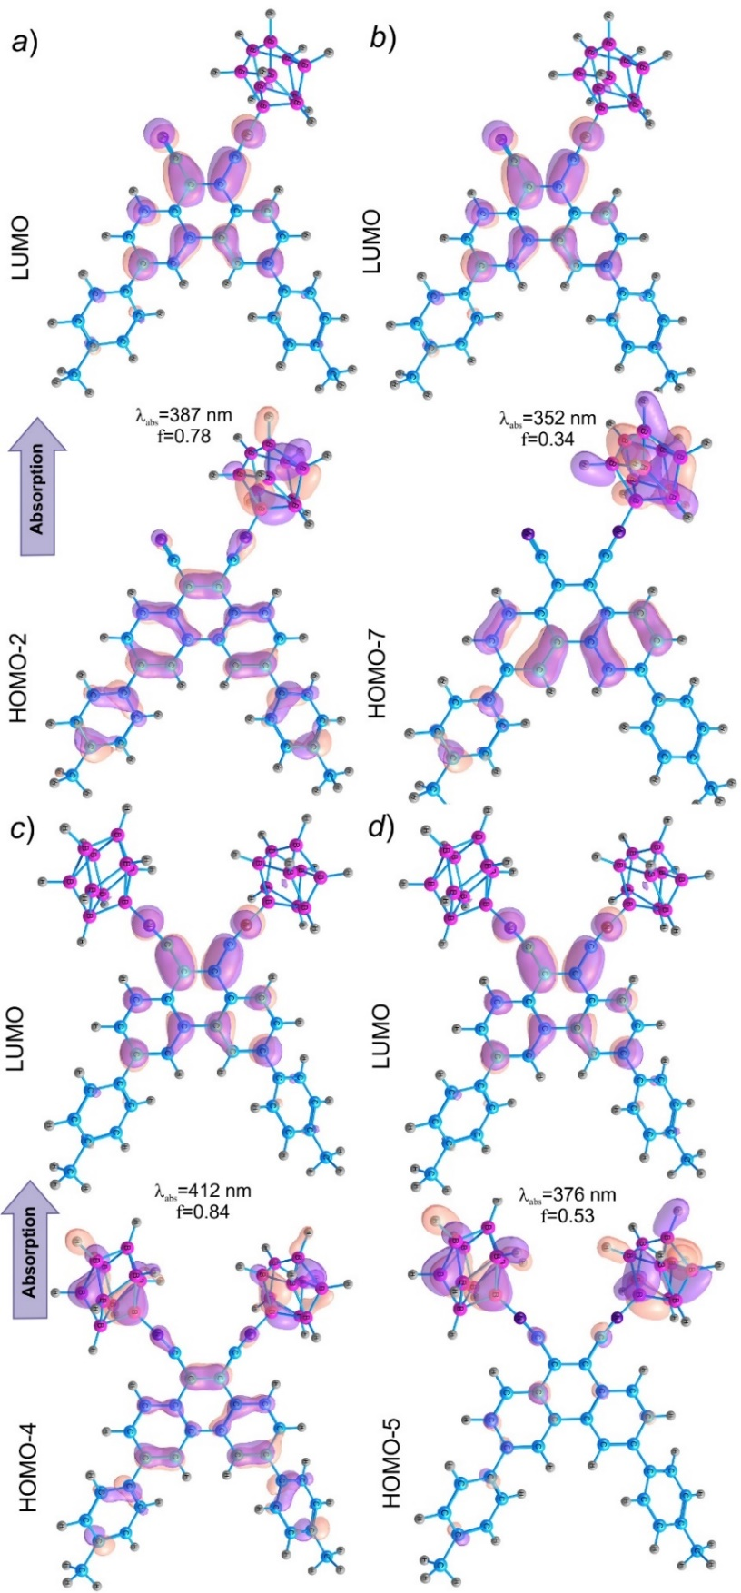
Figure S9. Molecular orbitals for the ground state of PFCN-B1 and PFCN-B2. a) Molecular orbitals for the S₀→S₁ transition of PFCN-B1; b) Molecular orbitals for the S₀→S₂ transition of PFCN-B1; c) Molecular orbitals for the S₀→S₁ transition of PFCN-B2; d) Molecular orbitals for the S₀→S₂ transition of PFCN-B2.
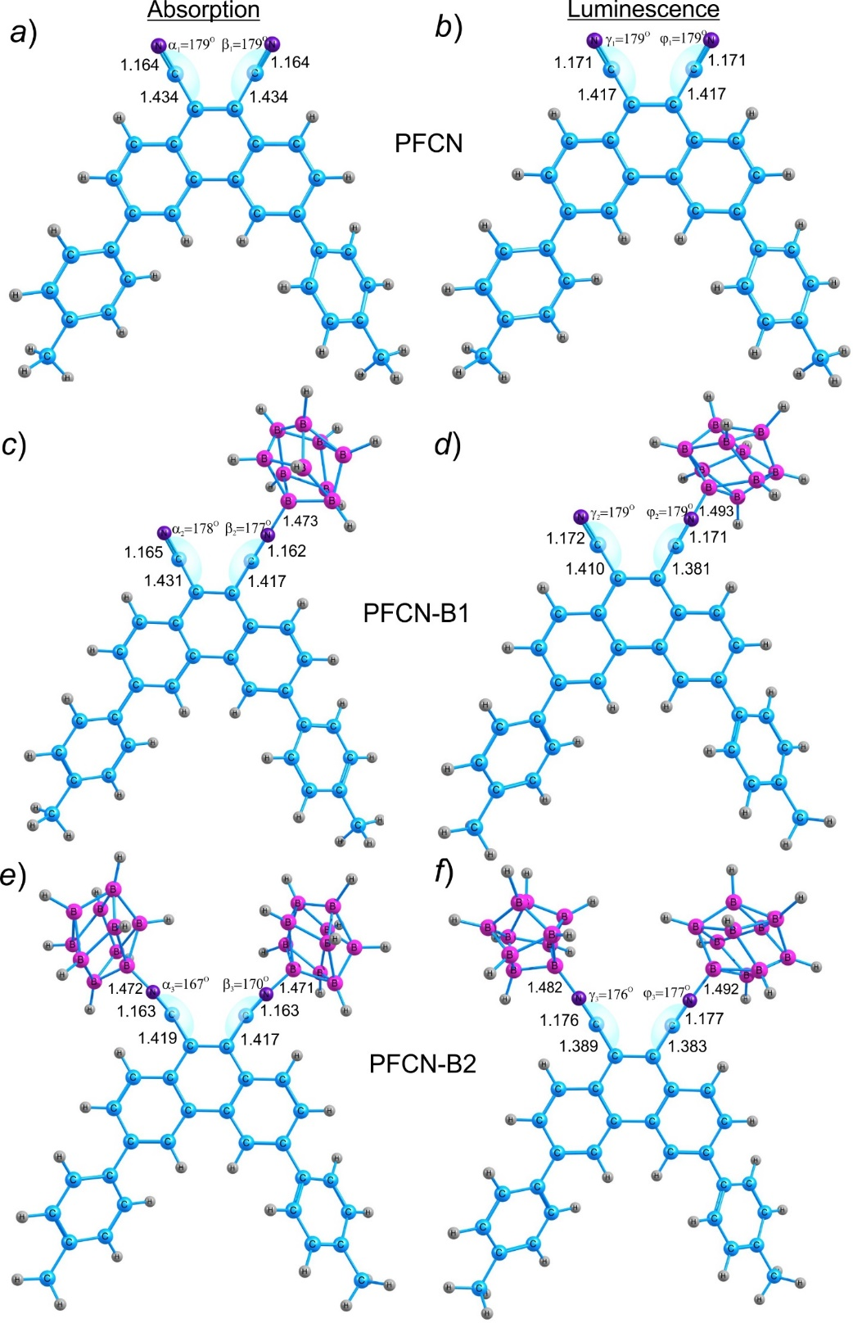
Figure S10. Atomic structure of the calculated molecules in the ground and excited states. Bond lengths (Å) and angles characterizing the change in spatial structure upon introduction of the boron cluster (B₁₀H₉⁻) in the ground and excited states for different phenanthrene compounds. a) PFCN geometry in the ground state; b) PFCN geometry in the excited state; c) PFCN-B1 geometry in the ground state; d) PFCN-B1 geometry in the excited state; e) PFCN-B2 geometry in the ground state; f) PFCN-B2 geometry in the excited state.

References
- Yakimanskiy, A.A.; Kaskevich, K.I.; Zhukova, E. V.; Berezin, I.A.; Litvinova, L.S.; Chulkova, T.G.; Lypenko, D.A.; Dmitriev, A. V.; Pozin, S.I.; Nekrasova, N. V.; et al. Synthesis, Photo- and Electroluminescence of New Polyfluorene Copolymers Containing Dicyanostilbene and 9,10-Dicyanophenanthrene in the Main Chain. Materials (Basel). 2023, 16, 1–15, doi:10.3390/ma16165592.

