Table S1. Oligonucleotides used for PCR-detection of the novel viruses.
Pool | Virus | Oligonucleotide name | Oligonucleotide sequence | Product length | Temperature
1 | Xanka Hybomitra Negev-like virus | NegevL-p1_F | GATGCGTTAAAAGAAGCGAA | 310 | 50
 |  | Negev_p1_P | (FAM)-ACCGACAAGCCAGTGATACCTGACA-(BHQ-1)
 |  | NegevL-p1_R | TTGGACAAAACACGGAATTG
 | Razdolnyj Hybomitra Phasma-like virus | Orto_p1_F | TGTTGTTGCTAATGTTCCAC | 308 | 50
 |  | Orto_p1_R | ATTCTGATGATTCCTGGGTG
2 | Kamenushka Hybomitra Narna-like virus | Narn_p2_F | CGTTAATCATTTGGCGTTGA | 399 | 50
 |  | Narn_p2_P | (FAM)-GCGCACTGAGGACAGTGGCC-(BHQ-1)
 |  | Narn_p2_R | CCATTTTTGAGGGTTGACAG
 | Volxa Hybomitra Toti-like virus | Toti_p2_F | AACTCGACGATGAATGTGAA | 358 | 50
 |  | Toti_p2_P | (FAM)-GCAGCTTGGTATCTGATGGCGCT-(BHQ-1)
 |  | Toti_p2_R | GAGAAGTGACTCGTAAGGAC
 | Komarovka Hybomitra Solemo-like virus | Sole_p2_F | CGTGCATTCCCGCTATTTGT | 362 | 55
 |  | Sole_p2_P | (FAM)-GCTCCCACTGTGCCTTGAC-(BHQ-1)
 |  | Sole_p2_R | AGTGATGCCAGCCCATGTTT
 | Barsukovka Hybomitra Ifla-like virus | Ifla_p2_F | TTTGTATTGATCCAGGTGCT | 363 | 52
 |  | Ifla_p2_P | (FAM)-ACTTTGAGACCACCCCGCCA-(BHQ-1)
 |  | Ifla_p2_R | TTTCTGCTATGCCTAAAGGT
3 | Big rock Hybomitra Ifla-like virus | C30_p3_F | TTCTTGCTGCACTAGTATTGA | 252 | 50
 |  |  | TGGGTCTGTGTTGGACAATAACACCCA
 |  | C30_p3_R | GAATTGACTGATGATGCTTCT
6 | Medvezhye Haematopota Flavi-like virus | LFla_p6_F | CCGAAAGTCAAGAAGAATGC | 286 | 50
 |  | LFla_p6_R | CTGGATGGTATATGCGTTGA
 | Melisia Haematopota Negev-like virus | NegevL_p6_F | CGTATGTTTGTCATTCGCAA | 261 | 50
 |  | NegevL_p6_P | (FAM)-CCATAGGCAGGGCAGTCACA-(BHQ-1)
 |  | NegevL_p6_R | CAGACCAAAAGGACTCATCA
 | Medvezhye Haematopota Xinmo-like virus | Anphe_p6_F | TTGTTATTATCCCAGGTGCC | 367 | 50
 |  | Anphe_p6_R | CGTCCTCTTGGATCTGTTAG
 | Medvezhye pound Haematopota Permuto-like virus | Permu_p6_F | CCCAACGCATATCCTCATTA | 283 | 50
 |  | Permu_p6_P | (FAM)-TGCCACGGGATGTTTCAACC-(BHQ-1)
 |  | Permu_p6_R | GAGCGGACAAATATACCCAT
 | Polka Haematopota Nora-like virus | C191_p6_F | TTTTGGAGGATTTGTGAATGC | 254 | 50
 |  | C191_p6_P | (FAM)-GATCCTCACAGCCCGGCGTG-(BHQ-1)
 |  | C191_p6_R | CCTGAATCTTTCTGGCCTTAT
 | Polka Haematopota Xinmo-like virus | C223_p6_F | TACCAAGTAGGCAACATACC | 270 | 50
 |  | C223_p6_R | TGTTTCAGACATGAACTGGT
7 | Medvezhye Chrysops Negev-like virus | NegevL_p7_F | CATTGACCACATCTTGCATC | 400 | 52
 |  | NegevL_p7_P | (FAM)-GGCATGTGAAGTGGTAATGGAATC-(BHQ-1)
 |  | NegevL_p7_R | ACTAAGGAGGGTCTAGTGTC
 | Big Soux River virus (strain Medveje) | BSR_p7_F | TTTAATATGCAACCACGGGA | 274 | 50
 |  | BSR_p7_P | (FAM)-TGCGCACTCGTCCCGAATGA-(BHQ-1)
 |  | BSR_p7_R | TGGTAGAACAGGATTGTGTG
 | Medvezhye Chrysops Solemo-like virus | Sol1_p7_F | TCTTTCTTCAAGATCGGCAA | 326 | 50
 |  | Sol1_p7_P | (FAM)-TCTGGGCGGCAGCAACTATG-(BHQ-1)
 |  | Sol1_p7_R | GGAGAGTCAGCATTGGTTTA
 | Melisia Chrysops Solemo-like virus | Sol2_p7_F | ATGATCAAACCGTGTTGAGA | 358 | 50
 |  | Sol2_p7_P | (FAM)-AACCATTTGCCACAAGATCTGTAA-(BHQ-1)
 |  | Sol2_p7_R | CAGTGATCAGAGCCTTAGAC
 | Polka Chrysops Solemo-like virus | Sol3_p7_F | AAAGTAAAACCAGGCGTTTG | 268 | 50
 |  | Sol3_p7_P | (FAM)-AACTCGAACGATTGATGCGGT-(BHQ-1)
 |  | Sol3_p7_R | AACTCGATGTATTCTGGCTC
 | Medvezhye Chrysops Narna-like virus | Nar1_p7_F | TTTTCTTCGACATATGGGCA | 255 | 50
 |  | Nar1_p7_R | GCTTTGATATCAGATGCTGC
 | Medvezhye Chrysops Narna-like virus 2 | Nar2_p7_F | ACAGTGCGAAGTTGTTATCT | 327 | 50
 |  | Nar2_p7_P | (FAM)-CAAATGGCTCGGCTTGGTAGATCG-(BHQ-1)
 |  | Nar2_p7_R | AGATCGGATAGCTTCGTCTA
 | Medvezhye Chrysops Solinvi-like virus | Soli_p7_F | ACATTGCCTTTTCCATTGTG | 335 | 50
 |  | Soli_p7_R | AAAAGTTAGGCGTGACAGAT
 | Medvezhye Chrysops Rhabdo-like virus | Rha_p7_F | AGAGGCTCTCACTGACAATA | 292 | 50
 |  | Rha_p7_P | (FAM)-TGGCTGACGGATCTGAGATCCCT-(BHQ-1)
 |  | Rha_p7_R | CCCTCCTAAATGTCCTTTCC
8 | Medvezhye Chrysops Ifla-like virus | Ifla_p8_F | CATAAGAAGCATAACGACGC | 350 | 50
 |  | Ifla_p8_P | (FAM)-ACGATCTCCCGATTTCATCCATTCTGA-(BHQ-1)
 |  | Ifla_p8_R | TGTGATGTGTCCTTACTTCG
 | Medvezhye Chrysops Toti-like virus | Toti_p8_F | TGGTAACATCCAGTTCACAG | 387 | 50
 |  | Toti_p8_P | (FAM)-TGCCGCTATGGGGGAGGCAT-(BHQ-1)
 |  | Toti_p8_R | TTTTCCGCCGTTATAGGTAG
 | Istie Chrysops Solemo-like virus | Sole_p8_F | ATTCCAATTCCGAGTCAACA | 268 | 50
 |  | Sole_p8_P | (FAM)-AGTTGGGTAATTTCGGGGTCTTGGA-(BHQ-1)
 |  | Sole_p8_R | CGACCCTCCAAAAGTAAAGA
 | Medvezhye Chrysops Xinmo-like virus | Rha_p8_F | GTTCAAGCTTAGGGGTTACA | 255 | 50
 |  | Rha_p8_P | (FAM)-TCACGCACATGGTACAGATGCAA-(BHQ-1)
 |  | Rha p8_R | TATGTGATGCCAGTACGTTT
 | Medvezhye Chrysops Phasma-like virus | Orto_p8_F | GCATGCACTCATAGATGTTG | 260 | 50
 |  | Orto_p8_R | GTGACTGGATTATCAACGGA
9 | Medvezhye Tabanus Phasma-like virus | Orto_p9_F | ACTACAAGTTTAGGTGCCAG | 370 | 50
 |  | Orto_p9_R | ATGATGTGTTAACTGCTGGT
 | Medvezhye Tabanus Chu-like virus | Rha_p9_F | TCACTTAAAGTTGCGGATGA | 334 | 50
 |  | Rha_p9_R | TTACAACTTATGGACACGCA
 | Medvezhye Tabanus Toti-like virus | Toti_p9_F | AGTCTTAGCCTATACAGCCA | 353 | 50
 |  | Toti_p9_P | (FAM)-TCCTCCATGCCCGGCTTGAGT-(BHQ-1)
 |  | Toti_p9_R | TGATTAGGCCACATGTGAAA

Table S2. Oligonucleotides used for internal control Poliovirus RT-qPCR.
Oligonucleotide | Sequence
PVR1 | 5’-CGAACGTGATCCTGAGTGTT-3’
PVP1 | (ROX)-TTGATTCATGAATTTCCTTCATTGGCA-(BHQ-2)
PVL1 | 5’- GGCAGACGAGAAATACCCAT- 3’

Table S3. Characteristics of viruses with complete and partial coding sequences.
Pool | Virus | Presence in the pool (%) | Comparison protein | Closest relative | Q cover | Identity
1 | Xanka Hybomitra Negev-like virus | 0.01 | ORF1 (RdRp) | [URQ09136.1] Halyomorpha halys negev-like virus 1 | 61% | 42.2%
2 | Kamenushka Hybomitra Narna-like virus | <0.01% | RdRp | [QVG74774.1] Riboviria sp. | 89% | 52.5%
 | Volxa Hybomitra Toti-like virus | 0.01 | RdRp | [UPT53761.1] Bactrocera zonata toti-like virus | 99% | 41.1%
 | Komarovka Hybomitra Solemo-like virus | <0.01% | RdRp | [UJG28005.1] Ulaatai Melophagus solemo-like virus | 75% | 63.6%
 |  |  | CP | [APG75767.1] Hubei sobemo-like virus 48 | 93% | 52.7%
6 | Medvezhye Haematopota Flavi-like virus | 0.29 | Polyprotein | [QTJ63573.1] Orthopteran flavi-related virus | 15% | 41.7%
 | Melisia Haematopota Negev-like virus | 0.23 | ORF1 (RdRp) | [URQ09136.1] Halyomorpha halys negev-like virus 1 | 61% | 39.2%
 | Medvezhye Haematopota Xinmo-like virus | 0.18 | RpRp | [YP_009337182.1] Hubei diptera virus 11 | 98% | 35.9%
 | Medvezhye pound Haematopota Permuto-like virus | 0.03 | Polyprotein | [WKV34304.1] Riboviria sp. | 61% | 35.8%
7 | Medvezhye Chrysops Negev-like virus | 1.08 | ORF1 (RdRp) | [UPT53679.1] Zeugodacus tau negev-like virus | 73% | 44.3%
 | Big Soux River virus (strain Medvezhye) | 0.48 | ORF1 | [ATI98938.1] Big Sioux River virus | 99% | 99.9%
 | Medvezhye Chrysops Solemo-like virus | 0.13 | RdRp | [YP_009330098.1] Hubei sobemo-like virus 13 | 73% | 51.1%
 |  |  | CP | [YP_009342449.1] Wuhan house centipede virus 5 | 99% | 37.7%
 | Melisia Chrysops Solemo-like virus | 0.28 | RdRp | [UCS96389.1] Riboviria sp. | 81% | 55.7%
 |  |  | CP | [APG75767.1] Hubei sobemo-like virus 48 | 86% | 52.6%
 | Polka Chrysops Solemo-like virus | 0.05 | RdRp | [QIJ70118.1] Jeffords solemo-like virus | 95% | 39.5%
 |  |  | CP | [QHA33885.1] Atrato Sobemo-like virus 3 | 86% | 35.4%
 | Medvezhye Chrysops Narna-like virus | 0.61 | RdRp | [UHR49680.1] Sanya cydistomyia duplonotatay narnavirus 1 | 91% | 51.2%
 | Medvezhye Chrysops Narna-like virus 2 | 0.23 | RdRp | [UHR49680.1] Sanya cydistomyia duplonotatay narnavirus 1 | 92% | 51.4%
8 | Medvezhye Chrysops Ifla-like virus | 0.02 | Polyprotein | [UQJ82152.1] Exitianus exitiosus virus 2 | 95% | 34.5%
 | Medvezhye Chrysops Toti-like virus | 0.03 | RdRp | [YP_009333170.1] Hubei toti-like virus 19 | 98% | 60%
 | Istie Chrysops Solemo-like virus | 0.01 | RdRp | [QXV86400.1] Solemoviridae sp. | 68% | 46.6%
 |  |  | CP | [APG75767.1] Hubei sobemo-like virus 48 | 98% | 42.2%
 | Medvezhye Chrysops Xinmo-like virus | 0.01 | L | [YP_009337182.1]Hubei diptera virus 11 | 98% | 39.2%

Table S4. Characteristics of genome fragments detected in the study.
Pool | Contig type and assigned name | Contig name | Closest relative | Protein | Q cover | Identity
1 | Orthophasma-like  Razdolnyj Hybomitra Phasma-like virus | NODE_8_length_1310_ | [QXV86665.1] Tibet bird virus 1 | nucleocapsid | 89% | 42.8%
 |  | NODE_19_length_530_ | [QID77675.1] Pink bollworm virus 2 | RdRp | 100% | 69.3%
 |  | NODE_21_length_478_ | [YP_009666959.1] Seattle Prectang virus | RdRp | 100% | 46%
 |  | NODE_22_length_468_ | [UHK03218] Hangzhou zicrona caerulea phasmavirus 1 | RdRp | 99% | 53.3%
2 | Iflaviridae-like  Barsukovka Hybomitra Ifla-like virus | NODE_11_length_1234_ | [WEU50803.1] Chrysopa pallens | Polyprotein | 93% | 35.7%
 |  | NODE_20_length_639_ | [CAF1136435.1] Ceratitis capitata iflavirus 3 | Polyprotein | 96% | 48.4%
 |  | NODE_21_length_616_ | [UJG27957.1] Khandagaity Melophagus ifla-like virus | Polyprotein | 100% | 36.9%
 |  | NODE_24_length_577_ | [WEU50803.1] Chrysopa pallens | Polyprotein | 100% | 31.8%
 |  | NODE_27_length_467_ | [QZZ63343.1] Leuven wasp-associated virus 3 | Polyprotein | 99% | 46.1%
 |  | NODE_28_length_466_ | [UUG74229.1]XiangYun picorna-like virus 4 | Polyprotein | 79% | 57.6%
 |  | NODE_37_length_408_ | [UQJ82152.1] Exitianus exitiosus virus 2 | Polyprotein | 100% | 63%
3 | Iflaviridae-like  Big rock Hybomitra Ifla-like virus | NODE_30_length_381_ | [CAF1136435] Ceratitis capitata iflavirus 3 | Polyprotein | 98% | 39.6%
6 | Nora virus-like  Polka Haematopota Nora-like virus | NODE_191_length_616_ | [ASM93992]Caledonia beadlet anemone Nora virus-like virus 1 | ORF2 | 96% | 42.9%
 | Xinoviridae-like  Polka Haematopota Xinmo-like virus | NODE_223_length_580_ | Hubei diptera virus 11 | RdRp | 97% | 53.6%
7 | Solinviviridae-like  Medvezhye Chrysops Solinvi-like virus | NODE_115_length_1354_ | [UHK03205.1] Hangzhou Solinvi-like virus 2 | Polyprotein | 99% | 38%
 |  | NODE_146_length_1248_ | [UHK03205.1] Hangzhou Solinvi-like virus 2 | Polyprotein | 99% | 72%
 |  | NODE_267_length_903_ | [UHK03205.1] Hangzhou Solinvi-like virus 2 | Polyprotein | 99% | 68.6%
 |  | NODE_312_length_849_ | [UHK03205.1] Hangzhou Solinvi-like virus 2 | Polyprotein | 100% | 75.5%
 |  | NODE_382_length_787_ | [UHK03205.1] Hangzhou Solinvi-like virus 2 | Polyprotein | 99% | 74.2%
 |  | NODE_574_length_664_ | [UHK03205.1] Hangzhou Solinvi-like virus 2 | Polyprotein | 100% | 75.1%
 |  | NODE_617_length_640_ | [UHK03205.1] Hangzhou Solinvi-like virus 2 | Polyprotein | 100% | 46.5%
7 | Rhabdo-like  Medvezhye Chrysops Rhabdo-like virus | NODE_9_length_4303_ | [AJG39162.1] Wuhan Fly Virus 3 | L | 99% | 36.8%
7 | Rhabdo-like  Melisia Chrysops Rhabdo-like virus | NODE_120_length_1338_ | [YP_009336837.1] Hubei lepidoptera virus 2 | L | 95% | 46.6%
 |  | NODE_12_NODE_108_ | [UZC34538.1] jopcycgri virus 1 | L | 99% | 50%
8 | Orthophasma-like  Medvezhye Chrysops Phasma-like virus | NODE_16_length_3720 | [QXV86663.1]Tibet bird virus 1 | RdRp | 99% | 52%
 |  | NODE_43_length_2382_ | [YP_010086190.1] Anopheles triannulatus orthophasmavirus | Glycoprotein | 90% | 29.4%
 |  | NODE_163_length_1495_ | [QXV86665.1]Tibet bird virus 1 | N | 69% | 39.1%
 |  | NODE_299_length_1184_ | [QXV86663.1]Tibet bird virus 1 | RdRp | 99% | 31.5%
8 | Solinviviridae-like | NODE_2118_length_528_ | [UHK03205.1]Hangzhou Solinvi-like virus 2 | Polyprotein | 67% | 82.4%
 |  | NODE_3267_length_436_ | [UHK03205.1]Hangzhou Solinvi-like virus 2 | Polyprotein | 99% | 70.8%
 |  | NODE_4305_length_385_ | [UHK03205.1]Hangzhou Solinvi-like virus 2 | Polyprotein | 99% | 50.8%
9 | Orthophasma-like  Medvezhye Tabanus Phasma-like virus | NODE_10_length_1088_ | [QXV86665.1] Tibet bird virus 1 | N | 97% | 38.9%
 |  | NODE_47_length_434_ | [YP_009666982] Ganda bee virus | Glycoprotein | 98% | 37.9%
9 | Toti-like  Medvezhye Tabanus Toti-like virus | NODE_20_length_755_ | [YP_009333170.1]Hubei toti-like virus 19 | VP2 | 99% | 67%
 |  | NODE_24_length_700_ | [YP_009333170.1]Hubei toti-like virus 19 | VP2 | 96% | 79.2%
 |  | NODE_64_length_393_ | [YP_009333170.1]Hubei toti-like virus 19 | VP2 | 100% | 67.7%
 |  | NODE_69_length_384_ | [YP_009333169.1]Hubei toti-like virus 19 | VP1 | 100% | 72.4%
9 | Chu-like  Medvezhye Tabanus Chu-like virus | NODE_19_length_798_ | [YP_010798609.1] megalopteran chu-related virus 119 | Glycoprotein | 39% | 52.8%
 |  | NODE_22_length_739_ | [YP_010798611.1] megalopteran chu-related virus 119 | RdRp | 97% | 34.8%
 |  | NODE_25_length_693_ | [APG78769.1] Hubei chuvirus-like virus 4 | RdRp | 99% | 48.3%
 |  | NODE_35_length_520_ | [YP_010798611.1] megalopteran chu-related virus 119 | RdRp | 100% | 32.4%
 |  | NODE_36_length_509_ | [YP_010798611.1] megalopteran chu-related virus 119 | RdRp | 98% | 54.5%

Table S5. Similarity estimation within tabanid negev-like viruses using discontiguous megablast on the full genome.
 | Xanka Hybomitra Negev-like virus | Medvezhye Chrysops Negev-like virus
Xanka Hybomitra Negev-like virus | - | 68.9% (51% Q cover)
Melisia Haematopota Negev-like virus | 70.1% (57% Q cover) | 71.2% (68% Q cover)

Table S6. Similarity estimation within tabanid xinmo-like sequences using L protein amino acid sequence.
 | Medvezhye Haematopota Xinmo-like virus | NODE_223_length_580_
Medvezhye Haematopota Xinmo-like virus | - | 57.2% (97% cover)
Medvezhye Chrysops Xinmo-like virus | 60.1% (98% cover) | 52.9% (98% cover)

Table S7. Similarity estimation within tabanid ifla-like sequences using polyprotein amino acid sequence.
Pool | Contig Name | Query cover to the GenBank Entry | Identity to the GenBank Entry | Query cover to Medvezhye Chrysops Ifla-like virus | Identity to the Medvezhye Chrysops Ifla-like virus
2 | NODE_11_length_1234_ | 93% | 35.7% | 93% | 50.0%
 | NODE_20_length_639_ | 96% | 48.4% | 99% | 59.3%
 | NODE_21_length_616_ | 100% | 36.9% | 99% | 43.4%
 | NODE_24_length_577_ | 100% | 31.8% | 100% | 35.0%
 | NODE_27_length_467_ | 99% | 46.1% | 99% | 54.5%
 | NODE_28_length_466_ | 79% | 57.6% | 79% | 59.6%
 | NODE_37_length_408_ | 100% | 63% | 100% | 72.5%
3 | NODE_30_length_381_ | 98% | 39.6% | 98% | 79.9%

Table S8. Similarity estimation within tabanid solinvi-like sequences using polyprotein amino acid sequence.
Pool 8 contig name | Pool 8 abundance | Pool 7 relative | Q cover | Identity
NODE_2118_length_528_ | 10 reads | NODE_146_length_1248_ | 35% | 99.5%
NODE_3267_length_436_ | 3 reads | NODE_312_length_849_ | 93% | 99.0%
NODE_4305_length_385_ | 5 reads | NODE_146_length_1248_ | 99% | 96.9%

Table S9. Similarity estimation of pool 1 orthophasma-like contig with orthophasma-like sequences from pools 8 and 9 using amino acid sequences.
Pool 1 contig name | Pool 8 relative | Q cover | Identity | Pool 9 relative | Q cover | Identity
NODE_8_length_1310_ | NODE_163_length_1495_ | 85% | 46.3% | NODE_10_length_1088_ | 89% | 62.6%
NODE_19_length_530_ | NODE_16_length_3720_ | 100% | 77.3% | no | - | -
NODE_21_length_478_ | NODE_16_length_3720_ | 100% | 56.2% | no | - | -
NODE_22_length_468_ | NODE_16_length_3720_ | 99% | 58.4% | no | - | -

Table S10. Similarity estimation of pool 9 orthophasma-like contig with orthophasma-like sequences from pools 8 and 1 using amino acid sequences.
Pool 9 contig name | Pool 8 relative | Q cover | Identity | Pool 1 relative | Q cover | Identity
NODE_10_length_1088_ | NODE_163_length_1495_ | 86 | 45.9% | NODE_8_length_1310_ | 93% | 62.6%
NODE_47_length_434_ | NODE_43_length_2382_ | 98 | 42.0% | no | - | -

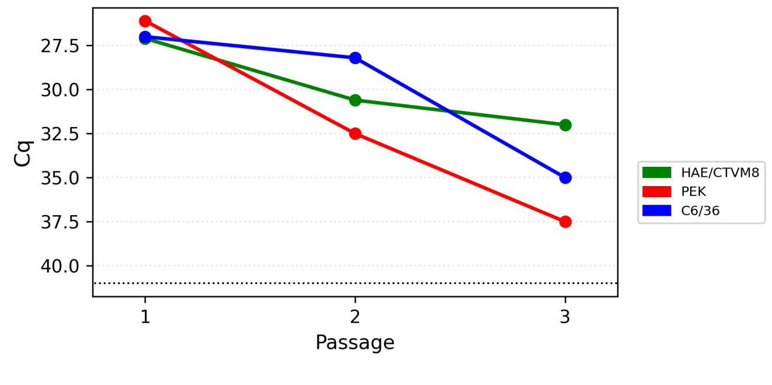
Figure S1. Dynamic of the real-time quantification cycle (Cq) during passages of the Xanka Hybomitra negev-like virus. Black dotted line represents qPCR detection limit (41 cycles).
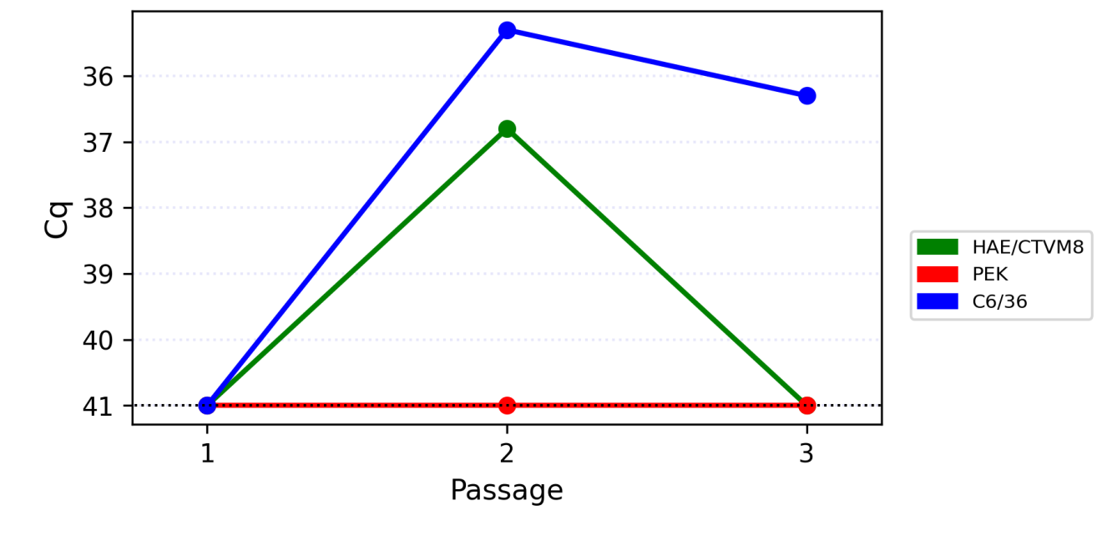
Figure S2. Dynamic of the real-time quantification cycle (Cq) during passages of the Volxa Hybomitra toti-like virus. Black dotted line represents qPCR detection limit (41 cycles).

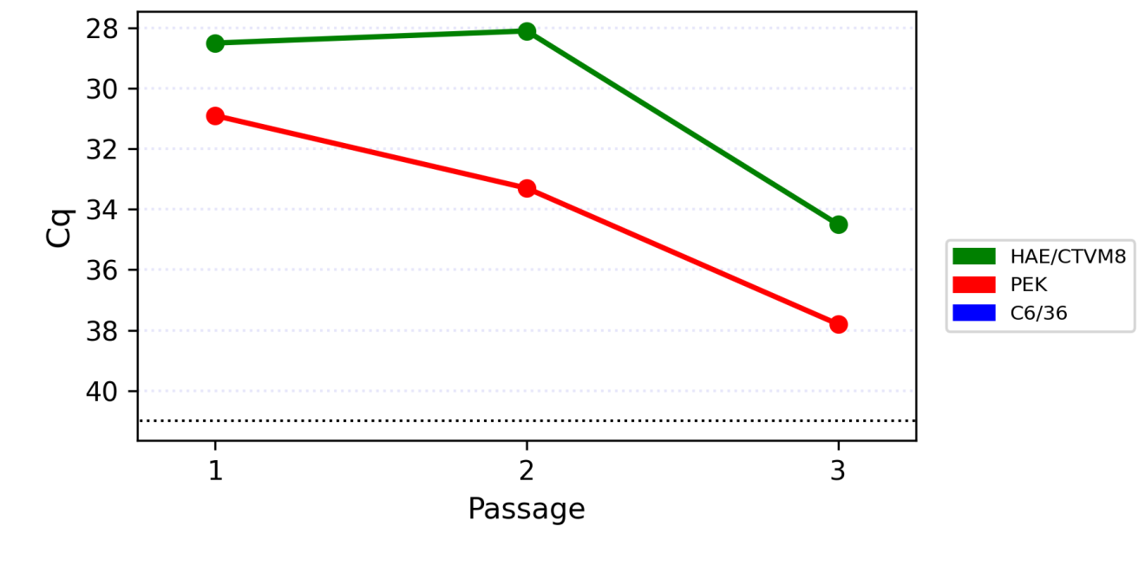
Figure S3. Dynamic of the real-time quantification cycle (Cq) during passages of the Kamenushka Hybomitra narna-like virus. Black dotted line represents qPCR detection limit (41 cycles).

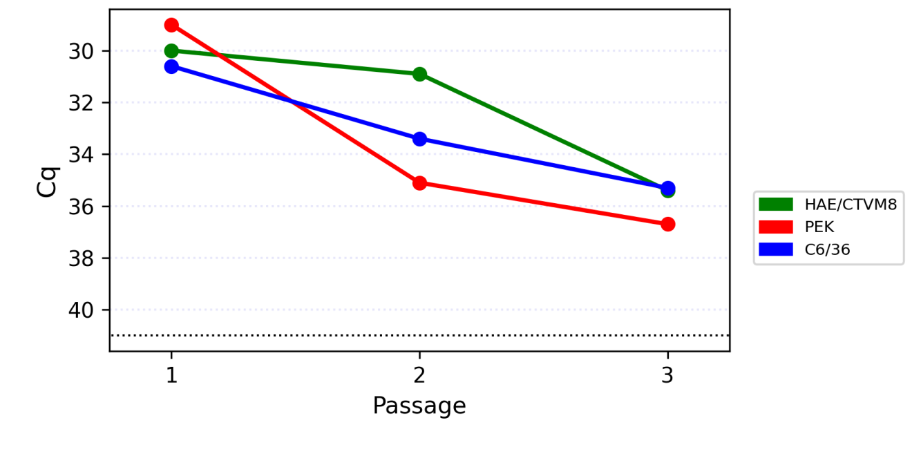
Figure S4. Dynamic of the real-time quantification cycle (Cq) during passages of the Medvezhye pound Haematopota permuto-like virus. Black dotted line represents qPCR detection limit (41 cycles).

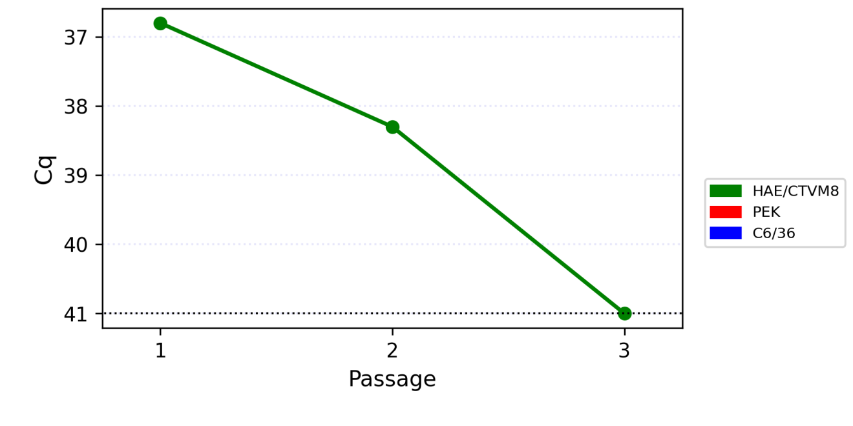
Figure S5. Dynamic of the real-time quantification cycle (Cq) during passages of the Polka Haematopota nora-like virus. Black dotted line represents qPCR detection limit (41 cycles).

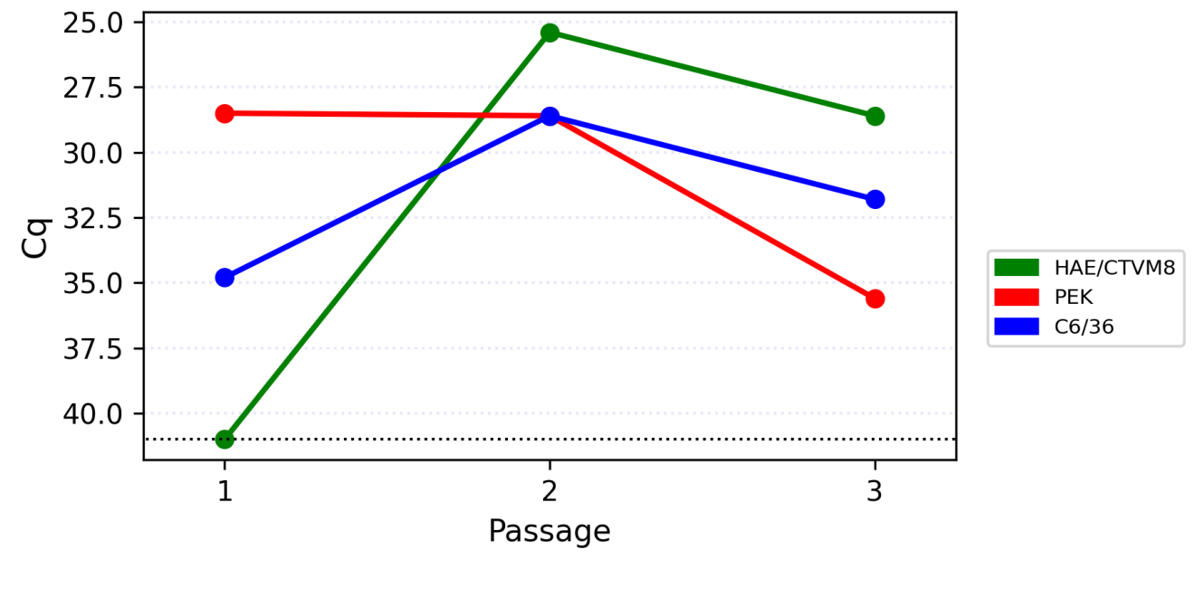
Figure S6. Dynamic of the real-time quantification cycle (Cq) during passages of the Big Soux River virus (strain Medvezhye). Black dotted line represents qPCR detection limit (41 cycles).

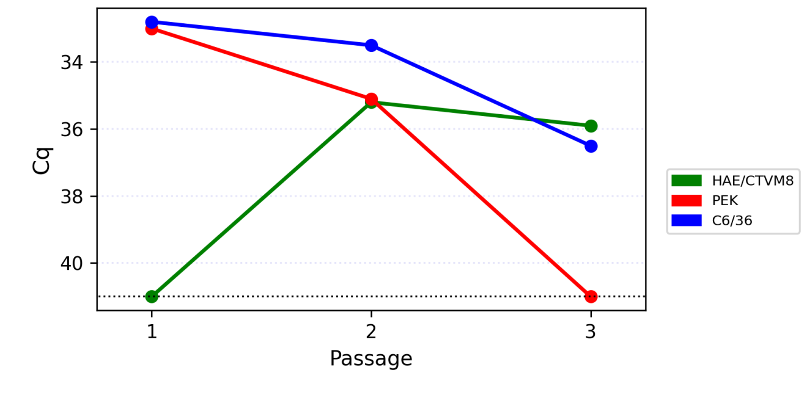
Figure S7. Dynamic of the real-time quantification cycle (Cq) during passages of the Melisia Chrysops solemo-like virus. Black dotted line represents qPCR detection limit (41 cycles).

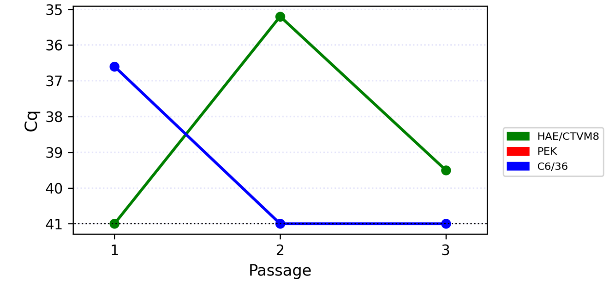
Figure S8. Dynamic of the real-time quantification cycle (Cq) during passages of the Polka Chrysops solemo-like virus. Black dotted line represents qPCR detection limit (41 cycles).

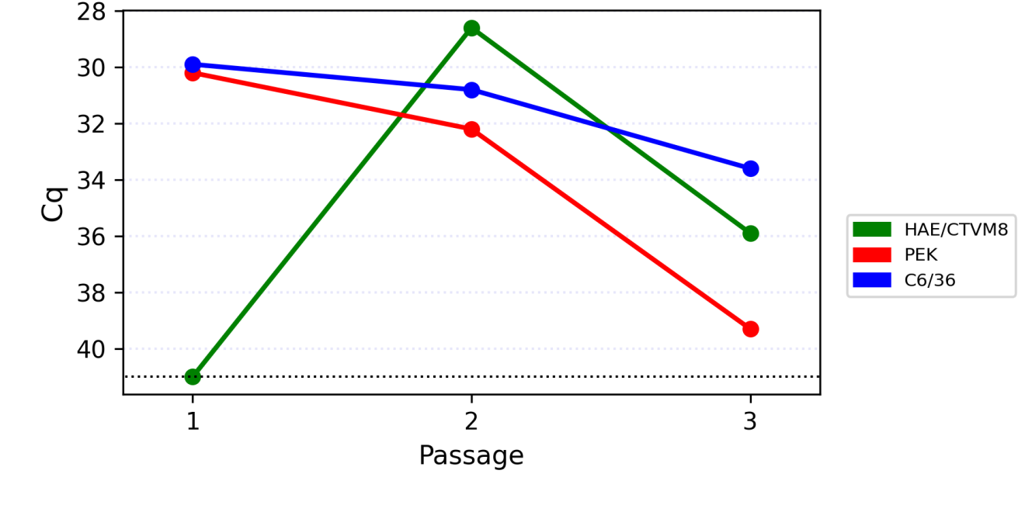
Figure S9. Dynamic of the real-time quantification cycle (Cq) during passages of the Medvezhye Chrysops narna-like virus 2. Black dotted line represents qPCR detection limit (41 cycles).

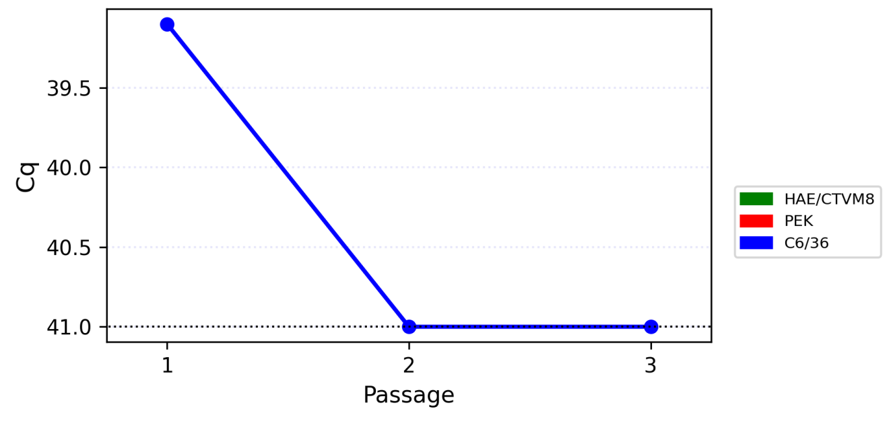
Figure S10. Dynamic of the real-time quantification cycle (Cq) during passages of the Medvezhye Chrysops rhabdo-like virus. Black dotted line represents qPCR detection limit (41 cycles).

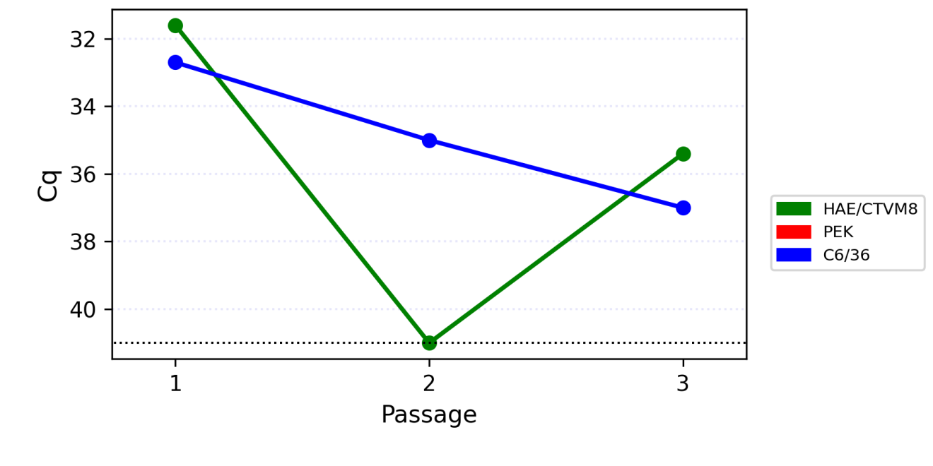
Figure S11. Dynamic of the real-time quantification cycle (Cq) during passages of the Istie Chrysops solemo-like virus. Black dotted line represents qPCR detection limit (41 cycles).

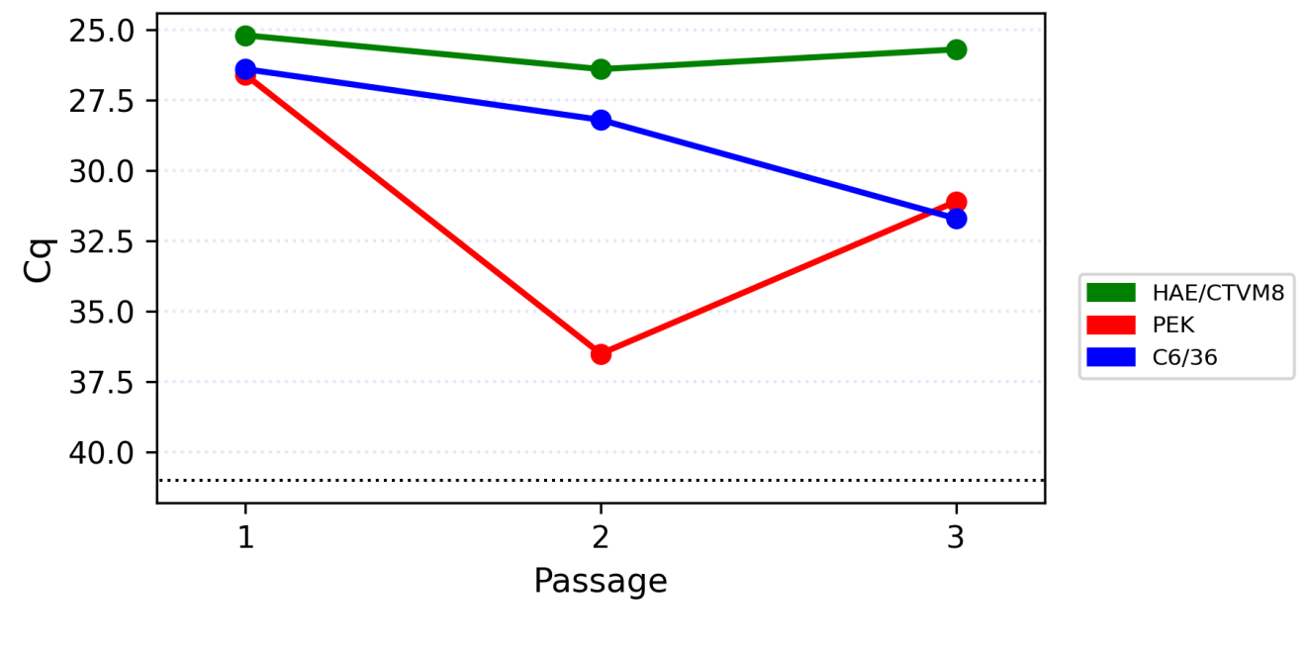
Figure S12. Dynamic of the real-time quantification cycle (Cq) during passages of the Medvezhye Tabanus toti-like virus. Black dotted line represents qPCR detection limit (41 cycles).

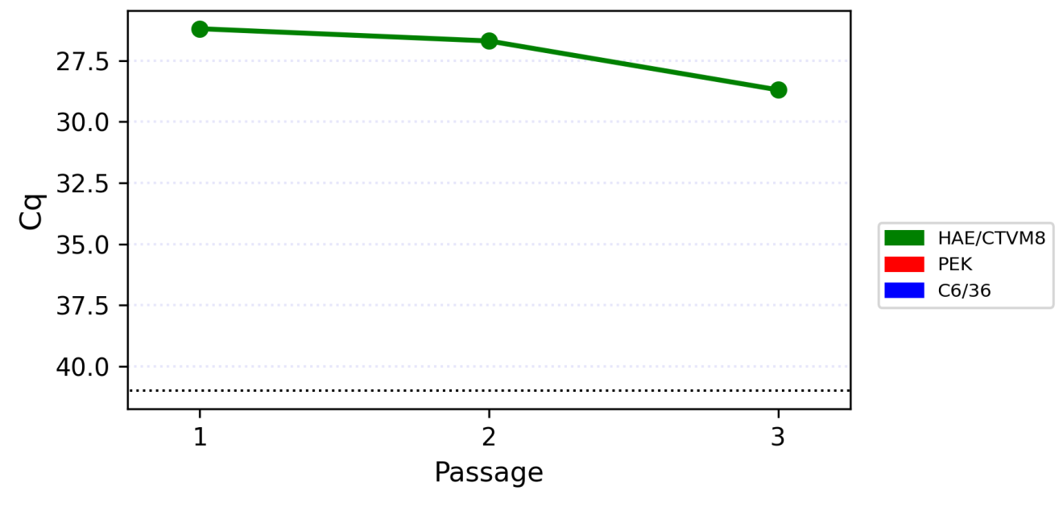
Figure S13. Dynamic of the real-time quantification cycle (Cq) during passages of the Komarovka hybomitra solemo-like virus. Black dotted line represents qPCR detection limit (41 cycles).
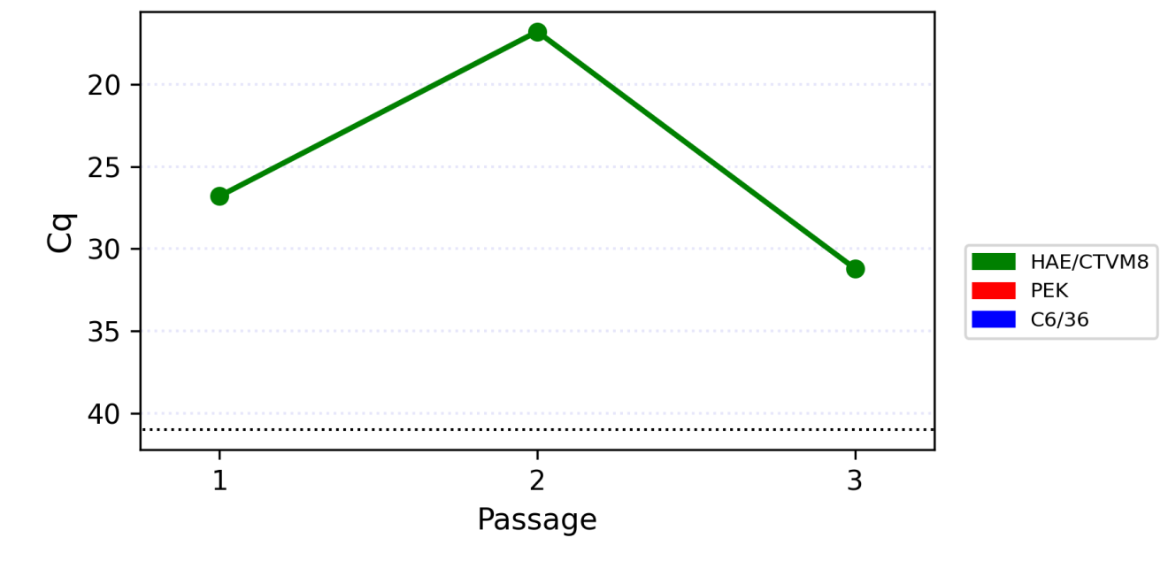
Figure S14. Dynamic of the real-time quantification cycle (Cq) during passages of the Barsukovka Hybomitra ifla-like virus. Black dotted line represents qPCR detection limit (41 cycles).

