Appendix A:

Appendix A. Representation of ROC curve using non-PRO variables.

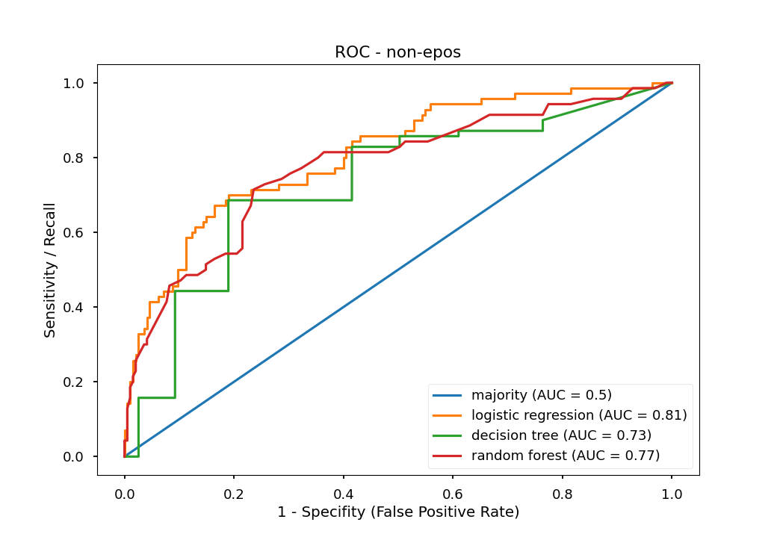

Appendix B:

Decision Tree
- Decision tree using all variables.
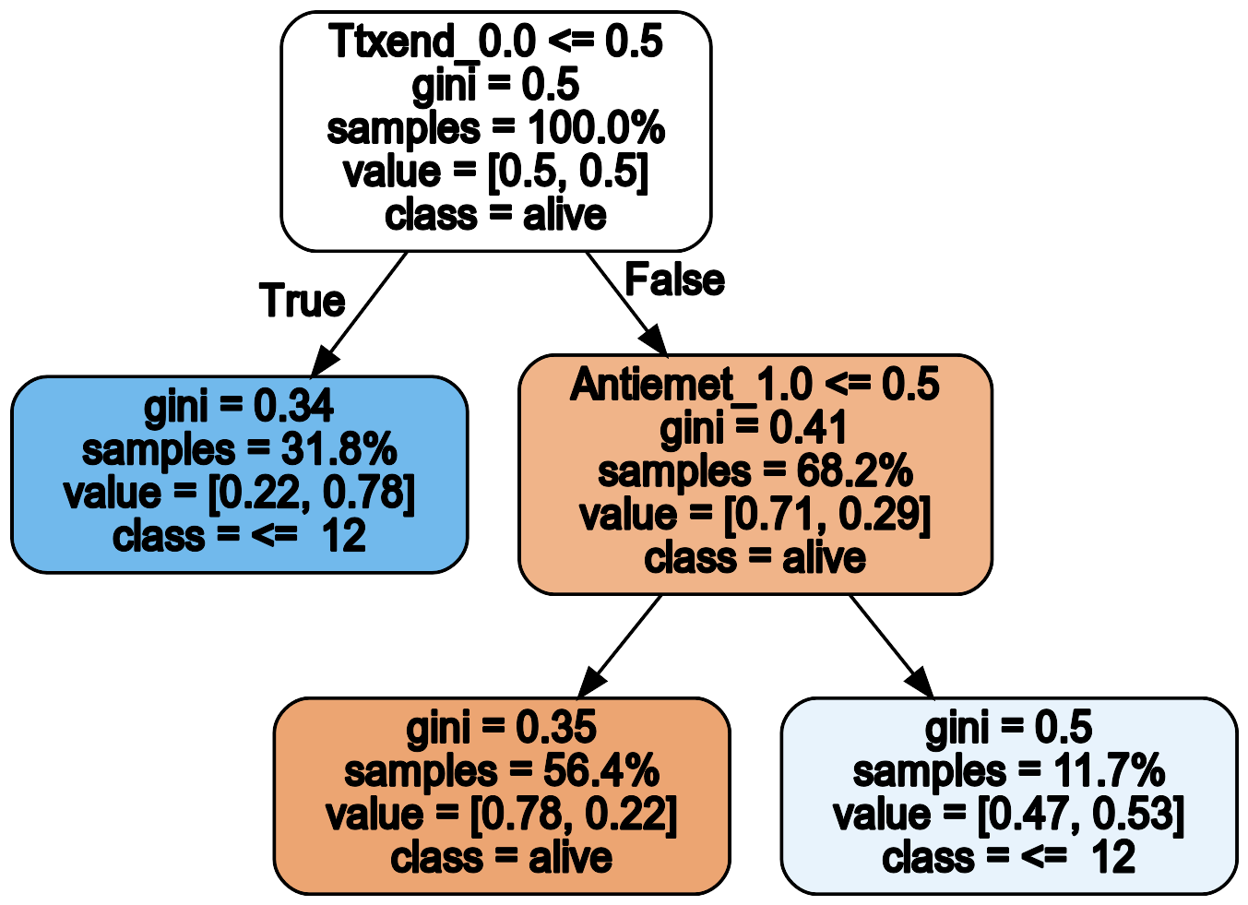

- Decision tree using PRO variables.

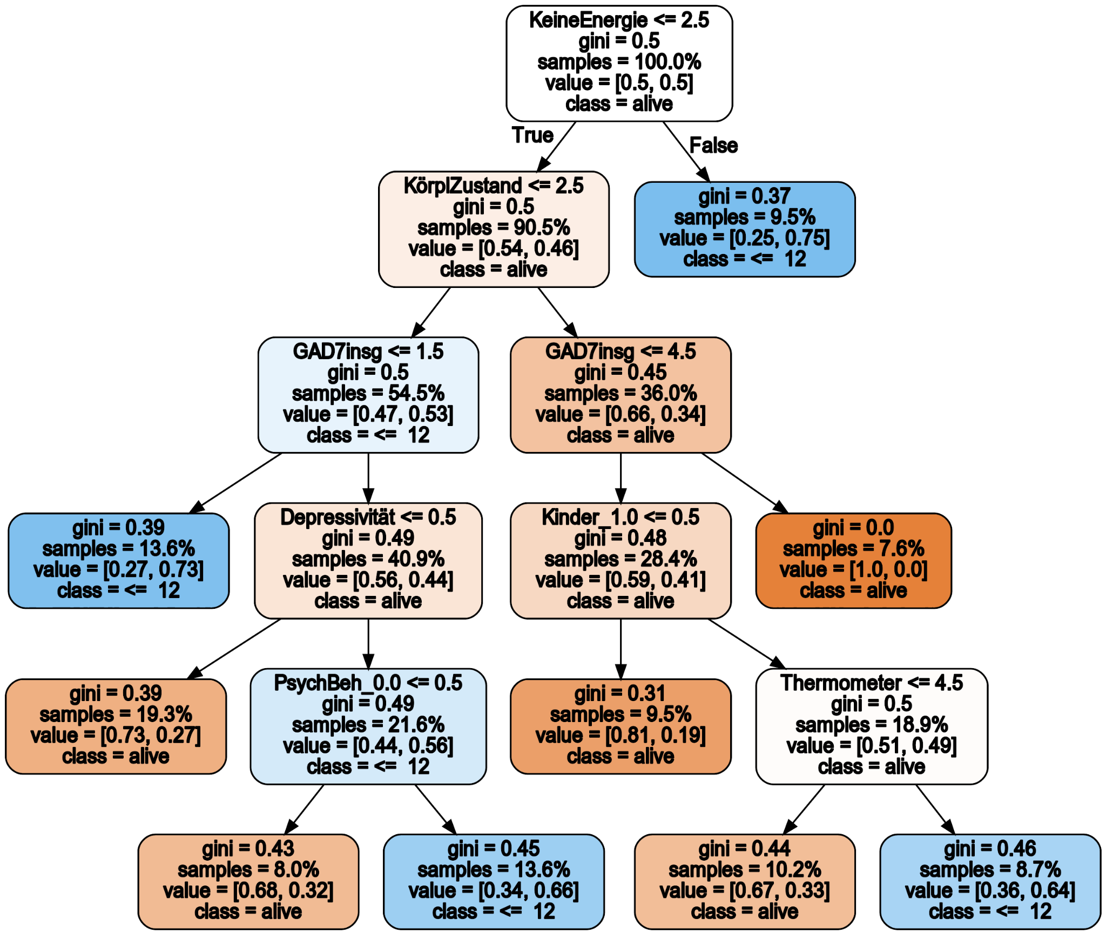

- Decision tree using non-PRO variables.

