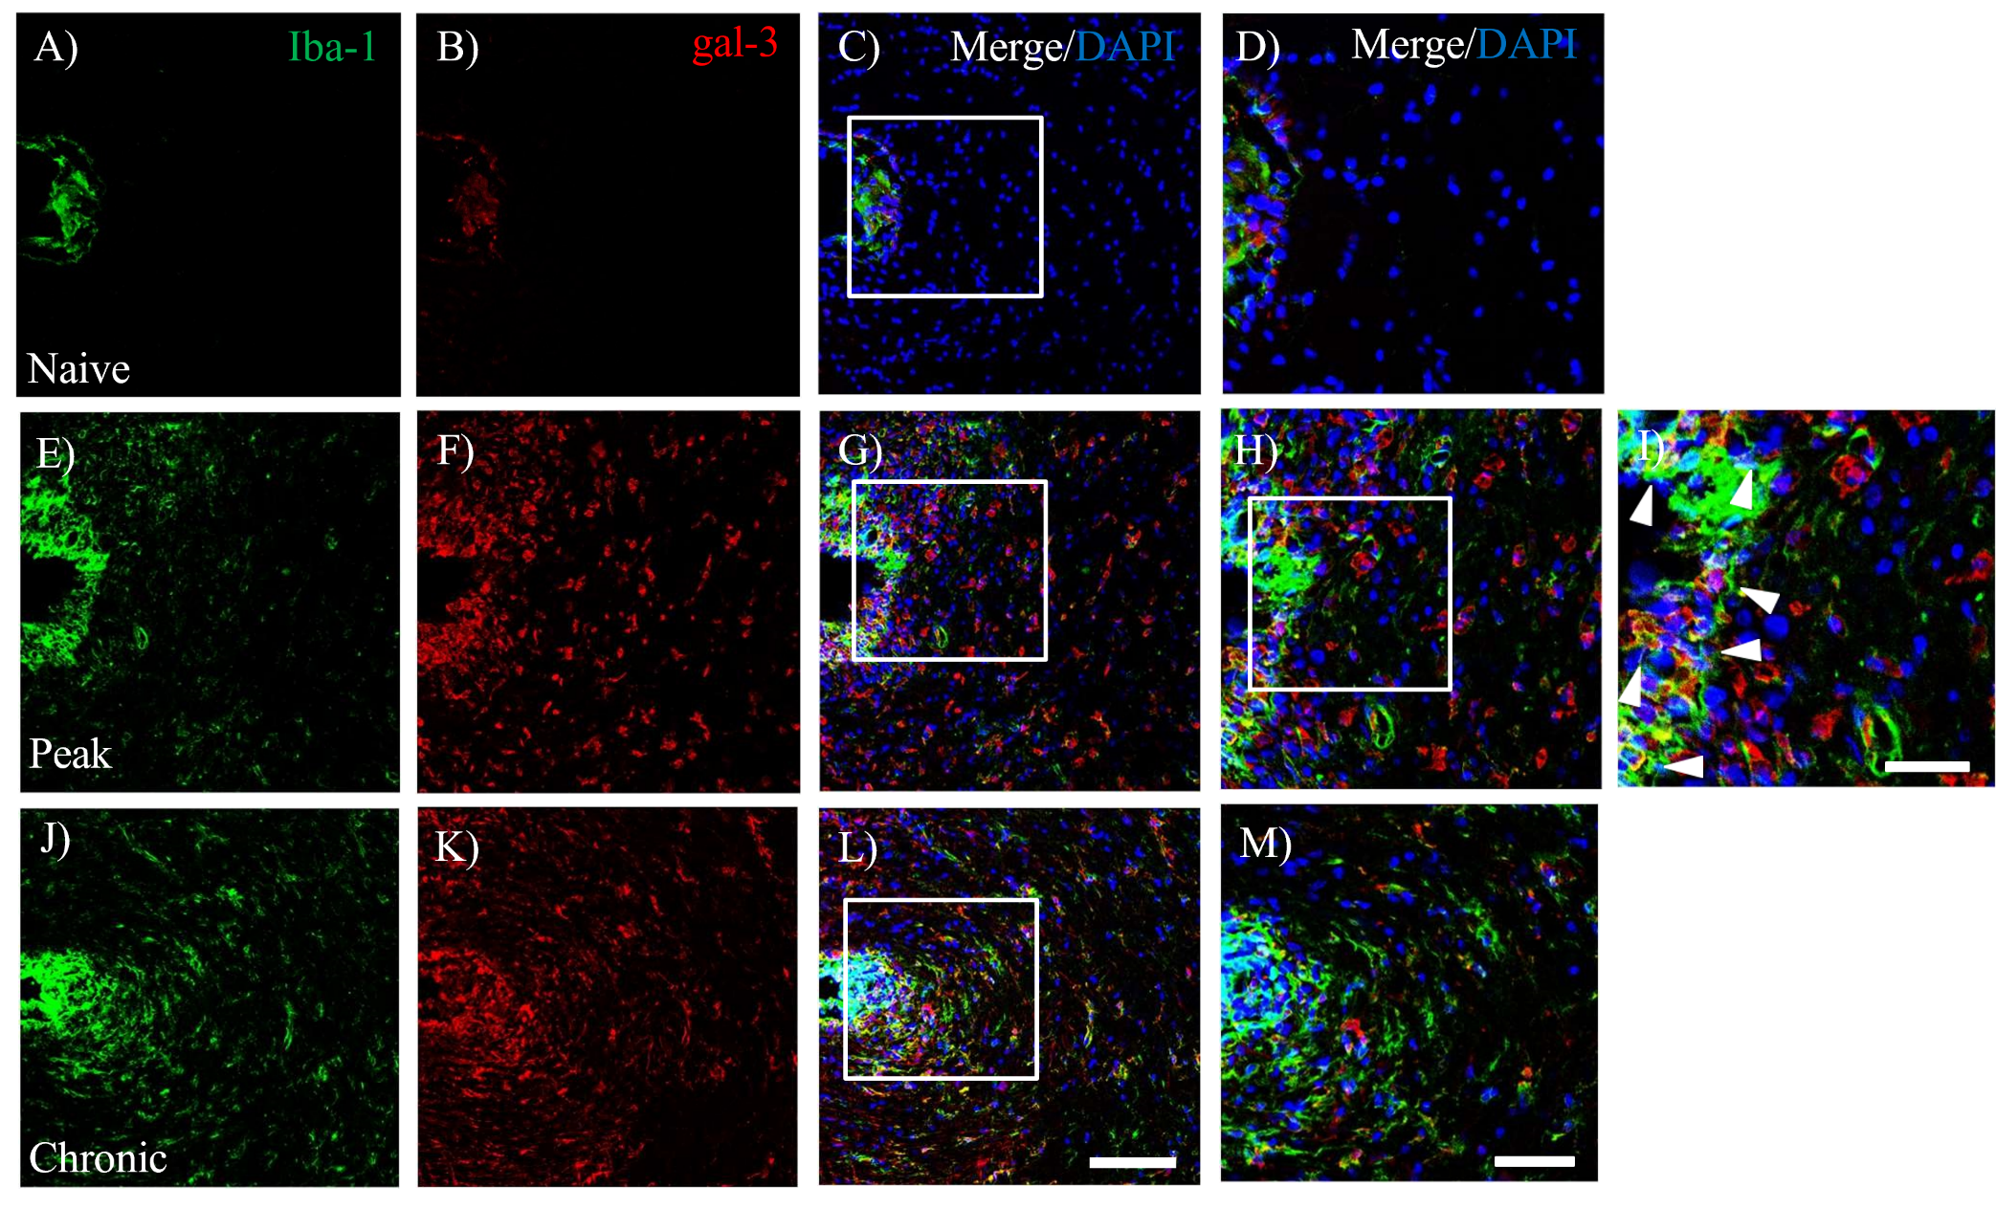
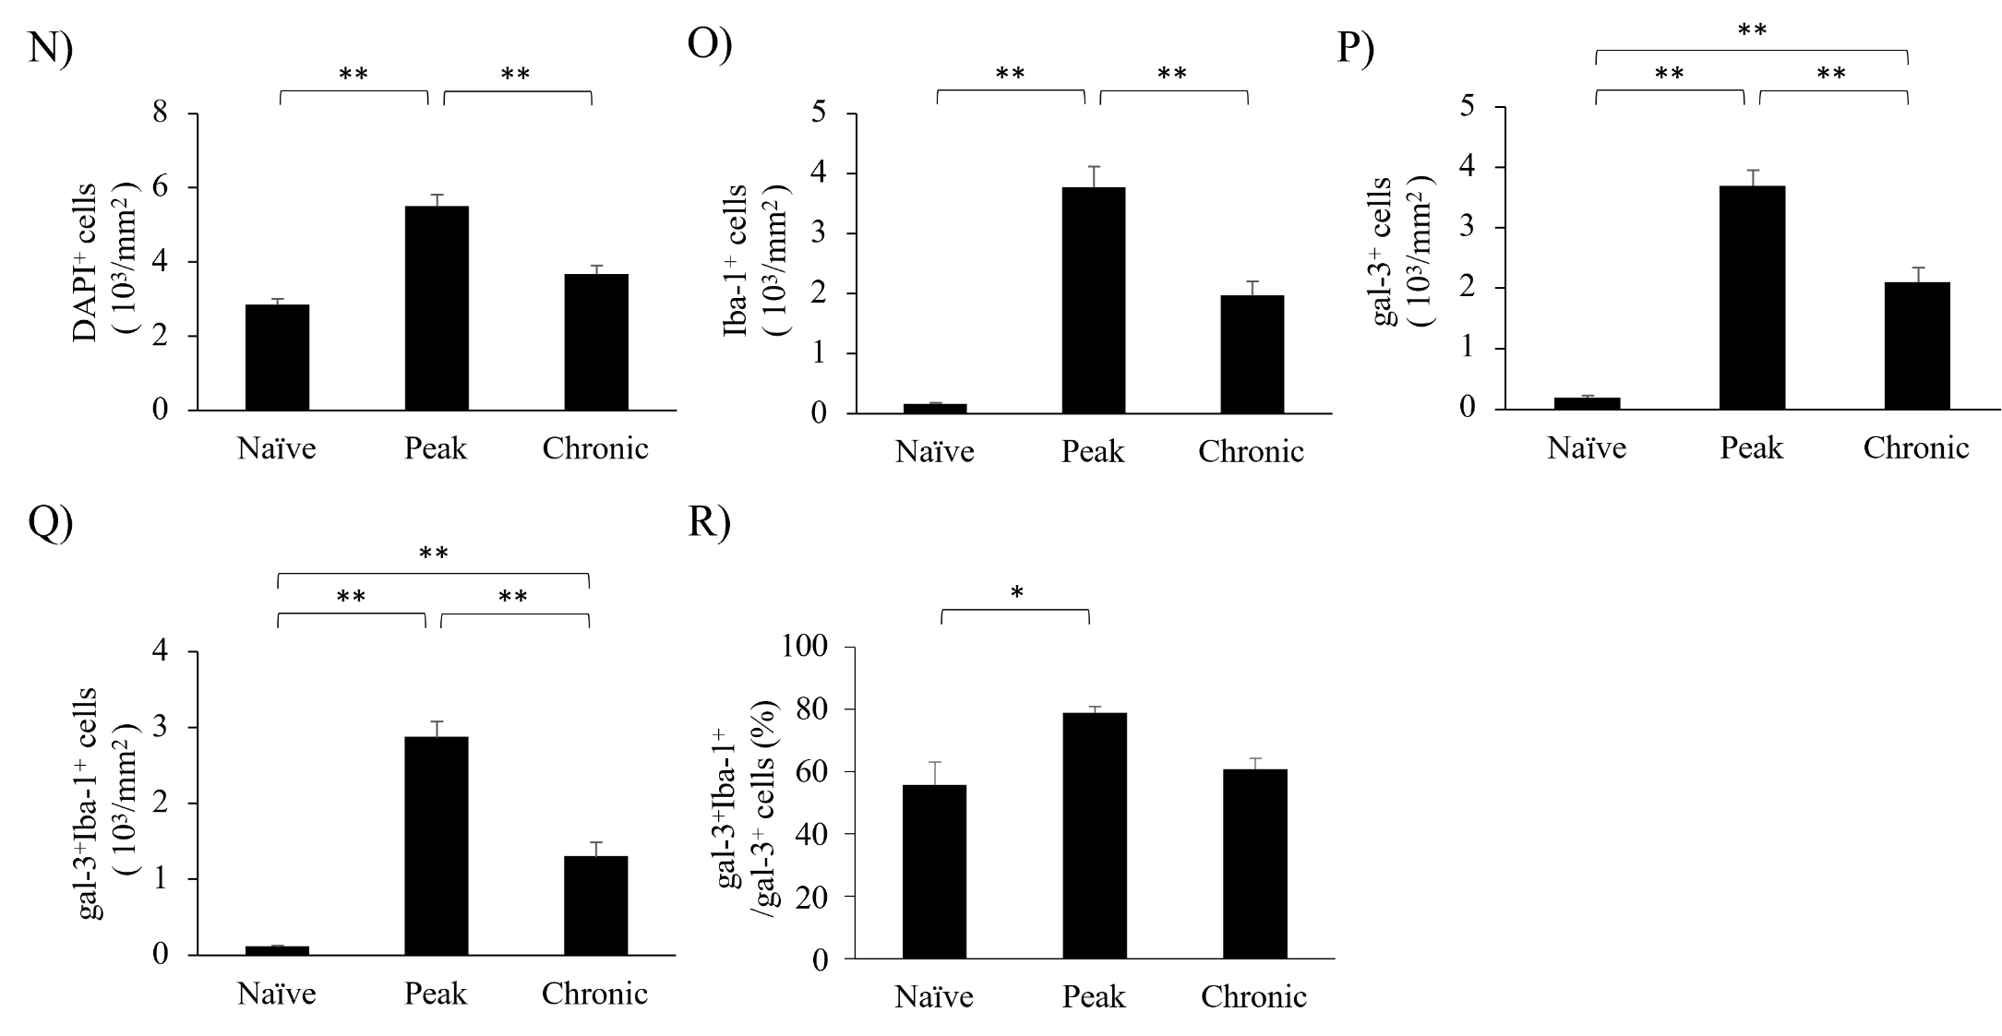
Figure S1. Expression of gal-3 in EAE optic chiasm. Naïve (A-D) and EAE mice were perfused at either the peak disease (E-I) or the chronic phase (J-M) after MOG immunization and optic nerve to optic tract with brain was taken out. Frozen sections were stained with anti-Iba-1 antibody (A, E, J, green) and anti-gal-3 antibody (B, F, K, red). DAPI staining (blue) was also performed. Merged images are also shown (C, D, G, H, I, L, M). Images with high-power magnification of each panel (C, G, L, inset) are shown, respectively (D, H, M). A High-power magnification of panel H (inset) is also shown in panel I. (N-R) Quantitative analysis were shown. The numbers of DAPI⁺ cells (N), Iba-1⁺ cells (O), gal-3⁺ cells (P), gal-3⁺Iba-1⁺ cells (Q), and gal-3⁺Iba-1⁺ cells/gal-3⁺ cells (R) in optic chiasm of naïve and EAE mice were shown. Six mice per group were examined. Scale bars: C, G, L: 100 μm, D, H, M: 50 μm, I: 25 μm. *p<0.05, **p<0.01 are shown.

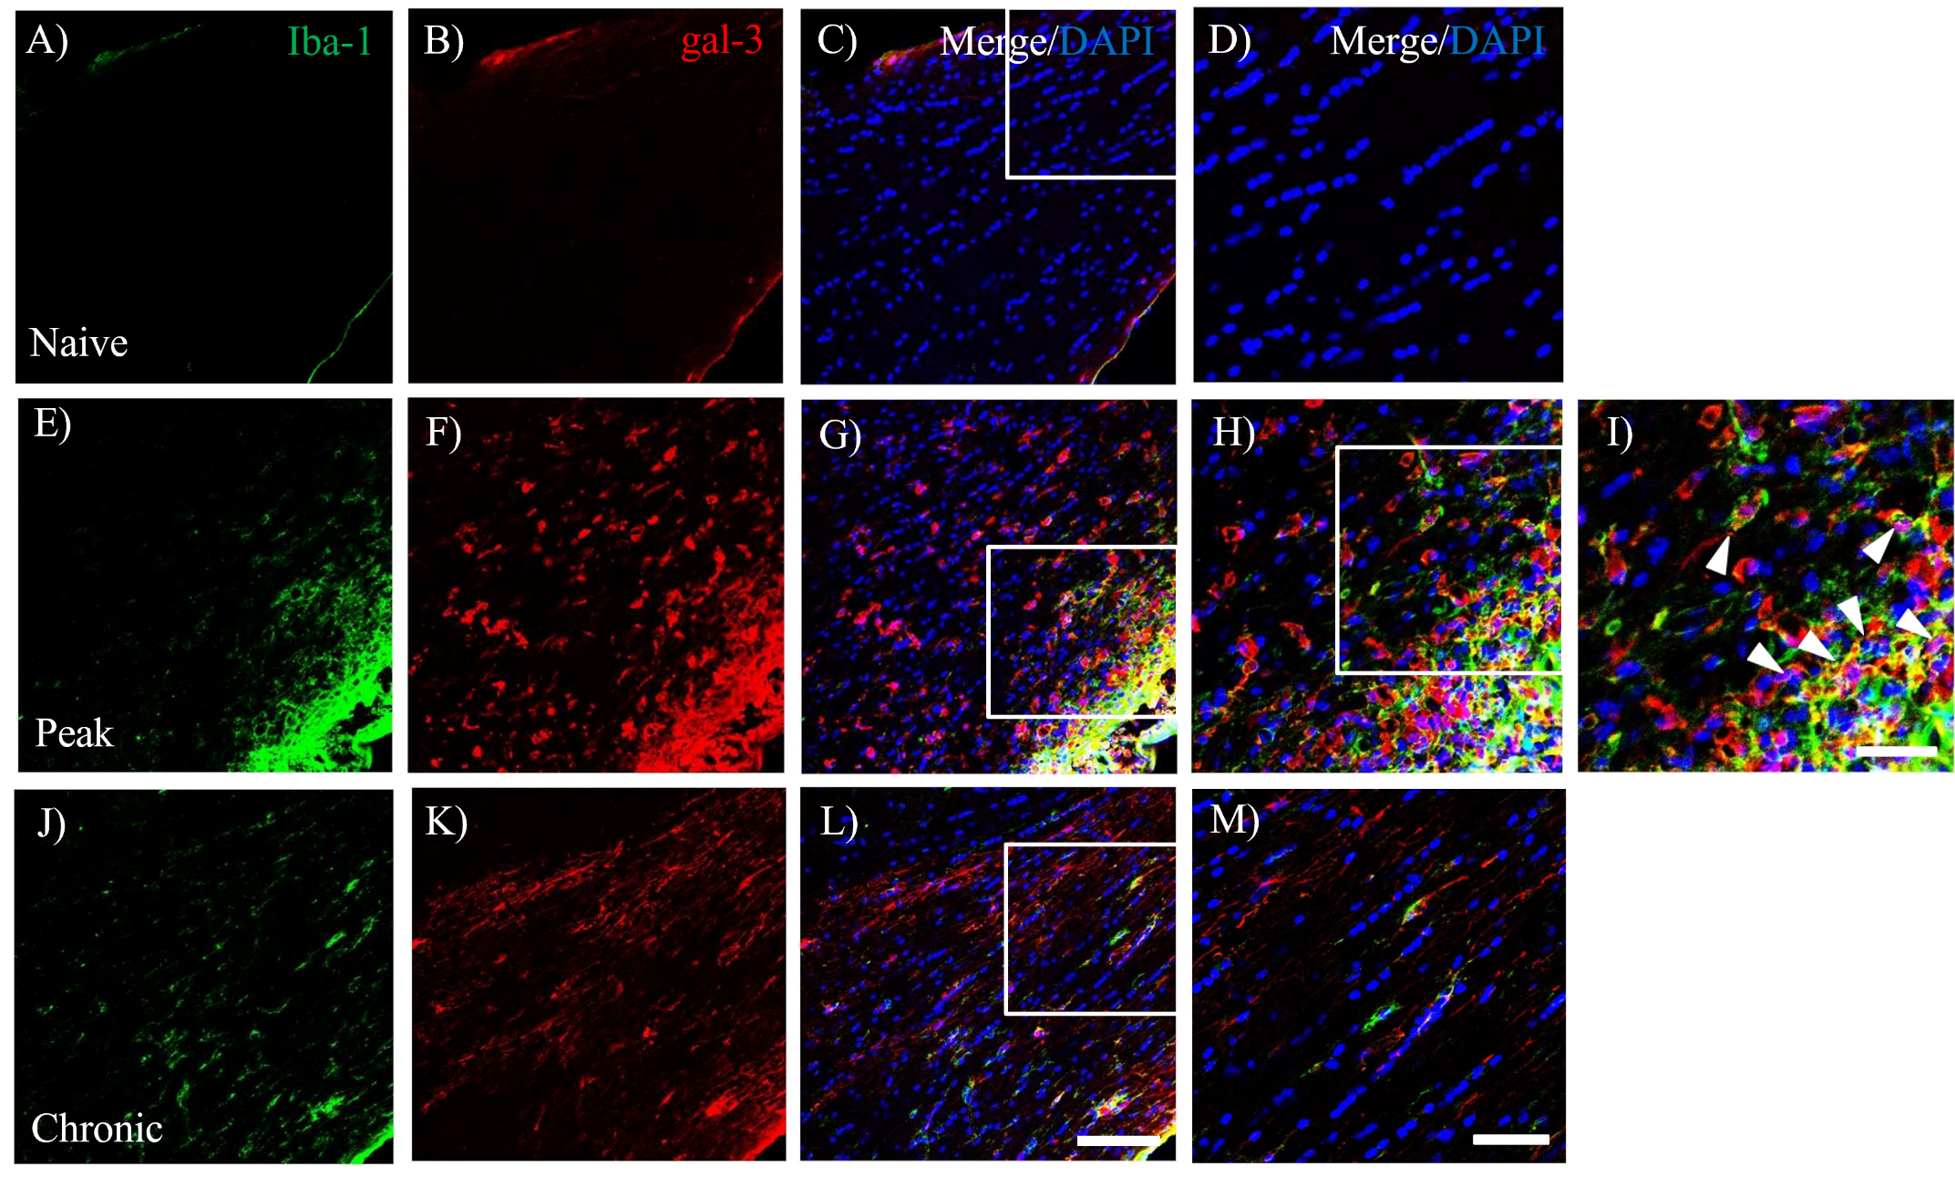
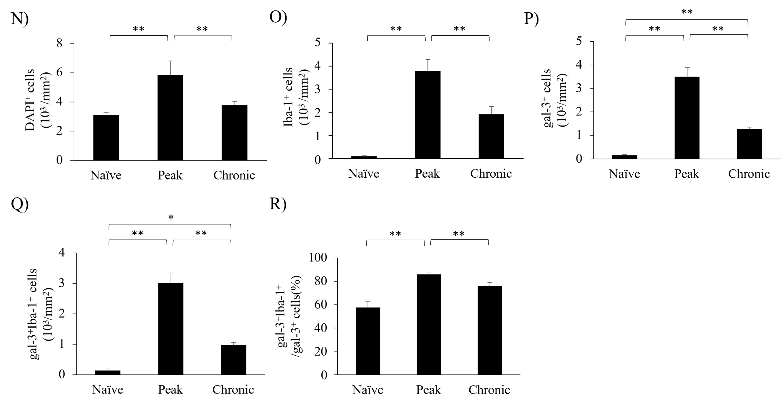
Figure.S2 Expression of gal-3 in EAE optic tract. Naïve (A-D) and EAE mice were perfused at either the peak disease (E-I) or the chronic phase (J-M) after MOG immunization and optic nerve to optic tract with brain was taken out. Frozen sections were stained with anti-Iba-1 antibody (A, E, J, green) and anti-gal-3 antibody (B, F, K, red). DAPI staining (blue) was also performed. Merged images are also shown (C, D, G, H, I, L, M). Images with high-power magnification of each panel (C, G, L, inset) are shown, respectively (D, H, M). A High-power magnification of panel H (inset) is also shown in panel I. (N-R) Quantitative analysis were shown. The numbers of DAPI⁺ cells (N), Iba-1⁺ cells (O), gal-3⁺ cells (P), gal-3⁺Iba-1⁺ cells (Q), and gal-3⁺Iba-1⁺ cells/gal-3⁺ cells (R) in optic tract of naïve and EAE mice were shown. Six mice per group were examined. Scale bars: C, G, L: 100 μm, D, H, M: 50 μm, I: 25 μm. *p<0.05, **p<0.01 are shown.

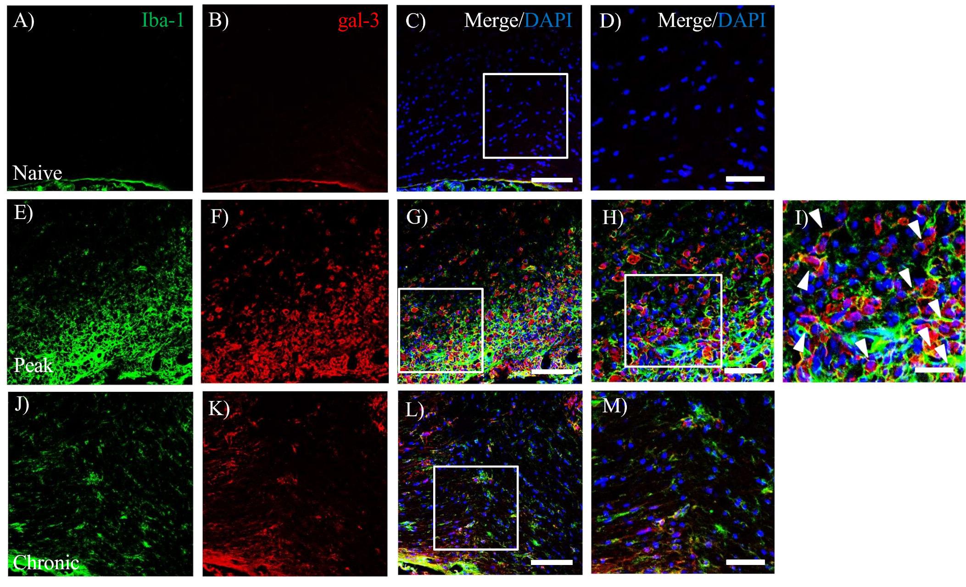
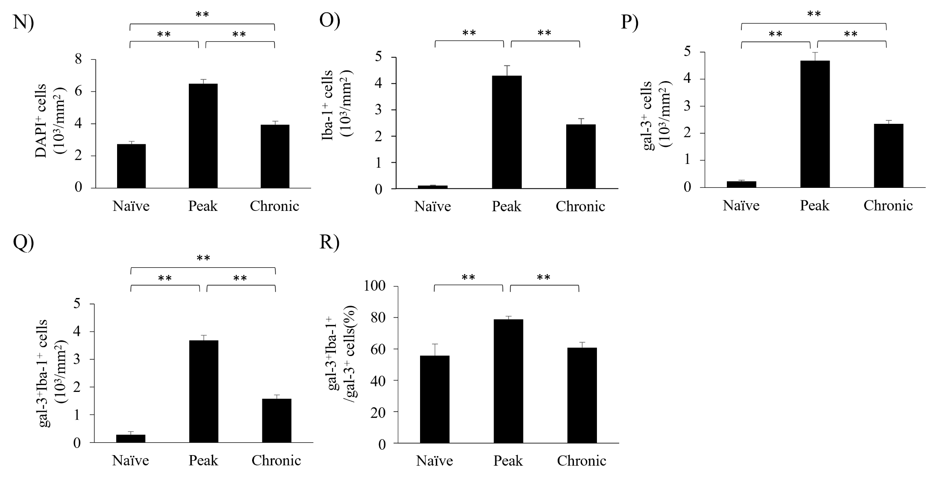
Figure. S3

