Article
Predictive model for occurrence of febrile neutropenia after chemotherapy in patients with diffuse large B-cell lymphoma: a multicenter, retrospective, observational study

Supplementary Material
Table S1. Univariate analysis of factors associated with febrile neutropenia incidence during any cycle for patients treated with R-CHOP-like regimen
 | Developed FN  during any cycle | Did not develop FN  during any cycle | p-value
 | n = 64 | n = 130
Age ≥ 65 years | 47 (73%) | 91 (70%) | 0.62
Sex: male | 38 (59%) | 71 (55%) | 0.53
Comorbidity
Diabetes | 10 (16%) | 22 (17%) | 0.82
Chronic kidney disease | 5 (8%) | 5 (4%) | 0.24
Cardiac disease | 12 (19%) | 21 (16%) | 0.65
Pulmonary disease | 2 (3%) | 2 (2%) | 0.46
Malignancy | 8 (12%) | 16 (12%) | 0.97
Baseline laboratory data
WBC < 3.5 × 10⁹ /L | 7 (11%) | 15 (12%) | 0.9
Hemoglobin < 12.0 g/dL | 33 (52%) | 59 (45%) | 0.42
Platelet < 100 × 10⁹ /L | 14 (22%) | 10 (8%) | 0.005
ANC < 1.5 × 10⁹ /L | 2 (3%) | 6 (5%) | 0.62
ALC < 0.7 × 10⁹ /L | 24 (38%) | 18 (14%) | < 0.001
T-Bil > 1.0 g/dL | 9 (14%) | 18 (15%) | 0.92
Albumin < 3.5 g/dL | 36 (58%) | 35 (27%) | < 0.001
LD > 222 IU/L | 43 (68%) | 66 (51%) | 0.025
CRP > 10 mg/dL | 5 (8%) | 5 (4%) | 0.29
eGFR < 60  mL/min/1.73 m² | 22 (34%) | 30 (23%) | 0.095
sIL2R > 2000 U/mL | 37 (58%) | 35 (27%) | < 0.001
Ann Arbor stage:  Advanced (III–IV) | 49 (78%) | 59 (45%) | < 0.001
Extranodal involvement | 41 (64%) | 61 (47%) | 0.025
Bone marrow infiltration | 16 (25%) | 14 (11%) | 0.01
Viral hepatitis status
Viral hepatitis | 18 (28%) | 22 (17%) | 0.07
HCV | 9 (14%) | 4 (3%) | 0.004
HBV | 13 (20%) | 20 (15%) | 0.39
HBsAg + | 1 (2%) | 2 (2%) | 0.99
anti-HBs + | 7 (11%) | 14 (11%) | 0.97
anti-HBc + | 13 (20%) | 15 (12%) | 0.1
Abbreviations:
ALC, absolute lymphocyte count; ANC, absolute neutrophil count; anti-HBc, hepatitis B core antibody; anti-HBs, hepatitis B surface antibody; CRP, C-reactive protein; eGFR, estimated glomerular filtration rate; FN, febrile neutropenia; HBsAg, hepatitis B surface antigen; HBV, hepatitis B virus; HCV, hepatitis C virus; LD, lactate dehydrogenase; R-CHOP, cyclophosphamide, doxorubicin, vincristine, and prednisone with added rituximab; sIL2R, soluble interleukin-2 receptor; T-Bil, total bilirubin; WBC, white blood cell

Table S2. Univariate analysis of factors associated with febrile neutropenia incidence during the first cycle among patients in the salvage therapy group
 | Developed FN  during the first therapy cycle | Did not develop FN  during the first therapy cycle | p-value
 | n = 9 | n = 43
Age ≥ 65 years | 7 (78%) | 29 (67%) | 0.54
Sex: male | 8 (89%) | 29 (67%) | 0.2
Comorbidity
Diabetes | 1 (11%) | 3 (7%) | 0.67
Chronic kidney disease | 0 (0%) | 4 (9%) | 0.34
Cardiac disease | 1 (11%) | 4 (9%) | 0.87
Pulmonary disease | 0 (0%) | 1 (2%) | 0.64
Malignancy | 2 (22%) | 5 (12%) | 0.4
Baseline laboratory data
WBC < 3.5 × 10⁹ /L | 1 (11%) | 6 (14%) | 0.82
Hemoglobin < 12.0 g/dL | 3 (33%) | 19 (44%) | 0.55
Platelet < 100 × 10⁹ /L | 2 (22%) | 6 (14%) | 0.53
ANC < 1.5 × 10⁹ /L | 1 (11%) | 0 (0%) | 0.027
ALC < 0.7 × 10⁹ /L | 3 (33%) | 9 (21%) | 0.42
T-Bil > 1.0 g/dL | 0 (0%) | 8 (20%) | 0.17
Albumin < 3.5 g/dL | 6 (67%) | 10 (24%) | 0.012
LD > 222 IU/L | 7 (78%) | 31 (72%) | 0.73
CRP > 10 mg/dL | 1 (12%) | 2 (5%) | 0.41
eGFR < 60  mL/min/1.73 m² | 2 (22%) | 7 (16%) | 0.67
sIL2R > 2000 U/mL | 7 (78%) | 18 (42%) | 0.05
Ann Arbor stage:  Advanced (III–IV) | 9 (100%) | 35 (81%) | 0.16
Extranodal involvement | 8 (89%) | 30 (70%) | 0.24
Bone marrow infiltration | 2 (22%) | 12 (28%) | 0.73
Viral hepatitis status
Viral hepatitis | 4 (44%) | 6 (14%) | 0.035
HCV | 4 (44%) | 6 (14%) | 0.035
HBV | 1 (11%) | 1 (2%) | 0.21
HBsAg + | 0 (0%) | 2 (5%) | 0.51
anti-HBs + | 2 (22%) | 4 (9%) | 0.27
anti-HBc + | 3 (33%) | 3 (7%) | 0.024
Abbreviations:
ALC, absolute lymphocyte count; ANC, absolute neutrophil count; anti-HBc, hepatitis B core antibody; anti-HBs, hepatitis B surface antibody; CRP, C-reactive protein; eGFR, estimated glomerular filtration rate; FN, febrile neutropenia; HBsAg, hepatitis B surface antigen; HBV, hepatitis B virus; HCV, hepatitis C virus; LD, lactate dehydrogenase; sIL2R, soluble interleukin-2 receptor; T-Bil, total bilirubin; WBC, white blood cell
Table S3. Univariate analysis of factors associated with febrile neutropenia incidence during any cycle among patients in the salvage therapy group
 | Developed FN  during any cycle | Did not develop FN  during any cycle | p-value
 | n = 36 | n = 16
Age ≥ 65 years | 25 (69%) | 11 (69%) | 0.96
Sex: male | 27 (75%) | 10 (62%) | 0.36
Comorbidity
Diabetes | 2 (6%) | 2 (12%) | 0.39
Chronic kidney disease | 4 (11%) | 0 (0%) | 0.17
Cardiac disease | 4 (11%) | 1 (6%) | 0.58
Pulmonary disease | 0 (0%) | 1 (6%) | 0.13
Malignancy | 5 (14%) | 2 (12%) | 0.89
Baseline laboratory data
WBC < 3.5 × 10⁹ /L | 7 (19%) | 0 (0%) | 0.058
Hemoglobin < 12.0 g/dL | 16 (44%) | 6 (38%) | 0.64
Platelet < 100 × 10⁹ /L | 7 (19%) | 1 (6%) | 0.22
ANC < 1.5 × 10⁹ /L | 1 (3%) | 0 (0%) | 0.5
ALC < 0.7 × 10⁹ /L | 11 (31%) | 1 (6%) | 0.055
T-Bil > 1.0 g/dL | 6 (18%) | 2 (12%) | 0.61
Albumin < 3.5 g/dL | 12 (34%) | 4 (25%) | 0.51
LD > 222 IU/L | 27 (75%) | 11 (69%) | 0.64
CRP > 10 mg/dL | 3 (9%) | 0 (0%) | 0.24
eGFR < 60  mL/min/1.73 m² | 7 (19%) | 2 (12%) | 0.54
sIL2R > 2000 IU/L | 21 (58%) | 4 (25%) | 0.026
Ann Arbor stage:  Advanced (III–IV) | 30 (83%) | 14 (88%) | 0.7
Extranodal involvement | 26 (72%) | 12 (75%) | 0.83
Bone marrow infiltration | 11 (31%) | 3 (19%) | 0.38
Viral hepatitis status
Viral hepatitis | 7 (19%) | 3 (19%) | 0.95
HCV | 7 (19%) | 3 (19%) | 0.95
HBV | 2 (6%) | 0 (0%) | 0.34
HBsAg + | 0 (0%) | 2 (12%) | 0.031
anti-HBs + | 5 (14%) | 1 (6%) | 0.43
anti-HBc + | 5 (14%) | 1 (6%) | 0.43
Abbreviations:
ALC, absolute lymphocyte count; ANC, absolute neutrophil count; anti-HBc, hepatitis B core antibody; anti-HBs, hepatitis B surface antibody; CRP, C-reactive protein; eGFR, estimated glomerular filtration rate; FN, febrile neutropenia; HBsAg, hepatitis B surface antigen; HBV, hepatitis B virus; HCV, hepatitis C virus; LD, lactate dehydrogenase; sIL2R, soluble interleukin-2 receptor; T-Bil, total bilirubin; WBC, white blood cell

Table S4. Multivariate logistic regression analysis of risk factors associated with febrile neutropenia incidence during any cycle among patients treated with the R-CHOP-like regimen
 |  |  |  | n = 191
 | Odds ratio [95% CI] | β coefficient [95% CI] | Score | p-value
ALC < 0.7 × 10⁹ /L | 2.61 [1.18–5.75] | 0.96 [0.17–1.75] | 1 | 0.018
Alb < 3.5 g/dL | 2.33 [1.16–4.67] | 0.85 [0.15–1.54] | 1 | 0.017
Ann Arbor stage:  Advanced (III–IV) | 3.32 [1.60–6.89] | 1.20 [0.47–1.93] | 1 | 0.001
Abbreviation: Alb, albumin; ALC, absolute lymphocyte count; CI, confidence interval; R-CHOP, cyclophosphamide, doxorubicin, vincristine, and prednisone with added rituximab

Table S5. Bootstrap validation of the predictive model for febrile neutropenia occurrence during any cycle among patients treated with the R-CHOP-like regimen and comparison with the original model
 |  |  | n = 191
 | Logistic regression  β coefficient [95% CI] | Bootstrapped  β coefficient [95% CI] | Score
ALC < 0.7 × 10⁹ /L | 0.96 [0.17–1.75] | 0.98 [0.12–1.79] | 1
Alb < 3.5 g/dL | 0.85 [0.15–1.54] | 0.88 [0.15–1.54] | 1
Ann Arbor stage:  Advanced (III–IV) | 1.20 [0.47–1.93] | 1.21 [0.44–1.97] | 1
Abbreviation: Alb, albumin; ALC, absolute lymphocyte count; CI, confidence interval; R-CHOP, cyclophosphamide, doxorubicin, vincristine, and prednisone with added rituximab

Table S6. Multivariate logistic regression of risk factors associated with febrile neutropenia incidence during the first cycle of chemotherapy among patients treated with the R-CHOP-like regimen, with a more detailed evaluation of the viral hepatitis status
 |  |  | n = 191
 | Odds ratio [95% CI] | β coefficient [95% CI] | p-value
ALC < 0.7 × 10⁹ /L | 6.04 [2.39–15.23] | 1.80 [0.87–2.72] | <0.001
sIL2R > 2000 U/mL | 3.03 [1.19–7.70] | 1.11 [0.17–2.04] | 0.020
Extranodal involvement | 3.05 [1.08–8.57] | 1.11 [0.08–2.15] | 0.035
HCV | 5.26 [1.28–21.69] | 1.66 [0.24–3.08] | 0.022
anti-HBc + | 3.11 [1.00–9.68] | 1.13 [-0.001–2.27] | 0.050
Abbreviations: ALC, absolute lymphocyte count; anti-HBc, hepatitis B core antibody; HCV, hepatitis C virus; CI, confidence interval; R-CHOP, cyclophosphamide, doxorubicin, vincristine, and prednisone with added rituximab; sIL2R, soluble interleukin-2 receptor
Figure S1. Differences in FN incidence between patients who received G-CSF during the first cycle of R-CHOP-like therapy and those who did not. Abbreviations: FN, febrile neutropenia; G-CSF, granulocyte colony-stimulating factor; R-CHOP, cyclophosphamide, doxorubicin, vincristine, and prednisone with added rituximab

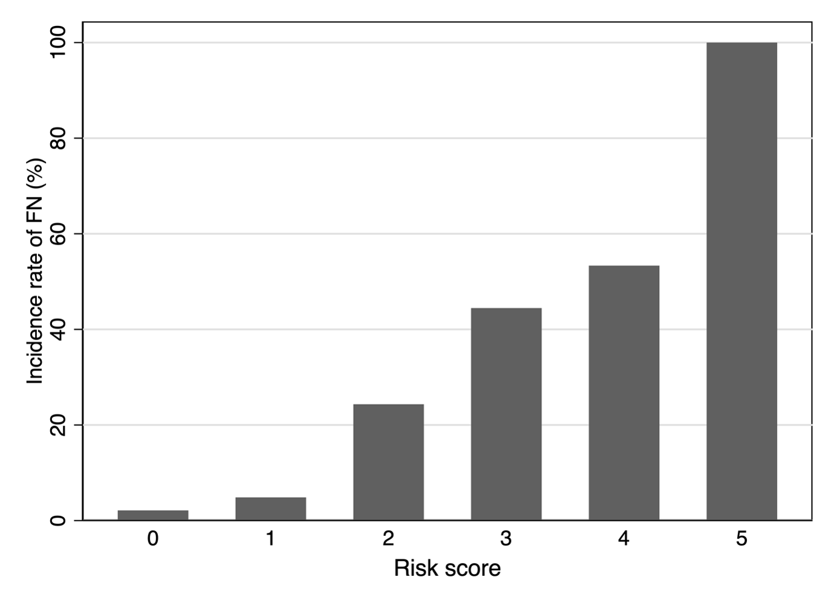
Figure S2. Incidence rate of FN during the first cycle of chemotherapy for patients treated with the R-CHOP-like regimen based on each prediction score. Abbreviations: FN, febrile neutropenia; R-CHOP, cyclophosphamide, doxorubicin, vincristine, and prednisone with added rituximab

