TMEM97/Sigma 2 Receptor Increases Estrogen Receptor α Activity in Promoting Breast Cancer Cell Growth
Yuanqin Zhang, Xiangwei Fang, Jiuhui Wang and Daotai Nie
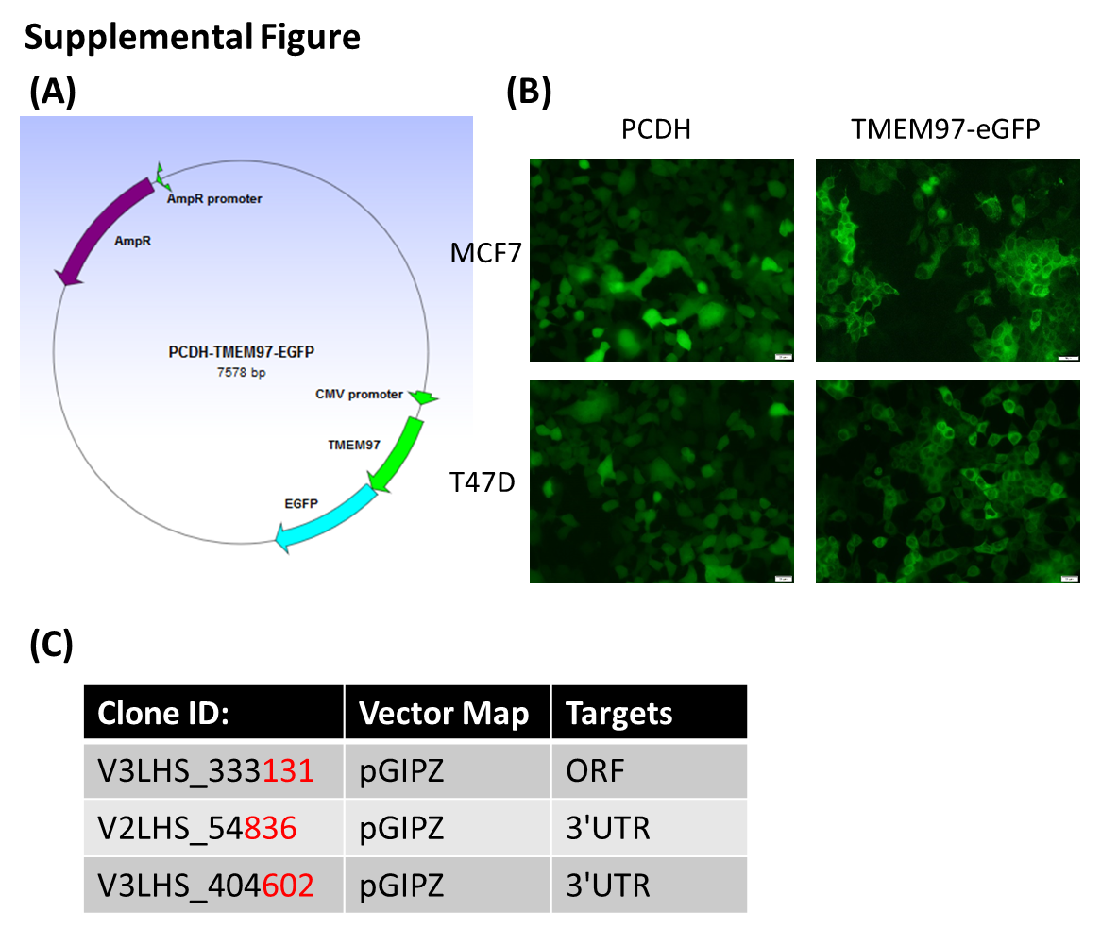
Supplemental Figure.
(A). The plasmid map of TMEM97-EGFP on PCDH-CMV vector to generate TMEM97 stable overexpression breast cancer cells.
(B). Visualization of TMEM97eGFP cells in MCF7 and T47D compared to vector control.
(C). Commercial modified miR-30 based GIPZ Lentiviral shRNA used for TMEM97 knockdown.
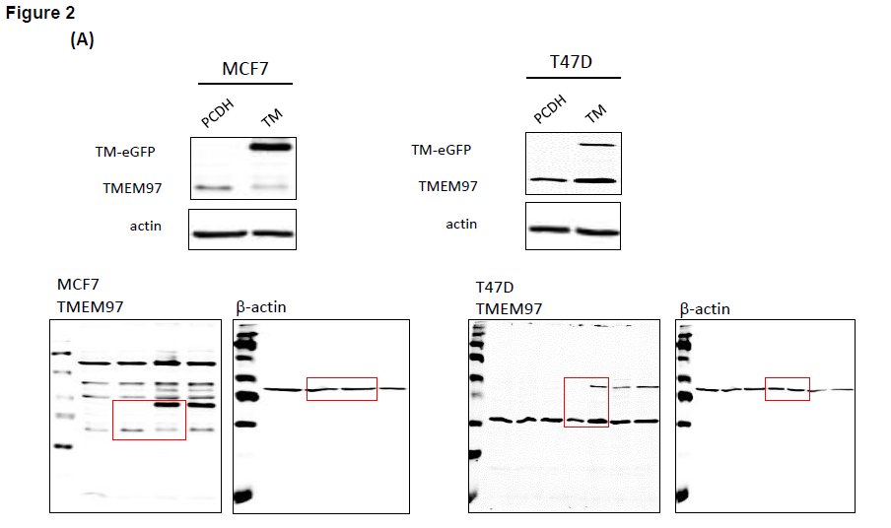
Original blots of Figure 2.
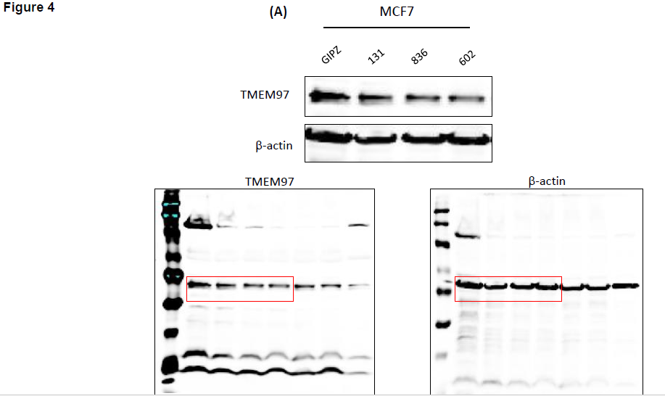
Original blots of Figure 4.

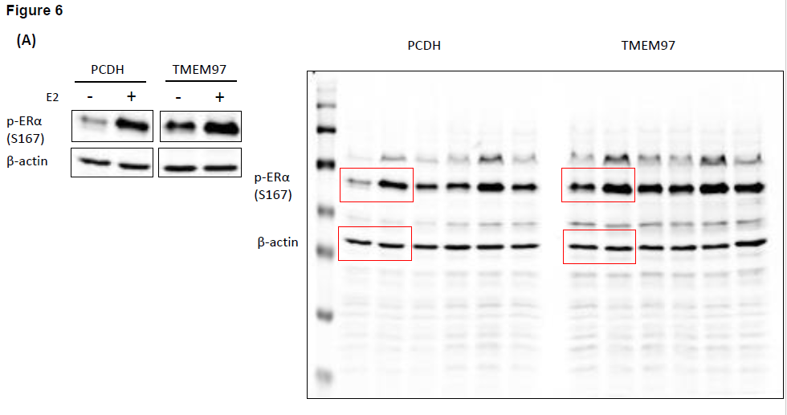
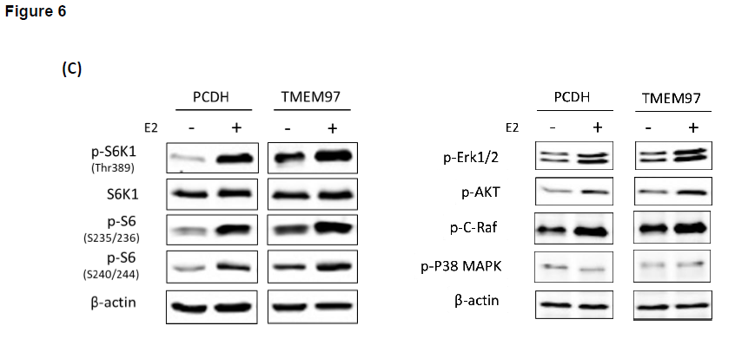
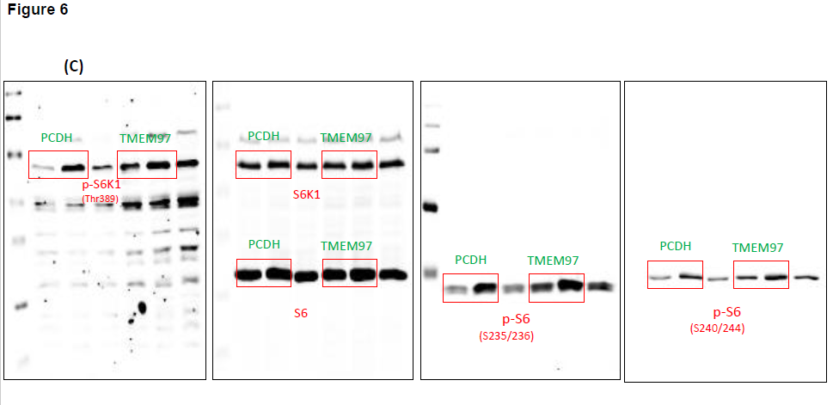
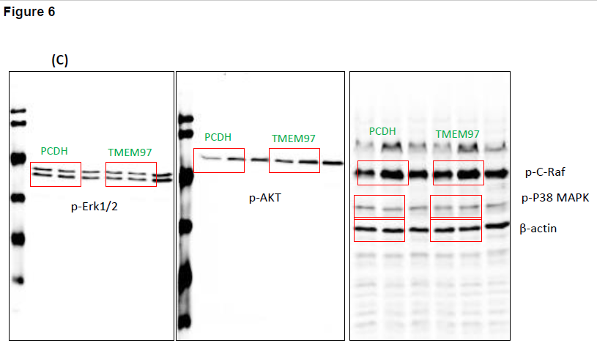
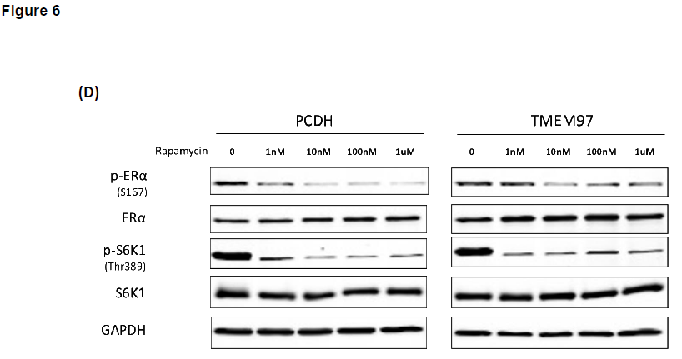
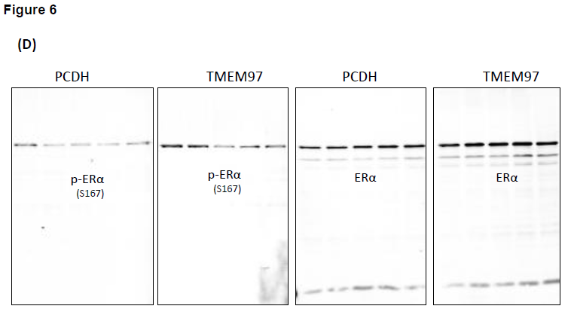
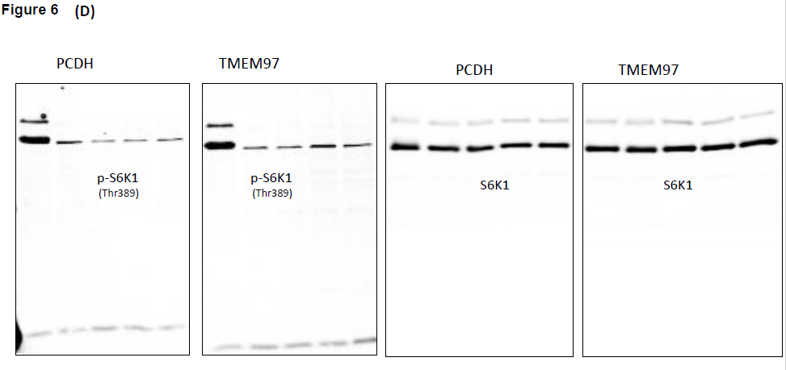
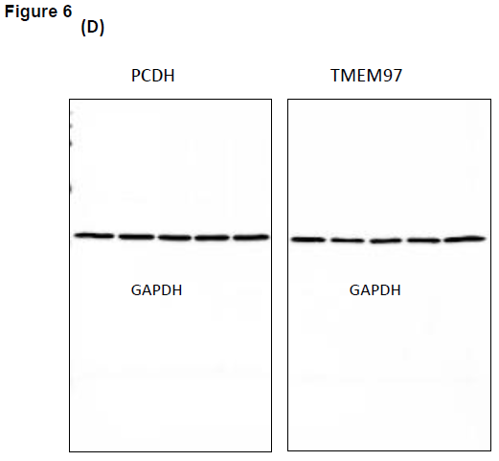
Original blots of Figure 6.

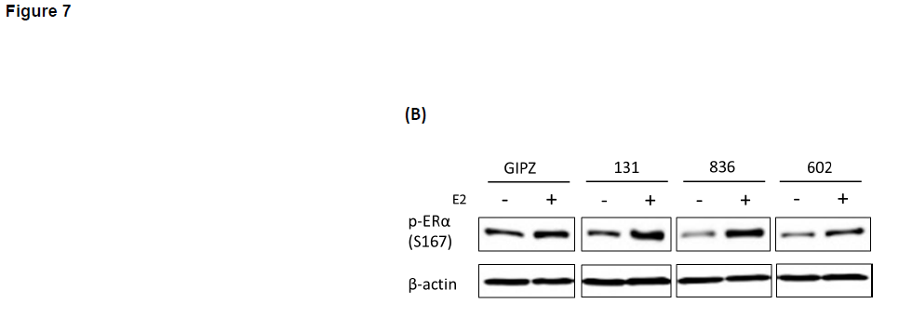
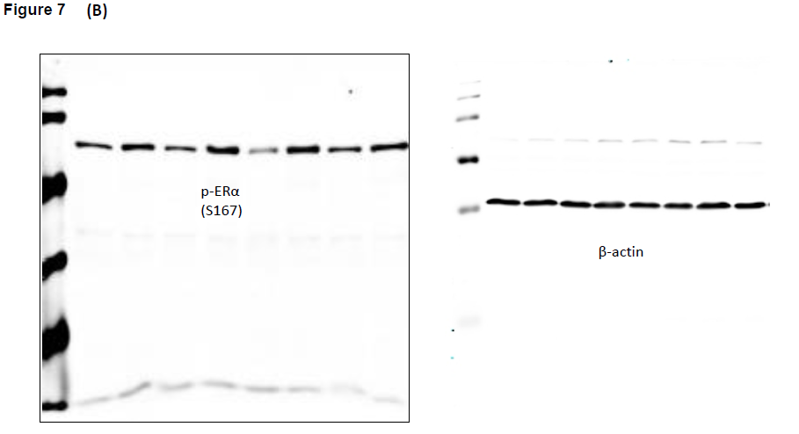
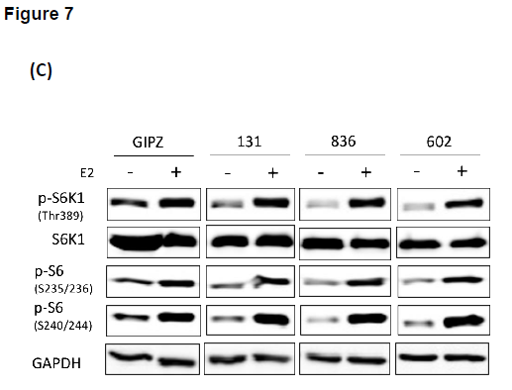
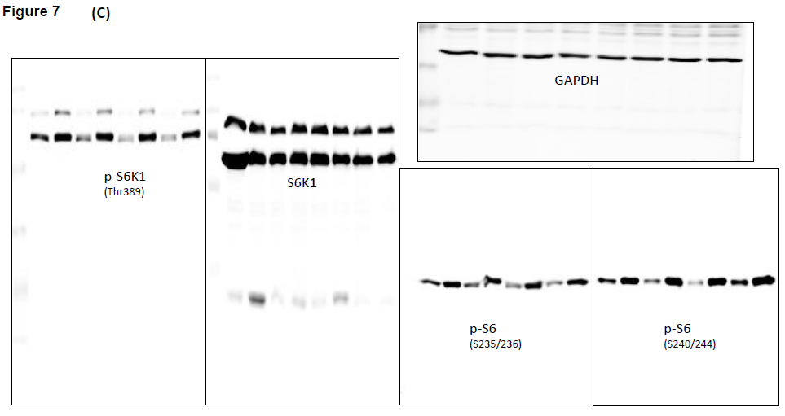
Original blots of Figure 7.

