Supplementary information

Supplementary Table 1: Cohort characteristics

Cohort | n | Female (n) | Age (median) | Age (min) | Age (max) | Days since last vacc./inf. (median) | Days since last vacc./inf. (min) | Days since last vacc./inf. (max)
2 x Vacc.-monov. | 11 | 9 | 40 | 20 | 81 | 20 | 15 | 34
3 x Vacc.-monov. | 14 | 11 | 46 | 27 | 64 | 28 | 15 | 40
4 x Vacc.-biv. (BA.1/WT) | 9 | 4 | 52 | 38 | 62 | 21 | 20 | 28
4 x Vacc.-biv. (BA.5/WT) | 13 | 8 | 50 | 32 | 57 | 21 | 21 | 30
WT infection | 18 | 4 | 48 | 22 | 77 | 20 | 11 | 25
Prepandemic control | 30 | 15 | 23 | 19 | 55 | / | / | /

Age in years. Days since last vacc./inf.: Days since last vaccination (vaccinated cohorts) or infection (WT infection cohort). /: not applicable. Vacc, vaccinated; WT, wild-type.
Supplementary Table 2: Vaccination history
Cohort | Vaccination history | n
2 x Vacc.-monov. | P + P | 10
 | P + P | 1
3 x Vacc.-monov. | P + P + P | 11
 | P + P + M | 3
4 x Vacc.-biv. (BA.1/WT) | P + P + P + P-BA.1 | 8
 | AZ + AZ + P + P-BA.1 | 1
4 x Vacc.-biv. (BA.5/WT) | P + P + P + P-BA.5 | 9
 | J + P + P + P-BA.5 | 3
 | AZ + AZ + P + P-BA.5 | 1
WT infection | not vaccinated | 18
Prepandemic control | not vaccinated | 30

AZ: Astra-Zeneca “Vaxzevria” ChAdOx1; P: Monovalent Biontech/Pfizer “Comirnaty” BNT162b2; P-BA.1: Biontech/Pfizer Bivalent (WT/BA.1) BNT162b2 BA.1; P-BA.5: Biontech/Pfizer Bivalent (WT/BA.5) BNT162b2 BA.5, M: Moderna “Spikevax” mRNA-1273. n: number of individuals.

Supplementary Table 3: sVNT cutoff values obtained by ROC and Youden’s Index
 | Cutoff value | Sensitivity | Specificity
WT | 26 | >99 % | >99 %
Delta | 43 | >99 % | >99 %
BA.1 | 24 | 92 % | 78 %
BA.2 | 9 | 91 % | 87 %
BA.5 | 28 | 88 % | 92 %

Supplementary Table 4: Regression coefficients
 | β | intercept
WT | 1.24 | -2.07
Delta | 0.98 | -0.35
BA.1 | 1.35 | -1.59
BA.2 | 1.32 | -0.25
BA.5 | 1.00 | -0.65
Linear regression coefficients for all tested variants. p < 0.05 for all coefficients.
Supplementary Table 5: Cohort-wise-comparisons of variant/WT ratios (Wilcoxon test)
Ratio | Cohort | WT infection | 2 x Vacc.-monov. | 3 x Vacc.-monov. | 4 x Vacc.-biv. (BA.1/WT)
Delta/WT | 2 x Vacc.-monov. | n.s.
 | 3 x Vacc.-monov. | ** | **
 | 4 x Vacc.-biv. (BA.1/WT) | ** | ** | n.s.
 | 4 x Vacc.-biv. (BA.5/WT) | ** | ** | n.s. | n.s.
BA.1/WT | 2 x Vacc.-monov. | **
 | 3 x Vacc.-monov. | n.s. | n.s.
 | 4 x Vacc.-biv. (BA.1/WT) | n.s. | *** | *
 | 4 x Vacc.-biv. (BA.5/WT) | * | **** | ** | n.s.
BA.2/WT | 2 x Vacc.-monov. | n.s.
 | 3 x Vacc.-monov. | *** | ****
 | 4 x Vacc.-biv. (BA.1/WT) | **** | **** | n.s.
 | 4 x Vacc.-biv. (BA.5/WT) | **** | **** | n.s. | n.s.
BA.5/WT | 2 x Vacc.-monov. | n.s.
 | 3 x Vacc.-monov. | n.s. | n.s.
 | 4 x Vacc.-biv. (BA.1/WT) | n.s. | n.s. | n.s.
 | 4 x Vacc.-biv. (BA.5/WT) | *** | *** | ** | n.s.

**** p < 0.0001, *** p < 0.001, ** p < 0.01, * p < 0.05, n.s.: not significant (p > 0.05) in pairwise Wilcoxon signed rank tests comparing the variant / WT ratios between cohorts for each variant (multiplicity adjusted using Bonferroni-Holm within each group).

Supplementary Figure 1: Schematic overview of the sVNT result calculation

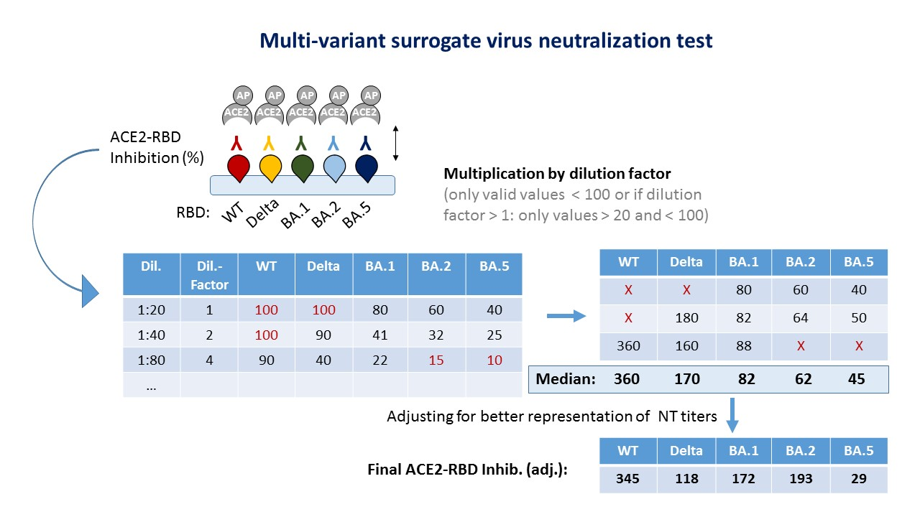
ACE2-RBD inhibition was obtained by measuring the binding of ACE2-AP to recombinant variant RBDs in the presence of serum-neutralizing antibodies relative to the control well (without serum). A value of 100 indicated total inhibition (i.e., no binding and no color reaction). This assessment was repeated at serial two-fold dilutions of 1:20 up to 1:360 for each serum and up to 1:2560 in some cases. Next, all valid values (i.e., not oversaturated (= 100) were corrected for the dilution relative to 1:20 (i.e., multiplication by the dilution factor relative to 1:20). Then, the median of all valid values was calculated for each variant. Finally, the correlation to live-virus NT titers was calculated, and the linear regression coefficients were used as adjustment factors for sVNT values(Supplementary Figure 2).

Supplementary Figure 2: Correlation and neutralization profiles after adjustment for variant-specific differences between sVNT and NT values.
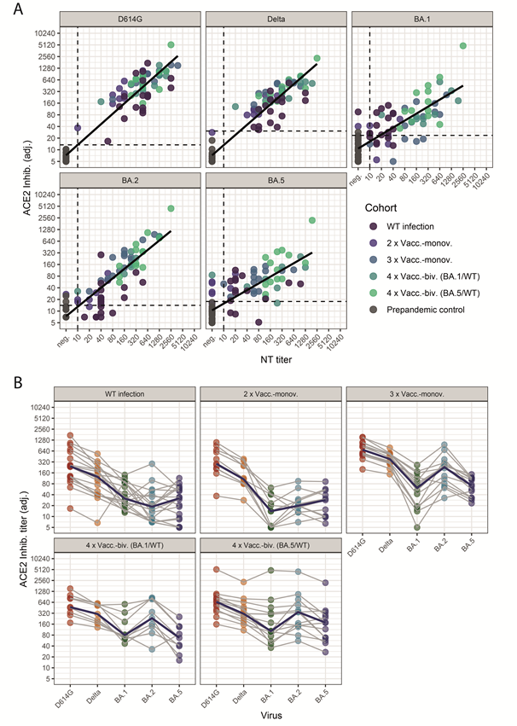
The figure corresponds to Figure 1 after adjustment (adj.) of the sVNT values using linear regression models to improve the comparison with live-virus NT titers .The adjusted sVNT values were obtained with coefficients from regression models (Supplementary Table 4 and Supplementary Figure 1. By applying these adjustment factors, the adjusted sVNT neutralization profiles were more similar to live virus NT profiles for future studies by accounting for differences in sensitivity between the RBD variants contained within the sVNT. See also legend to Figure 1..

