Table S1. General electrical characteristics of SPC from the n=24 whole-cell patch-clamp experiments and applied pharmacological compounds
Exp. no. | Cm (pF) | Rm (GOhms) | Ra (MOhms) | Tau (µs) | Hold (pA) | Pipette sol | Comp1. | Comp2. | Comp3. | Comp4. | Comp5.
19812 | 18.56668 | 5.082514 | 9.910785 | 183.636 | 0.087193 | efficient
a9812 | 53.65738 | 0.238585 | 9.236898 | 477.148 | -1.75839 | efficient
b9812 | 102.5927 | 0 | 19.3656 | 1566.091 | -1.75355 | efficient | isoprenaline 1uM (sw.4-6)
19813 | 19.98872 | 3.439259 | 18.31221 | 363.8603 | 7.706899 | efficient
a9813 | 22.22567 | 0.02929 | 12.1516 | 268.8575 | 127.7693 | efficient
b9813 | 89.67826 | 3.774866 | 37.55514 | 3333.431 | -1.79472 | efficient | phrixotoxin-1 280 nM (b9813006-007) | isoprenaline 1 uM (b9813008) | b9813010 sw.1-3 isopren.1uM; sw.4-10CTRL; sw.11-18 phrixotoxin1-280nM; sw.19-22 CTRL
19814 | 13.26327 | 9.414673 | 8.058297 | 106.7609 | 1.019675 | efficient+B-escin30uM | DIDS 100 uM | isoprenaline 1 uM
a9814 | 10.03194 | 0.738725 | 50.90118 | 477.5226 | -9.08988 | efficient+B-escin30uM
b9814 | 47.59146 | 5.126311 | 6.271327 | 298.0778 | -3.70571 | efficient+B-escin30uM | DIDS 100 uM (b9814006) | isoprenaline 1 uM (b9814006)
19815 | 46.72194 | 0.337481 | 16.20167 | 721.9554 | -171.623 | efficient+B-escin30uM
a9815 | 12.20971 | 5.351932 | 5.313883 | 64.80184 | -5.46168 | efficient+B-escin30uM
b9815 | 14.25296 | 1.038694 | 8.21407 | 116.1505 | -40.4552 | efficient+B-escin30uM | iberiotoxin 100 nM (b9815001 sw.4-12) | isoprenaline 1 uM (b9815003-005)
19821 | 28.66045 | 5.8211 | 5.259459 | 150.5858 | 1.295786 | efficient | nifedipine 1uM (19821004-005) | mibefradil 5 uM (19821006-007;008)
a9821 | 23.03082 | 4.831777 | 15.7046 | 360.4406 | -1.82137 | efficient | nifedipine 1uM | mibefradil 5 uM
b9821 | 29.08172 | 0.119746 | 9.406697 | 253.6306 | -72.4284 | efficient | nifedipine 1uM (b9821004-006) | mibefradil 5 uM (b9821007-009)
19822 | 19.73436 | 2.712283 | 22.58532 | 441.4361 | -14.5855 | efficient | NaCN 5 mM (19822006 sw.7-12) | glibenclamide 100 uM (19822006 sw.13-18) | DIDS 100 uM (19822006 sw.19-20)
a9822 | 37.59555 | 0.342509 | 9.341733 | 341.8629 | -18.2403 | efficient | NaCN 5 mM | glibenclamide 100 uM | DIDS 100 uM
b9822 | 33.23796 | 4.623733 | 4.336124 | 143.9814 | -0.51347 | efficient | NaCN 5 mM | glibenclamide 100 uM | DIDS 100 uM
19904 * | 27.61662 | 8.205615 | 13.25584 | 365.4303 | 1.261878 | efficient | NaCN 5 mM
a9904 * | 31.38796 | 3.23914 | 20.57461 | 641.6375 | -6.94638 | efficient |  |  |  | Nifedipine 1uM (a9904008) | Mibefradil 10uM (a9904009)
b9904 * | 27.96927 | 0.570465 | 7.877897 | 217.3263 | -2.26702 | efficient | NaCN 5 mM (b9904008-009)
19909 * | 38.3887 | 2.286035 | 16.83559 | 641.3249 | -6.49588 | efficient | NaCN 5 mM
a9909 * | 47.3762 | 5.394057 | 4.495904 | 212.7809 | -0.07266 | efficient | NaCN 5 mM
b9909 * | 43.96655 | 3.218766 | 8.215519 | 360.2402 | -1.26672 | efficient | NaCN 5 mM
Average | 34.95112 | 3.164065 | 14.14091 | 504.5404 | -9.214108517
SD | 22.58335 | 2.685901 | 10.86953 | 676.1914 | 47.30554816
* - SPC cultures pretreated with nifedipine 1 uM applied directly to the culture medium for 24-48 h

Table S2. Analysis of principal ionic current components recorded in SPC from the n = 24 whole-cell patch-clamp experiments
Exp. no. | I A current (pA) at +60 mV | tau at +60 mV (ms) | outward rectifier (pA) at +60 mV (average of last 100 ms) | BK-like current fluctuations at +60 mV |  | Na current |  | outward current at +80 mV (2.030-+0.07s) |  | inward rectifier | reversal potential (asc. ramp)
 |  |  |  | peak ampl (pA) | SD (last 250 ms) | peak ampl. (pA) | voltage step of peak | mean (pA) | SD (pA) | pA at -120 mV (base at -80 mV) | mV
19812 |  |  |  |  |  |  |  | 74.0487 | 7.64698 | -16.8 | -46.5
a9812 | 596.3 | 4.63876 | 240.166 | 36.3 | 8.79673 |  |  | 222.172272 | 8.810999 | -18.6 | -66.9
b9812 | 2469 | 6.88189 | 555.942 | 127.3 | 34.4758 |  |  | 854.371826 | 19.862598 | -42.1 | -94.9
19813 | 50.32 | 3.02378 | 15.88 | 43.8 | 7.45868 | -32.6 | 0 | 39.393467 | 13.509698 | -4.3 | -68.3
a9813
b9813 | 210.9 | 7.43316 | 77.791 | 35.1 | 8.60377
19814 | 391.5 | 13.9295 | 17.6061 | 29.3 | 5.34562 |  |  | 42.64294434 | 13.58994007 | -3.4 | -56.88
a9814
b9814 | - | - | 88.4995 | 113.2 | 31.539 |  |  | 339.7509155 | 57.75685883 | -5.5 | -53.28
19815 | - | - | 454.533 | 49.4 | 14.373
a9815 |  |  |  |  |  |  |  | 145.3754272 | 25.1792469 | - | -36.67
b9815 | 170.6 | 14.3085 | 6.18702 | 25.3 | 3.60635 |  |  | 289.8139038 | 48.3679924 | -17.1 | -26.98
19821 | - | - | 121.004 | 138.9 | 29.8054 |  |  | 323.9849243 | 59.25339127 | -41.5 | -37.5
a9821 | - | - | 45.0157 | 65.9 | 13.4368 |  |  | 86.2383194 | 19.70644379 | 1.2 | -72.2
b9821 | 510.6 | 26.4091 | 221.445 | 87.3 | 26.7935 |  |  | 451.7289429 | 36.21746063 | -90 | -42.24
19822 | - | - | 78.9054 | 62 | 13.7973 |  |  | 73.98690033 | 1.044837236 | -16.2 | -29.05
a9822 | 524.6 | 34.1908 | 198.322 | 144 | 34.1872 |  |  | 74.03349304 | 1.016172171 | -42.18 | -34.15
b9822 | 93.1 | 118.715 | 55.9557 | 97.9 | 21.5797 |  |  | 123.6133881 | 36.69259262 | -6.5 | -35.13
19904 | - | - | 27.396 | 37.3 | 10.9171 |  |  | 74.08636475 | 1.008280873 | -3.6 | -49.44
a9904 | - | - | 51.1314 | 86.1 | 20.1113 |  |  | 85.43177795 | 24.567379 | -3.7 | -51.71
b9904 | 119.6 | 73.4293 | 97.8734 | 104.1 | 26.4308 |  |  | 288.1426086 | 56.10247421 | -7.9 | -94.8
19909 | - | - | 103.275 | 82.9 | 26.6338 |  |  | 238.3852692 | 40.49472809 | -11.6 | -41.63
a9909 | - | - | 158.183 | 101.3 | 31.0576 |  |  | 312.6074524 | 64.26789856 | -7.3 | -84.38
b9909 | - | - | 141.104 | 118.7 | 33.886 |  |  | 251.4390564 | 50.62667465 | -4.6 | -89.75
average | 513.652 | 30.295979 | 137.810761 | 79.305 | 20.1417725 |  |  | 219.5623977 | 29.28613231 | -17.9831579 | -55.6195
SD | 715.031 | 37.572358 | 143.441984 | 38.339048 | 10.7132904 |  |  | 192.0598567 | 21.39648512 | 22.12896168 | 22.05950982

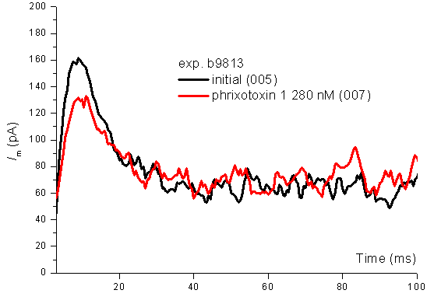
Figura S1. Inhibitory effect of phrixotoxin 1 (280 nM) on the I_{to} fast component, highlighted in the general IK voltage-clamp protocol at the depolarization step at +50 mV.
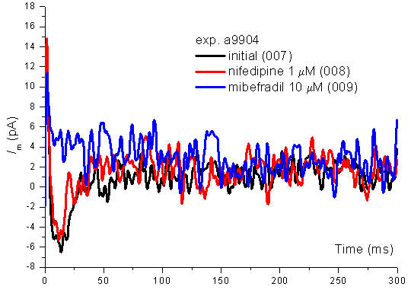
Figura S2. Lack of effect of 1 μM nifedipine and inhibitory effect of 10 μM mibefradil on the T-type Ca2+ current component (I_{CaT}) measured in the depolarizing step at -40 mV with the general IK protocol

Table S3. TaqMan assays used for characterization of progenitor cells.
Gene | TaqMan assay code | Producer
CD31 (PECAM-1) | Hs01065279_m1 | Thermo Fischer Scientific, Massachusetts, USA
eNOS | Hs01574665_m1 | Thermo Fischer Scientific, Massachusetts, USA
CD144 (VE-cadherin) | Hs00901465_m1 | Thermo Fischer Scientific, Massachusetts, USA
CD54 (ICAM-1) | Hs00164932_m1 | Thermo Fischer Scientific, Massachusetts, USA
vWF (von Wilebrand Factor) | Hs01109446_m1 | Thermo Fischer Scientific, Massachusetts, USA
Smoothelin | Hs01022255_g1 | Thermo Fischer Scientific, Massachusetts, USA
Calponin 1 | Hs00959434_m1 | Thermo Fischer Scientific, Massachusetts, USA
SMA (α- smooth muscle actin) | Hs00426835_g1 | Thermo Fischer Scientific, Massachusetts, USA
Myh11 (myosin heavy chain) | Hs00975796_m1 | Thermo Fischer Scientific, Massachusetts, USA
tropomyosin 1 | Hs04398572_m1 | Thermo Fischer Scientific, Massachusetts, USA
Caldesmon-1 | Hs00921987_m1 | Thermo Fischer Scientific, Massachusetts, USA
CACNA1G (cav3.1, R-type) | Hs00367969_m1 | Thermo Fischer Scientific, Massachusetts, USA

