Supplementary materials
About probit analysis and safety study

Tables for the parameters estimated for LD₅₀ calculation through the probit analyses methods via SPSS program

Parameter Estimates
Zeolites | Parameter | Estimate | Std. Error | Z | Sig. | 95% Confidence Interval
 |  |  |  |  |  | Lower Bound | Upper Bound
PROBITª | mg/kg | 5.597 | 1.359 | 4.117 | .000 | 2.933 | 8.262
 | Intercept | -19.658- | 4.754 | -4.135- | .000 | -24.412- | -14.904-
a. PROBIT model: PROBIT(p) = Intercept + BX (Covariates X are transformed using the base 10.000 logarithm.)

Chi-Square Tests
Zeolites |  | Chi-Square | df^{b} | Sig.
PROBIT | Pearson Goodness-of-Fit Test | 1.639 | 8 | .990ª
a. Since the significance level is greater than .050, no heterogeneity factor is used in the calculation of confidence limits.
b. Statistics based on individual cases differ from statistics based on aggregated cases.

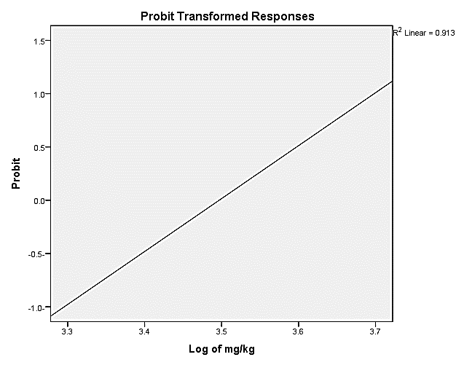

Linear regression for the probit transformed responses for Zeolites toxicity estimation
Parameter Estimates
ZnO NPS | Parameter | Estimate | Std. Error | Z | Sig. | 95% Confidence Interval
 |  |  |  |  |  | Lower Bound | Upper Bound
PROBITª | mg/kg | 7.439 | 2.193 | 3.392 | .001 | 3.141 | 11.738
 | Intercept | -26.553- | 7.820 | -3.396- | .001 | -34.373- | -18.733-
a. PROBIT model: PROBIT(p) = Intercept + BX (Covariates X are transformed using the base 10.000 logarithm.)

Chi-Square Tests
ZnO NPs |  | Chi-Square | df^{b} | Sig.
PROBIT | Pearson Goodness-of-Fit Test | .522 | 8 | 1.000ª
a. Since the significance level is greater than .050, no heterogeneity factor is used in the calculation of confidence limits.
b. Statistics based on individual cases differ from statistics based on aggregated cases.

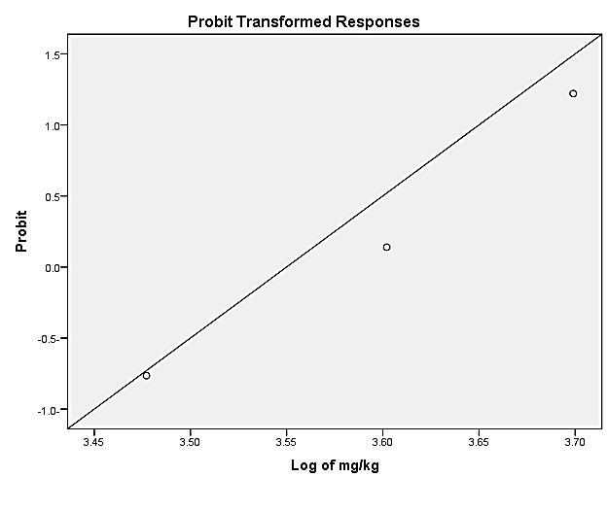
Linear regression for the probit transformed responses for propolis toxicity estimation

Parameter Estimates
nanocomposite | Parameter | Estimate | Std. Error | Z | Sig. | 95% Confidence Interval
 |  |  |  |  |  | Lower Bound | Upper Bound
PROBITª | mg/kg | 5.855 | 1.470 | 3.982 | .000 | 2.973 | 8.737
 | Intercept | -20.051- | 4.994 | -4.015- | .000 | -25.044- | -15.057-
a. PROBIT model: PROBIT(p) = Intercept + BX (Covariates X are transformed using the base 10.000 logarithm.)

Chi-Square Tests
nanocomposite |  | Chi-Square | df^{b} | Sig.
PROBIT | Pearson Goodness-of-Fit Test | .539 | 7 | .999ª
a. Since the significance level is greater than .050, no heterogeneity factor is used in the calculation of confidence limits.
b. Statistics based on individual cases differ from statistics based on aggregated cases.

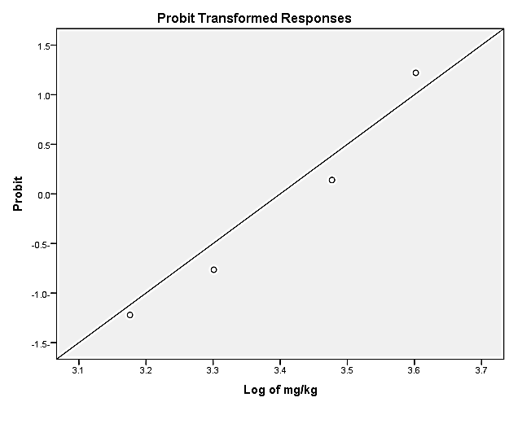
Linear regression for the probit transformed responses for nanocomposite toxicity estimation

