Supplementary data
Isoprenoid Biosynthesis Pathway Enzymes as Promising Drug Candidates Against Malaria Parasites: An In-Silico Investigation
Kuldeep Gupta 1, Gagandeep Singh Saggu 2*
1 Russel H. Morgan, Department of Radiology and Radiological Sciences, School of Medicine, Johns Hop-kins University, Baltimore, MD 21287, USA; kgupta14@jhmi.edu
2 Laboratory of Malaria and Vector Research, National Institute of Allergy and Infectious Diseases, National Institutes of Health, Rockville, MD, USA; gagan.saggu@nih.gov
* Correspondence: gagan.saggu@nih.gov; saggugagan.2007@gmail.com; Tel.: (+1 240-665-0263)
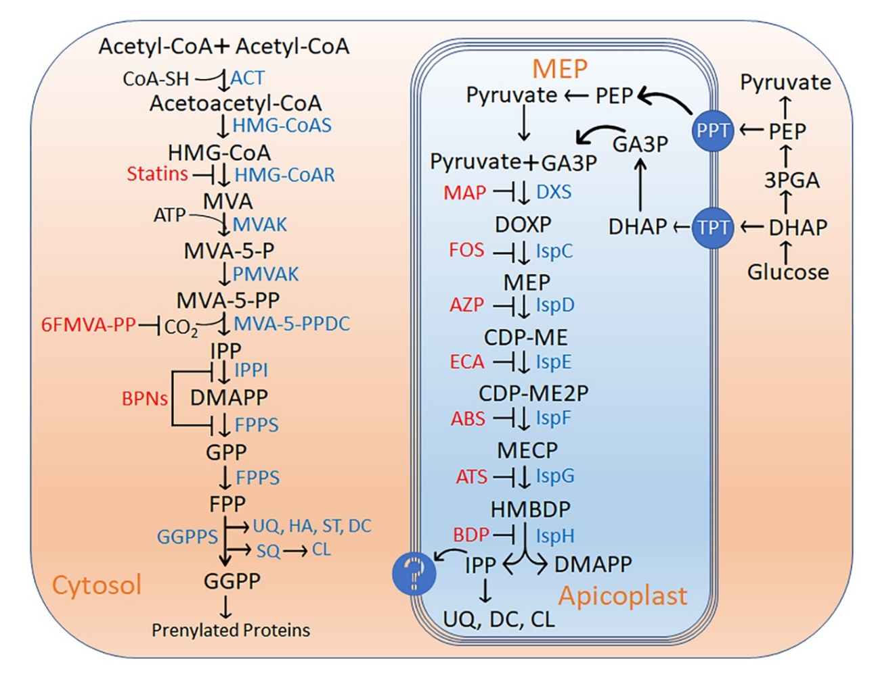
Figure 1: Isoprenoid biosynthesis by mevalonate dependent (MVA) and non-mevalonate pathway (MEP) in a typical cell. Isoprenoids are derived from the basic 5-carbon isoprenoid building blocks IPP and its isomer, DMAPP. In the MVA pathway, IPP and DMAPP are synthesized by condensation of acetyl CoA. Enzymes participating in this pathway are ACT, HMGS, HMGR, MVK, PMK, and MDS. Statins inhibit HMGR, the rate-limiting enzyme of the mevalonate pathway, and 6FMVA-PP and BPNs inhibit the other steps of the pathway. In the MEP pathway, IPP and DMAPP are generated from pyruvate and GA3P. Enzymes of this pathway are named here according to their E. coli homologs (DXS, IspC, IspD, IspE, IspF, IspG, and IspH). KCZ and FOS inhibit the rate-limiting steps of this pathway and blocks isoprenoids biosynthesis.
Abbreviations used: 3PGA; 3-Phospho-glyceraldehyde, 6FMVA-PP; 6-Fluoro-mevalonate-pyrophosphate, ABS; Aryl bis sulfonamide, ACT; Acyl CoA acetyl transferase, ATS; Atorvastatin, AZP; Azolopyrimidine, BDP; (E)-4-mercapto-3-methyl but-2-enyl diphosphate, BPNs; Bisphosphonates, CDP-ME; 4-diphosphocytidyl-2C-methyl-D-erythritol, CDP-ME2P; 4-diphosphocytidyl-2C-methyl-D-erythritol -2-phosphate, CL; Cholesterol, DC; Dolichols, DHAP; Dihydroxy acetone phosphate, DMAPP; Dimethylallyl pyrophosphate, DXS; 1-deoxy-D-xylose-5-phosphate synthase, DOXP; 1-deoxy-D-xylose-5-phosphate, DXS; 1-Deoxy-D-xylulose 5-phosphate synthase, ECA; ethyl {3-[4-amino-5-{3-[(cyclopropyl sulfonyl)amino] prop-1-yn-1-yl}-2-oxopyrimidin-1(2H)-yl] oxetan-3-yl}acetate, FOS; Fosmidomycin, FPP; Farnesyl diphosphate, FPPS; Farnesyl diphosphate synthase, GA3P; Glyceraldehyde-3-phosphate, GGPP; Geranyl geranyl pyrophosphate, GGPS; Geranyl geranyl pyrophosphate synthase, GPP; Geranyl pyrophosphate, HA; Heme A, HMBDP; 4-Hydroxy-3-methyl-2-(E)-butenyl-4-diphosphate, HMG-CoAS; 3-Hydroxyl-3-methylglutaryl-CoA synthase, HMG-CoA; 3-Hydroxy-3-methylglutaryl-CoA, HMG-CoAR; 3-Hydroxyl-3-methylglutaryl-CoA reductase, IPP; Isopentenyl-5-pyrophosphate, IPPI; Isopentenyl-5-pyrophosphate isomerise, IspC; 2C-methyl-D-erythritol 4-phosphate synthase, IspD; 4-Diphosphocytidyl-2C-methyl-D-erythritol synthase, IspE; 4-Diphosphocytidyl-2C-methyl-D-erythritol kinase, IspF; 2C-Methyl-D-erythritol 2,4-cyclodiphosphate synthase, IspG; 2C-Methyl-D-erythritol 2,4-cyclodiphosphate reductase, IspH; 1-Hydroxy-2-methyl-2-(E)-butenyl-4-diphosphate reductase, KCZ; Ketoclomazone, MAP; Methylacetylphosphonate, MECP; 2C-metyl-D-erythritol 2,4-cyclodiphosphate, MEP; 2C-Methyl-D-erythritol 4-phosphate, MVA; Mevalonic acid, MVA-5-P; Mevalonate-5-phosphate, MVA-5-PP; Mevalonate-5-pyrophosphate, MVA-5-PPDC; Mevalonate-5-pyrophosphate decarboxylase, MVAK; Mevalonate kinase, PEP; Phosphoenolpyruvate, PPT; Phosphoenolpyruvate transporter, PMVAK; Phosphomevalonate kinase, SQ; Squalene, ST; Sterol, TPT; Triose-phosphate transporter, UQ; Ubiquinones.

Figure S1: PfDXS enzyme interaction with ketoclomazone (KCZ). The interaction between the PfDXS enzyme and ketoclomazone was investigated through docking analysis using Molegro Virtual Docker. The analysis revealed a notable interaction involving conserved amino acids, specifically Asn 657 and Lys 751.

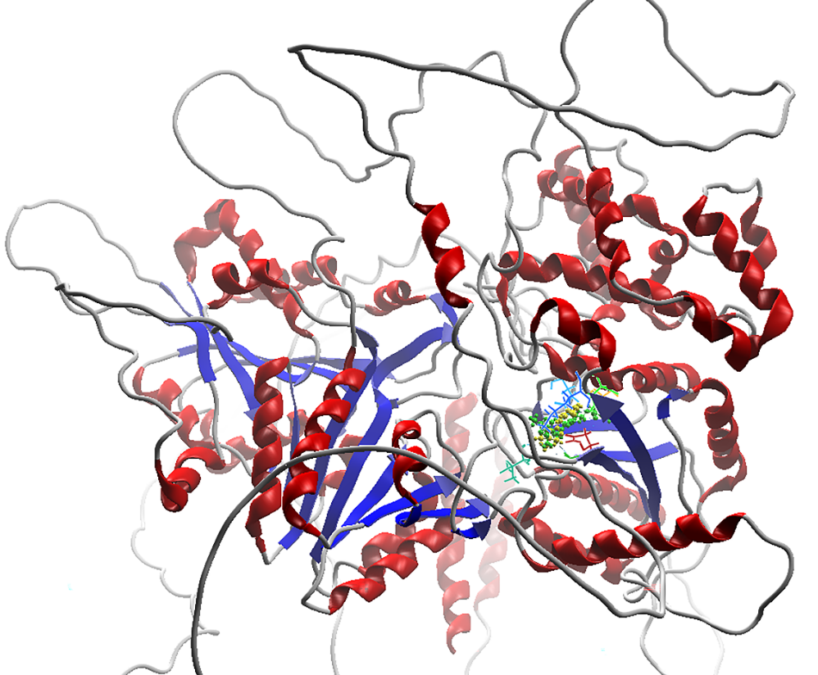
Figure S2: PfDXS interaction with TPP (green) and KCZ (Yellow). The comprehensive structure of the PfDXS enzyme, including its full length, was visualized alongside the docked molecules TPP (green) and KCZ (yellow). This representation emphasizes that both TPP and KCZ bind to a common binding site, interacting with conserved residues. This observation underscores the competitive inhibition of KCZ with the enzyme-substrate TPP.

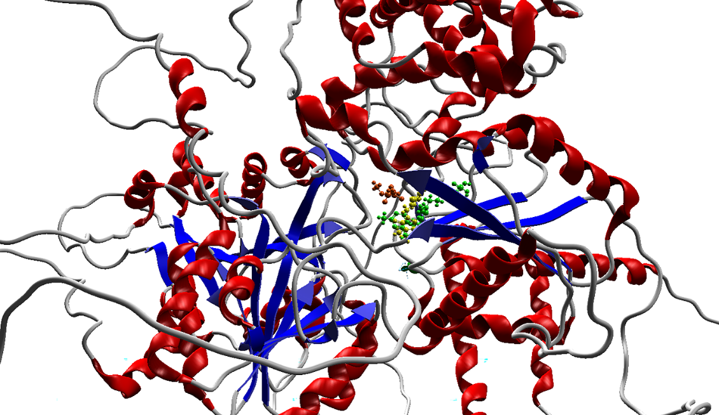
Figure S3: PfDXS interaction with TPP (green), pyruvate (Yellow), and MAP (red).
The complete structure of the PfDXS enzyme demonstrates its interaction with the enzyme-substrate TPP and MAP at the catalytic site. Notably, MAP binds adjacent to TPP, sharing binding amino acid residues such as Lys 751.

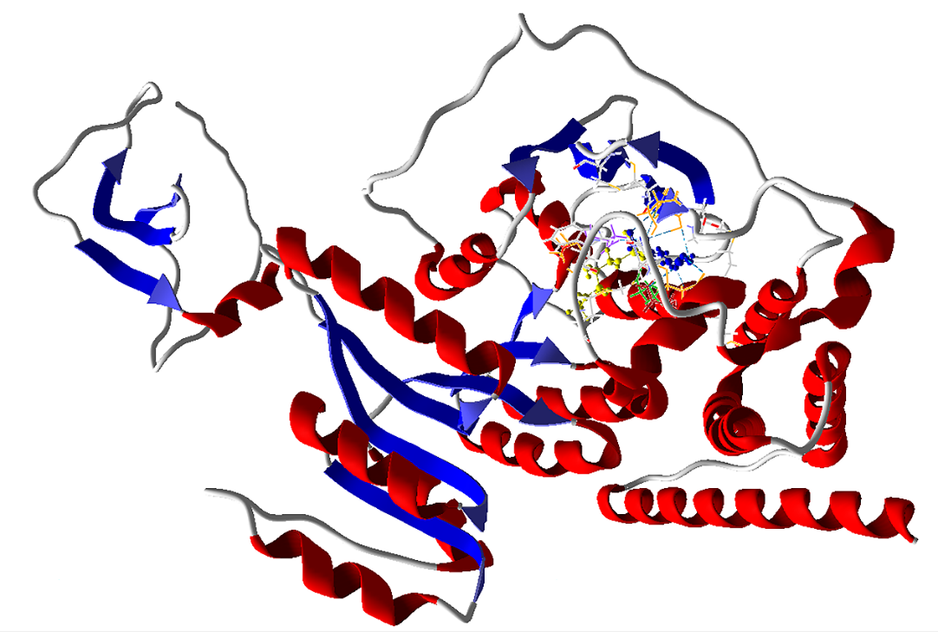
Figure S4: PfIspC interaction with DOXP (Yellow) and Fos (Blue).
The complete structure of the PfIspC enzyme underwent docking analysis against the enzyme-substrate DOXP and the inhibitor Fos, both binding to a shared cavity containing conserved residues. These molecules share amino acid residues, including Glu 233, Ser 270, Ser 306, Asn 311, and Lys 312, which elucidates their competitive inhibition. The phosphate group present in Fos and its analogs plays a crucial role in binding to the PfIspC enzyme.

Figure S5: PfIspD enzyme interaction with MMV008138. The interaction between the PfIspD enzyme and MMV008138 (a drug candidate from the Malaria Box venture) was investigated, revealing a significant interaction with the conserved amino acid residue Lys 662. This residue holds crucial importance for the catalytic activity of the enzyme.

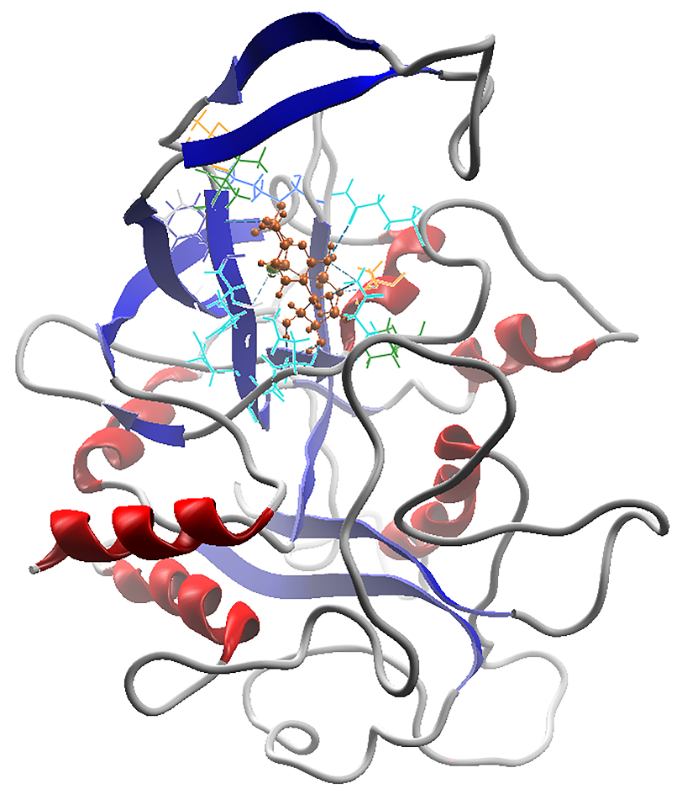
Figure S6: PfIspD interaction with CTP (Red).
Docking analysis was conducted for the enzyme-substrate CTP, which serves as a phosphate group donor in the reaction, facilitating the elongation of the MEP substrate. CTP binds proximately to the MEP substrate, sharing common amino acid residues for its interaction with the PfIspD enzyme.
Figure S7: PfIspD interaction with MEP (Cyan). Docking analysis was performed for the enzyme-substrate MEP, which functions as a phosphate group acceptor in the enzymatic reaction, ultimately forming CDP-ME that acts as a substrate for subsequent reactions. MEP binds in close proximity to the CTP substrate, sharing common amino acid residues for its interaction with the PfIspD enzyme.
Figure S8: PfIspD interaction with Azolopyrimidine (Green). Pyrimidine, containing the phosphate group, exhibits interaction with the IspD enzyme. Additionally, azolopyrimidines demonstrate interactions with residues commonly associated with the binding of both CTP and MEP substrates.
Figure S9: PfIspD interaction with Fosmidomycin (Cyan).
Fos was subjected to docking analysis with the PfIspD enzyme, exploiting the binding site similarities between IspC and IspD enzymes, leading to the formation of a comparable binding cavity. Notably, the phosphate group in Fos exhibited heightened interactions with positively charged amino acid residues situated within the binding cavity. Fos also serves as a competitive inhibitor, sharing amino acid residues with CTP and MEP.

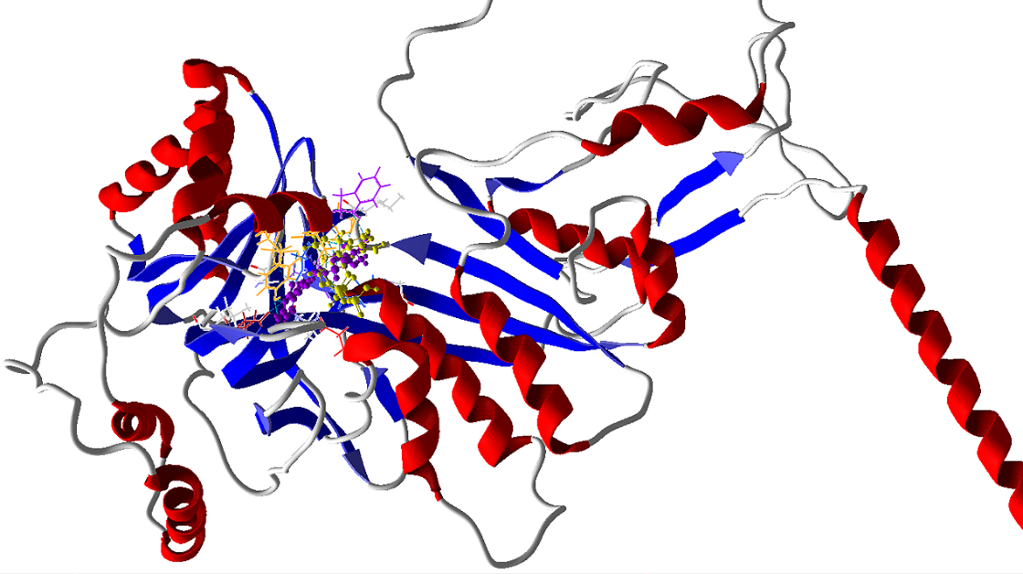
Figure S10: PfIspE interaction with CDP-ME (purple) and ATP (Yellow). Similar to PfIspD, PfIspE also involves two substrates, CDP-ME, and ATP, which exhibit interactions with each other as well as with the amino acid residues in the catalytic site. These substrates bind in close proximity, sharing common amino acid residues within the binding site.

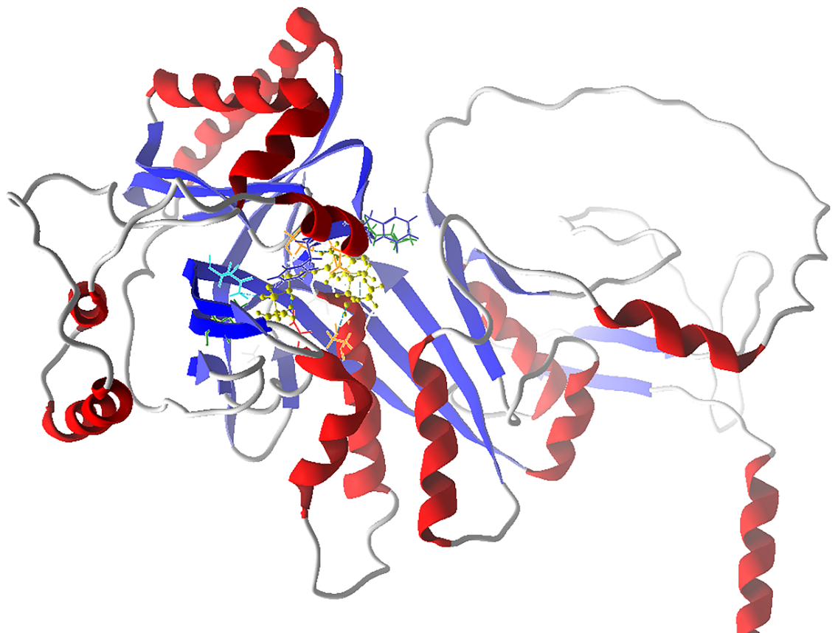
Figure S11: PfIspE interaction with ethyl {3-[4-amino-5-{3-[(cyclopropyl sulfonyl)amino] prop-1-yn-1-yl}-2-oxopyrimidin-1(2H)-yl] oxetan-3-yl}acetate (Yellow). High-Throughput Screening (HTS) was conducted to identify various inhibitors capable of binding to the PfIspE enzyme. Through docking analysis, cyclopropyl sulfonyl emerged as a potent inhibitor, exhibiting binding interactions with conserved catalytic residues.

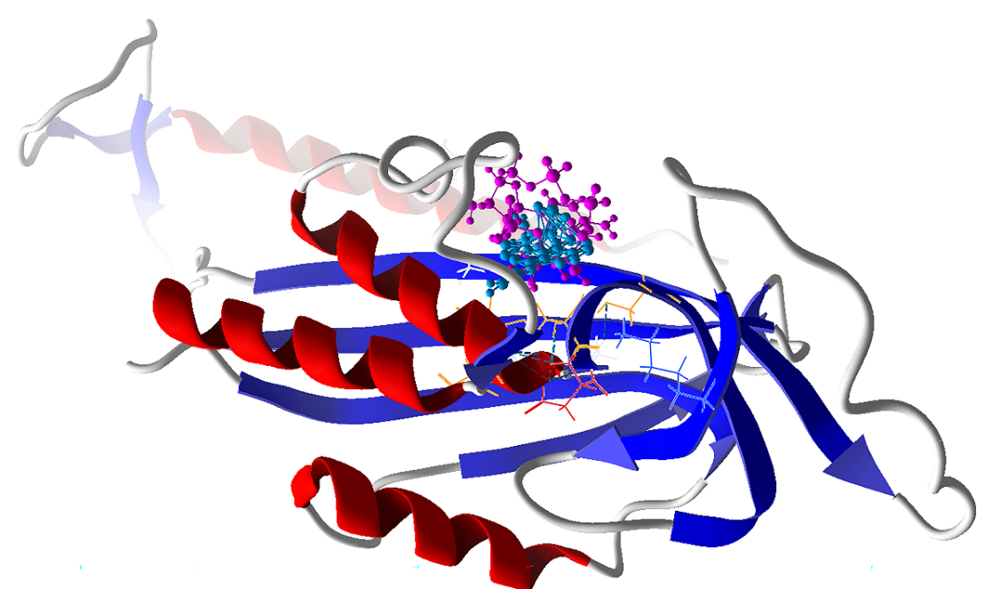
Figure S12: PfIspF interaction with CDP-ME-2P (Purple) and aryl bis sulfonamide (Blue). The full-length PfIspF enzyme was subjected to docking analysis against the CDP-ME-2P substrate and the inhibitory molecule Bis-sulfonamide, identified through High-Throughput Screening (HTS). Both molecules bind to conserved amino acid residues Ser 114, His 115, and Ser 116, indicating a competitive behavior of the inhibitor.
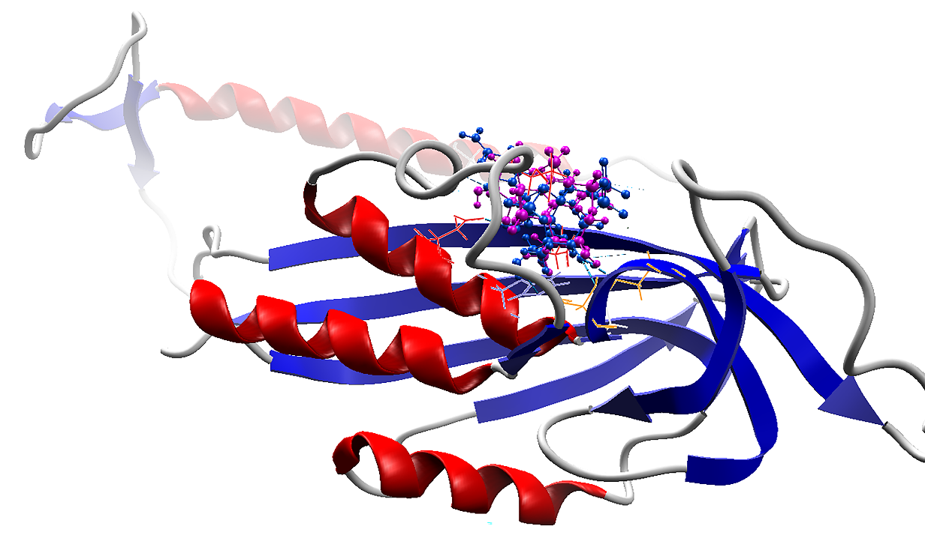
Figure S13: PfIspF interaction with CDP-ME-2P (Purple) and Ethyl (2Z)-2-(3,5-Dibromo-4-hydroxybenzylidene)-7-methyl-3-oxo-5-(2-thienyl)-2,3-dihydro-5H-[1,3]thiazolo[3,2-a]pyrimi-dine-6-carboxylate (Blue).
The inhibitor hydroxy benzylidene, identified through High-Throughput Screening (HTS), also binds with conserved residues Ser 114 and His 115 in PfIspF. These residues are found to be conserved in various IspF enzymes from different organisms.

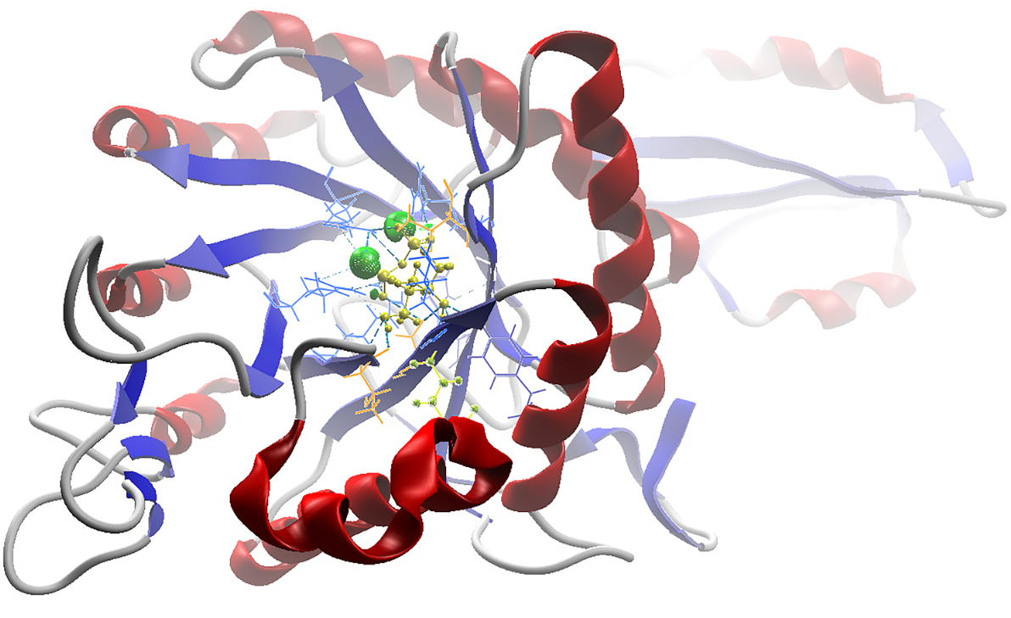
Figure S14: PfIspG interaction with MECP substrate (yellow).
The PfIspG enzyme forms a conserved core with arginine residues, serving as the binding site for the MECP substrate. Following substrate binding, the cap region, facilitated by the 4Fe-4S cluster, envelops this core region, creating a closed conformation conducive to catalytic reactions. In the docking analysis, interactions were observed between the MECP substrate and the conserved residues in the beta sheets of the core region. Notably, the binding of the Fe-S cluster towards the C-terminal conserved cysteine residues plays a critical role in this process.
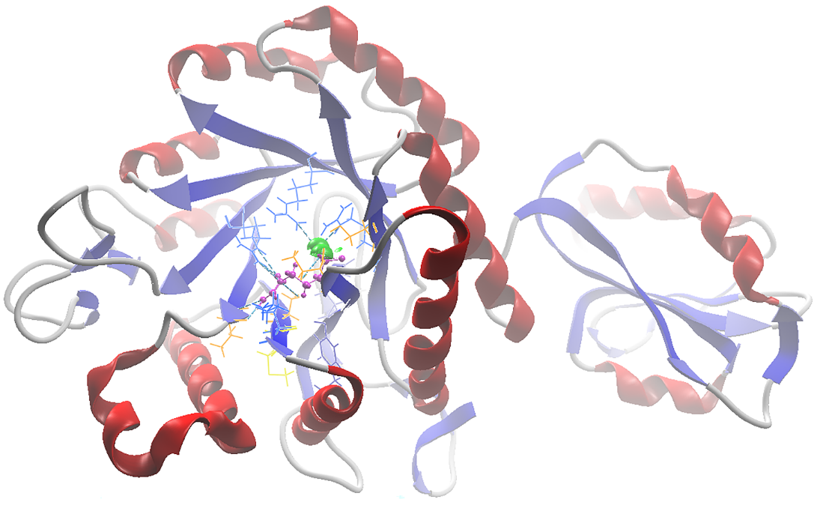
Figure S15: PfIspG interaction with Fosmidomycin (Purple).
In the docking analysis, Fos demonstrated interactions with the conserved residues in the core region, facilitated by the phosphate group's interaction with positively charged arginine residues. The binding of Fos in the core region has the potential to impede the binding of the 4Fe-4S cluster. Even in the absence of the MECP substrate, this interaction could hinder the production of HMBDP.
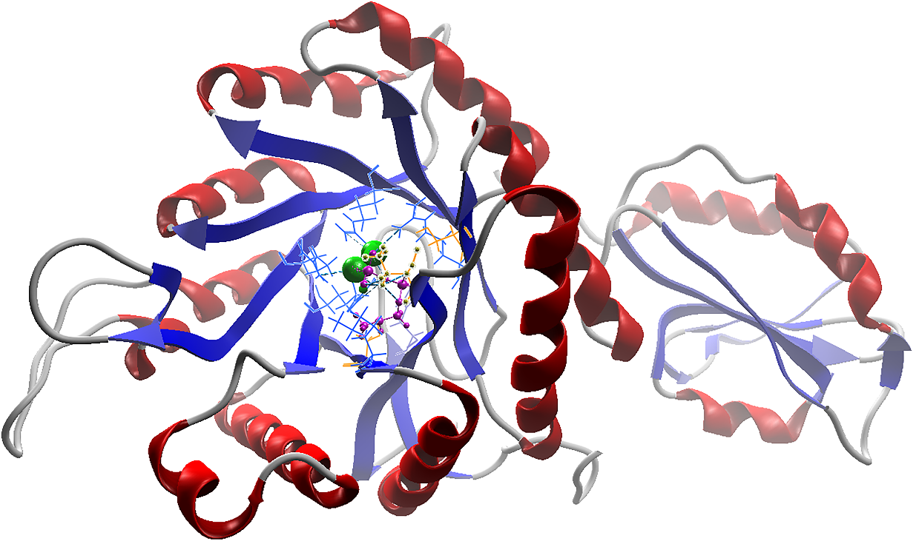
Figure S16: PfIspG interaction with Prop-2-yn-1-yl trihydrozen di phosphate (Purple).
The inhibitor obtained via High-Throughput Screening (HTS) follows a similar mechanism by binding to positively charged residues, thereby impacting the catalytic reaction of the PfIspG enzyme.
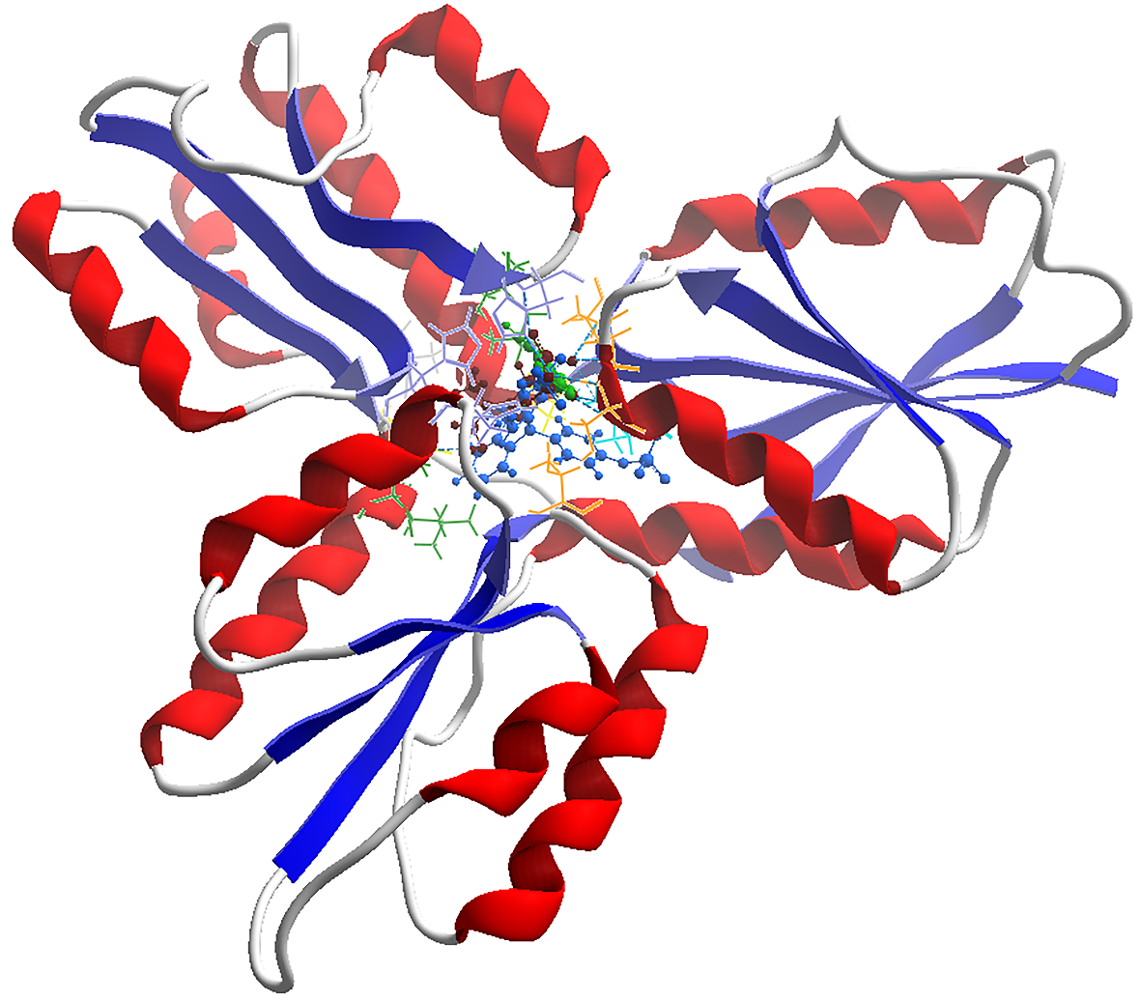
Figure S17: PfIspH interaction with HMBDP substrate (brown), (E)-4-mercapto-3-methyl but-2-enyl diphosphate (green) and Phenolphthalein diphosphate pyridine -(Blue). In the docking analysis, these inhibitors identified through HTS were found to interact with amino acid residues aligned in the catalytic activity site. Additionally, they shared amino acid residues with the substrate HMBDP.
Table S2: Binding energies (Gibbs free energy) and binding affinity (K_{d}) for MEP pathway enzyme’s interaction with substrates and different inhibitors. Data available in the PDB server was used as a reference.
Proteins | Ligand molecule | Binding energy ΔG (Kj/mol)/ Binding affinity (K_{d})
P. falciparum DXS | TPP | -110.63/ 2.1 x 10⁵
 | Pyruvate | -126.865/ 2.5 x 10⁵
 | MAP | -180.34/ 8.4 x 10⁵
P. falciparum IspC | DOXP | -275.434/ 9.35 x 10⁶
 | Fosmidomycin | -167.974/ 6.4 x 10⁵
E. coli IspD (1I52) | CTP | -289.658/ 9.85 x 10⁶
M. tuberculosis IspD (3Q80) | CDP-ME | -289.435/ 9.63 x 10⁶
A. thaliana IspD (2YC3) | Azolopyrimidines | -122.082/ 2.3 x 10⁵
P. falciparum IspD | CTP | -157.537/ 5.7 x 10⁵
 | MEP | -77.255/ 1.6 x 10⁵
 | CDP-ME | -150.985/ 5.4 x 10⁵
 | Fosmidomycin | -87.784/ 2.0 x 10⁵
 | MMV008138 | -128.078/ 2.42 x 10⁵
 | Azolopyrimidines | -151.686/ 5.6 x 10⁵
P. falciparum IspE | CDP-ME | -140.382/ 2.5 x 10⁵
 | ATP | -161.823/ 6.0 x 10⁵
 | Ethyl {3-[4-amino-5-{3-[(cyclopropyl sulfonyl)amino] prop-1-yn-1-yl}-2-oxopyrimidin-1(2H)-yl] oxetan-3-yl}acetate | -85.342/ 2.0 x 10⁵
P. falciparum IspF | CDP-ME-2P | -210.645/ 8.6 x 10⁶
 | Aryl bis sulfonamide | -180.54/ 8.4 x 10⁵
 | Hydroxy benzylidene | -174.36/ 7.4 x 10⁵
T. thermophilus IspG (4G9P) | MECP | -131.369/ 2.45 x 10⁵
A. aeolicus IspG (3NOY) | [4Fe-4S] cluster | -44.873/ 1.1 x 10⁵
P. falciparum IspG | MECP | -107.228/ 2.1 x 10⁵
 | [4Fe-4S] cluster | -42.136/ 1.0 x 10⁵
 | Atorvastatin | -167.325/ 6.1 x 10⁵
 | Fosmidomycin | -101.341/ 2.0 x 10⁵
 | Alkyne diphosphate | -140.101/ 2.5 x 10⁵
P. falciparum IspH | HMBDP | -124.87/ 2.4 x 10⁵
 | [4Fe-4S] cluster | -44.324/ 1.1 x 10⁵
 | (E)-4-mercapto-3-methyl but-2-enyl diphosphate | -180.34/ 8.4 x 10⁵
 | Phenolphthalein diphosphate pyridine | 155.64/ 5.62 x 10⁵

MSA Percent Identity Matrix - created by Clustal 2.1 for DXS enzyme

1: P_vivaxDXS 100.00 74.98 80.52 79.44 52.06 51.54 53.20 57.72 50.57 35.42 32.81 33.66 31.61 30.05 32.37 32.44 29.21 35.32 31.43 31.07
2: P_knowlesiDXS 74.98 100.00 80.90 78.86 51.79 51.42 52.74 57.47 50.56 34.81 31.11 31.82 29.67 29.98 30.66 31.70 28.57 34.72 29.56 30.12
3: P_cynomolgiDXS 80.52 80.90 100.00 87.18 54.15 52.15 54.18 60.26 51.04 36.68 33.90 35.25 33.40 32.14 32.87 33.60 28.99 37.16 31.61 31.42
4: P_inuiDXS 79.44 78.86 87.18 100.00 52.83 52.00 53.63 58.92 51.76 34.66 31.77 32.34 29.40 29.22 30.73 31.70 28.15 35.36 29.47 30.18
5: P_falciparumDXS 52.06 51.79 54.15 52.83 100.00 56.42 57.16 61.89 56.09 33.84 32.87 34.13 28.62 32.22 32.71 33.56 27.10 34.57 30.33 31.02
6: P_chabaudiDXS 51.54 51.42 52.15 52.00 56.42 100.00 91.67 88.65 84.07 34.76 32.43 33.14 29.28 30.15 30.92 32.12 27.52 33.48 30.75 31.13
7: P_vinckeiDXS 53.20 52.74 54.18 53.63 57.16 91.67 100.00 88.13 84.15 34.76 32.95 33.09 28.95 30.64 31.26 32.12 27.64 33.63 31.19 31.13
8: P_bergheiDXS 57.72 57.47 60.26 58.92 61.89 88.65 88.13 100.00 91.40 34.92 32.71 33.86 29.67 30.82 30.55 31.76 29.69 32.49 29.73 30.43
9: P_yoeliiDXS 50.57 50.56 51.04 51.76 56.09 84.07 84.15 91.40 100.00 34.25 33.33 34.18 28.27 29.13 29.88 31.03 25.80 31.77 29.48 30.32
10: B_bovisDXS 35.42 34.81 36.68 34.66 33.84 34.76 34.76 34.92 34.25 100.00 43.23 44.84 35.41 36.08 38.96 38.90 39.43 39.38 38.98 37.63
11: T_parvaDXS 32.81 31.11 33.90 31.77 32.87 32.43 32.95 32.71 33.33 43.23 100.00 82.61 33.10 33.39 36.33 38.19 34.40 39.35 35.76 35.07
12: T_annulataDXS 33.66 31.82 35.25 32.34 34.13 33.14 33.09 33.86 34.18 44.84 82.61 100.00 34.01 33.89 36.75 37.88 36.34 40.79 36.23 36.99
13: M_aviumDXS 31.61 29.67 33.40 29.40 28.62 29.28 28.95 29.67 28.27 35.41 33.10 34.01 100.00 39.64 41.24 38.98 36.78 39.84 39.42 39.34
14: B_subtilusDXS 30.05 29.98 32.14 29.22 32.22 30.15 30.64 30.82 29.13 36.08 33.39 33.89 39.64 100.00 44.70 44.94 41.52 43.55 43.18 44.46
15: T_thermophilusDXS 32.37 30.66 32.87 30.73 32.71 30.92 31.26 30.55 29.88 38.96 36.33 36.75 41.24 44.70 100.00 45.24 43.97 44.52 41.53 42.74
16: E_coliDXS 32.44 31.70 33.60 31.70 33.56 32.12 32.12 31.76 31.03 38.90 38.19 37.88 38.98 44.94 45.24 100.00 44.59 49.01 47.78 47.95
17: T_gondiiDXS 29.21 28.57 28.99 28.15 27.10 27.52 27.64 29.69 25.80 39.43 34.40 36.34 36.78 41.52 43.97 44.59 100.00 52.23 47.24 48.18
18: C_veliaDXS 35.32 34.72 37.16 35.36 34.57 33.48 33.63 32.49 31.77 39.38 39.35 40.79 39.84 43.55 44.52 49.01 52.23 100.00 52.59 54.11
19: A_protothecoidesDXS 31.43 29.56 31.61 29.47 30.33 30.75 31.19 29.73 29.48 38.98 35.76 36.23 39.42 43.18 41.53 47.78 47.24 52.59 100.00 63.34
20: A_thalianaDXS 31.07 30.12 31.42 30.18 31.02 31.13 31.13 30.43 30.32 37.63 35.07 36.99 39.34 44.46 42.74 47.95 48.18 54.11 63.34 100.00

MSA Percent Identity Matrix - created by Clustal 2.1 for IspC enzyme

1: T_thermophilusIspC 100.00 45.35 41.69 47.96 41.64 43.93 43.17 43.32 37.06 34.99 36.51 35.69 35.69 35.69 35.42 35.42 34.88 39.61 37.75 37.95
2: M_aviumIspC 45.35 100.00 41.08 43.73 40.76 42.98 42.82 43.64 34.48 34.56 35.01 34.22 34.67 34.93 34.67 33.60 33.07 36.86 36.41 34.96
3: E_coliIspC 41.69 41.08 100.00 43.04 41.95 46.17 43.64 43.30 37.78 35.66 37.03 37.03 35.52 37.03 38.04 36.78 36.02 38.82 35.43 35.92
4: T_gondiiIspC 47.96 43.73 43.04 100.00 47.52 46.59 41.76 44.93 35.90 34.37 35.34 34.71 36.92 36.34 35.70 35.70 34.70 40.67 40.85 37.74
5: B_subtilusIspC 41.64 40.76 41.95 47.52 100.00 45.71 46.46 46.86 40.26 40.73 41.32 40.53 40.00 41.05 40.53 42.11 40.53 43.28 37.43 36.56
6: C_veliaIspC 43.93 42.98 46.17 46.59 45.71 100.00 54.27 55.36 36.78 36.96 38.69 38.89 41.62 39.74 39.48 38.96 38.96 41.32 40.96 39.36
7: A_thalianaIspC 43.17 42.82 43.64 41.76 46.46 54.27 100.00 69.83 37.19 38.42 39.08 39.34 40.35 38.39 38.63 37.90 38.39 41.25 38.61 38.81
8: A_protothecoidesIspC 43.32 43.64 43.30 44.93 46.86 55.36 69.83 100.00 39.16 39.53 41.71 41.01 37.91 38.68 38.93 37.91 37.66 44.56 36.70 37.56
9: P_vivaxIspC 37.06 34.48 37.78 35.90 40.26 36.78 37.19 39.16 100.00 80.36 81.12 80.04 65.83 66.60 65.98 65.57 65.23 41.27 45.90 42.66
10: P_cynomolgiIspC 34.99 34.56 35.66 34.37 40.73 36.96 38.42 39.53 80.36 100.00 82.71 84.01 66.30 66.60 66.60 65.95 66.02 41.39 46.05 41.87
11: P_inuiIspC 36.51 35.01 37.03 35.34 41.32 38.69 39.08 41.71 81.12 82.71 100.00 82.63 64.46 67.82 67.21 66.60 66.67 42.95 45.90 42.76
12: P_knowlesiIspC 35.69 34.22 37.03 34.71 40.53 38.89 39.34 41.01 80.04 84.01 82.63 100.00 65.91 68.23 68.02 67.21 67.48 42.56 44.10 42.02
13: P_falciparumIspC 35.69 34.67 35.52 36.92 40.00 41.62 40.35 37.91 65.83 66.30 64.46 65.91 100.00 73.70 72.44 73.28 72.54 40.89 44.10 41.59
14: P_vinckeiIspC 35.69 34.93 37.03 36.34 41.05 39.74 38.39 38.68 66.60 66.60 67.82 68.23 73.70 100.00 96.77 91.72 90.47 39.59 43.33 39.29
15: P_chabaudiIspC 35.42 34.67 38.04 35.70 40.53 39.48 38.63 38.93 65.98 66.60 67.21 68.02 72.44 96.77 100.00 91.31 90.26 39.82 43.08 39.06
16: P_bergheiIspC 35.42 33.60 36.78 35.70 42.11 38.96 37.90 37.91 65.57 65.95 66.60 67.21 73.28 91.72 91.31 100.00 93.71 39.82 42.31 38.82
17: P_yoeliiIspC 34.88 33.07 36.02 34.70 40.53 38.96 38.39 37.66 65.23 66.02 66.67 67.48 72.54 90.47 90.26 93.71 100.00 38.85 42.05 38.59
18: B_bovisIspC 39.61 36.86 38.82 40.67 43.28 41.32 41.25 44.56 41.27 41.39 42.95 42.56 40.89 39.59 39.82 39.82 38.85 100.00 50.75 49.43
19: T_parvaIspC 37.75 36.41 35.43 40.85 37.43 40.96 38.61 36.70 45.90 46.05 45.90 44.10 44.10 43.33 43.08 42.31 42.05 50.75 100.00 81.80
20: T_annulataIspC 37.95 34.96 35.92 37.74 36.56 39.36 38.81 37.56 42.66 41.87 42.76 42.02 41.59 39.29 39.06 38.82 38.59 49.43 81.80 100.00

MSA Percent Identity Matrix - created by Clustal 2.1 for IspD enzyme

1: P_knowlesiIspD 100.00 61.65 69.30 68.61 37.23 36.92 40.58 41.34 40.44 16.34 24.67 23.74 21.55 25.86 19.82 23.58 26.20 21.50 21.47 27.59
2: P_vivaxIspD 61.65 100.00 71.92 69.26 38.37 35.43 38.10 40.15 40.33 16.67 24.59 23.92 25.96 24.14 22.03 23.56 27.95 21.40 20.25 24.83
3: P_cynomolgiIspD 69.30 71.92 100.00 79.60 36.53 37.24 40.64 42.17 41.49 15.56 22.02 22.40 22.00 25.86 20.26 22.17 26.64 20.77 21.10 25.00
4: P_inuiIspD 68.61 69.26 79.60 100.00 39.89 38.40 43.27 44.01 45.05 16.22 22.10 22.41 22.29 25.00 20.26 22.64 27.07 21.55 20.21 24.91
5: P_falciparumIspD 37.23 38.37 36.53 39.89 100.00 43.16 46.58 48.50 49.32 13.14 24.05 23.28 22.78 23.61 17.98 18.78 25.65 20.20 21.27 25.77
6: P_yoeliiIspD 36.92 35.43 37.24 38.40 43.16 100.00 77.88 69.16 67.66 15.47 25.00 23.58 19.37 24.46 18.06 18.75 26.09 18.31 19.18 25.18
7: P_bergheiIspD 40.58 38.10 40.64 43.27 46.58 77.88 100.00 78.39 75.41 13.77 24.86 22.77 23.32 25.64 18.94 18.75 26.41 18.86 19.81 26.15
8: P_chabaudiIspD 41.34 40.15 42.17 44.01 48.50 69.16 78.39 100.00 87.96 13.56 26.24 25.29 24.25 25.75 20.26 19.23 26.96 19.93 20.19 25.44
9: P_vinckeiIspD 40.44 40.33 41.49 45.05 49.32 67.66 75.41 87.96 100.00 13.75 26.54 25.29 23.33 25.32 18.94 19.23 26.96 20.21 20.32 26.33
10: T_gondiiIspD 16.34 16.67 15.56 16.22 13.14 15.47 13.77 13.56 13.75 100.00 20.54 22.12 23.23 25.85 26.50 23.74 28.86 27.76 28.14 30.60
11: T_annulataIspD 24.67 24.59 22.02 22.10 24.05 25.00 24.86 26.24 26.54 20.54 100.00 78.23 35.65 26.61 22.47 23.11 27.71 22.95 25.36 27.93
12: T_parvaIspD 23.74 23.92 22.40 22.41 23.28 23.58 22.77 25.29 25.29 22.12 78.23 100.00 34.10 25.32 24.23 24.53 28.14 25.52 27.86 29.30
13: B_bovisIspD 21.55 25.96 22.00 22.29 22.78 19.37 23.32 24.25 23.33 23.23 35.65 34.10 100.00 27.59 26.32 29.11 34.06 25.00 25.90 28.47
14: E_coliIspD 25.86 24.14 25.86 25.00 23.61 24.46 25.64 25.75 25.32 25.85 26.61 25.32 27.59 100.00 33.78 32.69 33.04 28.63 27.78 30.26
15: M_aviumIspD 19.82 22.03 20.26 20.26 17.98 18.06 18.94 20.26 18.94 26.50 22.47 24.23 26.32 33.78 100.00 40.98 35.32 28.19 29.65 26.67
16: T_thermophilusIspD 23.58 23.56 22.17 22.64 18.78 18.75 18.75 19.23 19.23 23.74 23.11 24.53 29.11 32.69 40.98 100.00 37.50 33.80 34.45 31.88
17: B_subtilisIspD 26.20 27.95 26.64 27.07 25.65 26.09 26.41 26.96 26.96 28.86 27.71 28.14 34.06 33.04 35.32 37.50 100.00 35.06 35.50 37.95
18: C_veliaIspD 21.50 21.40 20.77 21.55 20.20 18.31 18.86 19.93 20.21 27.76 22.95 25.52 25.00 28.63 28.19 33.80 35.06 100.00 43.49 40.86
19: A_protothecoidesIspD 21.47 20.25 21.10 20.21 21.27 19.18 19.81 20.19 20.32 28.14 25.36 27.86 25.90 27.78 29.65 34.45 35.50 43.49 100.00 52.65
20: A_thalianaIspD 27.59 24.83 25.00 24.91 25.77 25.18 26.15 25.44 26.33 30.60 27.93 29.30 28.47 30.26 26.67 31.88 37.95 40.86 52.65 100.00

MSA Percent Identity Matrix - created by Clustal 2.1 for IspE enzyme

1: B_bovisIspE 100.00 37.63 37.99 22.64 25.39 25.39 25.87 24.32 25.77 24.62 25.95 25.38 21.21 28.14 26.64 29.63 24.62 24.24 26.34 19.18
2: T_parvaIspE 37.63 100.00 83.95 28.32 27.41 27.11 26.87 26.09 26.95 27.33 26.47 26.43 21.56 21.02 23.79 25.61 22.22 26.27 25.00 20.99
3: T_annulataIspE 37.99 83.95 100.00 27.22 26.89 26.59 26.05 25.00 24.62 26.51 25.73 25.30 20.19 21.43 24.19 25.69 23.08 23.31 24.59 19.08
4: P_falciparumIspE 22.64 28.32 27.22 100.00 50.00 49.79 50.30 49.80 48.79 48.28 49.90 48.28 18.24 25.85 28.78 28.79 21.48 24.61 23.94 18.82
5: P_chabaudiIspE 25.39 27.41 26.89 50.00 100.00 91.87 86.51 83.73 53.55 53.05 53.86 52.85 20.91 27.36 29.67 31.78 17.93 24.90 24.41 18.09
6: P_vinckeiIspE 25.39 27.11 26.59 49.79 91.87 100.00 84.52 82.54 53.55 52.85 54.07 52.64 20.91 27.67 29.67 30.53 18.33 24.11 24.41 17.73
7: P_bergheiispE 25.87 26.87 26.05 50.30 86.51 84.52 100.00 89.88 51.59 52.10 53.29 52.10 20.00 27.04 28.57 31.15 19.12 23.32 24.41 17.02
8: P_yoeliiIspE 24.32 26.09 25.00 49.80 83.73 82.54 89.88 100.00 52.99 51.90 53.49 52.30 21.52 27.44 29.30 30.61 19.92 24.90 24.02 17.02
9: P_knowlesiIspE 25.77 26.95 24.62 48.79 53.55 53.55 51.59 52.99 100.00 78.30 80.28 77.91 20.99 28.75 26.84 27.41 21.51 26.59 24.41 19.50
10: P_vivaxIspE 24.62 27.33 26.51 48.28 53.05 52.85 52.10 51.90 78.30 100.00 86.79 84.42 20.14 29.07 27.57 29.60 20.32 26.59 22.83 19.15
11: P_cynomolgiIspE 25.95 26.47 25.73 49.90 53.86 54.07 53.29 53.49 80.28 86.79 100.00 90.93 19.74 26.84 27.44 28.17 20.72 26.19 23.46 19.86
12: P_inuiIspE 25.38 26.43 25.30 48.28 52.85 52.64 52.10 52.30 77.91 84.42 90.93 100.00 19.91 27.48 26.47 28.66 19.52 26.19 24.02 19.50
13: T_gondiiIspE 21.21 21.56 20.19 18.24 20.91 20.91 20.00 21.52 20.99 20.14 19.74 19.91 100.00 31.97 33.70 32.74 26.80 35.56 28.02 29.60
14: C_veliaIspE 28.14 21.02 21.43 25.85 27.36 27.67 27.04 27.44 28.75 29.07 26.84 27.48 31.97 100.00 47.40 40.69 28.57 35.02 33.46 27.15
15: A_protothecoidesIspE 26.64 23.79 24.19 28.78 29.67 29.67 28.57 29.30 26.84 27.57 27.44 26.47 33.70 47.40 100.00 47.70 28.02 33.07 30.00 28.82
16: A_thalianaIspE 29.63 25.61 25.69 28.79 31.78 30.53 31.15 30.61 27.41 29.60 28.17 28.66 32.74 40.69 47.70 100.00 27.48 30.89 31.85 25.08
17: E_coliIspE 24.62 22.22 23.08 21.48 17.93 18.33 19.12 19.92 21.51 20.32 20.72 19.52 26.80 28.57 28.02 27.48 100.00 34.27 29.34 24.82
18: T_thermophilusIspE 24.24 26.27 23.31 24.61 24.90 24.11 23.32 24.90 26.59 26.59 26.19 26.19 35.56 35.02 33.07 30.89 34.27 100.00 35.50 34.80
19: B_subtilusIspE 26.34 25.00 24.59 23.94 24.41 24.41 24.41 24.02 24.41 22.83 23.46 24.02 28.02 33.46 30.00 31.85 29.34 35.50 100.00 33.69
20: M_aviumIspE 19.18 20.99 19.08 18.82 18.09 17.73 17.02 17.02 19.50 19.15 19.86 19.50 29.60 27.15 28.82 25.08 24.82 34.80 33.69 100.00

MSA Percent Identity Matrix - created by Clustal 2.1 for IspF enzyme

1: P_inuiIspF 100.00 84.08 83.08 83.74 49.30 50.46 50.00 50.93 51.83 28.00 29.63 25.91 28.49 30.11 30.60 26.53 34.07 37.31 29.38 29.24
2: P_cynomolgiIspF 84.08 100.00 87.08 84.03 53.19 55.56 54.70 55.13 55.93 30.37 30.57 28.78 33.00 33.00 34.00 30.92 35.90 40.76 33.98 33.87
3: P_vivaxIspF 83.08 87.08 100.00 85.87 53.16 54.81 54.39 54.39 55.19 29.29 30.57 27.10 31.88 32.37 34.67 28.77 35.90 40.76 31.02 31.44
4: P_knowlesiIspF 83.74 84.03 85.87 100.00 53.85 56.78 56.36 56.36 57.14 27.41 29.94 28.97 33.00 33.50 33.33 27.57 35.90 40.13 32.56 32.12
5: P_falciparumIspF 49.30 53.19 53.16 53.85 100.00 60.34 60.34 59.92 60.67 27.03 29.30 27.23 34.87 33.85 32.67 31.34 37.18 38.85 33.66 32.60
6: P_vinckeiIspF 50.46 55.56 54.81 56.78 60.34 100.00 91.46 86.18 85.77 25.81 30.57 28.99 33.17 34.17 32.00 31.55 38.46 41.03 32.38 32.24
7: P_chabaudiIspF 50.00 54.70 54.39 56.36 60.34 91.46 100.00 86.18 86.59 25.81 29.30 29.47 32.16 33.17 31.33 31.07 37.82 40.38 31.43 31.69
8: P_bergheiIspF 50.93 55.13 54.39 56.36 59.92 86.18 86.18 100.00 91.87 26.88 29.94 29.95 33.67 34.17 32.67 31.55 37.18 41.67 31.90 31.15
9: P_yoeliiIspF 51.83 55.93 55.19 57.14 60.67 85.77 86.59 91.87 100.00 26.20 29.30 28.85 33.50 34.00 32.00 30.43 37.82 40.38 31.75 31.52
10: T_gondiiIspF 28.00 30.37 29.29 27.41 27.03 25.81 25.81 26.88 26.20 100.00 33.33 31.75 35.94 34.90 39.47 37.37 39.24 45.91 38.92 36.51
11: M_aviumIspF 29.63 30.57 30.57 29.94 29.30 30.57 29.30 29.94 29.30 33.33 100.00 34.39 31.85 31.85 40.94 32.70 38.71 39.35 33.54 32.08
12: B_bovisIspF 25.91 28.78 27.10 28.97 27.23 28.99 29.47 29.95 28.85 31.75 34.39 100.00 40.00 42.00 36.42 30.29 36.31 37.82 27.40 31.89
13: T_parvaIspF 28.49 33.00 31.88 33.00 34.87 33.17 32.16 33.67 33.50 35.94 31.85 40.00 100.00 86.67 39.74 37.37 43.95 46.15 40.82 47.31
14: T_annulataIspF 30.11 33.00 32.37 33.50 33.85 34.17 33.17 34.17 34.00 34.90 31.85 42.00 86.67 100.00 40.40 38.38 42.68 47.44 38.78 46.77
15: T_thermophilusIspF 30.60 34.00 34.67 33.33 32.67 32.00 31.33 32.67 32.00 39.47 40.94 36.42 39.74 40.40 100.00 41.45 35.53 42.76 44.08 44.74
16: C_veliaIspF 26.53 30.92 28.77 27.57 31.34 31.55 31.07 31.55 30.43 37.37 32.70 30.29 37.37 38.38 41.45 100.00 43.04 46.20 49.07 49.48
17: B_subtilusIspF 34.07 35.90 35.90 35.90 37.18 38.46 37.82 37.18 37.82 39.24 38.71 36.31 43.95 42.68 35.53 43.04 100.00 63.06 48.10 48.73
18: E_coliIspF 37.31 40.76 40.76 40.13 38.85 41.03 40.38 41.67 40.38 45.91 39.35 37.82 46.15 47.44 42.76 46.20 63.06 100.00 47.77 49.69
19: A_thalianaIspF 29.38 33.98 31.02 32.56 33.66 32.38 31.43 31.90 31.75 38.92 33.54 27.40 40.82 38.78 44.08 49.07 48.10 47.77 100.00 67.02
20: A_protothecoidesIspF 29.24 33.87 31.44 32.12 32.60 32.24 31.69 31.15 31.52 36.51 32.08 31.89 47.31 46.77 44.74 49.48 48.73 49.69 67.02 100.00

MSA Percent Identity Matrix - created by Clustal 2.1 for IspG enzyme

1: P_vivaxIspG 100.00 83.42 83.45 85.45 65.91 67.86 68.00 66.71 66.45 39.97 42.90 44.31 39.31 44.27 43.78 43.96 42.74 32.34 33.54 28.20 34.23 33.87
2: P_knowlesiIspG 83.42 100.00 81.91 85.47 67.05 68.38 69.02 68.14 67.25 38.90 42.24 43.89 38.92 45.33 44.70 42.72 42.56 31.74 32.32 27.33 33.63 33.55
3: P_cynomolgiIspG 83.45 81.91 100.00 86.29 65.46 66.38 66.72 66.55 65.87 39.16 40.26 40.15 38.29 42.45 42.34 41.04 41.09 27.83 30.22 28.45 29.57 31.63
4: P_inuiIspG 85.45 85.47 86.29 100.00 67.47 67.79 68.93 67.30 66.92 39.75 42.39 44.20 38.78 45.19 44.70 43.27 43.39 33.23 33.54 27.91 33.63 33.87
5: P_falciparumIspG 65.91 67.05 65.46 67.47 100.00 71.88 72.34 72.01 71.62 38.72 41.94 45.16 38.75 45.84 45.49 43.67 45.83 33.53 33.84 28.78 32.43 33.55
6: P_chabaudiIspG 67.86 68.38 66.38 67.79 71.88 100.00 97.15 91.09 91.89 38.10 42.69 45.14 39.03 44.05 44.25 44.00 43.86 32.34 34.45 27.33 32.43 33.87
7: P_vinckeiIspG 68.00 69.02 66.72 68.93 72.34 97.15 100.00 92.12 92.57 39.02 42.69 45.45 39.11 44.85 45.05 45.06 44.70 32.63 34.76 27.62 32.73 33.55
8: P_bergheiIspG 66.71 68.14 66.55 67.30 72.01 91.09 92.12 100.00 94.99 38.43 41.81 45.14 39.42 43.66 44.00 44.57 43.87 32.34 33.84 28.20 33.63 33.55
9: P_yoeliiIspG 66.45 67.25 65.87 66.92 71.62 91.89 92.57 94.99 100.00 38.10 42.40 45.30 39.74 43.91 43.97 44.41 44.14 32.04 34.45 28.20 33.63 33.55
10: T_gondiiIspG 39.97 38.90 39.16 39.75 38.72 38.10 39.02 38.43 38.10 100.00 47.60 48.59 44.50 38.88 39.11 42.18 43.35 32.19 35.15 30.55 33.24 33.71
11: C_veliaIspG 42.90 42.24 40.26 42.39 41.94 42.69 42.69 41.81 42.40 47.60 100.00 60.35 55.26 44.55 44.40 45.59 45.49 32.65 31.61 29.86 33.73 31.11
12: C_reinhardtiiIspG 44.31 43.89 40.15 44.20 45.16 45.14 45.45 45.14 45.30 48.59 60.35 100.00 62.89 46.03 46.17 46.15 47.27 32.74 34.46 33.23 33.23 33.12
13: A_thalianaIsPG 39.31 38.92 38.29 38.78 38.75 39.03 39.11 39.42 39.74 44.50 55.26 62.89 100.00 42.60 43.00 42.40 42.92 31.04 33.64 31.47 34.55 32.26
14: T_annulataIspG 44.27 45.33 42.45 45.19 45.84 44.05 44.85 43.66 43.91 38.88 44.55 46.03 42.60 100.00 90.76 55.67 62.63 29.86 31.53 29.60 32.74 31.35
15: T_parvaIspG 43.78 44.70 42.34 44.70 45.49 44.25 45.05 44.00 43.97 39.11 44.40 46.17 43.00 90.76 100.00 55.21 62.58 30.32 31.42 29.48 32.05 32.18
16: B_bovisIspG 43.96 42.72 41.04 43.27 43.67 44.00 45.06 44.57 44.41 42.18 45.59 46.15 42.40 55.67 55.21 100.00 62.78 32.65 33.54 29.94 32.93 31.53
17: B_equiIspG 42.74 42.56 41.09 43.39 45.83 43.86 44.70 43.87 44.14 43.35 45.49 47.27 42.92 62.63 62.58 62.78 100.00 33.14 32.82 31.29 34.64 32.69
18: T_thermophilusIspG 32.34 31.74 27.83 33.23 33.53 32.34 32.63 32.34 32.04 32.19 32.65 32.74 31.04 29.86 30.32 32.65 33.14 100.00 38.33 36.57 37.78 40.62
19: E_coliIspG 33.54 32.32 30.22 33.54 33.84 34.45 34.76 33.84 34.45 35.15 31.61 34.46 33.64 31.53 31.42 33.54 32.82 38.33 100.00 40.86 46.47 46.22
20: M_aviumIspG 28.20 27.33 28.45 27.91 28.78 27.33 27.62 28.20 28.20 30.55 29.86 33.23 31.47 29.60 29.48 29.94 31.29 36.57 40.86 100.00 45.45 49.86
21: B_subtilusIspG 34.23 33.63 29.57 33.63 32.43 32.43 32.73 33.63 33.63 33.24 33.73 33.23 34.55 32.74 32.05 32.93 34.64 37.78 46.47 45.45 100.00 49.58
22: A_aeolicusIspG 33.87 33.55 31.63 33.87 33.55 33.87 33.55 33.55 33.55 33.71 31.11 33.12 32.26 31.35 32.18 31.53 32.69 40.62 46.22 49.86 49.58 100.00

MSA Percent Identity Matrix - created by Clustal 2.1 for IspH enzyme

1: A_thalianaIspH 100.00 50.22 26.83 23.47 25.34 27.92 25.32 26.23 25.97 26.11 26.14 21.89 24.12 24.06 25.16 24.80 24.54 23.30 26.40 24.15
2: A_protothecoidesIspH 50.22 100.00 23.92 25.79 29.18 30.65 25.75 27.04 24.50 25.77 24.63 20.47 22.44 21.57 23.40 21.23 26.58 24.31 26.35 25.66
3: B_subtilusIspH 26.83 23.92 100.00 32.14 35.22 33.56 36.21 32.89 34.22 32.03 32.56 35.22 34.22 33.89 33.67 33.22 37.87 32.23 33.22 34.56
4: T_thermophilusIspH 23.47 25.79 32.14 100.00 43.91 48.08 39.75 37.42 36.16 36.58 36.16 36.48 36.79 36.48 36.91 37.11 40.69 37.11 38.05 38.38
5: E_coliIspH 25.34 29.18 35.22 43.91 100.00 50.49 45.69 40.26 40.58 37.88 39.62 39.62 40.58 40.26 40.06 40.58 46.47 44.73 42.17 42.61
6: M_aviumIspH 27.92 30.65 33.56 48.08 50.49 100.00 45.20 42.86 40.56 40.26 41.36 39.02 39.38 38.51 38.44 37.58 46.65 44.06 41.56 42.31
7: C_veliaIspH 25.32 25.75 36.21 39.75 45.69 45.20 100.00 43.01 42.29 39.75 42.07 35.66 38.41 38.82 45.24 36.55 34.79 42.86 46.43 48.56
8: P_inuiIspH 26.23 27.04 32.89 37.42 40.26 42.86 43.01 100.00 80.88 84.64 85.34 64.92 67.55 72.83 72.24 66.06 47.70 54.33 54.35 55.56
9: P_knowlesiIspH 25.97 24.50 34.22 36.16 40.58 40.56 42.29 80.88 100.00 80.79 81.99 61.34 63.06 65.17 71.22 60.56 42.79 48.81 51.72 54.24
10: P_cynomolgiIspH 26.11 25.77 32.03 36.58 37.88 40.26 39.75 84.64 80.79 100.00 88.64 57.96 59.56 63.16 70.35 57.73 42.76 50.14 50.63 52.73
11: P_vivaxIspH 26.14 24.63 32.56 36.16 39.62 41.36 42.07 85.34 81.99 88.64 100.00 63.32 65.42 68.80 71.99 61.76 44.58 51.52 52.68 54.05
12: P_falciparumIspH 21.89 20.47 35.22 36.48 39.62 39.02 35.66 64.92 61.34 57.96 63.32 100.00 62.95 67.41 75.60 58.79 38.93 48.68 53.03 53.25
13: P_chabaudiIspH 24.12 22.44 34.22 36.79 40.58 39.38 38.41 67.55 63.06 59.56 65.42 62.95 100.00 91.69 88.20 83.61 42.45 48.53 53.28 53.72
14: P_vinckeiIspH 24.06 21.57 33.89 36.48 40.26 38.51 38.82 72.83 65.17 63.16 68.80 67.41 91.69 100.00 85.30 83.79 43.57 48.81 53.52 54.05
15: P_bergheiIspH 25.16 23.40 33.67 36.91 40.06 38.44 45.24 72.24 71.22 70.35 71.99 75.60 88.20 85.30 100.00 91.88 50.14 52.17 53.25 55.48
16: P_yoeliiIspH 24.80 21.23 33.22 37.11 40.58 37.58 36.55 66.06 60.56 57.73 61.76 58.79 83.61 83.79 91.88 100.00 38.70 47.59 51.39 51.89
17: T_gondiiIspH 24.54 26.58 37.87 40.69 46.47 46.65 34.79 47.70 42.79 42.76 44.58 38.93 42.45 43.57 50.14 38.70 100.00 45.48 50.28 52.68
18: B_bovisIspH 23.30 24.31 32.23 37.11 44.73 44.06 42.86 54.33 48.81 50.14 51.52 48.68 48.53 48.81 52.17 47.59 45.48 100.00 57.57 60.57
19: T_parvaIspH 26.40 26.35 33.22 38.05 42.17 41.56 46.43 54.35 51.72 50.63 52.68 53.03 53.28 53.52 53.25 51.39 50.28 57.57 100.00 90.57
20: T_annulataIspH 24.15 25.66 34.56 38.38 42.61 42.31 48.56 55.56 54.24 52.73 54.05 53.25 53.72 54.05 55.48 51.89 52.68 60.57 90.57 100.00

Analysis for Isoprenoids biosynthesis (MEP) pathways enzymes in P. falciparum:
- PfDXS:
Apicoplast targeting peptide prediction:
Query sequence: (Please note, that only the first 150 AA have been considered for the analysis.)
> P_falciparumDXS
MIFNYVFFKNFVPVVLYILLIIYINLNGMNNKNQIKTEKI
YIKKLNRLSRKNSLCSSKNKIACLFDIGNDDNRNTTYGYN
VNVKNDDINSLLKNNYSNKLYMDKRKNINNVISTNKISGS
ISNICSRNQKENEQKRNKQRCLTQCHTYNM

Complete PlasmoAP output for query :

The submitted sequence CONTAINS an apicoplast targeting signal:
Criterion | Value | Decision
Signalpeptide | 3 of 4 tests positive | +
apicoplast-targeting peptide | 5 of 5 tests positive | ++
Ruleset 1
Ratio acidic/basic residues in first 22 amino acids <=0.7 | 0.143 | yes
Does a KN-enriched region exist (40 AA with min. 9 K or N) with a ratio acidic/basic <=0.9 | 0.200 | yes
Ruleset 2
number of acidic residues in first 15 amino acids (<=2) | 1 | yes
Does a KN-enriched region exist (40 AA with min. 9 K or N) ? Ratio acidic/basic residues in this region <0.6 | 0.200 | yes
Is the first charged amino acid basic ? |  | yes

Explanation of the output:
The final decision is indicated by "++, +, 0 or -", where apicoplast-localization for a given sequence is considered.
++ very likely
+ likely
0 undecided
- unlikely

- PfIspC
Apicoplast targeting peptide prediction:
Query sequence: (Please note, that only the first 150 AA have been considered for the analysis.)
> P_falciparumIspC
MKKYIYIYFFFITITINDLVINNTSKCVSIERRKNNAYIN
YGIGYNGPDNKITKSRRCKRIKLCKKDLIDIGAIKKPINV
AIFGSTGSIGTNALNIIRECNKIENVFNVKALYVNKSVNE
LYEQAREFLPEYLCIHDKSVYEELKELVKN

Complete PlasmoAP output for query :

The submitted sequence DOES NOT contain an apicoplast targeting signal:
Criterion | Value | Decision
Signalpeptide | 2 of 4 tests positive | 0
apicoplast-targeting peptide | 5 of 5 tests positive | ++
Ruleset 1
Ratio acidic/basic residues in first 22 amino acids <=0.7 | 0.500 | yes
Does a KN-enriched region exist (40 AA with min. 9 K or N) with a ratio acidic/basic <=0.9 | 0.333 | yes
Ruleset 2
number of acidic residues in first 15 amino acids (<=2) | 0 | yes
Does a KN-enriched region exist (40 AA with min. 9 K or N) ? Ratio acidic/basic residues in this region <0.6 | 0.333 | yes
Is the first charged amino acid basic ? |  | yes

3. PfIspD
Apicoplast targeting peptide prediction:
Query sequence: (Please note, that only the first 150 AA have been considered for the analysis.)
> P_falciparumIspD
MHFVHTFIRCVLLIYFIKWNGYNFHMLKRQFFKNGKNIIE
RSIRKCKKNNFSKSYHSIVYIKNGVTQYMCKNKKRGRGEQ
KKNIIINNKYLFLLNNFIDKNKDKTYLSTSLERKYLKNQK
DDAHKIWKNRIKNYKSINIYMSKIEEKSTK

Complete PlasmoAP output for query :

The submitted sequence CONTAINS an apicoplast targeting signal:
Criterion | Value | Decision
Signalpeptide | 3 of 4 tests positive | +
apicoplast-targeting peptide | 5 of 5 tests positive | ++
Ruleset 1
Ratio acidic/basic residues in first 22 amino acids <=0.7 | 0.167 | yes
Does a KN-enriched region exist (40 AA with min. 9 K or N) with a ratio acidic/basic <=0.9 | 0.083 | yes
Ruleset 2
number of acidic residues in first 15 amino acids (<=2) | 0 | yes
Does a KN-enriched region exist (40 AA with min. 9 K or N) ? Ratio acidic/basic residues in this region <0.6 | 0.083 | yes
Is the first charged amino acid basic ? |  | yes

4. PfIspE
Apicoplast targeting peptide prediction:
Query sequence: (Please note, that only the first 150 AA have been considered for the analysis.)
> P_falciparumIspE
MNQFLNLKCVLFYFFCTHLFFLHVITKHNLKKEKGYIIRN
DYKCKRKRKNNNLKKRSFFIICKNCRPNNNKFYIINNKGG
ENIYNVKKKKACGYVRLNNEANVEKNNVVNTNKEIEKLLL
DVLDNRNNWYDSKYFSPAKINLFLRLKEKK

Complete PlasmoAP output for query :

The submitted sequence DOES NOT contain an apicoplast targeting signal:
Criterion | Value | Decision
Signalpeptide | 2 of 4 tests positive | 0
apicoplast-targeting peptide | 5 of 5 tests positive | ++
Ruleset 1
Ratio acidic/basic residues in first 22 amino acids <=0.7 | 0.000 | yes
Does a KN-enriched region exist (40 AA with min. 9 K or N) with a ratio acidic/basic <=0.9 | 0.111 | yes
Ruleset 2
number of acidic residues in first 15 amino acids (<=2) | 0 | yes
Does a KN-enriched region exist (40 AA with min. 9 K or N) ? Ratio acidic/basic residues in this region <0.6 | 0.111 | yes
Is the first charged amino acid basic ? |  | yes

5. PfIspF
Apicoplast targeting peptide prediction:
Query sequence: (Please note, that only the first 150 AA have been considered for the analysis.)
> P_falciparumIspF
MFLKGYTSNVVLIILTFFILLTKEEKNIKNNISGYCFLNF
GLKKNAIIKKREKQNLKLFCYNGIRIGQGYDIHKIKVLDE
EYNTYANNDFNKNEQSFKTLTLGGVKINNVLVLSHSDGDI
IYHSIVDSILGALGSLDIGTLFPDKDEKNK

Complete PlasmoAP output for query :

The submitted sequence DOES NOT contain an apicoplast targeting signal:
Criterion | Value | Decision
Signalpeptide | 2 of 4 tests positive | 0
apicoplast-targeting peptide | 5 of 5 tests positive | ++
Ruleset 1
Ratio acidic/basic residues in first 22 amino acids <=0.7 | 0.000 | yes
Does a KN-enriched region exist (40 AA with min. 9 K or N) with a ratio acidic/basic <=0.9 | 0.500 | yes
Ruleset 2
number of acidic residues in first 15 amino acids (<=2) | 0 | yes
Does a KN-enriched region exist (40 AA with min. 9 K or N) ? Ratio acidic/basic residues in this region <0.6 | 0.500 | yes
Is the first charged amino acid basic ? |  | yes

6. PfIspG
Apicoplast targeting peptide prediction:
Query sequence: (Please note, that only the first 150 AA have been taken into account for the analysis.)
> P_falciparumIspG
MSYIKRLILFMLLFYSHVKIKKLFIKISNVNIFFAEAKKN
GKKEFFLFLLNIKKNSQQKKTYHITKRNTINKSDFLYSLL
NEEGNSSKKEYKNLKDEEKYNIIQNIKKYCECTKKYKRLP
TREVVIGNVKIGGNNKIAIQTMASCDTRNV

Complete PlasmoAP output for query :

The submitted sequence CONTAINS an apicoplast targeting signal:
Criterion | Value | Decision
Signalpeptide | 3 of 4 tests positive | +
apicoplast-targeting peptide | 5 of 5 tests positive | ++
Ruleset 1
Ratio acidic/basic residues in first 22 amino acids <=0.7 | 0.167 | yes
Does a KN-enriched region exist (40 AA with min. 9 K or N) with a ratio acidic/basic <=0.9 | 0.182 | yes
Ruleset 2
number of acidic residues in first 15 amino acids (<=2) | 0 | yes
Does a KN-enriched region exist (40 AA with min. 9 K or N) ? Ratio acidic/basic residues in this region <0.6 | 0.182 | yes
Is the first charged amino acid basic ? |  | yes

7. PfIspH
Apicoplast targeting peptide prediction:
Query sequence: (Please note, that only the first 150 AA have been considered for the analysis.)

>P_falciparumIspH
MSVTTFCSLKKTDKCNIYISKRAFSVFLFYLFFFLFFHFY
FLCSSSFAVIIHESEKRKNIMRRKRSILQIFENSIKSKEG
KCNFTKRYITHYYNIPLKIKKHDLPSVIKYFSHKPNGKHN
YVTNMITQKNRKSFLFFFFLYNKYFFGKQE

Complete PlasmoAP output for P_falciparumIspH :

The submitted sequence DOES NOT contain an apicoplast targeting signal:
Criterion | Value | Decision
Signalpeptide | 0 of 4 tests positive | -
apicoplast-targeting peptide | 3 of 5 tests positive | -
Ruleset 1
Ratio acidic/basic residues in first 22 amino acids <=0.7 | 0.200 | yes
Does a KN-enriched region exist (40 AA with min. 9 K or N) with a ratio acidic/basic <=0.9 | 0.000 | no
Ruleset 2
number of acidic residues in first 15 amino acids (<=2) | 1 | yes
Does a KN-enriched region exist (40 AA with min. 9 K or N) ? Ratio acidic/basic residues in this region <0.6 | 0.000 | no
Is the first charged amino acid basic ? |  | yes

The transcriptome expression level of MEP pathway enzymes from P. falciparum in various stages
The mRNA expression levels of diverse enzymes participating in the MEP pathway were retrieved from the PlasmoDB server [59]. Expression levels were assessed across various stages, commencing with red blood cell (RBC) invasion at 0 hours, progressing through distinct phases including Ring, trophozoite, and schizont stages. Within this transcriptomic analysis, expression levels were additionally juxtaposed among different parasite lines of P. falciparum (Dd2, HB3, and 3D7). A marginal disparity in the expression profiles was noted, wherein the expression levels of P. falciparum 3D7 (Chloroquine-sensitive) and Dd2 (Chloroquine-resistant) strains exhibited greater alignment compared to the HB3 (Chloroquine-sensitive) strain.

P. falciparum DXS
P. falciparum IspC
P. falciparum IspD
P. falciparum IspE
P. falciparum IspF
P. falciparum IspG
P. falciparum IspH

Extended Materials and Methods:
A three-dimensional (3D) model of the MEP pathway enzyme was constructed through homology modeling using the MODELLER 9v13 program [71]. Amino acid sequences obtained from PlasmoDB [25] were submitted to the HHpred online server [70] for template search, where the best result was determined based on sequence similarity and template structure resolution. Crystal structures available for similar proteins in the database were selected as templates for protein structure prediction. Discrete Optimized Protein Energy (DOPE) scores were calculated for each structure, and the structure with the minimum DOPE score was chosen for further analysis. Lower sequence identity observed with prokaryotic enzymes due to the presence of NEAT sequences was addressed by removing targeting sequences before submitting the selected region for protein modeling. This process yielded 3D models of the targets with all non-hydrogen atoms without user intervention.
The best model, as determined by the minimum DOPE score, underwent further structural refinement through energy minimization and molecular simulation using the GROMACS 4.6 software package [72]. Energy minimization (EM) and molecular dynamics (MD) were performed to achieve optimal protein folding. GROMOS 96 force field and the flexible SPC (Simple Point Charge) water model were utilized. A decahedron box of 0.7 Å was selected to determine the simulation box size, and water was added as a solvent using pre-equilibrated water coordinates from SPC. Short energy minimization was initially conducted to check for any broken hydrogen bond network in water that could lead to structural distortion. Standard cutoff values of 1.0 nm were used for neighbor list generation and Coulomb and Lennard-Jones interactions. The Particle-Mesh-Ewald (PME) summation method was employed for calculating electrostatic interactions, with energies and other statistical data stored every 10 steps.
Macromolecular structure validation was carried out using various online servers to assess the reliability of the three-dimensional protein structures. PROCHECK, VERIFY3D, and ERRAT were employed for the quality evaluation of the models in terms of the environment profile. Atomic contacts and packing of side chains in the final refined models were evaluated using the WHAT IF program. Z-scores calculated by the server confirmed the good quality of the structures. Comprehensive assessment and evaluation of the generated models were performed through Ramachandran plot analysis using RAMPAGE. Root-Mean-Square Deviation (RMSD) values were calculated by superimposing the template and modeled protein structures using Chimera. RMSD values in the range of 0.583 Å to 0.824 Å between the backbone atoms of the template and protein models indicated significant homology between the structures.

Substrate docking and In-silico drug inhibition study
The identification of a binding site for substrates is a distinctive feature of proteins involved in various enzymatic reactions. Using the BioLip online server [73], binding pockets comprising conserved amino acid residues were identified. Docking studies were then conducted based on the confidence score (C-score ranging from 0 to 1) obtained for these binding sites, utilizing Molegro Virtual Docker (MVD) [74]. In the initial step, coordinates for the proteins, substrate molecules, and drugs were stored as a PDB file using Discovery Studio 3.5 Client (BIOVIA, US) and uploaded to the workspace of MVD. The workspace in MVD serves as a central component, encompassing all information such as molecules (proteins, ligands, cofactors, water molecules, and poses), user-defined constraints (visualized as small spheres), cavities (visualized as a grid mesh), and various graphical objects (molecular surfaces, backbone visualizations, labels, etc.).
For this analysis, the chemical structures of the substrates and inhibitor molecules were obtained from the PubChem open chemistry and ChEMBL-NTD databases [75]. These chemical structures were then refined using LIGPREP v2.5, developed by Schrodinger LLC.
Binding cavities on these proteins were identified and selected as constraints for docking. The docking process was initiated and automatically terminated after 2000 iterations (or about 100,000 evaluations), with the expectation that a good solution would be found within approximately 800 iterations. Subsequently, docking results were imported from the output directory, along with the pose organizer. In the pose organizer, all poses were manually analyzed to examine the interactions between protein and ligand molecules. The affinity of conserved amino acid residues towards substrate ligands was studied, focusing on hydrogen bonds, electrostatic interactions, and steric interactions.
Concurrently, screening was conducted to assess the inhibition process of these proteins. Drug molecules known to inhibit prokaryotic isoprenoid biosynthesis were docked against Plasmodium proteins. The interactions of conserved amino acid residues were scrutinized and compared with the amino acids interacting with substrate molecules. The effect of different drug molecules was assessed based on the level of interactions observed.

Molecular Dynamics for ligand-docked proteins
The obtained ligand-protein complex was subjected to energy minimization and molecular dynamics simulation. This is a complicated multistep process and is divided into the following subparts.
- Generate topology
- Define box and solvate
- Add ions to the system
- Energy minimization
- Equilibration
- Molecular dynamics
- Analysis
In the initial step, the coordinates of the ligand were separated from the protein-ligand complex, and topology was generated separately for the protein and ligand molecules using the GROMACS87 force field. Once the topology was generated for both molecules, a complex topology was prepared by manually adding the ligand topology to the protein topology file. The next step involved determining the type and size of the box required for the simulation process. Three types of boxes can be used in simulation studies: triclinic, cubic, and octahedron, where the box size varies with the size of the protein. The protein-ligand complex, defined in the most favorable box, was solvated using the SPC (Simple Point Charge) water model system. The protein molecule in the solvated system carries a particular positive or negative charge, which was neutralized by using sodium or chloride ions.
During molecular simulation studies, hydrogen bonds are added to atoms, which may decrease the distance between the atoms, leading to collisions. To prevent this, energy minimization was performed, where required parameters were added in the form of an em.mdp (energy minimization molecular dynamics parameter) file, specifying steps and the cut-off scheme. After the completion of energy minimization, the system was equilibrated at the optimum temperature and pressure, with high control over both, achieved by using specific coupling group treatments in parameter files.
Following the two equilibration phases, the system was well-equilibrated and ready for running molecular dynamics (MD) simulations for data collection. The process of molecular simulation is similar to energy minimization, with required parameters added in the form of an md.mdp file, and the simulation can be run for 1 to 5 nanoseconds. Finally, the obtained results were analyzed, and the protein structure before and after simulation was compared.

