Reconstructive methodology in the synthesis of 2-aminopurine

Artyom O. Neymash ^{1,}*, Evgeny N. Ulomsky ^{1,}*, Victor V. Fedotov ¹, Semen V. Aminov ¹, Daniil N. Lyapustin ¹, Evgeny B. Gorbunov ², Vladislav A. Ishimnikov ¹, Pavel A. Slepukhin ² and Vladimir L. Rusinov

¹ Chemical Engineering Institute, Ural Federal University, 19 Mira St., Yekaterinburg 620002, Russia
² Institute of Organic Synthesis of the Ural Branch of the Russian Academy of Science, Sofii Kovalevskoy st. 22, Yekaterinburg, 620137, Russian Federation
* Correspondence: artyom.neymash@gmail.com; ulomsky@yandex.ru

ELECTRONIC SUPPLEMENTARY INFORMATION
(ESI)

Table of contents

1. Spectra of compounds 3
2. Crystallography 10

1. Spectra of compounds
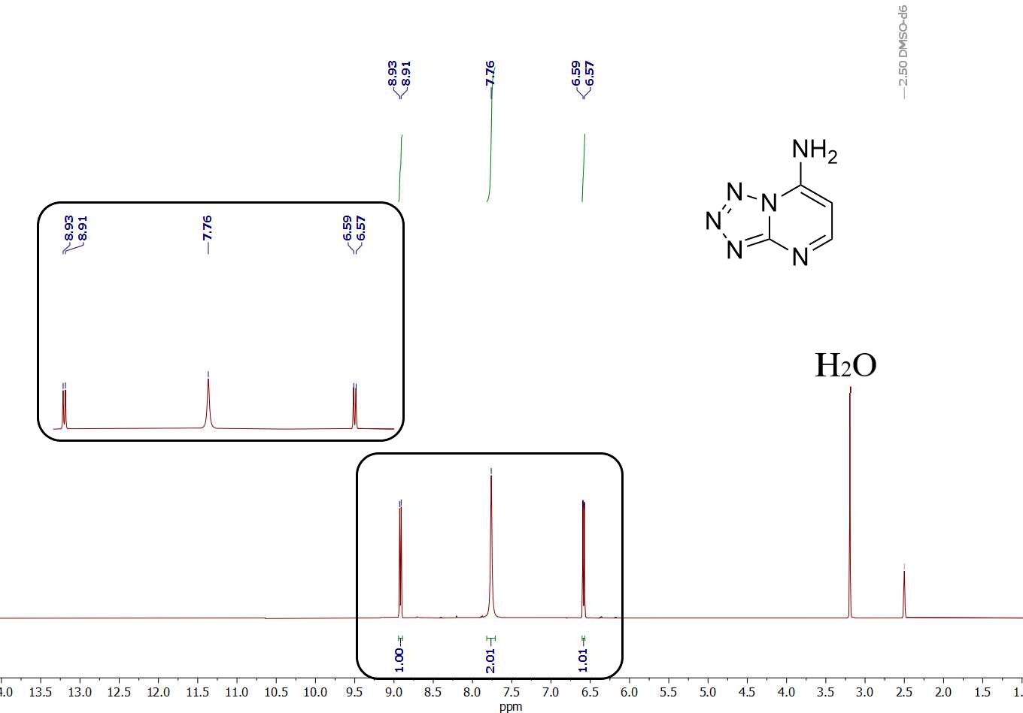
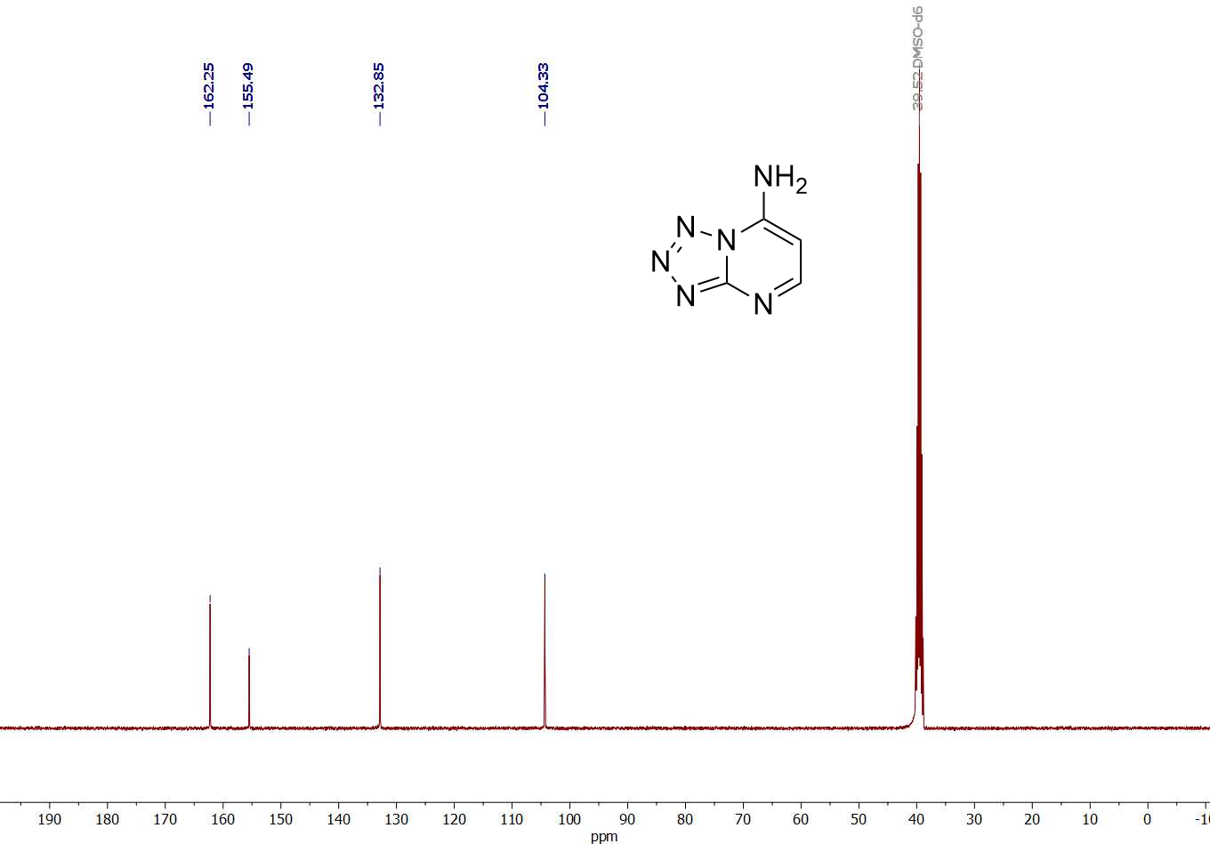
Figure S1. ¹H NMR (400 MHz, DMSO-d6) and ¹³C NMR (100 MHz, DMSO-d6) spectra of tetrazolo[1,5-a]pyrimidin-7-amine 3
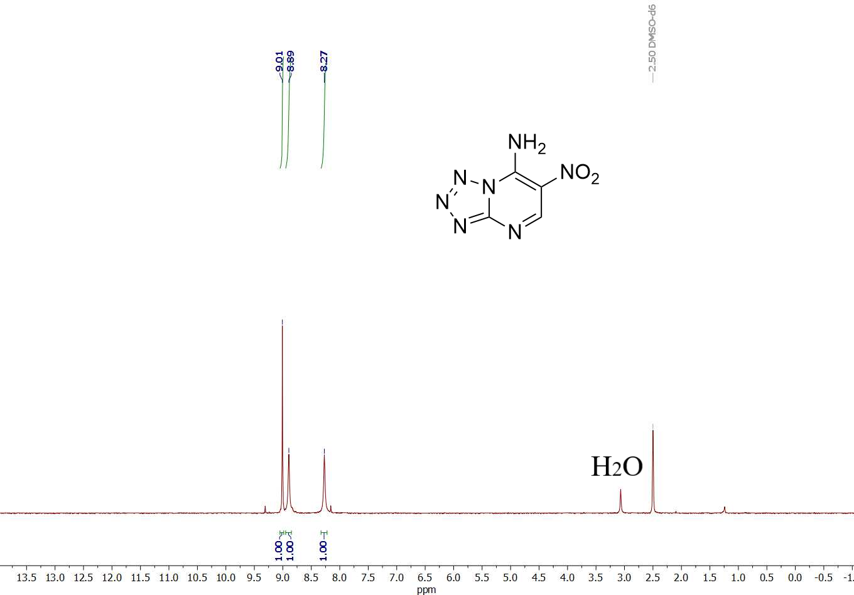
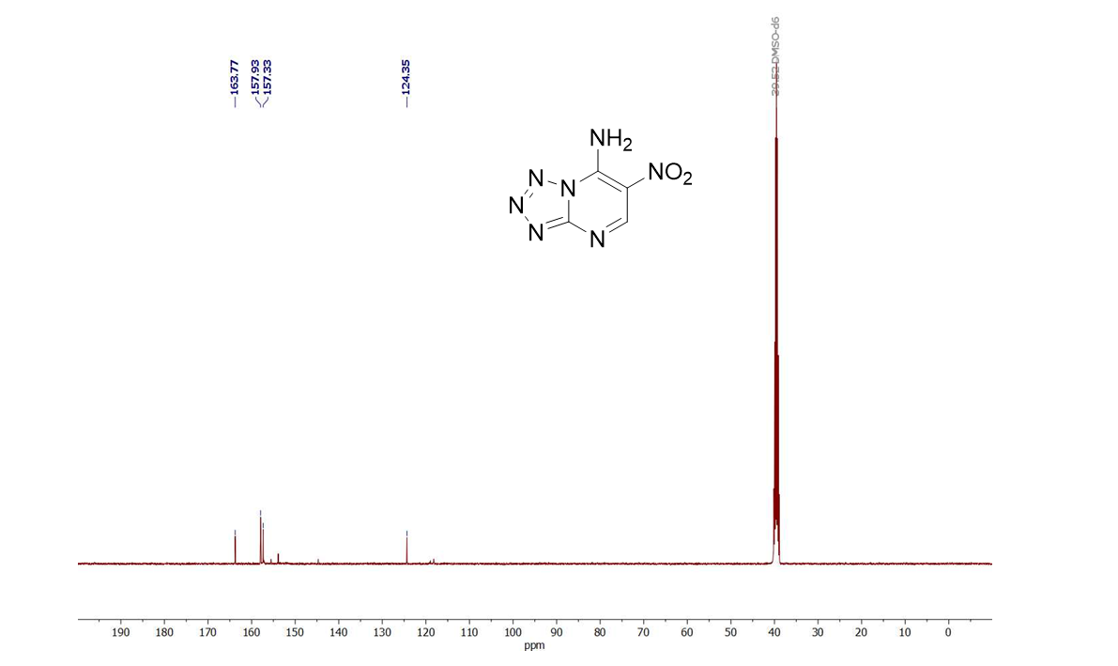
Figure S2. ¹H NMR (400 MHz, DMSO-d6) and ¹³C NMR (100 MHz, DMSO-d6) spectra of 6-nitrotetrazolo[1,5-a]pyrimidin-7-amine 4
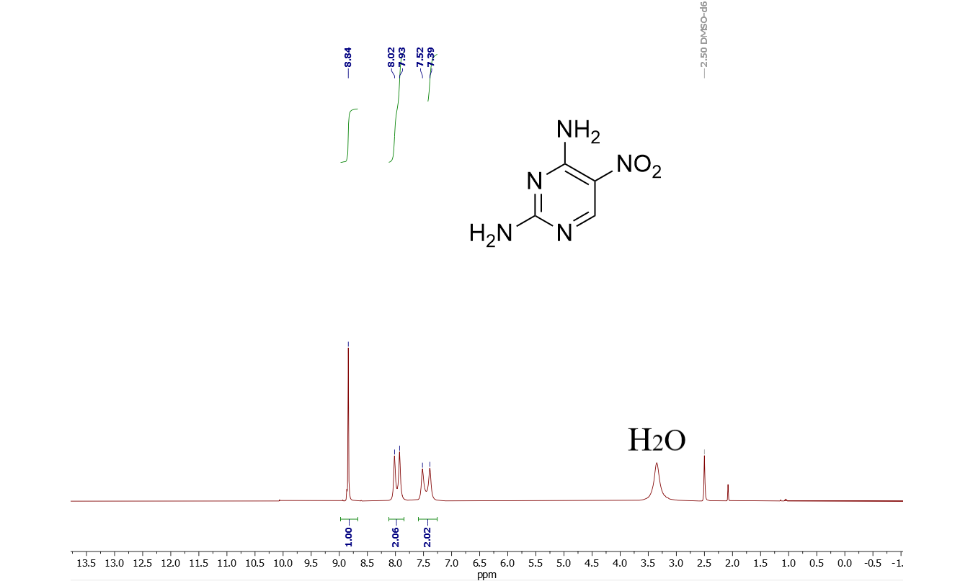

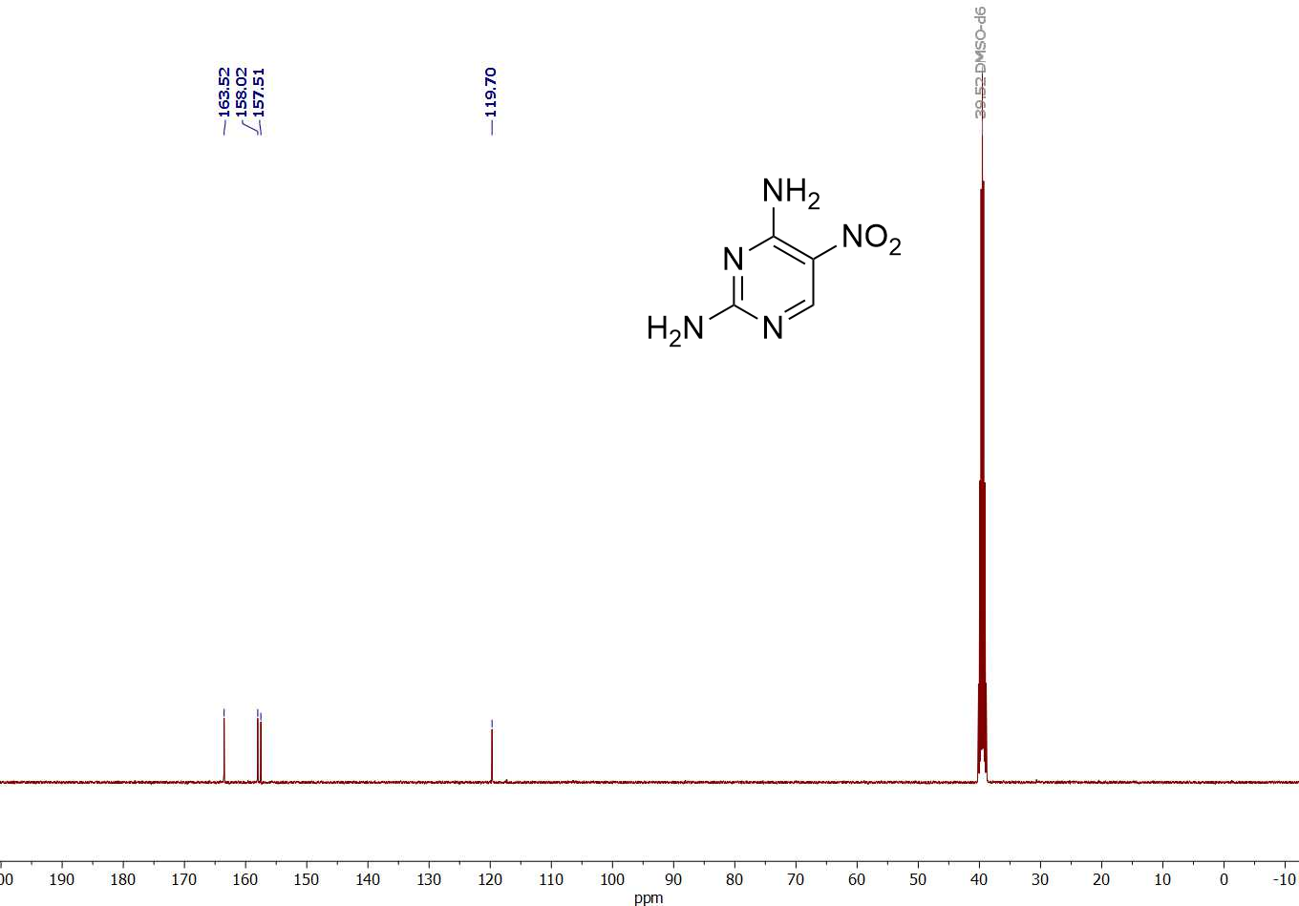
Figure S3. ¹H NMR (400 MHz, DMSO-d6) and ¹³C NMR (100 MHz, DMSO-d6) spectra of 5

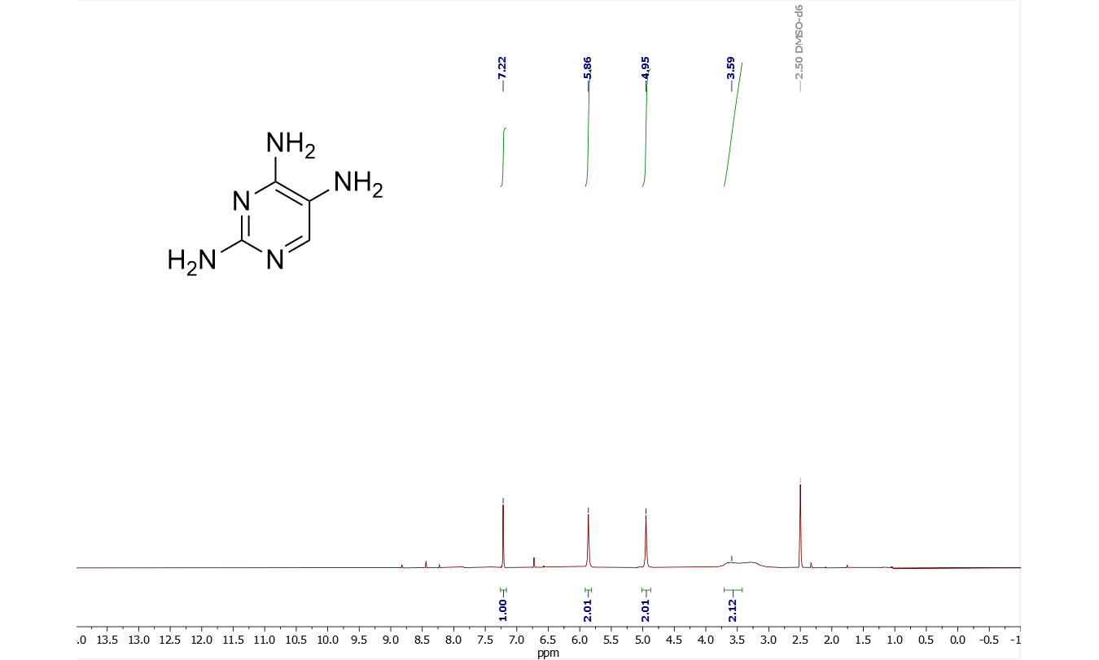

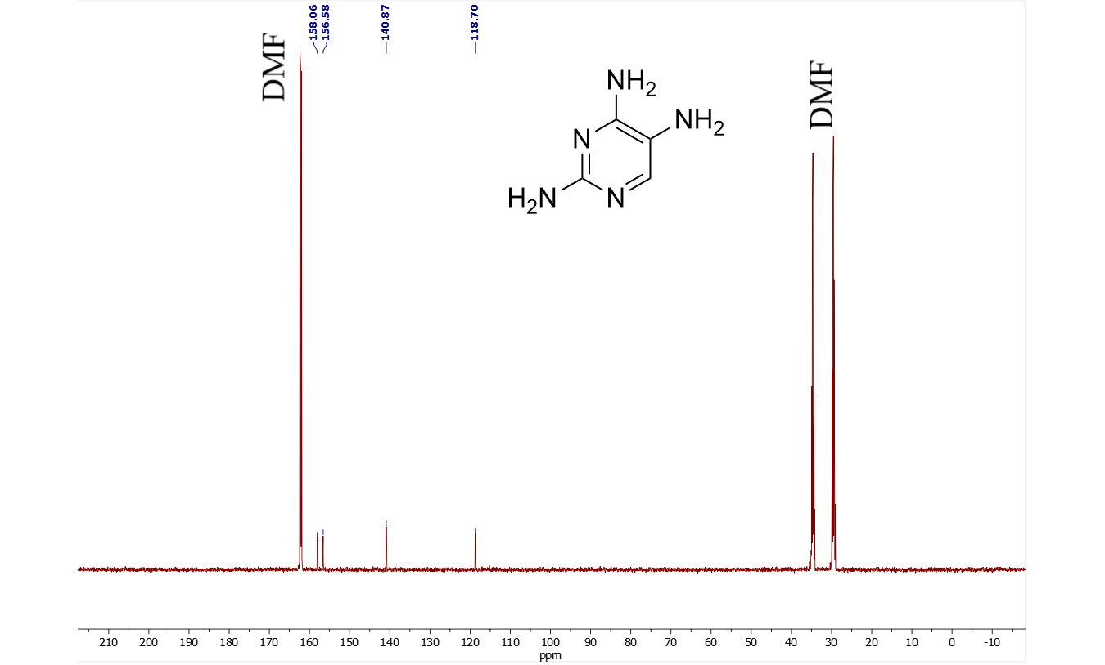
Figure S4. ¹H NMR (400 MHz, DMSO-d6) and ¹³C NMR (151 MHz, DMF-d7) spectra of pyrimidine-2,4,5-triamine 6

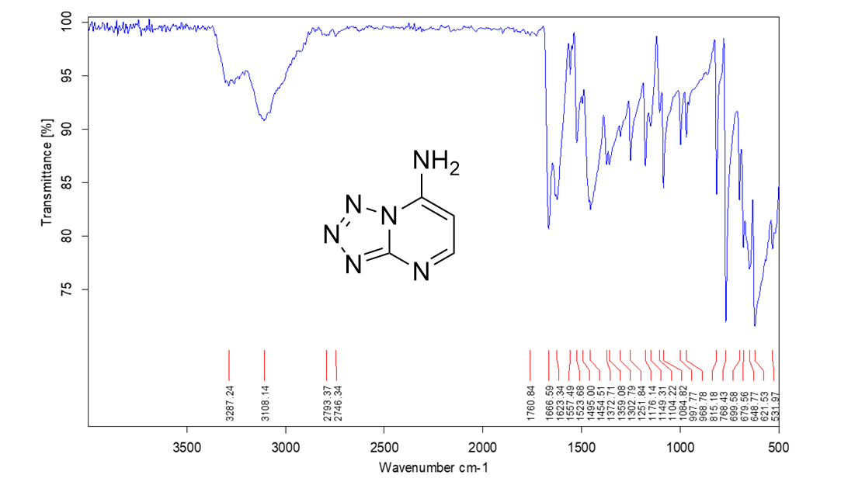
Figure S5. IR spectra of tetrazolo[1,5-a]pyrimidin-7-amine 3
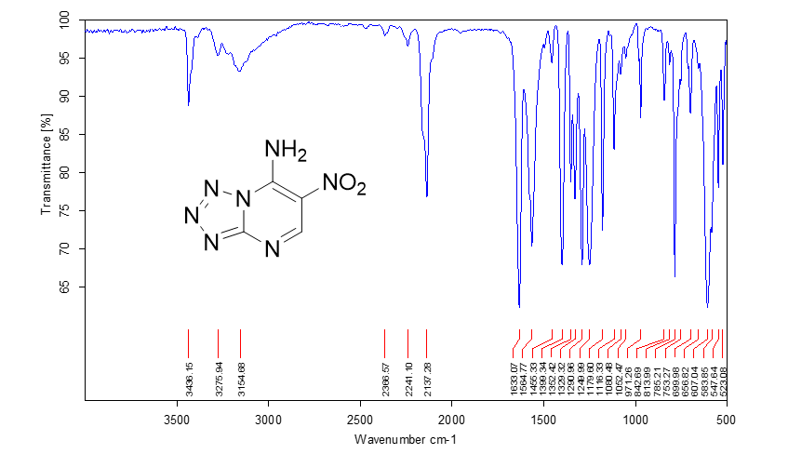
Figure S6. IR spectra of 6-nitrotetrazolo[1,5-a]pyrimidin-7-amine 4

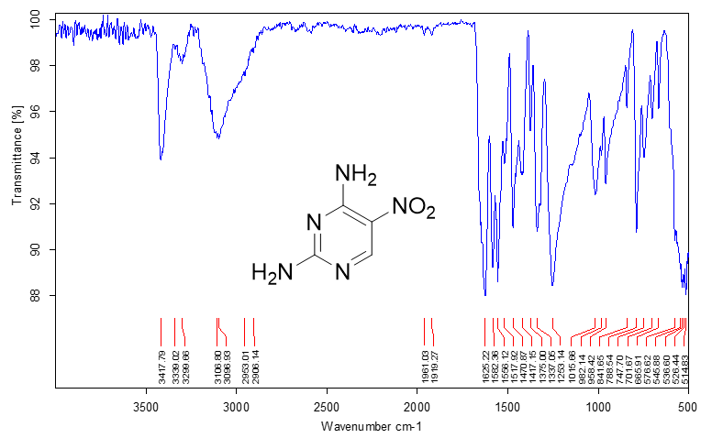
Figure S7. IR spectra of 5-nitropyrimidine-2,4-diamine 5

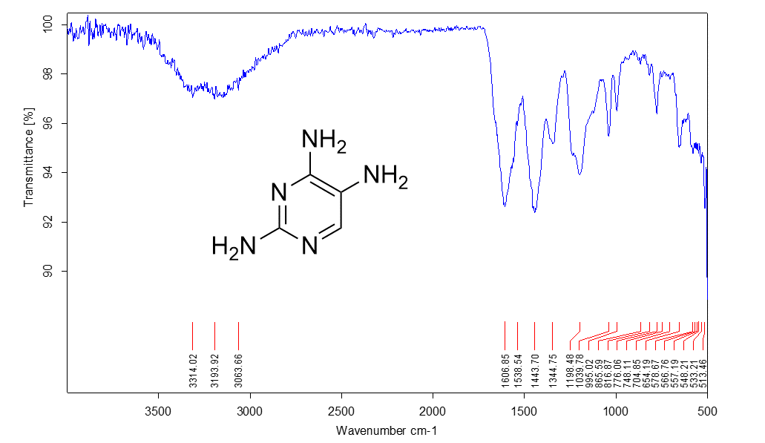
Figure S8. IR spectra of pyrimidine-2,4,5-triamine 6

2. Crystallography
D-H | d(D-H) | d(H..A) | <DHA | d(D..A) | A
N1A-H1A | 0.86(3) | 2.26(3) | 163(2) | 3.093(4) | Cl1 [2-x, 1-y, 1-z]
N2A-H2AA | 0.95(4) | 1.87(4) | 176(2) | 2.814(4) | O00H [2-x, 1-y, 1-z]
N2A-H2AB | 0.85(4) | 2.43(4) | 159(2) | 3.237(4) | Cl2 [x, y+1, z-1]
N4A-H4AA | 0.95(4) | 2.48(4) | 146(2) | 3.312(4) | Cl2 [1-x, -y, 1-z]
N4A-H4AA | 0.95(4) | 2.02(4) | 122(2) | 2.658(4) | O1A
N4A-H4AB | 0.80(4) | 2.28(4) | 167(2) | 3.064(4) | N3A [1-x, 1-y, -z]
N1-H1 | 0.81(3) | 2.38(3) | 154(2) | 3.129(4) | Cl2
N1-H1 | 0.81(3) | 2.58(3) | 124(2) | 3.100(4) | O1A [1-x, -y, 1-z]
N2-H2A | 0.87(4) | 2.33(4) | 166(2) | 3.176(4) | Cl1 [x+1, y, z]
N2-H2B | 0.92(4) | 2.38(4) | 151(2) | 3.212(4) | Cl2
N4-H4A | 0.82(3) | 2.57(3) | 146(2) | 3.287(4) | Cl1 [1-x, 1-y, 1-z]
N4-H4A | 0.82(3) | 2.12(3) | 125(2) | 2.684(4) | O1
N4-H4B | 0.85(3) | 2.22(3) | 169(2) | 3.064(4) | N3 [2-x, 1-y, 1-z]
C6-H6 | 0.930 | 2.414 | 125.3 | 3.047(4) | O1A [1-x, -y, 1-z]
C6A-H6A | 0.930 | 2.390 | 163.4 | 3.292(4) | O1 [x+1, y, z]
Table S1. Hydrogen bonds with H..A < r(A) + 2.000 Å and <DHA > 110º.

