Supplementary Material

- Methodology for obtaining climatic map covariates via statistical downscaling: comprehensive technical steps
This supplementary section provides a comprehensive overview of the technical steps employed to generate climatic map covariates, as outlined in the main text. At first, we established a correlation between Reanalysis Temperature data from Worldclim and an elevation raster with a spatial resolution of 1x1 km, as expressed by the following equation:
T = -E+2333.3/174.15 Eq S1
Where T is the predicted annual temperature in °C and E is the elevation in m.
Subsequently, Equation S1 was employed to predict temperature values for each individual pixel within a high-resolution Digital Terrain Model (DTM) of the study area, with spatial resolution of 20 X 20 m.
To obtain a more accurate temperature assessment, we introduced a correction approach based on geomorphometric attributes extracted from the DTM. This correction aims to capture the thermal variations controlled by the valley topography. Specifically, the correction is based on the empirical equations of Belloni and Pelfini (1987), which take aspect into account, supplemented by an additional slope factor introduced in this study. Aspect is taken into account via the Northness Index (cosine of the aspect in radians), allowing the K1 factor to be calculated:
K1 = -0.2914 x Northness Index Eq S2
The K2 factor is used to account for the slope:
K2 = 0.02 x Slope (%) Eq S3
Finally, K3 (final correction) is calculated as the product of K1 and K2:
K3 = K1 x K2 Eq S4
The resulting value, expressed in degrees Celsius, is then either added to or subtracted from the initial temperature estimation derived from the elevation-temperature regression.
For the prediction and mapping of precipitation, a nonlinear empirical correlation between elevation, latitude (North coordinates), and longitude (East coordinates) was employed:
P = (-25009.26-933.87×Long +757.44×Lat -0.0000000906×E³+0.0002959×E²-0.21628×E) Eq S5
Where P is the predicted annual precipitation (mm), Long is the longitude (m UTM), Lat is the latitude (m UTM), E is the elevation (m).
Figure S1 shows the obtained climate maps.

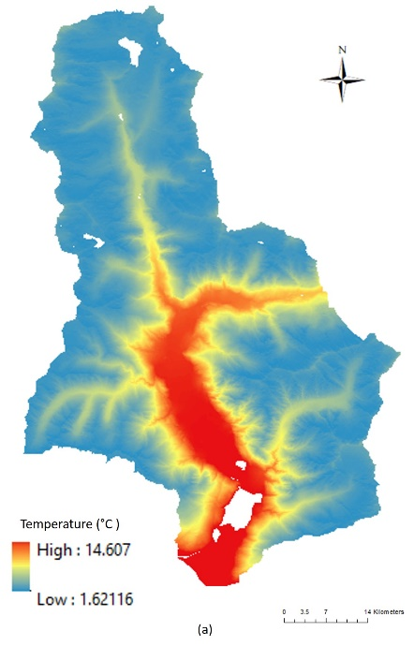 | 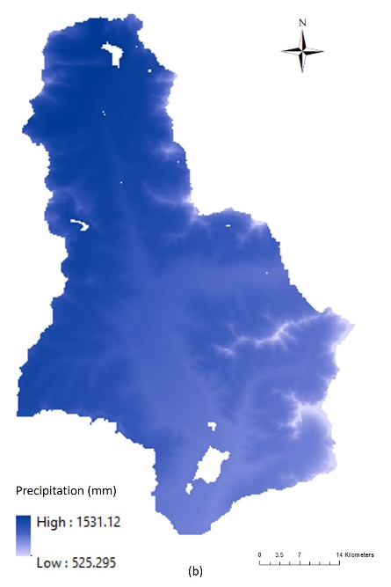 | 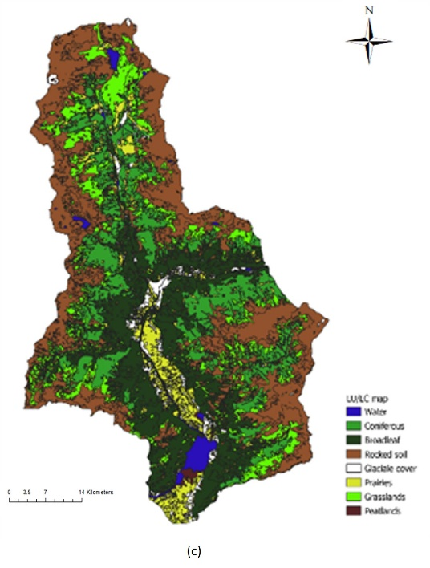
Figure S1: Climatic maps from downscaling approach and the land cover map: (a) Temperature map; (b) Precipitation map; (c) Land cover map (DUSAF).

- Supplementary analysis of statistical results and model validation
Table S1: Results of ANOVA (Tukey's Post-Hoc Test) for comparison of SOC stock 10 and land cover (CF: Coniferous forests; P: Prairies; GR: Grasslands; BF: Broadleaf forests; RS: Rocky soils; PT: Peatlands) (red for significance level <0.05).
Land cover | CF | P | GR | BF | RS | PT
CF |  | 0.989495 | 0.998613 | 0.999668 | 0.019960 | 0.058766
P | 0.989495 |  | 0.386496 | 0.999672 | 0.008412 | 0.000747
GR | 0.998613 | 0.386496 |  | 0.936488 | 0.000211 | 0.011557
BF | 0.999668 | 0.999672 | 0.936488 |  | 0.019843 | 0.011353
RS | 0.019960 | 0.008412 | 0.000211 | 0.019843 |  | 0.000121
PT | 0.058766 | 0.000747 | 0.011557 | 0.011353 | 0.000121

Table S2: Results of ANOVA (Tukey's Post-Hoc Test) for comparison of SOC stock 30 and land cover (CF: Coniferous forests; P: Prairies; GR: Grasslands; BF: Broadleaf forests; RS: Rocky soils; P: Peatlands)(red for significance level <0.05).
Land cover | CF | P | GR | BF | RS | PT
CF |  | 0.999937 | 0.996404 | 0.999864 | 0.173845 | 0.000202
P | 0.999937 |  | 0.770880 | 0.990456 | 0.061761 | 0.000120
GR | 0.996404 | 0.770880 |  | 0.999943 | 0.004853 | 0.000121
BF | 0.999864 | 0.990456 | 0.999943 |  | 0.056134 | 0.000152
RS | 0.173845 | 0.061761 | 0.004853 | 0.056134 |  | 0.000120
PT | 0.000202 | 0.000120 | 0.000121 | 0.000152 | 0.000120

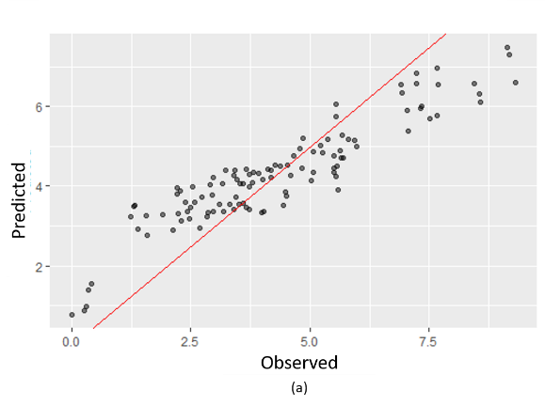 | 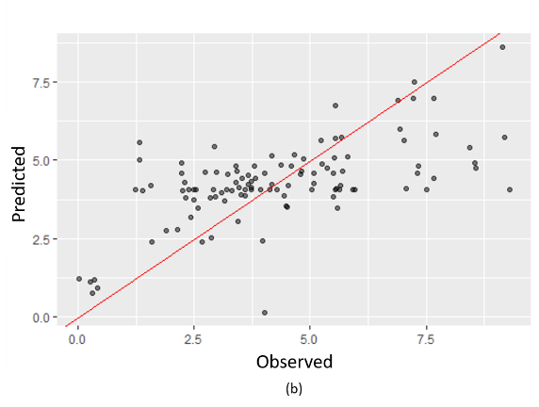
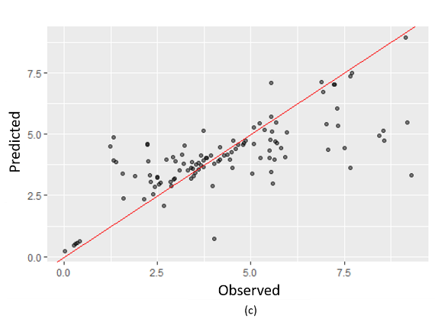 | 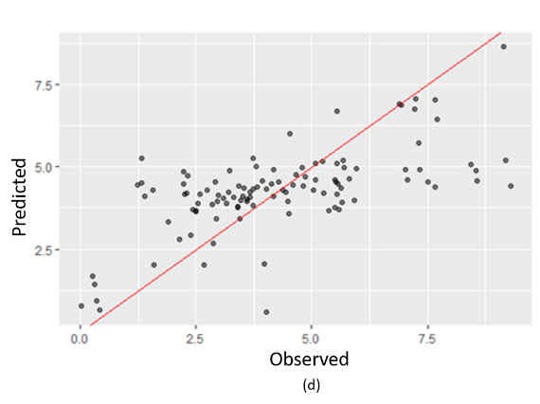

Figure S2: Biplot of SOC stock 10 observed and predicted data: (a) RF; (b) MARS; (c) SVR; (d) ENET.

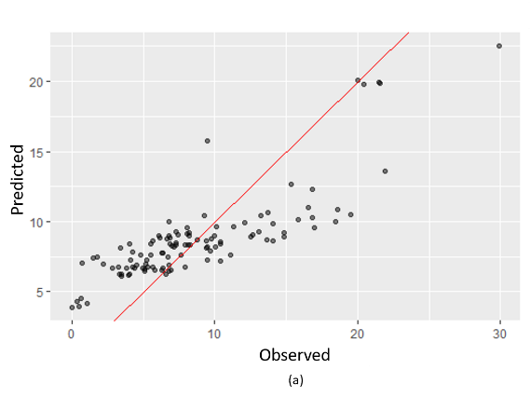 | 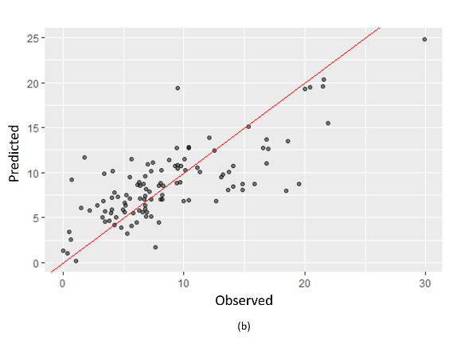
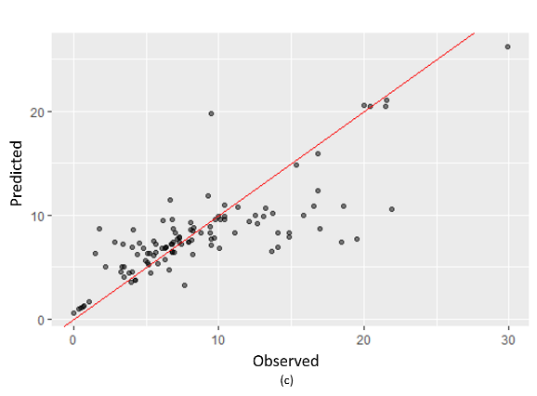 | 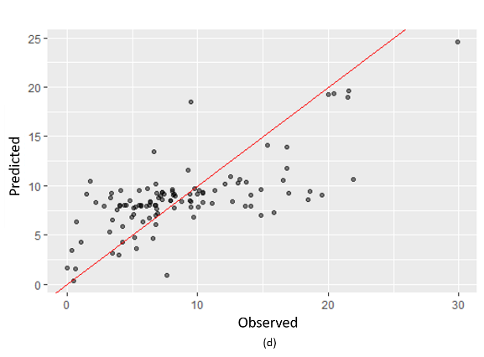
Figure S3: Biplot of SOC stock 30 observed and predicted data: (a) RF; (b) MARS; (c) SVR; (d) ENET.

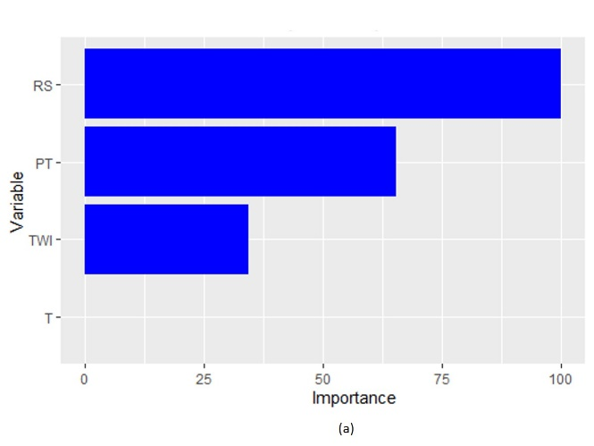 | 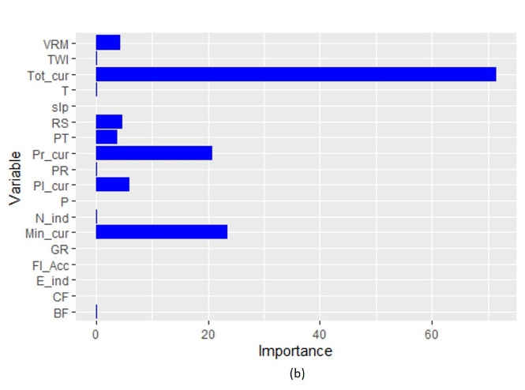
Figure S4: Variables importance of a) MARS and b) ENET model in the prediction of SOC stock 10 (See table 01 for the variables names abbreviation).

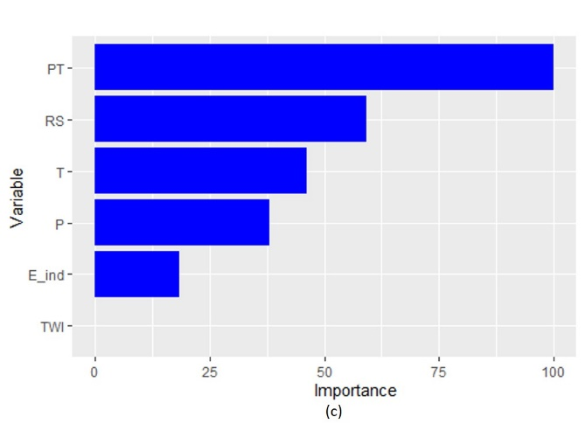 | 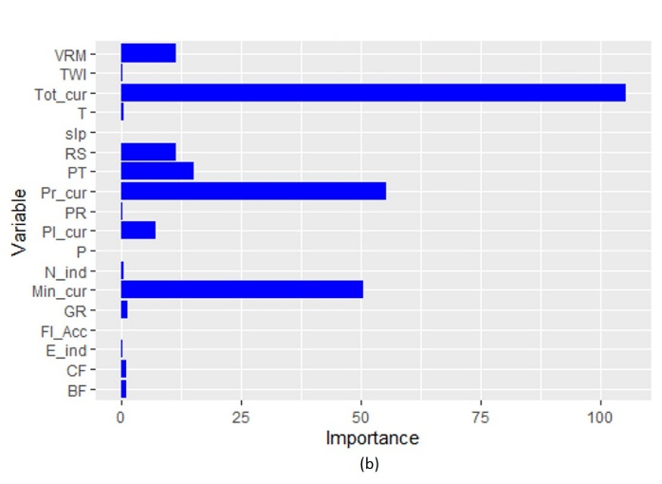
Figure S5: Variables importance of a) MARS and b) ENET model in the prediction of SOC stock 30 (See table 01 for the variables names abbreviation).

References:
https://www.worldclim.org/
https://www.geoportale.regione.lombardia.it/news/-/asset_publisher/80SRILUddraK/content/dusaf-7.0-uso-e-copertura-del-suolo-2023

