Supplemental table S1. PCR primers.
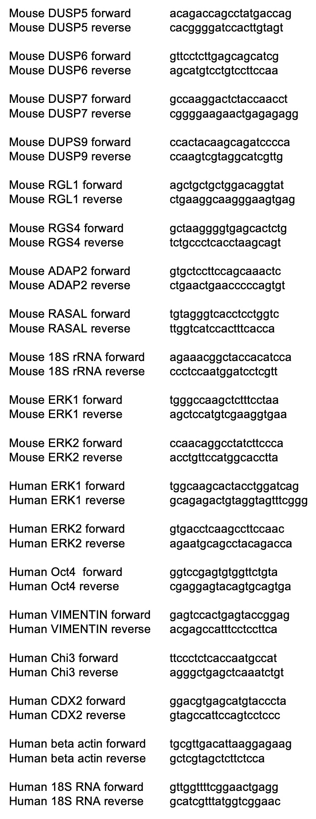

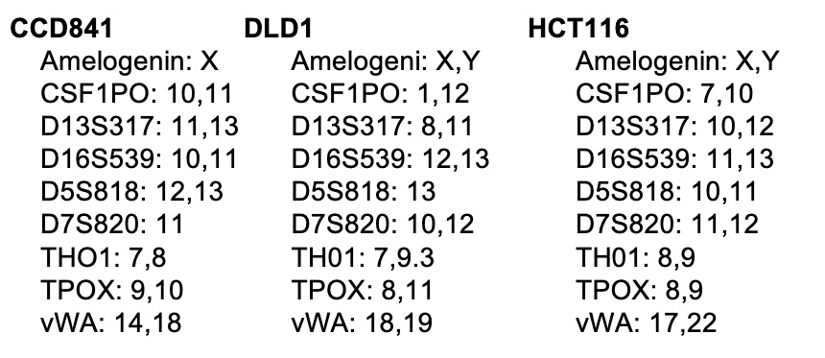
Supplemental Figure S1. STRs of cell CCD841, DLD1, and HCT116 showing marked differences between cell lines.

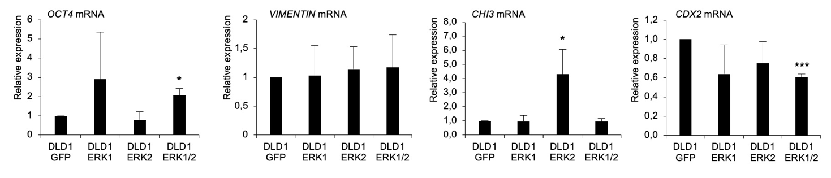
Supplemental Figure S2. OCT4, VIMENTIN, CHI3, and CDX2 differentiation marker expression in DLD1 cells expressing GFP, ERK1, ERK2, or ERK1/2. The data did not show any effect for ERK1 in the differentiation of the cells. The p-values are *p<0.05, **p<0.01, ***p<0.001, and ****p<0.0001. The p-value was determined using GFP expressing cells as a comparison control.

