Supplementary materials
Organic matter accelerated microbial iron reduction and available phosphorus release in reflooded paddy soils
Xipeng Liu^{1, 2, #}, Yuchen Shu^{1, #}, Kejie Li^{1#}, Haotian Wang³, Qingfang Bi^{1, 4}, Haibo Wang¹, Chengliang Sun¹, Xianyong Lin^{1*}
1 MOE Key Laboratory of Environment Remediation and Ecological Health, College of Environmental and Resource Sciences, Zhejiang University, Hangzhou 310058, China
2 Microbial Ecology cluster, Genomics Research in Ecology and Evolution in Nature (GREEN), Groningen Institute for Evolutionary Life Sciences (GELIFES), University of Groningen, 9747 AG Groningen, The Netherlands
3 Thünen Institute of Biodiversity, D-38116, Braunschweig, Germany
4 Max Planck Institute for Biogeochemistry, Jena, 07745, Germany

* Corresponding authors: Xianyong Lin (xylin@zju.edu.cn)
# The authors contributed to the manuscript equally.

The supplementary information includes the Figures S1-4 and Tables 1-5.

Supplementary Figures
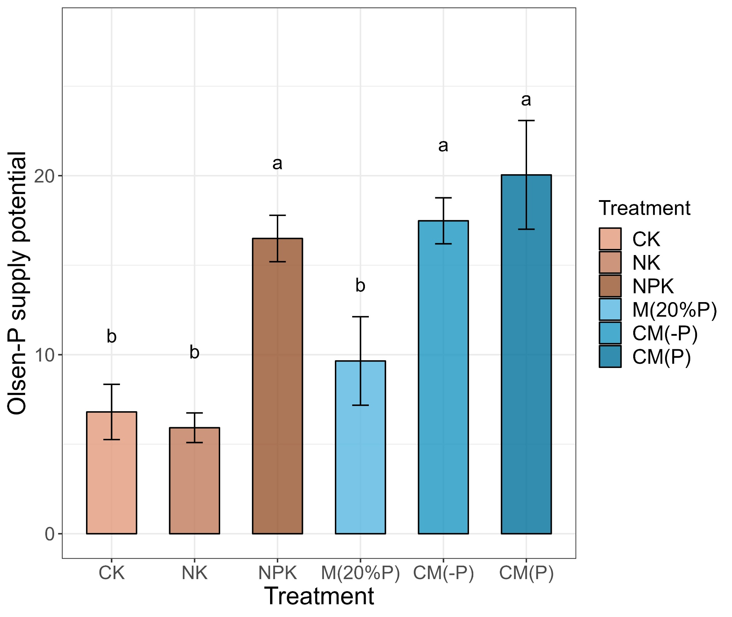
Figure S1. P activation potential supplying to plants under anaerobic flooding conditions, calculated as the difference between the Olsen-P content at day 0 and day 25 (ΔOlsen-P, mg kg⁻¹). Error bar represents the standard deviation. Letters above bars indicate significant difference between treatments testing with ANOVA with Tukey’s test (p < 0.05).
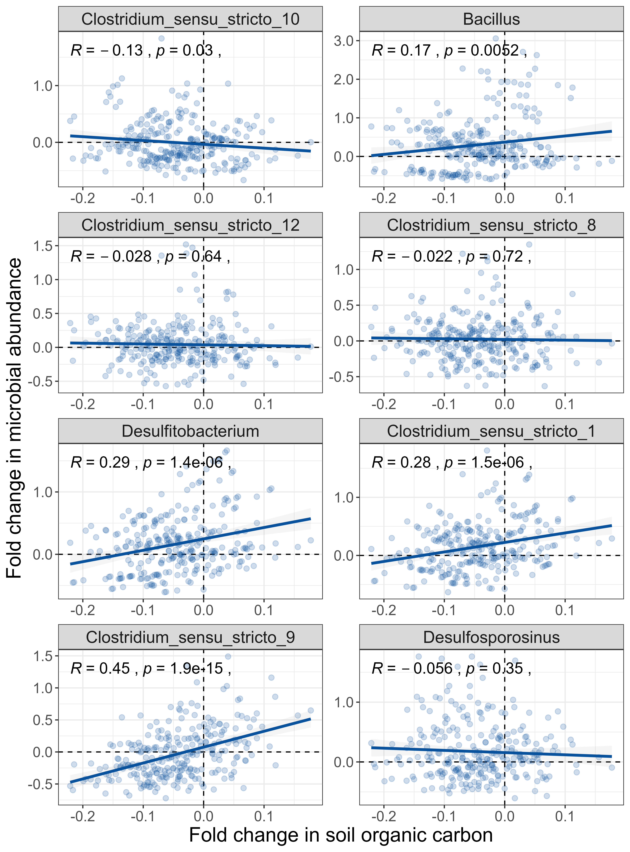
Figure S2. The Pearson’s correlation between (pairwise) fold changes in soil organic carbon content and the relative abundance of major iron-reducing microbes.
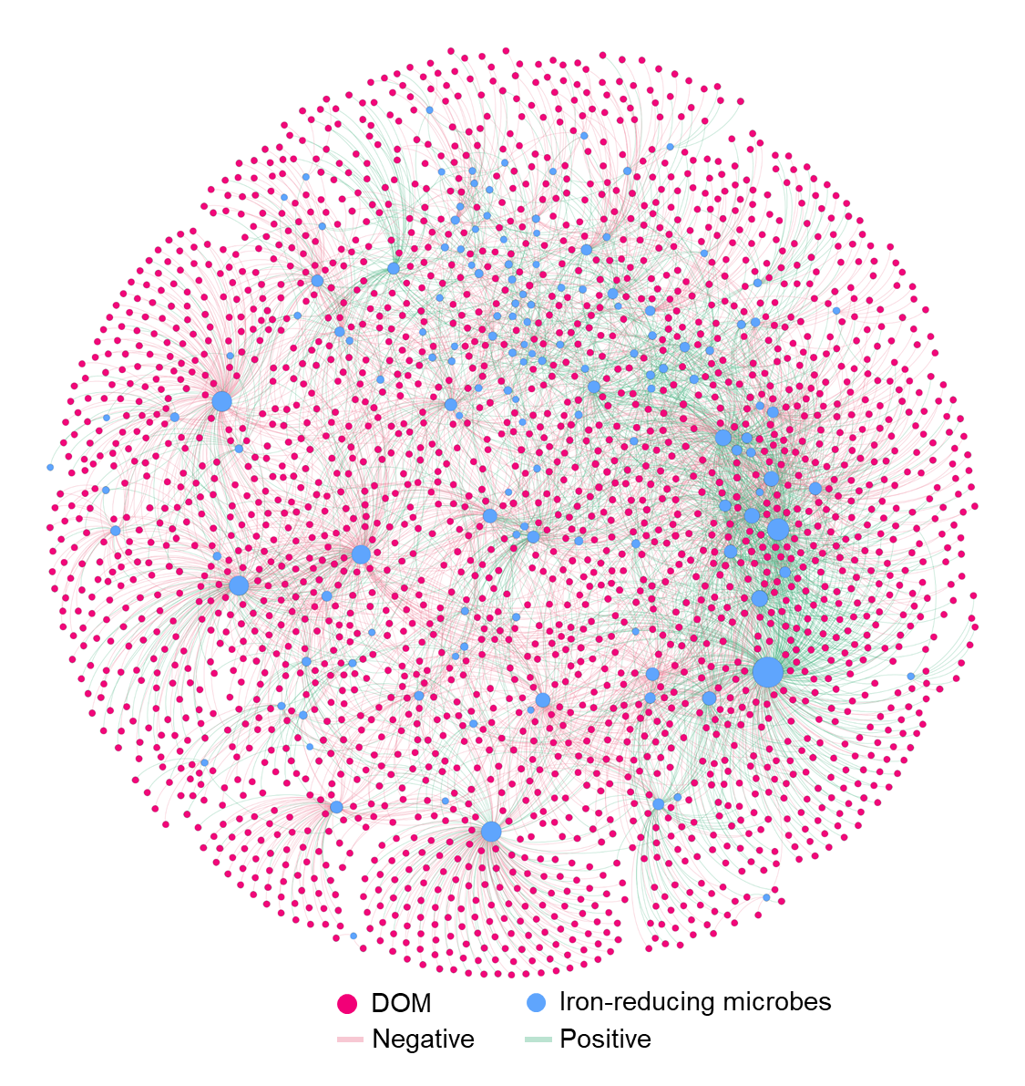
Figure S3. Network analysis of associations between DOM and iron-reducing microbes. Only significant correlations (the absolute value of R > 0.6 and p < 0.01) between DOM and iron-reducing microbes or among iron-reducing microbes were included in this network. Blue and red dots represent iron-reducing microbe and DOM, respectively. Green and pink links represent positive and negative correlations, respectively.
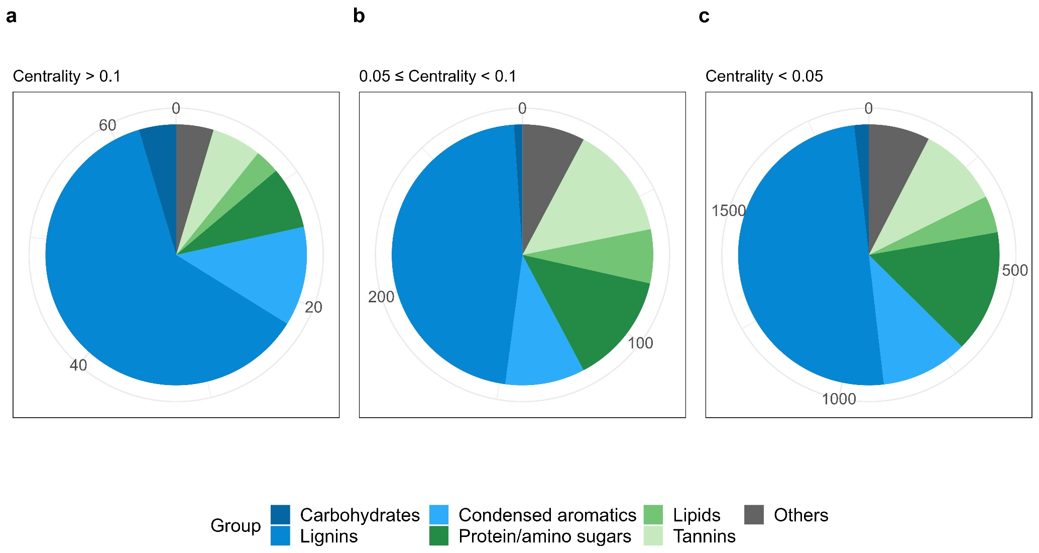
Figure S4. The count of DOM’s classifications with different centrality within the network.

Supplementary Tables
Table S1 Fertilization treatment and nutrient input in the field experiment (kg ha⁻¹)
Crop | Treatment | Chemical (kg ha⁻¹) |  |  |  | Organic (kg ha⁻¹)
 |  | N | P₂O₅ | K₂O |  | N | P₂O₅ | K₂O
Early-season rice | CK | 0 | 0 | 0 |  | 0 | 0 | 0
 | NK | 165 | 0 | 150 |  | 0 | 0 | 0
 | NPK | 165 | 90 | 150 |  | 0 | 0 | 0
 | M(20%P) | 0 | 0 | 0 |  | 11 | 18 | 5
 | CM(P) | 154 | 72 | 145 |  | 11 | 18 | 5
 | CM(-P) | 154 | 58 | 145 |  | 11 | 18 | 5
Late-season rice | CK | 0 | 0 | 0 |  | 0 | 0 | 0
 | NK | 195 | 0 | 150 |  | 0 | 0 | 0
 | NPK | 195 | 90 | 150 |  | 0 | 0 | 0
 | M(20%P) | 0 | 0 | 0 |  | 9 | 18 | 5
 | CM(P) | 187 | 72 | 145 |  | 9 | 18 | 5
 | CM(-P) | 187 | 58 | 145 |  | 9 | 18 | 5

Table S2 Physicochemical properties of the paddy soil, rice yield, and aboveground P uptake under 5-year different fertilization regimes.
Treatment | CK | NK | NPK | M(20%P) | CM(-P) | CM(P) | p value
pH | 5.30b | 5.17c | 5.18c | 5.28b | 5.44a | 5.49a | ***
SOC (g kg⁻¹) | 28.15ab | 27.72b | 29.63ab | 27.33b | 30.67a | 30.96a | **
Fe_{ox} (g kg⁻¹) | 2.23b | 2.19b | 1.96c | 2.50a | 2.30b | 2.30b | ***
Al_{ox} (g kg⁻¹) | 0.84ab | 0.82ab | 0.87a | 0.77b | 0.87a | 0.80ab | *
P_{ox} (mg kg⁻¹) | 49.52b | 12.14c | 165.41a | 60.72b | 158.25a | 147.92a | ***
TP (mg kg⁻¹) | 436.38cd | 401.00d | 582.09a | 446.07c | 535.45b | 533.10b | ***
DPS (%) | 2.25c | 0.56d | 7.93a | 2.67c | 6.96b | 6.74b | ***
NH₄⁺(mg kg⁻¹) | 66.80b | 102.81a | 101.78a | 73.47b | 97.48a | 104.15a | ***
NO₃⁻(mg kg⁻¹) | 67.54b | 117.74a | 120.84a | 61.33b | 111.32a | 107.92a | ***
Rice yield (Mg ha⁻¹) | 4.76d | 6.13c | 7.00b | 4.97d | 7.30ab | 7.57a | ***
Aboveground P uptake (kg ha⁻¹) | 13.55d | 24.72c | 31.83b | 14.94d | 32.71ab | 35.03a | ***
Different letter in the same row means significant differences at p < 0.05 tested with ANOVA Tukey’s HSD. SOC, soil organic matter; Fe_{ox}, Al_{ox}, and P_{ox}, ammonium oxalate extracted Fe, Al, and P, respectively; TP, total P; DPS, degree of P saturation.

Table S3 The parameters of logistics models for microbial Fe(III) reduction of soils under different fertilization regimes during the anaerobic incubation.
Treatment | Logistic model
 | a (mg g⁻¹) | V_{max}  (mg g⁻¹ d⁻¹) | T_{max} (d) | R²
CK | 4.76a | 0.34b | 6.26b | 0.99
NK | 4.77a | 0.29c | 6.82a | 0.98
NPK | 4.53b | 0.35b | 4.62d | 0.96
M(20%P) | 4.79a | 0.35b | 5.85c | 0.99
CM(P) | 4.66ab | 0.45a | 4.15e | 0.97
CM(-P) | 4.66ab | 0.45a | 4.20e | 0.96
a, the maximum iron reduction potential (P_{max}); V_{max}, maximum iron reduction rate; T_{max}, time to achieve the V_{max}; R², fitting coefficient of the model.

Table S4 The α-diversity of soil bacteria under different fertilization regimes.
Treatment | Richness | Chao1 | Shannon
CK | 1957a | 2189.01a | 8.53a
NK | 1940a | 2165.04a | 8.48a
NPK | 1918a | 2190.38a | 7.28b
M(20%P) | 2067a | 2182.29a | 8.51a
CM(P) | 2057a | 2385.28a | 8.36a
CM(-P) | 1988a | 2229.54a | 8.39a

Table S5 The typical iron-reducing microbes classified in this study.
No. | Genus | Family
1 | Acinetobacter | Moraxellaceae
2 | Alicyclobacillus | Alicyclobacillaceae
3 | Anaeromyxobacter | Anaeromyxobacteraceae
4 | Bacillus | Bacillaceae
5 | Brevibacillus | Brevibacillaceae
6 | Candidatus_Arthromitus | Clostridiaceae
7 | Clostridium | Caloramatoraceae
8 | Clostridium_sensu_stricto_1 | Clostridiaceae
9 | Clostridium_sensu_stricto_2 | Clostridiaceae
10 | Clostridium_sensu_stricto_3 | Clostridiaceae
11 | Clostridium_sensu_stricto_5 | Clostridiaceae
12 | Clostridium_sensu_stricto_6 | Clostridiaceae
13 | Clostridium_sensu_stricto_7 | Clostridiaceae
14 | Clostridium_sensu_stricto_8 | Clostridiaceae
15 | Clostridium_sensu_stricto_9 | Clostridiaceae
16 | Clostridium_sensu_stricto_10 | Clostridiaceae
17 | Clostridium_sensu_stricto_11 | Clostridiaceae
18 | Clostridium_sensu_stricto_12 | Clostridiaceae
19 | Clostridium_sensu_stricto_13 | Clostridiaceae
20 | Clostridium_sensu_stricto_16 | Clostridiaceae
21 | Clostridium_sensu_stricto_19 | Clostridiaceae
22 | Desulfitobacterium | Desulfitobacteriaceae
23 | Desulfobacca | Desulfobaccaceae
24 | Desulfobulbus | Desulfobulbaceae
25 | Desulfosporosinus | Desulfitobacteriaceae
26 | Desulfotomaculum | unidentified_Desulfotomaculales
27 | Desulfovirga | Syntrophobacteraceae
28 | Novosphingobium | Sphingomonadaceae
29 | Paenibacillus | Paenibacillaceae
30 | Pseudomonas | Pseudomonadaceae
31 | Sphingomonas | Sphingomonadaceae
32 | Symbiobacterium | Symbiobacteraceae
33 | Syntrophobacter | Syntrophobacteraceae
34 | Syntrophorhabdus | Syntrophorhabdaceae

