Supplementary materials
Comprehensive transcriptome profiling of T-2 toxin-induced nephrotoxicity in mice
Guoquan Wu¹, Xuan Wu^{2,3}, Yige Wu¹, Yuping Wu⁴, Hui Li²*, Chongshan Dai¹*

¹ National Key Laboratory of Veterinary Public Health and Safety, College of Veterinary Medicine, China Agricultural University, Beijing 100193, China.
² Beijing Key Laboratory of Diagnostic and Traceability Technologies for Food Poisoning, Beijing Center for Disease Prevention and Control, Beijing, China.
³ School of Public Health, Capital Medical University, Beijing 100069, China.
⁴ College of Life Science and Basic Medicine, Center for Biotechnology Research, Xinxiang University, Xinxiang, Henan, 453003, China.
Corresponding author. E-mail address: lihui@bjcdc.org (H.L.); daichongshan@cau.edu.cn (C.S.D.).
A
B
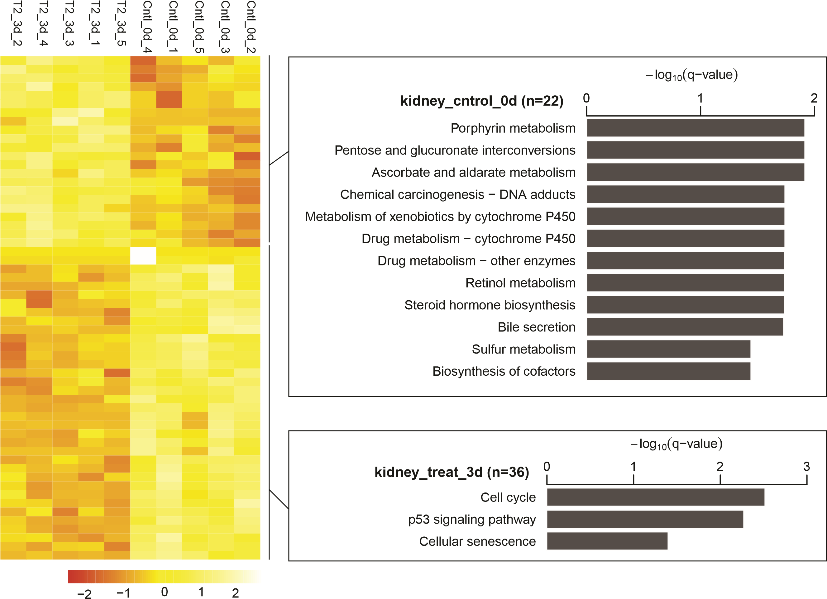
Figure S1 Transcriptome profiling of mice kidney at 3 d after T-2 toxin exposure.
(A) GO function enrichment of DEGs in TG_3d group using Metascape software. The horizontal coordinate is the number of DEGs and the vertical coordinate is the categorical entry of GO.
(B) Heatmap representation of Z score-transformed FPKM of genes predominantly expressed in TG_3d group (left). The genes are ranked in descending order according to their FPKM. Overrepresented pathways are shown on the right. The top ranked pathways are shown with q-values.
Pentose and glucuronate interconversions
Ascorbate and aldarate metabolism
Drug metabolism − other enzymes
p53 signaling pathway
Cell cycle
Porphyrin metabolism
Rrm2
Cdk1
Ccnb1
Cdc20
Ccna2
Ugt2a2
Alas2
Ugt2b35
Figure S2 Sankey diagram of KEGG pathway from overrepresentation analysis based on overlapping up-regulated and down-regulated genes in mice kidney at 3d after T-2 toxin exposure.
A

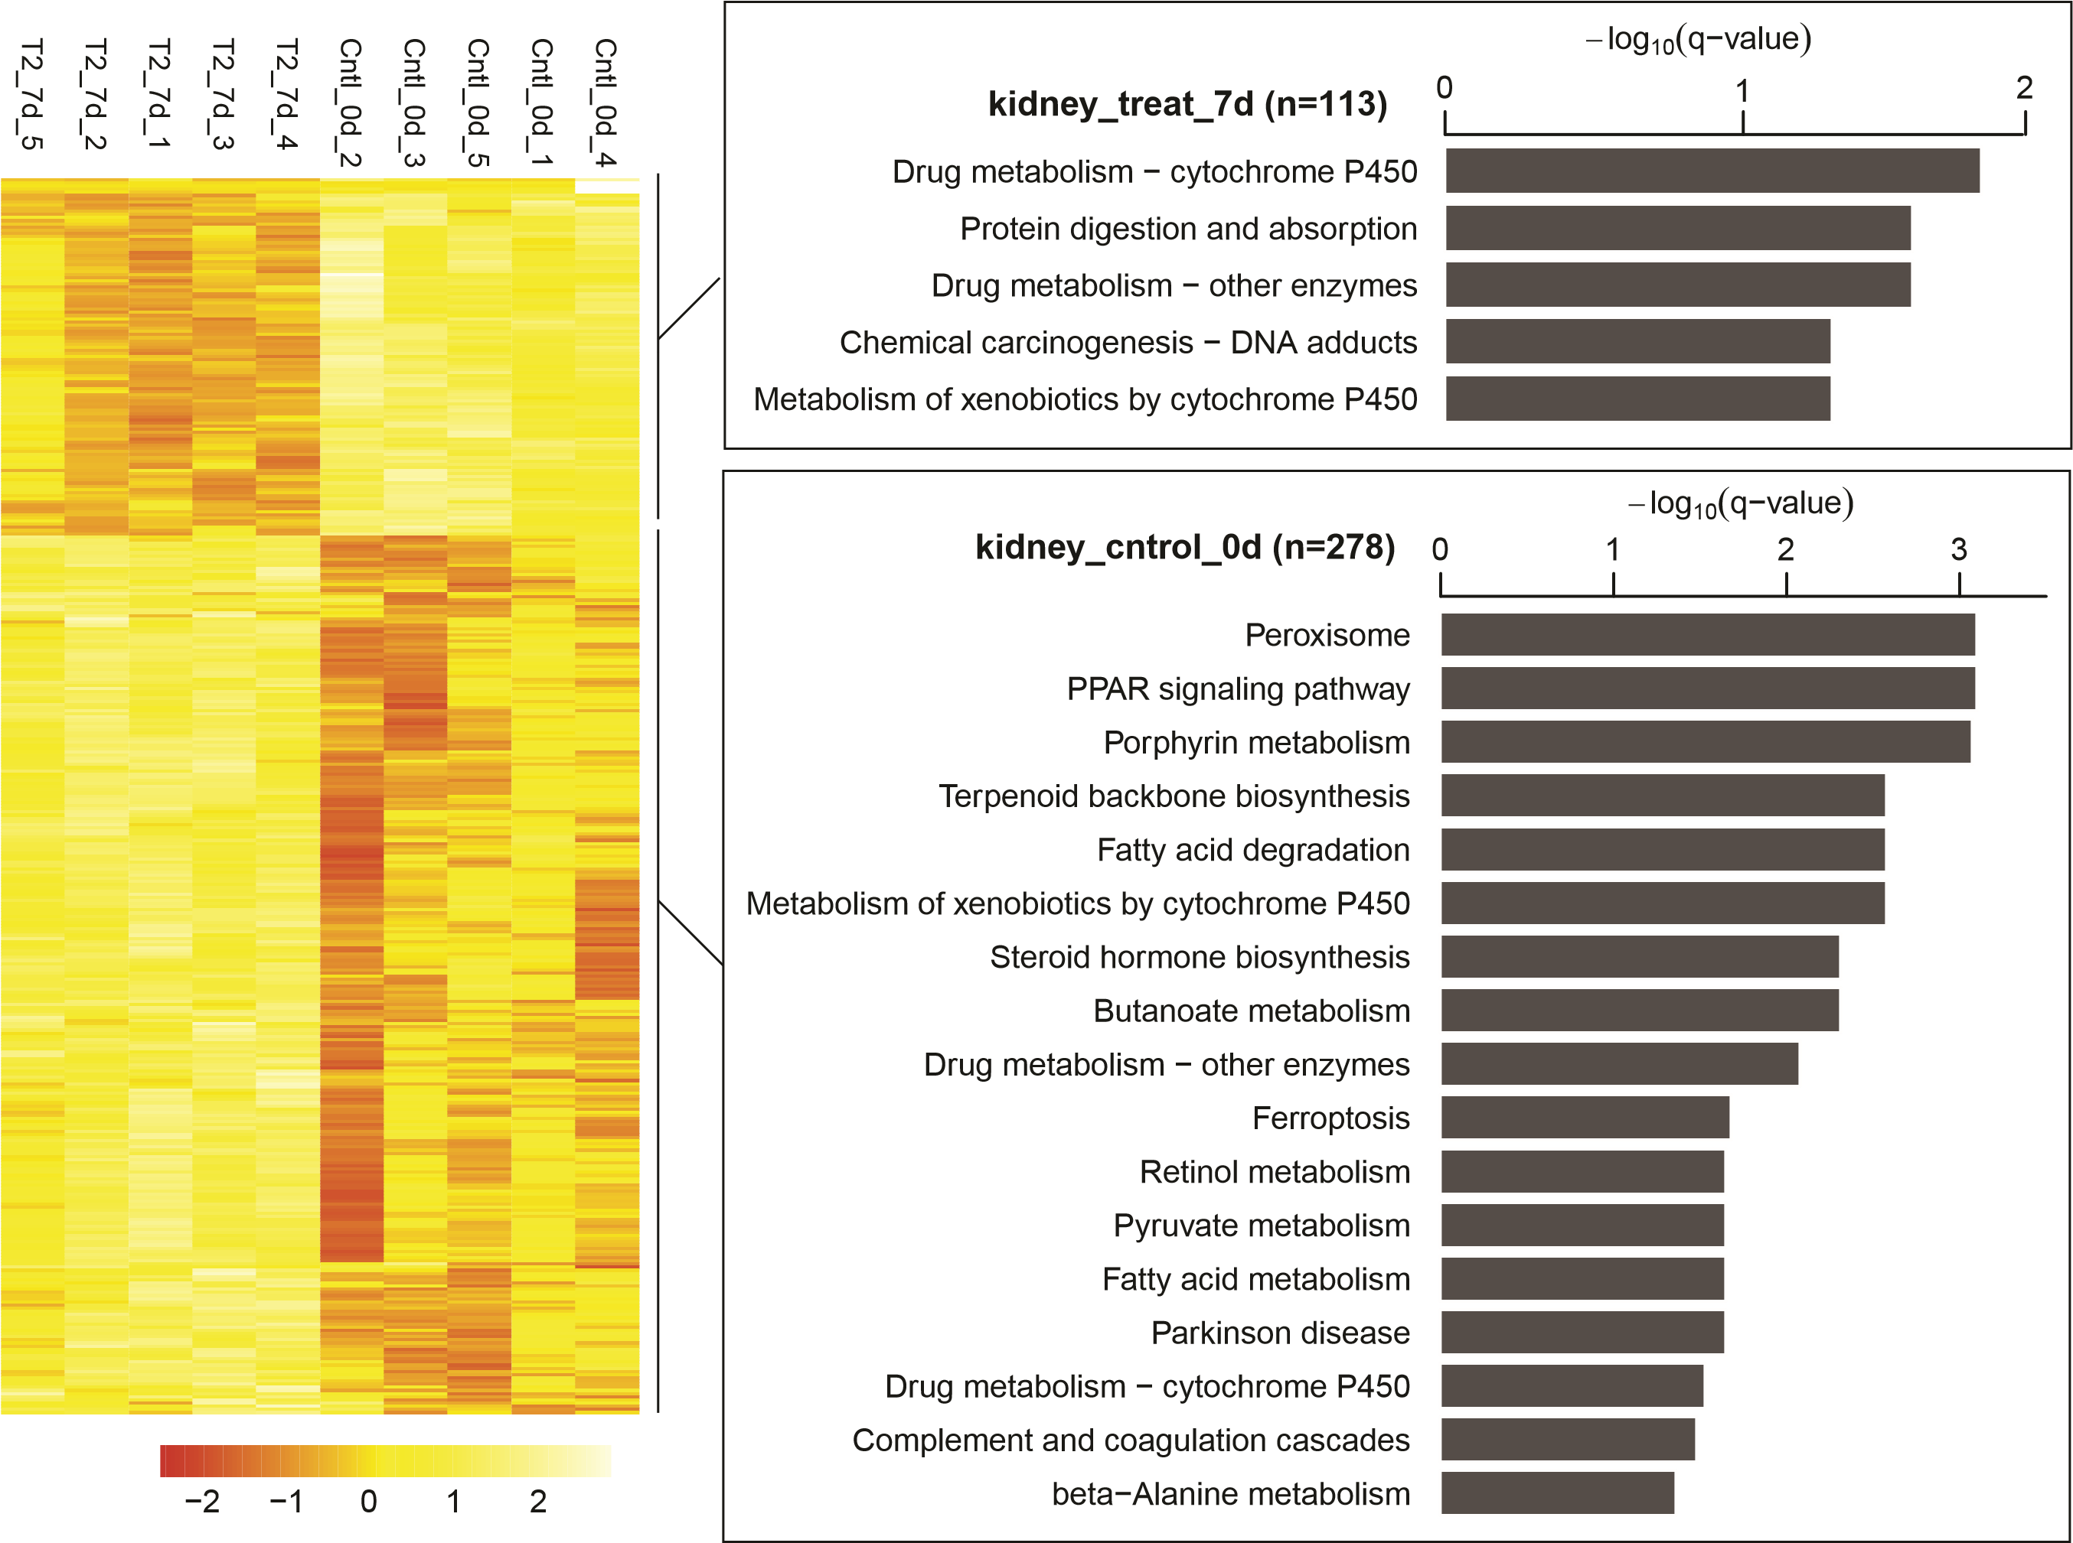
B
Figure S3 Transcriptome profiling of mice kidney at 7 d after T-2 toxin exposure.
(A) GO function enrichment of DEGs in TG_7d group using Metascape software. The horizontal coordinate is the number of DEGs and the vertical coordinate is the categorical entry of GO.
(B) Heatmap representation of Z score-transformed FPKM of genes predominantly expressed in TG_7d group (left). The genes are ranked in descending order according to their FPKM. Overrepresented pathways are shown on the right. The top ranked pathways are shown with q-values.
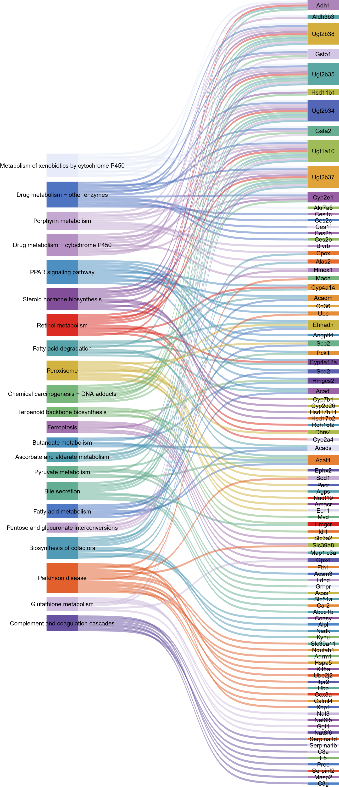
Figure S4 Sankey diagram of KEGG pathway from overrepresentation analysis based on overlapping up-regulated and down-regulated genes in mice kidney at 7 d after T-2 toxin exposure.
A
B
C
Figure S5 Enrichment analysis of transcriptional regulators involved in T-2 toxin exposure at 1 d (A), 3 d (B) and 7d (C).
Ugt2b38
Cyp4a14
Cyp2e1
Cyp2a4
Cdhr2
Rhov
Slc2a9
Pik3c2g
Myo10
Myh4
Hsp90ab1
Fkbp5
Rhoc
Arf4
Ank3
Ugt1a10
Cyp4a12a
Ugt2b35
b37
Ugt2
Ugt2b34
H2bc4
Ubc
Ubb
H2ac18
Echdc2
Nr1i2
Acads
Acadm
Acadl
Pecr
Nudt19
Ehhadh
Ech1
Dhrs4
Amacr
Ephx2
H2aj

Table S1 Effects of T-2 toxin on the body weight of mice at different periods ª.
Treatment | 0d Weight (g) | 1d Weight (g) | 3d Weight (g) | 7d Weight (g) | Growth rate (0d vs 7d)
CG | 20.76±0.65 | 20.81±0.63 | 21.48±0.82 | 22.97±0.63 | 9.56%±0.05
TG | 20.65±0.51 | 20.43±0.52 | 20.95±0.68*** | 22.12±0.68*** | 7.19%±0.04
ª Data expressed as mean ± SD for each group.
***p < 0.0001.

Table S2 Reference genome alignment analysis using HISAT.
Sample name | Total clean read | Total mapping genome ratio | Uniquely mapping genome ratio
CG_0d_1 | 23.86 | 96.75 | 74.45
CG_0d_2 | 23.87 | 96.81 | 76.11
CG_0d_3 | 23.86 | 96.79 | 73.26
CG_0d_4 | 19.59 | 96.67 | 74.92
CG_0d_5 | 23.84 | 96.15 | 75.68
CG_1d_1 | 23.84 | 96.38 | 75.32
CG_1d_2 | 23.84 | 96.55 | 74.08
CG_1d_3 | 23.83 | 96.36 | 74.25
CG_1d_4 | 23.83 | 96.34 | 76.01
CG_1d_5 | 23.84 | 96.35 | 75.12
CG_3d_1 | 23.84 | 96.32 | 75.87
CG_3d_2 | 23.84 | 96.44 | 75.50
CG_3d_3 | 23.84 | 96.48 | 74.86
CG_3d_4 | 23.80 | 96.31 | 75.97
CG_3d_5 | 23.85 | 96.39 | 76.08
TG_1d_1 | 23.84 | 96.33 | 75.81
TG_1d _2 | 23.79 | 96.09 | 75.27
TG_1d _3 | 23.78 | 96.04 | 75.44
TG_1d _4 | 23.84 | 96.33 | 74.17
TG_1d _5 | 23.85 | 96.50 | 75.80
TG_3d_1 | 23.80 | 96.23 | 75.58
TG_3d _2 | 23.81 | 96.51 | 75.47
TG_3d _3 | 23.79 | 96.25 | 75.90
TG_3d _4 | 23.78 | 96.29 | 76.07
TG_3d _5 | 23.80 | 96.27 | 75.45
TG_7d_1 | 23.78 | 96.25 | 74.36
TG_7d _2 | 23.79 | 96.17 | 75.44
TG_7d _3 | 23.80 | 96.27 | 74.75
TG_7d _4 | 23.75 | 96.42 | 73.68
TG_7d _5 | 23.83 | 96.09 | 75.33

