Knockout of Poly(ADP-ribose) polymerase 1 in human cell line: Influence on the Base Excision Repair Reactions in the Cellular Extracts
Svetlana N. Khodyreva^{1*}, Ekaterina S. Ilina^{1,3#}, Nadezhda S. Dyrkheeva^{1,3#}, Alina S. Kochetkova¹, Alexandra A. Yamskikh^{1,3}, Ekaterina A. Maltseva¹, Anastasia A. Malakhova², Sergey P. Medvedev^{2,3}, Suren M. Zakian^{2,3}, Olga I. Lavrik ^{1,3*}

¹Institute of Chemical Biology and Fundamental Medicine, Siberian Branch, Russian Academy of Sciences, Novosibirsk, 630090 Russia
²Federal Research Centre Institute of Cytology and Genetics, Siberian Branch of the Russian Academy of Sciences, 630090 Novosibirsk, 630090 Russia
³Novosibirsk State University, Novosibirsk, 630090 Russia

Keywords: CRISPR/Cas9 technique, activity of base excision repair enzymes, poly(ADP-ribose) polymerase 1, mRNAs, poly(ADP- ribosyl)ation

Table S1. Oligonucleotide sequences used in creation of PARP1 knockout cells
Name | Sequence | Function
PARP1-gRNA1 | 5ʹ-CTAGAACCTCCAATACCATG (TGG) | Protospacer
PARP1-gRNA2 | 5ʹ-GCAAGTGACCACAAAGGTGC (AGG) | Protospacer
PARP1-Del-F | 5ʹ-AGTGTGCCCTGCGTATTTGC-3ʹ | 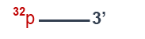  Forward primer for detection of deletion
PARP1-Del-R | 5ʹ-CGCTCCCTTGGTACCACATATG-3ʹ | Reverse primer for detection of deletion
PARP1-In-F | 5ʹ-CGCTCCCTTGGTACCACATATG-3ʹ | Forward primer for detection of WT allele
PARP1-In-R | 5ʹ-GGCTTACTGACAGTCAGCGAAG-3ʹ | Reverse primer for detection of WT allele

Table S2. Primers used in qPCR
Gene | Sequences of forward/reverse primers
Gapdh | 5′-AGATCATCAGCAATGCCTCCT-3′/  5′-TGGTCATGAGTCCTTCCACG-3′
B2M | 5′-CGCTCCGTGGCCTTAGCTGT-3′/  5′-aaagacaagtctgaatgctc-3′
Tubβ | 5′-TGGTGGATCTAGAACCTGGGA-3′/  5′-CTGCCCCAGACTGACCAAAT-3′
ACBT | 5′-TTCCTGGGCATGGAGTCCT-3′/  5′-TGTGTTGGCGTACAGGTCTT-3′
Parp1 | 5′-GCTTCAGCCTCCTTGCTACAG-3′/  5′-CTTCTTCGCCACTTCATCCAC-3′
Parp2 | 5′-TCCTAAGGCCGAAGGATTGC-3′/  5′-CCCATTCAGGGTGACGAAGT-3′
Ung2 | 5′-AAGCAAGGTGTTCTCCTTCTCA-3′/  5′-GCCAGGACACAACTGCATC-3′
Apex1 | 5′-GATCTCGCGAGTAGGGCAAC-3′/  5′-TTCGGCATTCCCGTTACGAA-3′
Polβ | 5′-GAACACTCTGGGGTTCTCGG-3′/  5′-TGCGAGTTCTGTGAGCATGT-3′
Lig3 | 5′-CCAGGCTAAGTTGACAACCAC-3′/  5′-TGTTGGGCTTGGCTGAAAAG-3′
Xrcc1 | 5′-TACAGCAAGGACTCCCCCTT-3′/  5′-CACTGTCACCTTCTGGGACG-3′

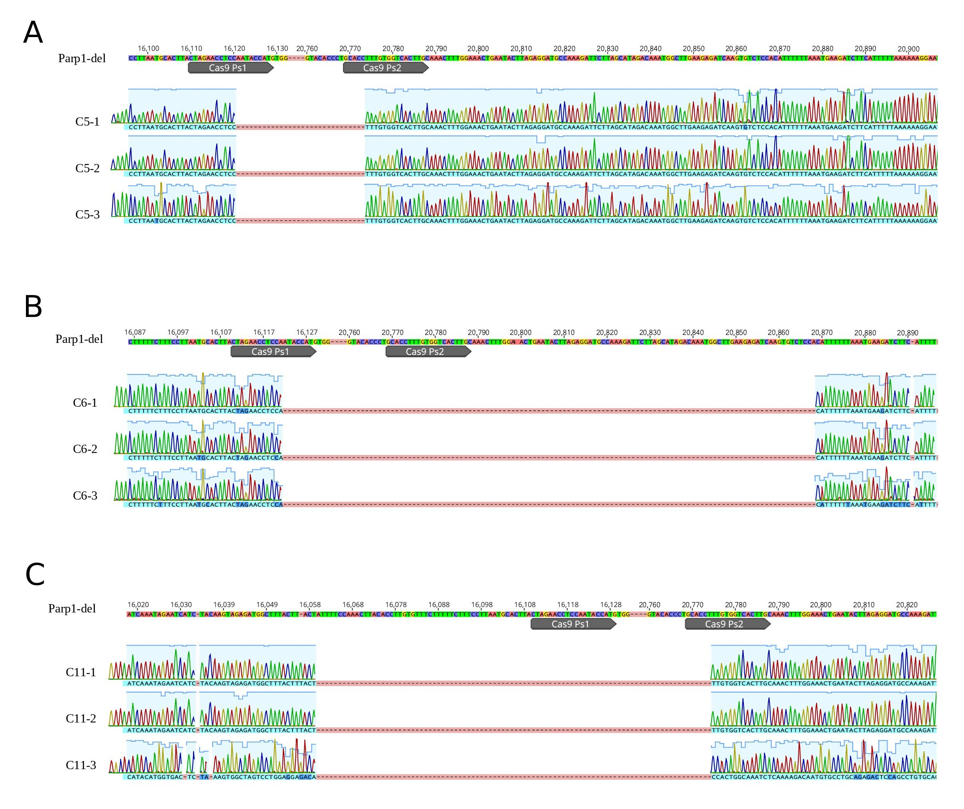
Figure S1. Alignment of the DNA sequence of the wild-type PARP1 gene and sequencing of the plasmid containing the PCR products, which were obtained from the genomic DNA of HEK293FT clones C5 (A), C6 (B) and C11 (C) with putative deletions in the PARP1 gene. Only for three sequenograms for each clone are shown.

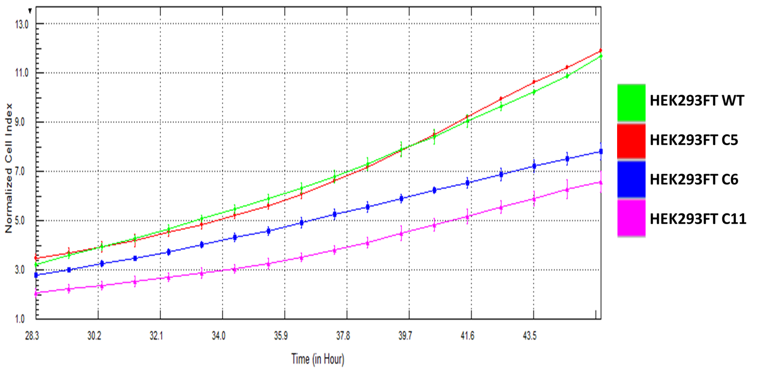
Figure S2. Estimation of doubling time for HEK293FT WT and 3FT/P1-KO cells.

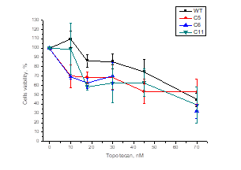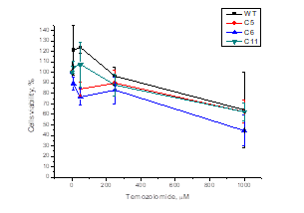
Figure S3. Sensitivity of HEK293FT WT and 3FT/P1-KO cells to topotecan and temozolomide.

A  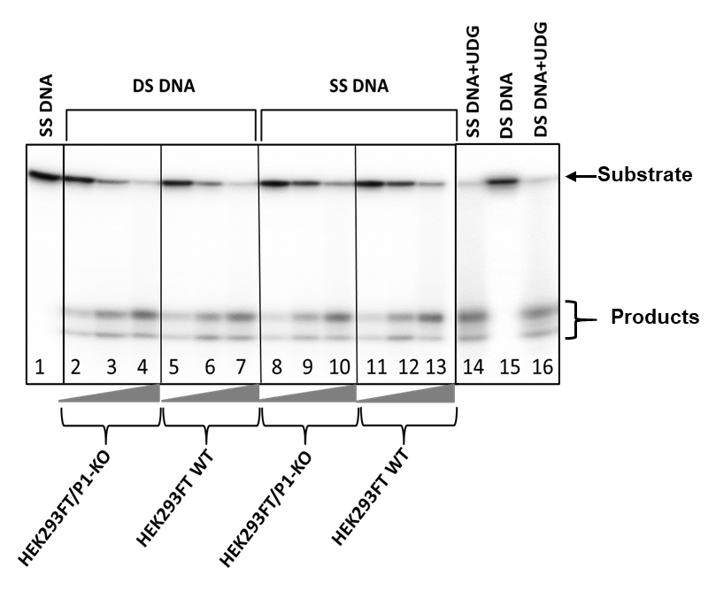 | B  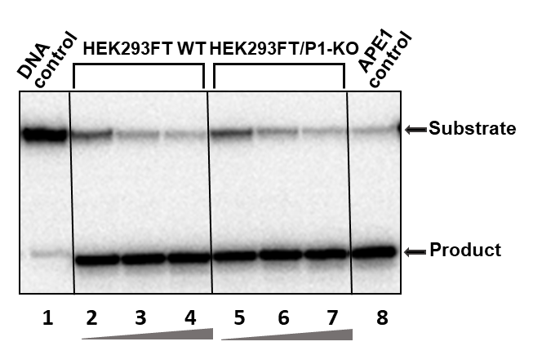
C  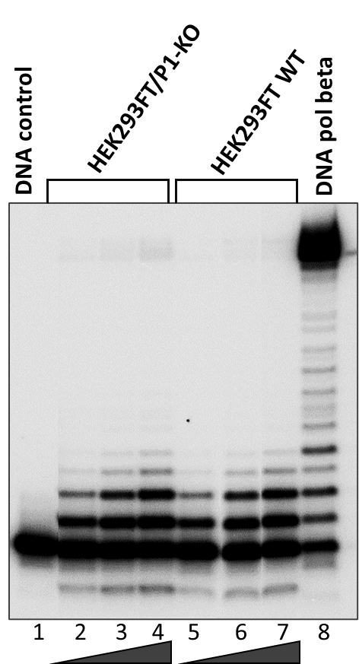 | D  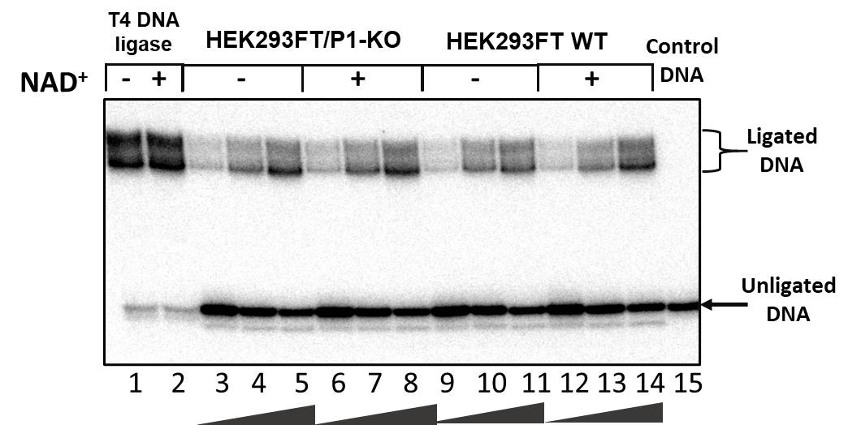
Figure S4. Efficiencies of the BER reactions catalyzed by endogenous enzymes of the WCEs of HEK293FT WT and HEK293FT/P1-KO cells. A – uracil excision from single-strand and double-strand substrate DNAs. Time: 3, 5, 10 min.; B – cleavage of AP site. Time: 2, 4, 8 min.; C – elongation of the primer. Time: 5, 10, 15 min.; D – ligation of the nick. Time: 5, 15, 30 min.

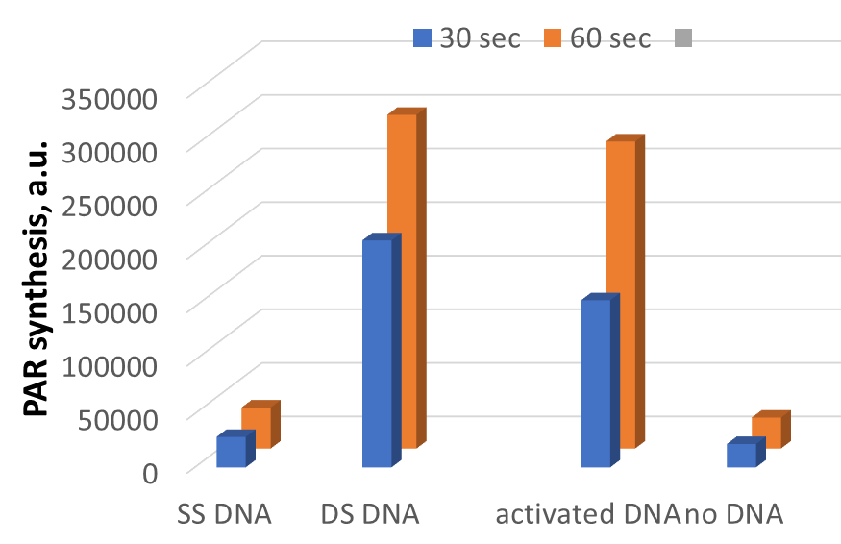
Figure S5. Comparison of PARP1 activation by different DNAs.
SSDNA-DNA – Non-labeled DNA-1, DS - Non-labeled DNA-3 (Table 1).

FUNDING
This work was supported by the Russian Science Foundation (project no. № 19-04-00204) for main part of the work and
partially by the Russian state-funded project for ICBFM SB RAS (Grant Number 121031300041-4) for creation of PARP1 knockout cell lines.

