Supplementary materials

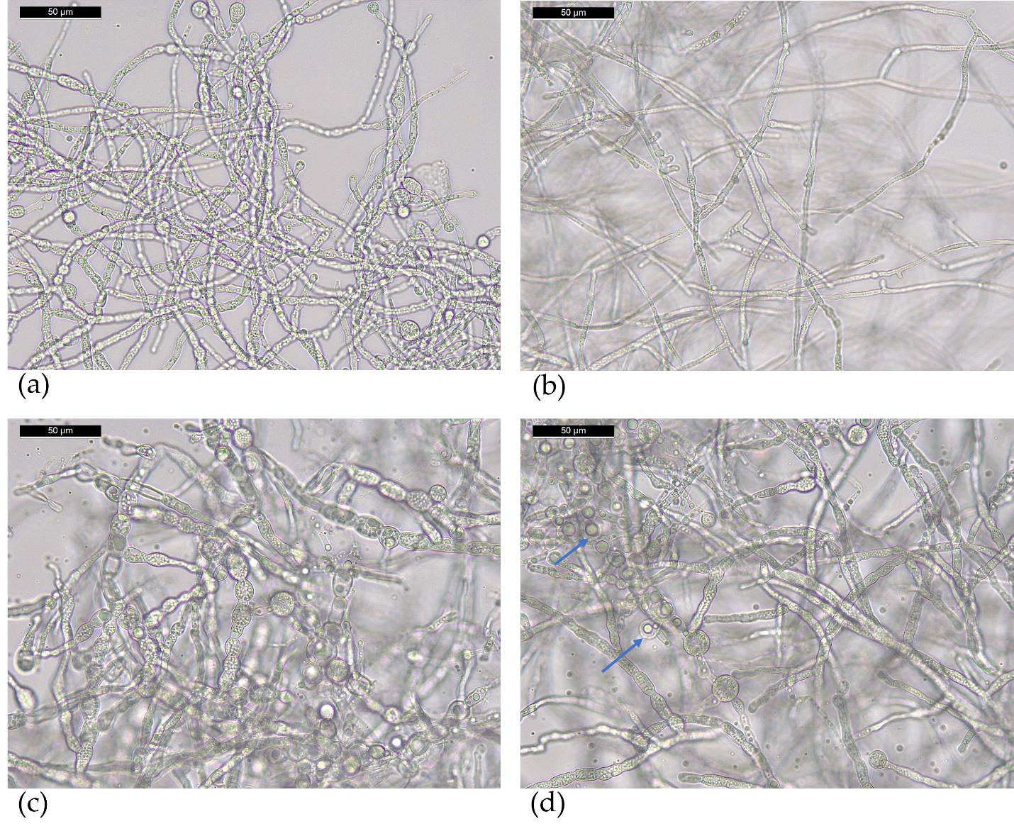
Figure S1. Optical microscopical images of T. asperellum T36 NCAIM F 001434 grown in PDB (a, b) and cornmeal medium (c, d). The blue arrows indicate the presence of vacuoles/droplets inside hyphae.
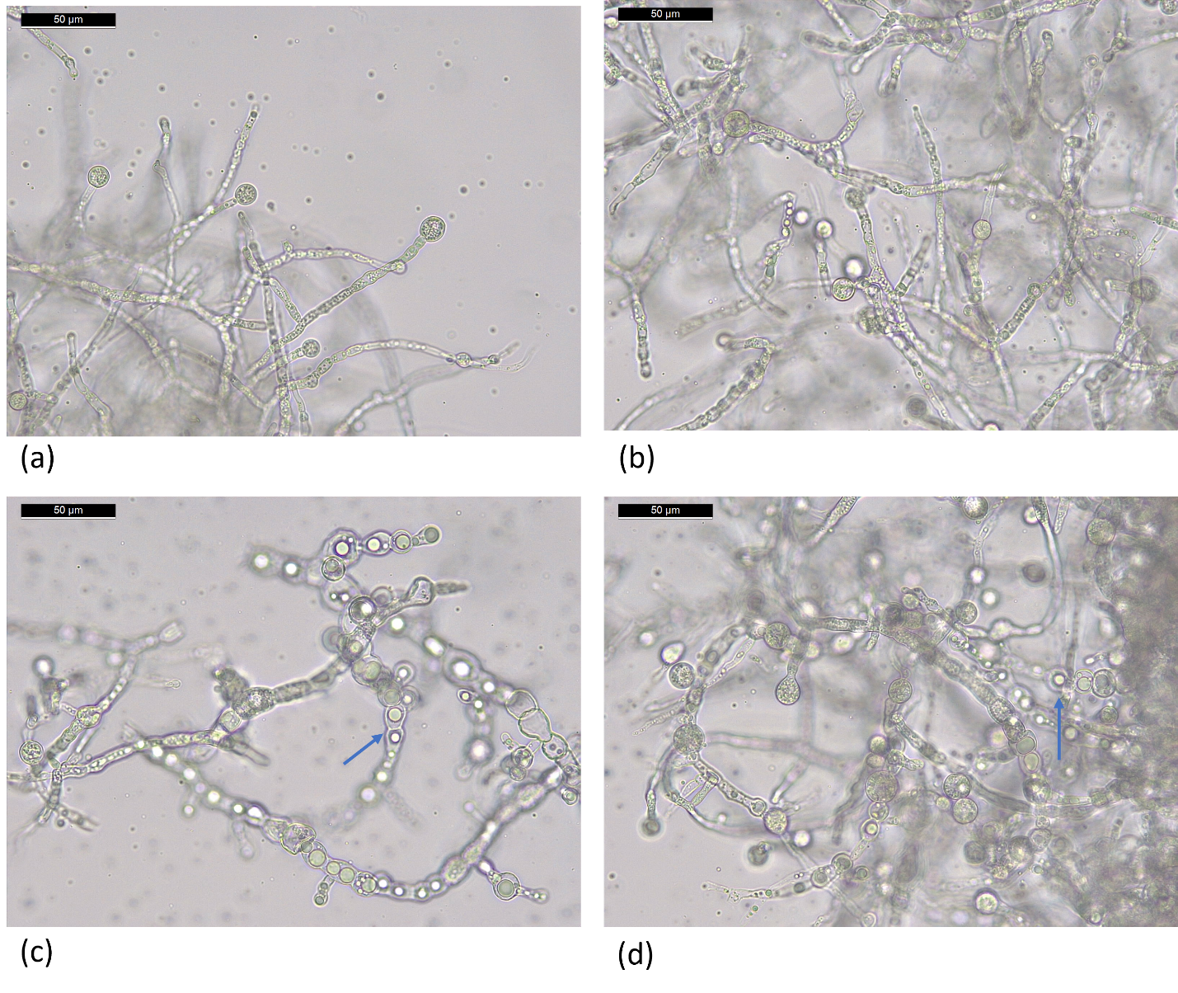
Figure S2. Optical microscopical images of T. harzianum, Td50b, NCAIM F001412 grown in PDB (a, b) and cornmeal medium (c, d). The blue arrows indicate the presence of vacuoles/droplets inside hyphae.

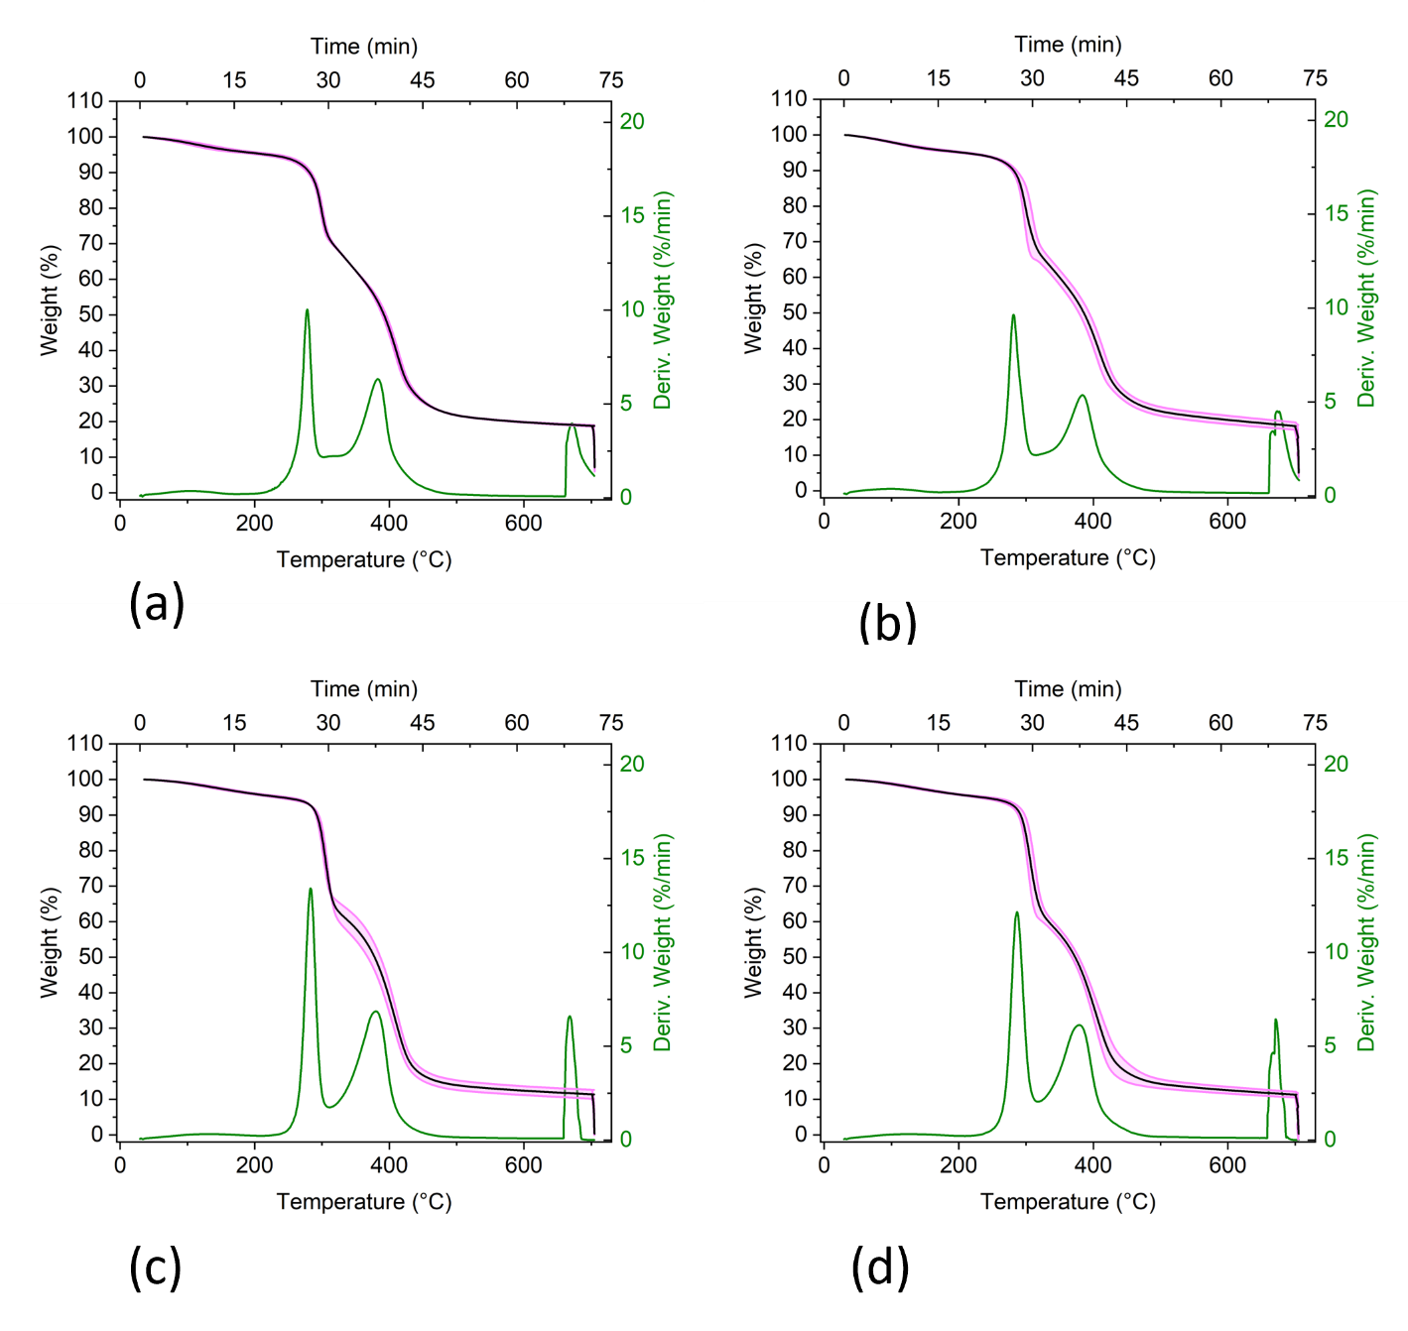
Figure S3. Thermogravimetric analysis of T. asperellum T36 NCAIM F 001434 (a, c) and T. harzianum, Td50b, NCAIM F001412 (b, d) grown in PDB (a, b) and cornmeal medium (c, d). The weight (%) is shown with the error bar limits (light magenta).

