Phosphine Catalyzed Michael-Type Additions: Synthesis of Glutamic Acid derivatives from arylidene-α-amino esters
Lesly V. Rodríguez-Flórez,ª María González-Marcos,ª Eduardo García-Mingüens,^{a,b} Gracia Retamosa,ª Misa Kawase,ª Elisabet Selva^{b} and José M. Sansano,ª*

Dedicated to the memory of Prof. David A. Evans

ª Departamento de Química Orgánica, Centro de Innovación en Química Avanzada (ORFEO-CINQA) and Institute of Organic Synthesis. Universidad de Alicante. Ctra. Alicante-San Vicente s/n, 03080-Alicante, Spain.
^{b} Medalchemy, S. L. Ancha de Castelar, 46-48, entlo. A. San Vicente del Raspeig, 03690-Alicante (Spain).

Table of Contents

1. NMR copies……………………………………………………………………. S1
2. REPRESENTATIVE FTIR COPIES ………………………………………….. s29

1. NMR COPIES
Figure S1, ¹H NMR of compound 3a

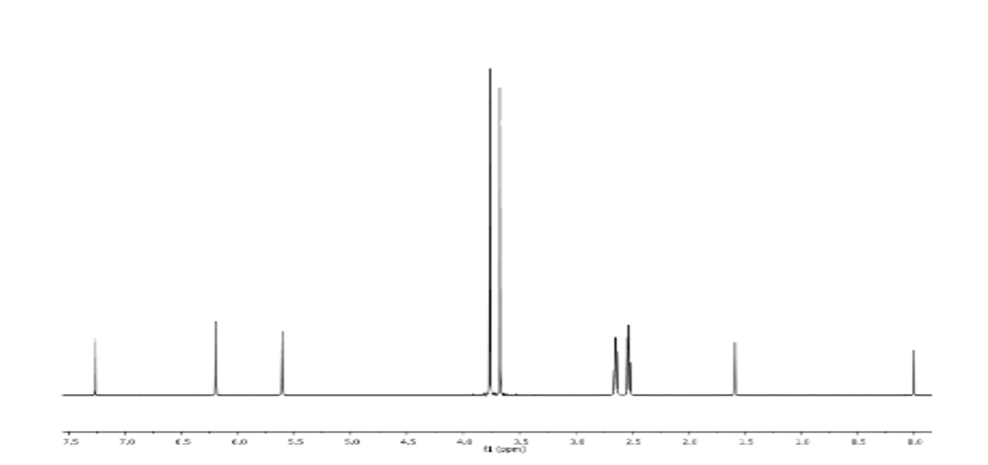
Figure S2, ¹H NMR of compound 4

Figure S3, ¹H NMR of compound 5
Figure S4, ¹H NMR of compound 2a

Figure S5, ¹³C NMR of compound 2a

Figure S6, ¹H NMR of compound 2b
Figure S7, ¹³C NMR of compound 2b

Figure S8, ¹H NMR of compound 2c

Figure S9, ¹³C NMR of compound 2c
Figure S10, ¹H NMR of compound 2d

Figure S11, ¹³C NMR of compound 2d
Figure S12, ¹H NMR of compound 2e

Figure S13, ¹³C NMR of compound 2e

Figure S14, ¹H NMR of compound 2f

Figure S15, ¹³C NMR of compound 2f

Figure S16, ¹H NMR of compound 2g

Figure S17, ¹³C NMR of compound 2g

Figure S18, ¹H NMR of compound 2h

Figure S19, ¹³C NMR of compound 2h

Figure S20, ¹H NMR of compound 2i

Figure S21, ¹³C NMR of compound 2i

Figure S22, ¹H NMR of compound 2j

Figure S23, ¹³C NMR of compound 2j

Figure S24, ¹H NMR of compound 2k

Figure S25, ¹³C NMR of compound 2k

Figure S26, ¹H NMR of compound 2l

Figure S27, ¹³C NMR of compound 2l

Figure S28, ¹H NMR of compound 2m
Figure S29, ¹³C NMR of compound 2m
Figure S30, ¹H NMR of compound 2n

Figure S31, ¹³C NMR of compound 2n

Figure S32, ¹H NMR of compound 2o
Figure S33, ¹³C NMR of compound 2o

Figure S34, ¹H NMR of compound 2p

Figure S35, ¹³C NMR of compound 2p
Figure S36, ¹H NMR of compound 2q

Figure S37, ¹³C NMR of compound 2q

Figure S38, ¹H NMR of compound 2u

Figure S39, ¹³C NMR of compound 2u

Figure S40, ¹H NMR of compound 6v

Figure S41, ¹³C NMR of compound 6v

Figure S42, ¹H NMR of compound 8a

Figure S43, ¹³C NMR of compound 8a

Figure S44, ¹H NMR of compound 8b

Figure S45, ¹³C NMR of compound 8b

Figure S46, ¹H NMR of compound 8c

Figure S47, ¹³C NMR of compound 8c

Figure S48, ¹H NMR of compound 8d
Figure S49, ¹³C NMR of compound 8d
Figure S50, ¹H NMR of compound 8e

Figure S51, ¹³C NMR of compound 8e
Figure S52, ¹H NMR of compound 8f
Figure S53, ¹³C NMR of compound 8f
Figure S54, ¹H NMR of compound 9

Figure S55, ¹³C NMR of compound 9

2. REPRESENTATIVE FTIR COPIES

Figure S56, FTIR of compound 2a

Figure S57, FTIR of compound 2b

Figure S58, FTIR of compound 2g

Figure S59, FTIR of compound 2h

Figure S60, FTIR of compound 2m

Figure S61, FTIR of compound 8a

Figure S62, FTIR of compound 8b

Figure S63, FTIR of compound 8c

Figure S64, FTIR of compound 9

