Supplementary Figure 1

Mask 1  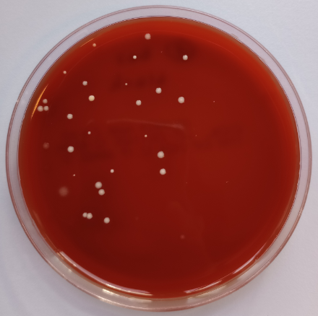 | Mask 2  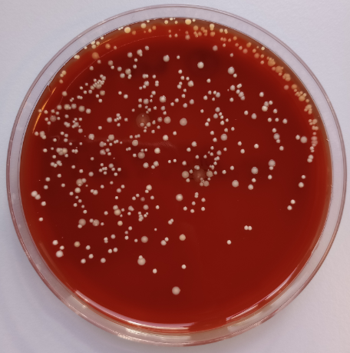 | Mask 3  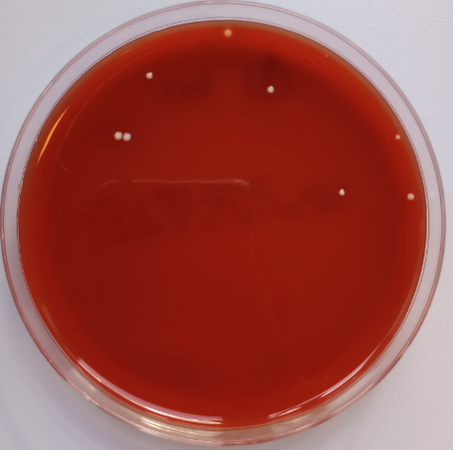
Mask 4  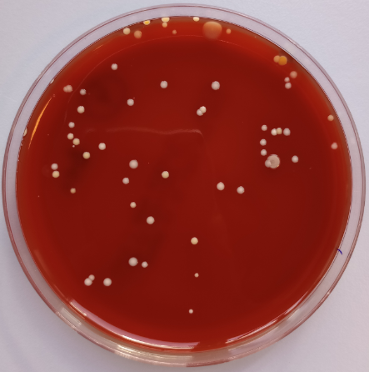 | Mask 5  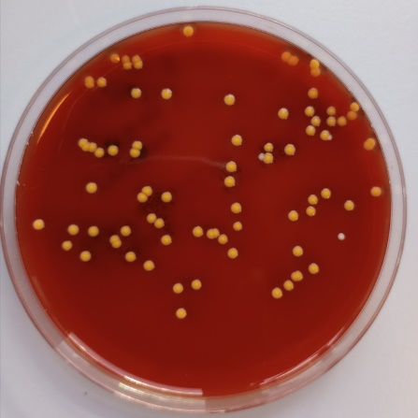 | Mask 6  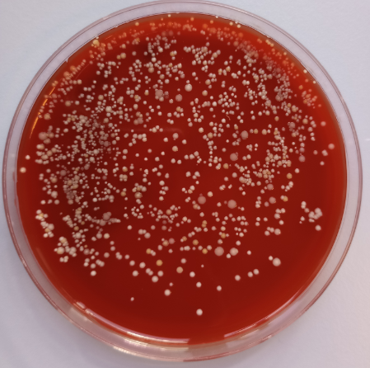
Mask 7  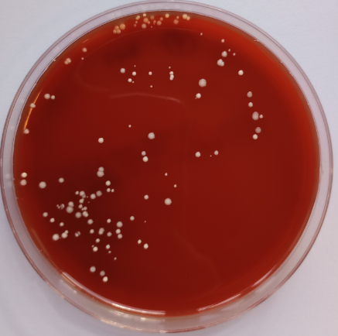 | Mask 8  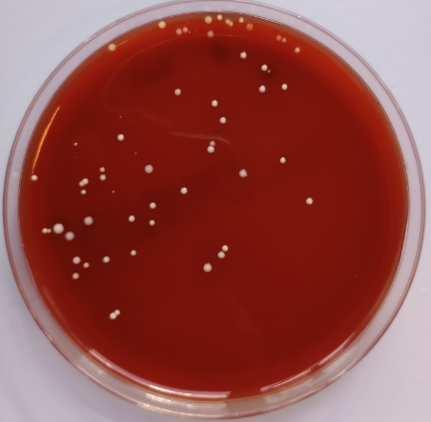 | Mask 9  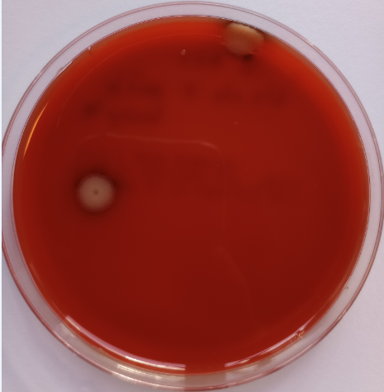
Mask 10  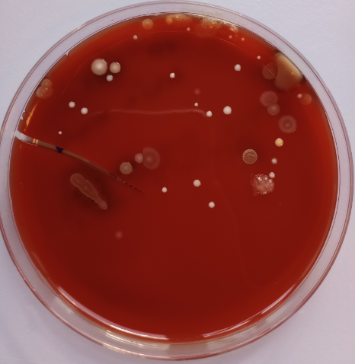 | Mask 11  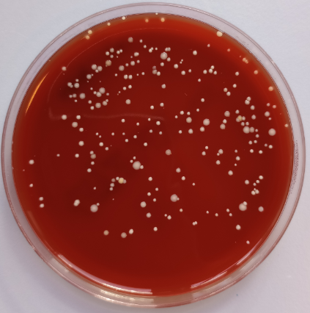 | Mask 12  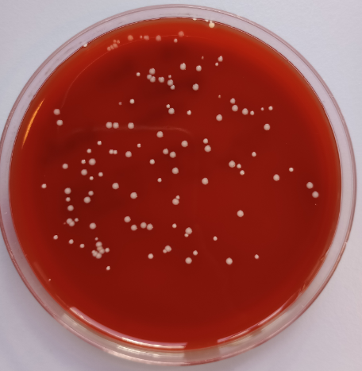
Mask 13  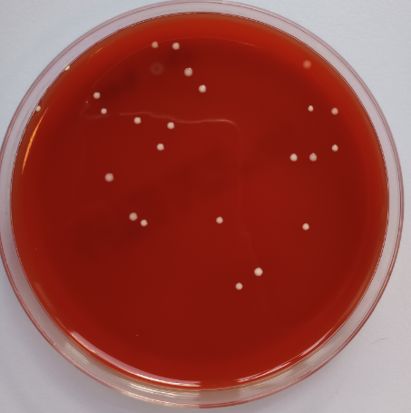 | Mask 14  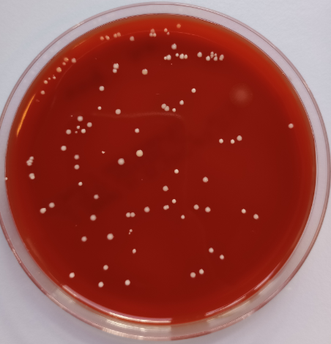 | Mask 15  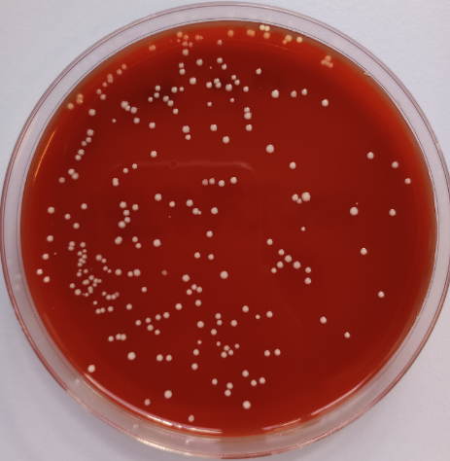
Supplementary Figure 1. Bacterial colonies isolated from 15 randomly collected surgical face masks on blood agar.

Supplementary Table 1. BLASTn results of 16S rRNA-based identification of isolated bacteria from masks
 | Mask number | Clone number | Seqeunce code | Trimmed sequence range | Sequence length | The highest identity record | Coverage (%) | Identity (%) | Genome accession number of the first highest identity record
1 | 1 | 2 | 21CDZAD040 | C:10-C:1095 | 1086 | Bhargavaea ginsengi | 100 | 100 | KT719934.1
2 | 1 | 5 | 21CDZAD020 | C:15-A:1078 | 1064 | Staphylococcus epidermidis | 100 | 100 | CP119047.1
3 | 1 | 6 | 21CDZAD014 | C:13-A:806 | 794 | Staphylococcus warneri/pasteuri | 100 | 100 | MK203007.1
4 | 2 | 1 | 21CDZAD049 | T:10-A:1074 | 1065 | Staphylococcus epidermidis | 100 | 100 | CP065656.1
5 | 2 | 2 | 21CDZAD039 | C:16-A:976 | 961 | Staphylococcus epidermidis/warneri | 100 | 100 | CP040883.1
6 | 2 | 4 | 21CDZAD005 | C:9-T:1050 | 1042 | Staphylococcus epidermidis | 100 | 100 | CP040883.1
7 | 3 | 1 | 21CDZAD029 | C:16-A:1142 | 1127 | Staphylococcus epidermidis | 100 | 100 | CP040883.1
8 | 3 | 6 | 21CDZAD013 | C:15-T:806 | 792 | Staphylococcus epidermidis | 100 | 100 | MT482624.1
9 | 4 | 2 | 21CDZAD038 | A:31-T:1121 | 1091 | Staphylococcus epidermidis | 100 | 100 | MT613456.1
10 | 4 | 3 | 21CDZAD035 | A:35-T:675 | 641 | Staphylococcus warneri/pasteuri | 100 | 100 | MT642942.1
11 | 4 | 5 | 21CDZAD012 | C:17-T:882 | 866 | Staphylococcus epidermidis | 100 | 100 | MT482624.1
12 | 5 | 1 | 21CDZAD048 | G:33-C:995 | 963 | Staphylococcus aureus/argenteus | 100 | 100 | CP119113.1
13 | 5 | 3 | 21CDZAD026 | A:36-A:1123 | 1088 | Staphylococcus aureus/argenteus | 100 | 100 | CP119113.1
14 | 5 | 4 | 21CDZAD025 | T:17-A:1121 | 1105 | Staphylococcus aureus/argenteus | 100 | 100 | CP119113.1
15 | 6 | 1 | 21CDZAD037 | C:14-C:1151 | 1138 | Staphylococcus warneri/pasteuri | 100 | 100 | OP263325.1
16 | 6 | 2 | 21CDZAD032 | C:14-A:1120 | 1107 | Staphylococcus epidermidis | 100 | 100 | MT604781.1
17 | 7 | 1 | 21CDZAD028 | C:19-A:1082 | 1064 | Staphylococcus epidermidis | 100 | 100 | CP119047.1
18 | 7 | 3 | 21CDZAD027 | C:16-A:1079 | 1064 | Staphylococcus epidermidis | 100 | 100 | CP119047.1
19 | 8 | 1 | 21CDZAD047 | C:16-C:1043 | 1028 | Staphylococcus hominis | 100 | 100 | MT544813.1
20 | 8 | 2 | 21CDZAD031 | C:15-A:1147 | 1133 | Staphylococcus epidermidis | 100 | 100 | CP024408.1
21 | 9 | 1 | 21CDZAD046 | C:10-G:981 | 972 | Paenibacillus lemnae | 100 | 99.07 | MN581184.1
22 | 9 | 2 | 21CDZAD030 | C:19-C:1039 | 1021 | Bacillus spp.* | 100 | 100 | OQ509998.1
23 | 9 | 4 | 21CDZAD011 | G:25-C:1087 | 1063 | Bacillus spp.* | 100 | 100 | OQ534872.1
24 | 10 | 1 | 21CDZAD045 | A:25-T:1030 | 1006 | Staphylococcus epidermidis | 100 | 100 | MT605363.1
25 | 10 | 2 | 21CDZAD024 | C:14-A:1077 | 1064 | Staphylococcus epidermidis | 100 | 100 | CP119047.1
26 | 10 | 7 | 21CDZAD016 | A:22-A:1025 | 1004 | Psychrobacter faecalis/pulmonis | 100 | 100 | MT269580.1
27 | 10 | 10 | 21CDZAD015 | T:19-G:1031 | 1013 | Staphylococcus epidermidis | 100 | 100 | KY623304.1
28 | 11 | 1 | 21CDZAD044 | T:14-A:1063 | 1050 | Staphylococcus epidermidis | 100 | 100 | MT604781.1
29 | 11 | 4 | 21CDZAD019 | T:13-G:916 | 904 | Staphylococcus epidermidis | 100 | 100 | MT445298.1
30 | 11 | 6 | 21CDZAD010 | T:10-T:795 | 786 | Staphylococcus warneri/pasteuri | 100 | 100 | MT642942.1
31 | 12 | 2 | 21CDZAD036 | C:16-A:995 | 980 | Staphylococcus epidermidis | 100 | 100 | CP040883.1
32 | 12 | 5 | 21CDZAD009 | C:12-C:1139 | 1128 | Staphylococcus epidermidis | 100 | 100 | MT482624.1
33 | 12 | 7 | 21CDZAD008 | T:24-A:1089 | 1066 | Staphylococcus epidermidis | 100 | 99.91 | KY623304.1
34 | 13 | 1 | 21CDZAD043 | T:15-A:973 | 959 | Staphylococcus hominis | 100 | 100 | CP054883.1
35 | 13 | 2 | 21CDZAD034 | C:13-C:1125 | 1113 | Staphylococcus warneri/pasteuri | 100 | 100 | MT642942.1
36 | 14 | 1 | 21CDZAD042 | G:24-T:1120 | 1097 | Bacillus altitudinis | 100 | 99.91 | OM670223.1
37 | 14 | 2 | 21CDZAD018 | T:21-G:1033 | 1013 | Bacillus spp.** | 100 | 100 | MT605432.1
38 | 14 | 3 | 21CDZAD017 | T:20-C:993 | 974 | Sporosarcina newyorkensis | 100 | 100 | LN774518.1
39 | 15 | 1 | 21CDZAD041 | C:16-T:1123 | 1108 | Staphylococcus epidermidis | 100 | 100 | MK425675.1
40 | 15 | 4 | 21CDZAD021 | C:22-A:1126 | 1105 | Staphylococcus epidermidis | 100 | 100 | CP119047.1
*Bacillus spp: B. thuringiensis, B. tropicus, B. cereus, B. proteolyticus, B. albus, B. toyonensis, B. subtilis, B. paranthracis, B. mobilis, B. wiedmanni,
**Bacillus spp.: B. megaterium, B. aryabhattai, B. acidiceler, B. zanthoxyli
Supplementary Table 2. Molecular identification of bacteria isolated from surgical masks, and their selected biochemical characteristics
Mask number | Clone number | Haemolysis* | Salt tolerance  (6.5 % NaCl) | Mannitol fermentation | Coagulase | Result of molecular identification based on 16S rRNA
1 | 2 | - | + | - | - | Bhargavaea ginsengi
 | 5 | + | + | - | - | Staphylococcus epidermidis
 | 6 | + | + | + | - | Staphylococcus warneri/pasteuri
2 | 1 | ++ | + | - | - | Staphylococcus epidermidis
 | 2 | ++ | + | - | - | Staphylococcus epidermidis/warneri
 | 4 | ++ | + | - | - | Staphylococcus epidermidis
3 | 1 | ++ | + | - | - | Staphylococcus epidermidis
 | 6 | + | + | - | - | Staphylococcus epidermidis
4 | 2 | + | + | - | - | Staphylococcus epidermidis
 | 3 | + | + | + | - | Staphylococcus warneri/pasteuri
 | 5 | ++ | + | - | - | Staphylococcus epidermidis
5 | 1 | + | + | + | + | Staphylococcus aureus/argenteus
 | 3 | + | + | + | + | Staphylococcus aureus/argenteus
 | 4 | + | + | + | + | Staphylococcus aureus/argenteus
6 | 1 | + | + | - | - | Staphylococcus warneri/pasteuri
 | 2 | ++ | + | - | - | Staphylococcus epidermidis
7 | 1 | + | + | - | - | Staphylococcus epidermidis
 | 3 | + | + | - | - | Staphylococcus epidermidis
8 | 1 | + | + | - | - | Staphylococcus hominis
 | 2 | + | + | - | - | Staphylococcus epidermidis
9 | 1 | - | - | - | - | Paenibacillus lemnae
 | 2 | ++ | - | - | - | Bacillus spp.
 | 4 | ++ | - | - | - | Bacillus spp.
10 | 1 | + | + | - | - | Staphylococcus epidermidis
 | 2 | + | + | - | - | Staphylococcus epidermidis
 | 7 | - | - | - | - | Psychrobacter faecalis/pulmonis
 | 10 | ++ | - | - | - | Staphylococcus epidermidis
11 | 1 | + | + | - | - | Staphylococcus epidermidis
 | 4 | + | + | - | - | Staphylococcus epidermidis
 | 6 | + | + | + | - | Staphylococcus warneri/pasteuri
12 | 2 | + | + | - | - | Staphylococcus epidermidis
 | 5 | ++ | + | - | - | Staphylococcus epidermidis
 | 7 | ++ | + | - | - | Staphylococcus epidermidis
13 | 1 | + | + | - | - | Staphylococcus hominis
 | 2 | + | + | + | - | Staphylococcus warneri/pasteuri
14 | 1 | ++ | + | + | - | Bacillus altitudinis
 | 2 | - | + | + | - | Bacillus spp.
 | 3 | - | - | - | - | Sporosarcina newyorkensis
15 | 1 | + | + | - | - | Staphylococcus epidermidis
 | 4 | + | + | - | - | Staphylococcus epidermidis
++ intense haemolysis, + haemolysis visible under colonies, Both salt tolerance and mannitol fermentation were measured in Mannitol Salt Agar

