Core and valence level spectroscopy study of the enhanced reduction of CeO₂ by iron substitution. Implication on the thermal water splitting activity.

Hicham Idriss
Institute of Functional Interfaces, Karlsruhe Institute of Technology (KIT), 76344 Eggenstein-Leopoldshafen, Germany

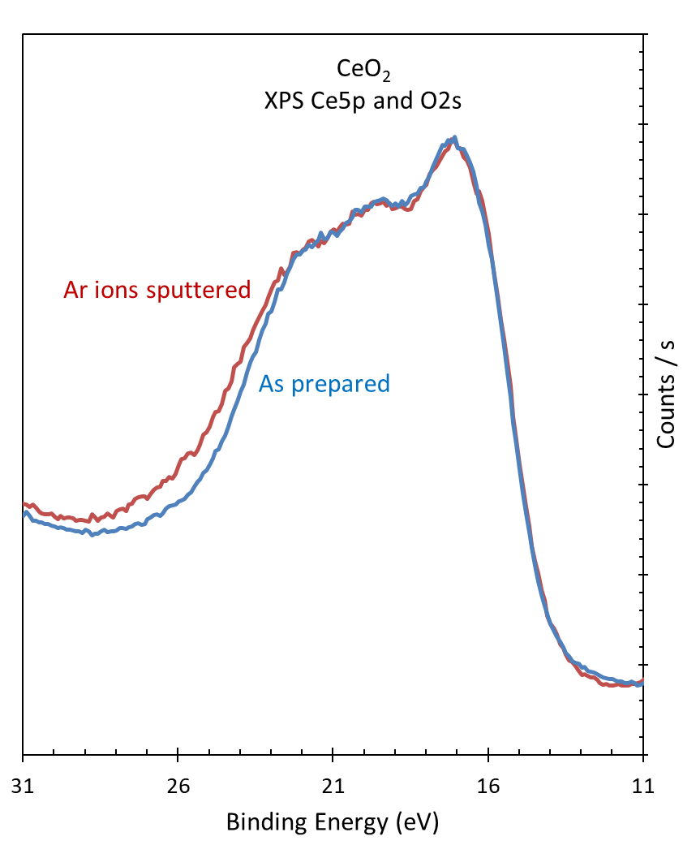

Figure S1.
Normalized XPS Ce5p and O2s of as prepared CeO2 and after 5-minute argon ions sputtering.

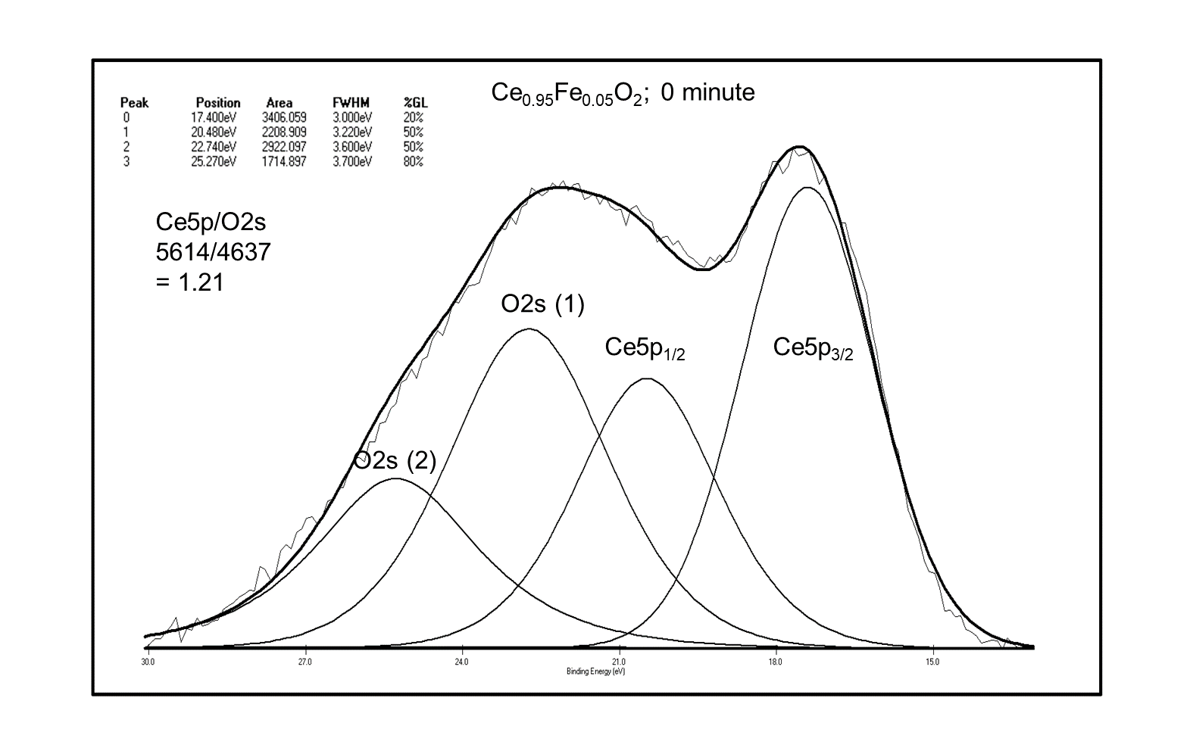A
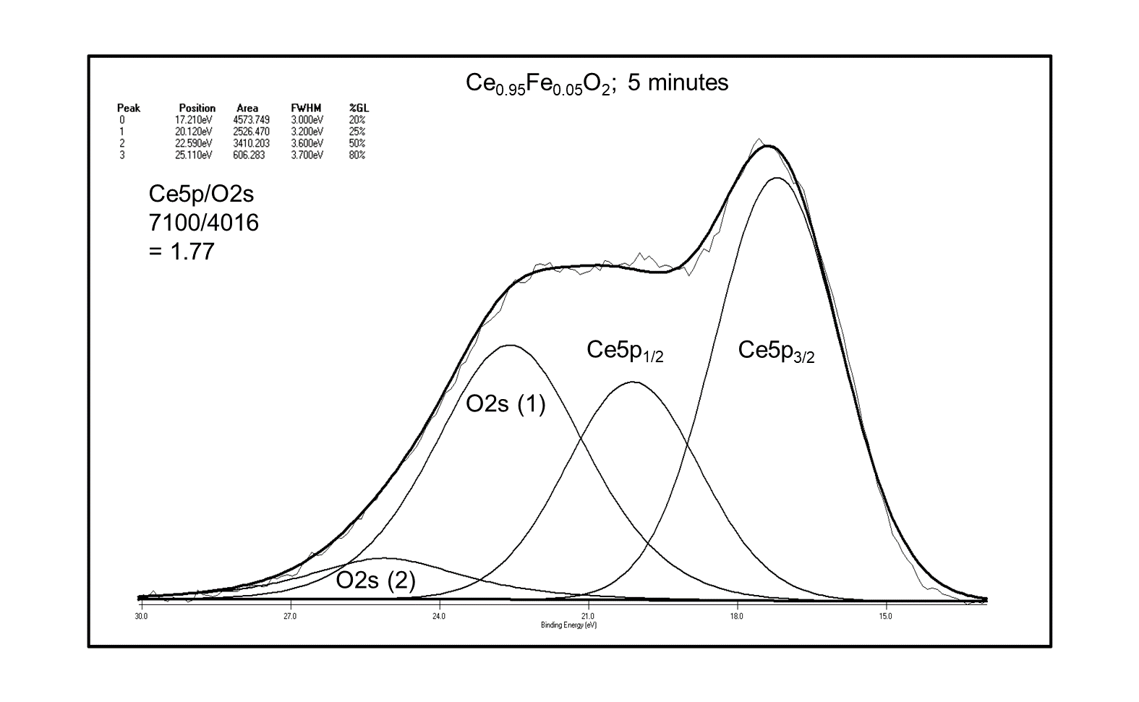B
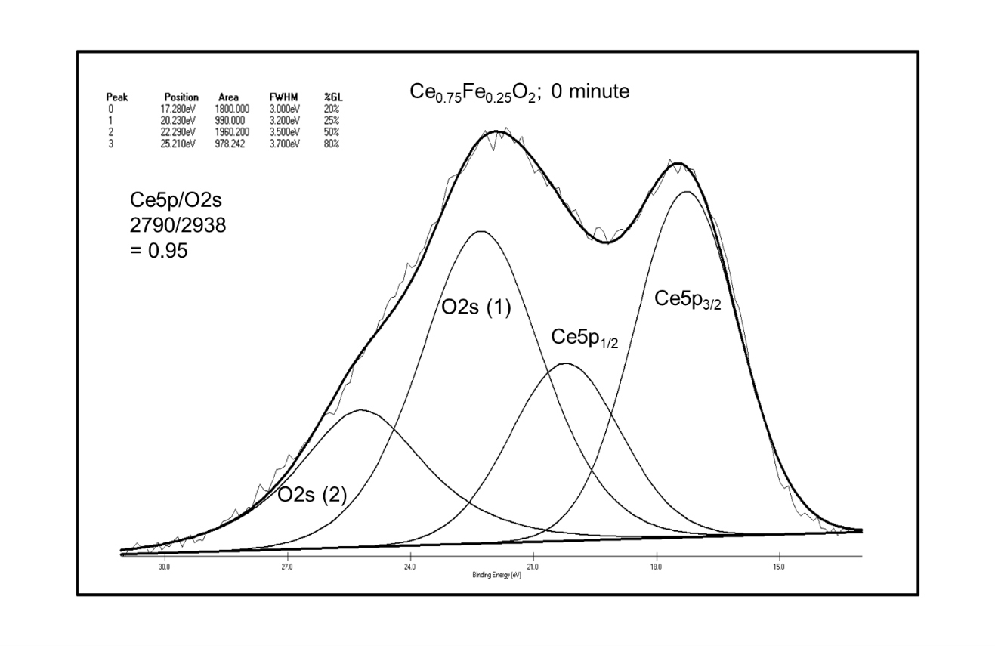C
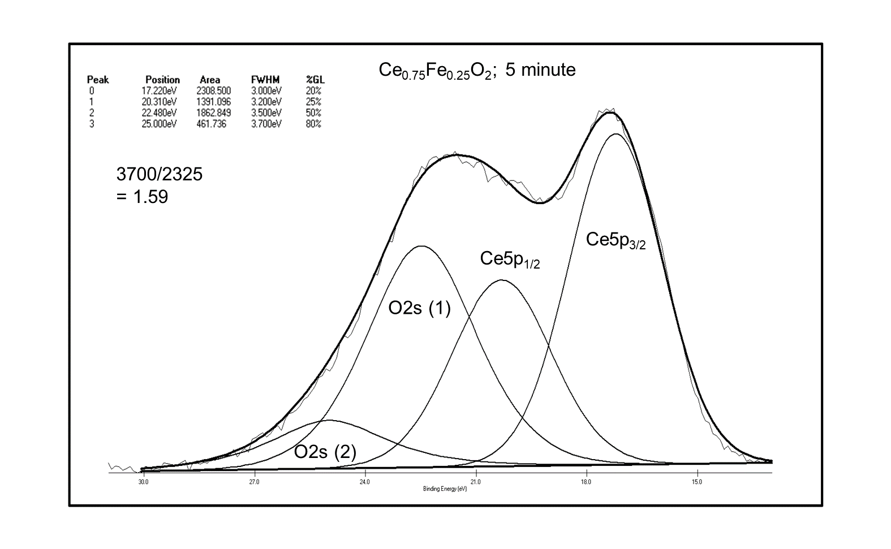D

Figure S2
Curve fitting of the XPS Ce5p and O2s peaks for the fresh A and C and Argon ions sputtered B and D Ce_{0.95}Fe_{0.05}O₂ and Ce_{0.75}Fe_{0.25}O₂, respectively.

