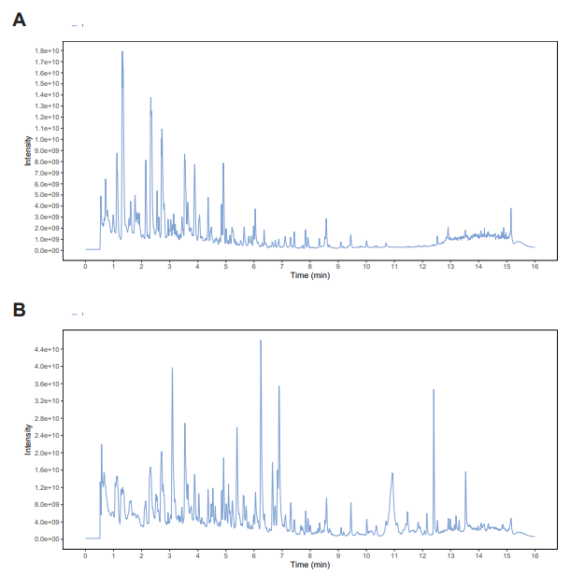
Figure S1 UPLC-MS/MS total ion chromatograms of QLF in negative -ion mode (A) and positive-ion mode (B)
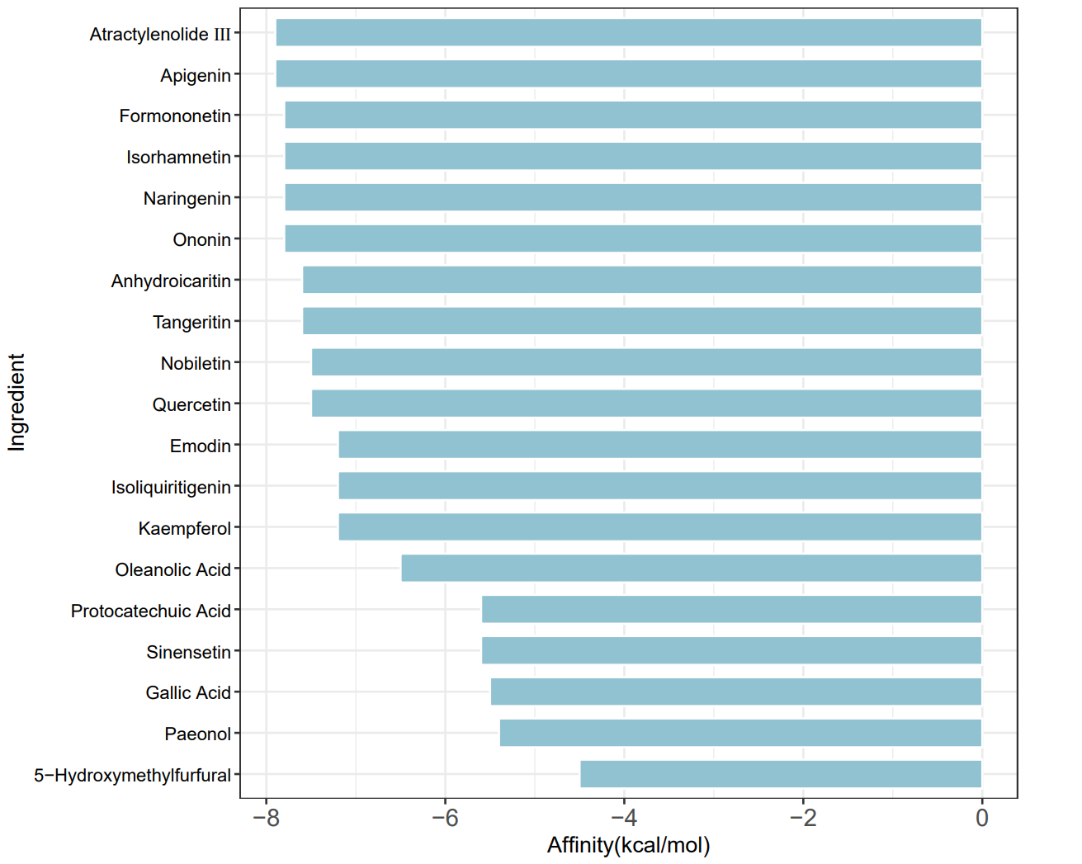
Figure S2 The result of the docking of the main active ingredient with the KIT
Retention time(min) | Molecular formula | M¹ | M² | Identification | Classification
3.33 | C15H10O6 | 285.04[M-H]- | 133.03;286.05;151.00 | Kaempferol | Flavonoids
4.83 | C15H10O5 | 269.05[M-H]- | 270.05;241.05;223.04 | Apigenin | Flavonoids
9.26 | C21H20O6 | 367.12[M-H]- | 309.04;352.10;297.04 | Anhydroicaritin | Flavonoids
3.40 | C15H10O7 | 301.04[M-H]- | 151.00;178.10;121.03 | Quercetin | Flavonoids
4.47 | C16H12O7 | 315.05[M-H]- | 300.03;151.00;316.06 | Isorhamnetin | Flavonoids
3.19 | C15H12O4 | 255.07[M-H]- | 119.05;135.01;153.02 | Isoliquiritigenin | Flavonoids
5.15 | C16H12O4 | 267.07[M-H]- | 252.04;268.07;253.05 | Formononetin | Flavonoids
2.15 | C15H12O5 | 271.06[M-H]- | 151.01;119.05;107.01 | Naringenin | Flavonoids
14.25 | C30H48O3 | 455.35[M-H]- | 456.35;50.60;409.35 | Oleanolic Acid | Terpenoids
0.56 | C7H6O5 | 169.01[M-H]- | 126.03;125.03;70.04 | Gallic Acid | Phenols
0.67 | C7H6O4 | 153.02[M-H]- | 109.03;108.02;110.03 | Protocatechuic Acid | Phenols
4.83 | C15H10O5 | 271.06[M+H]+ | 272.06;253.05;123.01 | Emodin | Anthraquinones
3.15 | C22H22O9 | 431.13[M+H]+ | 269.08;270.09;254.06 | Ononin | Flavonoids
6.90 | C20H20O7 | 395.11[M+H]+ | 365.06;380.09;251.18 | Tangeritin | Flavonoids
5.63 | C20H20O7 | 373.13[M+H]+ | 343.08;312.10;357.10 | Sinensetin | Flavonoids
6.25 | C21H22O8 | 403.14[M+H]+ | 373.09;388.12;355.08 | Nobiletin | Flavonoids
3.76 | C9H10O3 | 167.07[M+H]+ | 152.05;134.04;106.04 | Paeonol | Phenols
0.63 | C6H6O3 | 127.04[M+H]+ | 109.03;81.03;53.04 | 5-hydroxymethylfurfural | Others
6.83 | C15H20O3 | 249.15[M+H]+ | 163.08;69.07;189.09 | Atractylenolide Ⅲ | Terpenoids
Table S1 Mass spectral data of the characterized compounds from QLF by UPLC-MS/MS.

