Supplementary Materials

for
Gold(I) N-heterocyclic carbene complexes with 7-azaindoles demonstrate in vitro antiproliferative effects on ovarian cancer cells and anti-inflammatory activity
Zdeněk Trávníček ^{1,}*, Ján Vančo ¹, Jan Belza ¹, Michal Čajan,¹ Jan Hošek ¹ and Zdeněk Dvořák ²
¹ Czech Advanced Technology and Research Institute, Regional Centre of Advanced Technologies and Materials, Palacký University, Šlechtitelů 27, CZ-779 00 Olomouc, Czech Republic; zdenek.travnicek@upol.cz; jan.vanco@upol.cz; jan.belza01@upol.cz; michal.cajan@upol.cz; jan.hosek@upol.cz
² Department of Cell Biology and Genetics, Faculty of Science, Palacký University, Šlechtitelů 27, CZ-779 00 Olomouc, Czech Republic; zdenek.dvorak@upol.cz

Table of Contents | Page
Figs. S1-S4 ESI-MS spectra of complexes [Au(iPr)(HLn)] 1–4 measured in MeOH solution in positive/negative ionization modes. | S2-S8
Figs. S5-S8 IR spectra of complexes [Au(iPr)(HLn)] 1–4. | S9-S10
Figs. S9-S12 IR spectra of free HL1-4 ligands. | S11-S12
Fig. S13 IR spectrum of the starting [Au(iPr)Cl] complex. | S13
Fig. S14 Part of crystal structure of complex 1, showing the C–H⋅⋅⋅N and C–H⋅⋅⋅C non-covalent contacts (blue dotted lines) connecting individual molecules of 1 into infinite 1D-polymeric chains. | S14
Fig. S15 Part of crystal structure of complex 4, showing the C–H⋅⋅⋅N, C–H⋅⋅⋅C and C⋅⋅⋅C non-covalent contacts (blue dotted lines) connecting two individual molecules of 4 into centrosymmetric dimmers. The presence of voids associated with the squeezed atoms belonging to the unknown solvent molecule(s) are shown in yellow color. | S14
Fig. S16 The intracellular levels of ROS (A) and superoxide (B) in A2780 cells after 24 h incubation with half-cytotoxic concentrations of (4), and reference drug Cisplatin. | S15
A
B

C

Fig. S1. The ESI-MS spectrum of (1) measured in MeOH solution in positive ionization mode in the range of 100-2200 m/z (A), and enhanced part of the spectra in the range of 1000-1500 m/z (B). The ESI-MS spectrum of (1) measured in MeOH solution in negative ionization mode in the range of 100-2200 m/z (C).

A
B
Fig. S2. The ESI-MS spectrum of (2) measured in MeOH solution in positive ionization mode in the range of 100-2200 m/z (A), and enhanced part of the spectrum in the range of 772-813 m/z (B).

A
B

C

Fig. S3. The ESI-MS spectrum of (3) measured in MeOH solution in positive ionization mode in the range of 100-2200 m/z (A), and enhanced part of the spectrum in the range of 200-800 m/z (B). A part of the ESI-MS spectrum of (3) measured in MeOH solution in positive ionization mode in the range of 1000-1500 m/z (C).

A
B
C
Fig. S4. The ESI-MS spectrum of (4) measured in MeOH solution in positive ionization mode in the range of 100-2200 m/z (A), and enhanced part of the spectrum in the range of 585-885 m/z (B). A part of the ESI-MS spectrum of (4) measured in MeOH solution in positive ionization mode in the range of 1000-1500 m/z (C).

Fig. S5 IR spectrum of [Au(iPr)(L1)] (1).

Fig. S6 IR spectrum of [Au(iPr)(L2)] (2).

Fig. S7 IR spectrum of [Au(iPr)(L3)] (3).

Fig. S8 IR spectrum of [Au(iPr)(L4)] (4).
Fig. S9 IR spectrum of ligand HL1. IR (ATR; cm⁻¹): ν = 471 (vs), 577 (m), 613 (s), 626 (m), 719 (vs), 747 (vs), 782 (s), 867 (m), 884 (s), 980 (m), 1068 (m), 1110 (m), 1136 (s), 1205 (m), 1246 (s), 1292 (m), 1313 (m), 1331 (m), 1406 (m), 1447 (m), 1500 (m), 1570 (m), 1586 (m), 1850 (m) , 2757 (w), 2814 (w), 2887 (m), 2934 (m), 2993 (m), 3070 (m), 3140 (m).
Fig. S10 IR spectrum of ligand HL2. IR (ATR; cm⁻¹): ν = 430 (m), 453 (s), 570 (m), 601 (s), 670 (s), 729 (vs), 778 (s), 861 (m), 918 (s), 1066 (m), 1076 (m), 1185 (m), 1247 (m), 1280 (s), 1298 (m), 1337 (m), 1399 (m), 1431 (w), 1464 (m), 1493 (w), 1570 (m), 1594 (w), 2730 (w), 2767 (w), 2859 (m), 2885 (m), 2989 (m), 3013 (m), 3045 (m), 3128 (m), 3191 (m).
Fig. S11 IR spectrum of ligand HL3. IR (ATR; cm⁻¹): ν = 431 (m), 507 (s), 571 (s), 595 (s), 661 (s), 759 (vs), 785 (m), 809 (w), 893 (m), 921 (w), 999 (s), 1066 (m), 1040 (w), 1120 (w), 1210 (w), 1288 (m), 1298 (m), 1413 (m), 1451 (w), 1509 (w), 1589 (m), 1609 (m), 2691 (m), 2778 (m), 2821 (m), 2870 (m), 2914 (m), 2985 (m), 3023 (m), 3080 (m), 3128 (m).
Fig. S12 The IR spectrum of ligand HL4. Ligand (HL4): IR (ATR; cm⁻¹): ν = 425 (m), 488 (s), 567 (s), 589 (s), 640 (s), 762 (vs), 787 (s), 801 (m), 895 (m), 923 (w), 963 (m), 1041 (w), 1114 (m), 1191 (m), 1245 (m), 1283 (m), 1313 (m), 1335 (w), 1353 (w), 1410 (m), 1436 (w), 1487 (w), 1581 (m), 1610 (w), 2815 (m), 2860 (m), 2904 (m), 2981 (m), 3010 (m), 3054 (m), 3111 (m).

Fig. S13 IR spectrum of [Au(iPr)Cl]. IR (ATR): ν = 451 (w), 552 (w), 637 (w), 705 (m), 742 (s), 764 (s), 808 (s), 937 (m), 947 (m), 976 (w), 1042 (m), 1058 (m), 1076 (w), 1102 (w), 1116 (m), 1177 (m), 1212 (m), 1255 (w), 1289 (w), 1305 (m), 1327 (m), 1356 (m), 1365 (m), 1383 (m), 1416 (m), 1456 (m), 1470 (s), 1549 (w), 1582 (m), 1682 (m), 2765 (s), 2868 (m), 2925 (m), 2967 (vs), 3080 (w), 3140 (w), 3163 (w).

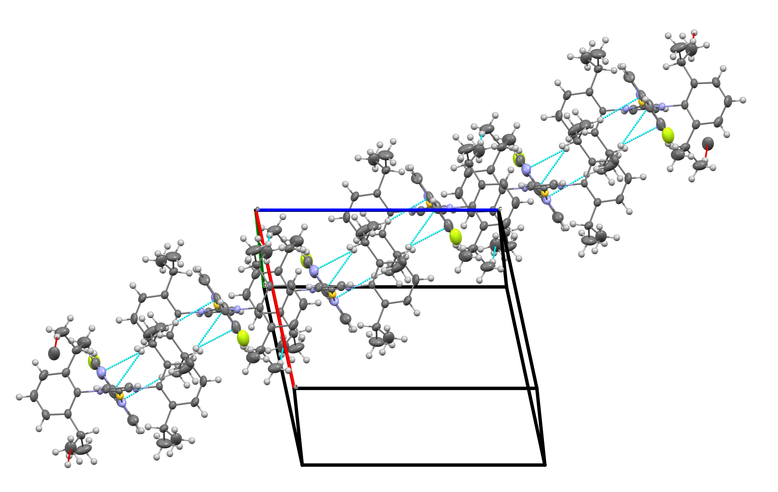
Fig. S14 Part of crystal structure of complex 1, showing the C–H⋅⋅⋅N and C–H⋅⋅⋅C non-covalent contacts (blue dotted lines) connecting individual molecules of 1 into infinite 1D-polymeric chains.

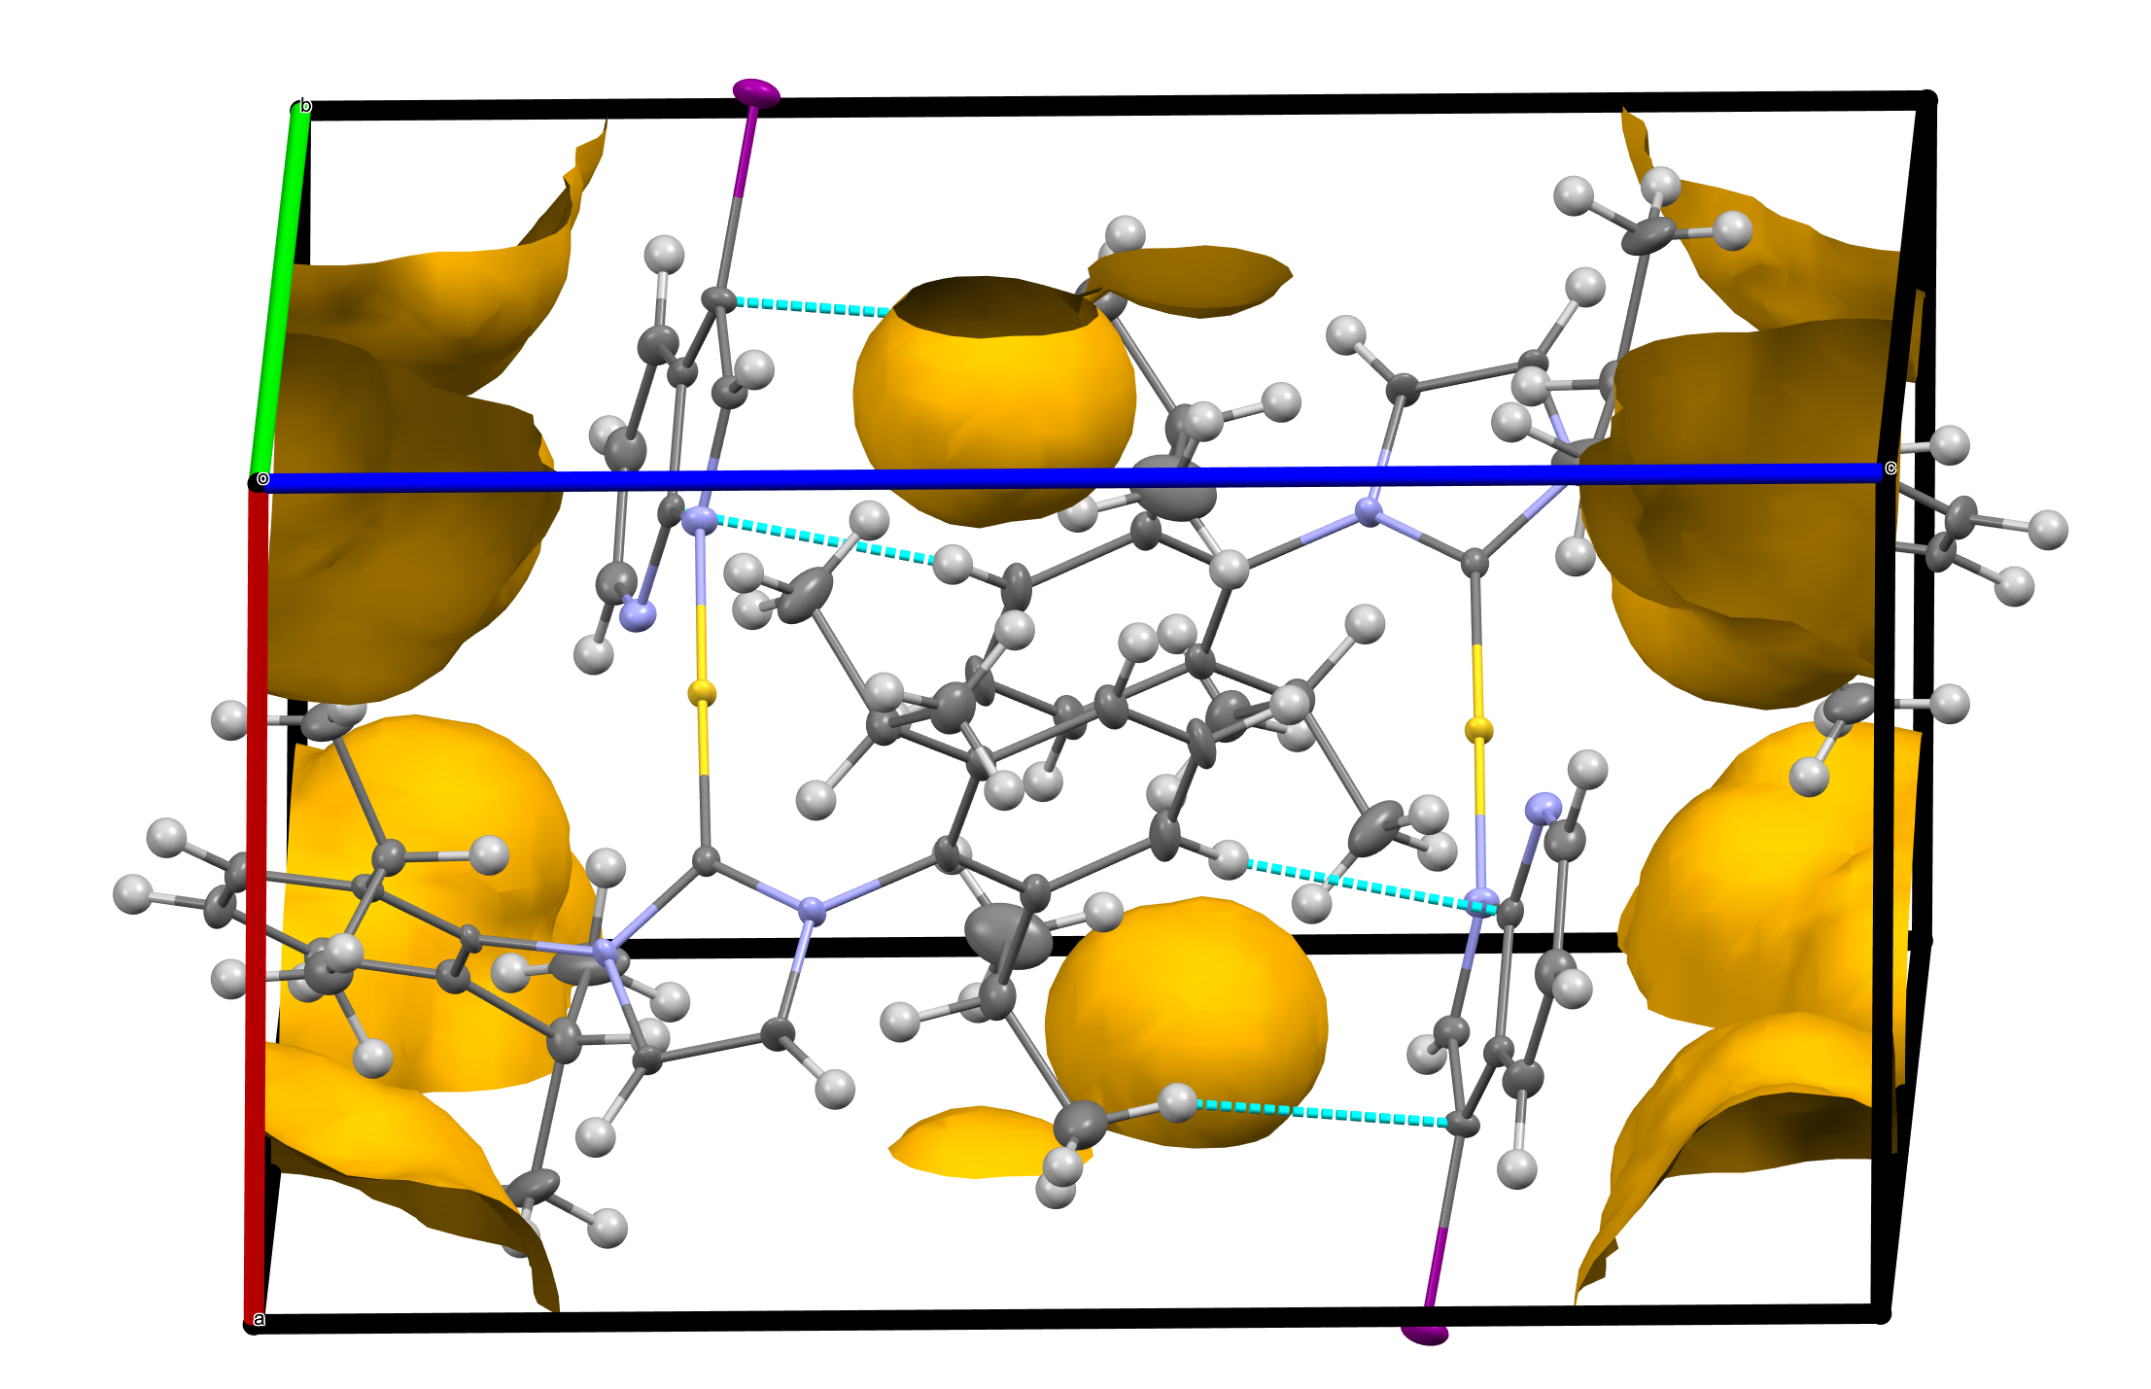
Fig. S15 Part of crystal structure of complex 4, showing the C–H⋅⋅⋅N and C–H⋅⋅⋅C non-covalent contacts (blue dotted lines) connecting two individual molecules of 4 into centrosymmetric dimmers. The presence of voids associated with the squeezed atoms belonging to the unknown solvent molecule(s) are shown in yellow colour. Volume of solvent accessible voids in the structure ≈ 160 Å³.
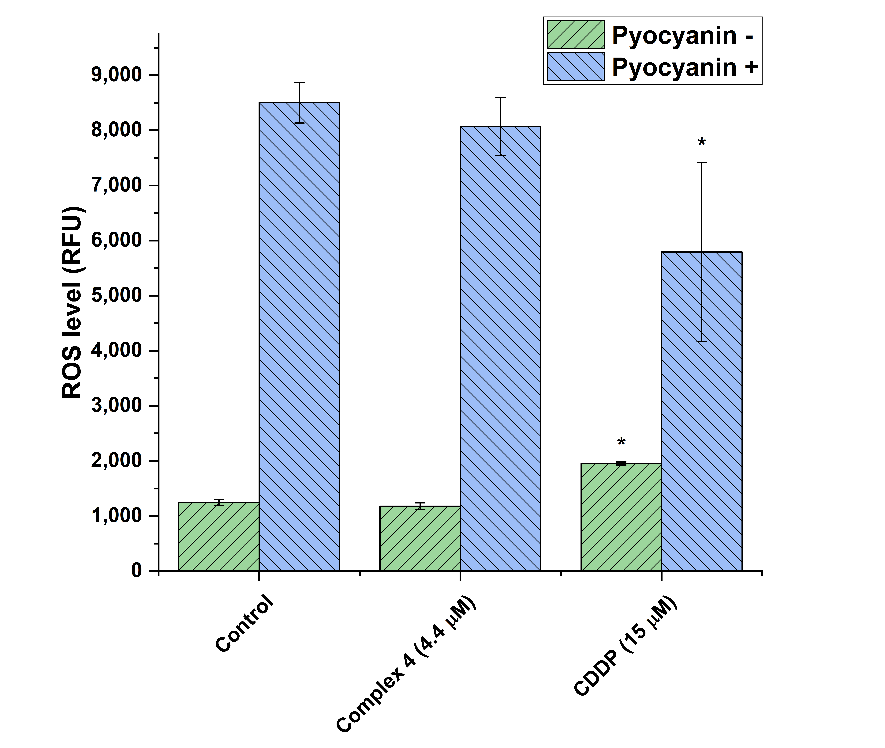
A

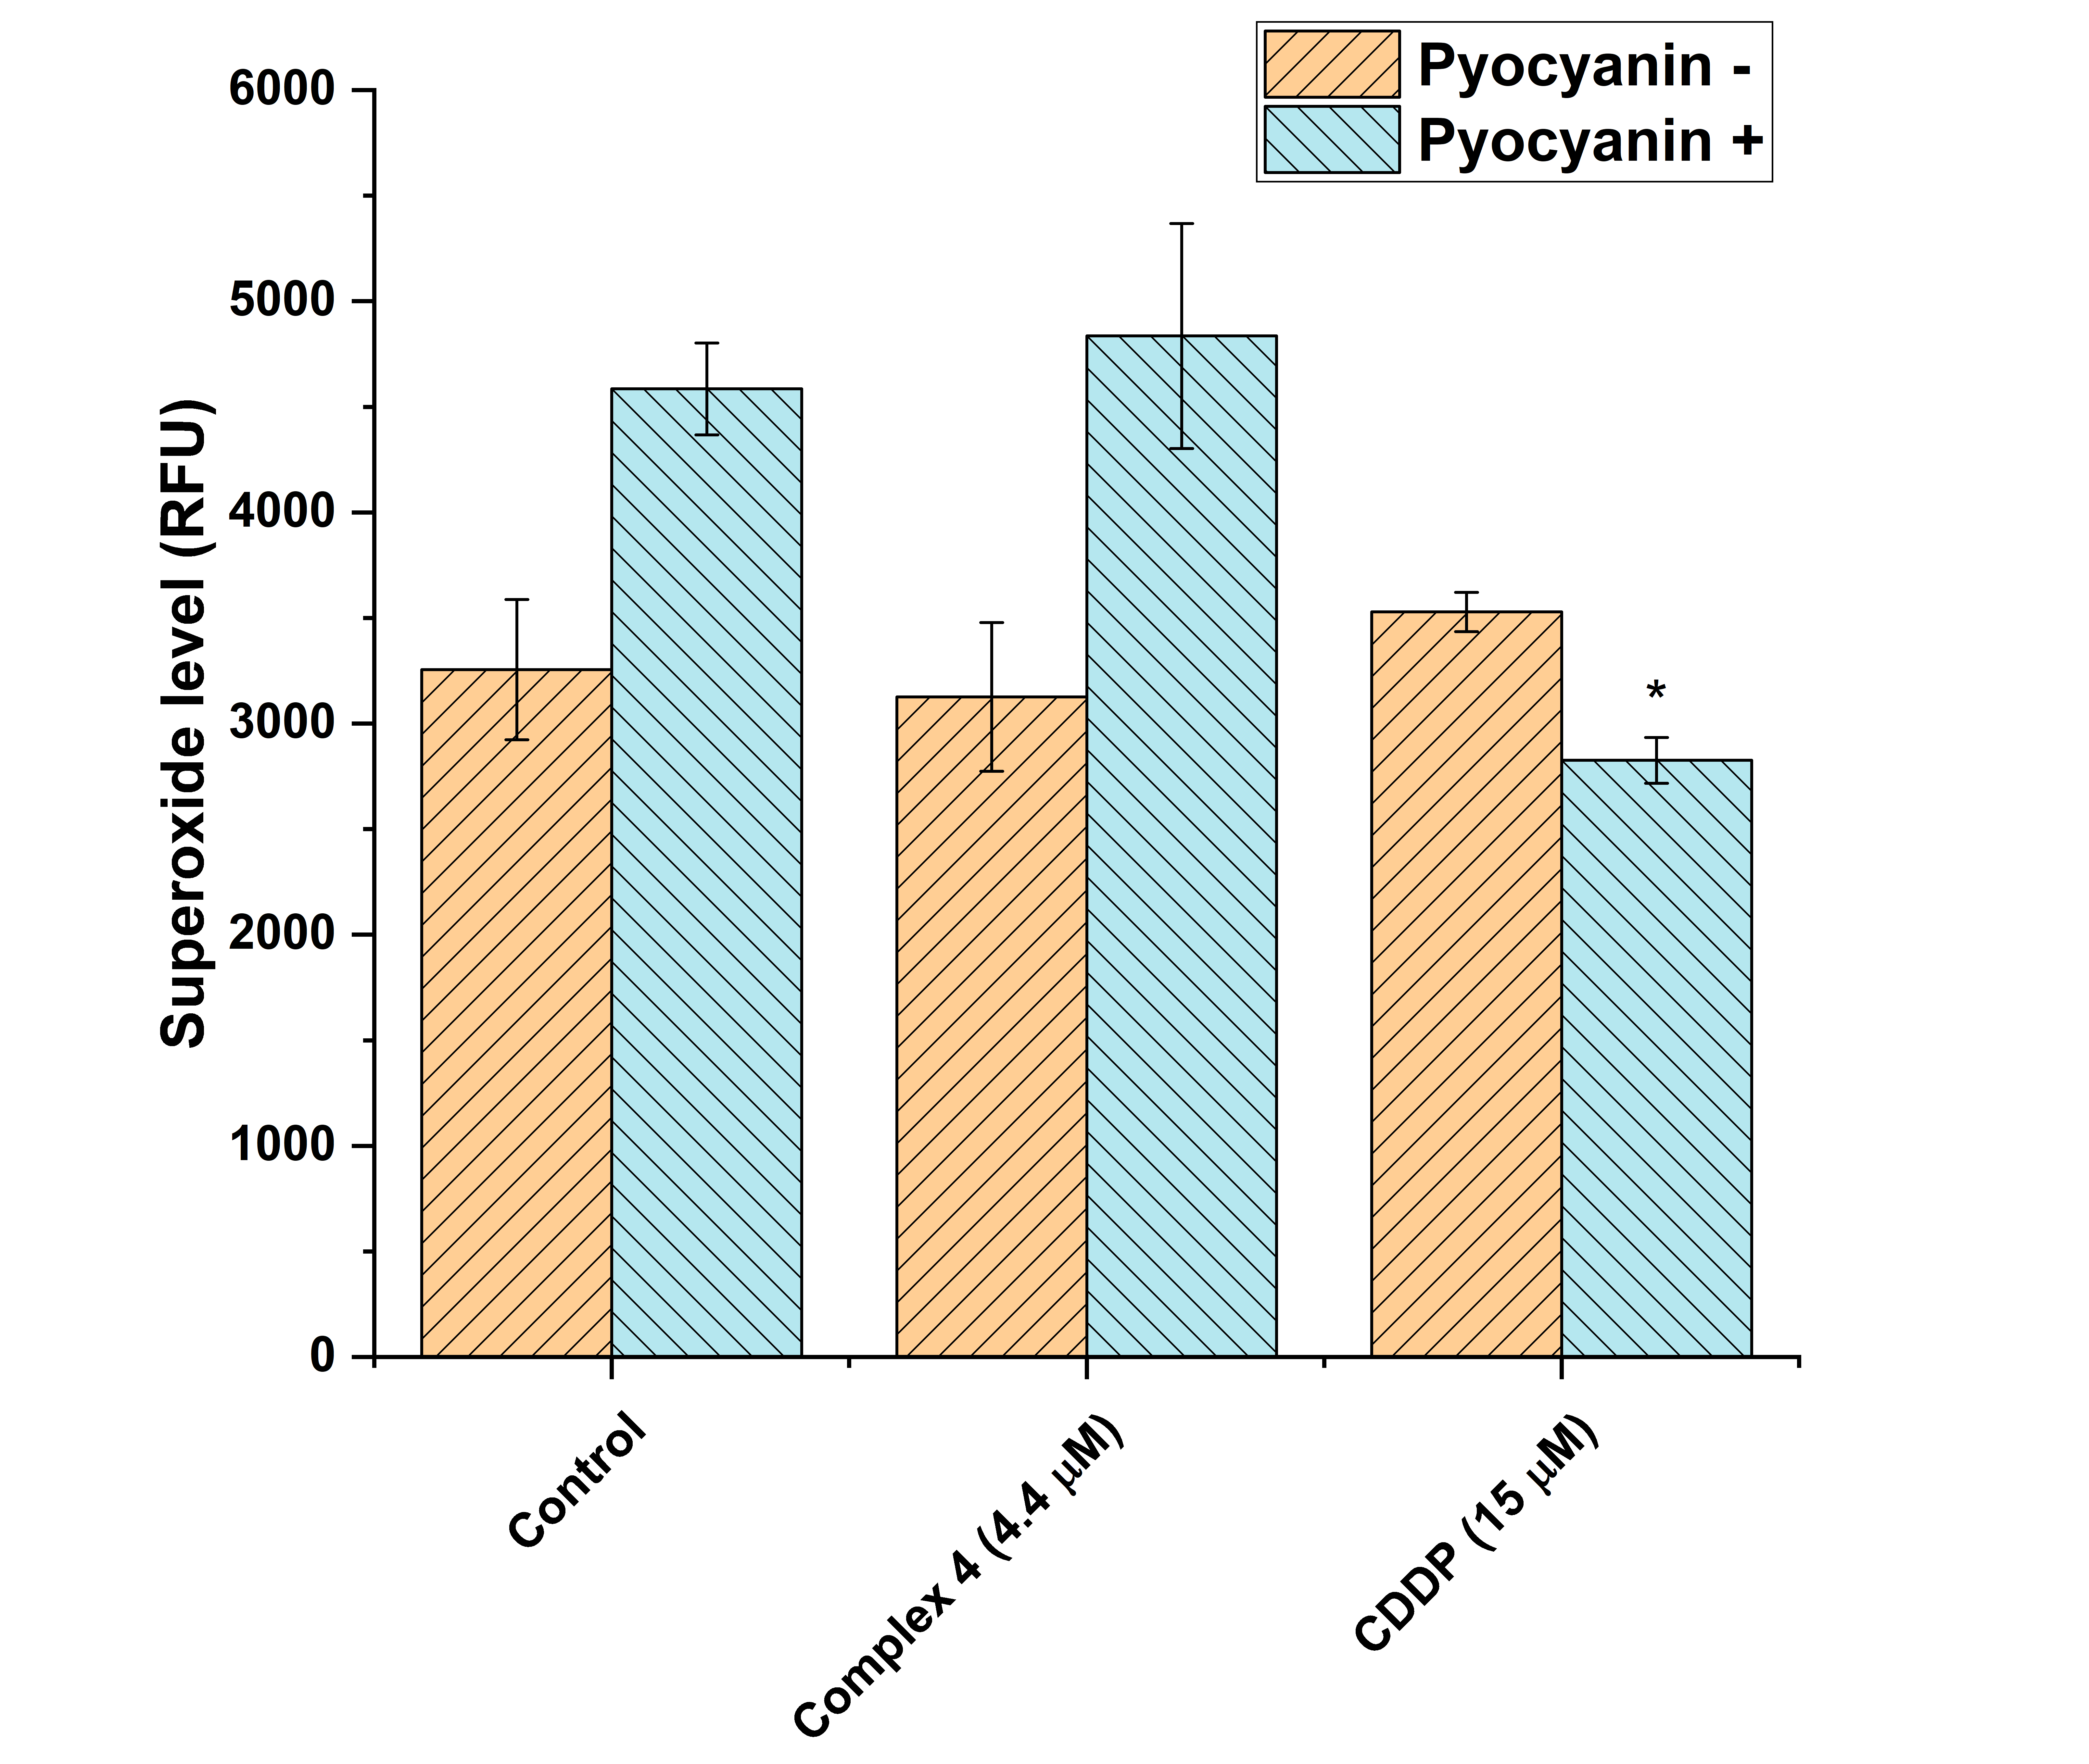
B

Fig. S16 The intracellular levels of ROS (A) and superoxide (B) in A2780 cells after 24 h incubation with half-cytotoxic concentrations of (4), and reference drug Cisplatin. The statistical significance was considered at the following levels: * p<0.05 with respect to the untreated control group.

