Supplementary Material

Table S1. Severity grading scale for local reactions and systemic events.
 | Mild | Moderate | Severe
Local reaction
Pain | Does not interfere with activity | Interferes with activity | Prevents daily activity
Redness | >2.0–5.0 cm | >5.0–10.0 cm | >10 cm
Swelling | >2.0–5.0 cm | >5.0–10.0 cm | >10 cm
Systemic event
Vomiting | 1–2 × in 24 h | >2 × in 24 h | Requires IV hydration
Diarrhea | 2–3 loose stools in 24 h | 4–5 loose stools in 24 h | ≥6 loose stools in 24 h
Headache | Does not interfere with activity | Some interference with activity | Prevents daily routine activity
Fatigue | Does not interfere with activity | Some interference with activity | Prevents daily routine activity
Chills | Does not interfere with activity | Some interference with activity | Prevents daily routine activity
Muscle pain | Does not interfere with activity | Some interference with activity | Prevents daily routine activity
Joint pain | Does not interfere with activity | Some interference with activity | Prevents daily routine activity
IV=intravenous.
For the fever scale, refer to the key of Figure 3.

Table S2. Participant demographics of the variant neutralization subset
 | Current study:  XBB.1.5-adapted BNT162b2 30 μg |  |  | Comparator group:  BA.4/BA.5-adapted BNT162b2 30 μg
 | 18–55 years old  (Nª=20) | >55 years old  (Nª=20) | Total  (Nª=40) | 18–55 years old  (Nª=20) | >55 years old  (Nª=20) | Total  (Nª=40)
Sex, n^{b} (%)
Male | 12 (60.0) | 7 (35.0) | 19 (47.5) | 12 (60.0) | 7 (35.0) | 19 (47.5)
Female | 8 (40.0) | 13 (65.0) | 21 (52.5) | 8 (40.0) | 13 (65.0) | 21 (52.5)
Race, n^{b} (%)
White | 18 (90.0) | 16 (80.0) | 34 (85.0) | 17 (85.0) | 16 (80.0) | 33 (82.5)
Black or African American | 2 (10.0) | 2 (10.0) | 4 (10.0) | 1 (5.0) | 3 (15.0) | 4 (10.0)
Other | 0 | 2 (10.0) | 2 (5.0) | 1 (5.0) | 1 (5.0) | 2 (5.0)
Ethnicity, n^{b} (%)
Hispanic/Latino | 9 (45.0) | 4 (20.0) | 13 (32.5) | 3 (15.0) | 4 (20.0) | 7 (17.5)
Age at vaccination (years)
Mean (SD) | 38.0 (10.04) | 70.1 (6.51) | 54.0 (18.30) | 37.9 (9.97) | 69.7 (5.95) | 53.8 (18.00)
Median (range) | 35.5 (25–55) | 69.5 (56–82) | 55.5 (25–82) | 36.0 (25–54) | 69.5 (56–81) | 55.0 (25–81)
Baseline SARS-CoV-2 status, n^{b} (%)
Positive^{c} | 20 (100.0) | 20 (100.0) | 40 (100.0) | 20 (100.0) | 20 (100.0) | 40 (100.0)
Time from last dose of mRNA COVID-19 vaccine^{d} to the study vaccination (months^{e})
Mean (SD) | 8.8 (1.98) | 9.6 (2.04) | 9.2 (2.03) | 11.0 (1.41) | 11.4 (1.16) | 11.2 (1.29)
Median (range) | 8.3 (5.8–12.0) | 10.2 (5.8–11.9) | 9.5 (5.8–12.0) | 11.3 (7.4–12.8) | 11.9 (8.5–12.6) | 11.4 (7.4–12.8)
≥5 to <7 months, n^{b} (%) | 4 (20.0) | 4 (20.0) | 8 (20.0) | 0 | 0 | 0
≥7 to <9 months, n^{b} (%) | 7 (35.0) | 2 (10.0) | 9 (22.5) | 3 (15.0) | 1 (5.0) | 4 (10.0)
≥9 to ≤12 months, n^{b} (%) | 9 (45.0) | 14 (70.0) | 23 (57.5) | 13 (65.0) | 10 (50.0) | 23 (57.5)
>12 months, n^{b} (%) | 0 | 0 | 0 | 4 (20.0) | 9 (45.0) | 13 (32.5)
Time from last dose of mRNA COVID-19 vaccine to study vaccination (days)
Mean (SD) | 245.7 (55.35) | 269.5 (57.01) | 257.6 (56.75) | 306.7 (39.39) | 318.8 (32.39) | 312.7 (36.12)
Median (range) | 233.5 (162–336) | 285.0 (162–333) | 265.5 (162–336) | 317.0 (207–359) | 334.5 (239–354) | 320.5 (207–359)
BMI, n^{b} (%)
Underweight (<18.5 kg/m²) | 0 | 1 (5.0) | 1 (2.5) | 0 | 0 | 0
Normal weight (≥18.5–24.9 kg/m²) | 6 (30.0) | 6 (30.0) | 12 (30.0) | 5 (25.0) | 3 (15.0) | 8 (20.0)
Overweight (≥25.0–29.9 kg/m²) | 9 (45.0) | 7 (35.0) | 16 (40.0) | 8 (40.0) | 12 (60.0) | 20 (50.0)
Obese (≥30.0 kg/m²) | 5 (25.0) | 6 (30.0) | 11 (27.5) | 7 (35.0) | 5 (25.0) | 12 (30.0)
Data are for the all-available immunogenicity population. Data for BA.4/BA.5-adapted BNT162b2 are in a comparator group of participants from another study (NCT05472038) who were matched by age, and baseline SARS-CoV-2 status.
BMI=body mass index; NAAT=nucleic acid amplification test; N-binding=SARS-CoV-2 nucleoprotein–binding; SARS-CoV-2=severe acute respiratory syndrome coronavirus 2; SD=standard deviation.
ªN was the number of participants in the specified group, or the total sample; this value was the denominator for the percentage calculations.
^{b}n was the number of participants with the specified characteristic.
^{c}Positive N-binding antibody result at baseline, positive NAAT result at baseline, or medical history of COVID-19.
^{d} The inclusion criteria required the participant to have received: ≥3 prior doses of a US-authorized mRNA COVID-19 vaccine with the most recent dose being a US-authorized Omicron BA.4/BA.5–adapted vaccine ≥150 days before study vaccination (current study); 3 or 4 prior doses of 30 μg BNT162b2 with the last dose being 150–365 days before study vaccination (comparator group).
^{e}Month was calculated as 28 days.

Figure S1. Serum neutralizing GMTs (95% CIs) before and 7 days after vaccination with XBB.1.5-adapted BNT162b2 30 μg or BA.4/BA.5-adapted BNT162b2 30 μg and GMFRs (95% CIs) from before to 1 week after vaccination to Omicron XBB.1.5 (a), EG.5.1 (b), and BA.2.86 (c). Data for BA.4/BA.5-adapted BNT162b2 are in participants from another study (NCT05472038) who were matched by age, sex, and baseline SARS-CoV-2 status. Data are for the all-available immunogenicity population. Assay results <LLOQ were set to 0.5 × LLOQ. Numbers within the bars are the GMTs. 7d=7 days after vaccination; FFRNT=fluorescent focus reduction neutralization test; GMFR=geometric mean fold rise; GMT=geometric mean titer; LLOQ=lower limit of quantitation; Pre=before vaccination.
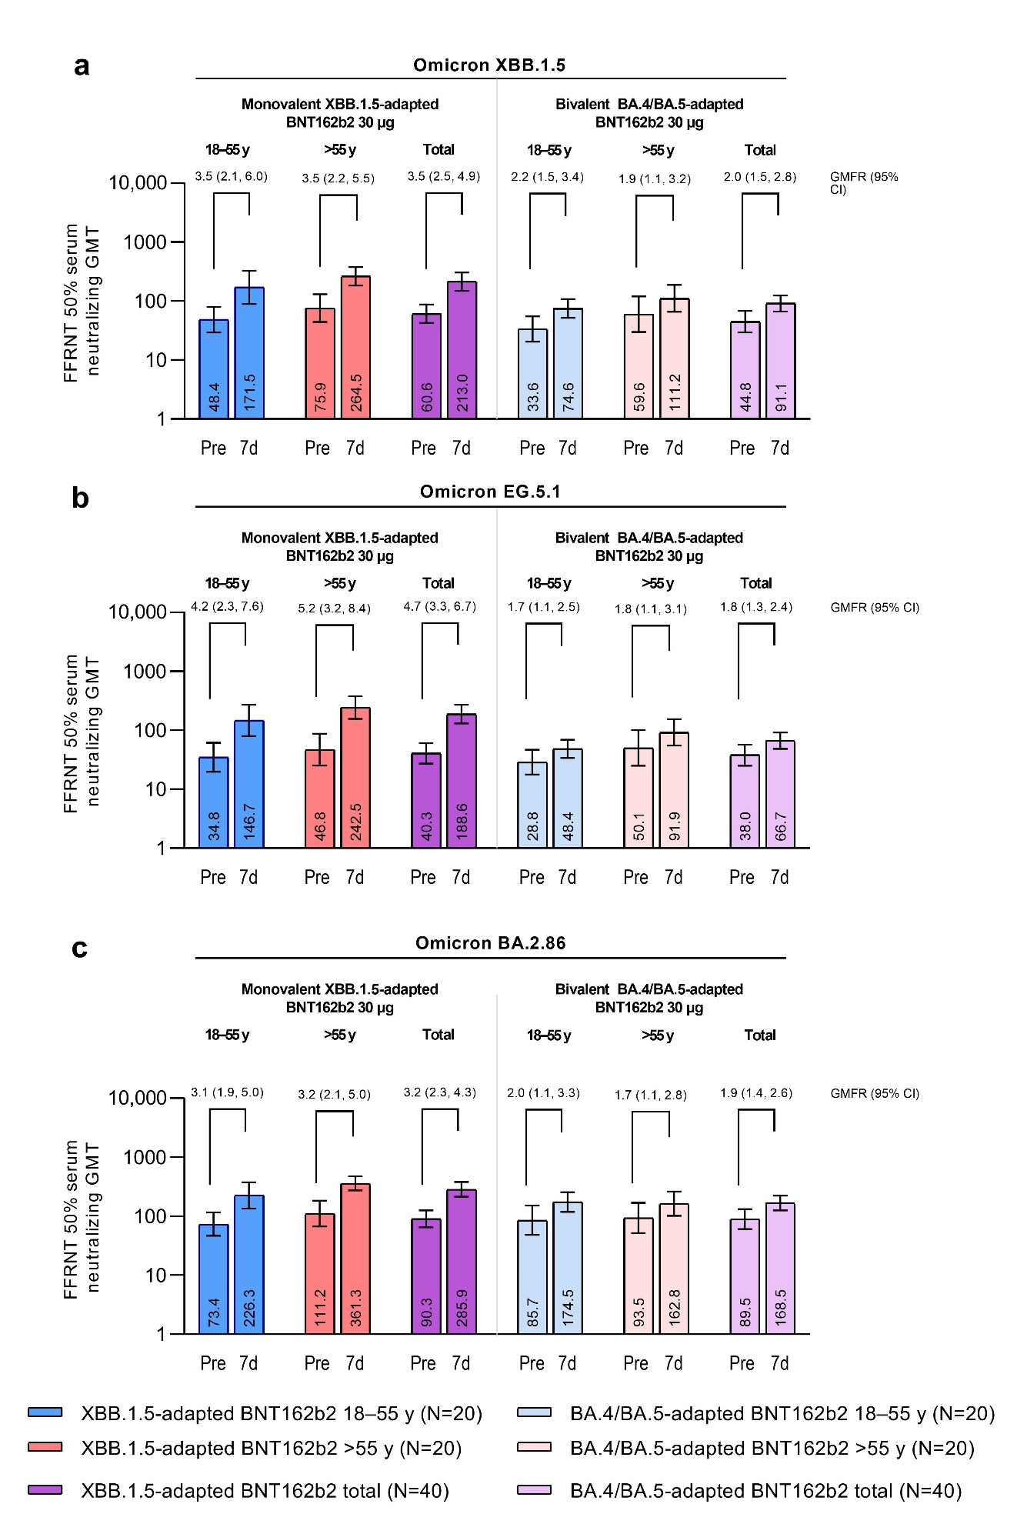

Figure S2. Percentage of participants achieving seroresponse (95% CIs) 1 week after vaccination with XBB.1.5-adapted BNT162b2 30 μg or BA.4/BA.5-adapted BNT162b2 30 μg to Omicron XBB.1.5 (a), EG.5.1 (b), and BA.2.86 (c). Data for BA.4/BA.5-adapted BNT162b2 are in participants from another study (NCT05472038) who were matched by age, sex, and baseline SARS-CoV-2 status. Data are for the all-available immunogenicity population. Seroresponse was defined as achieving a ≥4-fold rise from before study vaccination in FFRNT 50% serum neutralizing titers. If the baseline measurement was <LLOQ, a postvaccination assay result ≥4 × LLOQ was considered a seroresponse. Numbers above the bars are percentages rounded to the nearest full number. FFRNT=fluorescent focus reduction neutralization test; LLOQ=lower limit of quantitation.

