Supporting information.
Figure S1. ¹HNMR of 3a
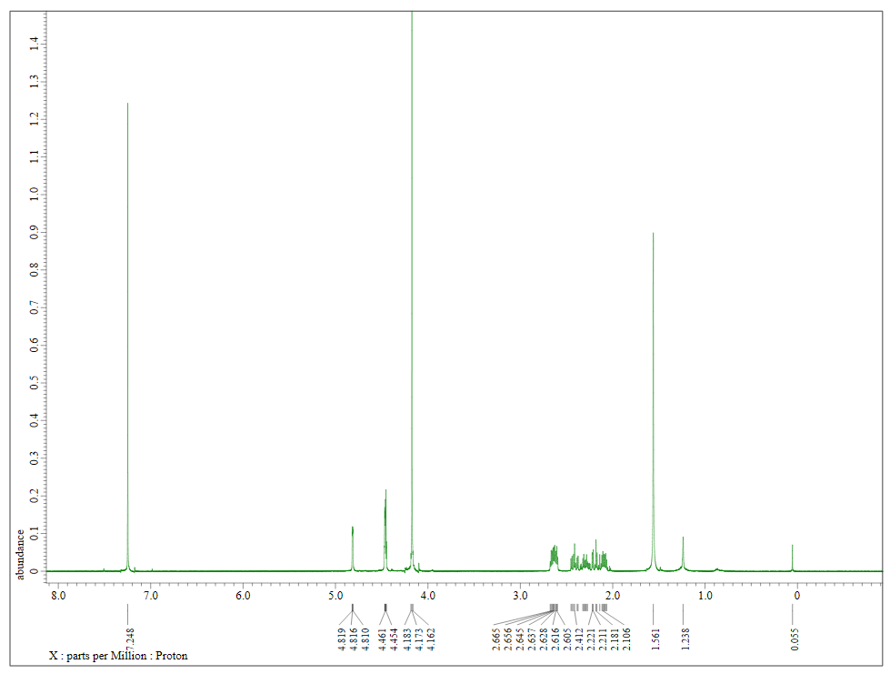

Figure S2. ¹³C NMR of 3a
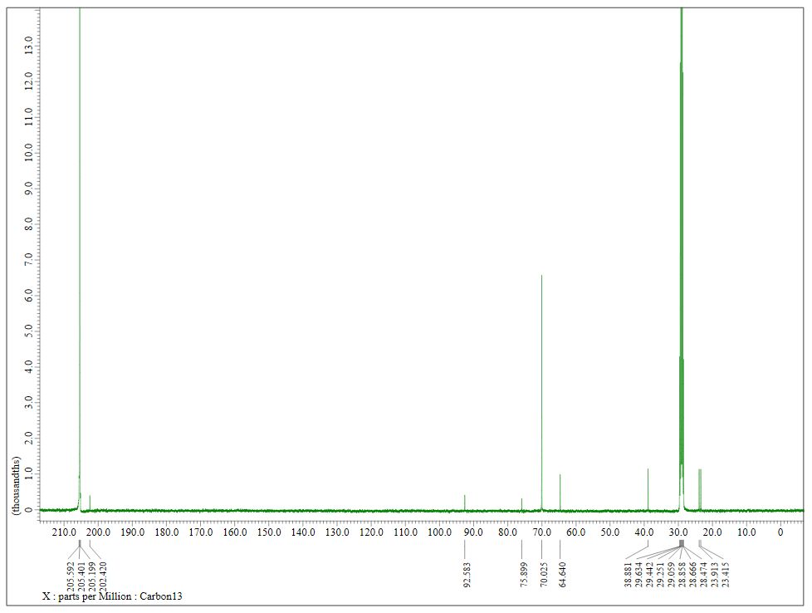

Figure S3. ¹H NMR of 3b
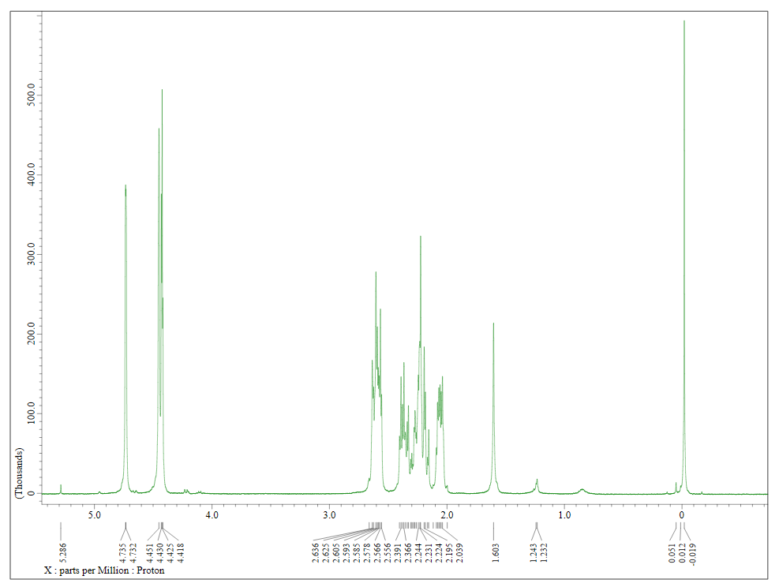

Figure S4. ¹³CNMR of 3b
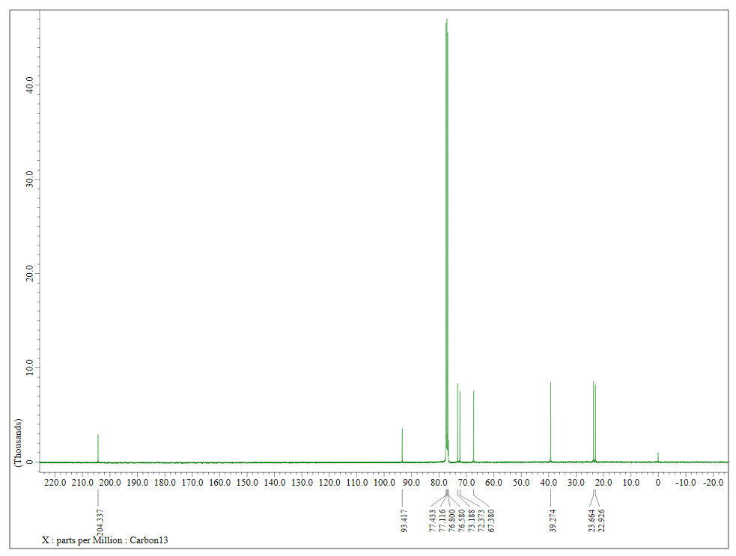

Figure S5. ¹H NMR of 3b’
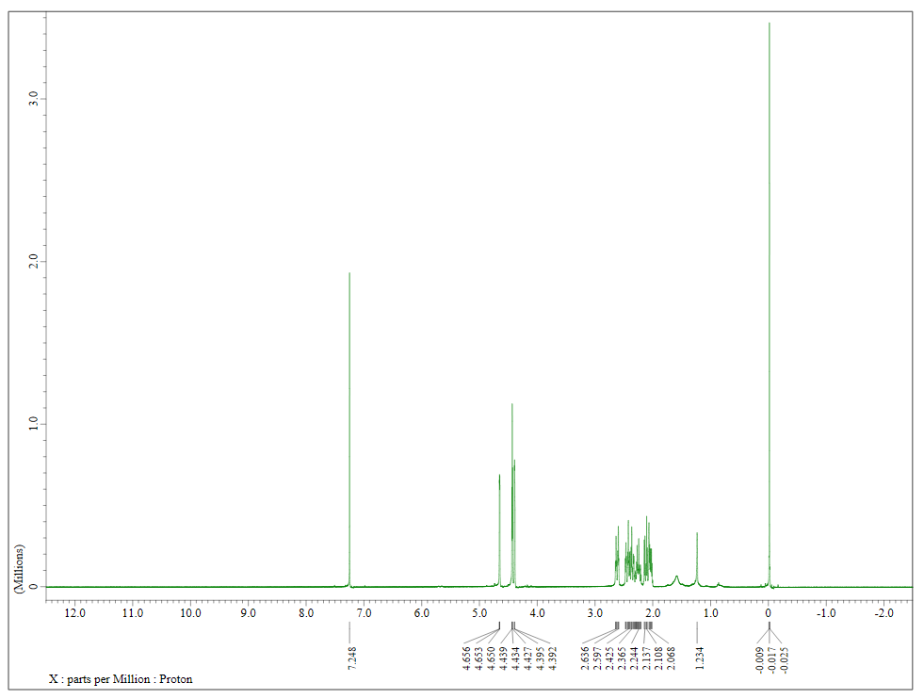

Figure S6. ¹³C NMR of 3b’
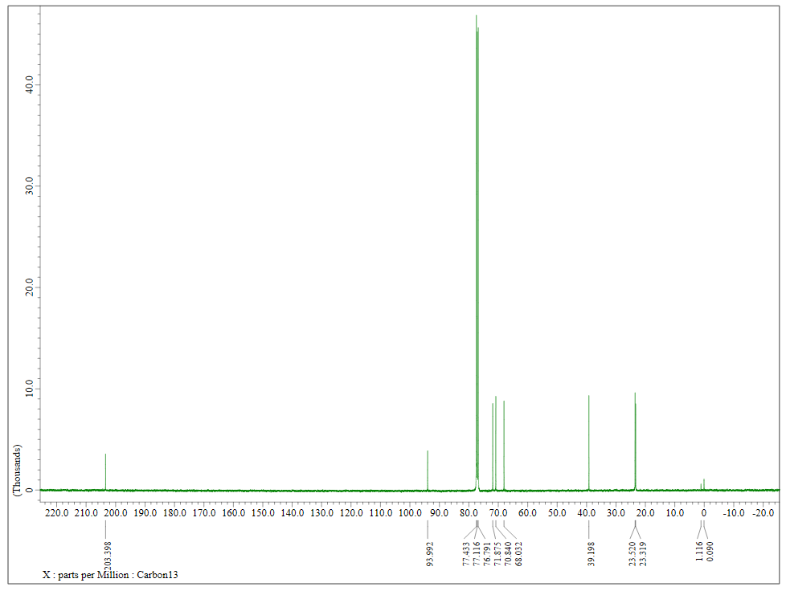

Figure S7. ¹H NMR of 4a
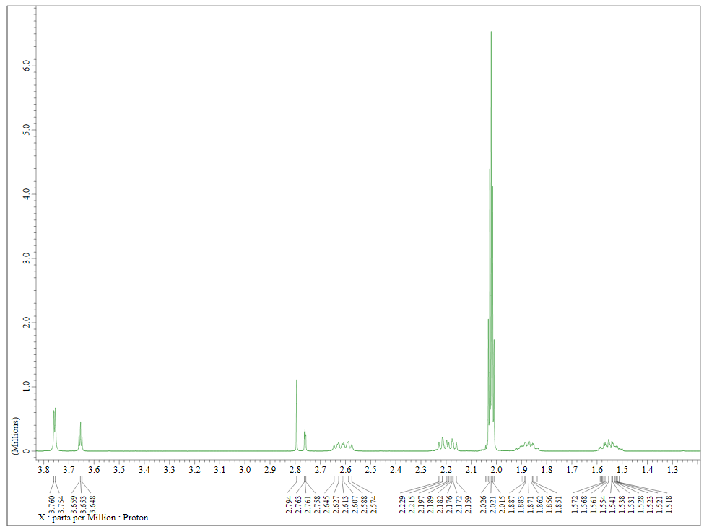

Figure S8. ¹³C NMR of 4a
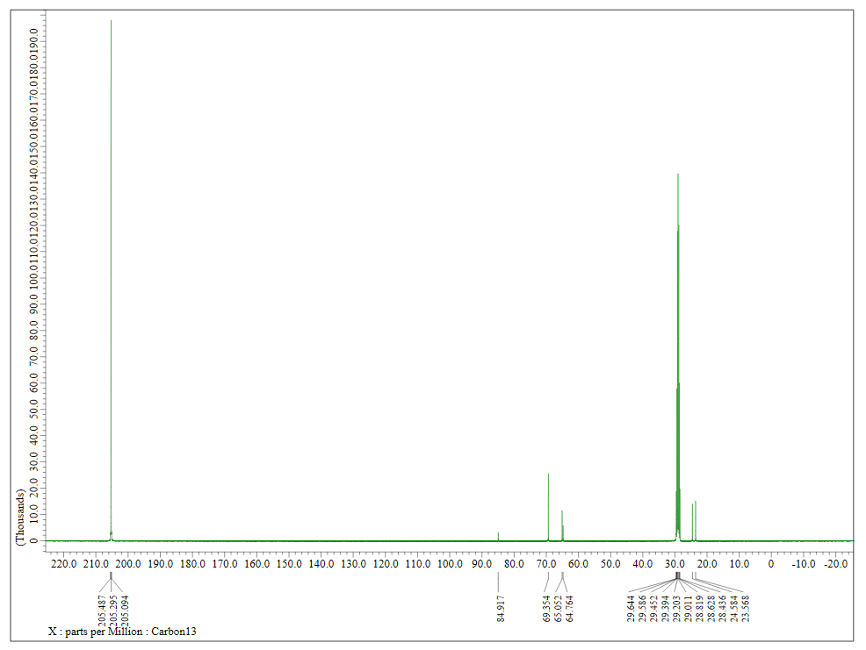

Figure S9. ¹HNMR of 4b

