Supplementary Table 1. Summary of the Unigene database annotation results
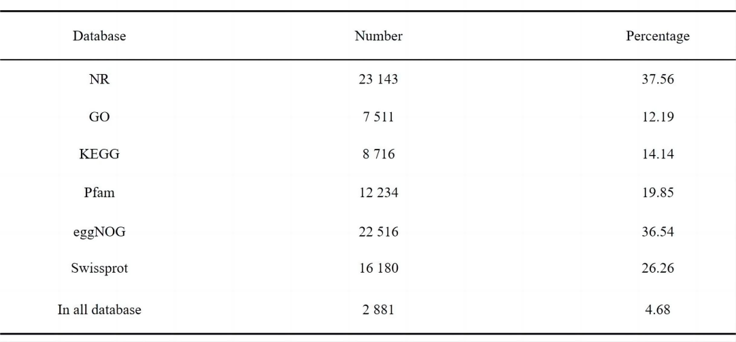

Note: Database: the type of database; number: number of unigenes successfully annotated; percentage (%): the proportion of successfully annotated unigenes in total unigenes; in all databases: the total number of unigenes annotated to all databases.

Supplemental Table 2. Contents of endogenous hormone in flower bud and leaf bud
Types of hormones | Flower bud (ng/g, FW) | Leaf bud (ng/g, FW) | Significance of difference
Abscisic acid | 64.07±19.30 | 11.53±2.131 | **
3-Indoleacetic acid | 7.554±2.046 | 48.00±13.63 | **
Trans-zeatin-riboside | 13.06±2.552 | 8.556±0.949 | *
N6-(Δ2-Isopentenyl)adenosine | 2.089±0.536 | 0.655±0.222 | **
Jasmonic acid | 41.77±39.54 | 6.996±0.499
Salicylic acid | 7.852±2.468 | 6.532±2.276
Jasmonic acid-isoleucine | 7.703±7.330 | 0.875±0.528
1-Aminocyclopropane carboxylic acid | 0.277±0.087 | 0.223±0.080
Gibberellin A1  Gibberellin A4 | 0.081±0.029  1.495±0.986 | 0.041±0.018  0.612±0.511
Gibberellin A7 | 0.031±0.022 | 0.010±0.006
N6-(Δ2-Isopentenyl)adenine | 0.080±0.017 | 0.066±0.008
Methyl Jasmonate | 0.084±0.016 | 0.715±0.181
Gibberellin A3 | - | -
Trans-zeatin | - | -
Brassinolide | - | -
Note: * 0.05 significant difference; * * 0.01 significant difference; -Not detected

Supplementary Table 3. Statistics of 118 differentially abundant metabolites
DAM | VIP | mean_H | sd_H | mean_Y | sd_Y | Fold Change_H/Y | log2(FC_H/Y) | p value | FDR
4-Aminobutyraldehyde | 1.468 | 988.9 | 0 | 243884007.5 | 175369880.5 | 4.10E-06 | -17.91 | 0.0028 | 0.0209
Gyromitrin | 1.73 | 284576546.4 | 128808704.7 | 988.8508326 | 0 | 2.90E+05 | 18.14 | 0.0028 | 0.0209
Catechol | 1.995 | 988.9 | 0 | 48813863073 | 3431027683 | 2.00E-08 | -25.56 | 0.0028 | 0.0209
Ketoleucine | 1.387 | 26500401 | 21383260.2 | 988.8508326 | 0 | 2.70E+04 | 14.71 | 0.0028 | 0.0209
Beta-Leucine | 1.54 | 988.9 | 0 | 185297260.7 | 119457121.8 | 5.30E-06 | -17.52 | 0.0028 | 0.0209
5-Aminopentanoic acid | 1.26 | 988.9 | 0 | 413395400.9 | 395998967 | 2.40E-06 | -18.67 | 0.0028 | 0.0209
Phenylethylamine | 1.392 | 81993597.7 | 65704175.1 | 988.8508326 | 0 | 8.30E+04 | 16.34 | 0.0028 | 0.0209
Isonicotinic acid | 1.738 | 988.9 | 0 | 61794354.75 | 27433974.29 | 1.60E-05 | -15.93 | 0.0028 | 0.0209
Ciliatine | 1.653 | 988.9 | 0 | 16666613.97 | 8832267.162 | 5.90E-05 | -14.04 | 0.0028 | 0.0209
1,2,3-Trihydroxybenzene | 1.895 | 988.9 | 0 | 767169850.5 | 204270511.8 | 1.30E-06 | -19.57 | 0.0028 | 0.0209
(S)-2-amino-6-oxohexanoate | 1.253 | 988.9 | 0 | 10841563.66 | 10472493.11 | 9.10E-05 | -13.42 | 0.0028 | 0.0209
Pyroglutamic acid | 1.359 | 988.9 | 0 | 32293389.51 | 27088408.42 | 3.10E-05 | -15 | 0.0028 | 0.0209
Pipecolic acid | 1.281 | 988.9 | 0 | 1548082415 | 1441827132 | 6.40E-07 | -20.58 | 0.0028 | 0.0209
3-Methyl-2-oxovaleric acid | 1.938 | 180493405.9 | 36488712.5 | 988.8508326 | 0 | 1.80E+05 | 17.48 | 0.0028 | 0.0209
Ectoine | 1.615 | 988.9 | 0 | 186776081.2 | 106205253.4 | 5.30E-06 | -17.53 | 0.0028 | 0.0209
D-Lyxose | 1.653 | 988.9 | 0 | 1303842.529 | 691451.1186 | 7.60E-04 | -10.37 | 0.0028 | 0.0209
Gentisic acid | 1.87 | 988.9 | 0 | 157329334.5 | 46929823.95 | 6.30E-06 | -17.28 | 0.0028 | 0.0209
DHHA | 1.574 | 988.9 | 0 | 248517845.7 | 151497273.2 | 4.00E-06 | -17.94 | 0.0028 | 0.0209
(3S,5S)-Carbapenam-3-carboxylic acid | 1.629 | 988.9 | 0 | 32418182.93 | 17964805.16 | 3.10E-05 | -15 | 0.0028 | 0.0209
Oxoadipic acid | 1.468 | 988.9 | 0 | 13538290.09 | 9734882.04 | 7.30E-05 | -13.74 | 0.0028 | 0.0209
myo-Inositol | 1.269 | 988.9 | 0 | 68992105.7 | 65292038.1 | 1.40E-05 | -16.09 | 0.0028 | 0.0209
Homovanillic acid | 1.759 | 988.9 | 0 | 3014862.349 | 1273274.097 | 3.30E-04 | -11.57 | 0.0028 | 0.0209
Mannitol | 1.84 | 988.9 | 0 | 17360352.58 | 5790577.058 | 5.70E-05 | -14.1 | 0.0028 | 0.0209
trans-Ferulic acid | 1.051 | 988.9 | 0 | 102725941.9 | 129177257.8 | 9.60E-06 | -16.67 | 0.0028 | 0.0209
Gluconic acid | 1.649 | 988.9 | 0 | 8004985.513 | 4277819.789 | 1.20E-04 | -12.98 | 0.0028 | 0.0209
gamma-Glutamyl-beta-aminopropiononitrile | 1.089 | 5588130.8 | 6686904.6 | 988.8508326 | 0 | 5.70E+03 | 12.46 | 0.0028 | 0.0209
Hydroxykynurenine | 1.963 | 988.9 | 0 | 75320372.89 | 11829291.53 | 1.30E-05 | -16.22 | 0.0028 | 0.0209
1-Benzyl-1,2,3,4-tetrahydroisoquinoline | 1.478 | 68788352 | 48729364.6 | 988.8508326 | 0 | 7.00E+04 | 16.09 | 0.0028 | 0.0209
Deoxyuridine | 1.382 | 988.9 | 0 | 36093843.8 | 29329429.6 | 2.70E-05 | -15.16 | 0.0028 | 0.0209
Thiamine | 1.273 | 988.9 | 0 | 374461214.7 | 352560977.2 | 2.60E-06 | -18.53 | 0.0028 | 0.0209
Apigenin | 1.406 | 988.9 | 0 | 21315017.52 | 16746955.46 | 4.60E-05 | -14.4 | 0.0028 | 0.0209
(S)-N-Methylcoclaurine | 1.12 | 988.9 | 0 | 2346729.881 | 2695954.439 | 4.20E-04 | -11.21 | 0.0028 | 0.0209
Hydromorphone | 1.84 | 988.9 | 0 | 202326691 | 67433925.19 | 4.90E-06 | -17.64 | 0.0028 | 0.0209
5-Methylthioadenosine | 1.548 | 988.9 | 0 | 19691714.02 | 12533555.07 | 5.00E-05 | -14.28 | 0.0028 | 0.0209
Sertraline | 1.792 | 988.9 | 0 | 4612639.816 | 1783807.408 | 2.10E-04 | -12.19 | 0.0028 | 0.0209
Erucic acid | 1.652 | 988.9 | 0 | 139651021.1 | 74266904.78 | 7.10E-06 | -17.11 | 0.0028 | 0.0209
Kojibiose | 1.927 | 988.9 | 0 | 89253357.54 | 19659300.93 | 1.10E-05 | -16.46 | 0.0028 | 0.0209
AMP | 1.251 | 988.9 | 0 | 80946784.45 | 78473400.16 | 1.20E-05 | -16.32 | 0.0028 | 0.0209
17alpha,21-Dihydroxypregnenolone | 1.144 | 988.9 | 0 | 3859222.745 | 4297348.202 | 2.60E-04 | -11.93 | 0.0028 | 0.0209
LysoPA(16:0/0:0) | 1.59 | 988.9 | 0 | 4696376.34 | 2788570.507 | 2.10E-04 | -12.21 | 0.0028 | 0.0209
Ginkgolide B | 1.378 | 988.9 | 0 | 985597.203 | 805326.6078 | 1.00E-03 | -9.96 | 0.0028 | 0.0209
ADP | 1.319 | 988.9 | 0 | 3440577.068 | 3044634.044 | 2.90E-04 | -11.77 | 0.0028 | 0.0209
Adenosine diphosphate ribose | 1.781 | 988.9 | 0 | 5256799.516 | 2097921.592 | 1.90E-04 | -12.38 | 0.0028 | 0.0209
N,N-Dimethylaniline | 1.187 | 5953932281 | 6144594119 | 118333143.4 | 91416495.21 | 5.00E+01 | 5.65 | 0.0051 | 0.0279
Maltol | 1.537 | 314322924.8 | 89536928.3 | 1386283685 | 688718187.6 | 2.30E-01 | -2.14 | 0.0051 | 0.0279

Supplementary Table 4. q-PCR primers for 7 flowering-related DEGs and the reference gene EIF4A
