Supplemental Online Content

Postprandial plasma glucose and associated cancer mortality
Yutang Wang, Yan Fang, Andreas J.R. Habenicht, Jonathan Golledge, Edward L. Giovannucci, Antonio Ceriello

eFigure 1. Effect of mealtime and meal type on postprandial plasma glucose
eFigure 2. Cancer mortality risk associated with plasma glucose (categorical)
eFigure 3. All-cause mortality risk associated with a 1-natural-log-unit increase in plasma glucose
eFigure 4. Sensitivity analysis of mortality risk associated with a 1-natural-log-unit increase in plasma glucose when the imputed data were not used
eFigure 5. Sensitivity analysis of mortality risk associated with a 1-natural-log-unit increase in plasma glucose when those with a follow-up of <1 year were excluded
eFigure 6. Scatter plot, PPG_{4-7.9h} versus HbA_{1c}
eFigure 7. All-cause mortality risk associated with normal, borderline high, and high PPG_{4-7.9h}
eFigure 8. Cancer mortality risk associated with PPG_{4-7.9h}, stratified by prior diagnosis of cancer
eFigure 9. Hourly PPG_{4-7.9h}
eTable 1. Baseline characteristics of 14,860 participants
eTable 2. Baseline characteristics of Sub-cohort 1: participants with PPG_{0-3.9h}
eTable 3. Baseline characteristics of Sub-cohort 2: participants with PPG_{4-7.9h}
eTable 4. Baseline characteristics of Sub-cohort 3: participants with PG_{fasting}
eTable 5. Baseline characteristics of Sub-cohort 4: participants with PG_{2hOGTT}
eTable 6. Mortality and follow-up
eTable 7. Cancer mortality risk associated with a 1-natural-log-unit increase in HbA_{1c}
eTable 8. Fasting glucose and PPG_{4-7.9h} in patients with type 2 diabetes with relatively good diabetic control
eReferences

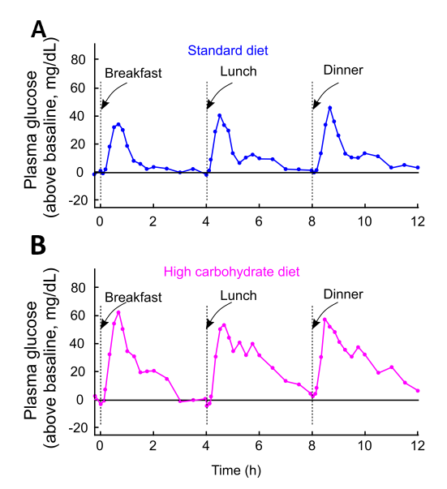
eFigure 1. Effect of mealtime and meal type on postprandial plasma glucose.
Mean plasma glucose after consumption of 3 consecutive identical meals over 12 h in 22 healthy participants. A, Participants (N=12 including 5 females) consumed a standard diet (% carbohydrate/fat/protein= 40/49/11). B, Participants (N=10 including 4 females) consumed a high carbohydrate diet (% carbohydrate/fat/protein= 63/27/10). The results were from a published study (Journal of Diabetes Science and Technology 2022:16:1532).¹ eFigure 1 was modified from a figure from the cited study which was published under a Creative Commons Attribution CC BY license.

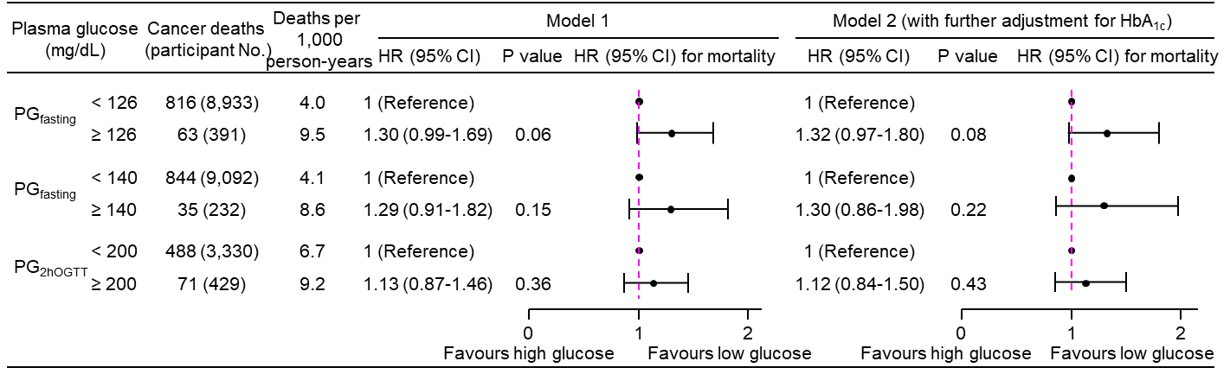

eFigure 2. Cancer mortality risk associated with plasma glucose (categorical).
The cutoff for high PG_{fasting} was 126 (criterion after 1997)^{2,3} or 140 mg/dL (criterion before 1997).³ The cutoff for high PG_{2hOGTT} was 200 mg/dL.^{2,3}
Model 1: adjusted for age, sex, ethnicity, body mass index, education, poverty-income ratio, survey period, physical activity, alcohol consumption, smoking status, systolic blood pressure, total cholesterol, HDL cholesterol, family history of diabetes, and fasting time.
Model 2: adjusted for all the factors in Model 1 plus HbA_{1c}.
CI, confidence interval; HbA_{1c}, hemoglobin A_{1c}; HDL, high-density lipoprotein; HR, hazard ratio; No., number; PG_{2hOGTT}, plasma glucose measured from blood taken at 2 h after an oral glucose tolerance test; PG_{fasting}, plasma glucose measured from blood taken in a fasting state (fasting time ≥8 h).

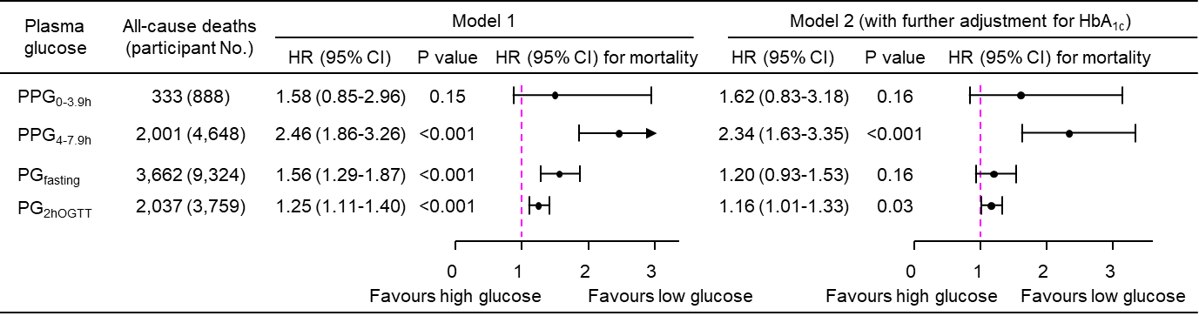
eFigure 3. All-cause mortality risk associated with a 1-natural-log-unit increase in plasma glucose.
Model 1: adjusted for age, sex, ethnicity, body mass index, education, poverty-income ratio, survey period, physical activity, alcohol consumption, smoking status, systolic blood pressure, total cholesterol, HDL cholesterol, family history of diabetes, and fasting time.
Model 2: adjusted for all the factors in Model 1 plus HbA_{1c}.
CI, confidence interval; HbA_{1c}, hemoglobin A_{1c}; HDL, high-density lipoprotein; HR, hazard ratio; No., number; PG_{2hOGTT}, plasma glucose measured from blood taken at 2 h after an oral glucose tolerance test; PG_{fasting}, plasma glucose measured from blood taken in a fasting state (fasting time ≥8 h); PPG_{0-3.9h}, postprandial plasma glucose measured from blood taken between 0 and 3.9 h; PPG_{4-7.9h}, postprandial plasma glucose measured from blood taken between 4 and 7.9 h.

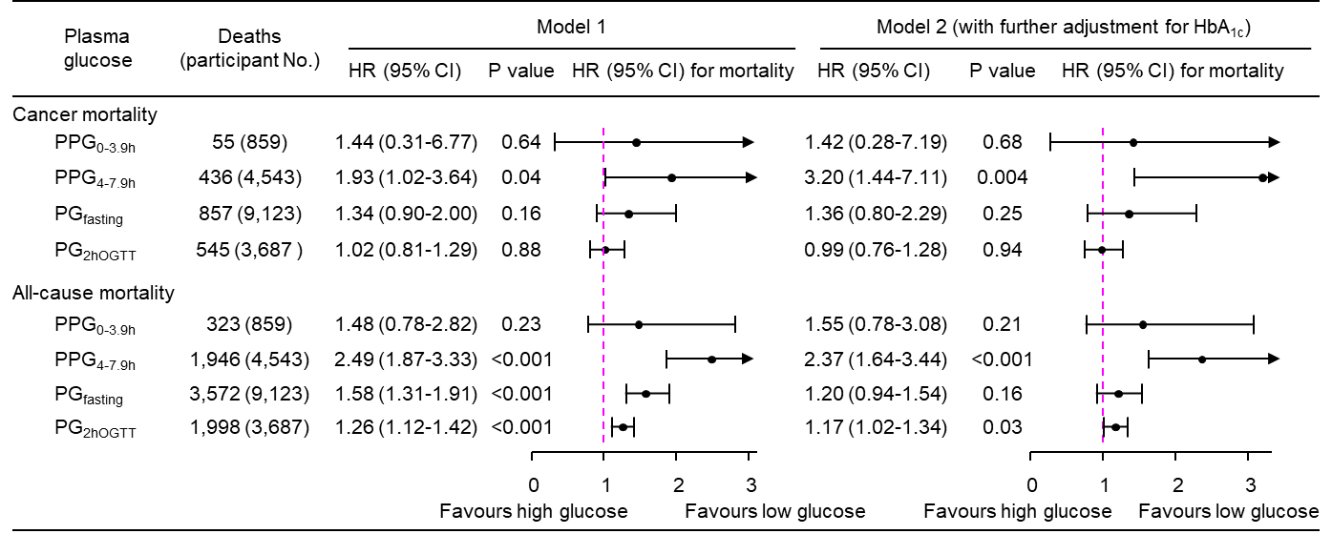
eFigure 4. Sensitivity analysis of mortality risk associated with a 1-natural-log-unit increase in plasma glucose when the imputed data were not used.
Out of 14,860 participants, 335 (2.3%) had missing data which were imputed in the main analysis. In this sensitivity analysis, those 335 participants were excluded.
Model 1: adjusted for age, sex, ethnicity, body mass index, education, poverty-income ratio, survey period, physical activity, alcohol consumption, smoking status, systolic blood pressure, total cholesterol, HDL cholesterol, family history of diabetes, and fasting time.
Model 2: adjusted for all the factors in Model 1 plus HbA_{1c}.
CI, confidence interval; HbA_{1c}, hemoglobin A_{1c}; HDL, high-density lipoprotein; HR, hazard ratio; No., number; PG_{2hOGTT}, plasma glucose measured from blood taken at 2 h after an oral glucose tolerance test; PG_{fasting}, plasma glucose measured from blood taken in a fasting state (fasting time ≥8 h); PPG_{0-3.9h}, postprandial plasma glucose measured from blood taken between 0 and 3.9 h; PPG_{4-7.9h}, postprandial plasma glucose measured from blood taken between 4 and 7.9 h.

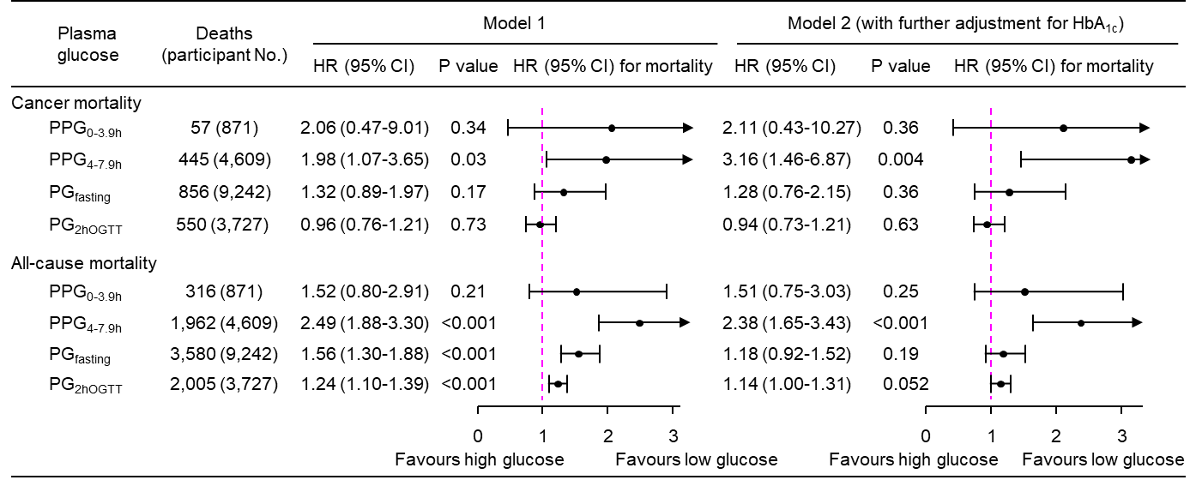
eFigure 5. Sensitivity analysis of mortality risk associated with a 1-natural-log-unit increase in plasma glucose when those with a follow-up of <1 year were excluded.
A total of 138 participants had a follow-up time of <1 year and they were excluded in this sensitivity analysis.
Model 1: adjusted for age, sex, ethnicity, body mass index, education, poverty-income ratio, survey period, physical activity, alcohol consumption, smoking status, systolic blood pressure, total cholesterol, HDL cholesterol, family history of diabetes, and fasting time.
Model 2: adjusted for all the factors in Model 1 plus HbA_{1c}.
CI, confidence interval; HbA_{1c}, hemoglobin A_{1c}; HDL, high-density lipoprotein; HR, hazard ratio; No., number; PG_{2hOGTT}, plasma glucose measured from blood taken at 2 h after an oral glucose tolerance test; PG_{fasting}, plasma glucose measured from blood taken in a fasting state (fasting time ≥8 h); PPG_{0-3.9h}, postprandial plasma glucose measured from blood taken between 0 and 3.9 h; PPG_{4-7.9h}, postprandial plasma glucose measured from blood taken between 4 and 7.9 h.

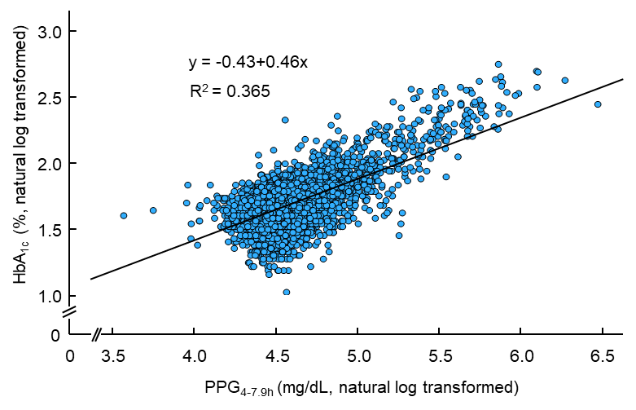
eFigure 6. Scatter plot, PPG_{4-7.9h} versus HbA_{1c}.
HbA_{1c}, hemoglobin A_{1c}; PPG_{4-7.9h}, postprandial plasma glucose measured from blood taken between 4 and 7.9 h.

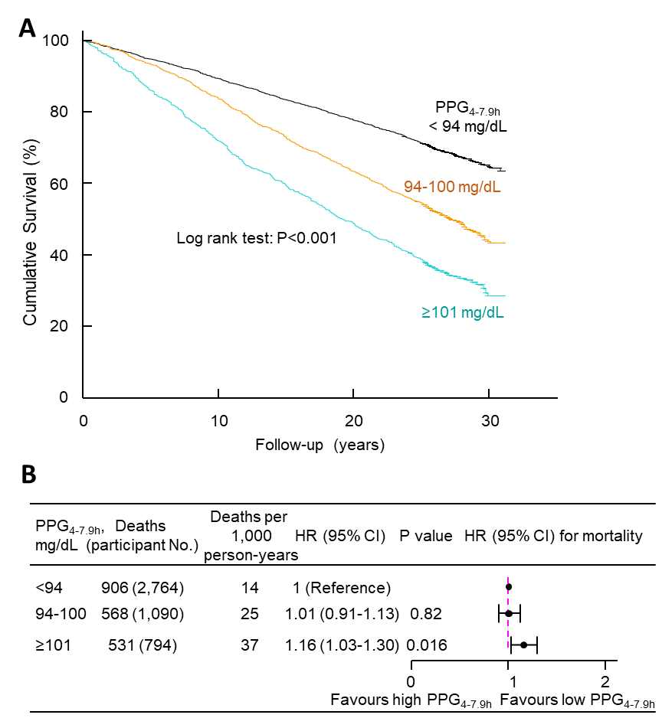
eFigure 7. All-cause mortality risk associated with normal, borderline high, and high PPG_{4-7.9h}.
A, Kaplan-Meier survival curves. B, All-cause mortality risk associated with normal, borderline high, and high PPG_{4-7.9h}. The analysis was adjusted for age, sex, ethnicity, body mass index, education, poverty-income ratio, survey period, physical activity, alcohol consumption, smoking status, systolic blood pressure, total cholesterol, high-density lipoprotein (HDL) cholesterol, family history of diabetes, fasting time, and HbA_{1c}. CI, confidence interval; HbA_{1c}, hemoglobin A_{1c}; HR, hazard ratio; No., number; PPG_{4-7.9h}, postprandial glucose measured from blood taken between 4 and 7.9 h.

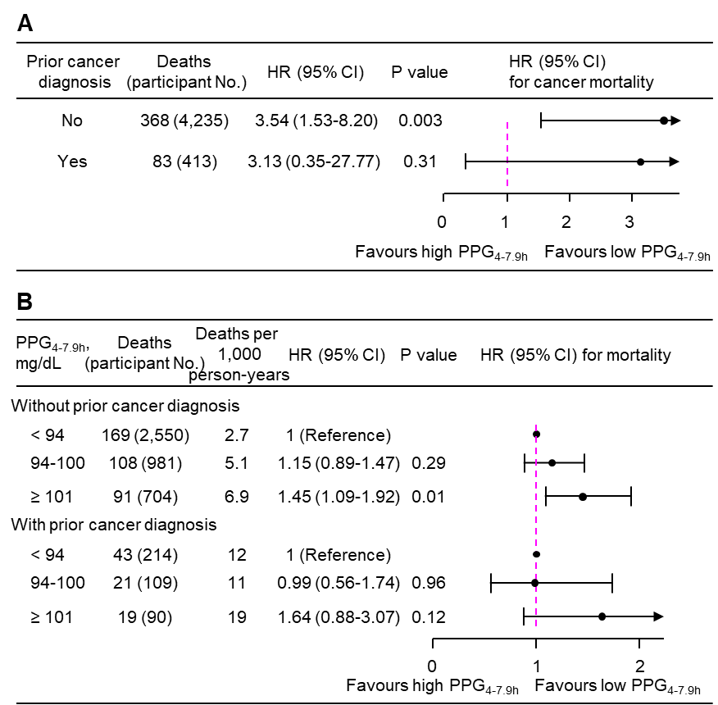
eFigure 8. Cancer mortality risk associated with PPG_{4-7.9h}, stratified by prior diagnosis of cancer.
Cancer mortality risk associated with continuous (A) or categorical PPG_{4-7.9h} (B). The analysis was adjusted for age, sex, ethnicity, body mass index, education, poverty-income ratio, survey period, physical activity, alcohol consumption, smoking status, systolic blood pressure, total cholesterol, high-density lipoprotein (HDL) cholesterol, family history of diabetes, fasting time, and HbA_{1c.} CI, confidence interval; HbA_{1c}, hemoglobin A_{1c}; HR, hazard ratio; No., number; PPG_{4-7.9h}, postprandial plasma glucose measured from blood taken between 4 and 7.9 h.

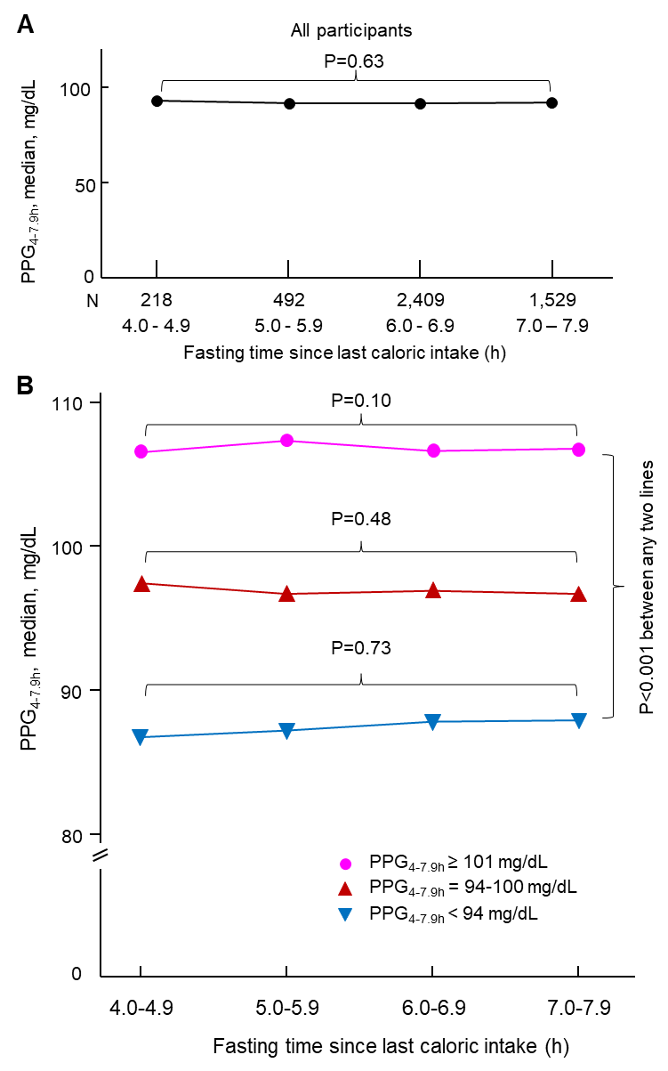
eFigure 9. Hourly PPG_{4-7.9h}.
Hourly PPG_{4-7.9h} in all participants who had PPG_{4-7.9h} (A) or in sub-groups of participants with normal, borderline high, or high PPG_{4-7.9h} (B). PPG_{4-7.9h}, postprandial plasma glucose measured from blood taken between 4 and 7.9 h.

eTable 1. Baseline characteristics of 14,860 participants.
 | All participants | Sub-cohort 1ª | Sub-cohort 2^{b} | Sub-cohort 3^{c}
Sample size | 14,860 | 888 | 4,648 | 9,324
PG, mg/dL, median (IQR) | 93 (87-101) | 95 (86-105) | 92 (87-98) | 94 (88-102)
HbA_{1c}, %, median (IQR) | 5.3 (5.0-5.7) | 5.4 (5.0-5.7) | 5.3 (5.0-5.7) | 5.3 (5.0-5.7)
HbA_{1c}, N (%)
<5.7% | 11,017 (74.1) | 632 (71.2) | 3,427 (73.7) | 6,958 (74.6)
5.7%-6.4% | 3,217 (21.6) | 220 (24.8) | 1,010 (21.7) | 1,987 (21.3)
≥6.5% | 626 (4.2) | 36 (4.1) | 211 (4.5) | 379 (4.1)
BMI, kg/m², median (IQR) | 26 (23-30) | 26 (23-29) | 26 (23-30) | 26 (23-30)
SBP, mm Hg, median (IQR) | 121 (111-136) | 121 (110-135) | 123 (112-138) | 121 (111-134)
Total cholesterol, mg/dL, median (IQR) | 201 (174-232) | 196 (168-229) | 204 (177-235) | 200 (174-230)
HDL cholesterol, mg/dL, median (IQR) | 49 (41-60) | 49 (40-60) | 50 (41-60) | 49 (40-60)
Age, y, mean (SD) | 47 (19) | 45 (20) | 49 (19) | 46 (19)
Fasting time, h, mean (SD) | 10.9 (4.6) | 2.2 (1.0) | 6.6 (0.8) | 13.9 (2.9)
Sex (male), N (%) | 6,996 (47.1) | 445 (50.1) | 2,136 (46.0) | 4,415 (47.4)
Ethnicity, N (%)
Non-Hispanic white | 6,213 (41.8) | 249 (28.0) | 2,211 (47.6) | 3,753 (40.3)
Non-Hispanic black | 4,029 (27.1) | 353 (39.8) | 1,082 (23.3) | 2,594 (27.8)
Mexican-American | 4,014 (27.0) | 230 (25.9) | 1,177 (25.3) | 2,607 (28.0)
Other | 604 (4.1) | 56 (6.3) | 178 (3.8) | 370 (4.0)
Education, N (%)
< High School | 5,824 (39.2) | 394 (44.4) | 1,782 (38.3) | 3,648 (39.1)
High School | 4,599 (30.9) | 267 (30.1) | 1,432 (30.8) | 2,900 (31.1)
> High School | 4,343 (29.2) | 216 (24.3) | 1,404 (30.2) | 2,723 (29.2)
Unknown | 94 (0.6) | 11 (1.2) | 30 (0.6) | 53 (0.6)
Poverty-income ratio, N (%)
< 130% | 4,355 (29.3) | 341 (38.4) | 1,242 (26.7) | 2,772 (29.7)
130%-349% | 6,006 (40.4) | 306 (34.5) | 1,920 (41.3) | 3,780 (40.5)
≥ 350% | 3,156 (21.2) | 149 (16.8) | 1,121 (24.1) | 1,886 (20.2)
Unknown | 1,343 (9.0) | 92 (10.4) | 365 (7.9) | 886 (9.5)
Physical activity, N (%)
Active | 5,493 (37.0) | 318 (35.8) | 1,705 (36.7) | 3,470 (37.2)
Insufficiently active | 6,155 (41.4) | 323 (36.4) | 1,964 (42.3) | 3,868 (41.5)
Inactive | 3,212 (21.6) | 247 (27.8) | 979 (21.1) | 1,986 (21.3)
Alcohol consumption, N (%)
0 drink/week | 2,538 (17.1) | 160 (18.0) | 806 (17.3) | 1,572 (16.9)
< 1 drink/week | 1,736 (11.7) | 90 (10.1) | 527 (11.3) | 1,119 (12.0)
1-6 drinks/week | 2,914 (19.6) | 175 (19.7) | 900 (19.4) | 1,839 (19.7)
≥ 7 drinks/week | 1,952 (13.1) | 116 (13.1) | 590 (12.7) | 1,246 (13.4)
Unknown | 5,720 (38.5) | 347 (39.1) | 1,825 (39.3) | 3,548 (38.1)
Smoking status, N (%)
Past smoker | 3,941 (26.5) | 312 (35.1) | 1,132 (24.4) | 2,497 (26.8)
Current smoker | 3,569 (24.0) | 169 (19.0) | 1,193 (25.7) | 2,207 (23.7)
Other | 7,350 (49.5) | 407 (45.8) | 2,323 (50.0) | 4,620 (49.5)
Survey period, N (%)
1988-1991 | 7,247 (48.8) | 362 (40.8) | 2,290 (49.3) | 4,595 (49.3)
1991-1994 | 7,613 (51.2) | 526 (59.2) | 2,358 (50.7) | 4,729 (50.7)
Family history of diabetes, N (%)
Yes | 6,404 (43.1) | 314 (35.4) | 2,006 (43.2) | 4,084 (43.8)
No | 8,211 (55.3) | 559 (63.0) | 2,558 (55.0) | 5,094 (54.6)
Unknown | 245 (1.6) | 15 (1.7) | 84 (1.8) | 146 (1.6)

Abbreviations: BMI, body mass index; HbA_{1c}, hemoglobin A_{1c}; HDL, high-density lipoprotein; IQR, interquartile range; N, number; PG, plasma glucose; SBP, systolic blood pressure; SD, standard deviation; y, year.
ª Sub-cohort 1, 888 participants whose blood was taken with a fasting time of 0-3.9 h.
^{b} Sub-cohort 2, 4,648 participants whose blood was taken with a fasting time of 4-7.9h.
^{c} Sub-cohort 3, 9,324 participants whose blood was taken with a fasting time of ≥8 h.

.

eTable 2. Baseline characteristics of Sub-cohort 1: participants with PPG_{0-3.9h}.
 | Bottom 9 deciles | Top decile | Overall | P value
Sample size | 799 | 89 | 888 | N/A
PPG_{0-3.9h},  mg/dL, median (IQR) | 93 (86-101) | 136 (125-158) | 95 (86-105) | <0.001
HbA_{1c}, %, median (IQR) | 5.3 (5.0-5.7) | 5.7 (5.3-6.4) | 5.4 (5.0-5.7) | <0.001
BMI, kg/m², median (IQR) | 26 (22-29) | 27 (24-31) | 26 (23-29) | 0.01
SBP, mm Hg, median (IQR) | 120 (110-134) | 133 (119-145) | 121 (110-135) | <0.001
Total cholesterol, mg/dL, median (IQR) | 195 (168-229) | 205 (173-229) | 196 (168-229) | <0.001
HDL cholesterol, mg/dL, median (IQR) | 50 (41-61) | 44 (36-55) | 49 (40-60) | 0.25
Age, y, mean (SD) | 43 (20) | 56 (21) | 45 (20) | <0.001
Fasting time, h, mean (SD) | 2.3 (1.0) | 1.9 (1.0) | 2.2 (1.0) | <0.001
Sex (male), N (%) | 391 (48.9) | 54 (60.7) | 445 (50.1) | 0.04
Ethnicity, N (%) |  |  |  | 0.45
Non-Hispanic white | 226 (28.3) | 23 (25.8) | 249 (28.0)
Non-Hispanic black | 317 (39.7) | 36 (40.4) | 353 (39.8)
Mexican-American | 209 (26.2) | 21 (23.6) | 230 (25.9)
Other | 47 (5.9) | 9 (10.1) | 56 (6.3)
Education, N (%) |  |  |  | <0.001
< High School | 333 (41.7) | 61 (68.5) | 394 (44.4)
High School | 256 (32.0) | 11 (12.4) | 267 (30.1)
> High School | 199 (24.9) | 17 (19.1) | 216 (24.3)
Unknown | 11 (1.4) | 0 (0) | 11 (1.2)
Poverty-income ratio, N (%) |  |  |  | 0.28
< 130% | 303 (37.9) | 38 (42.7) | 341 (38.4)
130%-349% | 279 (34.9) | 27 (30.3) | 306 (34.5)
≥ 350% | 138 (17.3) | 11 (12.4) | 149 (16.8)
Unknown | 79 (9.9) | 13 (14.6) | 92 (10.4)
Physical activity, N (%) |  |  |  | 0.03
Active | 289 (36.2) | 29 (32.6) | 318 (35.8)
Insufficiently active | 298 (37.3) | 25 (28.1) | 323 (36.4)
Inactive | 212 (26.5) | 35 (39.3) | 247 (27.8)
Alcohol consumption, N (%) |  |  |  | 0.76
0 drink/week | 144 (18.0) | 16 (18.0) | 160 (18.0)
< 1 drink/week | 84 (10.5) | 6 (6.7) | 90 (10.1)
1-6 drinks/week | 156 (19.5) | 19 (21.3) | 175 (19.7)
≥ 7 drinks/week | 106 (13.3) | 10 (11.2) | 116 (13.1)
Unknown | 309 (38.7) | 38 (42.7) | 347 (39.1)
Smoking status, N (%) |  |  |  | 0.13
Past smoker | 284 (35.5) | 28 (31.5) | 312 (35.1)
Current smoker | 145 (18.1) | 24 (27.0) | 169 (19.0)
Other | 370 (46.3) | 37 (41.6) | 407 (45.8)
Survey period, N (%) |  |  |  | 0.19
1988-1991 | 320 (40.1) | 42 (47.2) | 362 (40.8)
1991-1994 | 479 (59.9) | 47 (52.8) | 526 (59.2)
Family history of diabetes, N (%) |  |  |  | 0.90
Yes | 283 (35.4) | 31 (34.8) | 314 (35.4)
No | 502 (62.8) | 57 (64.0) | 559 (63.0)
Unknown | 14 (1.8) | 1 (1.1) | 15 (1.7)
Abbreviations: BMI, body mass index; HbA_{1c}, hemoglobin A_{1c}; HDL, high-density lipoprotein; IQR, interquartile range; N, number; NA, not applicable; PPG_{0-3.9h}, postprandial plasma glucose measured from blood taken between 0 and 3.9 h; SBP, systolic blood pressure; SD, standard deviation; y, year.

eTable 3. Baseline characteristics of Sub-cohort 2: participants with PPG_{4-7.9h}.
 | Bottom 9 deciles | Top decile | Overall | P value
Sample size | 4,182 | 466 | 4,648 | N/A
PPG_{4-7.9h}, mg/dL, median (IQR) | 91 (86-96) | 113 (108-124) | 92 (87-98) | <0.001
HbA_{1c}, %, median (IQR) | 5.3 (5.0-5.6) | 5.8 (5.4-6.7) | 5.3 (5.0-5.7) | <0.001
BMI, kg/m², median (IQR) | 26 (23-30) | 28 (24-31) | 26 (23-30) | <0.001
SBP, mm Hg, median (IQR) | 122 (111-136) | 136 (123-150) | 123 (112-138) | <0.001
Total cholesterol, mg/dL, median (IQR) | 203 (175-234) | 214 (189-247) | 204 (177-235) | 0.0497
HDL cholesterol, mg/dL, median (IQR) | 50 (41-60) | 48 (40-58) | 50 (41-60) | <0.001
Age, y, mean (SD) | 48 (18) | 61 (18) | 49 (19) | <0.001
Fasting time, h, mean (SD) | 6.6 (0.8) | 6.6 (0.8) | 6.6 (0.8) | 0.47
Sex (male), N (%) | 1,908 (45.6) | 228 (48.9) | 2,136 (46.0) | 0.18
Ethnicity, N (%) |  |  |  | 0.002
Non-Hispanic white | 1,986 (47.5) | 225 (48.3) | 2,211 (47.6)
Non-Hispanic black | 1,003 (24.0) | 79 (17.0) | 1,082 (23.3)
Mexican-American | 1,033 (24.7) | 144 (30.9) | 1,177 (25.3)
Other | 160 (3.8) | 18 (3.9) | 178 (3.8)
Education, N (%) |  |  |  | <0.001
< High School | 1,541 (36.8) | 241 (51.7) | 1,782 (38.3)
High School | 1,310 (31.3) | 122 (26.2) | 1,432 (30.8)
> High School | 1,303 (31.2) | 101 (21.7) | 1,404 (30.2)
Unknown | 28 (0.7) | 2 (0.4) | 30 (0.6)
Poverty-income ratio, N (%) |  |  |  | <0.001
< 130% | 1,100 (26.3) | 142 (30.5) | 1,242 (26.7)
130%-349% | 1,744 (41.7) | 176 (37.8) | 1,920 (41.3)
≥ 350% | 1,030 (24.6) | 91 (19.5) | 1,121 (24.1)
Unknown | 308 (7.4) | 57 (12.2) | 365 (7.9)
Physical activity, N (%) |  |  |  | <0.001
Active | 1,550 (37.1) | 155 (33.3) | 1,705 (36.7)
Insufficiently active | 1,784 (42.7) | 180 (38.6) | 1,964 (42.3)
Inactive | 848 (20.3) | 131 (28.1) | 979 (21.1)
Alcohol consumption, N (%) |  |  |  | <0.001
0 drink/week | 702 (16.8) | 104 (22.3) | 806 (17.3)
< 1 drink/week | 490 (11.7) | 37 (7.9) | 527 (11.3)
1-6 drinks/week | 834 (19.9) | 66 (14.2) | 900 (19.4)
≥ 7 drinks/week | 532 (12.7) | 58 (12.4) | 590 (12.7)
Unknown | 1,624 (38.8) | 201 (43.1) | 1,825 (39.3)
Smoking status, N (%) |  |  |  | <0.001
Past smoker | 1,043 (24.9) | 89 (19.1) | 1,132 (24.4)
Current smoker | 1,035 (24.7) | 158 (33.9) | 1,193 (25.7)
Other | 2,104 (50.3) | 219 (47.0) | 2,323 (50.0)
Survey period, N (%) |  |  |  | 0.11
1988-1991 | 2,044 (48.9) | 246 (52.8) | 2,290 (49.3)
1991-1994 | 2,138 (51.1) | 220 (47.2) | 2,358 (50.7)
Family history of diabetes, N (%) |  |  |  | 0.49
Yes | 1,795 (42.9) | 211 (45.3) | 2,006 (43.2)
No | 2,313 (55.3) | 245 (52.6) | 2,558 (55.0)
Unknown | 74 (1.8) | 10 (2.1) | 84 (1.8)
Abbreviations: BMI, body mass index; HbA_{1c}, hemoglobin A_{1c}; HDL, high-density lipoprotein; IQR, interquartile range; N, number; NA, not applicable; PPG_{4-7.9h}, postprandial plasma glucose measured from blood taken between 4 and 7.9 h; SBP, systolic blood pressure; SD, standard deviation; y, year.

eTable 4. Baseline characteristics of Sub-cohort 3: participants with PG_{fasting}.
 | Bottom 9 deciles | Top decile | Overall | P value
Sample size | 8,383 | 941 | 9,342 | N/A
PG_{fasting}, mg/dL, median (IQR) | 93 (87-99) | 123 (116-140) | 94 (88-102) | <0.001
HbA_{1c}, %, median (IQR) | 5.3 (5.0-5.6) | 6.1 (5.6-6.8) | 5.3 (5.0-5.7) | <0.001
BMI, kg/m², median (IQR) | 26 (23-30) | 29 (26-33) | 26 (23-30) | <0.001
SBP, mm Hg, median (IQR) | 119 (110-132) | 134 (123-149) | 121 (111-134) | <0.001
Total cholesterol, mg/dL, median (IQR) | 199 (173-228) | 215 (186-249) | 200 (174-230) | <0.001
HDL cholesterol, mg/dL, median (IQR) | 50 (41-60) | 43 (37-52) | 49 (40-60) | <0.001
Age, y, mean (SD) | 45 (19) | 60 (16) | 46 (19) | <0.001
Fasting time, h, mean (SD) | 13.9 (3.0) | 13.8 (2.5) | 13.9 (2.9) | 0.53
Sex (male), N (%) | 3,901 (46.5) | 514 (54.6) | 4,415 (47.4) | <0.001
Ethnicity, N (%) |  |  |  | 0.18
Non-Hispanic white | 3,353 (40.0) | 400 (42.5) | 3,753 (40.3)
Non-Hispanic black | 2,360 (28.2) | 234 (24.9) | 2,594 (27.8)
Mexican-American | 2,336 (27.9) | 271 (28.8) | 2,607 (28.0)
Other | 334 (4.0) | 36 (3.8) | 370 (4.0)
Education, N (%) |  |  |  | <0.001
< High School | 3,150 (37.6) | 498 (52.9) | 3,648 (39.1)
High School | 2,648 (31.6) | 252 (26.8) | 2,900 (31.1)
> High School | 2,536 (30.3) | 187 (19.9) | 2,723 (29.2)
Unknown | 49 (0.6) | 4 (0.4) | 53 (0.6)
Poverty-income ratio, N (%) |  |  |  | 0.13
< 130% | 2,471 (29.5) | 301 (32.0) | 2,772 (29.7)
130%-349% | 3,409 (40.7) | 371 (39.4) | 3,780 (40.5)
≥ 350% | 1,716 (20.5) | 170 (18.1) | 1,886 (20.2)
Unknown | 787 (9.4) | 99 (10.5) | 886 (9.5)
Physical activity, N (%) |  |  |  | <0.001
Active | 3,147 (37.5) | 323 (34.3) | 3,470 (37.2)
Insufficiently active | 3,495 (41.7) | 373 (39.6) | 3,868 (41.5)
Inactive | 1,741 (20.8) | 245 (26.0) | 1,986 (21.3)
Alcohol consumption, N (%) |  |  |  | <0.001
0 drink/week | 1,399 (16.7) | 173 (18.4) | 1,572 (16.9)
< 1 drink/week | 1,040 (12.4) | 79 (8.4) | 1,119 (12.0)
1-6 drinks/week | 1,696 (20.2) | 143 (15.2) | 1,839 (19.7)
≥ 7 drinks/week | 1,126 (13.4) | 120 (12.8) | 1,246 (13.4)
Unknown | 3,122 (37.2) | 426 (45.3) | 3,548 (38.1)
Smoking status, N (%) |  |  |  | <0.001
Past smoker | 2,301 (27.4) | 196 (20.8) | 2,497 (26.8)
Current smoker | 1,867 (22.3) | 340 (36.1) | 2,207 (23.7)
Other | 4,215 (50.3) | 405 (43.0) | 4,620 (49.5)
Survey period, N (%) |  |  |  | 0.19
1988-1991 | 4,112 (49.1) | 483 (51.3) | 4,595 (49.3)
1991-1994 | 4,271 (50.9) | 458 (48.7) | 4,729 (50.7)
Family history of diabetes, N (%) |  |  |  | <0.001
Yes | 3,619 (43.2) | 465 (49.4) | 4,084 (43.8)
No | 4,636 (55.3) | 458 (48.7) | 5,094 (54.6)
Unknown | 128 (1.5) | 18 (1.9) | 146 (1.6)
Abbreviations: BMI, body mass index; HbA_{1c}, hemoglobin A_{1c}; HDL, high-density lipoprotein; IQR, interquartile range; N, number; NA, not applicable; PG_{fasting}, plasma glucose measured from blood taken in a fasting state (fasting time ≥8 h); SBP, systolic blood pressure; SD, standard deviation; y, year.

eTable 5. Baseline characteristics of Sub-cohort 4: participants with PG_{2hOGTT}.
 | Bottom 9 deciles | Top decile | Overall | P value
Sample size | 3,383 | 376 | 3,759 | N/A
PG_{fasting}, mg/dL, median (IQR) | 97 (91-104) | 127 (108-170) | 98 (91-106) | <0.001
PG_{2hOGTT}, mg/dL, median (IQR) | 114 (93-141) | 262 (225-322) | 119 (96-154) | <0.001
HbA_{1c}, %, median (IQR) | 5.4 (5.1-5.7) | 6.4 (5.8-7.7) | 5.5 (5.1-5.8) | <0.001
BMI, kg/m², median (IQR) | 27 (24-31) | 30 (26-33) | 27 (24-31) | <0.001
SBP, mm Hg, median (IQR) | 126 (115-139) | 137 (126-150) | 127 (116-141) | <0.001
Total cholesterol, mg/dL, median (IQR) | 213 (188-240) | 221 (195-255) | 214 (189-242) | <0.001
HDL cholesterol, mg/dL, median (IQR) | 49 (40-60) | 44 (37-54) | 48 (40-59) | <0.001
Age, y, mean (SD) | 55 (10) | 60 (9) | 56 (10) | <0.001
Fasting time, h, mean (SD) | 13.7 (2.4) | 14.1 (3.3) | 13.7 (2.5) | 0.03
Sex (male), N (%) | 1,650 (48.8) | 196 (52.1) | 1,846 (49.1) | 0.22
Ethnicity, N (%) |  |  |  | <0.001
Non-Hispanic white | 1,570 (46.4) | 146 (38.8) | 1,716 (45.7)
Non-Hispanic black | 890 (26.3) | 80 (21.3) | 970 (25.8)
Mexican-American | 778 (23.0) | 133 (35.4) | 911 (24.2)
Other | 145 (4.3) | 17 (4.5) | 162 (4.3)
Education, N (%) |  |  |  | <0.001
< High School | 1,387 (41.0) | 216 (57.4) | 1,603 (42.6)
High School | 1,018 (30.1) | 96 (25.5) | 1,114 (29.6)
> High School | 957 (28.3) | 64 (17) | 1,021 (27.2)
Unknown | 21 (0.6) | 0 (0) | 21 (0.6)
Poverty-income ratio, N (%) |  |  |  | <0.001
< 130% | 789 (23.3) | 125 (33.2) | 914 (24.3)
130%-349% | 1,350 (39.9) | 147 (39.1) | 1,497 (39.8)
≥ 350% | 925 (27.3) | 66 (17.6) | 991 (26.4)
Unknown | 319 (9.4) | 38 (10.1) | 357 (9.5)
Physical activity, N (%) |  |  |  | 0.42
Active | 1,228 (36.3) | 131 (34.8) | 1,359 (36.2)
Insufficiently active | 1,444 (42.7) | 155 (41.2) | 1,599 (42.5)
Inactive | 711 (21.0) | 90 (23.9) | 801 (21.3)
Alcohol consumption, N (%) |  |  |  | <0.001
0 drink/week | 479 (14.2) | 80 (21.3) | 559 (14.9)
< 1 drink/week | 401 (11.9) | 33 (8.8) | 434 (11.5)
1-6 drinks/week | 631 (18.7) | 51 (13.6) | 682 (18.1)
≥ 7 drinks/week | 424 (12.5) | 46 (12.2) | 470 (12.5)
Unknown | 1,448 (42.8) | 166 (44.1) | 1,614 (42.9)
Smoking status, N (%) |  |  |  | 0.02
Past smoker | 942 (27.8) | 87 (23.1) | 1,029 (27.4)
Current smoker | 1,044 (30.9) | 142 (37.8) | 1,186 (31.6)
Other | 1,397 (41.3) | 147 (39.1) | 1,544 (41.1)
Survey period, N (%) |  |  |  | 0.96
1988-1991 | 1,642 (48.5) | 182 (48.4) | 1,824 (48.5)
1991-1994 | 1,741 (51.5) | 194 (51.6) | 1,935 (51.5)
Family history of diabetes, N (%) |  |  |  | 0.03
Yes | 1,474 (43.6) | 191 (50.8) | 1,665 (44.3)
No | 1,868 (55.2) | 182 (48.4) | 2,050 (54.5)
Unknown | 41 (1.2) | 3 (0.8) | 44 (1.2)
Abbreviations: BMI, body mass index; HbA_{1c}, hemoglobin A_{1c}; HDL, high-density lipoprotein; IQR, interquartile range; N, number; NA, not applicable; PG_{2hOGTT}, plasma glucose measured from blood taken at 2 h after an oral glucose tolerance test; PG_{fasting}, plasma glucose measured from blood taken in a fasting state (fasting time ≥8 h); SBP, systolic blood pressure; SD, standard deviation; y, year.

eTable 6. Mortality and follow-up.
Cohort | Sample size | All-cause deaths | Cancer deaths | Mean follow-up, y | Total follow-up, person-years
Whole cohort | 14,860 | 5,996 | 1,388 | 22.4 | 332,313
Sub-cohort 1:  Fasting time 0-3.9 h | 888 | 333 | 58 | 22.1 | 19,597
Sub-cohort 2:  Fasting time 4-7.9 h | 4,648 | 2,001 | 451 | 22.1 | 102,810
Sub-cohort 3:  Fasting time ≥8 h | 9,324 | 3,662 | 879 | 22.5 | 209,906
Sub-cohort 4:  Fasting time ≥8 h and with plasma glucose at 2 h after OGTT | 3,759 | 2,037 | 559 | 21.5 | 80,831

Abbreviations: OGTT, oral glucose tolerance test; y, year.

eTable 7. Cancer mortality risk associated with a 1-natural-log-unit increase in HbA_{1c}.
 | All participants |  |  | Sub-cohort 1 ª |  |  | Sub-cohort 2 ^{b} |  |  | Sub-cohort 3 ^{c} |  |  | Sub-cohort 4 ^{d}
 | HR | 95% CI | P value | HR | 95% CI | P value | HR | 95% CI | P value | HR | 95% CI | P value | HR | 95% CI | P value
Model 1 | 1.40 | 0.90-2.16 | 0.13 | 1.95 | 0.21-18.40 | 0.56 | 1.07 | 0.47-2.44 | 0.87 | 1.53 | 0.91-2.59 | 0.11 | 1.40 | 0.76-2.60 | 0.28
Model 2 | 1.23 | 0.79-1.93 | 0.36 | 1.60 | 0.16-16.36 | 0.69 | 0.78 | 0.34-1.81 | 0.56 | 1.47 | 0.86-2.52 | 0.16 | 1.30 | 0.69-2.45 | 0.42
Model 3 | 1.08 | 0.67-1.72 | 0.76 | 1.10 | 0.08-14.57 | 0.94 | 0.73 | 0.30-1.78 | 0.48 | 1.31 | 0.74-2.30 | 0.35 | 1.27 | 0.65-2.50 | 0.49
Model 4 | 1.05 | 0.66-1.68 | 0.84 | 1.09 | 0.07-15.93 | 0.95 | 0.72 | 0.29-1.76 | 0.47 | 1.27 | 0.72-2.25 | 0.40 | 1.26 | 0.64-2.50 | 0.50
Model 5 | 1.03 | 0.64-1.65 | 0.91 | 1.11 | 0.08-16.47 | 0.94 | 0.72 | 0.29-1.77 | 0.47 | 1.24 | 0.70-2.18 | 0.47 | 1.18 | 0.59-2.35 | 0.64
Model 6 | 1.03 | 0.64-1.65 | 0.91 | 1.15 | 0.08-16.36 | 0.92 | 0.72 | 0.29-1.77 | 0.47 | 1.23 | 0.70-2.18 | 0.47 | 1.18 | 0.59-2.34 | 0.65

Abbreviations: CI, confidence interval; HbA_{1c}, hemoglobin A_{1c}; HR, hazard ratio.
ª Sub-cohort 1, 888 participants whose plasma glucose was measured from blood taken with a fasting time of 0-3.9 h.
^{b} Sub-cohort 2, 4,648 participants whose plasma glucose was measured from blood taken with a fasting time of 4-7.9h.
^{c} Sub-cohort 3, 9,324 participants whose plasma glucose was measured from blood taken with a fasting time of ≥8 h.
^{d} Sub-cohort 4, 3,759 participants whose plasma glucose was measured from blood taken at 2 h after an oral glucose tolerance test (OGTT) with 75 g glucose.
Model 1: adjusted for age.
Model 2: adjusted for age, sex, and ethnicity.
Model 3: adjusted for all the factors in Model 2 plus body mass index, education, poverty-income ratio, survey period, physical activity, alcohol consumption, and smoking status.
Model 4: adjusted for all the factors in Model 3 plus systolic blood pressure, total cholesterol, and high-density lipoprotein (HDL) cholesterol.
Model 5: adjusted for all the factors in Model 4 plus family history of diabetes.
Model 6: adjusted for all the factors in Model 5 plus fasting time.

eTable 8. PG_{fasting} and PPG_{4-7.9h} in patients with type 2 diabetes with relatively good diabetic control.
Study | Patients | N | PG_{fasting}, mg/dL | PPG_{4-7.9h}, mg/dL | Difference  (PG_{fasting} - PPG_{4-7.9h}), mg/dL
Avignon et al ⁴ | T2D with HbA_{lc}<7.0% | 20 | 133 | 104 ª | 29
Peter et al ⁵ | T2D with HbA_{1c}<7.3% | 18 | 127 | 102 ^{b} | 25
Weighted Mean | N/A | N/A | 130.2 | 103.1 | 27.1

Abbreviations: HbA_{1c}, hemoglobin A_{1c}; PG_{fasting}, plasma glucose measured from blood taken in a fasting state (fasting time ≥8 h); PPG_{4-7.9h}, postprandial plasma glucose measured from blood taken between 4 and 7.9 h; Ref, reference; T2D, type 2 diabetes.
ª PPG_{4-7.9h} was defined as 5 h after lunch.
^{b} PPG_{4-7.9h} was defined as 4 h after breakfast, lunch and dinner.

eReferences

1. Eichenlaub MM, Khovanova NA, Gannon MC, Nuttall FQ, Hattersley JG. A Glucose-Only Model to Extract Physiological Information from Postprandial Glucose Profiles in Subjects with Normal Glucose Tolerance. J Diabetes Sci Technol. 2022;16(6):1532-1540. doi:10.1177/19322968211026978
2. American Diabetes Association. 2. Classification and Diagnosis of Diabetes: Standards of Medical Care in Diabetes—2021. Diabetes Care. 2021;44(Supplement 1):S15-S33. doi:10.2337/dc21-S002
3. Diagnosis TECot, Mellitus CoD. Report of the Expert Committee on the Diagnosis and Classification of Diabetes Mellitus. Diabetes Care. 1997;20(7):1183-1197. doi:10.2337/diacare.20.7.1183
4. Avignon A, Radauceanu A, Monnier L. Nonfasting plasma glucose is a better marker of diabetic control than fasting plasma glucose in type 2 diabetes. Diabetes Care. 1997;20(12):1822-6. doi:10.2337/diacare.20.12.1822
5. Peter R, Dunseath G, Luzio SD, Chudleigh R, Roy Choudhury S, Owens DR. Daytime variability of postprandial glucose tolerance and pancreatic B-cell function using 12-h profiles in persons with Type 2 diabetes. Diabet Med. 2010;27(3):266-73. doi:10.1111/j.1464-5491.2010.02949.x

