Supplementary materials
Unlocking the Potential of Chemically Modified Carbon Gels in Gallic Acid Adsorption
Regina C. Carvalho¹, Carlos J. Durán-Valle^{1,2*} and Marta Adame-Pereira^{1,2}

¹Departamento de Química Orgánica e Inorgánica, Universidad de Extremadura, Avda. de Elvas, s/n, 06006 Badajoz, Spain
²IACYS, Universidad de Extremadura, Avda. de Elvas, s/n, 06006 Badajoz, Spain

FTIR band assignation table
Table S1. FT-IR spectra of the samples. Band assignment.
Wavenumber (cm⁻¹) | Assignmentª | Atomic grouping
3650-3200 | ν(O-H) | Hydroxy group, H-bonded OH stretch
 | ν(N-H) | Primary amine, NH stretch
3000-2800 | ν(C-H) | Hydrocarbons (aliphatics, olefinic, and aromatic)
1770-1650 | ν(C=O) | Carbonyl compounds
1700-1500 | ν(C=C) | Olefinic and aromatic structures
1480-1400 | δ(C-H) | Aliphatic structures
1450-1200 | δ(C-H) | Olefinic and methyl groups
 | δ(O-H) | Primary or secondary alcohol and carboxylic acid
1300-1200 | ν(C-O) | Ether structures and phenol
1210-1100 |  | Tertiary alcohol
1120-1070 |  | Secondary alcohol
1075-1000 |  | Primary alcohol
900-700 | γ(C-H) | Aromatic structure

Kinetic models
The kinetic data were fitted to the pseudo-first-order (Lagergren), pseudo-second-order (Ho and McKay), and Weber and Morris kinetic models. The pseudo-first-order equation rearranged to a linear form is usually written as Equation (1):
$log\left(q_{e}-q_{t}\right)={log q}_{e}-\frac{K_{1}}{2.303}t$ (1)
Where q_{e} and q_{t} are the amounts of GA adsorbed at equilibrium and at time t (mg g⁻¹), respectively, and K₁ is the pseudo-first-order rate constant (h⁻¹). The representation of log(q_{e} - q_{t}) versus t should be a straight line with slope log q_{e} and intercept -K₁/2.303.
Assuming that the adsorption capacity is proportional to the number of active sites occupied on the surface of the adsorbent, the linear form for the pseudo-second-order reaction is written as equation (2):
$\frac{t}{q_{t}}=\frac{1}{K_{2}q_{e}^{2}}+\frac{1}{q_{e}}t$ (2)
Where q_{e} and q_{t} have the same meaning as in the previous model, and K₂ is the rate constant of pseudo-second-order adsorption (g mg⁻¹ h⁻¹). Here, the plot of t/q_{t} versus t should generate a linear relationship, from which q_{e} and K₂ can be obtained from the slope and the intersection of the plot.
The model proposed by Weber and Morris allows us to know if the limiting step of the adsorption process is intraparticle diffusion. This model is not strictly kinetic but decides whether the adsorption rate depends on mass transfer within the adsorbent particle or on other factors. The equation of this model in linear form is written as equation (3):
$q_{t}=k_{id}t_{e}^{1/2}+C$ (3)
Where K_{id} is the intraparticle diffusion rate constant (mg g⁻¹ h^{-1/2}), t_{e} is the equilibrium time (h⁻¹), and C is the intercept with the vertical axis (mg g⁻¹). This parameter gives an idea of the value of the boundary layer. The plot of q_{t} versus t^{1/2} should provide a straight line in which K_{id} and C can be obtained from the slope and the intersection.
Isotherm models
The Langmuir and Freundlich isotherm models analyzed the adsorption of GA under equilibrium conditions. The isotherm model proposed by Langmuir admits that the solid has a limited adsorption capacity, where molecules are adsorbed on well-defined, energetically equivalent sites far enough away from each other not to allow interaction between molecules adsorbed on adjacent sites. Langmuir linear form is written as equation (4):
$\frac{C_{e}}{q_{e}}=\frac{1}{S_{m}K_{L}}+\frac{C_{e}}{S_{m}}$ (4)
Where C_{e} is the equilibrium concentration in the liquid phase (mg L⁻¹), q_{e} is the amount adsorbed per unit of adsorbent mass (mg g⁻¹), S_{m} is the constant related to the maximum adsorption capacity (mg g⁻¹), and K_{L} is the Langmuir constant associated with the intensity of adsorption (L mg⁻¹). The representation of C_{e}/q_{e} against C_{e} generates a straight line; thus, from the slope and the intersection of the graph, 1/S_{m} and 1/S_{m}K_{L} can be obtained.
The Freundlich isotherm arises to explain adsorption in multilayers with interaction between adsorbed molecules. The application of this model suggests that the adsorption energy decreases exponentially once the adsorption active sites are complete. This model applies to adsorption on heterogeneous surfaces with a uniform energy distribution and reversible adsorption. The equation describing the isotherm is given in equation (5):
${log q}_{e}={log K}_{F}+\frac{1}{n}{log C}_{e}$ (5)
Where q_{e} and C_{e} have the same meaning as in the previous model, K_{F} (mg g⁻¹) and 1/n are the Freundlich constants, with 1/n and K_{F} being computed from the slope and intercept of the Freundlich plot of log q_{e} against log C_{e}.

XPS spectra
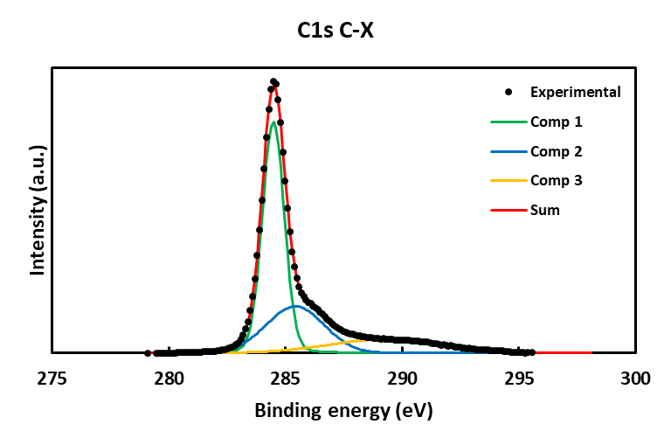
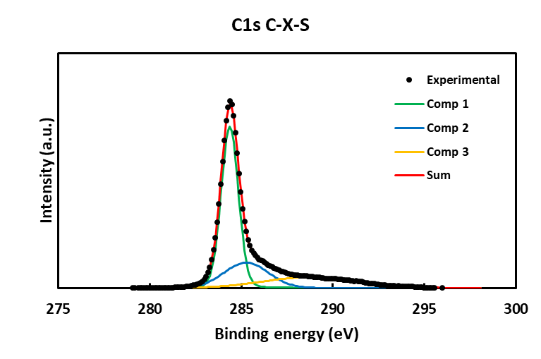
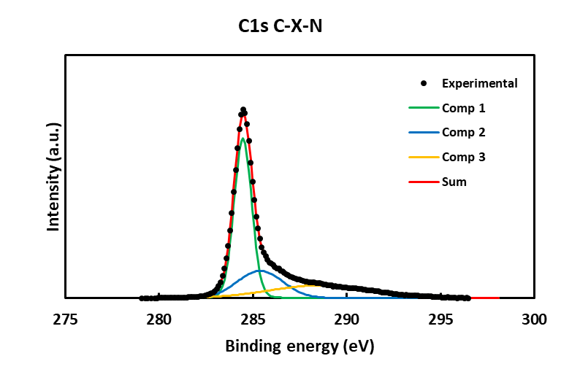
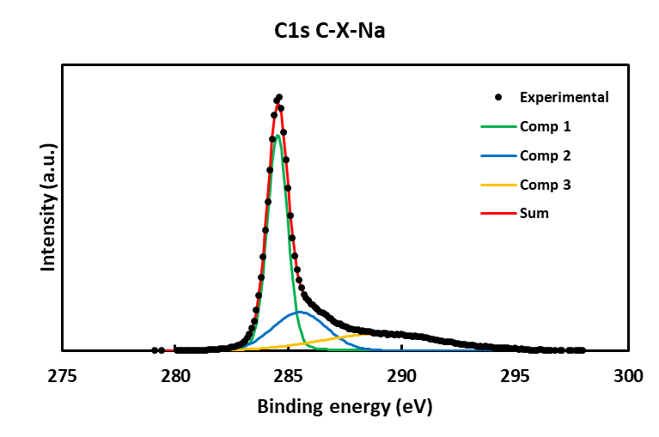
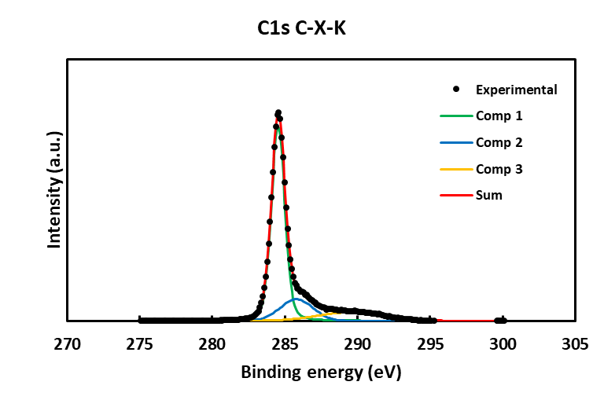
Figure S1. XPS spectra of C 1s

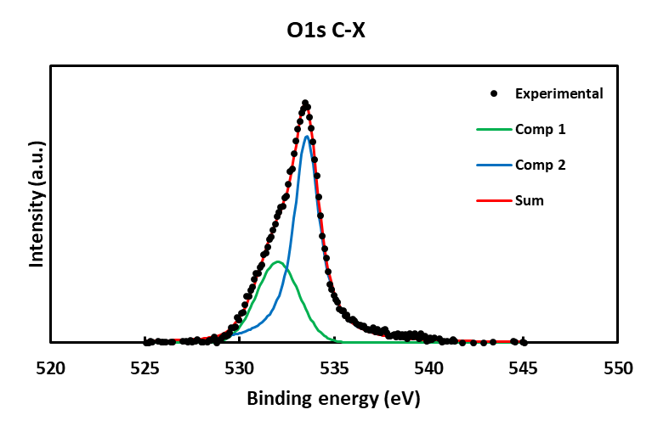
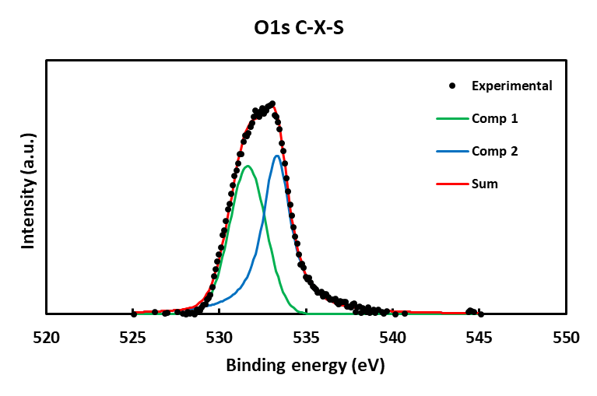
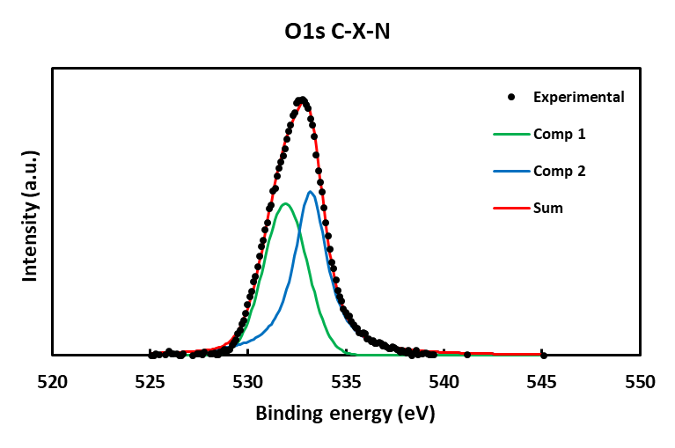
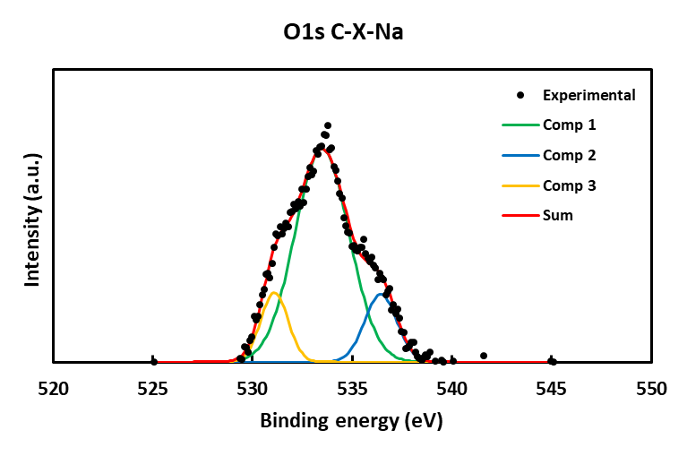
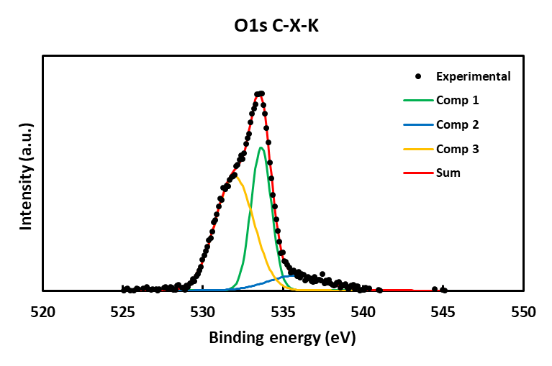
Figure S2. XPS spectra of O 1s

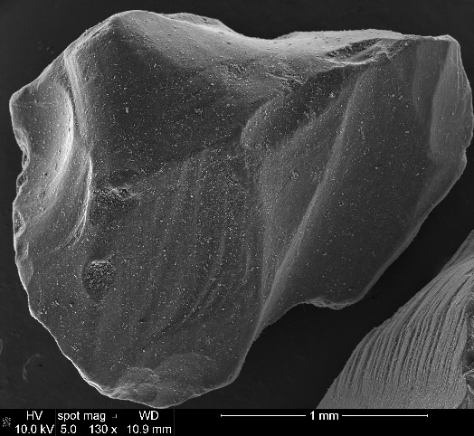
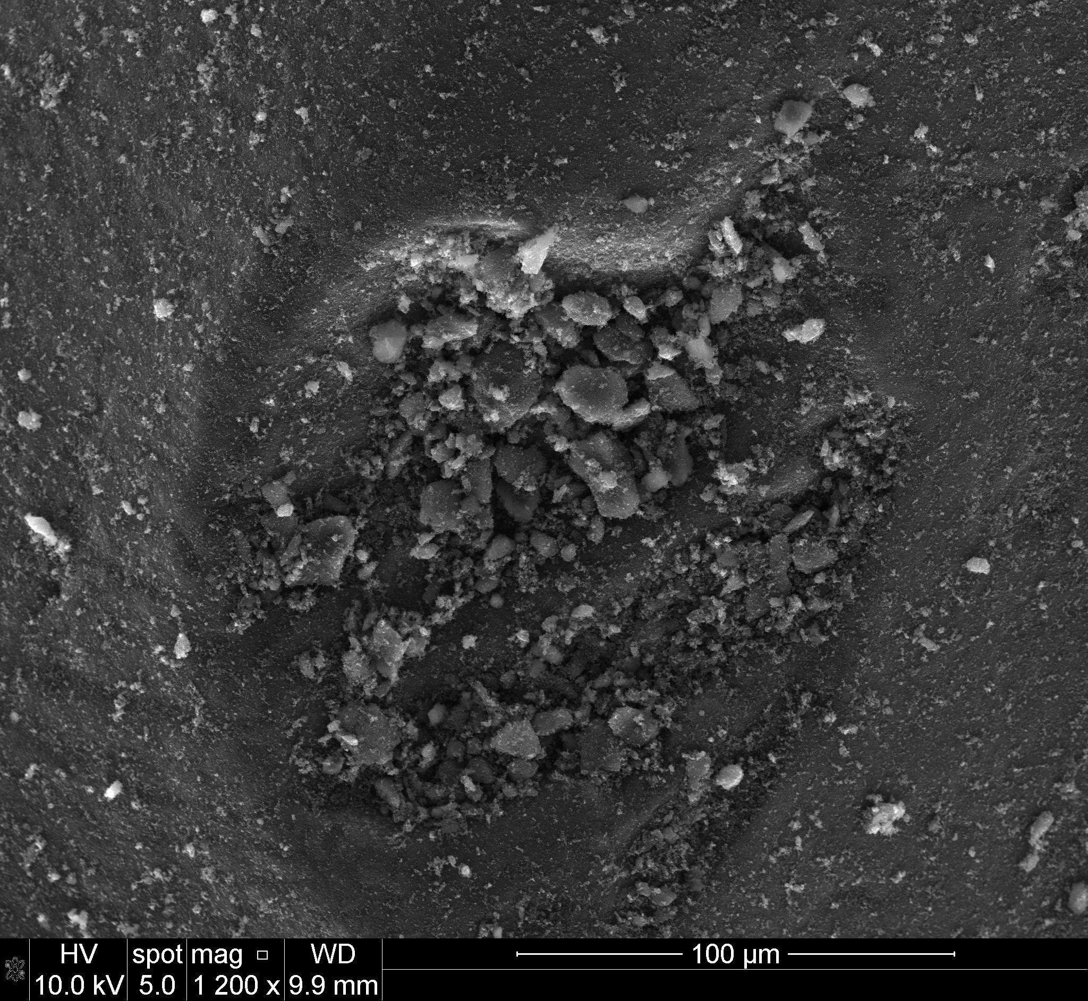
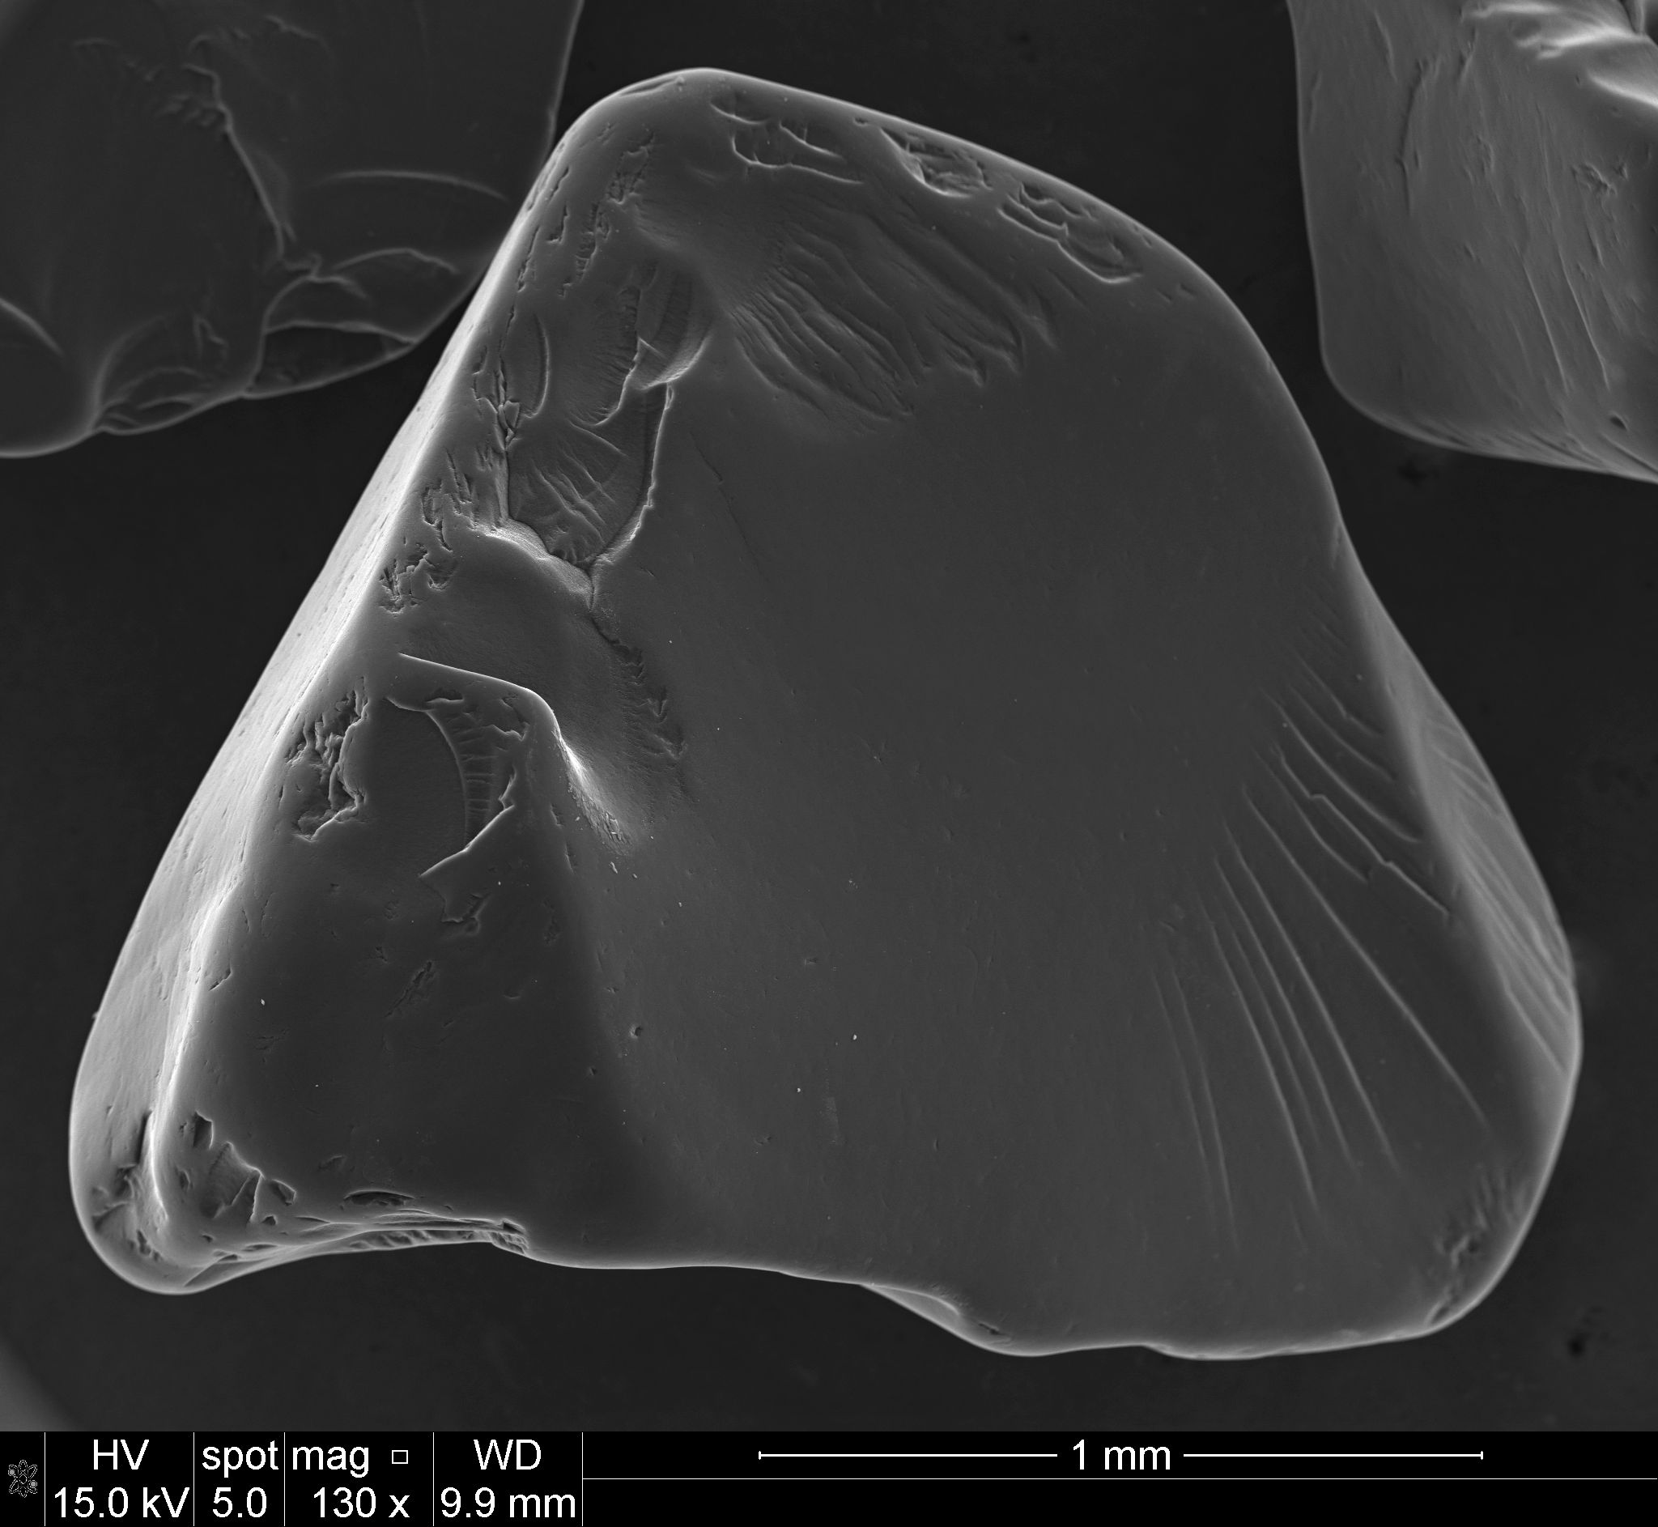
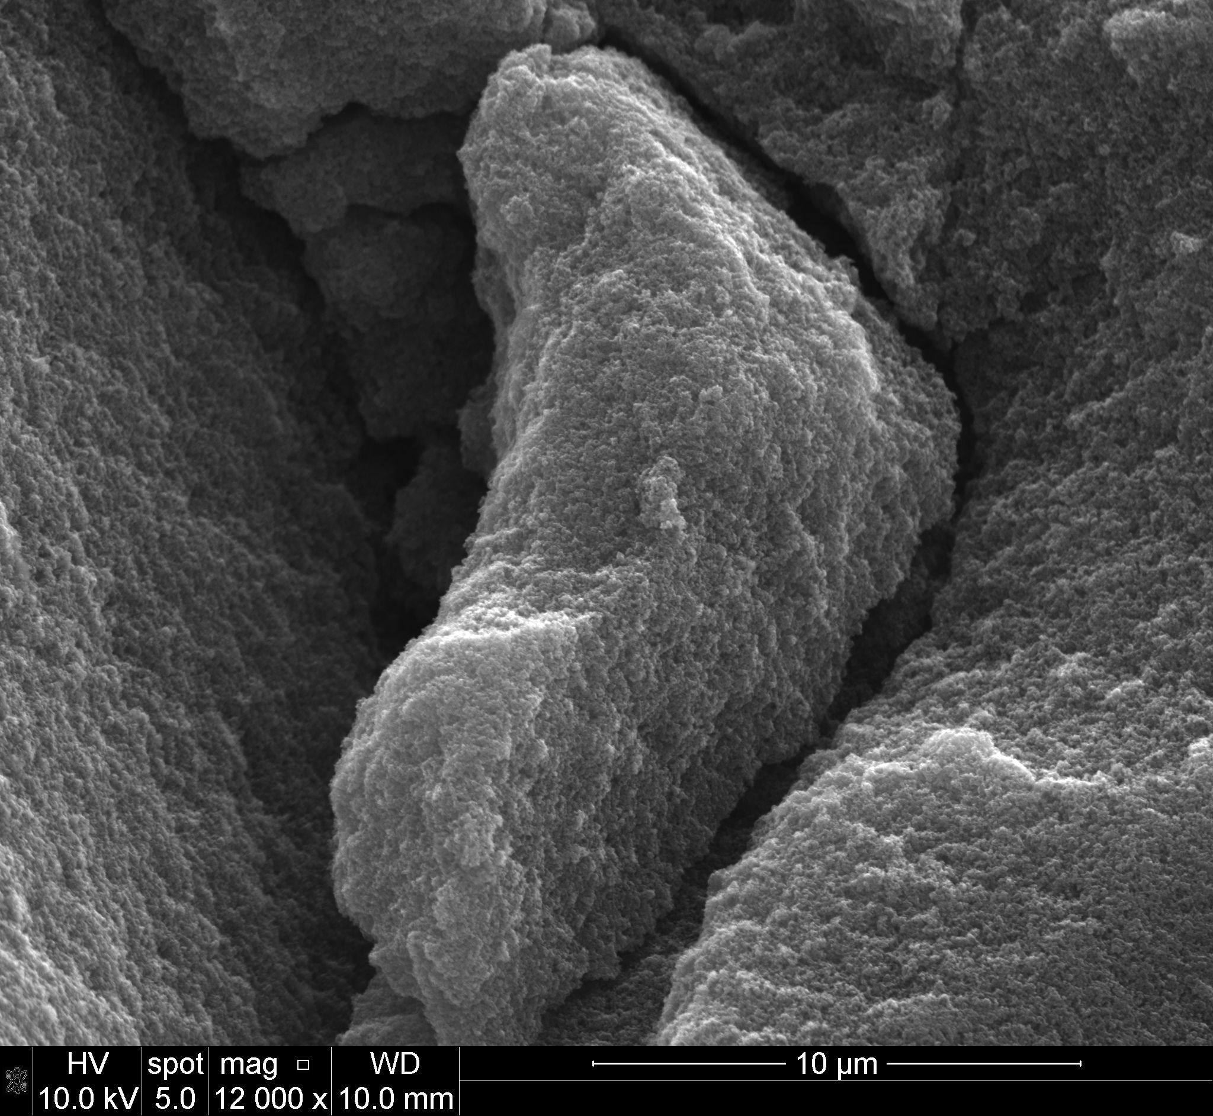
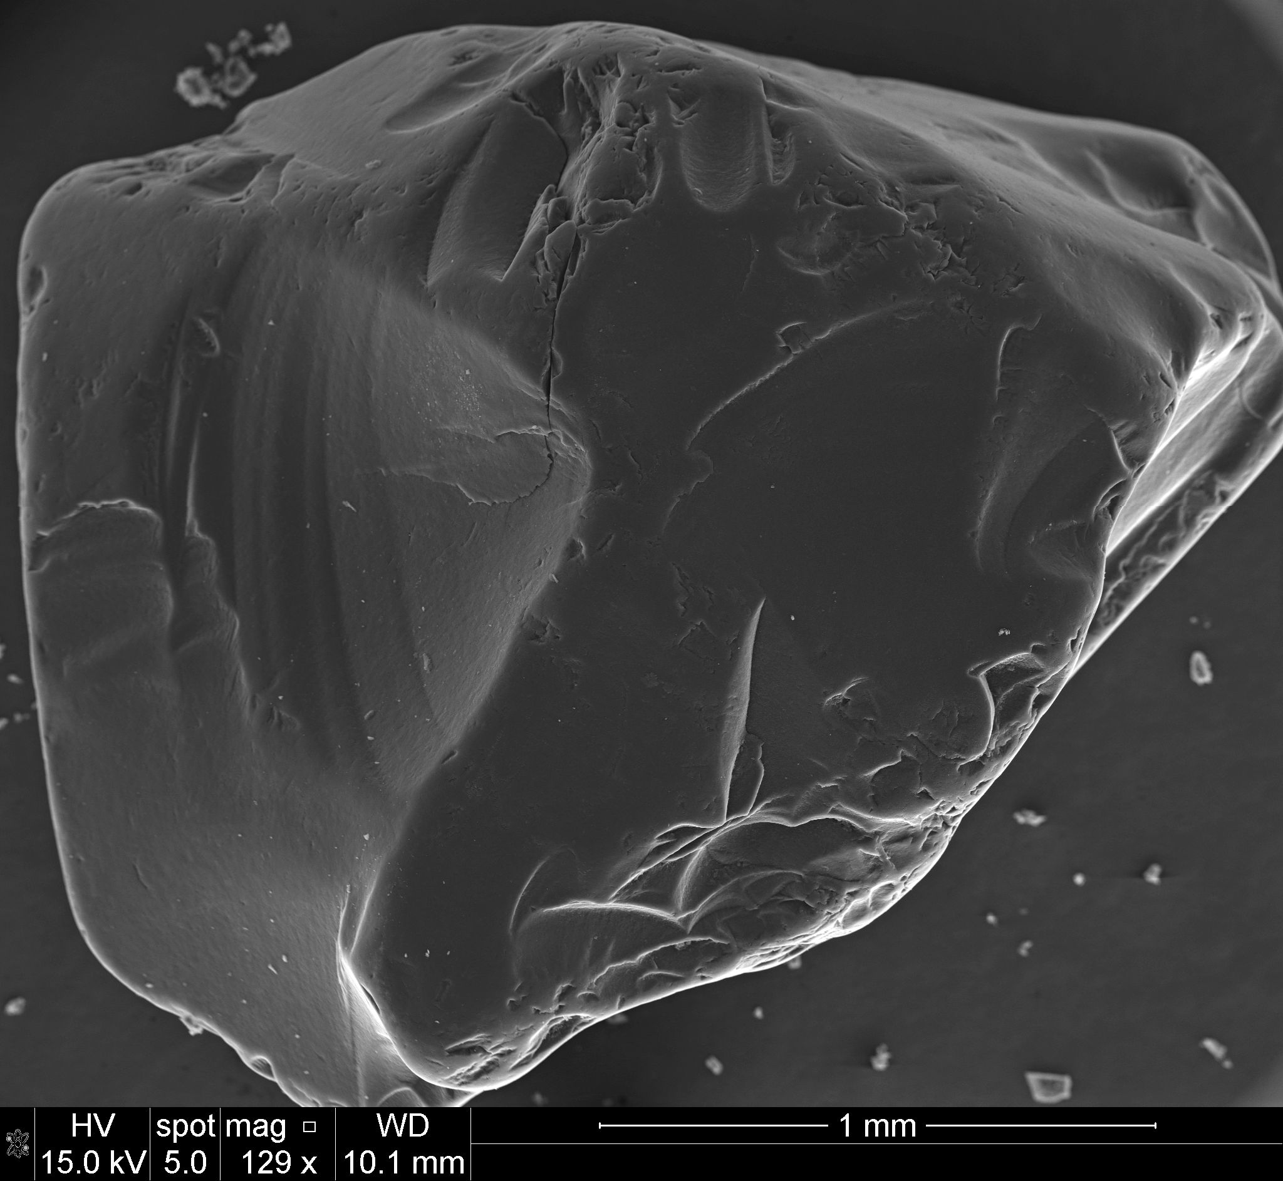
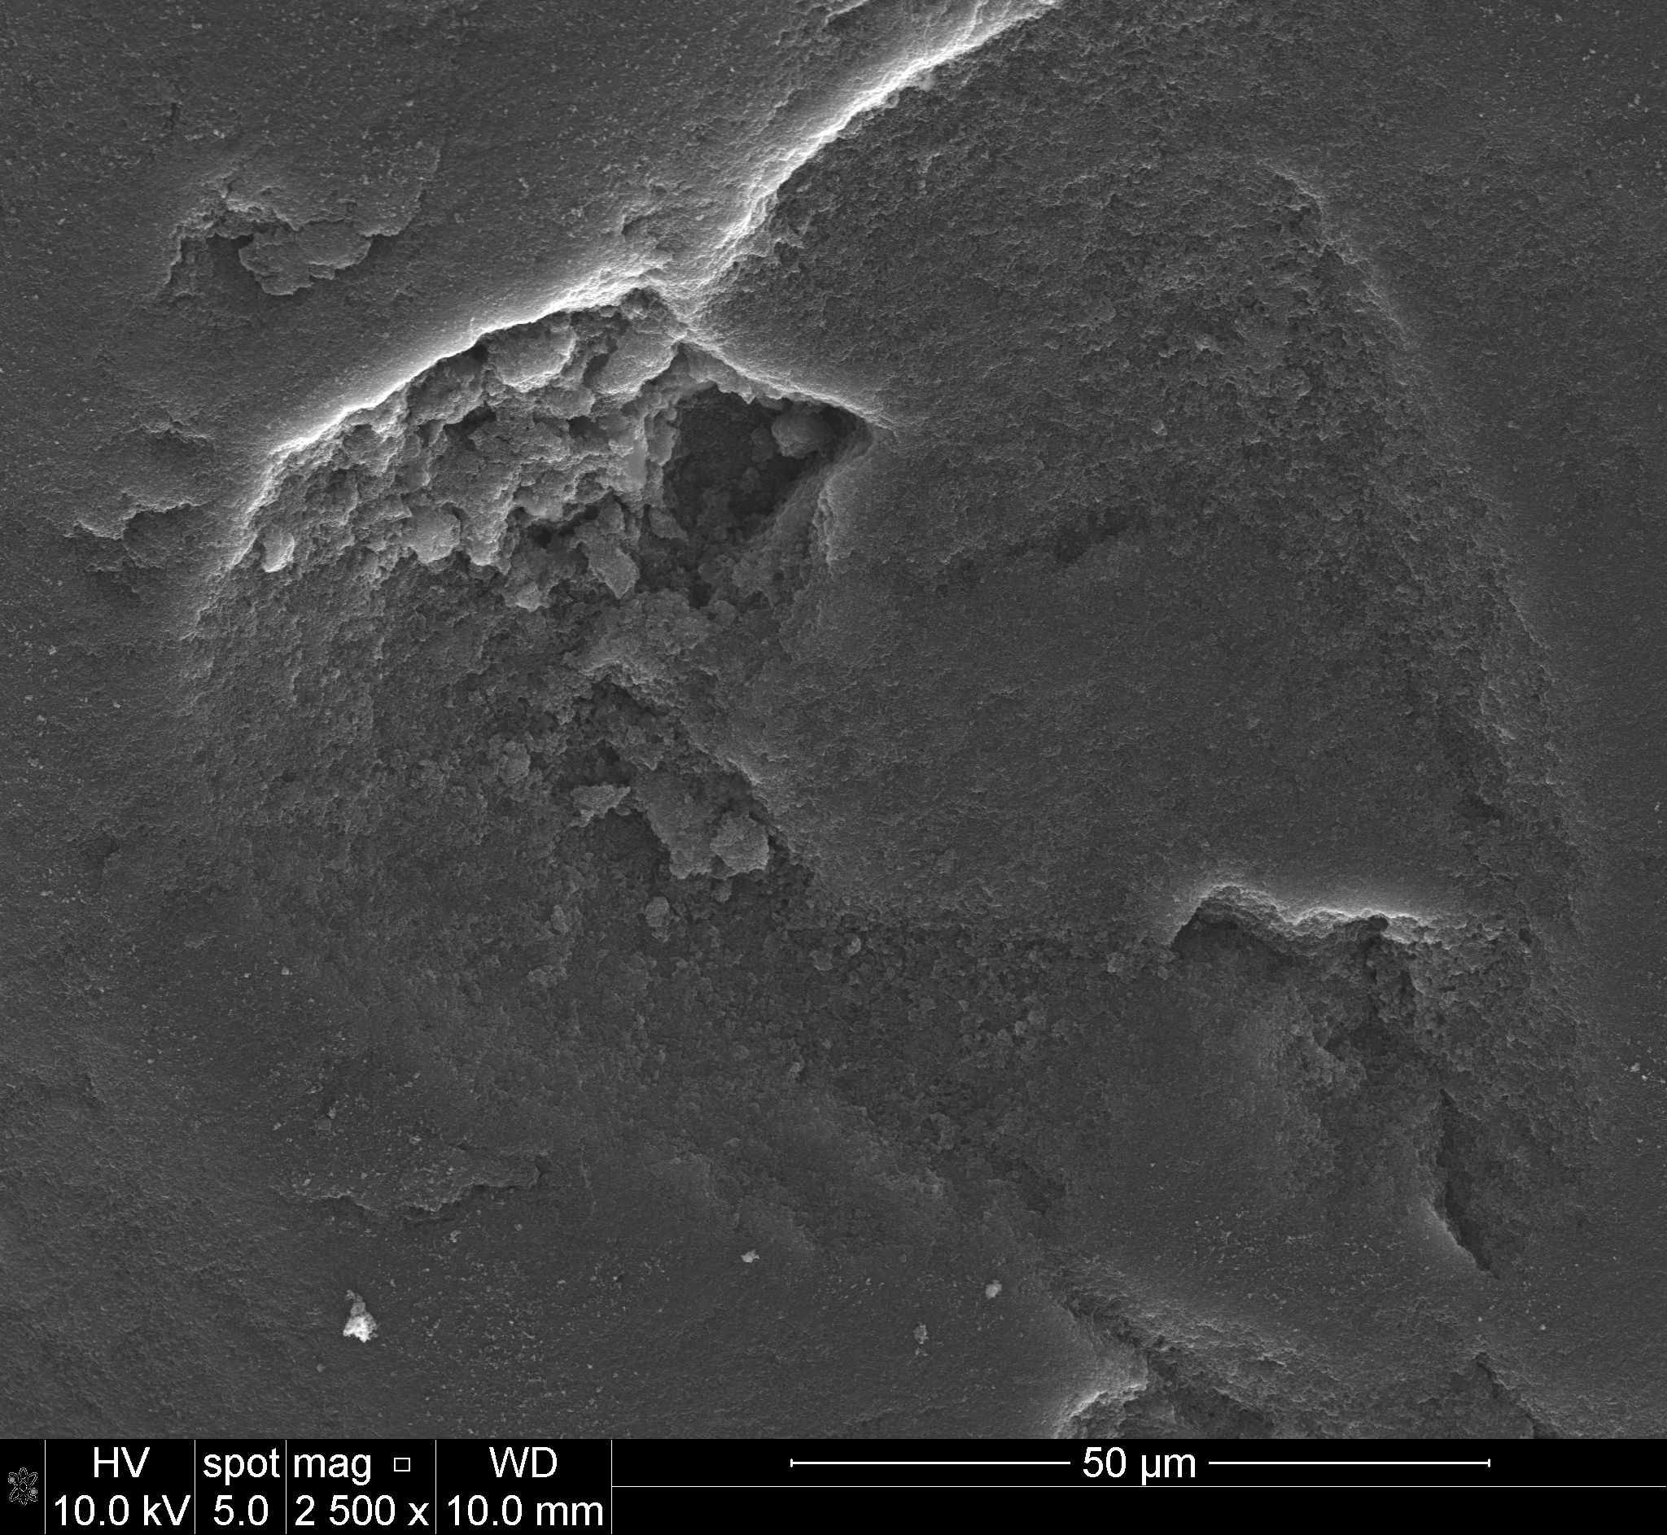
SEM images
a
b
c
d
e
f
Figure S3. SEM images of C-X (a, b), C-X-N (c, d), C-X-S (e, f).

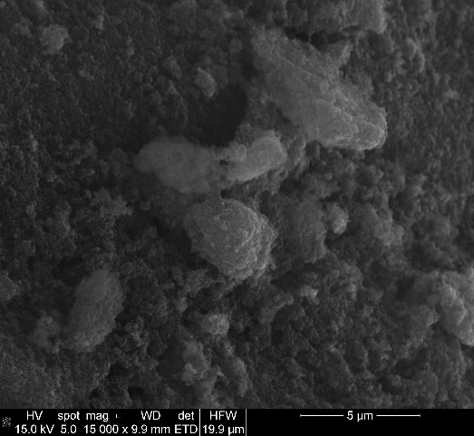
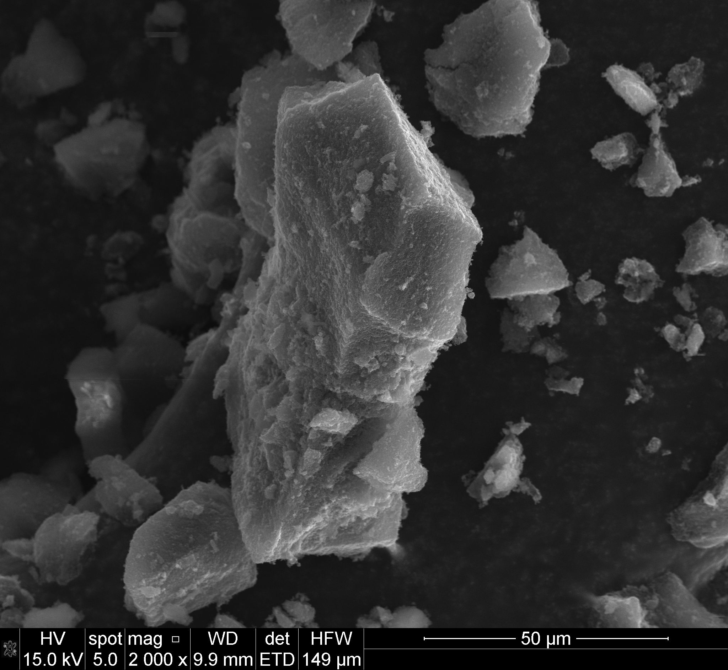
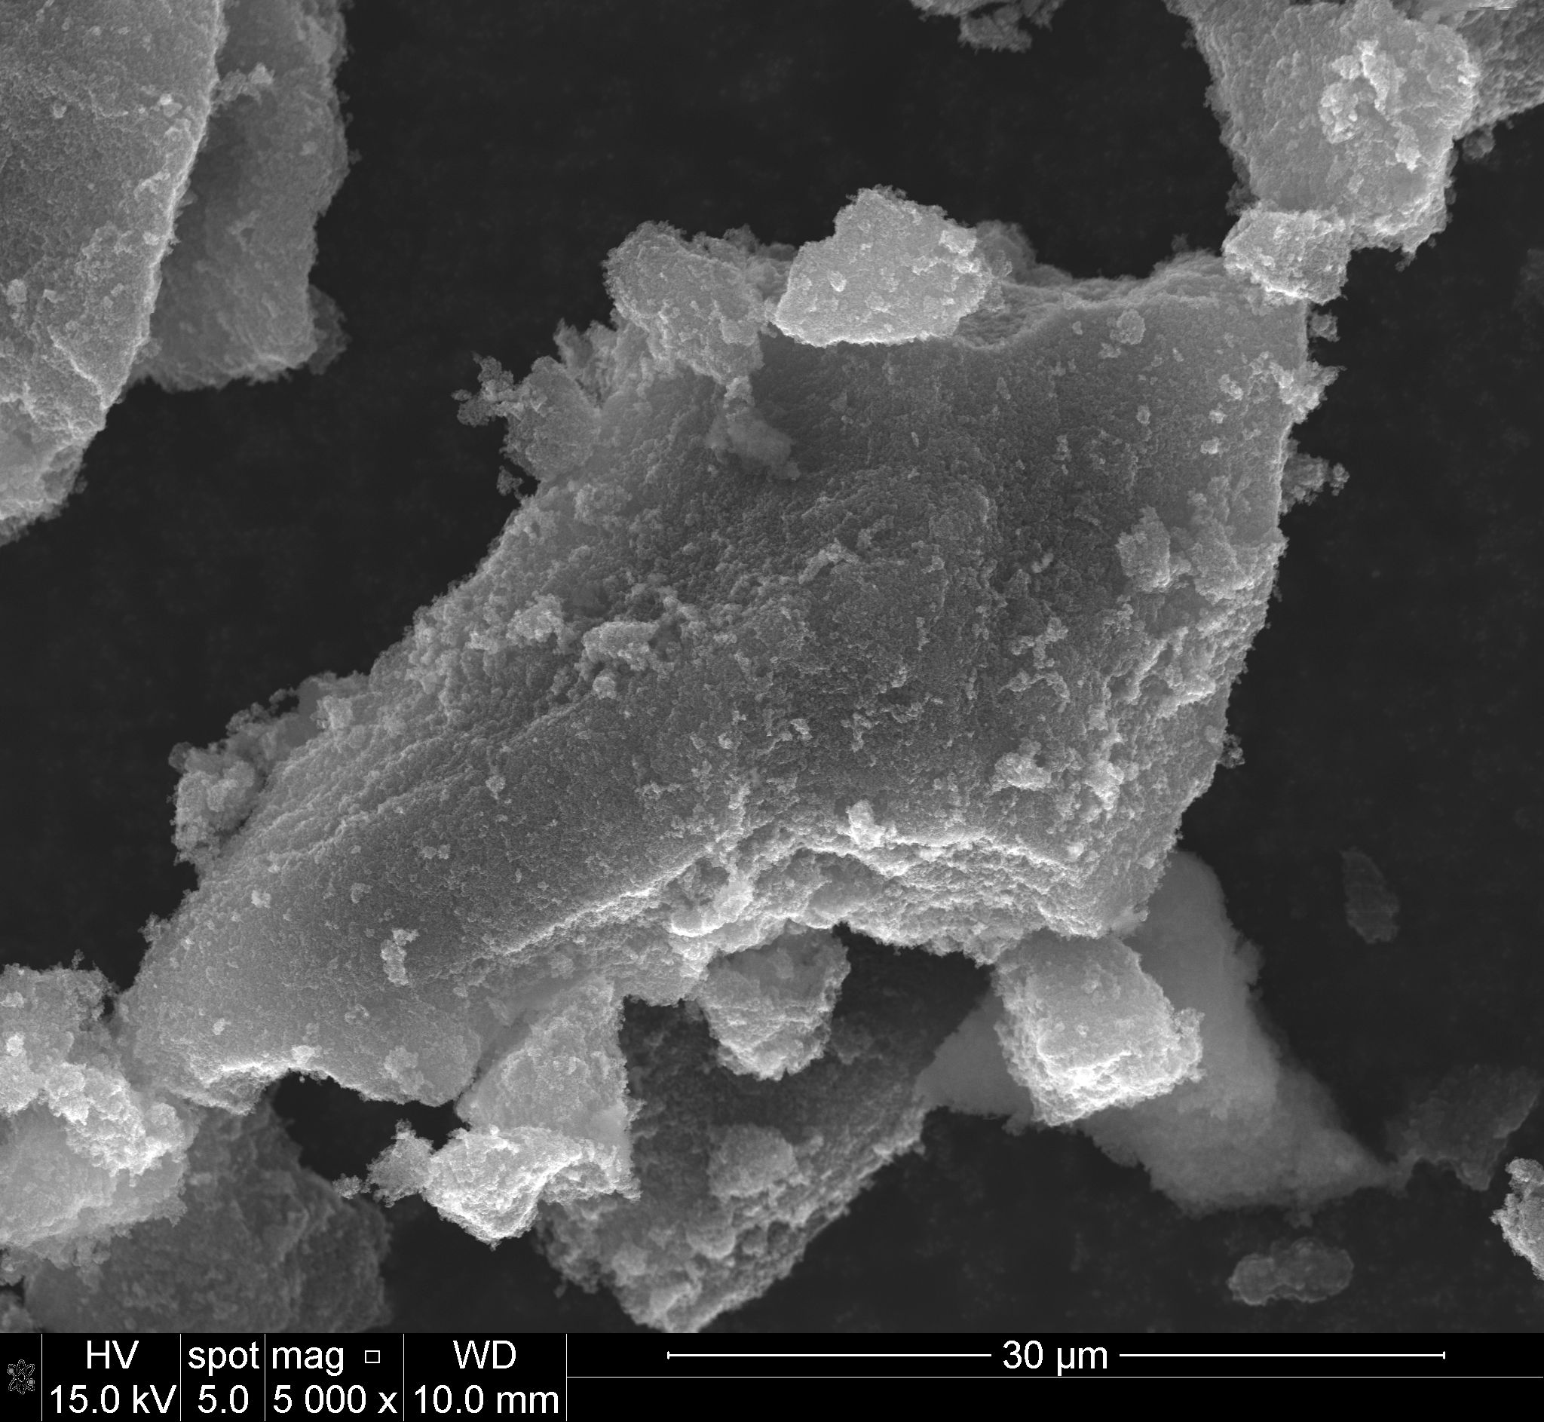
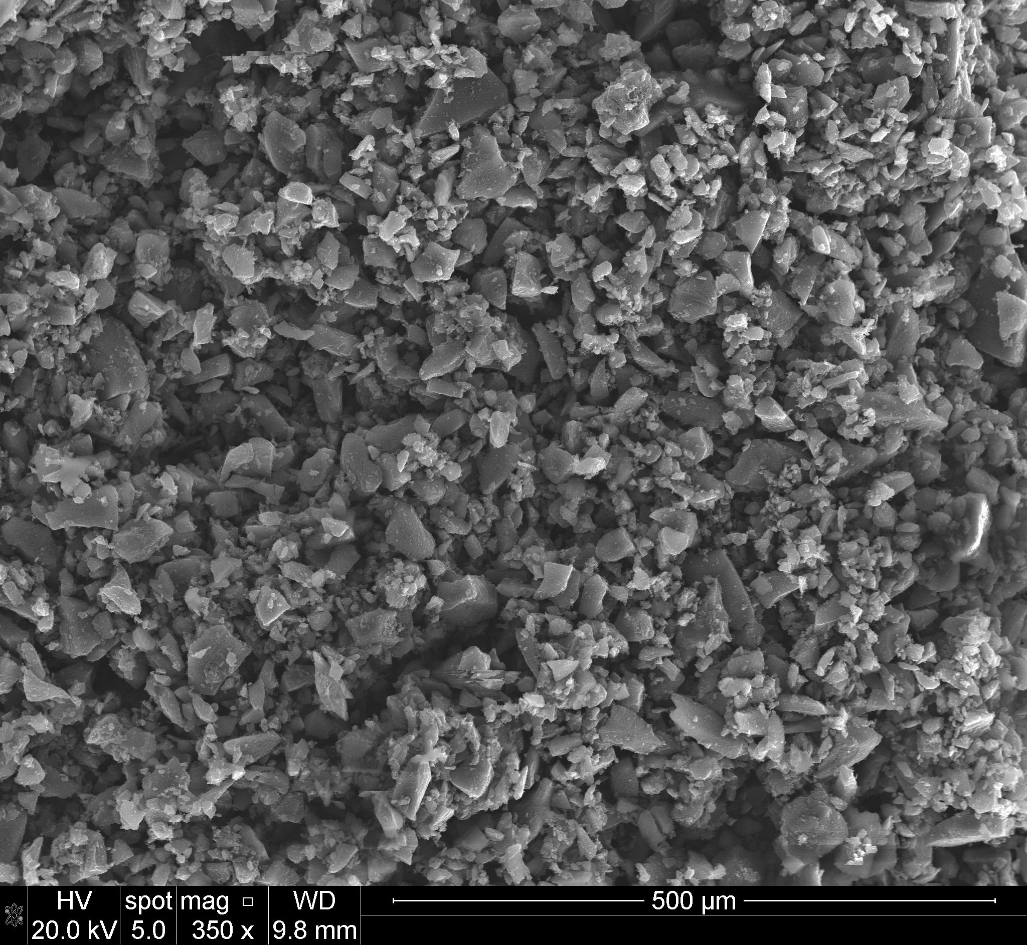
a
b
c
d
Figure S4. SEM images of C-X-Na (a, b), C-X-K (c, d).

