SUPPLEMENTARY METHODOLOGY
1.- Oximetry (Contribution of OXPHOS to ATP consumption)
An YSI model 5360 oxygen meter with a chamber volume of 1.9 mL was utilized. The cell pellet was resuspended in Krebs Ringer buffer (125 mM NaCl, 5 mM KCl, 1 mM MgCl2, 1.4 mM CaCl2, 1 mM KH2PO4, 25 mM HEPES, pH 7.4), centrifuged at 1,500 rpm for 5 minutes and the supernatant was removed. This process was repeated three times to remove any residual medium completely. The final cell pellet was resuspended in 1 mL of Krebs medium and quantified.
The chamber was brought to a volume of 1.9 mL with Krebs medium previously incubated at 37°C with constant bubbling. The chamber was calibrated to 100% oxygen, adding 4 mg of cells.
The recording was allowed to run until a constant slope was observed. Then, 5 µM oligomycin was added until a constant slope was reached. Subsequently, 1 mM CN was added until a constant slope was achieved. Finally, a small amount of dithionite was added to reduce any remaining oxygen completely, thus concluding the tracing. Calculation of the ng O₂/min/mg was performed.
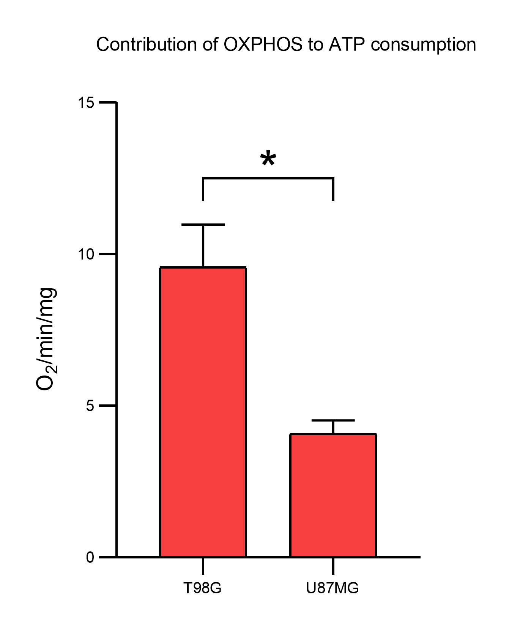
Supplementary figure 1. Oxygen consumption measurements were conducted in triplicate, and a t-test was performed to assess statistical significance (t=5.33; p=0.033).

2.- Lactate measurement (Contribution of glycolysis to ATP consumption)
The cell pellet was resuspended in Krebs Ringer buffer (125 mM NaCl, 5 mM KCl, 1 mM MgCl2, 1.4 mM CaCl2, 1 mM KH2PO4, 25 mM HEPES, pH 7.4), then centrifuged at 1,500 rpm for 5 minutes, and the supernatant was removed. This process was repeated three times to remove any residual medium completely. The final cell pellet was resuspended in 1 mL of Krebs medium and quantified. 4 mg of cells was taken and brought to a final volume of 2 mL with Krebs medium. This mixture was incubated under agitation at 150 rpm and 37°C for 10 minutes.
Two labeled tubes were prepared, one marked as "time 0" and the other as "time 10". To both tubes, 50 µL of PCA was added. After 10 minutes of agitation, 500 µL of cells were taken and placed in the tube labeled as "time 0". 37.5 µL of glucose (200 mM) was added to the remaining cells under agitation, and incubation was continued for an additional 10 minutes.
At the end of the last 10-minute period, 500 µL of cells were taken and placed in the tube labeled as "time 10". Both tubes were agitated and allowed to rest for 15-30 minutes at 4°C. Then, they were centrifuged at 2,500 rpm for 5 minutes. The supernatant was transferred to labeled tubes containing 50 µL of Kodak indicator. 60 µL of a 3M KOH solution with 0.1M Tris was added and mixed. Finally, 5 µL increments of this last solution were added until the color turned milky white. The samples were stored at -70°C for subsequent lactate measurement by spectrophotometry.
As the LDH enzyme contains lactate that maintains it undenatured, it had to be consumed entirely to avoid interference with the measurements. For this purpose, 20 µL of NAD+ (100 mM), 40 µL of LDH, and 1890 µL of hydrazine lysine medium were placed in 2 mL quartz cells. One cell was used for each sample. The cells were inserted into a diode array computerized spectrophotometer (Agilent 8453) calibrated at 340 nm. The spectrophotometer measured absorbance every 3 seconds, plotted in real-time. Once the lactate in the LDH solution was entirely consumed, the absorbances remained constant, and a consistent slope was observed. At this point, 50 µL of previously thawed samples were added at room temperature and centrifuged at 10,000 rpm for 2 minutes.
The absorbance reading continued every 3 seconds until the lactate in the samples was utterly consumed. The absorbance deltas (Δ) and the nmol/min/mg of glucose consumed by each sample were calculated.
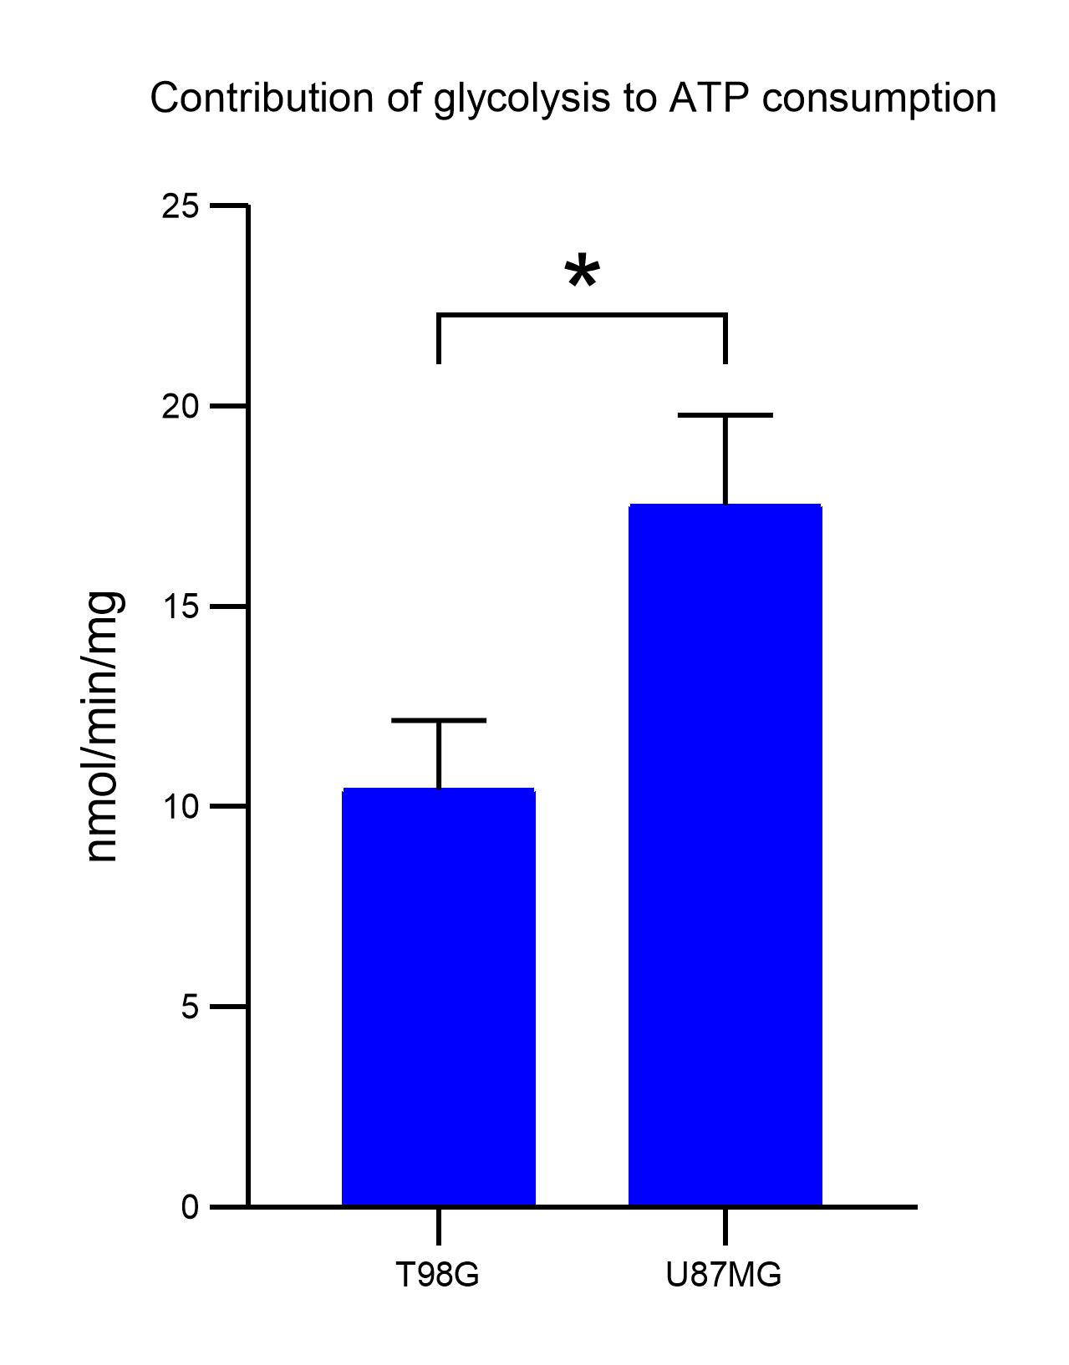
Supplementary figure 2. Lactate production measurements were conducted in triplicate, and a t-test was performed to assess statistical significance (t=4.35; p=0.012).

