Supplementary Files
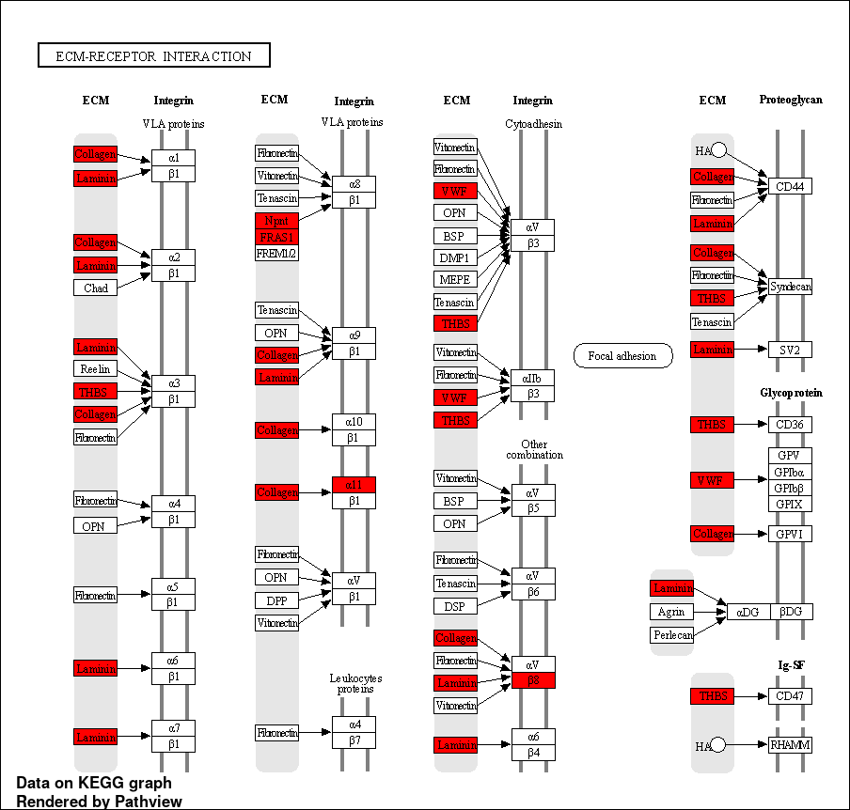
Supplementary Figure 1. ECM-receptor interaction pathway in response to 25 and 50 µM TQ treatment for 48 hours in A172 glioblastoma cells. DEGs from experimental dataset are highlighted in red.
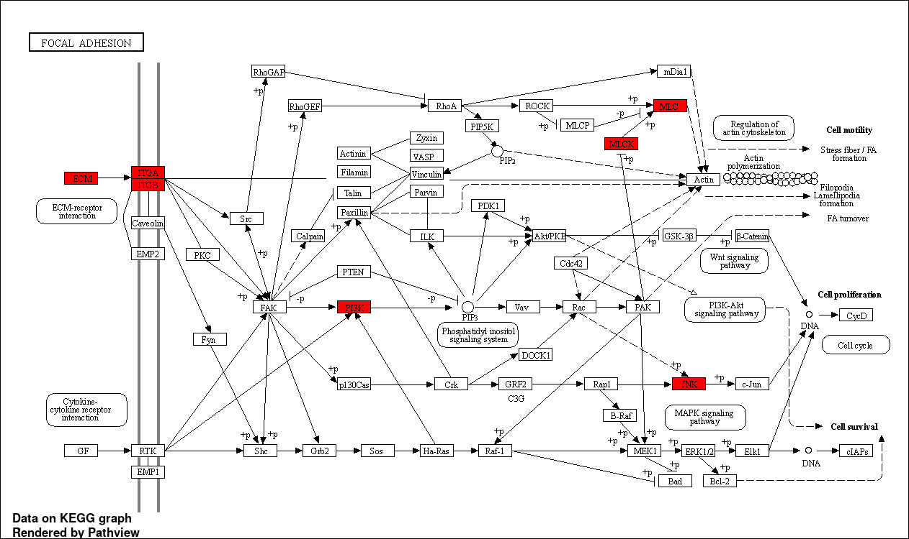
Supplementary Figure 2. Focal adhesion pathway in response to 25 and 50 µM TQ treatment for 48 hours in A172 glioblastoma cells. DEGs from experimental dataset are highlighted in red.
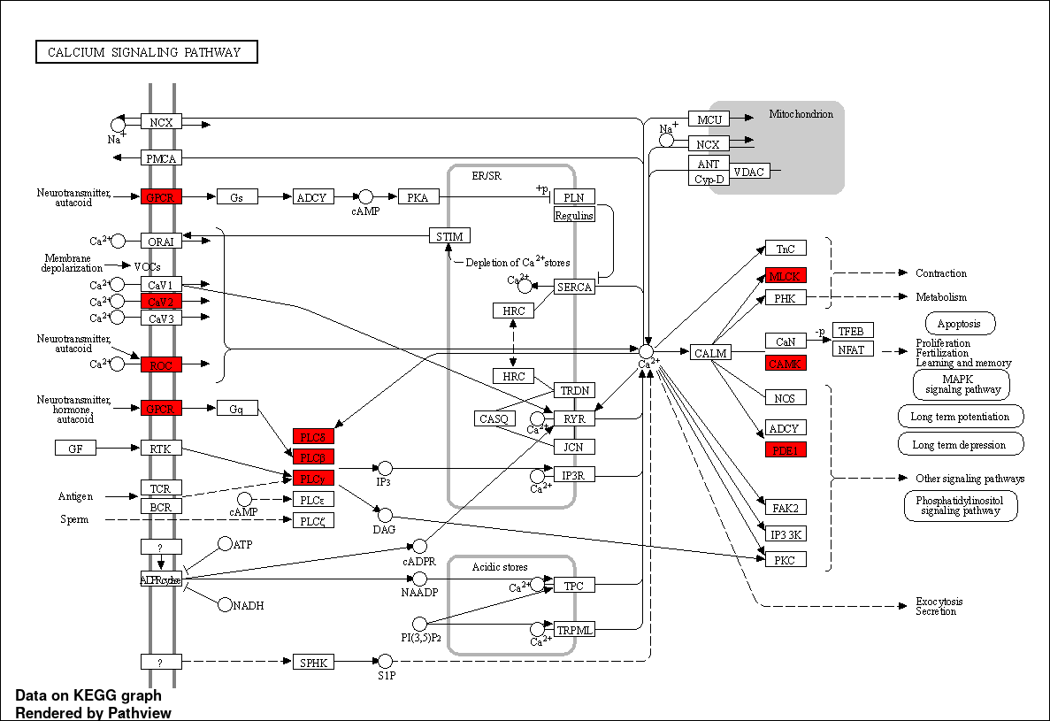
Supplementary Figure 3. Calcium signaling pathway in response to 25 and 50 µM TQ treatment for 48 hours in A172 glioblastoma cells. DEGs from experimental dataset are highlighted in red.

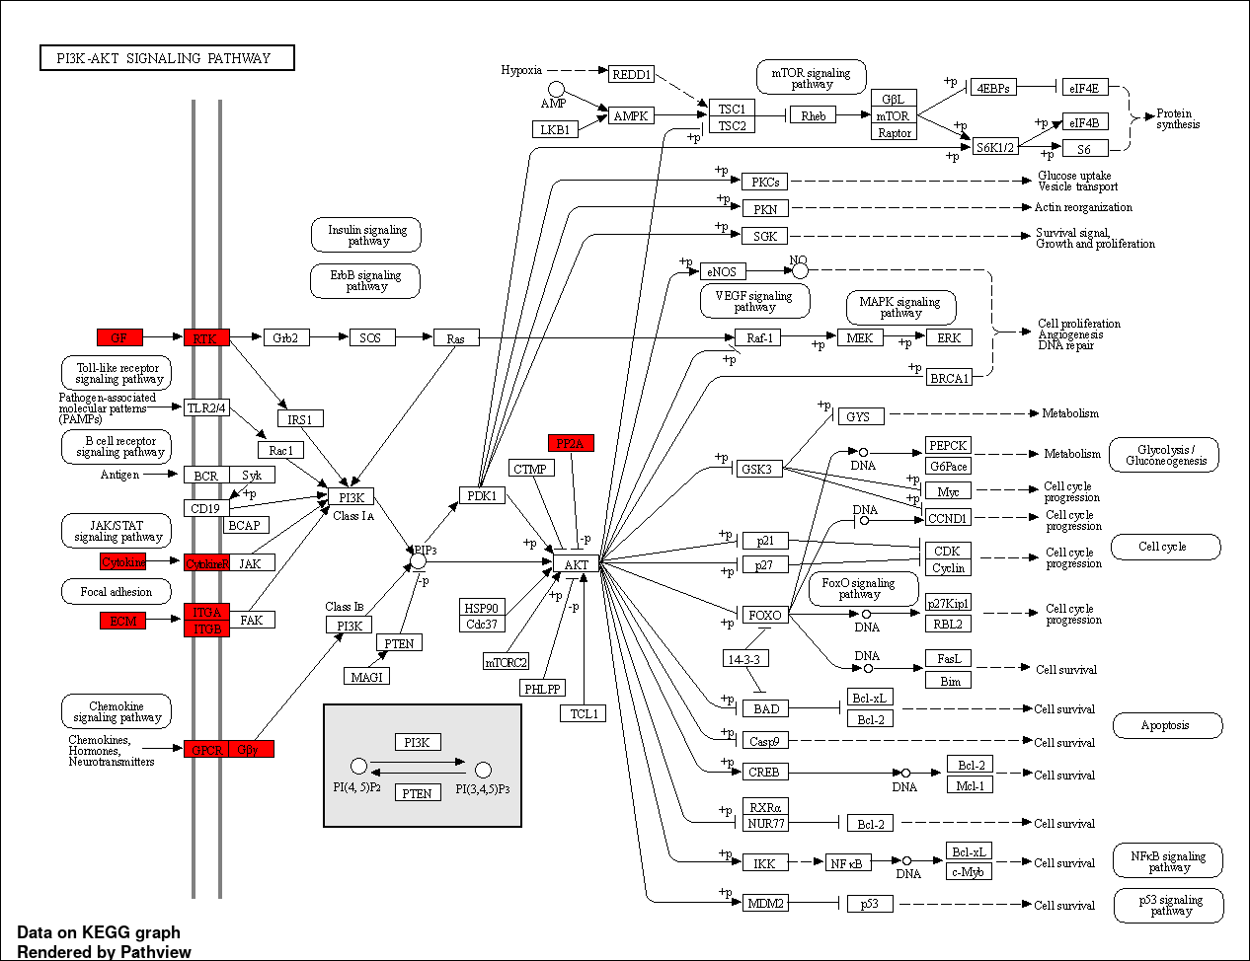
Supplementary Figure 4. PI3K-AKT signaling pathway in response to 50 µM TQ treatment for 48 hours in A172 glioblastoma cells. DEGs from experimental dataset are highlighted in red.
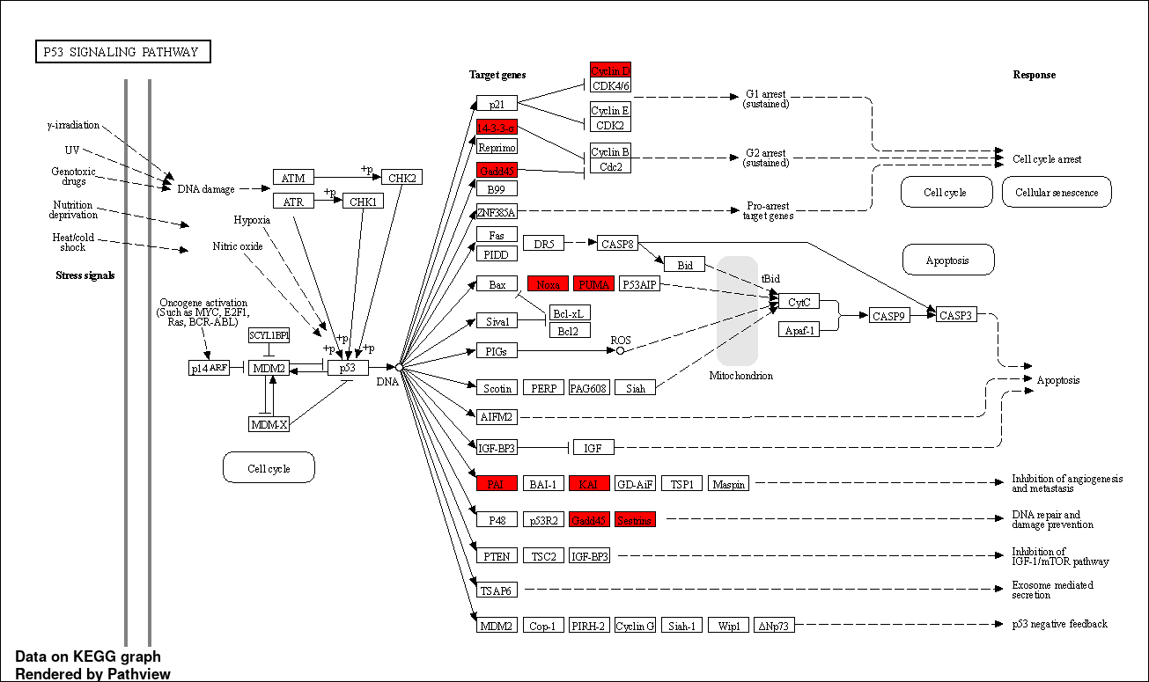
Supplementary Figure 5. P53 signaling pathway in response to 25 and 50 µM TQ treatment for 48 hours in A172 glioblastoma cells. DEGs from experimental dataset are highlighted in red.
Supplementary Table 1. Target genes and their respective primer sequences for qRT-PCR.
Target Gene Symbol | Primer Sequence (5' to 3') | References
18S rRNA | Forward- AGAAACGGCTACCACATCCA  Reverse- CACCAGACTTGCCCTCCA | Harvard Primer Bank
WNT7B | Forward- CACAGAAACTTTCGCAAGTGG  Reverse- GTACTGGCACTCGTTGATGC | Harvard Primer Bank
CHAC1 | Forward- GAACCCTGGTTACCTGGGC  Reverse- CGCAGCAAGTATTCAAGGTTAT | Harvard Primer Bank
DUSP5 | Forward- TGTCGTCCTCACCTCGCTA  Reverse- GGGCTCTCTCACTCTCAATCTTC | Harvard Primer Bank
CD300A | Forward- CCCGAGAGGTCTTTTTCCGAG  Reverse- CCAGCCCATGATGGTTCTGAT | Harvard Primer Bank

