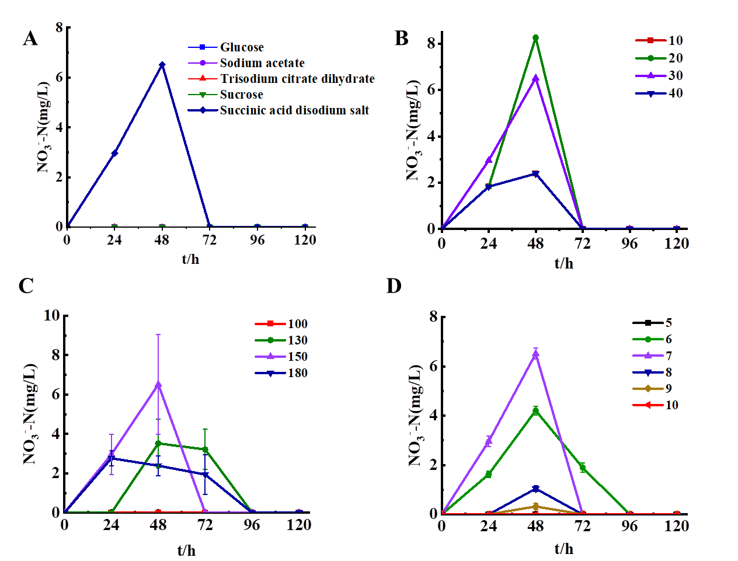
Figure S1 nitrate accumulation of strain HS2 under various factors (A: Carbon source, B: Carbon-to-nitrogen ratio, C: Dissolved oxygen, D: pH)

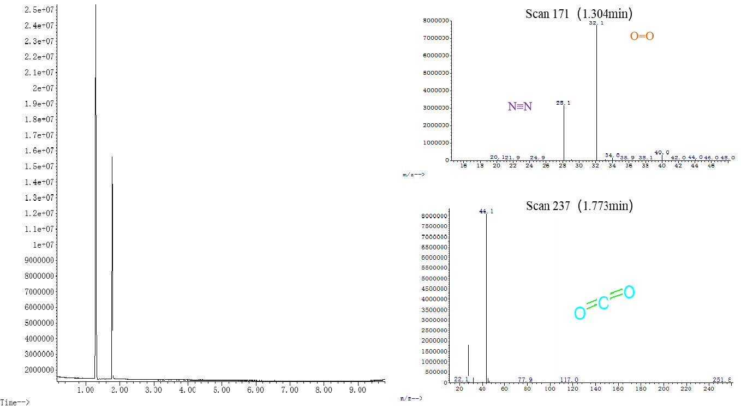
Figure S2 Gas products of strain HS2 in HN-AD

