Supporting Information
Improving device-to-device reproducibility of light-emitting diodes based on layered halide perovskites
Quang-Huy Do, Rémi Antony, Bernard Ratier, Johann Bouclé*
XLIM UMR 7252, University of Limoges / CNRS, Limoges, 87000, France

*E-mail: johann.boucle@unilim.fr

Keywords: layered halide perovskites, perovskite light-emitting devices, device-to-device reproducibility

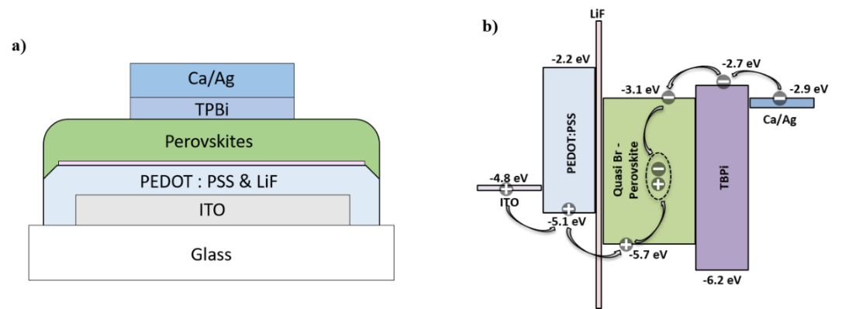
Figure S1. a) Device structure and b) Energy alignment diagram of the green PeLEDs based on layered bromide perovskite
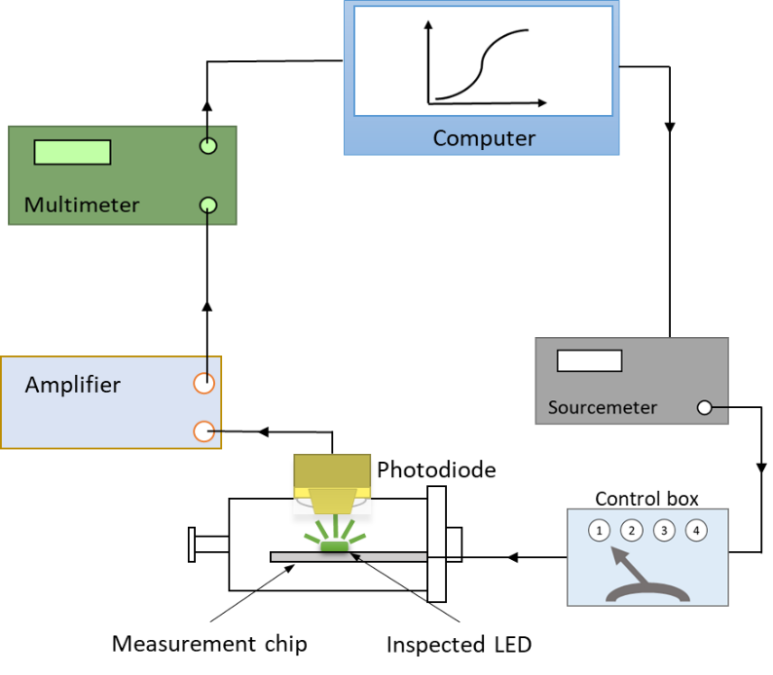
Figure S2. Measurement set-up for device characterization

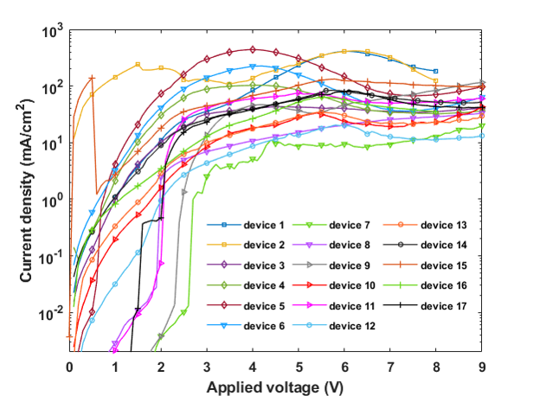
Figure S3. Current density-voltage curves of 17 devices fabricated using Set-up A
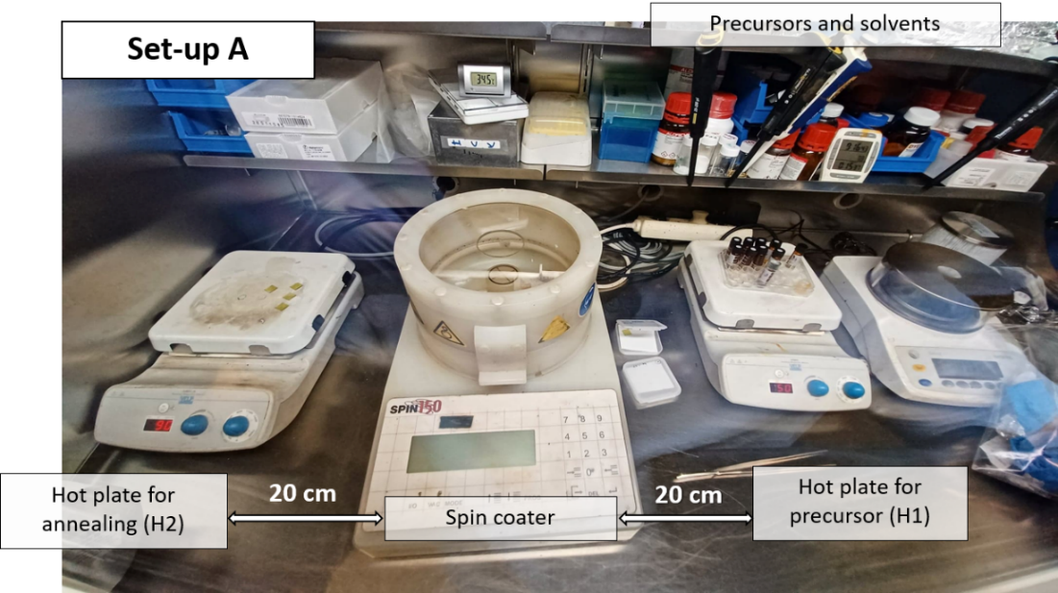
Figure S4. The original set-up (Set-up A) of perovskite deposition in glove box: A spin-coater is placed in the middle of two hot plates, 20-centimeter away for each other. All chemical species that are necessary for perovskite precursor preparation and deposition are stored in the shelf above the spin-coater.

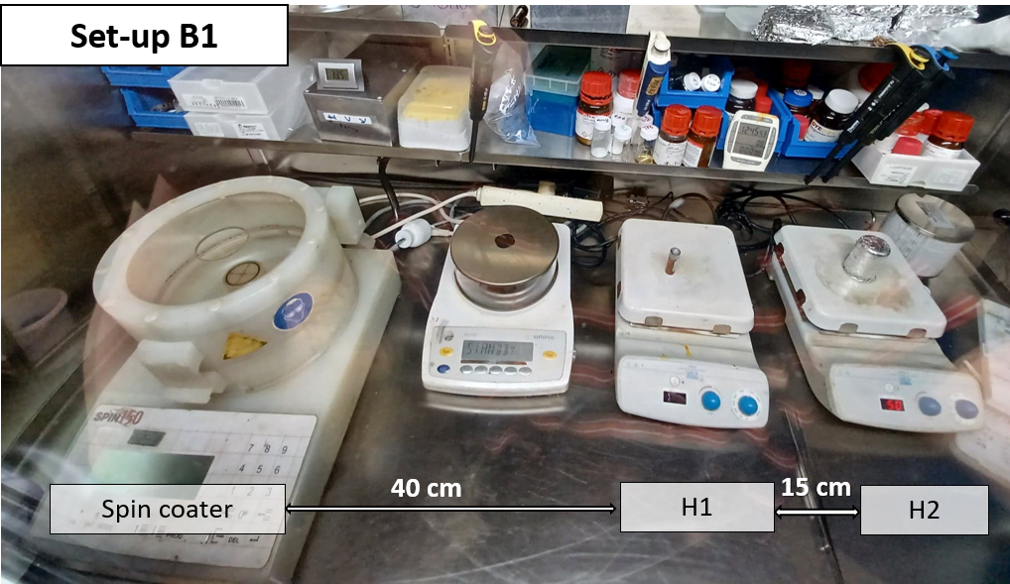
Figure S5. Rearrangement of equipment in Set-up B – sub-scenario B1: The hot plates are placed 40 cm and 55 cm respectively from the spin-coater. The chemical species are still stored in the deposition glovebox as in Set-up A.

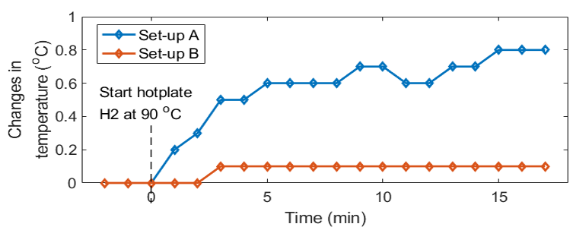
Figure S6. Changes in temperature at the spin-coating holder during the perovskite deposition and annealing processes in two deposition scenarios A and B.

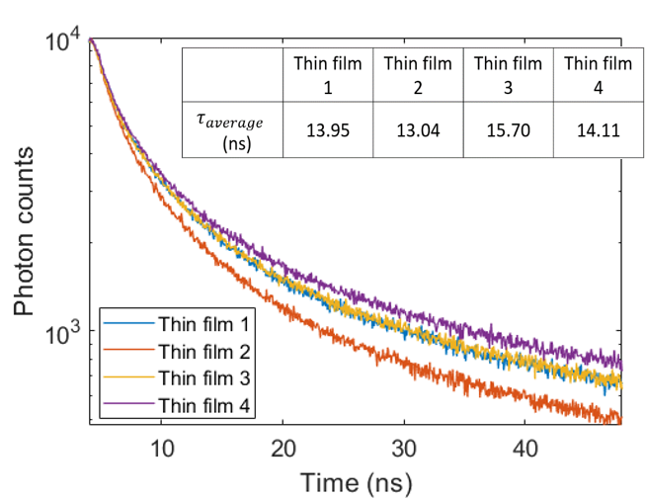
Figure S7. PL decays of 4 intrabatch perovskite thin films deposited using Set-up B1. The inset shows the average lifetime of each sample.

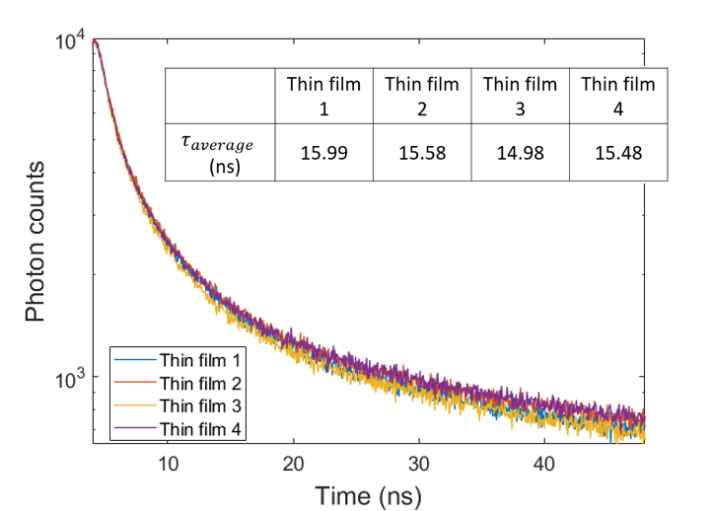
Figure S8. PL decays of 4 intrabatch perovskite thin films deposited using Set-up B2. The inset shows the average lifetime of each sample.

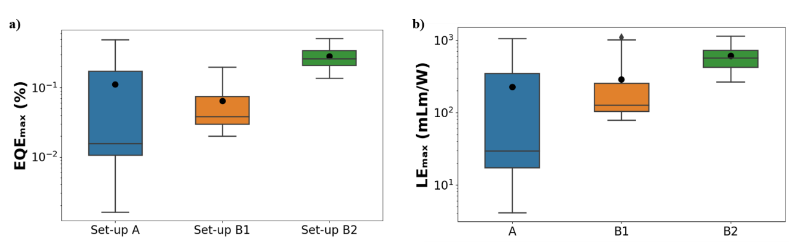
Figure S9. Statistical distribution of a) maximum EQE and b) maximum LE values with respect to Set-up A, B1, and B2. The whiskers represent the upper and lower quartiles, the diamond markers represent the outliers, the middle lines represent the median value, and the black dots represent the mean value of each dataset.

