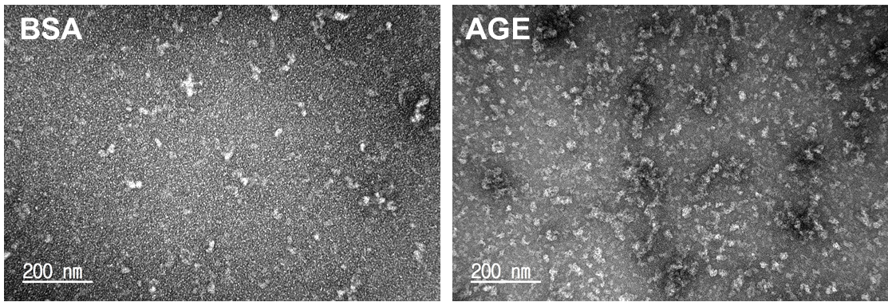
Figure S1. TEM images support AGE formation compared to only BSA.
Figure S1. TEM images support AGE formation compared to only BSA.
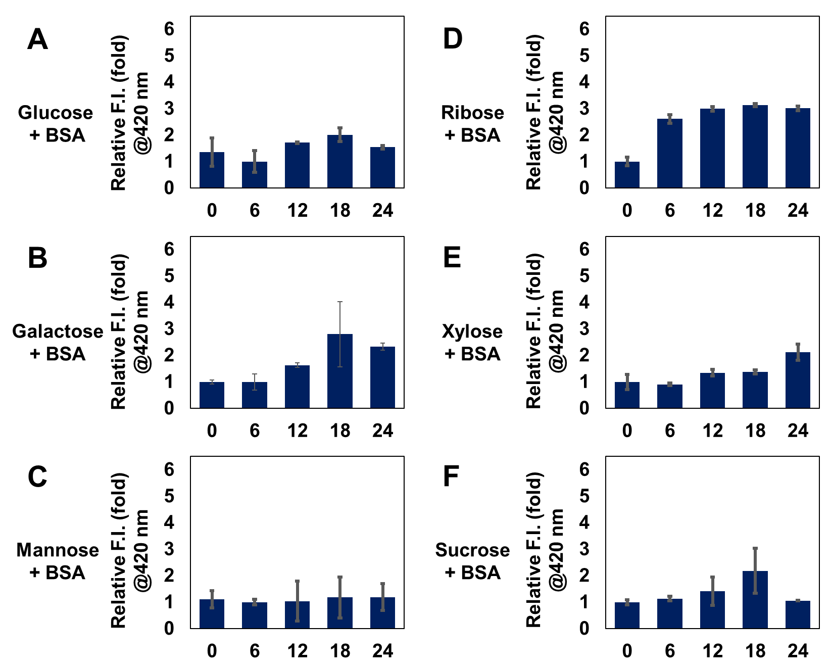
Figure S2. Autofluorescence from carbohydrate type-dependent AGEs formation. AGEs were formed by A) Glucose; B) Galactose; C) Mannose; D) Ribose; E) Xylose; and F) Sucrose along with BSA incubation until 24 days at intervals of 6 days. Autofluorescence was measured by the plate reader (ex: 370 nm, em: 420 nm).

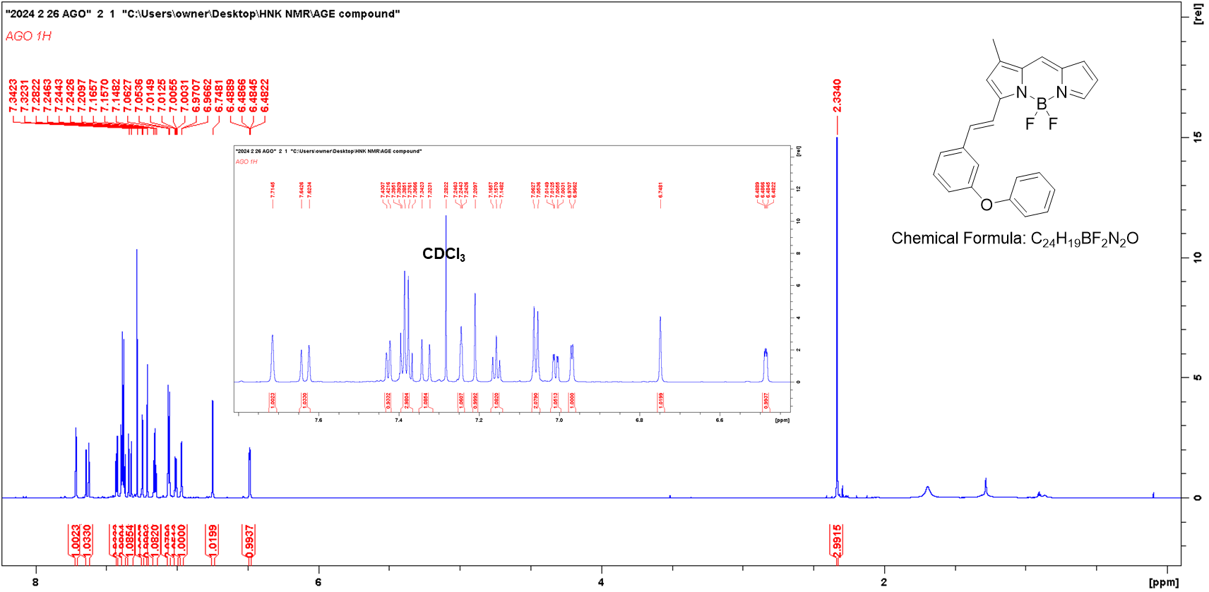
Figure S3. ¹H NMR spectrum of AGO (850 MHz, CDCl₃).

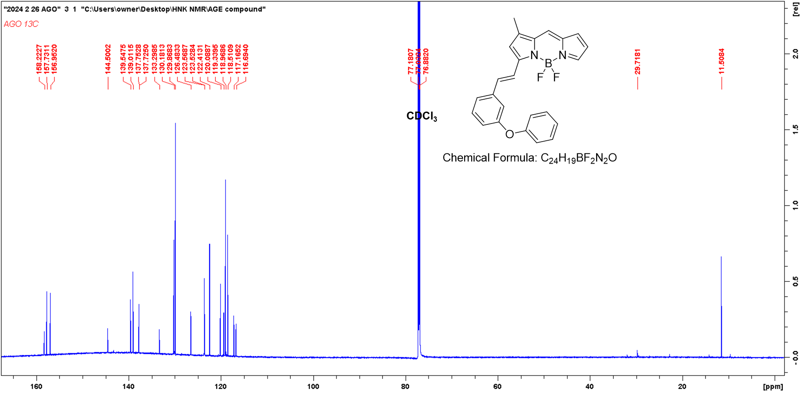
Figure S4. ¹²C NMR spectrum of AGO (214 MHz, CDCl₃).

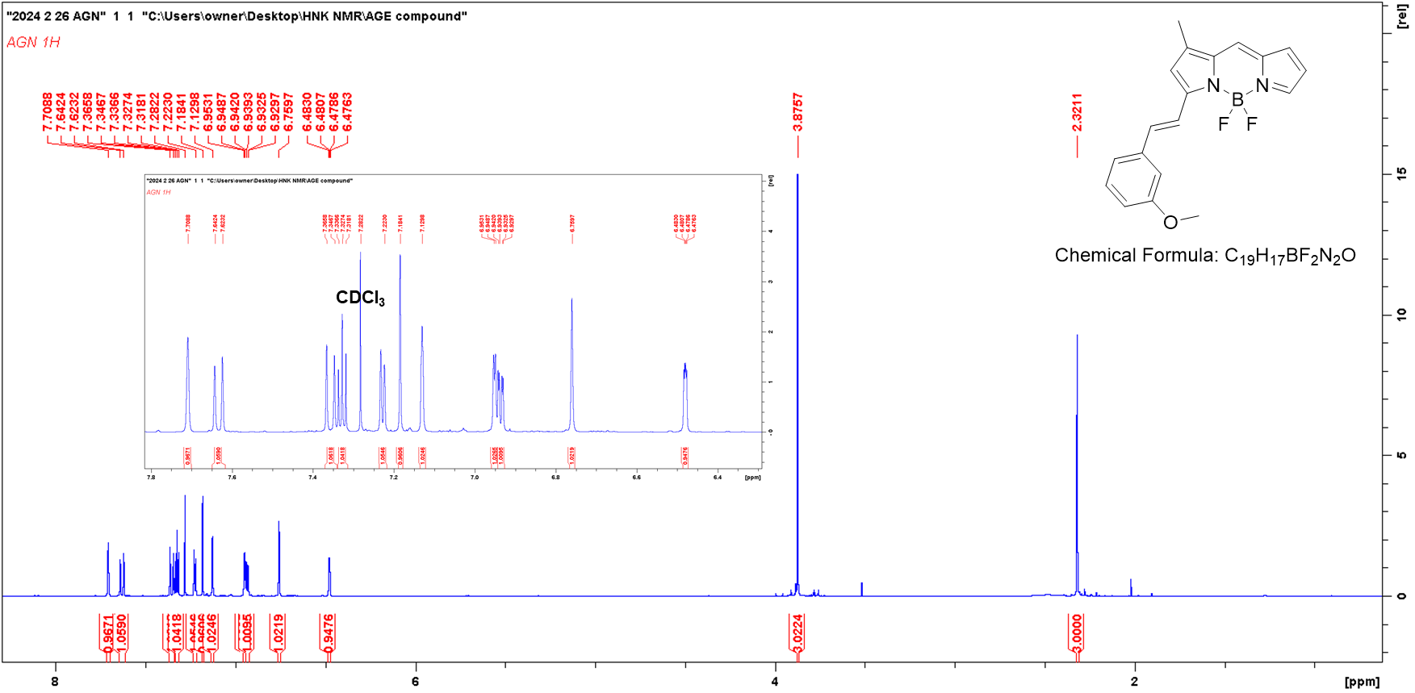
Figure S5. ¹H NMR spectrum of AGN (850 MHz, CDCl₃).

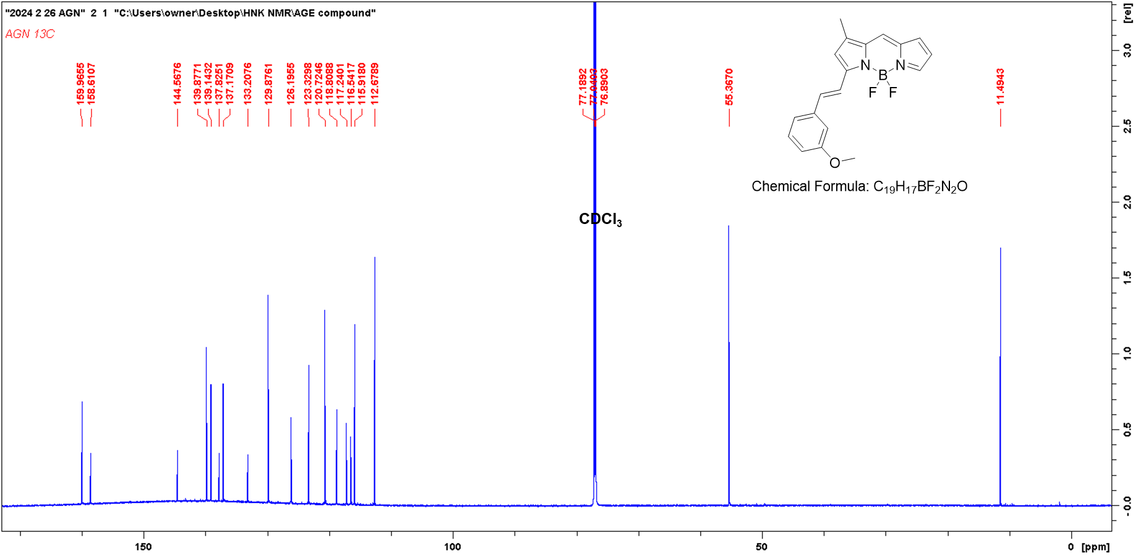
Figure S6. ¹²C NMR spectrum of AGN (214 MHz, CDCl₃).

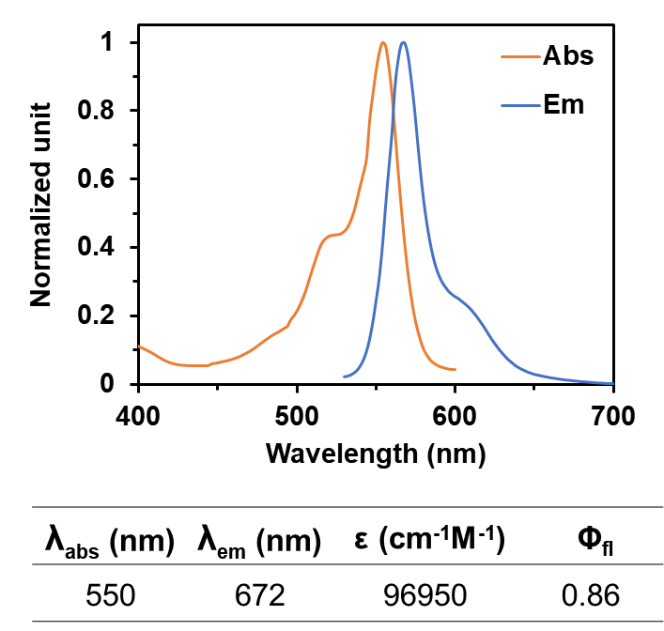
Figure S7. Optical properties of AGO.

