Apendix A: Supplementary data

Taxonomic identification and antagonistic mechanism of Streptomyces luomodiensis sp. nov. against phytopathogenic fungi
Dengfeng Qi^{a#}, Qiao Liu^{a#}, Liangping Zouª, Miaoyi Zhangª, Kai Liª, Yankun Zhaoª Yufeng Chenª, Junting Fengª, Dengbo Zhouª, Yongzan Weiª, Wei Wang^{a*}, Lu Zhang^{b*}, Jianghui Xie^{a*}

a Key Laboratory of Biology and Genetic Resources of Tropical Crops, Ministry of Agriculture, Institute of Tropical Bioscience and Biotechnology, Chinese Academy of Tropical Agricultural Sciences, Haikou, 571101, China
b Ministry of Education Key Laboratory for Ecology of Tropical Islands, Key Laboratory of Tropical Animal and Plant Ecology of Hainan Province, College of Life Sciences, Hainan Normal University, Haikou, Hainan 571158, China

#These authors have contributed equally to this work (co-first authors)

*Correspondence Authors:

Dr. Jianghui Xie (xiejianghui@itbb.org.cn) Dr. Lu Zhang (luzhangtest@hainnu.edu.cn) Dr. Wei Wang (wangweisys@ahau.edu.cn)
Tables
Table S1. Allele sequence accession numbers of Streptomyces used for the present study

Species | Strains | atpD | gyrB | recA | rpoB | trpB
Streptomyces luomodiensis | SCA4-21T | CP117522 | CP117522 | CP117522 | CP117522 | CP117522
Streptomyces iranensis | HM 35T | MW197742.1 | MW197743.1 | MW197744.1 | MW197745.1 | MW197746.1
Streptomyces rapamycinicus | NRRL B-5491T | NC_022785.1 | NC_022785.1 | NC_022785.1 | NC_022785.1 | NC_022785.1
Streptomyces hygroscopicus subsp.  hygroscopicus | NBRC 13472T | NZ_BBOX01000262.1 | NZ_BBOX01000097.1 | NZ_BBOX01000200.1 | NZ_BBOX01000138.1 | NZ_BBOX01000120.1
Streptomyces demainii | NRRL B-1478  (DSM 41600)T | FJ406182.1 | FJ406238.1 | FJ406294.1 | FJ406349.1 | FJ406405.1
Streptomyces melanosporofaciens | DSM 40318T | NZ_FNST01000002.1 | NZ_FNST01000002.1 | NZ_FNST01000002.1 | NZ_FNST01000002.1 | NZ_FNST01000002.1
Streptomyces antimycoticus | NBRC 12839T | NZ_BJHV01000001.1 | NZ_BJHV01000001.1 | NZ_BJHV01000001.1 | NZ_BJHV01000001.1 | NZ_BJHV01000001.1
Streptomyces himastatinicus | ATCC 53653T | NZ_GG657754.1 | NZ_GG657754.1 | NZ_GG657754.1 | NZ_GG657754.1 | NZ_GG657754.1
Streptomyces lydicamycinicus | NBRC 110027T | BBNO01000001.1 | BBNO01000002.1 | BBNO01000008.1 | BBNO01000005.1 | BBNO01000012.1
Streptomyces caniferus | NBRC 15389T | NZ_BLIN01000002.1 | NZ_BLIN01000005.1 | NZ_BLIN01000002.1 | NZ_BLIN01000005.1 | NZ_BLIN01000005.1
Streptomyces platensis | JCM 4662 (DSM 40041)T | NZ_MIGA01000003.1 | NZ_MIGA01000008.1 | NZ_MIGA01000021.1 | NZ_MIGA01000026.1 | NZ_MIGA01000017.1
Streptomyces celluloflavu | NRRL B-2493T | NZ_JOEL01000012.1 | NZ_JOEL01000017.1 | NZ_JOEL01000056.1 | NZ_JOEL01000011.1 | NZ_JOEL01000004.1
Streptomyces morookaense | LMG 20074 (DSM  40503)T | NZ_JABBXF010000065.1 | NZ_JABBXF010000006.1 | NZ_JABBXF010000043.1 | NZ_JABBXF010000039.1 | NZ_JABBXF010000021.1
Streptomyces lacticiproducens | GIMN4.001 (NRRL B-  24800)T | KT384614.1 | KT384963.1 | KT385313.1 | KT388934.1 | KT389283.1
Streptomyces palmae | MU-AB 204 (JCM  31289)T | MH534869.1 | MH534870.1 | MH534871.1 | MH534872.1 | MH534873.1
Streptomyces cuspidosporus | NBRC 12378 (NRRL B-  5620)T | KT384533.1 | KT384882.1 | KT385230.1 | KT388852.1 | KT389202.1
Streptomyces sparsogenes | ATCC 25498T | NZ_MAXF01000096.1 | NZ_MAXF01000061.1 | NZ_MAXF01000107.1 | NZ_MAXF01000083.1 | NZ_MAXF01000016.1

Table S2. Physiological and biochemical characteristics of strain SCA4-21^{T}
Characteristics | Result | Characteristics | Result
Morphological |  | Antibiotic sensitivity (μg/slice)
Aerial mycelium | Branched | Clindamycin (2) | S
Spore chain shape | Spiral | Chloramphenicol (30) | S
Spore shape | Cylindrical | Furazolidone (300) | R
Spore surface | Shrinkage | Compound sulfamethoxazole (1.25) | R
Biochemical |  | Polymyxin B (300 IU/slice) | R
Urease test | + | Vancomycin (30) | R
Twain-20 | + | Penicillin (10 U/slice) | S
Twain-40 | - | Erythromycin (15) | R
Twain-60 | - | Minocycline (30) | R
Gelatin liquefaction | - | Kanamycin (30) | R
Starch hydrolysis | + | Gentamicin (10) | R
Nitrate reduction | - | Cefepime (75) | S
Degradation of cellulose | - | Ceftriaxone (30) | R
Melanoid pigment | + | Cefotaxime (30) | S
H₂S production | - | Cefuroxime (30) | R
Siderophores | + | Cefamandole (30) | S
Physiological |  | Midecamycin (30) | S
pH range for growth | 6-9 | Carbenicillin (100) | S
Optimum pH for growth | 7 | Ampicillin (10) | S
NaCl tolerance (%) | 1-3 | Benzylpenicillin (1) | S
Optimum NaCl toleranc (%) | 2.00 | Piperacillin (100) | S
Note: Note: “+” means positive; “-” means negative; S, sensitivity; R, resistance.

Table S3. The carbon and nitrogen utilization of strain SCA4-21T
Characteristic | Results
Carbon source utilization
D- mannose | +++
D- trehalose | ++
L- arabinose | -
Sorbose | +++
D- fructose | ++
α- Lactose | +
D- ribose | +++
Mannitol | ++
Xylan | +
Raffinose | -
Inositol | -
Nitrogen source utilization
L- phenylalanine | +
L- asparagine | ++
Anhydrous inositol | -
L- methionine | +
L- valine | +++
L- histidine | +
L- glutamic acid | -
L- tryptophan | ++
L- tyrosine | -
D- cellobiose | +++
L- arginine | -
L- hydroxyproline | +
L- cysteine | +
Glycine | -
Note: “+++” represented that the strain grew well; “+ +” represented the general growth of the strain; “+” represented that the strain can grow; ‘-’ represented the strain cannot grow.

Table S4. COG functional cluster of predicted genes in strain SCA4-21T
COG functional categories | Type | Gene  No. | % of Gene  No.
Information storage and processing |  | 1489 | 19.7%
RNA processing and modification | A | 1
Translation, ribosomal structure and biogenesis | J | 296
Transcription | K | 1032
Replication, recombination and repair | L | 160
Metabolism |  | 3578 | 47.4%
Energy production and conversion | C | 441
Amino acid transport and metabolism | E | 589
Nucleotide transport and metabolism | F | 138
Carbohydrate transport and metabolism | G | 772
Coenzyme transport and metabolism | H | 484
Lipid transport and metabolism | I | 568
Inorganic ion transport and metabolism | P | 309
Secondary metabolites biosynthesis, transport and  catabolism | Q | 277
Cellular processes and signaling |  | 1528 | 20.2%
Cell cycle control, cell division, chromosome  partitioning | D | 86
Cell wall/membrane/envelope biogenesis | M | 310
Cell motility | N | 20
Posttranslational modification, protein turnover,  chaperones | O | 255
Signal transduction mechanisms | T | 484
Intracellular trafficking, secretion, and vesicular  transport | U | 53
Defense mechanisms | V | 212
Extracellular structures | W | 14
Cytoskeleton | Z | 5
Mobilome: prophages, transposons | X | 89
Poorly characterized |  | 953 | 12.6%
General function prediction only | R | 794
Function unknown | S | 159

Table S5. Family and gene ID of strain SCA4-21^{T} CAZymes

Family | Genes No. | Gene ID
Auxiliary Activities（AA） | 36
AA1 | 2 | gene0968, gene2542
AA2 | 1 | gene6975
AA3 | 11 | gene0094, gene0190, gene1355, gene1407, gene1519, gene2924, gene3679, gene3692, gene4873, gene6812, gene7011
AA3_2 | 3 | gene1526, gene3647, gene6518
AA4 | 3 | gene3323, gene7037, gene7935
AA5 | 1 | gene3264
AA6 | 5 | gene0059, gene0636, gene7628, gene7709, gene8112
AA7 | 3 | gene1000, gene4505, gene6047
AA10 | 7 | gene0624, gene1675, gene1780, gene2049, gene3257, gene5523, gene6167
Carbohydrate-Binding Modules (CBM) | 6
CBM2 | 1 | gene2825
CBM13 | 2 | gene5170, gene7842
CBM35 | 1 | gene3777
CBM66 | 2 | gene6392, gene7306
Carbohydrate Esterases (CE) | 74
CE1 | 24 | gene0176, gene0177, gene0396, gene0570, gene0767, gene1439, gene1563, gene1656, gene1898, gene2671, gene3543, gene3567, gene3714, gene3914, gene4651, gene4833, gene5174, gene5350, gene5357, gene7311, gene7724, gene7864, gene7996, gene8217
CE2 | 2 | gene0498, gene0681
CE3 | 6 | gene1102, gene2034, gene3277, gene3491, gene6265, gene6586
CE4 | 7 | gene2216, gene4634, gene4840, gene6952, gene7425, gene7656, gene8060
CE7 | 5 | gene0562, gene4053, gene7026, gene7877, gene8194
CE8 | 1 | gene0661
CE9 | 1 | gene3774
CE10 | 21 | gene0003, gene0081, gene0199, gene0305, gene0476, gene1047, gene1138, gene1175, gene1685, gene1712, gene3597, gene4022, gene4408, gene5315, gene5675, gene6198, gene6272, gene6316, gene6361, gene7673, gene7840
CE12 | 2 | gene2218, gene7487
CE14 | 4 | gene1650, gene5187, gene5317, gene6111
CE15 | 1 | gene7746
Glycoside Hydrolases (GH) | 155
GH1 | 2 | gene1587, gene3177
GH2 | 8 | gene0100, gene0974, gene6895, gene6996, gene7224, gene7387, gene8209, gene8222
GH3 | 4 | gene3119, gene5445, gene6959, gene8067
GH4 | 3 | gene3020, gene6988, gene0953
GH5_1 | 1 | gene3947
GH5_8 | 1 | gene7006
GH5_18 | 1 | gene8068
GH5_19 | 1 | gene6958
GH5_40 | 1 | gene3171
GH5_43 | 1 | gene0548
GH6 | 7 | gene0172, gene1998, gene3172, gene3265, gene3949, gene5764, gene6217
GH8 | 1 | gene3962
GH9 | 1 | gene7050
GH10 | 2 | gene1734, gene6953
GH11 | 1 | gene4355
GH12 | 1 | gene5893
GH13_3 | 1 | gene5658
GH13_9 | 1 | gene5655
GH13_10 | 1 | gene6165
GH13_11 | 2 | gene5690, gene6169
GH13_13 | 1 | gene2526
GH13_16 | 1 | gene5657
GH13_26 | 1 | gene6168
GH13_30 | 2 | gene2532, gene7053
GH13_32 | 1 | gene2527
GH15 | 3 | gene2098, gene2175, gene7351
GH16 | 4 | gene0917, gene5654, gene6893, gene7651
GH18 | 10 | gene1565, gene1638, gene2872, gene2907, gene3179, gene5217, gene5218, gene5259, gene5648, gene6873
GH19 | 1 | gene6597
GH20 | 3 | gene3148, gene3345, gene3624
GH23 | 3 | gene1828, gene2670, gene4503
GH25 | 3 | gene4119, gene5503, gene5697
GH26 | 1 | gene0108
GH27 | 1 | gene0179
GH30_5 | 2 | gene4557, gene4926
GH30_7 | 1 | gene2753
GH31 | 2 | gene1301, gene3371
GH33 | 4 | gene1036, gene2559, gene6377, gene7662
GH35 | 1 | gene7807
GH36 | 3 | gene0101, gene0376, gene6585
GH42 | 1 | gene5892
GH43 | 1 | gene1515
GH43_3 | 1 | gene7226
GH43_5 | 1 | gene0563
GH43_10 | 1 | gene7070
GH43_24 | 1 | gene0553
GH43_26 | 2 | gene0554, gene6994
GH43_34 | 2 | gene0507, gene0555
GH44 | 1 | gene7198
GH46 | 1 | gene6600
GH48 | 1 | gene3170
GH51 | 3 | gene2748, gene6815, gene6831
GH54 | 1 | gene0178
GH55 | 1 | gene0843
GH62 | 2 | gene0173, gene1735
GH63 | 1 | gene2853
GH64 | 2 | gene2099, gene7246
GH65 | 2 | gene0539, gene0972
GH67 | 1 | gene0266
GH74 | 1 | gene1467
GH76 | 2 | gene6995, gene7247
GH77 | 1 | gene3010
GH78 | 2 | gene0515, gene2612
GH85 | 1 | gene8066
GH87 | 4 | gene1641, gene7052, gene7828, gene7829
GH89 | 1 | gene2524
GH92 | 4 | gene0931, gene6109, gene6112, gene7344
GH93 | 3 | gene2646, gene7412, gene8210
GH95 | 1 | gene0583
GH106 | 2 | gene0514, gene0516
GH109 | 4 | gene0602, gene2576
GH113 | 1 | gene7311
GH114 | 2 | gene2359, gene6983
GH127 | 2 | gene0557, gene8140
GH128 | 1 | gene7213
GH135 | 1 | gene5362
GH145 | 1 | gene6910
GH146 | 3 | gene0517, gene0552, gene8139
GH152 | 1 | gene7212
GH154 | 2 | gene1022, gene7690
Glycosyl Transferases (GT) | 65
GT1 | 5 | gene0005, gene1180, gene3194, gene3883, gene6414
GT2_Glycos_transf_2 | 12 | gene0098, gene1210, gene1211, gene3460, gene3581, gene3863, gene4092, gene6148, gene6560, gene6827, gene6879, gene7922
GT2_Glyco_tranf_2_3 | 11 | gene0027, gene0030, gene1219, gene1383, gene1997, gene2580, gene3613, gene3952, gene6830, gene6852, gene7308
GT4 | 15 | gene0925, gene1215, gene1216, gene1333, gene1334, gene1987, gene1996, gene2081, Gene2100, gene2448, gene2614, gene3874, gene6502, gene6711, gene7874
GT5 | 1 | gene1807
GT9 | 3 | gene1212, gene1217, gene6836
GT20 | 1 | gene3769
GT28 | 3 | gene2400, gene5130, gene7422
GT35 | 1 | gene5662
GT39 | 1 | gene5075
GT41 | 2 | gene2299, gene3007
GT76 | 2 | gene2068, gene4393
GT81 | 1 | gene3768
GT83 | 4 | gene0158, gene3953, gene4091, gene7362
GT87 | 3 | gene2632, gene4908, gene7459
Polysaccharide Lyases (PL) | 12
PL1 | 1 | gene7071
PL1_5 | 1 | gene0392
PL1_6 | 1 | gene2217
PL3_4 | 1 | gene5660
PL7_3 | 2 | gene7568, gene7569
PL8 | 1 | gene7236
PL9 | 1 | gene6336
PL9_3 | 1 | gene2215
PL11 | 1 | gene5661
PL26 | 1 | gene6698
PL31 | 1 | gene2302
Total No. | 348

Figures

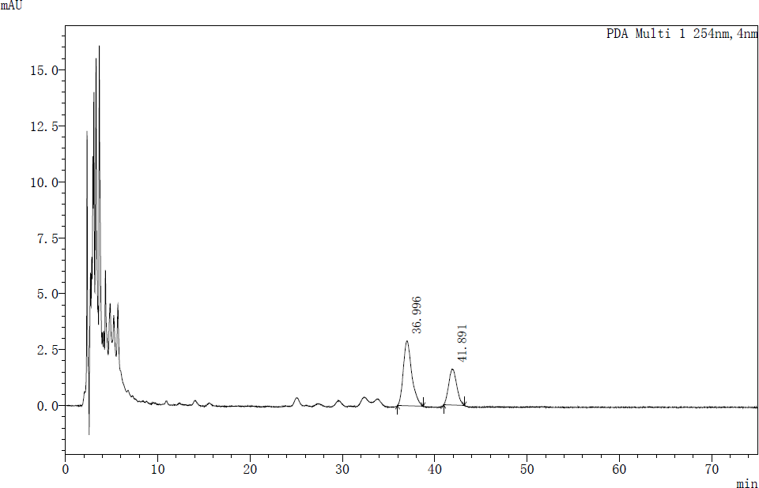

Fig. S1. The analysis of high-performance liquid chromatography (Shimadzu LabSolutions) showed that strain SCA4-21T mainly contained dominant menaquinones composed of MK9 (H8) (65.50%) and MK10 (H2) (34.50%).

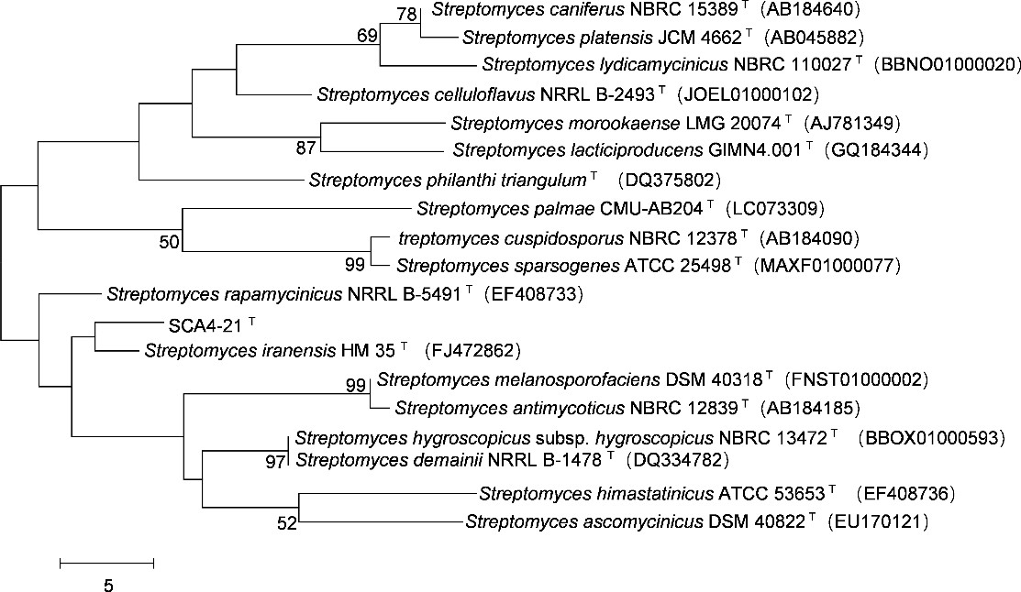
Fig. S2. Maximum-parsimony tree based on 16S rRNA gene showing position of strain SCA4-21T among its phylogenetic neighbors in the genus Streptomyces. Bootstrap percentages (based on 1000 replications) were shown at branching points. Bar, 5 base changes between nodes.

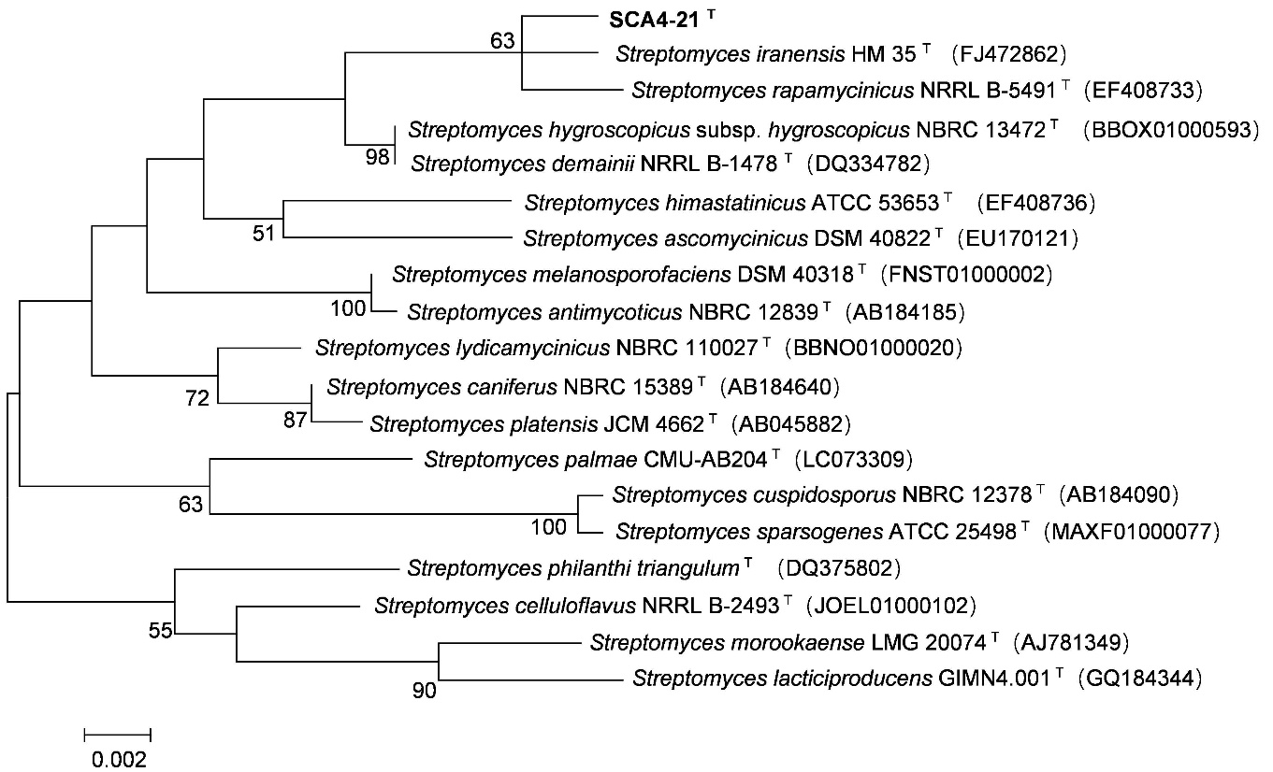

Fig. S3. Maximum-likelihood tree based on 16S rRNA gene showing position of strain SCA4- 21T among its phylogenetic neighbors in the genus Streptomyces. Bootstrap percentages (based on 1000 replications) were shown at branching points. Bar, 0.002 substitutions per nucleotide position.

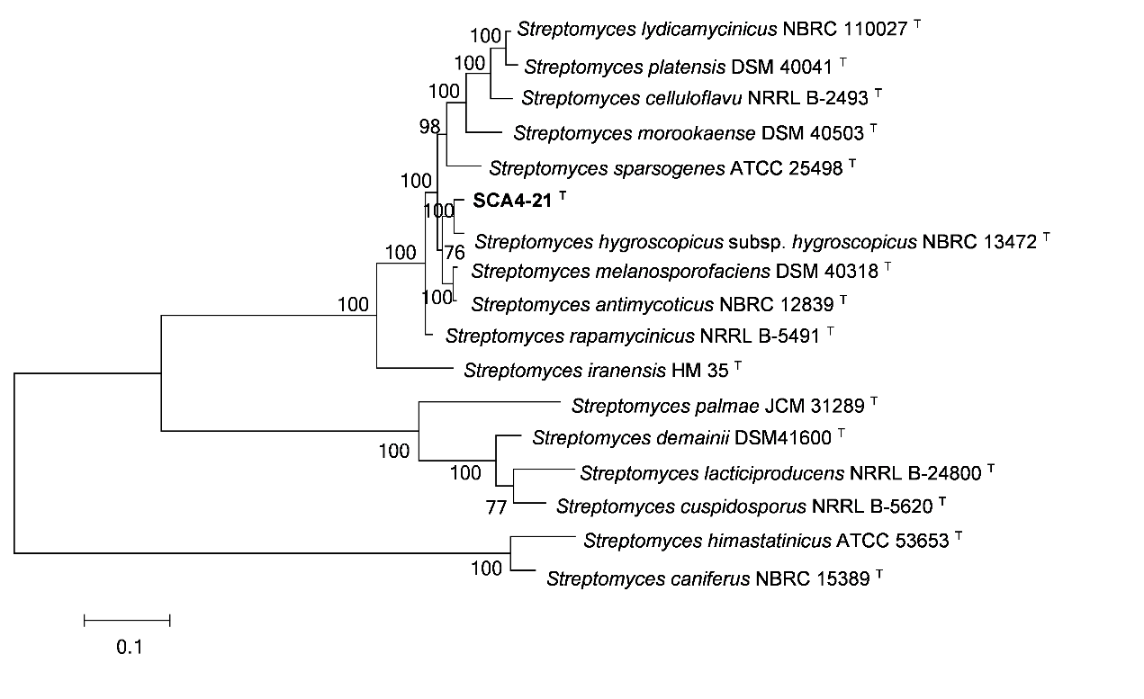
Fig. S4. Maximum-likelihood tree based on five housekeeping genes (atpD, gyrB, recA, rpoB, and trpB) showing position of strain SCA4-21T among its phylogenetic neighbors in the genus Streptomyces. Bootstrap percentages (based on 1000 replications) were shown at branching points. Bar, 0.1 substitutions per nucleotide position.

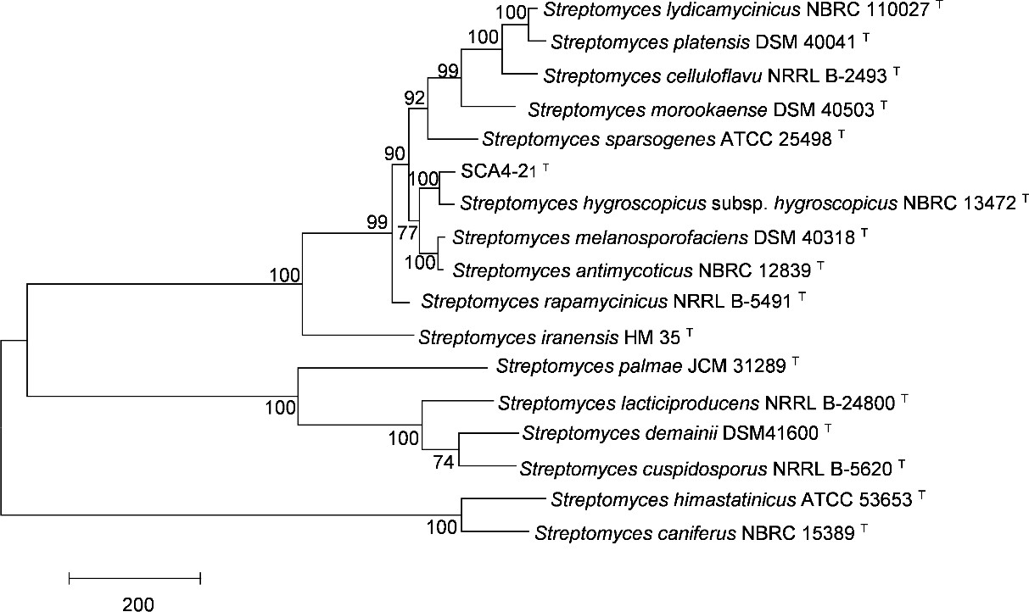

Fig. S5. Maximum-parsimony tree based on five housekeeping genes (atpD, gyrB, recA, rpoB, and trpB) showing position of strain SCA4-21T among its phylogenetic neighbors in the genus Streptomyces. Bootstrap percentages (based on 1000 replications) were shown at branching points. Bar, Bar, 200 base changes between nodes.

