Efficient photocatalytic core/shell of titanate nanowire/rGO

Xiaofang Ye,^{1,‡} Yang Tian,^{2,‡} Mengyao Gao,^{1,‡} Fangjun Cheng,¹ Jinshen Lan,¹ Han Chen,¹ Mark Lanoue,³ Shengli Huang,^{1,2,4*} Z. Ryan Tian^{2,3,4*}
¹ Engineering Research Center of Micro-nano Optoelectronic Materials and Devices, Ministry of Education, Fujian Key Laboratory of Semiconductor Materials and Applications, CI Center for OSED, Department of Physics, Xiamen University, Xiamen 361005, China
² Material Science and Engineering, University of Arkansas, Fayetteville, AR 72701, USA
³ Environmental Dynamics, University of Arkansas, Fayetteville, AR 72701, USA
⁴ Chemistry and Biochemistry, University of Arkansas, Fayetteville, AR 72701, USA

Contents
- Image of Photocatalytic workstation
- SEM images and EDS spectra of the specimens
- SAED pattern of the specimens
- FTIR spectra of the NWs
- Raman spectra of the specimens
- XPS of the specimens
- UV-Vis spectra of the NWs
- Hyperspectroscopy of the specimens
- Nitrogen adsorption–desorption isotherm of the specimens
- Adsorption spectra of the degraded MB solution under visible and UV light irradiation
- Photocatalytic mechanism

- Image of photocatalytic study setup.
Figure S1. Photocatalytic workstation.

- SEM images and EDS spectra of the specimens
Figure S2. SEM images and EDS spectra of (a₁,a₂) TiO₂ NWs, (b₁,b₂) TiO₂/GO NWs, and (c₁,c₂) TiO₂/rGO NWs.

- SAED pattern of the specimens
Figure S3. Structural and elemental characterization of the specimens SAED pattern.

- FTIR spectra of the specimens
Figure S4. FT-IR spectra of the specimens.

- Raman spectra of the specimens
Figure S5. Raman spectra of the specimens.

- XPS of the specimens
Figure S6. (a) XPS survey spectra; XPS spectra of (b) O 1s, and (c) Ti 2p.

- UV-Vis spectra of the NWs
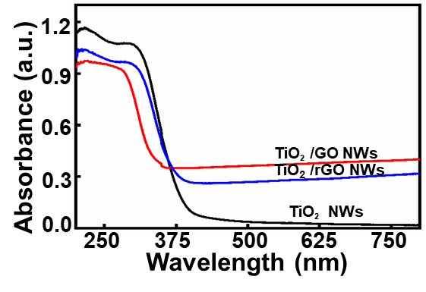
Figure S7. UV-Vis absorption spectra for GO-Titanate NFs, rGO-Titanate NFs, and Titanate NFs.

- Hyperspectroscopy of the specimens
Figure S8. Hyperspectroscopy for rGO flakes, rGO-Titanate NFs, and Titanate NFs.

- Nitrogen adsorption–desorption isotherm of the specimens
Figure S9. Nitrogen adsorption–desorption isotherm of the specimens

- Adsorption spectra of the degraded MB solution under visible and UV light irradiation
Figure S10. Absorption spectra of degraded MB aqueous solutions as catalyzed by the specimens under visible (a-c) and UV (d-f) light irradiation in different periods: (a)(c) TiO₂ NWs, (b)(d) TiO₂/GO NWs, and (c)(f) TiO₂/rGO NWs.

- Photocatalytic mechanism
Figure S11. Photocatalytic mechanism.

References
- D. Ma, X. Li, Y. Guo, Y. Zeng, Acta Photonica Sinica 2017, 46, 1216002.
- E. Kusiak-Nejman, A. W. Morawski, Applied Catalysis B: Environmental 2019, 253, 179.
- H. Ding, S. Zhang, J. Chen, X. Hu, Z. Du, Y. Qiu, D. Zhao, Thin Solid Films 2015, 584, 29.
- A. Shaikh, S. P. Mishra, P. Mohapatra, S. Parida, Journal of Nanoparticle Research 2017, 19, 206.
- T.-F. Yeh, J.-M. Syu, C. Cheng, T.-H. Chang, H. Teng, Advanced Functional Materials 2010, 20, 2255.

