Review

Comprehensive Review of Canine Entropion: Types, Surgical Techniques, and Prognosis

Alejandra Estrada Araya 1, Johan Macuer-Guzmán 1,*, Cecilia Echeverria-Jaque1, Florina Freidl 1, Camila Cifuentes-Castro1 and Claudia Giovagnoli-Vicuña 2.

|  |
| --- |
| **Citation:** To be added by editorial staff during production.  Academic Editor: Firstname Lastname  Received: date  Revised: date  Accepted: date  Published: date    **Copyright:** © 2023 by the authors. Submitted for possible open access publication under the terms and conditions of the Creative Commons Attribution (CC BY) license (https://creativecommons.org/licenses/by/4.0/). |

1 Facultad de Ciencias Agropecuarias, Universidad del Alba, Av. Ejército Libertador 171, Santiago 8370007, Chile; alejandra.estrada.mozz@gmail.com, cecilia.echeverria@udalba.cl, flo.m.freidl@gmail.com, camila.cifuentes@udalba.cl

2 Departamento de Química Inorgánica, Facultad de Química y de Farmacia, Pontificia Universidad Católica de Chile, Avenida Vicuña Mackenna 4860, Macul, Santiago 7810000, Chile; ccgiovagnoli@uc.cl

**\*** Correspondence: johan.macuer@udalba.cl; Tel.: ´+56 9 45972385

**Simple Summary:** Entropion is a disorder in which the eyelid border flips inward, rubbing the eyelashes or facial hair on the surface of the eye. This may occur in a variety of species, but it is more frequent in dogs. It most commonly affects the lower eyelid; however, it can occur elsewhere on the eyelid. Irritation, discomfort, ulceration, and eye difficulties can result from rubbing. Entropion can be either congenital (present at birth) or acquired later in life (developmental). It is diagnosed by examining the symptoms, the animal's history, and its breed. It is critical to assess the severity of entropion without anesthesia. This research examines several surgical procedures for correcting entropion in dogs.

**Abstract:** Entropion is a condition characterized by the total or partial inversion of the eyelid margin, resulting in contact between the outer skin and the corneal or conjunctival surface, and sometimes both. This condition can affect various animals, including horses, pigs, goats, sheep, rabbits, felines, and particularly canines. It typically manifests in the lower lid's lateral portion but can affect any part of the lid. This contact between eyelashes or facial hair and the cornea or conjunctiva leads to severe irritation, causing self-inflicted trauma, as evidenced by clinical signs of pain, irritation, ulcerations, and vision loss. Entropion can be classified as primary (congenital or developmental) or secondary (spastic and scarring). Diagnosis relies on clinical signs, the animal's history, and its breed. It's essential to assess the degree of entropion in the dog without applying topical anesthesia. This study conducts a literature review on surgical techniques for correcting various types of entropion in canines.

**Keywords:** canine, surgical, Hotz-Celsus technique, eyelids



Figure S1. Entropion correction by means of retraction sutures (Tacking): A) Affected eye with inferior entropion, B) Use of 2 to 4 simple interrupted sutures, and C) The knots of the sutures are left away from the eye.



Figure S2. Hotz-Celsus technique for entropion correction. A) The eye is protected with a Jaeger spatula and the cut is made along the length of the entropion starting 3 mm from the margin and skin is removed in a crescent shape. B) Begin closing with simple stitches through the center of the wound. C) and D) Add stitches separated from each other, until the entire wound is covered.

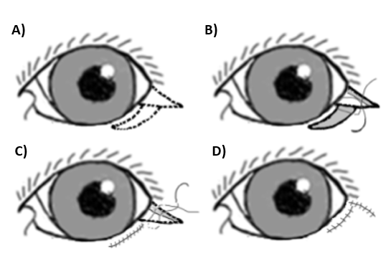

Figure S3. Modified Hotz-Celsus Technique with Wedge Resection for entropion correction. A) The eye is protected with a Jaeger spatula and an incision is made along the length of the entropion, starting 3 mm from the margin. Then, the skin is removed in a crescent shape with a wedge. B) Closure is initiated with simple interrupted sutures through the center of the wound. C) and D) Additional sutures are added spaced apart from each other until the entire wound is closed.



**Figure S4.** Stades procedure: **A)** 15 to 25mm of skin is removed from the eyelid in an arc, **B)** The edge of the wound is dissected and cut **C)** Stitches are made with absorbable material, until the entire wound is covered.