The antitumoral effect in ovo of a new inclusion complex from dimethoxycurcumin with magnesium and beta-cyclodextrin
William Meza-Morales ^{1,†}, Karla Daniela Rodríguez-Hernández ^{1,†}, M. Mirian Estevez-Carmona ², Leidys L. Pérez-González ¹ Rosario Tavera-Hernández ¹, María Teresa Ramírez-Apan ¹, David Barrera-Hernández ³, Mitzi García-Olivares ³, Brian Monrroy-Torres ¹, Antonio Nieto-Camacho ¹, María Isabel Chávez ¹, Rubén Sanchez-Obregón ¹, Marco A. Obregón-Mendoza ^{1,}* and Raúl G. Enríquez ^{1,}*
- Instituto de Química, Universidad Nacional Autónoma de México, Ciudad de México 04510, México; william9023.wm@gmail.com (W.M.-M.); xandy411@comunidad.unam.mx (K.D.R.-H.); leidyslaura92@gmail.com (L.L.P.-G.); rosario.tavera@gmail.com (R.T.-H.); mtrapan@yahoo.com.mx (M.T.R.-A.); brianuami@gmail.com (B.M.-T.); camanico2015@yahoo.com (A.N.-C.); isabel@unam.mx (M.I.C.); rubens@unam.mx (R.S.-O.)
- Departamento de Farmacia, Escuela Nacional de Ciencias Biológicas, Instituto Politécnico Nacional, M. Wilfrido Massieu SN, U. A. Zacatenco, Ciudad de México 07738, Mexico; mirianestevezc@gmail.com (M.M.E.-C.)
- Departamento de Biología de la Reproducción “Dr. Carlos Gual Castro”, Instituto Nacional de Ciencias Médicas y Nutrición Salvador Zubirán, México, Ciudad de México, 14080, México; barrera1912@gmail.com (D.B.-H); mariol48@ciencias.unam.mx (M.G.-O)

* Correspondence: marco.obregon@zaragoza.unam.mx (M.A.O.-M.); habib@unam.mx, enriquezhabib@gmail.com (R.G.E.); Tel.: +52-55562-24404
† These authors contributed equally to this work.

Index

Fig S1. ¹H NMR spectrum of Dimethoxycurcumin-BF₂ ( DiMeOC-BF₂, 400 MHz, DMSO-d₆). | 3
Fig S2. ¹³C NMR spectrum of Dimethoxycurcumin-BF₂ ( DiMeOC-BF₂, 100 MHz, DMSO-d₆). | 4
Fig S3. IR Spectrum of DiMeOC-BF₂. | 5
Fig S4. Mass Spectrum of DiMeOC-BF₂ (IE⁺). | 6
Fig S5. 1H NMR spectrum of DiMeOC (400 MHz, DMSO- d₆). | 7
Fig S6. 13C NMR spectrum of DiMeOC (100 MHz, DMSO- d₆). | 8
Fig S7. UV-VIS spectrum in methanol of DiMeOC. | 9
Fig S8. HPLC spectrum of DiMeOC (417nm, CH₃CN/H₂O (0.02% formic acid) 55:45). | 10
Fig S9. Mass Spectrum of DiMeOC (DART⁺). | 11
Fig S10. ¹H NMR spectrum of DiMeOC-Mg (400 MHz, DMSO- d₆). | 12
Fig S11. ¹³C NMR spectrum of DiMeOC-Mg (100 MHz, DMSO-d₆). | 13
Fig S12. HSQC NMR spectrum of DiMeOC-Mg (400 MHz, DMSO-d₆). | 14
Fig S13. HMBC NMR spectrum of DiMeOC-Mg (400 MHz, DMSO-d₆). | 15
Fig S14. IR Spectrum of DiMeOC-Mg. | 16
Fig S15. UV-VIS spectrum in methanol of DiMeOC-Mg . | 17
Fig S16. HPLC spectrum of DiMeOC-Mg (417 nm, CH₃CN/H₂O (0.02% formic acid) 55:45). | 18
Fig S17. Mass Spectrum of DiMeOC-Mg (MALDI-TOF). | 19
Fig S18. ¹H NMR spectrum of DiMeOC-Mg-BCD (400 MHZ, DMSO- d₆). | 20
Fig S19. ¹³C NMR spectrum of DiMeOC-Mg-BCD (100 MHz, DMSO-d₆). | 21
Fig S20. HSQC NMR spectrum of DiMeOC-Mg-BCD (400 MHz, DMSO-d₆). | 22
Fig S21. HMBC NMR spectrum of DiMeOC-Mg-BCD (400 MHz, DMSO-d₆). | 23
Fig S22. IR Spectrum of DiMeOC-Mg-BCD. | 24
Fig S23. UV-VIS spectrum in methanol of DiMeOC-Mg-BCD . | 25
Fig S24. HPLC spectrum of DiMeOC-Mg-BCD (417nm, CH₃CN/H₂O (0.02% formic acid) 55:45). | 26
Fig S25. Mass Spectrum of DiMeOC-Mg-BCD (ESI). | 27
Fig S26. Standard curve of DiMeOC-Mg (415nm, 1-Octanol). | 28
Fig S27. Inclusion ratio DiMeOC-Mg and BCD (PBS media). | 29
Fig S28. 1H NMR spectrum of Beta-cyclodextrin (BCD, 400 MHz, DMSO- d₆). | 30
Fig S29. ¹³C NMR spectrum of BCD (100 MHz, DMSO-d₆). | 31
Fig S30. HSQC NMR spectrum of BCD (500 MHz, DMSO-d₆). | 32
Fig S31. HMBC NMR spectrum of BCD (500 MHz, DMSO-d₆). | 33
Fig S32. IR Spectrum of BCD. | 34

Fig S1. ¹H NMR spectrum of Dimethoxycurcumin-BF₂ ( DiMeOC-BF₂, 400 MHz, DMSO-d₆).

Fig S2. ¹³C NMR spectrum of Dimethoxycurcumin-BF₂ ( DiMeOC-BF₂, 100 MHz, DMSO-d₆).

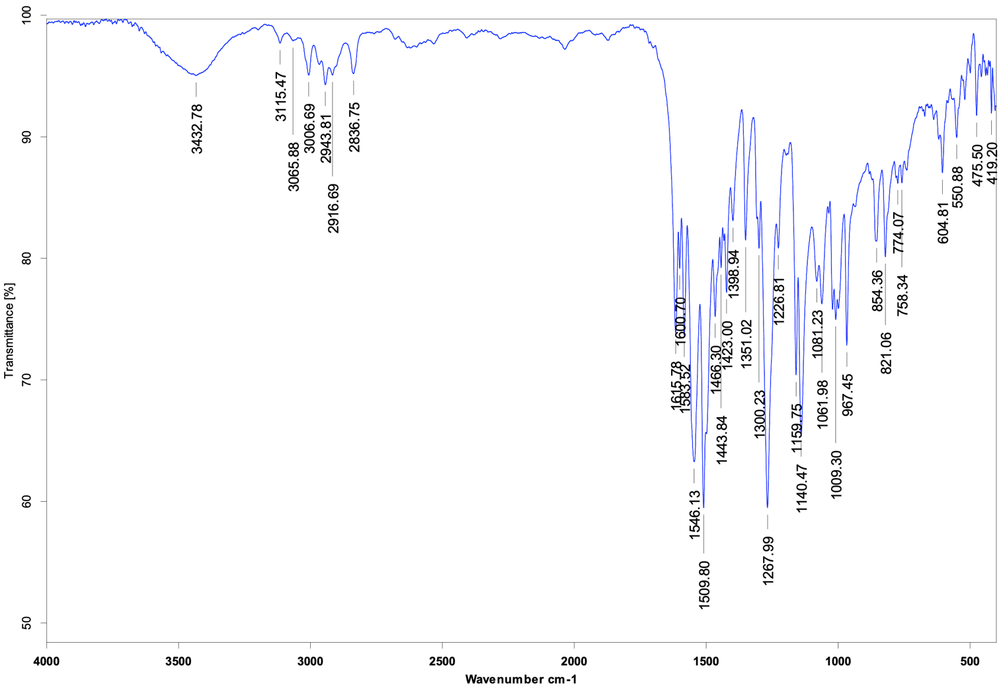

Fig S3. IR Spectrum of DiMeOC-BF₂.

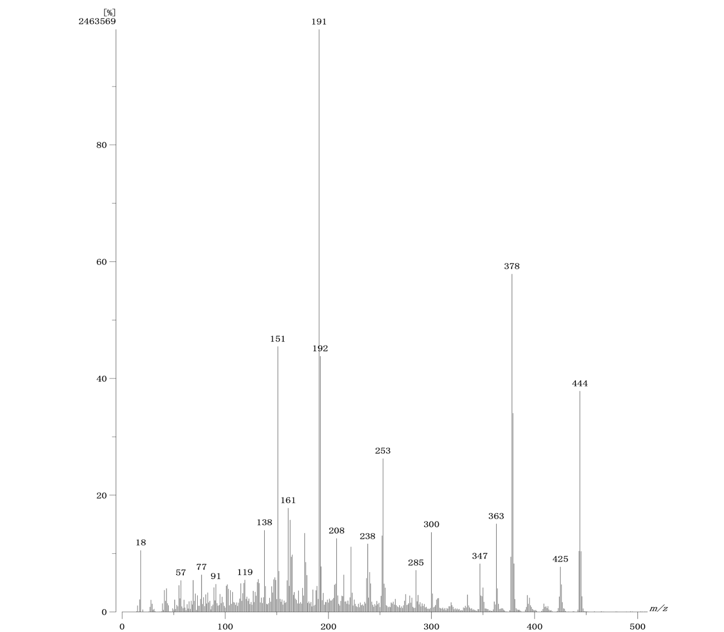

Fig S4. Mass Spectrum of DiMeOC-BF₂ (IE⁺).

Fig S5. 1H NMR spectrum of DiMeOC (400 MHz, DMSO- d₆).

Fig S6. 13C NMR spectrum of DiMeOC (100 MHz, DMSO- d₆).

Fig S7. UV-VIS spectrum in methanol of DiMeOC.

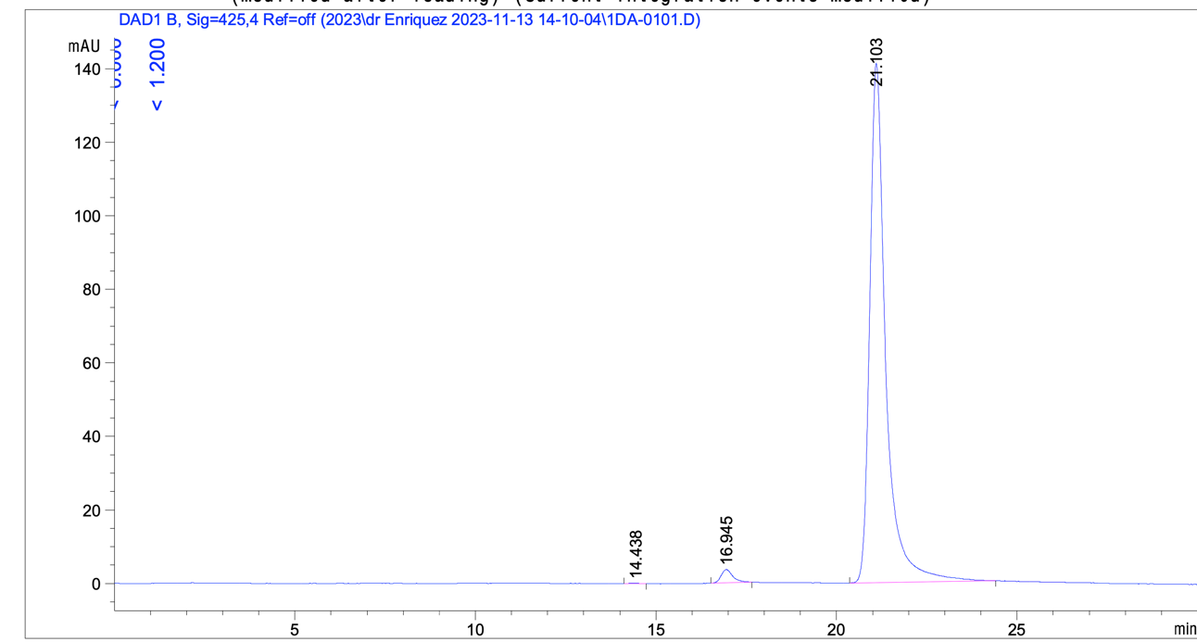

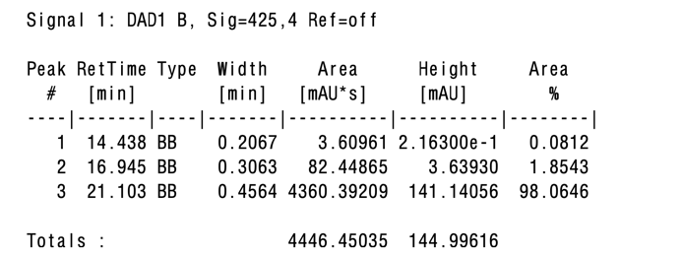

Fig S8. HPLC spectrum of DiMeOC (417nm, CH₃CN/H₂O (0.02% formic acid) 55:45)

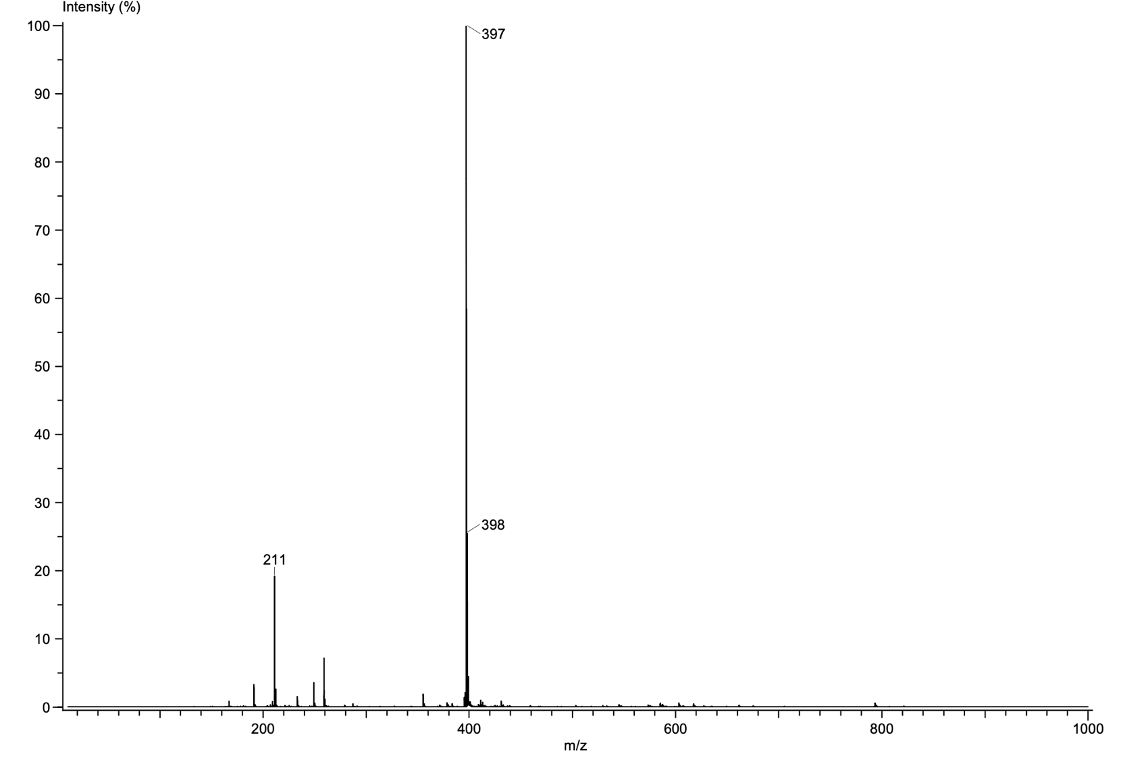

Fig S9. Mass Spectrum of DiMeOC (DART⁺).

Fig S10. ¹H NMR spectrum of DiMeOC-Mg (400 MHz, DMSO- d₆)

Fig S11. ¹³C NMR spectrum of DiMeOC-Mg (100 MHz, DMSO-d₆).

Fig S12. HSQC NMR spectrum of DiMeOC-Mg (400 MHz, DMSO-d₆).

Fig S13. HMBC NMR spectrum of DiMeOC-Mg (400 MHz, DMSO-d₆).

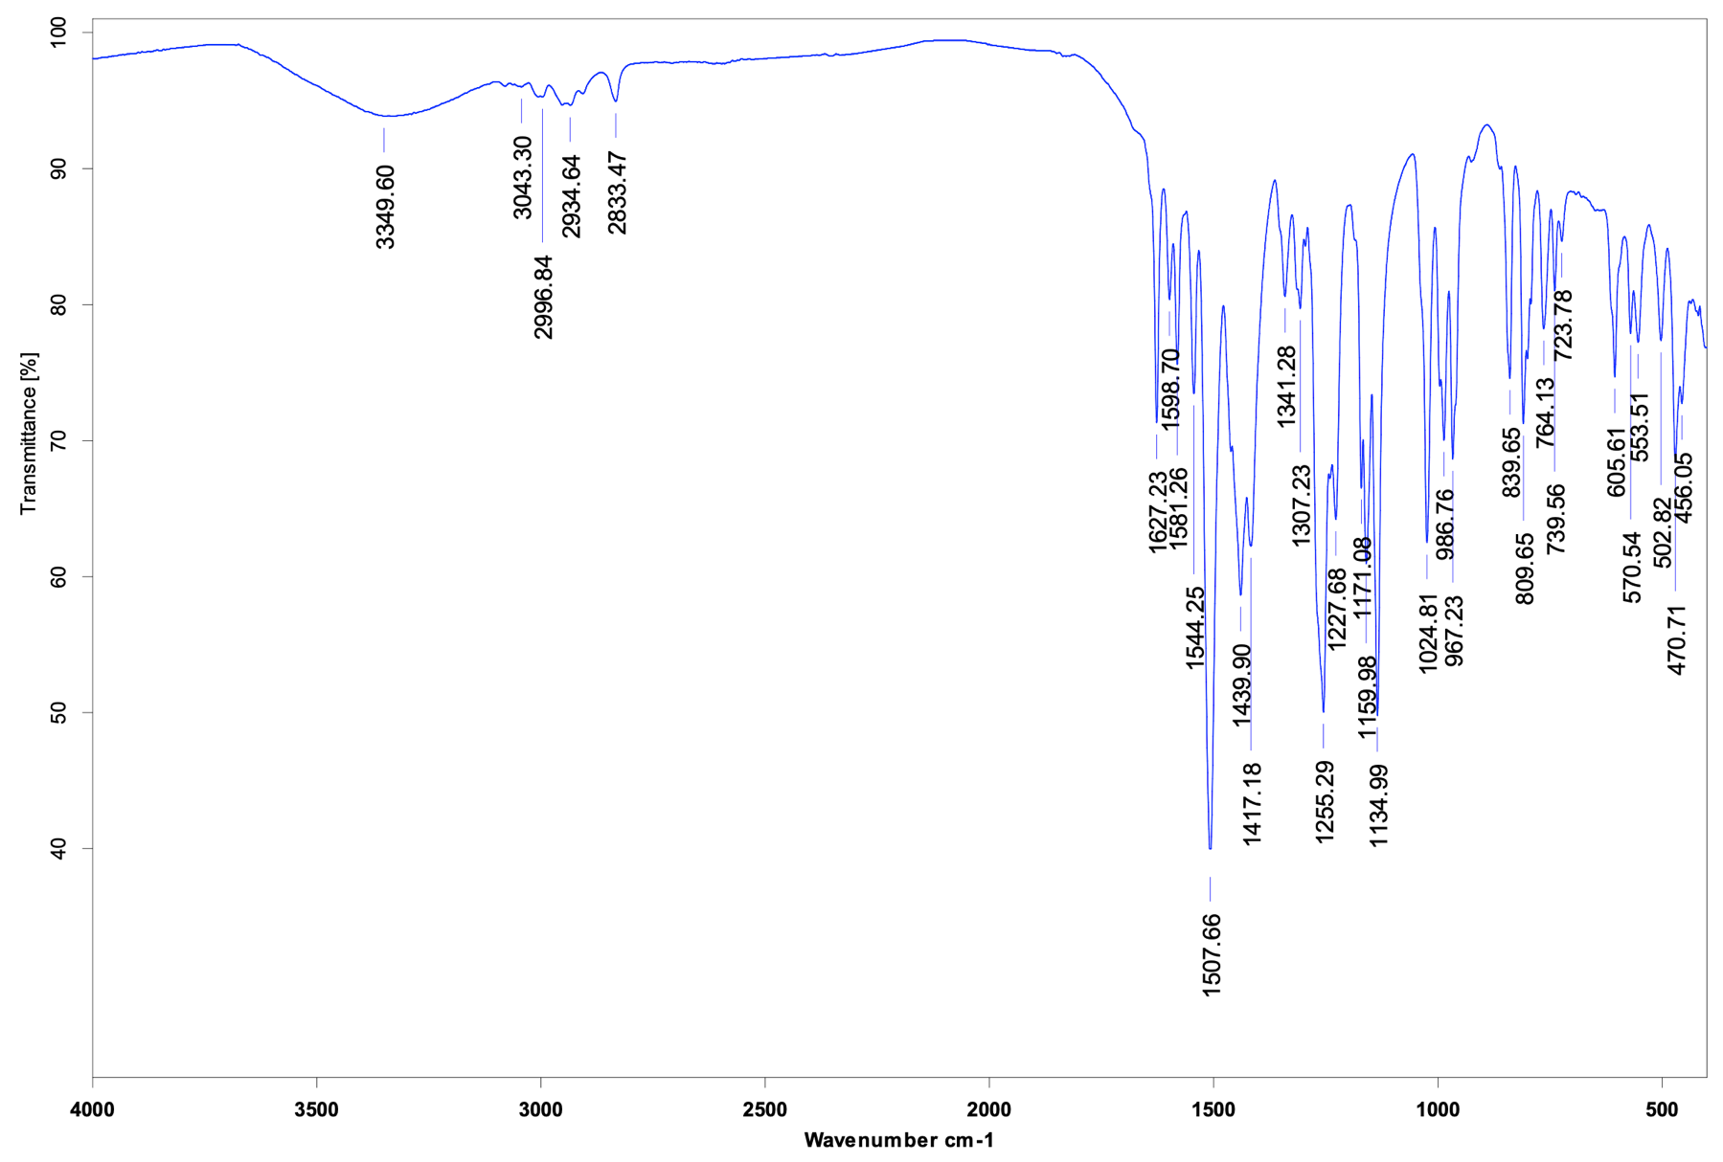

Fig S14. IR Spectrum of DiMeOC-Mg.

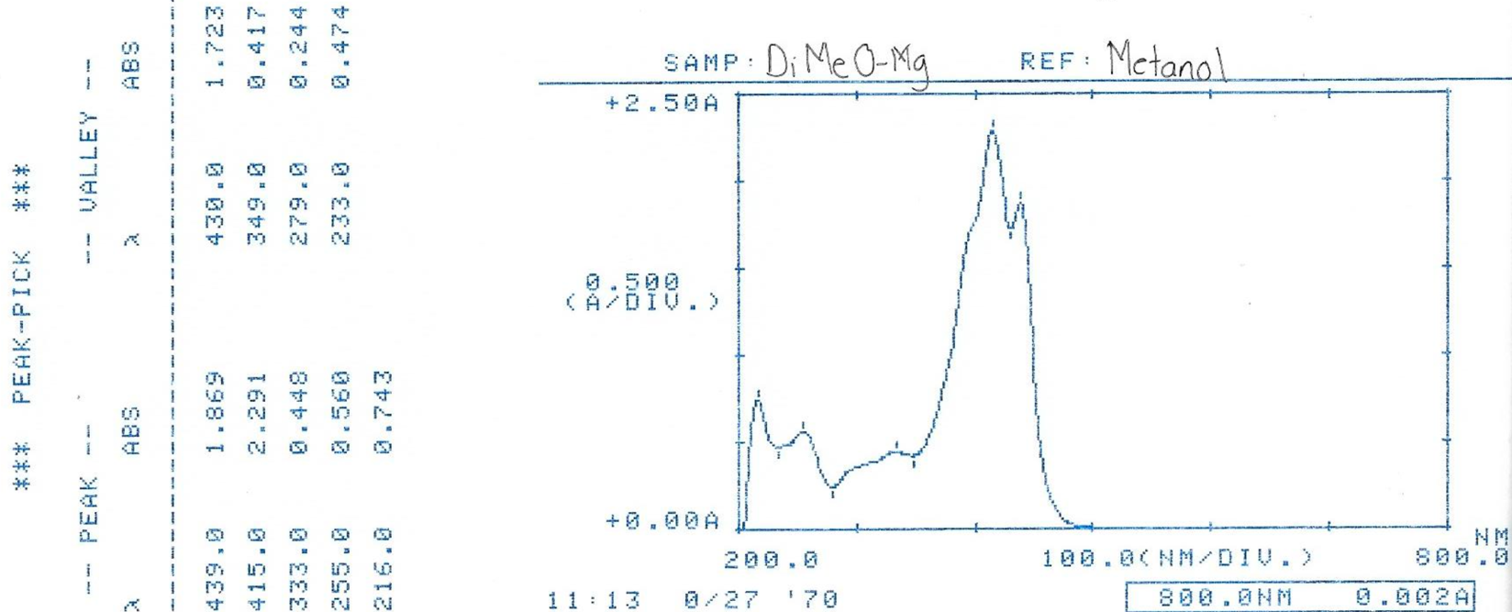

Fig S15. UV-VIS spectrum in methanol of DiMeOC-Mg .

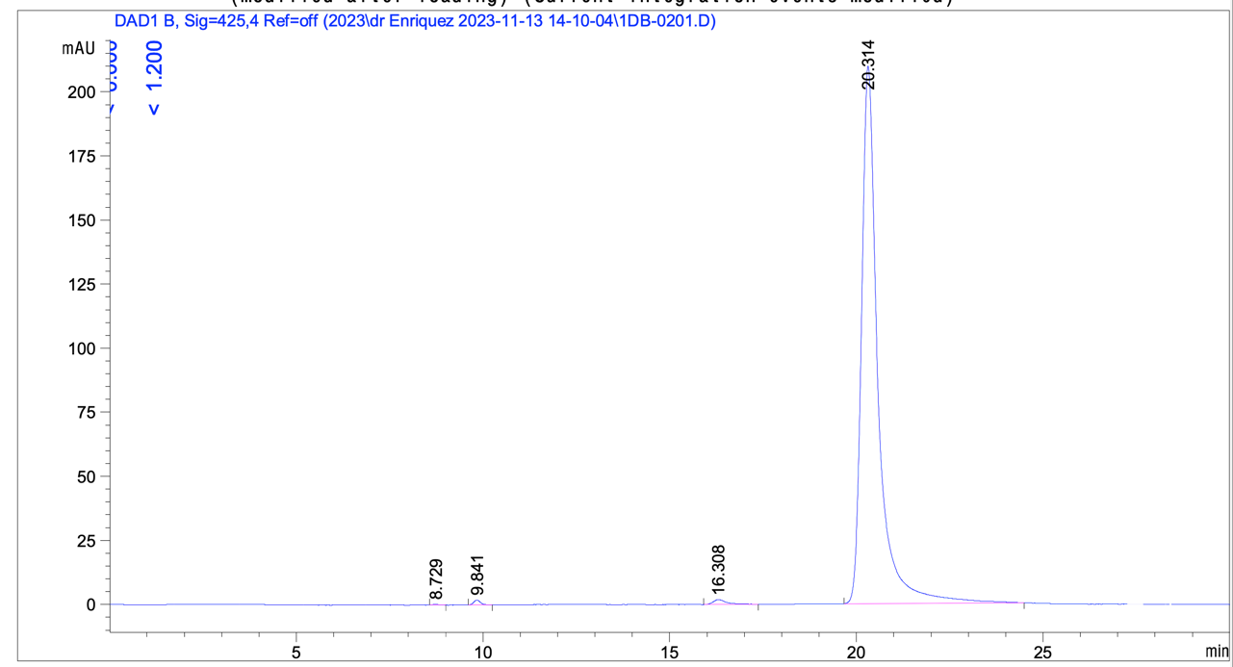

Fig S16. HPLC spectrum of DiMeOC-Mg (417 nm, CH₃CN/H₂O (0.02% formic acid) 55:45).

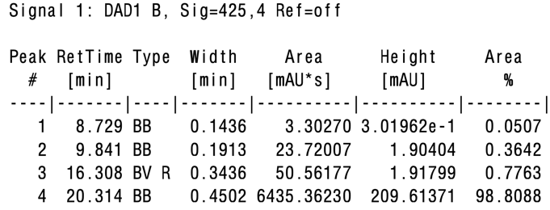

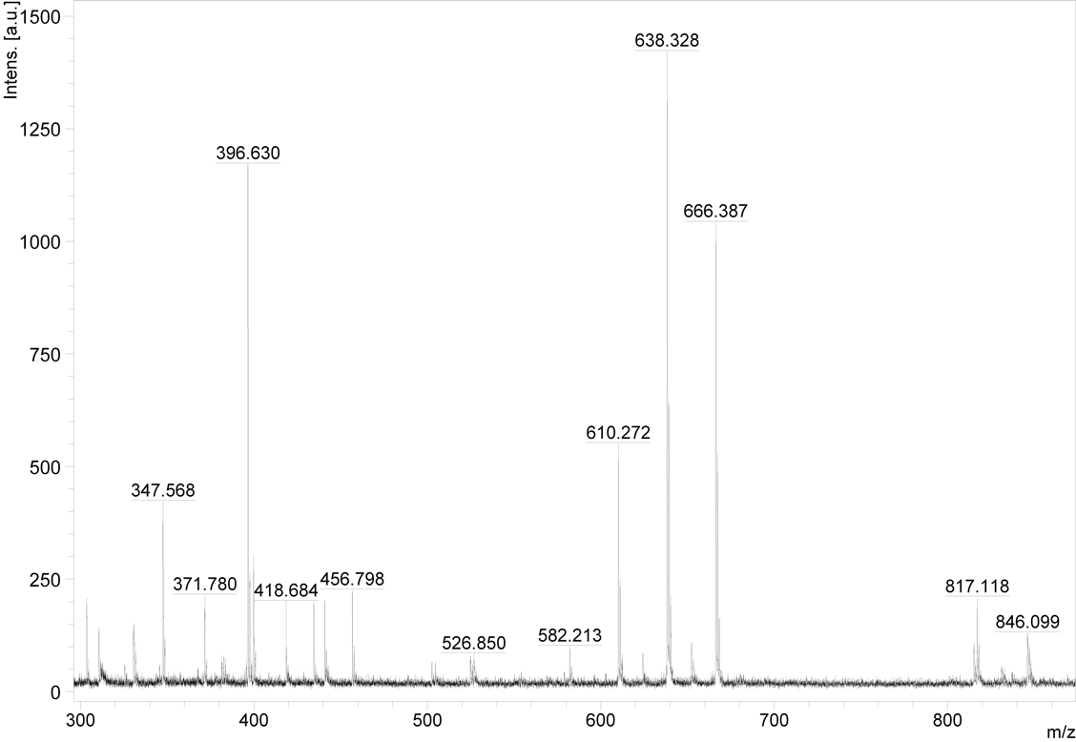

Fig S17. Mass Spectrum of DiMeOC-Mg (MALDI-TOF).

Fig S18. ¹H NMR spectrum of DiMeOC-Mg-BCD (400 MHZ, DMSO- d₆).

Fig S19. ¹³C NMR spectrum of DiMeOC-Mg-BCD (100 MHz, DMSO-d₆).

Fig S20. HSQC NMR spectrum of DiMeOC-Mg-BCD (400 MHz, DMSO-d₆).

Fig S21. HMBC NMR spectrum of DiMeOC-Mg-BCD (400 MHz, DMSO-d₆).

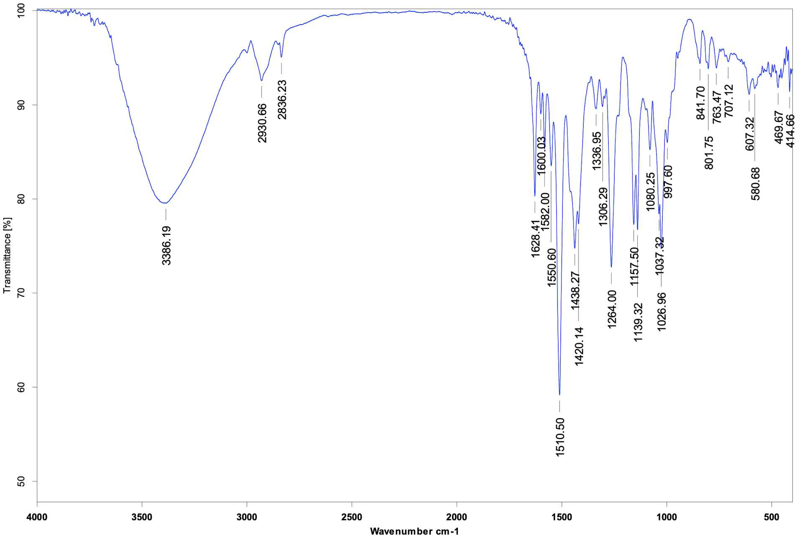

Fig S22. IR Spectrum of DiMeOC-Mg-BCD.

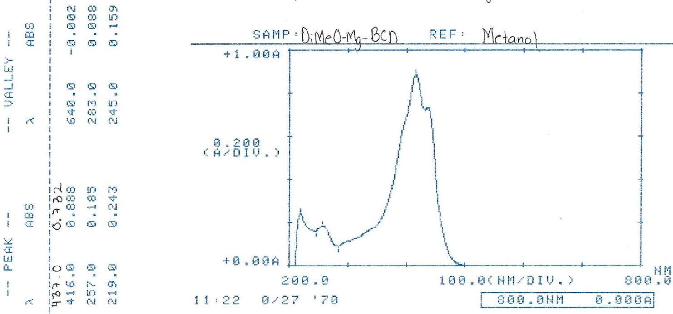

Fig S23. UV-VIS spectrum in methanol of DiMeOC-Mg-BCD .

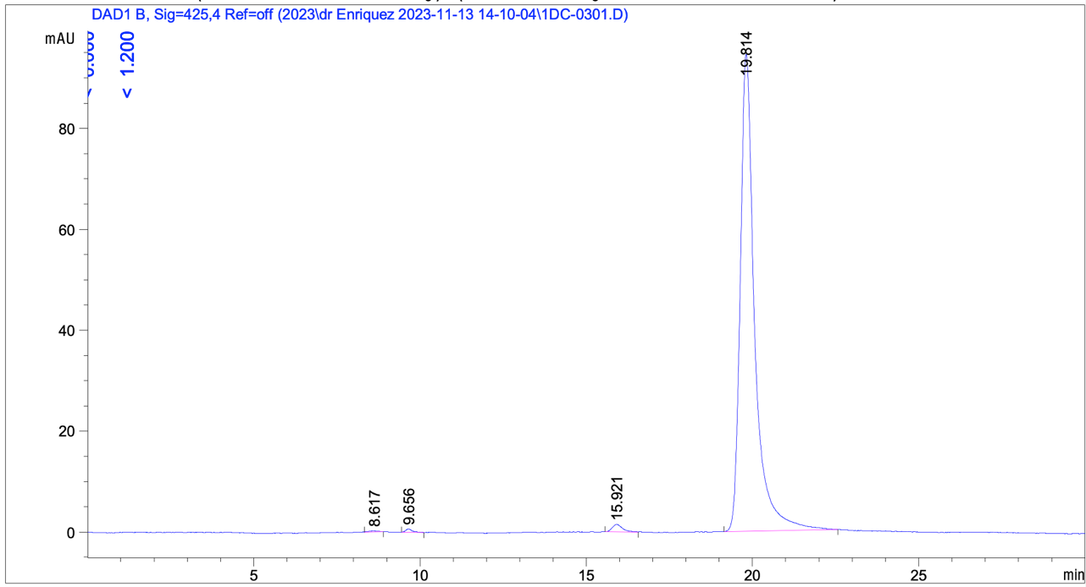

Fig S24. HPLC spectrum of DiMeOC-Mg-BCD (417nm, CH₃CN/H₂O (0.02% formic acid) 55:45).
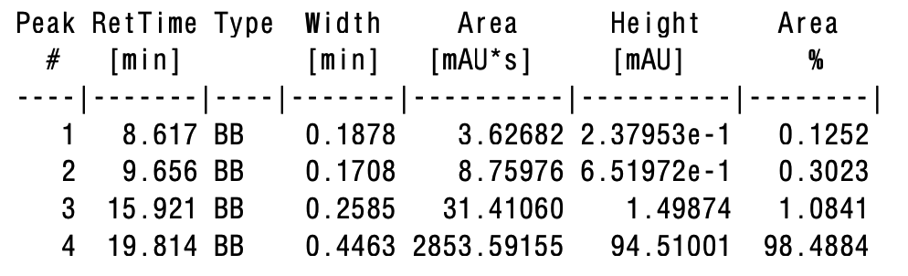

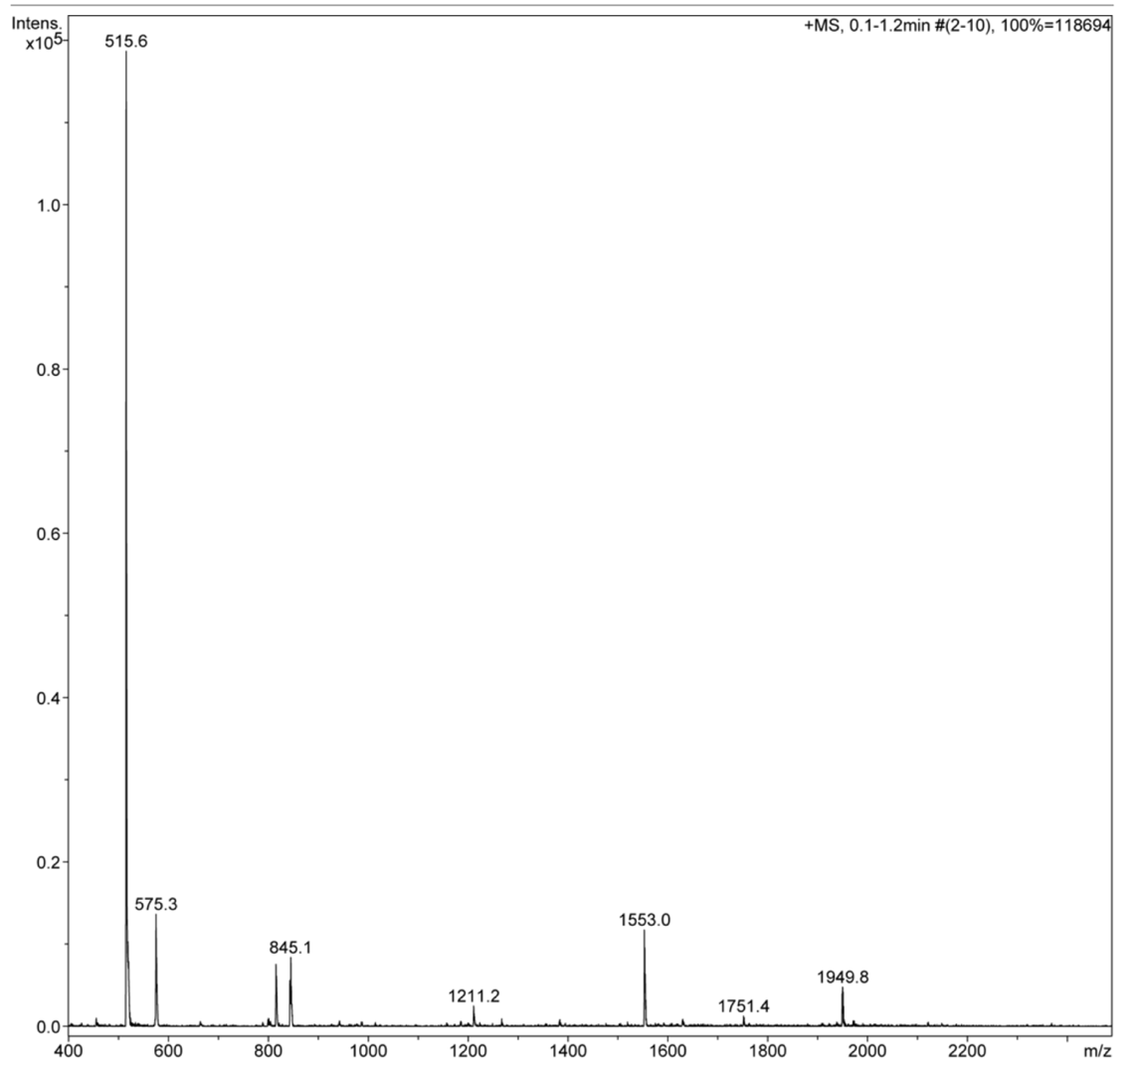

Fig S25. Mass Spectrum of DiMeOC-Mg-BCD (ESI).

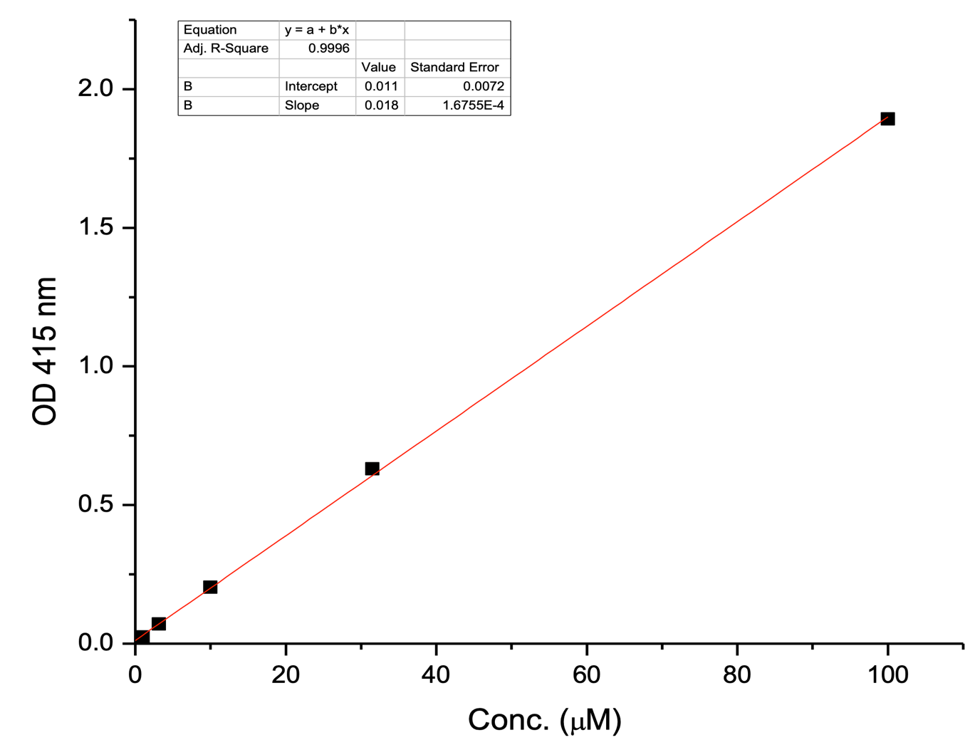

Fig S26. Standard curve of DiMeOC-Mg (415nm, 1-Octanol).

Fig S27. Inclusion ratio DiMeOC-Mg and BCD (PBS media).

The inclusion ratio test results between DiMeOC-Mg and BCD are shown in Fig. s27. The mole fraction represents r of BCD in the mixture. when r = 0.5, the molar concentration value of DiMeOC-Mg was the largest, concluding that the inclusion complex was formed to the molar ratio of 1:1.

Fig S28. ¹H NMR spectrum of Beta-cyclodextrin (BCD, 400 MHz, DMSO- d₆).

Fig S29. ¹³C NMR spectrum of BCD (100 MHz, DMSO-d₆).

Fig S30. HSQC NMR spectrum of BCD (500 MHz, DMSO-d₆).

Fig S31. HMBC NMR spectrum of BCD (500 MHz, DMSO-d₆).

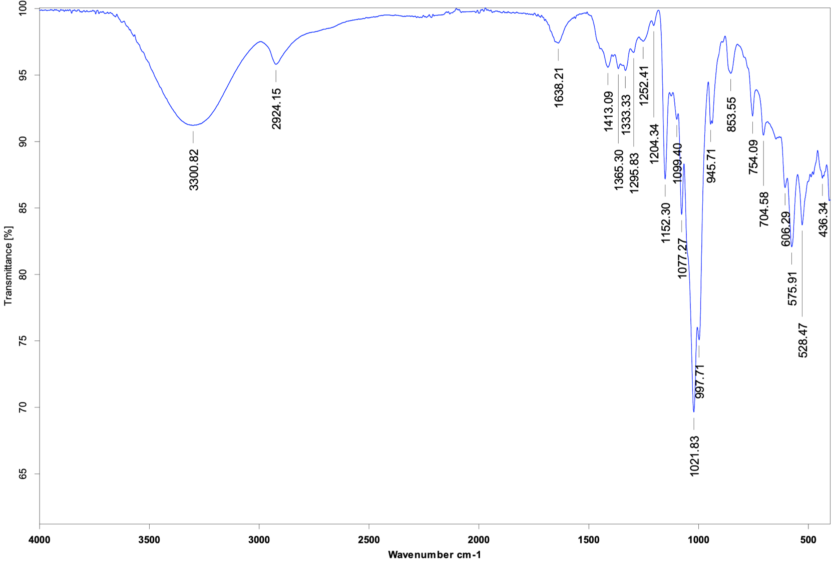

Fig S32. IR Spectrum of BCD.

