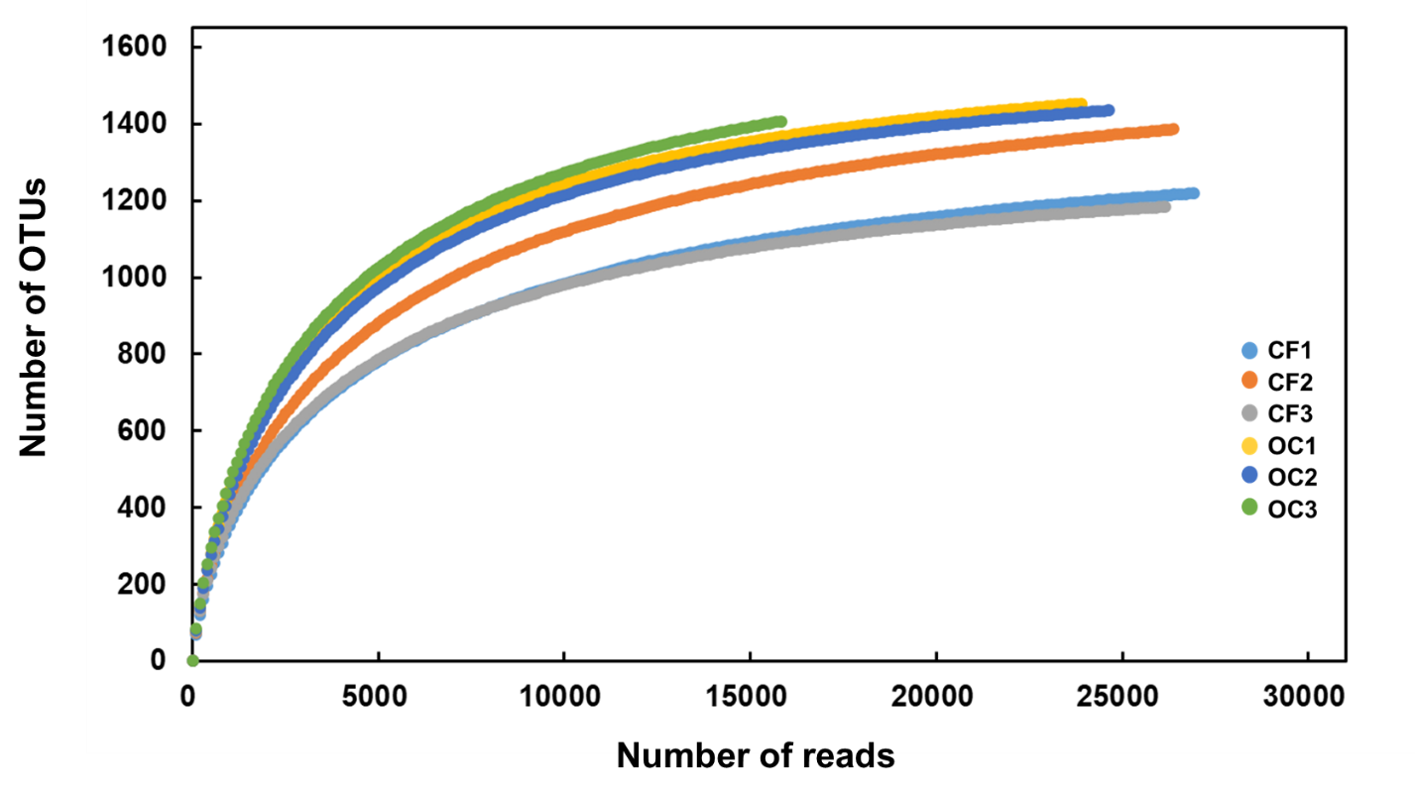

Fig. S1. Rarefaction curve of bacterial 16SrRNA sequences obtained from the studied soil groups.

