Thermal Decomposition of Bio-Based Plastic Materials

Inés Oliver¹, Juan A. Conesa^{1,2,*}, Andrés Fullana^{1,2}
¹ Institute of Chemical Process Engineering, University of Alicante, Ap.99, 03080, Alicante, Spain.
² Department of Chemical Engineering, University of Alicante, Ap. 99, 03080, Alicante, Spain.
* Corresponding author: ja.conesa@ua.es

SUPPLEMENTARY MATERIAL

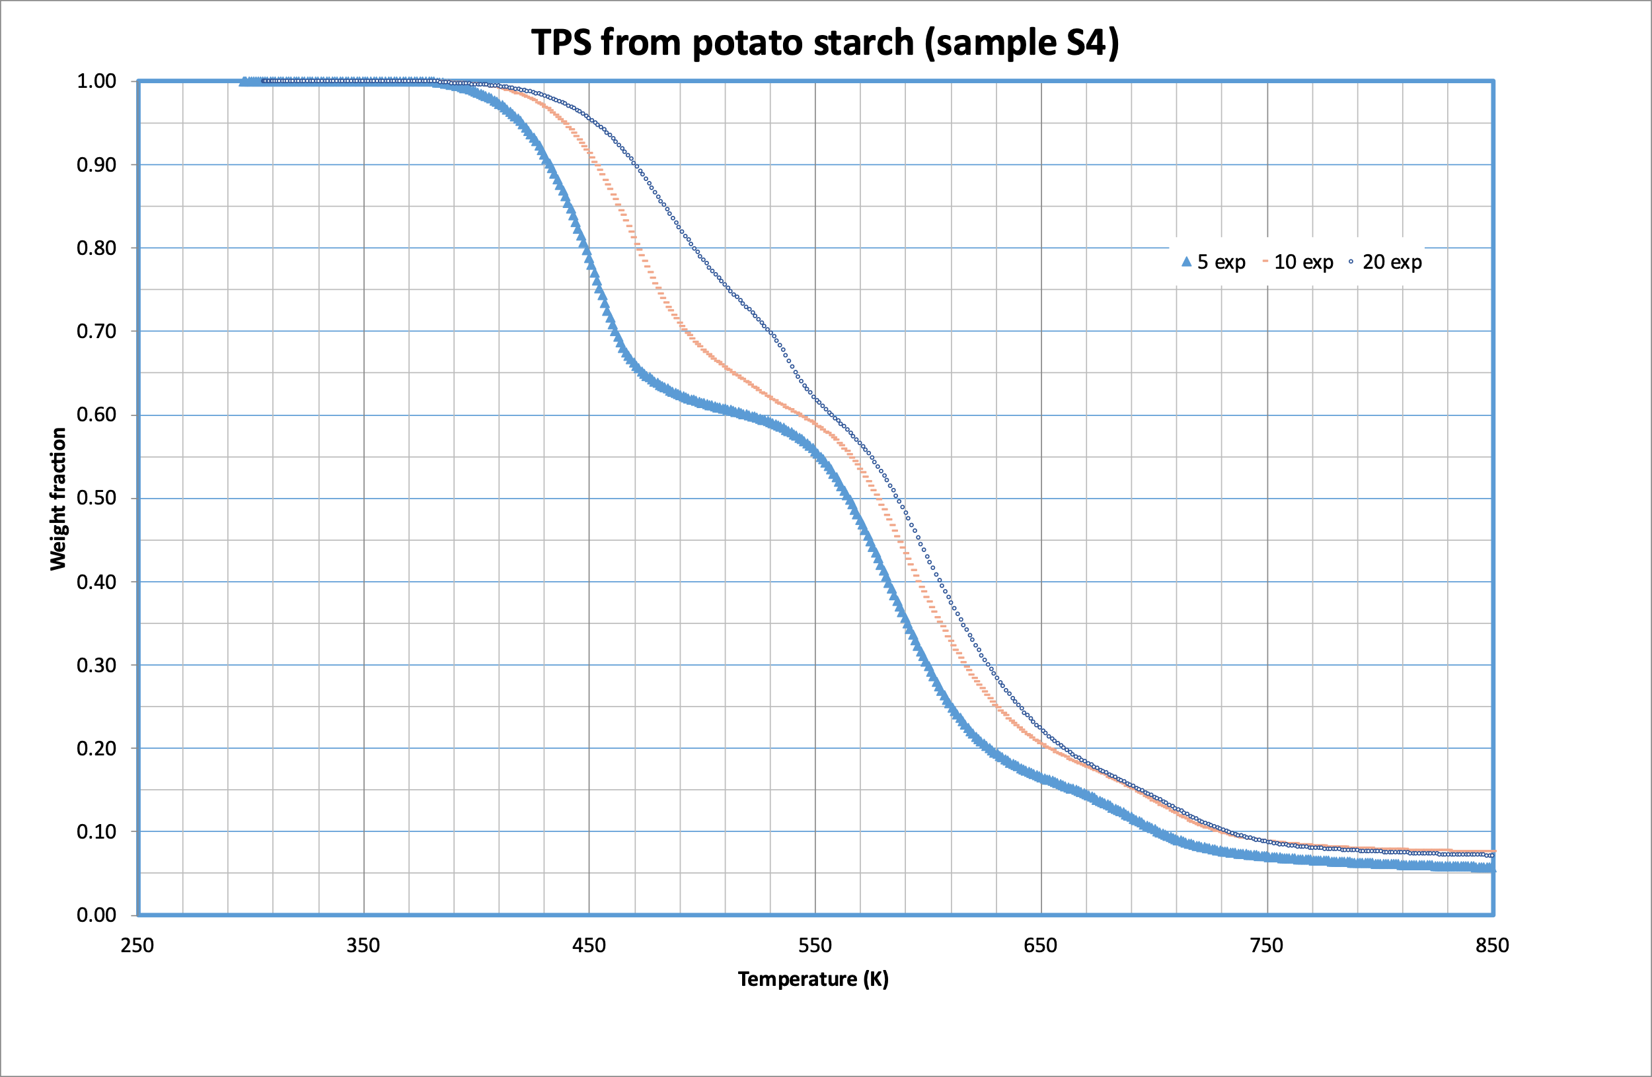
Figure SM1. Pyrolysis of TPS from potato starch at three heating rates.
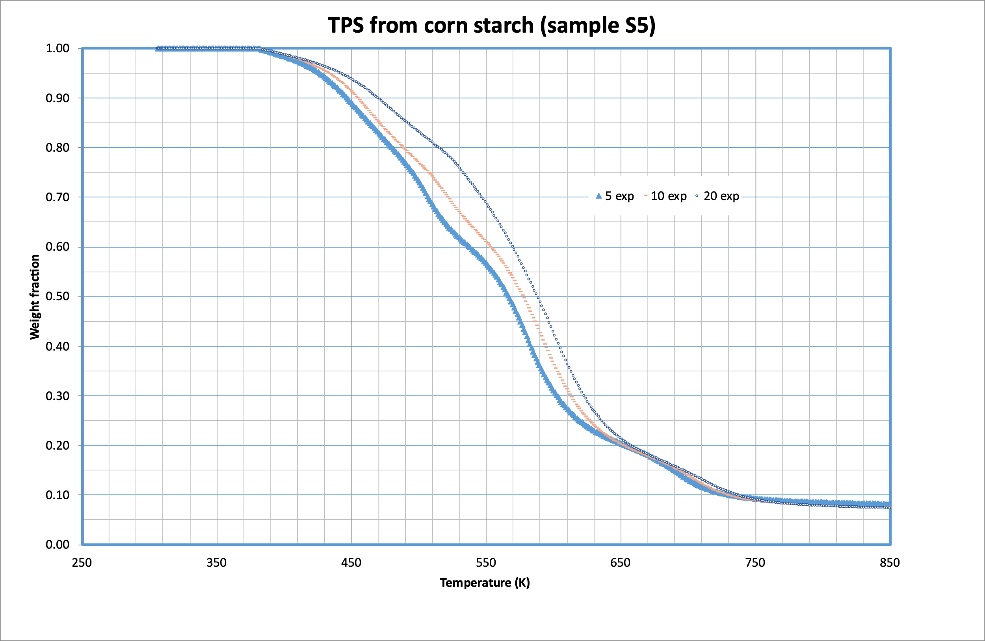
Figure SM2. Pyrolysis of TPS from corn starch at three heating rates.

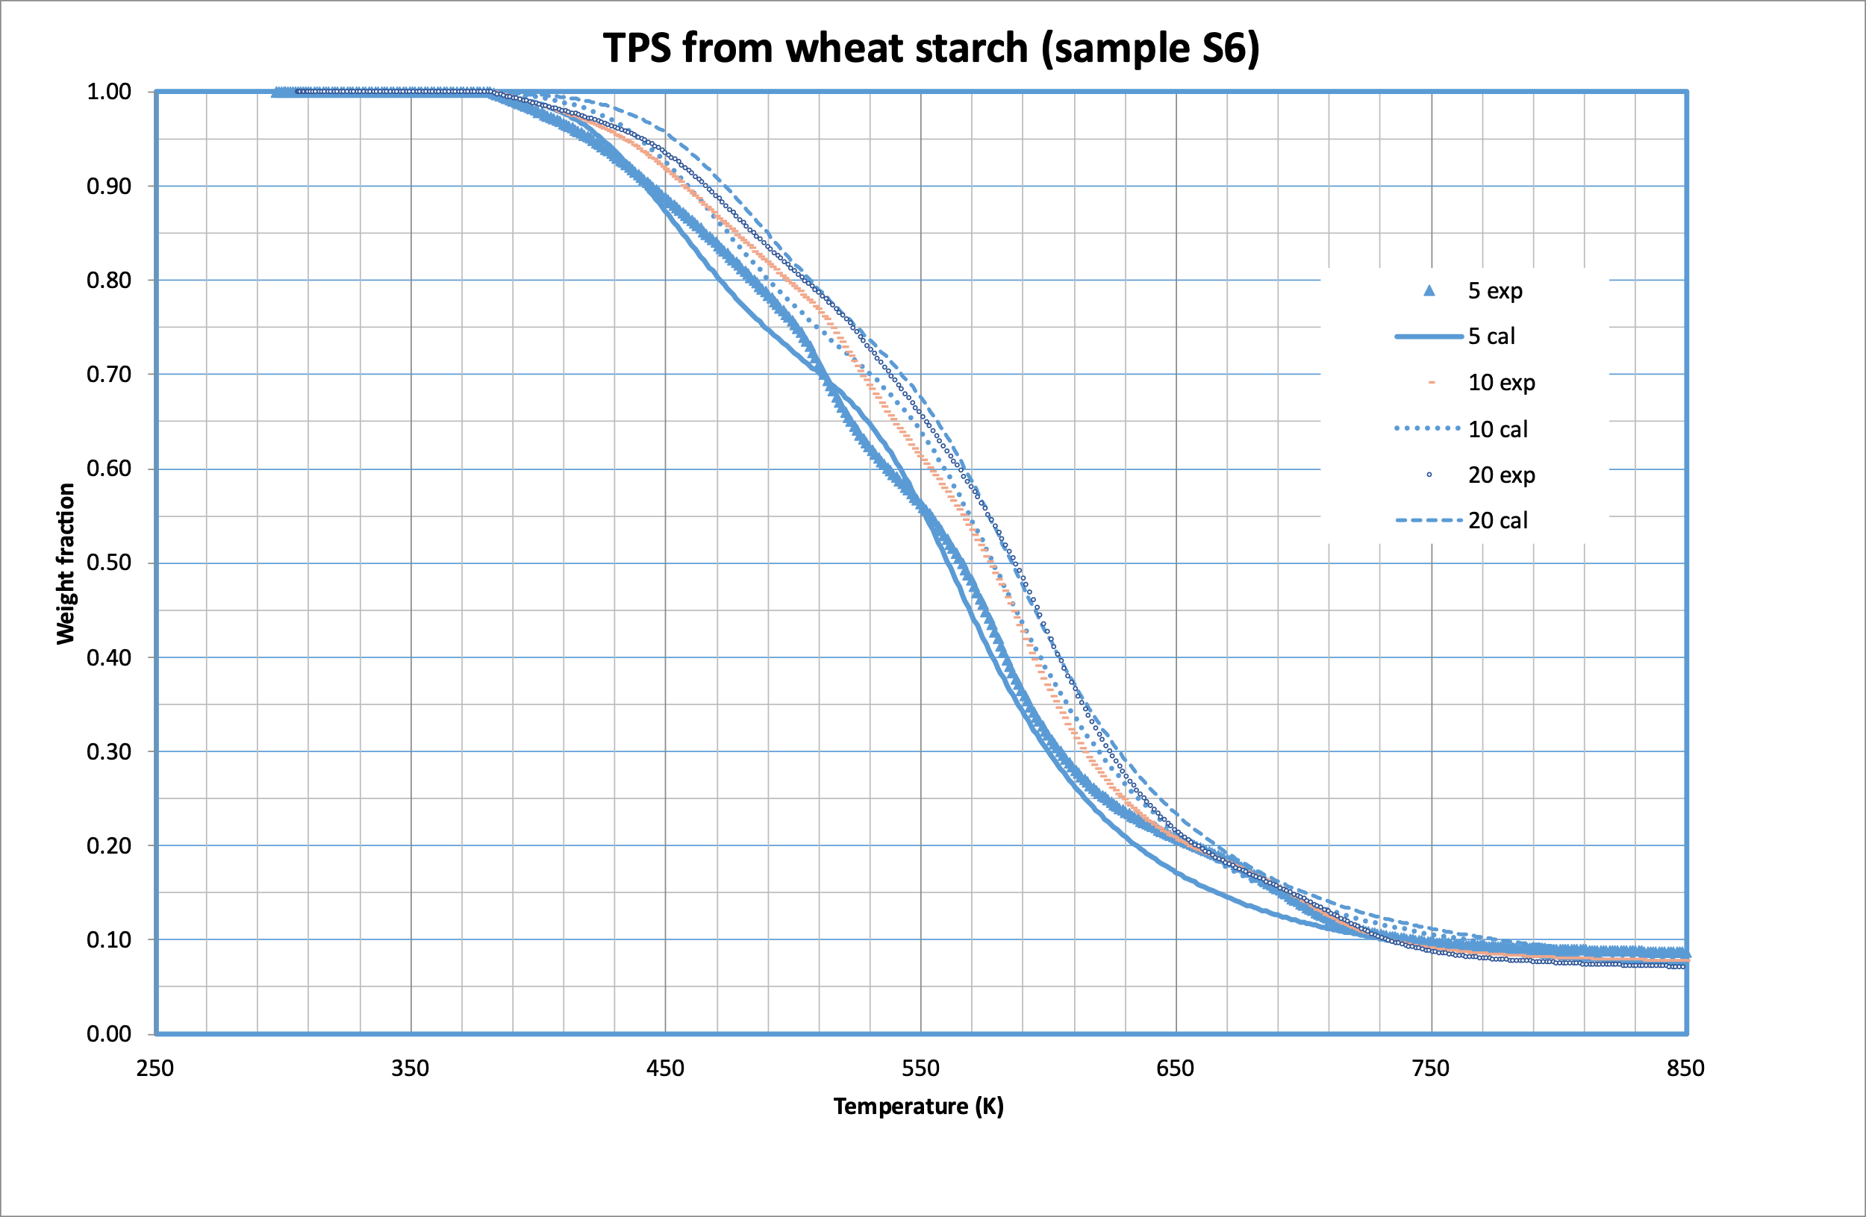
Figure SM3. Pyrolysis of TPS from wheat starch at three heating rates.

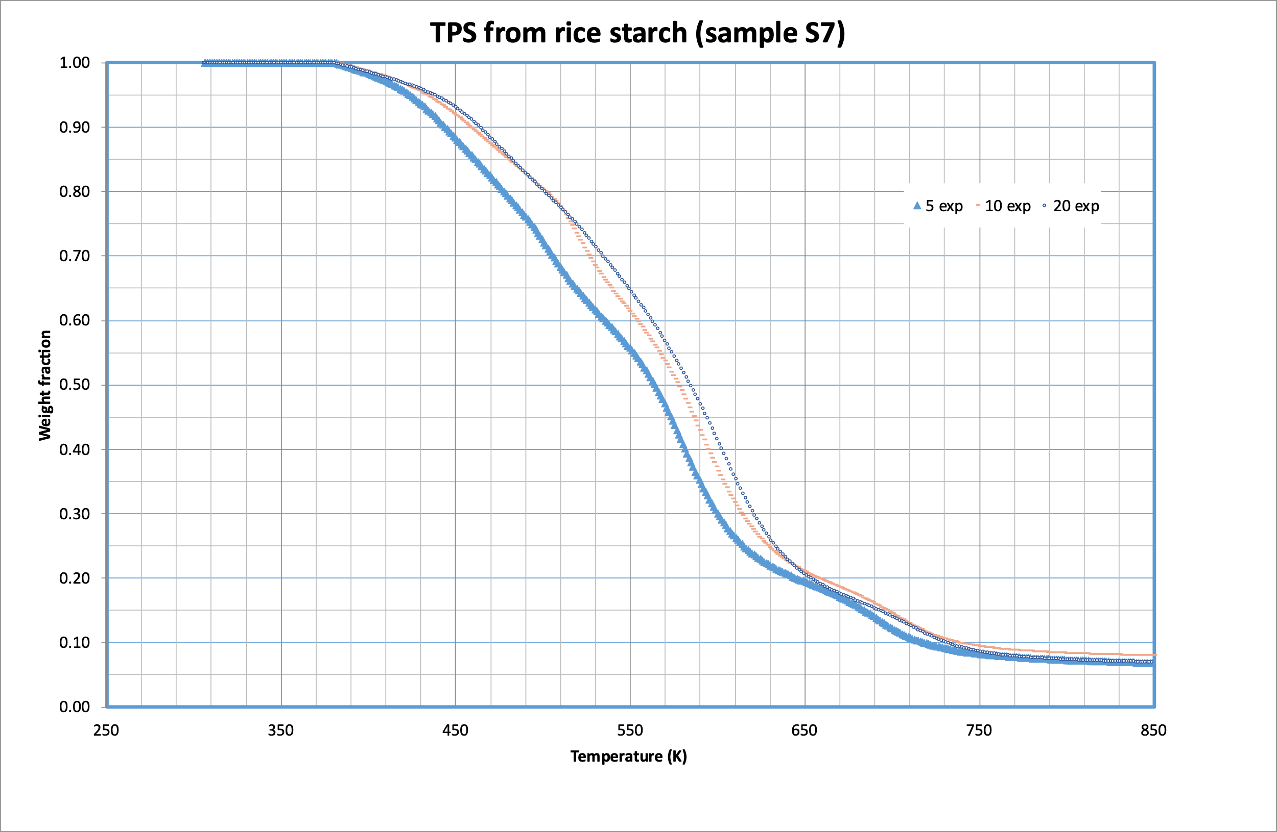
Figure SM4. Pyrolysis of TPS from rice starch at three heating rates.

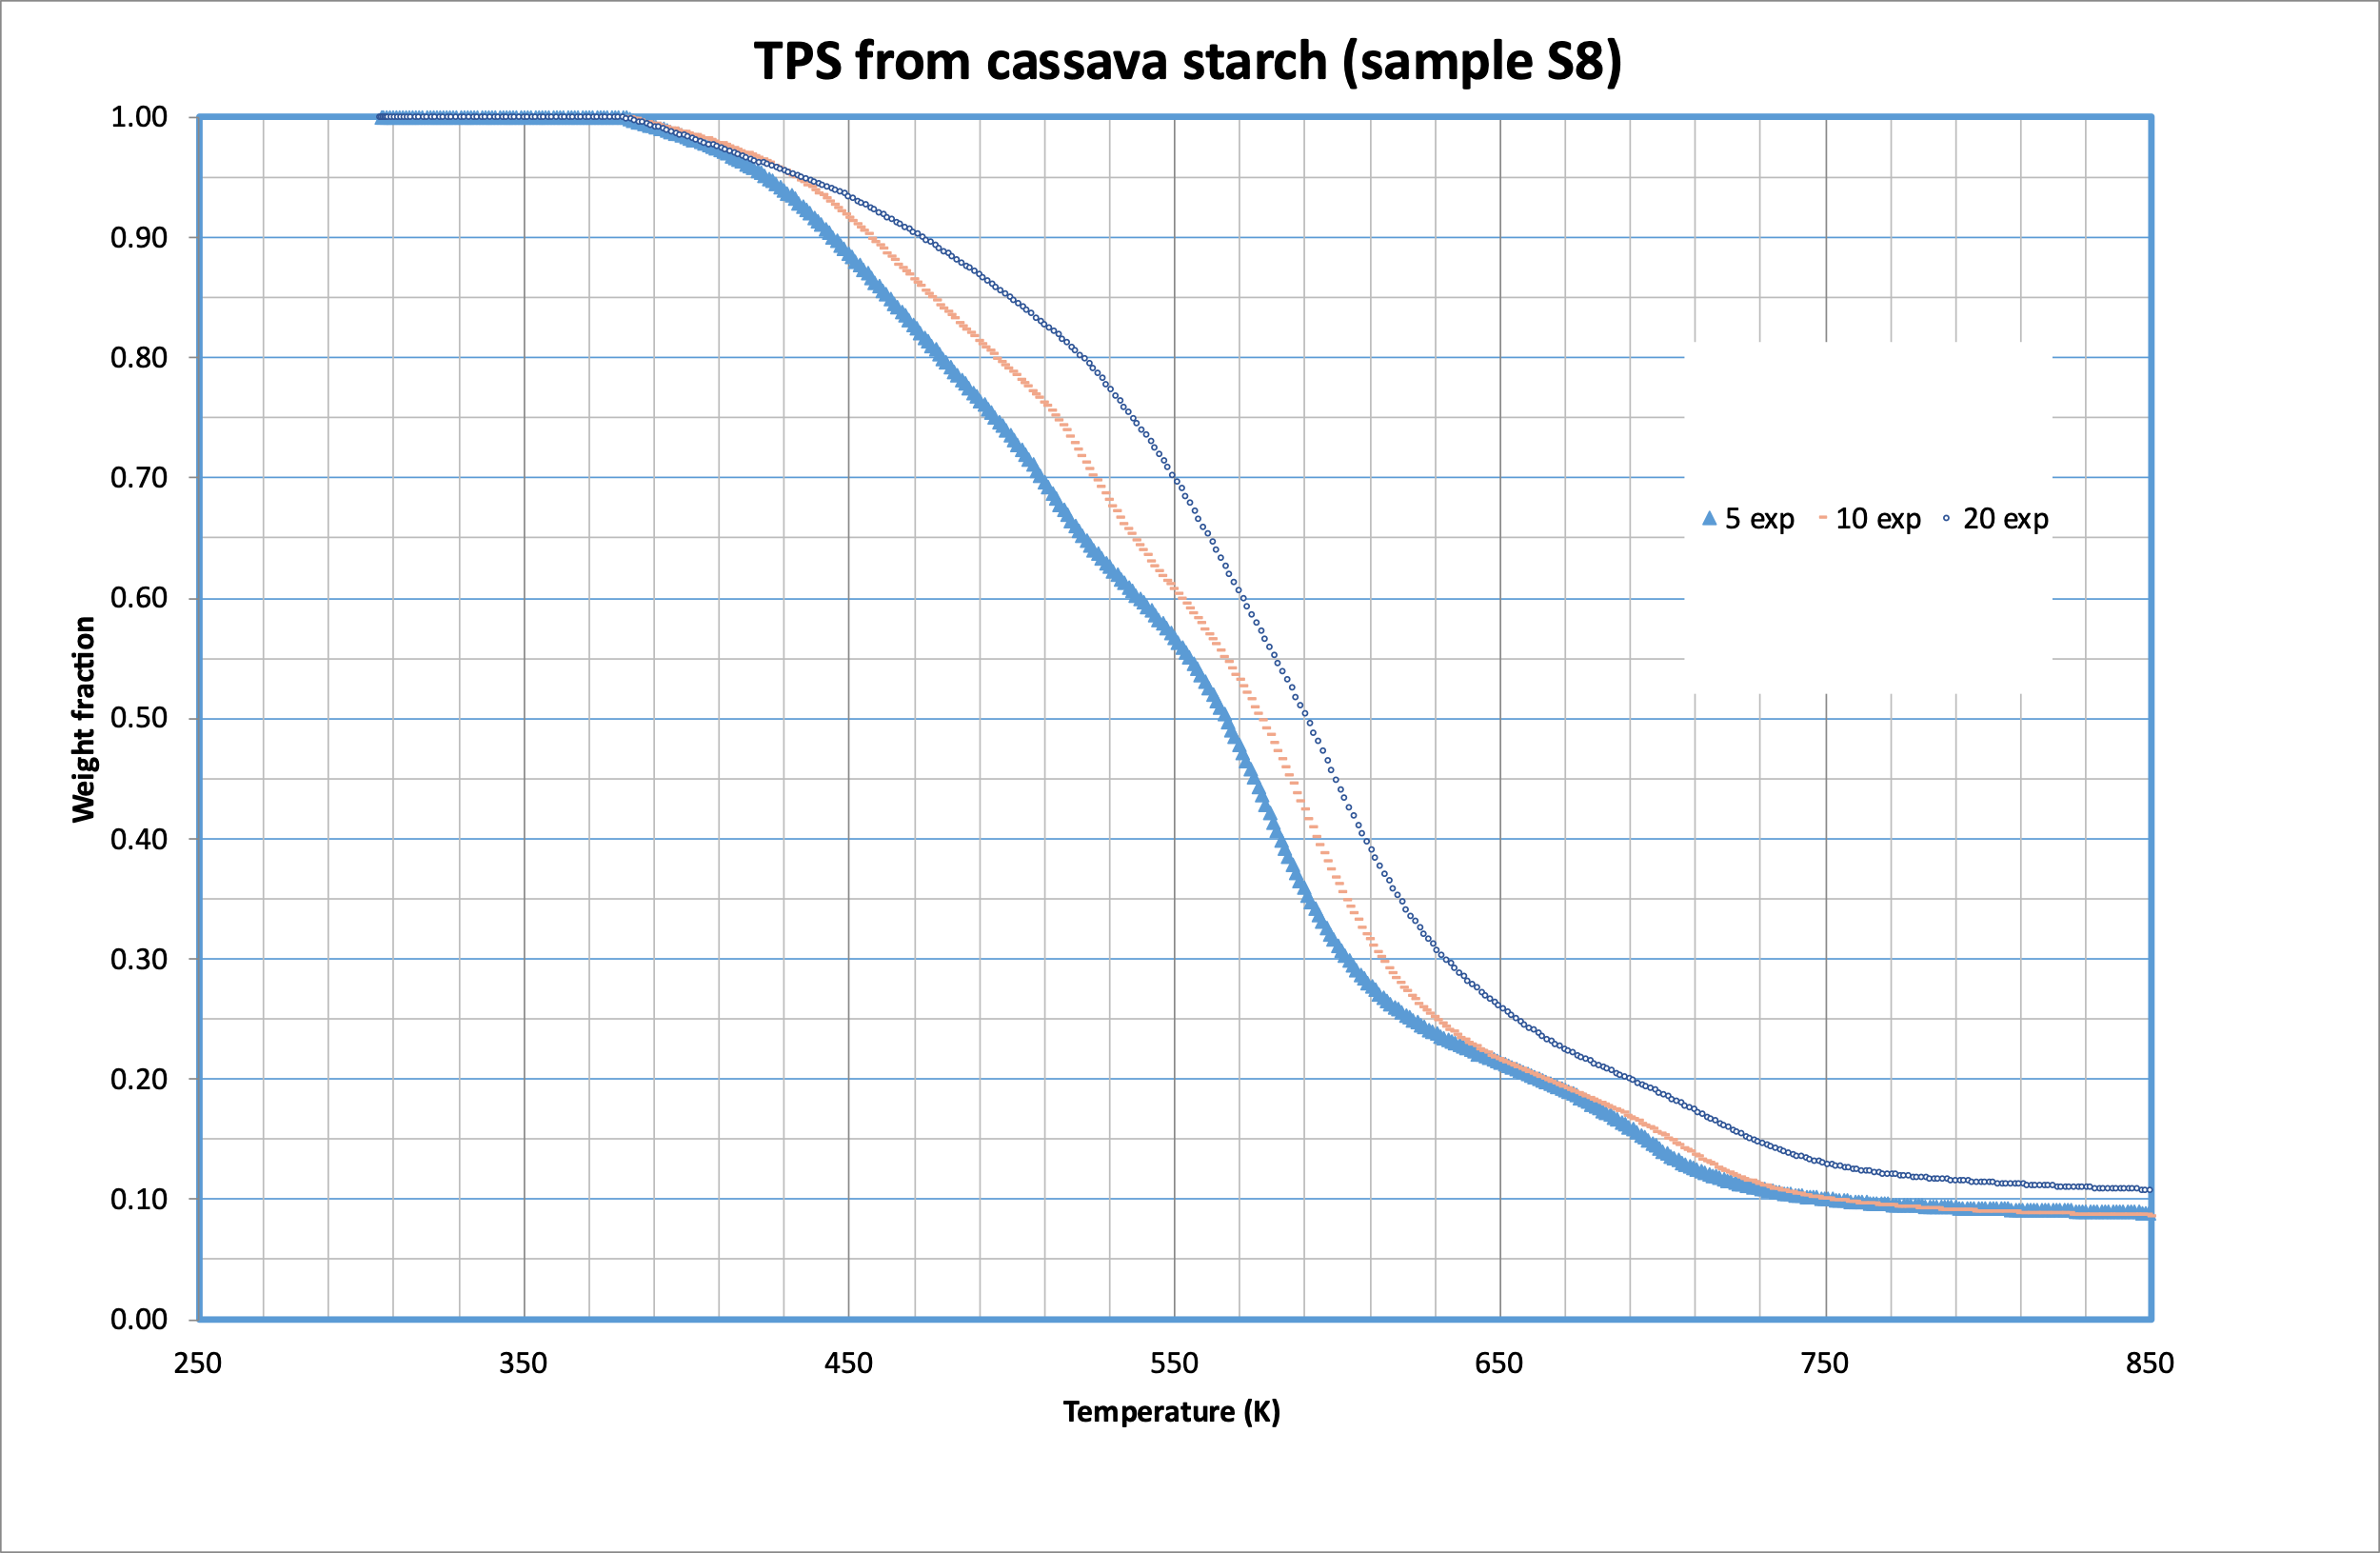
Figure SM5. Pyrolysis of TPS from cassava starch at three heating rates.

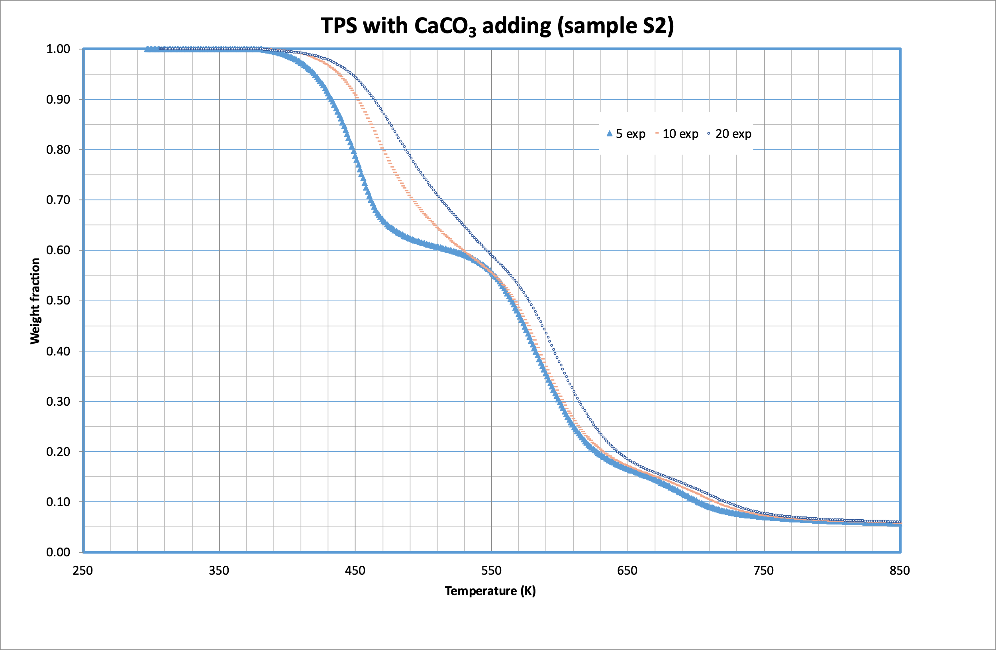
Figure SM6. Pyrolysis of TPS from potato starch and 1 % CaCO₃ adding at three heating rates.

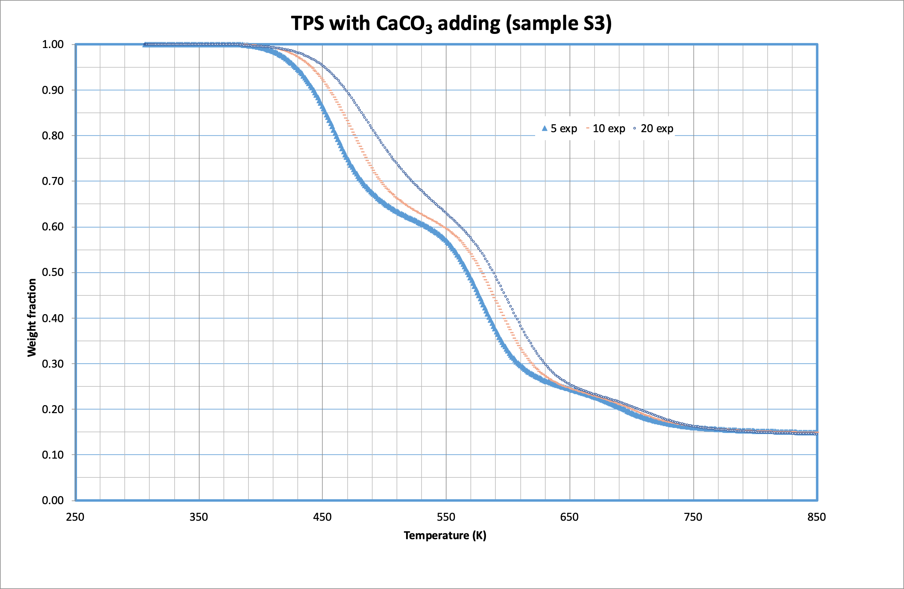
Figure SM7. Pyrolysis of TPS from potato starch and 5 % CaCO₃ adding at three heating rates.

