Supplementary Information
Electrochemical characterization of electrodeposited copper catalyst for CCU: Supplementary information
Corentin Penot ¹, Kranthi Kumar Maniam ¹ and Shiladitya Paul ^{1,2,} *
Citation: To be added by editorial staff during production.
Academic Editor: Firstname Lastname
Received: date
Revised: date
Accepted: date
Published: date
Copyright: © 2024 by the authors. Submitted for possible open access publication under the terms and conditions of the Creative Commons Attribution (CC BY) license (https://creativecommons.org/licenses/by/4.0/).
¹ Materials Innovation Centre, School of Engineering, University of Leicester, Leicester, LE1 7RH, UK; km508@leicester.ac.uk
² Materials Performance and Integrity Technology Group, TWI, Cambridge, CB21 6AL, UK.
* Correspondence: shiladitya.paul@twi.co.uk

- Electroplating of copper

1.1 Materials

Copper sulfate pentahydrate (CuSO4.5H2O), sulfuric acid (H2SO4, 98% purity), and hydrochloric acid (HCl, 37% purity) were procured from Fischer Scientific (United Kingdom). Copper panels were acquired from Schloetter (United Kingdom).

1.2 Experimental Setup

1.2.1 Experimental Preparation

Initially, copper substrates were cut into 2.5 x 2.5 cm⁻² sized specimens and polished using 600 and 1200 grade emery paper. Subsequently, they were rinsed in deionized water and activated in a 10 wt % HCl solution. Afterward, the samples were rinsed again with deionized water (DI) and utilized as the cathode for the copper deposition process. A copper plate measuring 5 x 10 cm⁻² was employed as the anode.

1.2.2 Electroplating Solution

The electroplating solution was formulated by mixing 150 g.L⁻¹ of CuSO₄.5H₂O, 40 mL.L⁻¹ of H₂SO₄, and deionized water. Initially, DI water was warmed upto 45-50 deg C followed by the slow addition of 150 g.L⁻¹ of CuSO₄.5H₂O. Once the solution is well mixed, 40 mL.L⁻¹ of H₂SO₄ is added to the solution drop by drop until a homogeneous mixture is obtained. The resultant solution was cooled to laboratory temperature and employed as the electroplating solution

2.2.3 Electroplating Experiment
The electroplating experiment was conducted by applying a voltage of 0.63 V using a DC rectifier (10 A, 12 V, British Electricals Limited, United Kingdom) for a duration of 35 minutes. The distance between the anode and the cathode was maintained at 95 mm (as illustrated in Figure S1), and air agitation was employed to ensure the uniform distribution of concentrations near the cathode.

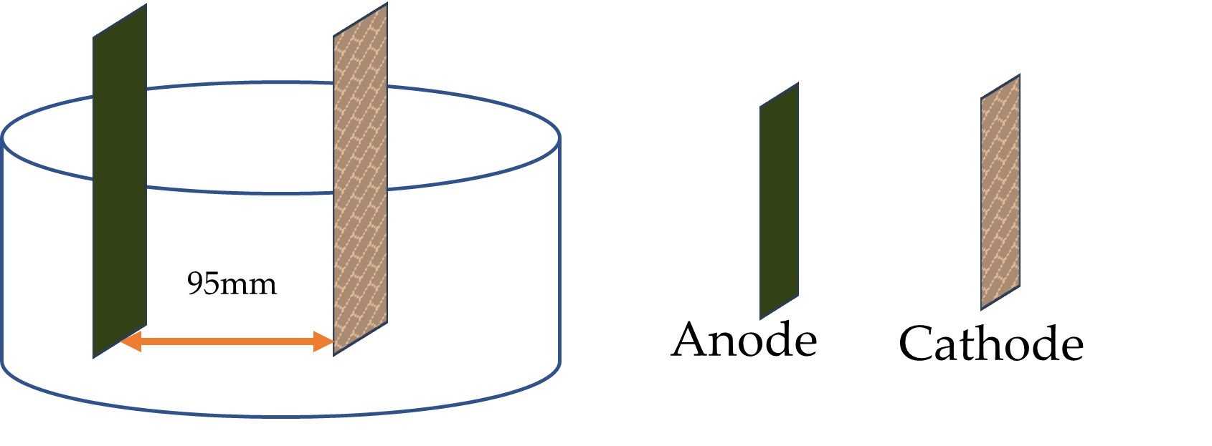
Figure S1. Schematic representing the electroplating setup, highlighting the positioning of the anode and cathode, maintained at a consistent distance of 95 mm

- Electrochemical testing

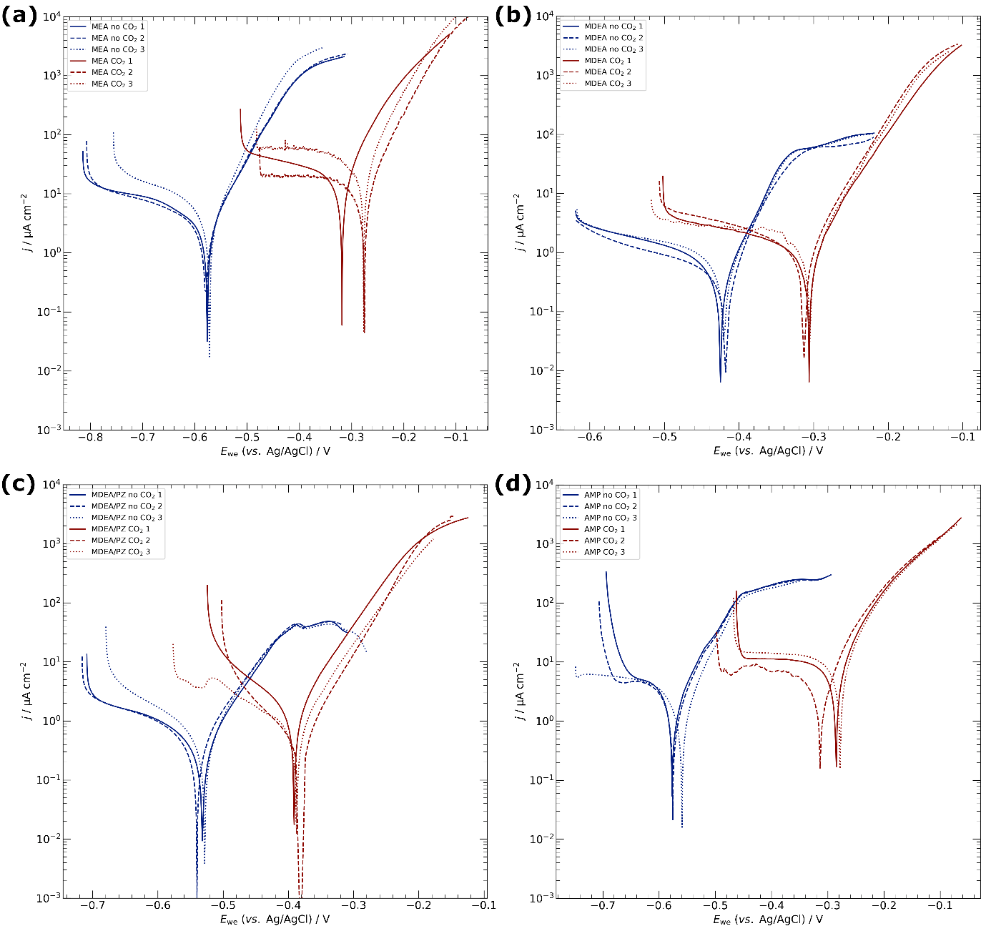
Figure S2. Potentiodynamic polarization of copper specimens in the different amine-based capture media. (a) MEA, (b) MDEA, (c) MDEA/PZ, (d) AMP. Scan rate 10 mV min⁻¹.
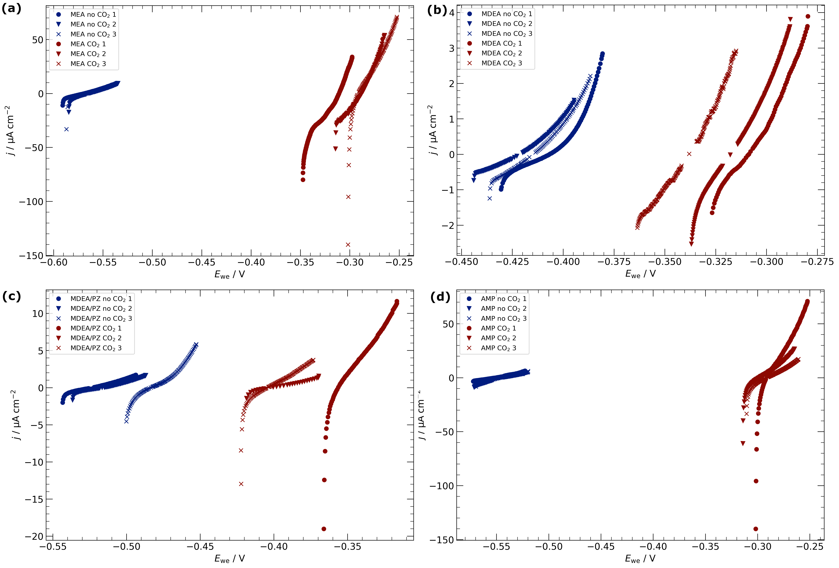
Figure S3. Linear polarization resistance of copper specimens in the different amine-based capture media. (a) MEA, (b) MDEA, (c) MDEA/PZ, (d) AMP. Scan rate 0.125 mV s⁻¹.
Table S1. Average cell resistances in the different amine solutions
Media | CO₂ | R_{cell} / Ω
MEA | no | 7.8 ± 0.6
 | yes | 2.0 ± 0.2
MDEA | no | 17.4 ± 2.7
 | yes | 8.3 ± 0.7
MDEA/PZ | no | 18.7 ± 9.0
 | yes | 12.6 ± 2.4
AMP | no | 7.5 ± 1.2
 | yes | 4.4 ± 0.2
KCl | no | 2.4 ± 2.1

