Supplementary Materials
Determination of Microplastics in Omega-3 oil supplements
Moonhae Kim^{1,2,†}, Juyang Kim^{2,†}, Seulah Park², Dowoon Kim², Jaehak Jung^{2,*,‡} and Dongha Cho^{1,*,‡}
1 Department of Bio-Health Convergence, College of Biomedical Science, Kangwon National University, Chuncheon 24341, Korea
2 Korea Institute of Analytical Science and Technology, Seoul 04790, Korea
* Correspondence: jh3370@naver.com (J.J.); chodh@kangwon.ac.kr (D.C.)
† These authors contributed equally to this work.
‡ These authors contributed equally to this work.

Supplementary Results

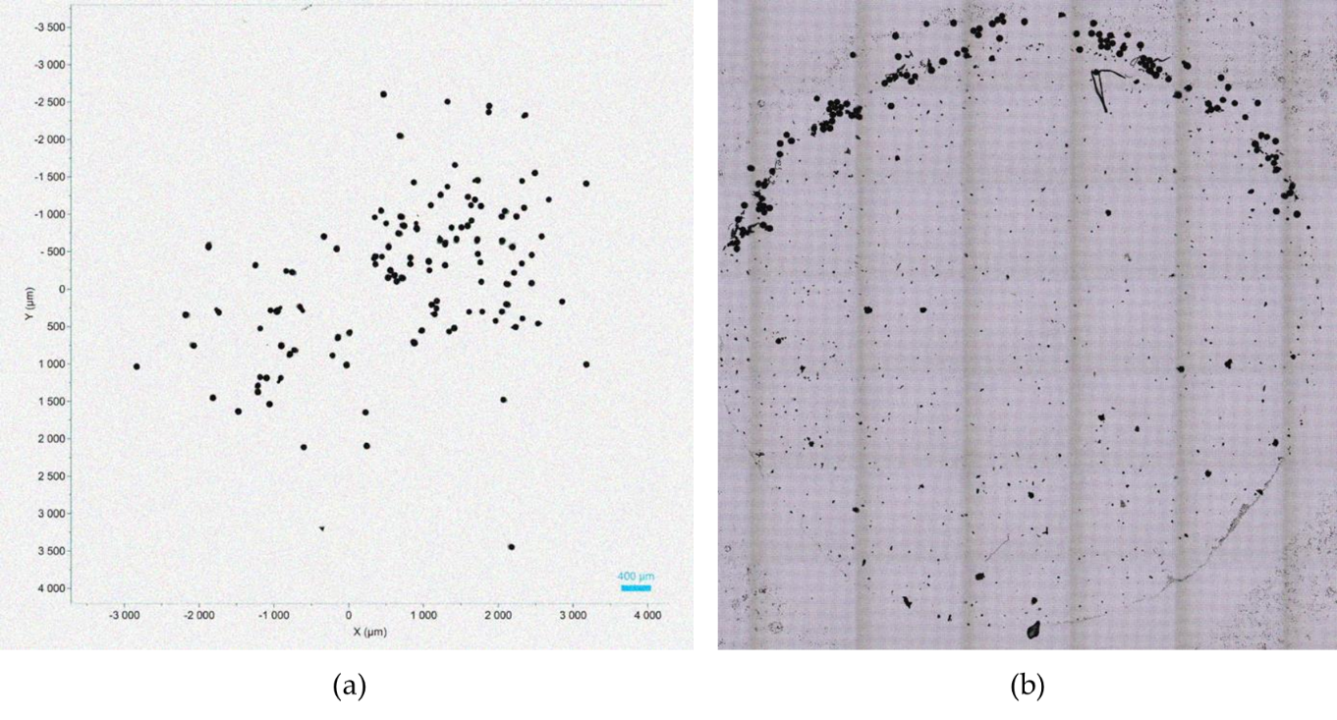
Figure S1. PE spheres used for recovery test: (a)before addition; (b) recovered PE spheres on filter.

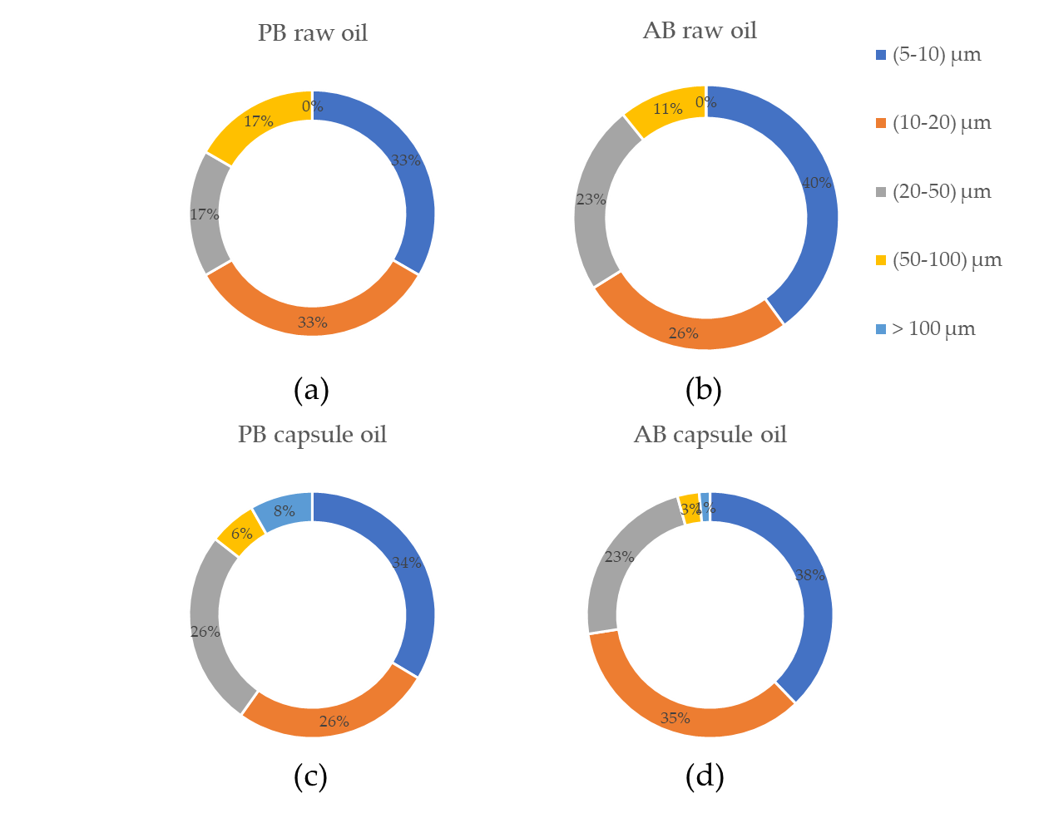
Figure S2. Distribution by polymer size of: (a) PB raw oil; (b) PB capsule oil; (c) AB raw oil; (d) AB capsule oil.

Table S1. Numbers of MPs in omega-3 samples
Sample type | Based oil | Total number of MPs | Composition of MPs | Amount of sample (g)
Raw oil | PB | 6 | 3 PP, 1 PS, 2 PET | 2.5
Raw oil | PB | 0 | N.D.* | 2.5
Raw oil | AB | 7 | 7 PP | 2.5
Raw oil | AB | 6 | 5 PP, 1 PET | 2.5
Raw oil | AB | 1 | 1 PP | 2.5
Raw oil | AB | 10 | 8 PP, 1 PS, 1 PET | 2.5
Raw oil | AB | 2 | 2 PP | 2.5
Raw oil | AB | 7 | 7 PP | 2.5
Raw oil | AB | 2 | 2 PP | 2.5
Raw oil | AB | 2 | 1 PE, 1 PET | 2.5
Raw oil | AB | 3 | 3 PP | 2.5
Raw oil | AB | 14 | 14 PP | 2.5
Raw oil | AB | 8 | 5 PP, 3 PET | 2.5
Raw oil | AB | 1 | 1 PP | 2.5
Capsule oil | PB | 34 | 17, PP, 16 PET, 1 PVC | 2.9
Capsule oil | PB | 7 | 7 PP | 1.4
Capsule oil | PB | 4 | 3 PP, 1 PVC | 2.7
Capsule oil | PB | 5 | 1 PE, 4 PET | 2.2
Capsule oil | PB | 0 | N.D. | 3.0
Capsule oil | PB | 8 | 4 PP, 1 PE, 3 PET | 3.0
Capsule oil | PB | 5 | 1 PP, 4 PET | 3.0
Capsule oil | AB | 0 | N.D. | 3.0
Capsule oil | AB | 13 | 8 PP, 3 PET, 2 PMMA | 2.1
Capsule oil | AB | 9 | 8 PP, 1 PS | 2.1
Capsule oil | AB | 11 | 10 PP, 1 PMMA | 1.1
Capsule oil | AB | 8 | 8 PP | 1.1
Capsule oil | AB | 17 | 7 PP, 10 PET | 2.5
Capsule oil | AB | 73 | 53 PP, 20 PET | 2.4
Capsule oil | AB | 44 | 6 PP, 34 PET, 4 PVC | 2.8
Capsule oil | AB | 52 | 21 PP, 31 PET | 2.7
Capsule oil | AB | 18 | 8 PP, 10 PET | 0.8
Capsule oil | AB | 34 | 26 PP, 8 PE | 2.2
Capsule oil | AB | 0 | N.D. | 1.1
Capsule oil | AB | 8 | 5 PP, 3 PET | 1.1
Capsule oil | AB | 3 | 2 PP, 1 PET | 1.0
Raw oil | PB | 6 | 3 PP, 1 PS, 2 PET | 2.5
*N.D. : Not Detected.

